UNIT 1
THE EVOLVING ROLE OF INFORMATION SYSTEMS AND TECHNOLOGY IN ORGANIZATIONS: A STRATEGIC PERSPECTIVE

OUTLINE
- ♦ Information Systems (IS), Information Technology (IT) and ‘Digital’
- ♦ ‘Digital Disruption’: The Impact of IS/IT
- ♦ A Three-era Model of Evolving IT Application in Organizations
- ♦ A Classification of the Strategic Uses of IS/IT
- ♦ Success Factors in Strategic Information Systems
- ♦ A Portfolio Management Perspective on IS/IT Investments
- ♦ What Is an IS/IT or Digital Strategy?
- ♦ From Strategic Alignment to Strategy Co-evolution
- ♦ Digital Strategies for the 21st Century: Building a Dynamic Capability to Leverage IS/IT
Most organizations in all sectors of industry, commerce, not-for-profit, and government are now fundamentally dependent on their information systems (IS) and information technology (IT). In industries such as telecommunications, media, entertainment, gambling and financial services, where the product is already, or is being increasingly, digitized, the very existence of an organization depends on the effective application of IS/IT. Since the commercialization of the Internet, the use of technology has become the expected way of conducting many aspects of business and some businesses exist purely online. Governments and public administrations have launched many digital services. The ubiquity of mobile devices and new forms of social media are raising consumer demands for immediacy of access and speed of response. The increasing pervasiveness of smart connected devices and ‘things’ of all kinds is opening up opportunities for new products and services, further operational efficiencies and new types of businesses and business models.
While organizations want to develop a more ‘strategic’ approach to harnessing and exploiting IS/IT, most have arrived at their current situation as a result of many short-term, ‘tactical’ decisions. Many would no doubt like to rethink their investments, or even begin again with a ‘clean sheet’, but unfortunately have a ‘legacy’ resulting from a less than strategic approach to IS/IT in the past; many organizations including banks, insurance companies and public administrations still depend on systems first developed over 30 years ago. Even investments that were once seen as ‘strategic’ eventually become part of a costly and complex legacy. Learning from previous experience – the successes and failures of the past – is perhaps one of the most important aspects of strategic management. Much of the learning about the capability of IT is experiential, and organizations tend to learn to manage IS/IT by doing, not appreciating the challenges until they have faced them.
However, few organizations are likely to have been exposed to the whole range of IS/IT experiences; nor is it likely that those experiences have been evaluated objectively. This chapter provides an overview and appraisal of the general evolution of IS/IT in organizations, from which lessons can be learned for its future strategic management. This evolution is considered from a number of viewpoints, using a variety of models, some of which are further developed and used later in the book, when considering the particular approaches required in thinking and planning strategically for IS/IT investments.
A number of forces affect the pace and effectiveness of progress in using IS/IT and in delivering operational and strategic benefits. The relative importance of each factor varies over time, and will also vary from one organization to another. These factors include:
- the capabilities of the technology and the applications that are feasible;
- the economics of acquiring provisioning, deploying and maintaining the technology: applications, services and infrastructure;
- the skills and abilities available, either in-house or from external sources, to design and implement the applications;
- the skills and competences within the organization to use the applications and information;
- the capability to manage any organizational changes accompanying technology deployments;
- the pressures on the particular organization or its industry to improve performance or adapt to changing circumstances, such as a new regulatory environment or ‘digital disruption’.
This list is not meant to be exhaustive and could be expressed in other terms – but it is presented in a deliberate sequence of increasing ‘stress’, as the complexity and criticality of management decision making becomes more strategic. Most assessments of the evolution of IS/IT in organizations tend to focus on one or two aspects of its development, such as organizational, applications, management of technology or planning, but in this chapter these various perspectives will be brought together, as much as possible.

Information Systems (IS), Information Technology (IT) and ‘Digital’
Before considering a strategic perspective, it is important to have a clear understanding of the terms information systems (IS) and information technology (IT) and how they are distinguished. While IS and IT are often used interchangeably or even casually, it is important to differentiate between them to create a meaningful dialogue between business staff and IS/IT specialists; this is essential if successful IS/IT strategies are to be developed. Recently the term ‘digital’ is being used more frequently in many organizations and in the practitioner and academic literature¹ – so how digital relates to IS/IT is also important to recognize.
Information systems (IS) existed in organizations long before the advent of information technology (IT) and, even today, there are still many ‘systems’ present in organizations with technology nowhere in sight. IT refers specifically to technology, essentially hardware, software and telecommunications networks, including devices of all kinds: computers, sensors, cables, satellites, servers, routers, PCs, phones, tablets; and all types of software: operating systems, data management, enterprise and social applications and personal productivity tools. IT facilitates the acquisition and collection, processing, storing, delivery, sharing and presentation of information and other digital content, such as video and voice. Sometimes the term Information and Communication Technologies (ICT) is used instead of IT to recognize the convergence of traditional computer technology and telecommunications.
Information systems (IS) are the means by which people and organizations, increasingly utilizing technology, gather, process, store, use and disseminate information.² The domain of interest for IS researchers includes the study of theories and practices related to the social and technological phenomena which determine the development, use and effects of information systems in organizations and society. It is thus concerned with the purposeful utilization of information technology, not the technology per se. IS is part of the wider domain of human language, cognition, behaviour and communication. Consequently, ‘IS will remain in a state of continual development and change in response both to technological innovation and to its mutual interaction with human society as a whole.’³
Some information systems are totally automated by IT. For example, airlines, comparison websites, banks and some public agencies have systems where no human intervention is required.⁴ Dell went further with its ‘build-to-order’ model for its PCs, including an element of ‘intelligence’ to help the customer in making decisions regarding the configuration of components, ensuring that ‘non-optimal’ configurations or configurations not technically possible are not selected. Once a customer order has been confirmed, purchase orders for components are automatically generated and electronically transmitted to suppliers. This enables Dell to achieve a stock turn of 30.7 times per year (competitor Lenovo has a stock turn of 22.2).⁵ Dell also feeds real-time data from technical support and manufacturing lines directly through to suppliers on a minute-by-minute basis. This ‘suite’ of interconnected information systems is underpinned by a variety of different technologies – servers, storage, software, routers, sensors and networks.
People can find it difficult distinguishing between IS and IT because the technology (the T of IT) seems to overwhelm their thinking, obscuring the business information system that the technology is intended to support or enable.⁶ This perhaps also gives a clue as to why organizations may fail to realize benefits from many of their investments in IT. Technology investments are often made without understanding or identifying the business benefits that could or should result from improving the performance of activities by using IT. We have even heard stories recounted of senior executives returning from business trips abroad, demanding that a new technology be purchased or a new application be implemented because they have seen an advertisement in an airline's in-flight magazine! It is important to acknowledge that IT has no inherent value – the mere purchase of IT does not confer any benefits on the organization; these benefits must be unlocked,⁷ normally by making changes to the way business is conducted, how the organization operates or how people work.⁸ Achieving organizational change on any scale can be difficult, even without the introduction of new technology.
Another term that is frequently used along with IS and IT is application, i.e. an application of IT to handle information in some way. Essentially, an application refers to software, or a combination of software and hardware, used to address or enable a business or personal activity: for example, in businesses for general accounting, production scheduling, patient administration, customer order management or enabling collaborative working; or for an individual to book theatre tickets, check in for a flight or pay for parking. Other examples include general uses of hardware and software to carry out tasks such as word processing, email, preparing presentation materials or conducting online meetings. They are usually large, general-purpose programs that can do many different things, built on top of operating systems.
These applications can be purchased, pre-written software programs for a particular business activity or developed ‘in-house’ to provide particular functionality. Many applications for personal productivity as well as business use are now delivered via mobile devices of all kinds and increasingly they are being provisioned from the cloud (see Box 1.1 for an overview of cloud computing). Some business application software packages can be tailored or customized to the specific requirements of an organization. One of the key selling points of large Enterprise Resource Planning (ERP) and Customer Relationship Management (CRM) software suites is that they can be configured, to some extent, to meet the specific way in which an organization operates.⁹

BOX 1.1

An introduction to cloud computing
Software has evolved from custom-coded, proprietary applications to pre-packaged or off-the-shelf applications and now to the development of Internet-centric applications. The convergence of software and IT infrastructure to an Internet-centric environment has enabled the concept of cloud computing to emerge. In its simplest form, a cloud provider is a third-party service firm that deploys, manages and remotely hosts a pre-packaged software application through centrally located servers in a ‘rental’, lease or ‘pay-as-you-go’ arrangement. In exchange for accessing the application, the client renders rental-like payments. An early example of a cloud-based service, although it wasn't referred to as such at the time it was launched, is Hotmail (www.hotmail.com), which provides an email address with storage and access from any browser. Individuals with a Hotmail account can access and send email from any location as long as they are connected to the Internet.
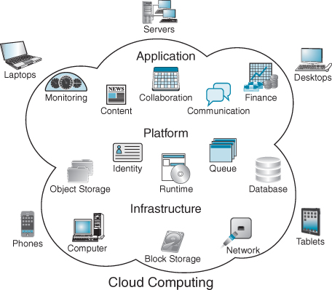
Schematic of cloud computing.
Source: Sam Johnston, 3 March 2009, CC BY-SA 3.0.
No matter how the cloud provider is structured, the ultimate objective is a ‘seamless’ service, in which the client interacts only with the cloud. The most significant elements of a ‘seamless’ integration of services include providing the hardware and software, integration and testing, a secure network infrastructure, reliable mission-critical data centre facilities and a highly qualified team of IT experts managing the entire solution. The primary categories of cloud services provided to date are (see the following figure):
- ♦ Applications provisioning – essentially providing an information handling capability, either through proprietary applications such as property management, specialized healthcare patient record keeping or analytical/mathematical services, or widely used software packages from the leading ERP and CRM vendors. This is often referred to as Software as a Service (SaaS).
- ♦ Infrastructure operations – which can include provisioning the customer's desktop environment, as well as operating data centres to host the applications. Data centre operations include the full range of hardware/systems software management, provisioning services, security and disaster recovery as well as the necessary back-office systems such as service usage, monitoring, accounting and billing. This is often referred to as Infrastructure as a Service (IaaS).
- ♦ A computing platform – typically including an operating system, programming language execution environment, database, and web server. Application developers can then develop and run their software solutions on a cloud platform without the cost and complexity of buying and managing the underlying hardware and software layers. This is known as Platform as a Service (PaaS). Some PaaS providers like Microsoft Azure and Google App Engine offer underlying computer and storage resources that scale automatically to match application demand so that the cloud user does not have to allocate resources manually.
- ♦ Network connectivity – providing connections to the Internet for end-customers or the application provider (essentially acting like an Internet service provider (ISP)). Reliability, performance and security of network communications are potentially weak links in the chain.
- ♦ Supporting services – providing hardware installation and maintenance services at customer sites or end-to-end management services for all aspects of implementation and operations across the entire cloud delivery chain for the duration of the service contract.
Services are accessed, via the Internet or a private network, without having to pay for the installation, the hardware or the software. Price per user per month (PUPM) has emerged as the standard pricing method for cloud services. The roots of this model stem directly from user-based licence pricing for applications and the PUPM model allows providers to manage pricing based on numbers of users as well as by categories of users. User categories include designations such as ‘power user’ or ‘inquiry or casual user’, which refer to access privileges and functionality. Cloud service models are seen as:
- ♦ Reducing ‘costs of ownership’. Although costs and service levels vary widely according to the types of service provided, studies have indicated that by renting an application from the cloud, a company can save between 30% and 60% over purchasing and managing the hardware and software for the application themselves.
- ♦ Shifting IT spend from capital expenditure (CapEx) to operating expenditure (OpEx) and providing more predictable costs with less financial risk. Pay-as-you-go pricing takes the economic burden of buying software and attendant hardware and transfers it to the cloud.
- ♦ Flexibility to exit or radically change operating scale. Cloud contracts are typically for one year with minimal or no exit fees. Many clouds represent multiple software package vendors, and clients are generally free to add or change services as needed.
- ♦ Quicker deployment of new applications and IT capabilities. There can be a significant reduction in the overall cycle time to put a new information system into productive operation.
Despite all the hype around the cloud, 90% or more of what is deployed today are really private clouds – in-house data centres taking advantage of cloud technologies – rather than services provisioned from a public cloud. To date, most deployments of cloud computing are for infrastructure while applications tend to be point-to-point solutions for business areas such as sales force automation and human resource management.
With the emergence of smartphones and tablets, the concept of ‘an app’ has entered the lexicon and it is usually seen as differing from an application.¹⁰ In general, an app is designed for a single purpose, i.e. it has one piece of functionality, not as a means to an end but an end in itself. An application, on the other hand, may handle a wide variety of functions. Many of the standard apps on a smartphone are small bits of what a web browser can do: stock quotes, maps, YouTube, weather, messaging. Google.com is an app; the one function it performs is search, and it provides a highly usable interface for that function. And, of course, Google's search app is delivered through desktops, laptops, phones and tablets. Enterprise applications from Oracle, SAP, Workday and Salesforce and most internally developed software applications contain a larger number of capabilities packed into a single program or suite of programs.
In recent years, ‘digital’ has been gaining attention, with the label being increasingly used. Many consultancies and IT vendors are now promoting their wares under the label of ‘digital disruption’, ‘digital transformation’ or the ‘digital enterprise’. Governments have relabelled e-government as ‘digital government’.¹¹ Organizations of all types are looking to build ‘digital strategies’ or ‘digital business strategies’. We have even encountered one company where they refer to their digital strategy as social media, mobile devices, analytics and cloud computing (so-called SMAC); everything else is seen as IT! In our parlance, these are all IT. The challenge is figuring out the purpose for which these are going to be used by the organization.
In this book we are using the label ‘digital’ to embrace both IS and IT. For us, digital has both an IS component and an IT component. We emphasize that in building a digital strategy it is imperative to understand how information and systems (IS) will be leveraged and used as well as the underpinning technological (IT) capabilities that will be required.

‘Digital Disruption’: The Impact of IS/IT
Disruption caused by IS/IT actually began many decades ago when it was known at the time as ‘business transformation’ or ‘business process re-engineering’. Today's focus on ‘big data’ and analytics is another iteration of the promised ‘information revolution’ that was predicted in the late 1970s, became more feasible in the 1990s with the arrival of Data Warehousing and OnLine Application Processing (OLAP) tools, but as yet has been more a data deluge for many organizations rather than the source of strategic opportunities. Indeed, back in 1985, Porter and Millar wrote a seminal article titled ‘How information gives you a competitive advantage’ with prescriptions that still resonate today.¹² Microsoft founder Bill Gates noted:
“I have a simple but strong belief. The most meaningful way to differentiate your company from your competition, the best way to put distance between you and the crowd, is to do an outstanding job with information. How you gather, manage, and use information will determine whether you win or lose.¹³”
However, many still struggle with this quest.
Despite the irritating ‘relabelling’ habit of the IT industry, advances in IT continue to challenge established, even dominant, views about organizations and organizing, markets and competition.

Digital Disruption of Organizations
For some decades now, technology has been undermining the very logic of the organization, particularly those that are vertically integrated.¹⁴ Nobel economist Ronald Coase, in his seminal 1937 article ‘The Nature of the Firm’,¹⁵ argued that organizations were created because the ‘transaction costs’ of doing business in the open market were too great for complex enterprises, like building railroads, manufacturing cars or creating telephone networks. Large, vertically integrated companies were established to reduce these transaction costs. Coase's work was later extended by Oliver Williamson with his transaction cost economics.¹⁶
A transaction cost is incurred in making an economic exchange, i.e. the cost of participating in a market. Information is at its core. Transaction costs include search and information costs such as: those incurred in determining that the required good or service is available on the market, which provider has the lowest price etc.; bargaining costs required to come to an acceptable agreement with the other party to the transaction; drawing up an appropriate contract; and policing and enforcement costs to make sure the other party sticks to the terms of the contract, and taking appropriate action if necessary.¹⁷ Many economists argue that the value of organizing (and therefore organizations) is based on the principle of exploiting information asymmetries (i.e. specialization), culminating in thinking of organizations as knowledge ‘engines’ or ‘information processors’ operating in a knowledge economy.¹⁸
But since the commercialization of the Internet and the accelerated shift online, all these transaction costs have plummeted¹⁹ as technology made it easier to search for information and transact with workers, suppliers and customers – what has been referred to as a frictionless economy. Companies can focus on their so-called core competences and outsource or buy in others.²⁰ For example, through automated supply chains, information sharing and transparency, manufacturers no longer have to hold raw material stocks ‘just in case’ a supplier has production or logistics problems. By providing visibility, suppliers essentially become an extension of the manufacturer.
Work by Shapiro and Varian has highlighted the difference between ‘physical goods’ and ‘information goods’ in the digital world and the profound implications of those differences for strategy.²¹ One defining attribute is that the market value of information goods is derived from the information they contain. Other core distinguishing features of information goods are listed in Box 1.2.

BOX 1.2

Distinguishing features of information goods
Information goods are experience goods; that is, the customer has to experience them in order to value them. How do you know the value of a newspaper until you have read it? Or whether you like a piece of music until you have listened to it? Or the usefulness of a report until you have read it? Therefore customer choice decisions are influenced by emotional expectations rather than cognitive product attributes. Informational inputs such as critics' reviews, word of mouth and advertising, as well as latent product interest, are also important determinants of consumer choice.ª
The lack of tangible cues for the customer to assess the quality of information products poses particular problems for their marketing. A way around this problem is to distribute samples or previews of parts of the information product for free. Building a brand and reputation, which provide some sort of guarantee that the content will have a certain quality or profile, also becomes a critical activity. For example, Gartner Group conducts research in the IT industry and makes it available to its membership, who pay a subscription to have access to their analysis and reports. Prospects can browse its website to get samples of the information products it sells. Gartner has established a strong brand that sees chief information officers (CIOs) from many of the world's largest corporations look to it for advice and trends in the technology area.
Information products are non-rivalrous, in an economic sense. That is, one person's consumption does not diminish the amount available to others. Reading a report, for example, does not mean that the information it contains is now not available to others. In fact, any number of people can read the same report at the same time. And, unlike a traditional physical asset, it does not depreciate through usage. This is why the issue of transfer of ownership becomes complex. The seller of an information product still retains the valuable information, no matter how many people it is sold to. However, by becoming widely available its value may reduce; scarcity often means that a higher price can be extracted for particular information. On the other hand, the opposite situation may also be true; it is only when an information product has become widely known (e.g. a book or a movie), or there are a sufficient number of other compatible information products available on the market, that the information product reaches a critical mass and thus has a greater value to the users (e.g. Facebook or MS Windows). This is the network effect, and it can be particularly powerful for digital information products because of their ease of distribution.^{b}
Finally, information products have a different cost structure than physical products. Traditional financial models are built upon cost. The initial cost of creating the first copy of an information product can be very high, but the marginal cost is generally very low, with perfect fidelity (no quality loss). With information goods, reproduction costs are next to nothing, as are distribution costs. Nor are there any capacity limitations for production and distribution. This means that traditional economic pricing models, calculated by using fixed cost divided by number of products plus marginal cost, are inapplicable. When the initial cost for a certain number of producers is sunk, the competitive forces tend to force price towards the marginal cost – which in the case of information goods is close to zero. The implication is that it is very difficult to make money from undifferentiated information goods, a lesson that many pure-play Internet start-ups found to their peril.
Notes:
ª R. Neelamegham, and D. Jain, ‘Consumer choice process for experience goods: an econometric model and analysis’, Journal of Marketing Research, XXXVI, 1999, 373–386.
^{b} B. Arthur, Increasing Returns and Path Dependence in the Economy, University of Michigan Press, Ann Arbor, 1994.
Other organizational models are emerging that are a synthesis of firms and markets – often called ‘platform’ companies. Uber (the online taxi organization) is one example – it is already a big, global company and growing larger by shaping and creating a new marketplace. Platform companies have been gathering momentum, both in terms of numbers and market shares, for the past two decades: for example, the online retail and auction markets created by Amazon and eBay, the information and media marketplaces created by Google and Facebook, or the music and app markets built by Apple. More recently these new hybrids have extended into human resources, with services like Freelancer, TaskRabbit and WorkFusion, and even to clean energy, at companies like Sungevity. The growth rates of these platform businesses are often phenomenal and they are redefining some of the boundaries of other firms. Platform and network effects, and the economics of networks, are more important now than before and both drive the adoption of IS/IT and are enabled by IS/IT.²²
The changes can also be seen at older, more established industrial companies. The process of innovation at many firms has changed in recent decades. Traditionally the whole model for innovation was internal but now, between government funding for R&D, collaboration with small companies, joint ventures and crowdsourcing ideas using Internet sites like Innocentive, it is often very different. Companies now have to work out how to innovate in an open and collaborative environment.

Digital Disruption of Industries
While no industry is immune to the impact of IT, some have been more affected than others.²³ Gambling and real estate, for example, have largely moved from the physical to the virtual world, making it no longer necessary to have a physical presence to compete.²⁴ IT also accelerates the speed of disruption. With its iTunes store, it took Apple only five years to become America's largest music retailer, and just seven to become the world's largest. In 18 short months, search engine Google erased 85% of the market capitalization of Garmin and TomTom after launching its mobile maps app. Alibaba, China's equivalent to Amazon, became China's largest seller of money market funds in only seven months. Six years after it came into existence, Airbnb had more rooms available than IHG or Hilton, the world's top hotel groups. As technology puts new tools into innovators' hands, the old boundaries between sectors are breaking down. Amazon has transformed bookselling, branched out into general retail and is now experimenting with delivery by drones (and even considering opening retail outlets!).
For retailers, technology advances in mobile computing and augmented reality are blurring the boundaries between traditional and online retailing, enabling them to interact with consumers through multiple touch points and expose them to a rich blend of off-line sensory information and online content. As the industry evolves towards a seamless ‘omnichannel retailing’ experience, the distinctions between physical and online are likely to disappear.²⁵
As banks recover from the economic downturn, non-banks are taking advantage by proceeding aggressively with digital innovations and capturing more and more of the banking value chain. Payments, a source of up to 25% of traditional bank revenues, are one of the most contested areas. PayPal is now the number one online payment method in some countries, and start-up companies like Square and Stripe are earning multi-billion dollar valuations. Apple has launched Apple Pay, which lets customers pay in hundreds of thousands of stores accepting contactless payments. Retailers are also moving in as well: nearly one-third of Starbucks' US revenues are paid through its own loyalty cards and Google recently introduced a plastic debit card for its Google Wallet. Technology giants, telcos and retailers have a long way to go to compete against banks product for product and service for service, and many believe that regulatory barriers will dampen disruption. But new entrants already pose a threat to banks by raising service expectations and creating distance between banks and their customers. The risk for banks is that new competitors will consign them to a limited role as back-office utilities, while non-banks become the new face of their customers' financial lives.
New business models that are being shaped by the capabilities of new technology are also disrupting industries; in particular, harnessing information to deliver new value propositions to customers. Gambling exchanges like Betaq and Betfair offer a means for consumers to negotiate bets (and set odds) directly with other consumers and disintermediate traditional betting shops. Rolls-Royce, for example, like many manufacturers, has moved away from selling products to selling services.²⁶ Its value proposition is based on the availability of an engine rather than the sale of an actual engine. To deliver this service requires a significant application of IS/IT. Every engine has an Engine Monitoring Unit where sensors collect data on the ‘health’ of the engine, which is transmitted, in real time, via satellite to an engine monitoring centre in Derby. There, engineers, using both diagnostic and prognostic tools as well as advanced analytics, determine the health of the engine and make maintenance decisions about not only individual engines but a fleet of engines to maximize availability for the airline customer.
This instrumenting of physical products, assets and all ‘things’ physical has led to the emergence of the so-called Internet of Things (see Box 1.3).²⁷ These smart, connected machines are generating prodigious amounts of data. Gas and oil companies, for example, are looking to harness data collected from off-shore platforms to reduce unplanned downtime.²⁸ Other companies are now seeking to capitalize on all this data and create innovative business models and new value propositions for customers. For example, power generation corporations, energy retail companies, domestic appliance manufacturers, heating companies and even Google and Apple are now vying to carve out leadership positions for ‘smart homes’.

BOX 1.3

The Internet of Things
The Internet of Things (IoT) is the global network of physical objects or ‘things’ embedded with electronics, software, sensors and connectivity to enable it to achieve greater value and service by exchanging data with the manufacturer, operator and/or other connected devices.ª Each thing is uniquely identifiable through its embedded computing system but is able to interoperate within the existing Internet infrastructure. Typically, IoT is expected to offer advanced connectivity of devices, systems and services that goes beyond machine-to-machine communication and covers a variety of protocols, domains and applications. The interconnection of these embedded devices (including smart objects) is expected to usher in automation in nearly all fields, while also enabling advanced applications like a Smart Grid for energy providers.
‘Things’ can refer to a wide variety of devices such as heart monitoring implants, biochip transponders on farm animals, cars with built-in sensors, or field operation devices that assist firefighters in search and rescue. These devices collect data with the help of various sensor technologies and other miniaturized computer devices and then autonomously flow the data between other devices. Current market examples include smart thermostat systems, security alarms and washer/dryers that utilize WiFi for remote operation and monitoring. In manufacturing, the focus is on automating inventory management, real-time monitoring and controlling of machine operations.^{b}
Besides the plethora of potential new application areas for Internet connected automation, the IoT is expected to generate large amounts of data from diverse locations, aggregated at a very high velocity, thereby increasing the need to better index, store and process such data.
Notes:
ª GE refer to the IoT as the Industrial Internet. See P.C. Evans and M. Annunziata, Industrial Internet: Pushing the Boundaries of Minds and Machines, GE, November 26, 2012.
^{b} In Germany, this is referred to as Industry 4.0. See M. Russmann, M. Lorenz, P. Gerbert, M. Waldner, J. Justus, P. Engel and M. Harnish, Industry 4.0: The Future of Productivity and Growth in Manufacturing Industries, BCG, April 2015.
Governments are also making data available for external parties to leverage.²⁹ So-called ‘open data’ initiatives have seen new services being offered to citizens based on apps that use this public data.³⁰ To spur citizen creativity and practical applications, Data.gov,³¹ the data portal of the US government, makes available data from agencies such as the US Census Bureau, the Centers for Disease Control, the Environmental Protection Agency and the Department of Interior, without focusing on specific ‘customer’ needs. Trafikverket, the transportation agency in Sweden, publishes real-time data on train departure and expected arrival times and track numbers for all trains travelling through the country. Third parties have used these data to create applications that allow travellers and shippers to make better informed decisions on travel modes and routes.

The Characteristics of Digital Disruption
There seem to be a number of fundamental pillars that characterize digital disruption and the shifts that those building the IS/IT strategy must be aware of (see Figure 1.1).³²
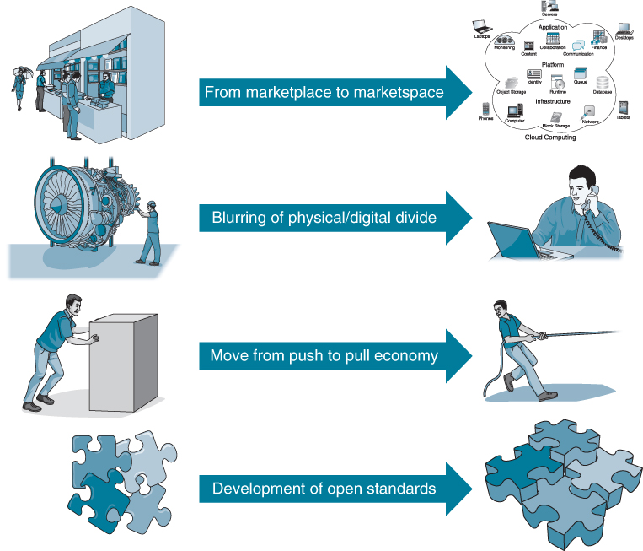
FIGURE 1.1 The pillars of digitization.

From marketplace to marketspace
With the opening up of the Internet for commercial activity over 25 years ago, business has been steadily moving from being conducted in the physical marketplace to the virtual marketspace.³³ This online environment has a number of distinctive features. First, it is pervasive, directly reaching end-customers, facilitating the conduct of business directly with them. Second, the trade-off between richness (the degree to which an organization can facilitate the exchange of information to deliver products/services that match customers' exact wants) and reach (the degree to which an organization can manage its activities to connect its customers) made in the physical world does not apply in an online environment.³⁴ Third, it is interactive, which is of crucial importance as much business and public sector activity consists of interactions: human and machine-to-machine (M2M) communication, data gathering, collaborative problem solving and negotiation.³⁵ As discussed earlier, it is these interactions that generate the majority of transaction costs. This is a transformation in much of business activity – moving from a physical place with fixed locations, inventories and products to an information-defined ‘virtual’ transaction space.
This shift ranges from basic business transactions such as ordering and invoicing to utilizing sophisticated business-to-business (B2B) exchanges and electronic marketplaces³⁶ that bring together industry players in a neutral market setting. This has implications for organizations' brands, for understanding trust, product and service pricing, issues of location, collaborative ventures and, as is becoming an increasingly hot topic for governments, collecting duties and taxes.³⁷
However, the absence of physical and tangible artefacts in this information-defined space can have significant implications for consumer behaviour: their absence has implications for trust, for building brands and for establishing customer relationships. For example, one of the principal reasons that many pure-play Internet banks failed was the lack of trust that existed between the online venture and customers. Confidentiality and security are key components of trust.³⁸ Traditional banks with large imposing branches and staff, apparently managing your account, contribute to the creation of trust. Online such cues are absent, which has resulted in many people being reluctant to deposit their money with such virtual institutions. Contrast this with the relative success of online brokerages where an ‘intelligent’ customer base, trading process and the dematerialization of the product over many years made them more suited to new start-ups. Researchers in consumer behaviour have found that consumers recognize differences in size and reputations among Internet stores, which influence their assessment of store trustworthiness and hence their willingness to shop with a particular store.³⁹ A customer who believes that there is a physical store behind a website is more likely to trust the site on first encounter,⁴⁰ although younger customers who know nothing but online do not have such constraints.
Online retailers also contribute to a phenomenon known as the long tail.⁴¹ In the physical world, retailers have limited space and will carry only goods that can generate sufficient demand, normally from the local population, to earn their keep. The online world does not have such constraints. Consequently, products in low demand or that have a low sales volume can collectively make up a market share that rivals or exceeds the relatively few current bestsellers and blockbusters, if the store or distribution channel is large enough.⁴² A significant portion of Amazon.com's sales comes from obscure books not available in brick-and-mortar stores.⁴³ These sales are often helped by its recommendation engine: ‘readers who liked this book also liked this one’. The long tail is a potential market and, as the examples illustrate, the distribution and sales channel opportunities created by the Internet often enable businesses to tap that market successfully. The long tail has grown longer over time, with niche products accounting for a larger share of total sales for many e-retailers.
In addition, the advent of massive new datasets and the spread of mobile devices mean that services can now be personalized cost-effectively to a much higher degree. A large creditcard provider, for example, partners with retailers to create personalized, real-time discounts for products and services through a mobile app. The app generates offers by matching customers' locations (determined from their smartphones) to products and services that should appeal to them, given their purchasing habits and preferences. The creditcard company also works with social media players to draw on the preferences of participating customers, using ‘likes’ and other markers to refine its offers. The initiative helps the company to strengthen its relationships with merchants and serve them better, while also staying relevant to (usually) younger, digitally savvy customers.

Blurring of physical/digital divide
Physical products are becoming increasingly digitized, blurring the traditional distinction between physical and virtual products. For example, the engineers at Rolls-Royce previously had to take an engine ‘off wing’ to inspect it: this inspection task in the physical world is all about collecting data and information in order to be in a position to make maintenance decisions. Even some of this decision making has now been automated using prognostic and diagnostic software, whilst the advanced analytical tools augment the knowledge, experience and capabilities of the engineers.
In business-to-consumer (B2C) markets, Nest (acquired by Google) uses machine-to-machine (M2M) connectivity to link its smart thermostats to other home devices, including washing machines and personal-fitness bands, thus positioning the company as providing the network hub in a digitally connected home. The prevalence of connected devices opens up possibilities for proactive, remote or ‘touchless’ servicing and new business models quite unlike traditional ‘fee-for-service’.

Move from push to pull economy
As products, buildings, roads and assets of all types are ‘instrumented’ and able to gather data on their ‘health’, and become ever more connected, machine intelligence will be able to make decisions, or at least suggest answers, for us. The modern car, for example, with its inbuilt diagnostic software, can detect when a component needs to be replaced or a maintenance service is required and thus can automatically book an appointment with a garage. The garage will ‘know’ what components need replacement and can order them from the manufacturer, scheduling them to be delivered when the car arrives at the garage. This data can also be very useful to manufacturers in designing the next generation of components.
Using analytics, retail organizations in particular are trying to predict which customers are likely to demand particular products and services. Rather than waiting for an approach from the customer, they seek to be proactive, even influencing their demand. Garanti, for example, one of Turkey's largest banks, offers a free mobile app that gives customers personalized offers and advice based on their location and past spending. It uses GPS and Foursquare to tell them if they are close to a store with a special offer, provide saving suggestions, and to estimate how much customers will have in their account for the rest of the month based on past spending.

Development of open standards
An important lesson from past experiences in the technology world is that adoption and innovation are accelerated by open standards, which make the interchange and flow of data both easy to achieve technically and seamless to users. While establishing proprietary standards, where equipment and software from one vendor would not interconnect easily with another, was once a competitive strategy seen as building customer ‘lock-in’, customer backlash and the negative impact on overall industry growth have confined it to some niche areas. Even competitors are more likely to work together to develop standards for interconnection as they recognize that they too can benefit with market expansion – the so-called network effects.
It is against this backdrop of a rapidly changing, complex and volatile environment that managers have to decide what investments to make in IS/IT. Some decisions may see IT deployed to improve organizational efficiencies by reducing transaction costs. Other investments might be made to make it easier for customers to transact business. Some IS/IT spend might enable a new value proposition, suggesting a new business model. At the same time, getting the IS/IT investment decision wrong can have serious implications; there are examples of companies that have ceased trading as a result of bad IS/IT decisions. As we will see later in the book, IS/IT can also hardwire a company, framing what it can and cannot do, severely limiting its strategic options. But let us first look at the ways IS/IT use in organizations has evolved.

A Three-era Model of Evolving IT Application in Organizations
The evolution of the role of information systems and technology in organizations can be described as encompassing three eras. The first early investments in IT – traditionally known as the Data Processing (DP) era – were concerned with automating manual information processes using computers. Later, the concern was about providing information from operations for managerial decision making – the so-called Management Information Systems (MIS) era. In the early 1980s a third era began and continues today – it is often called the Strategic Information Systems (SIS) era – which refers to the search for opportunities to create or achieve strategic advantages from IS/IT.
Although it is tempting to simplify nearly 60 years of often-haphazard, uncertain progress with the benefit of hindsight into three, albeit overlapping, eras, it must be remembered that it is never that simple. While the ‘three eras’ view is, however, easy to criticize as being over-simplistic, it has proved popular with many IS/IT theorists, researchers and practitioners, resulting in some useful analyses from which valuable insights and conclusions can be drawn. It is first worth clarifying the fundamental differences and interdependencies of the three eras.
The prime objective of using IS/IT in the eras differs:
- Data Processing (DP): to improve operational efficiency by automating information flows and processes (often referred to as digitizing processes today).
- Management Information Systems (MIS): to increase management effectiveness by satisfying their information requirements for decision making.
- Strategic Information Systems (SIS): to improve competitiveness by changing the nature or conduct of business (i.e. IS/IT investments can be a source of strategic advantage).
The objectives of DP and MIS are, strictly speaking, a subset of the SIS objective – to improve competitiveness, but this tends to be achieved indirectly by using IS/IT to improve current business processes and practices. While the SIS objective is more immediately related to the business, achieving the DP and MIS objectives can contribute considerably to business success, and further improvements are always possible as IT capabilities are extended and costs decrease. Although the DP label has long disappeared, the ever-improving economics have enabled the technology to extend the automation of processes to those involving documents, images and voice. So, too, with MIS: a combination of improved economics, more powerful processing capability, sophisticated analytics software and the greater availability of external data enables the collection, analysis and presentation of information to be more comprehensive and useful. This is not to suggest that it is easy and many challenges remain.
This arrival of so-called ‘big data’ has shifted the emphasis away from information enquiry and presentation, the focus of MIS, to knowledge discovery. While MIS can sometimes aid with new knowledge discovery or ‘insights’, this is not their primary objective. While the decision support systems (DSS)⁴⁴ of the 1970s represented the forerunner of advanced analytical tools, today's technology is more powerful and when coupled with machine learning technologies, the knowledge discovery process can be significantly enhanced. Previously unseen patterns, correlations and relationships can be surfaced, which can lead to novel insights about, for example, customers, processes and product performance. However, it must be remembered that people, not technology, make sense of any patterns and give meaning to information; business intelligence resides in the minds of managers and professionals, not in the data warehouse.⁴⁵
Moreover, to be of value, any new knowledge has to be acted upon. Some well-defined decisions and decision-making processes can be automated using a combination of workflow and rules engines so that, if a certain event, condition or situation occurs, then some specific action is taken. However, the types of decisions that the use of analytical tools mainly support have to be consciously made by people. For example, interrogating customer data from internal operational systems and external sources revealing a pattern explaining why customers defect, still needs managerial action to be taken about how best to correct the causes of the problem. Such applications of analytics seek to augment human cognitive processes. Figure 1.2 illustrates the relationships between DP, MIS, analytics and SIS. The role of big data and analytics in innovation leading to strategic advantages is explored in depth in Chapter 5.
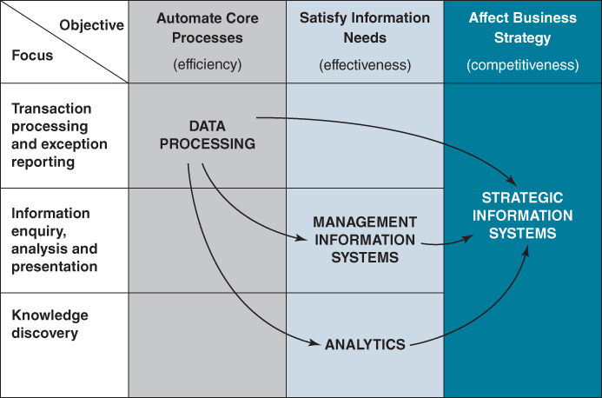
FIGURE 1.2 Relationship between DP, MIS, analytics and SIS.
We can describe the relationship between the three eras and the evolving application objectives as follows:
- Just as good MIS systems rely on comprehensive, operational DP systems for accurate and timely information, SIS (such as those linking the company directly to its customers via the Internet and mobile devices) rely on sound DP or MIS systems for appropriate information provisioning or efficient processing. Many companies have established websites permitting customers to place orders online, but have not always fully integrated them with resource management, replenishment and other back-office systems. Similarly, the data underpinning analytics can come from high-volume, operational DP systems as well as from external sources.
- SIS are not essentially different types of applications – the functions they perform are often the same as for DP or MIS applications – it is their impact on the business due to the changes they enable or cause that is the source of advantage. Thus, automating an element of a supply chain process can create a source of competitive advantage or using analytics to uncover new knowledge about customers can similarly enable an organization to develop a new business model to differentiate itself.
- The strategic applications may put considerable stress on the DP and MIS applications that were developed for a less demanding environment – they may need to be redeveloped not because of intrinsic shortcomings but because they inhibit the benefits to be gained from the SIS. We have seen this happen as some organizations struggle to deliver apps to customers via smartphones.

A Classification of the Strategic Uses of IS/IT
From a research base of over several hundred examples and case studies spanning nearly 40 years of cases of claimed ‘strategic systems’, the following classification is helpful in considering the implications of strategic IS/IT use. In general, these examples and cases can be classified into one of four types, although some clearly exhibit the characteristics of more than one type.
The four main types of strategic system are those applications that:
- share information via technology-based systems with customers/consumers and/or suppliers and change the nature of the relationship;
- produce more effective integration of the use of information in the organization's value-adding processes;
- enable the organization to create, develop, produce, market and deliver new or enhanced products or services or new value propositions based on information;
- augment people's cognitive processes in generating knowledge and insight from information; they provide executives, management and professionals with information to support the development, implementation and evaluation of strategies.
A similar approach was adopted by Venkatraman⁴⁶ in assessing how the strategic benefits from IT resulted from increasing the extent of business change (and risk). He described three types of ‘revolutionary’ uses of IT, which require considerable transformation in terms of what the organization does or how it does it:
- Business process redesign – using IS/IT to realign business activities and their relationships to achieve performance breakthroughs.
- Business network redesign – changing the way information is used by the organization and its trading partners, thereby changing how the industry overall carries out the value-adding processes.
- Business scope redefinition – extending the market or creating new products, based on information, or changing the role of the organization in the industry, such as with the introduction of a new information-enabled business model.
Though not identical, these are similar to our classification; plus they have a clear emphasis on the extent of the changes required to achieve a strategic advantage (or, more generally, significant business benefits) from IS/IT. Hence, the four categories suggested above seem to cover many of the possibilities. Each type of strategic IS/IT application has different implications in terms of identification, planning and implementation. Box 1.4 describes a selection of case examples of strategic applications of IS/IT that have gained organizations advantages since the 1970s.

BOX 1.4

Examples of IS/IT and competitive advantage through the decades

1970s

Merrill Lynch
In the US, Merrill Lynch launched its Cash Management Account in 1978. This combined traditionally separate banking products such as line of credit, cheque, investment and equity accounts into a single monthly statement, with idle funds being swept automatically into a high interest-bearing account. The new accounts attracted $1 billion of assets in the first year. Merrill Lynch set out to permanently change the shape of the financial marketplace by taking several existing but separate services and tying them together through information technology to create a new service that shattered the traditional boundaries between the banking and securities industries.
Although it dates back to the 1970s, this is an example of product innovation using IS/IT and was a game changer at the time.

American Hospital Supply
American Hospital Supply competed in the wholesale healthcare industry in the 1970s and 1980s. To gain an important edge over its rivals, AHS pioneered an order entry distribution system that linked most of the firm's customers to its computers. AHS owned terminals were placed directly in the purchasing departments of hospitals, giving them an early mover advantage – hospitals didn't wish to have multiple terminals from different vendors cluttering up their offices. In addition to ordering merchandise, the system allowed customers to control their inventories by having direct access to AHS's stock records, increasing the likelihood of their coming to rely upon AHS as a key supplier. The fact that the company's initial move to electronic ordering was spearheaded by a regional manager seeking to meet the needs of a single customer suggests that starting small may be the key to success.
AHS is an example of innovation in the customer interaction using information systems. As a first mover, it erected significant entry barriers that made it difficult for competitors to develop an equivalent system and get it into hospitals. An example also of how the company culture enabled an individual manager to start the process of strategic change.

1980s

Thomson Holidays
Thomson Holidays is a UK tour operator selling holidays to the general public through travel agents. Until 1982, enquiries and bookings were made by telephone, often resulting in chaos during peak periods. When its online reservation system, TOP, was introduced, agents could make on-screen bookings of holidays via a Viewdata system. This immediately reduced some of the double handling costs of bookings (in the travel agency and at Thomson's) and speeded up the process of booking, hence saving agency time and cost. Later, Thomson developed similar links to their suppliers (airlines, hotels and other service providers).
It was the first tour operator to offer on-screen bookings to high street agents. During a single day at the start of the 1986 holiday sales campaign, 105,000 holidays were booked through TOP, resulting in Thomson carrying over one million passengers that year. This ability to handle mass bookings enabled Thomson to pursue its fiercely aggressive marketing strategy, and to stimulate huge demand. The ‘system’ gave Thomson a major advantage when demand dropped suddenly as it did in 1987 (USA bombed Libya) and 1991 (Gulf War). In 1987 Horizon Holidays (No. 3 in the industry) failed and in 1991 International Leisure Group (No. 2 in the industry) failed. Neither was able to respond to the rapid changes in demand as effectively as Thomson, and both had lower margins due to higher cost structures. Thomson was able to adapt more quickly and was more efficient in the context of the overall industry structure.
Thomson's TOP is an example of how IS/IT can enable a more agile response to environmental changes.

American Airlines
American Airlines (AA) gained a lead over the competition as the first US carrier to offer an online reservation system to travel agents. This system, Sabre, captured 10,000 of the 24,000 travel agents in the US at that time. Sabre listed the flight schedules of over 400 airlines, but when launched, it gave AA a crucial edge by displaying its own flights first. So effective was this tactic that other US carriers persuaded the Government to intervene. American still benefited, however, by charging for every booking made, bringing in significant revenue. In fact, Sabre was more profitable than the airline itself.
This is an example of how development of a back-end inventory management system could be used to provide a marketing and sales advantage to AA. It was also an example of a first mover advantage that proved so difficult for competitors to replicate, they had to join in – a game changer.

Otis Elevators
In the 1980s Otis Elevators identified ‘customer services’ as being a key element of its customer strategy. It decided that one of the aspects of its service that would give its customers most satisfaction was a prompt lift repair service. So it built an automated system, called Otisline, to dispatch repairmen. When something started to go wrong with Otis's lifts, they (the lifts!) automatically called in their complaint to a computer and an engineer was dispatched – without human intervention. Otis's rivals suddenly had to compete on quality of service as well as the price and quality of lifts themselves.
Although the technology used was primitive compared to that available today, Otisline can be seen as an early example of what is now called the Internet of Things (IoT), yet predates the availability of the Internet for commercial activity.

1990s

Schneider
Schneider, a $3.9 billion company, is the premier provider of truckload logistics and intermodal services in the US: solutions include Van Truckload, Dedicated, Regional, Bulk, Intermodal, Brokerage, Supply Chain Management and Port Logistics services. Schneider has provided expert transportation and logistics solutions for 80 years.
1980 saw the advent of deregulation in this traditional industry and Schneider recognized earlier than most the strategic potential of IT. Over the years the company has developed many applications in order to stay ahead of the competition. The company moved from freight modelling applications, to EDI, to satellite technology with onboard terminals, to incorporating this satellite data into customer communications and load scheduling processes. While each application of technology gave it a significant advantage in the marketplace, its competitors soon developed similar applications and it quickly became standard for the industry. Yet while the competition was looking to imitate Schneider, it had already moved on to develop a new strategic application. In essence, the competition was continually playing catch-up. Schneider continues to apply its IT capability as it moves into logistics outsourcing. While logistics is an entirely different business from trucking, it similarly depends on fast, cost-effective, strategic implementations of IT.
This case demonstrates that Schneider was not successful because of any particular leading-edge technology – these are also available to its competitors – but because it has developed a capability for applying IT to ever-changing business opportunities.

Amazon.com
Amazon.com was launched in July 1995 and has probably become the most famous site in cyberspace. It initially started out with a mission to use the Internet to transform book buying into the fastest, easiest and most enjoyable experience possible. Jeff Bezos, its founder, selected books as it was a fragmented industry, with the two biggest booksellers at the time accounting for less than 12% of total book sales. Customers can search for a specific book, topic or author or browse their way through the book catalogue and also read book reviews from other customers, the New York Times and other newspapers and magazines. Customers' orders are processed immediately and books in stock, generally bestsellers, are shipped the same day. Customers are contacted by email when their order has been dispatched. Orders for non-bestsellers are immediately placed with the appropriate book publisher by Amazon.com. All contact with the company is done either through their website or by email.
The initial idea behind Amazon was to exploit the Internet to deconstruct traditional bookselling, with a catalogue 10 times larger than that of the largest Main Street superstore, at prices 10 to 15 per cent cheaper. But that was not a sustainable advantage: competitors such as BN.com would rapidly establish comparable selections and price points. Amazon went on to exploit the emerging economics of community with its curated reviewer community, encouraging the rating of reviews and awarding badges to the best-rated reviewers. The company has also pioneered technologies such as customer profiling and ‘1-click’ shopping. The profiling technology has enabled Amazon to recommend products based on previous purchasing history and what other customers, who have bought similar products, are also buying. On the selling side, the company launched Amazon Marketplace as a fixed-price rival to eBay: a platform hosting a community of small sellers that now numbers more than 2 million. All these strategies benefited from the network effect: the more participants, the more choices; the more reviews, the richer the experience.
Over the years, the company has also expanded into other areas and now sells a huge range of products from consumer electronics, toys and games to foods. Today, Amazon earns less than 7% of its revenue from books. Furthermore, the company has not sat back and waited for trends to emerge. Rather, it seizes the strategic opportunities presented by technology, ruthlessly cannibalizing its own business where necessary. E-books were inevitable, so it launched the Kindle. Given the scale of its own IT infrastructure, it now sells cloud computing services.
Amazon is an example of a pure-play, new entrant, online business that disrupted the retail industry.

Ryanair
Ryanair is one of the world's most successful ‘low fares’ airlines. To support this strategy, the company looked to the Internet to provide a low cost distribution channel for its seats. Its online booking facility was launched in 1999, migrating customers away from the more expensive travel agent and call centre channels. Customers can now search for flights online and book them with a credit or debit card. In addition to booking flights, the site also sells travel insurance, car hire and hotel accommodation. Customers can now check in for their flights online or using an app on a smartphone.
Ryanair is an example of a company that used the Internet to support its low cost strategy.

2000s ONWARDS

Uber
Uber, the ride-hailing app provider, has become Silicon Valley's poster child for disruption. The company has revolutionized the taxi market in more than 230 cities in 51 countries without owning a single car. Its marketplace connects drivers of regular cars and taxis with passengers through its smartphone app, backed by a ‘big data’ team that tries to ensure a ride is never more than five minutes away. Uber is not satisfied with taking on taxis alone. From burgers in Beirut and cycle couriers in New York to kittens in Seattle, it is already experimenting with moving more than just people. But in other cities, such as Paris and Delhi, Uber is facing fierce resistance from both existing taxi companies and local authorities.
Owning no taxis, Uber is an example of a platform company, facilitating a two-sided market that brings customers and suppliers together.

John Deere
US agricultural manufacturer John Deere has always been a pioneering company. It is more than a company that sells machinery: one area that it has focused on is increasing the efficiency of production of crops. It has launched several big data-enabled services which let farmers benefit from crowdsourced, real-time monitoring of data collected from its thousands of users. The company provides a suite of services to allow everything from land preparation to seeding, fertilizing and harvesting to be controlled from a central hub.
Myjohndeere.com is an online portal which allows farmers to access data gathered from sensors attached to their own machinery as they work the fields, as well as aggregated data from other users around the world. It is also connected to external datasets including weather and financial data. These services allow farmers to make better informed decisions about how to use their equipment, where they will get the best results from and what return on their investment they are providing. For example, fuel usage of different combines can be monitored and correlated with their productivity levels. By analysing the data from thousands of farms, working with many different crops in many different conditions, it is possible to fine-tune operations for optimum levels of production.
The system also helps to minimize downtime by predicting, based on crowdsourced data, when and where equipment is likely to fail. This data can be shared with engineers who will stand ready to supply new parts and service machinery as and when it is needed – cutting down on waste caused by expensive machinery sitting idle.
John Deere is an example of a company that is shifting from selling hardware to selling services.

Zopa
In March 2005, Zopa became the first company in the world to launch a peer-to-peer (P2P) lending operation. The company implemented a radical concept: the ‘Zone of Possible Agreement’ (from which the name is derived). The term refers to the price point where both borrower and lenders agree that a particular interest rate is fair to both sides. Borrowers are credit-checked using a credit reference agency as well as the platform's own credit test. Zopa links parties up to this price and facilitates the actual transaction. No bank is involved.
Zopa is an example of what is often referred to as a Fintech company. Using IS/IT, Zopa is disrupting lending which has traditionally been done through banks and other financial institutions.

Linking to Customers, Business Partners and Suppliers
Technology today enables organizations to connect cheaply and easily with customers, business partners and suppliers almost anywhere in the world; an outcome that has been described as the ‘second economy’.⁴⁷ E-procurement and smartphone-based ordering systems have enabled low cost linkages with customers and suppliers, plus in many cases enabling customers to track order and delivery progress online. Many companies are placing emphasis on finding ways to leverage social media and customers' growing eagerness to share opinions on brands, products and services, evidenced, for example, by the many comments about hotels and restaurants that customers post on TripAdvisor and video product reviews on YouTube. Insurance companies are aggressively leveraging mobile connectivity. AXA, Nationwide and NRMA, for example, now offer their auto-insurance customers smartphone apps that provide comprehensive post-accident assistance, from first-aid tips to one-touch contact with police, emergency services and garages. The app also makes it easy for policyholders to complete and file damage reports on the spot.
The key people involved in the consideration of improving these external linkages will be sales/marketing and distribution management at the customer end, and purchasing and operations managers at the supplier end. Also, they are not entirely within the organization's power to control – since suppliers, customers and competitors may take the initiative at any stage – and such applications can require the cooperation of the trading partners involved. Many organizations are now competing for consumers' attention and time, so that they now have to consider the efficiency and ease of use of the app from the consumers' perspective. In the early days of e-commerce, companies made savings by effectively transferring ‘work’ to the customer, but that is now something the customer is less willing to accept. In the public sector, the challenge is often changing citizen behaviour.
Identifying and exploiting these types of business opportunities are considered in more detail in Chapters 5 and 6.

Improved Integration of Internal Processes
Effective internal integration of information requires the organization to overcome some of the traditional barriers to successful IS/IT investments, such as sharing and integrating information, reorganization of job roles, new accountabilities, new performance measures and organizational changes. For instance, telemarketing can dramatically reduce the cost of generating orders. But, imagine the reaction of a good customer to a telephone call suggesting a reorder when he or she has just received a demand from the Accounts Department for payments for goods not received or when a machine is idle due to a service engineer calling without the right parts! All of the relevant information about the customer and the organization's ability to deliver is required at the point of selling to make it effective. This is what many organizations are seeking to achieve with the implementation of a single view of the customer, often enabled by Customer Relationship Management (CRM) software.
The ventures into ‘direct’ servicing of financial customers from call centres, pioneered by First Direct and Direct Line, were early examples of improved product and service delivery based on internal integration of processes and systems. The products were essentially the same as those of competitors, but they were delivered directly to consumers via the telephone (and later online) rather than via agents or branches – a new type of personalized service based on the availability of comprehensive customer and product information. Many more traditional banks and insurance companies have followed suit. Interestingly, Direct Line has not made its products available via comparison websites as ‘disintermediation’ would damage established customer relationships – Direct does mean direct.
Enterprise Resource Planning (ERP) suites are an example of configurable information systems that provide integrated information and core information processes within and across functions in many types of organization. However, there is an argument that the use of such standard applications packages, which is a common strategy today, can limit an organization's ability to innovate.⁴⁸ At the same time, investments made in technology infrastructure are becoming increasingly significant and inappropriate decisions in this area can severely affect an organization's ability to respond swiftly and flexibly to changing market conditions and can, in some instances, become a significant competitive liability.⁴⁹
Senior management need to understand the organizational implications of increasing degrees of integration on the roles of people and departments, since reorganization is often required if significant benefits are to be obtained and any relative advantages sustained. It is the inability to implement the necessary business and organizational changes that means many IT investments deliver fewer benefits than expected.
The nature of business operating models and the implications for internal integration are considered in more detail in Chapters 4 and 6.

Information-based Products and Services
Adding information to, or ‘informating’,⁵⁰ existing products has become an increasingly popular strategy. The classic example of enhancing the product/service, based on information, is the Merrill Lynch Cash Management Account, described in Box 1.4. Unlike many of the examples, this concept resulted from strategic thinking in the corporate planning department, where it was realized that a whole range of financial services were converging. More recently, online and mobile banking have incorporated a similar logic. Financial service companies increasingly can provide customers with all their aggregated financial information through a couple of keyboard, voice or smartphone commands. Being able to see all of it in one place has many advantages for customers over looking at a variety of individual websites, with their different passwords and ways of displaying financial information. This convenience means customers are more likely to buy further products or services from the same company.
Achieving advantages from this type of application requires a thorough knowledge of the products of the industry, their relative merits and, in particular, which customers will buy them and how they use and obtain value from them. Obviously, an understanding of the organization's own products and services and the economics of providing them is also required.
In going online, many organizations have also added more value to the physical products they sell by providing additional information-based services. These can include online support, order tracking, order history, product use advice etc., mostly focusing on deepening the relationship with customers or suppliers. Others have moved their trading platform either partially or entirely onto the Internet, for example the auction house Christies and the Aalsmeer Flower Auction. RS Components, a leading distributor of electronic and industrial components in the UK, permits its customers' employees to make purchases from its website of low cost (less than €300) items, with RS managing the total process, including establishing purchasing controls, which cover spending limits, barring the ordering of certain products, applying cost codes, call offs from blanket orders and security.
The creation of information-based products and ‘informating’ existing products and services are covered in more detail in Chapters 5 and 6.

Augmenting Human Cognitive Processes to Support Strategic Decision Making
The final type of strategic IS/IT application – to provide executives, managers and professionals with information to support strategic decisions – is dependent on other factors for success. Making strategic decisions requires a range of different types of information covering, for example, markets, customers and non-customers, industry, technologies and product developments and both global economics and the economies of the countries in which they operate. In addition, the experience of the decision maker is important, as very often intuition or ‘gut feeling’ plays a large part in some decisions, even strategic ones.
Supporting management in making decisions has always been an objective of deploying IT. Early MIS were designed to provide the information that managers determined they needed to make specific decisions. Recognizing that executives frequently make ‘unstructured’ decisions, a modelling capability was added. While these applications were typically referred to as Decision Support Systems in the 1970s, technological developments have seen them evolve over the years into online analytical processing (OLAP), data mining, business intelligence (BI) and analytics.
However, management information systems, historically at least, rarely satisfied strategic decision-making requirements. There are several reasons for this: the lack of external information included, the simplicity of the applications, the rawness of the data and the lack of context. Strategic decisions are complex or ‘wicked’ and require the application of knowledge, judgement and experience to information for new knowledge to be uncovered or greater sense made of a situation. The increased availability of external data sources, which are readily accessible via the Internet, plus the potential offered by knowledge-based and scenario planning applications, used in conjunction with analytics applied to extensive ‘big data’ sources, enable organizations to explore and evaluate strategic options. Although this has made this type of application more practicable, it still provides the lowest number of strategic IS/IT examples.
This topic is considered in more detail in Chapters 4 and 5.
Figure 1.3 summarizes the evolving role of IS/IT from efficiency and effectiveness of existing activities to changing what the business does and the changing focus of investment, from internal to external. In the figure, electronic trading or e-business, at its basic level of automating existing business transactions, is not considered strategic since it merely improves the efficiency of transaction handling. Also, systems to support executive decision making (so-called executive information systems (EIS)) have been included under MIS since, to date, the majority are ‘higher-level’ versions of MIS; only a few fit the ‘strategic’ description given above.
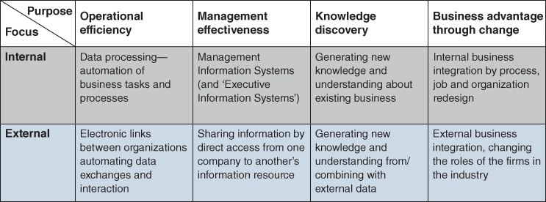
FIGURE 1.3 The information systems management environment.

Success Factors in Strategic Information Systems
Further analysis of our research base, and published work by others, identified some of the key factors that seem to recur frequently and underpin success with strategic information systems. Few, if any, strategic information systems exhibit all of the factors, but many show more than one.
- External, not internal, focus: looking at customers, competitors, suppliers, even other industries and what is happening in the outside world – both business and social. Traditionally IS/IT was focused on internal processes and issues. As can be seen from three of the four categories above, changing relationships with customers and suppliers, developing new information-based products and services and having comprehensive and meaningful information to help strategic decision making all rely on knowledge about what is happening beyond the organization boundary.
- Adding value, not cost reduction: although cost reductions may accrue due to business expansion at reduced marginal costs, ‘doing it better, not cheaper’ seems to be the maxim. This is consistent with the requirements of companies striving to be innovative and differentiate themselves from competitors through better products and services which customers value. Historically, and still prevalent in some organizations, IS/IT was mainly seen as a way of increasing efficiency and reducing costs – doing the same things but cheaper. While this is obviously important in any business environment and every opportunity to use IS/IT to significantly reduce costs should be taken, it is not the only way to succeed.
- Sharing the benefits: within the organization, with suppliers, customers, consumers and even competitors (on occasion!). In many cases in the past, benefits accruing from IS/IT investments have not been shared even within an organization, which discourages non-benefiting departments or functions from making changes which could increase the overall benefits realized. Or put another way: ‘the issue of gainsharing is of critical importance… with no apparent benefits to them, stakeholders are likely to resist the system.’⁵¹ Almost all of the examples above involve some sharing of the benefits, with suppliers, customers, consumers and even competitors, to help provide barriers of entry to the industry. For instance, the introduction of debit cards to replace cheques depended for its success on banks sharing some of the reduced processing costs with the retailers and consumers, since the benefits, mainly cost savings for the banks, depended on the acceptance by retailers and use by consumers. (Some might argue that this was achieved by increasing the cost of processing cheques!)
- Understanding customers and what they do with the product or service: how they obtain value from it, and the problems they may encounter in gaining that value. In the 1980s, McKesson, the pharmaceutical wholesaler, followed this principle very closely in providing a range of information-based services to small drugstores, starting from a simple problem of stock control, solved by delivering products in shelf-sized batches. Many distribution companies allow customers access to their order tracking systems, enabling them to know when they need to be available to accept delivery. Such facilities become more important as people's expectations of service levels become more stringent. With business model innovation, organizations ask themselves what is the problem the customer needs solving, what value proposition can be defined and offered to them and how can IS/IT help make it happen. Rolls-Royce selling availability rather than engines acknowledges that many airlines do not wish to own their own maintenance, repair and overhaul (MRO) operations.
- Business-driven innovation, not technology-driven: the pressures of the marketplace drove developments in most cases. On first read, this factor might cast doubt on the idea of competitive advantage from IT but, in practice, it means that new or existing IT provides or enables a business opportunity or idea to be converted into reality. The lead or the driving force is from the business, rather than technology ideas being pushed by the IT suppliers and specialists. The priority for the business issue to be resolved is paramount: why take two risks at the same time – that is, a new way of doing business based on new technology? Although sometimes it is the only way to deliver the desired solution, it tends to be a recipe for failure. Keen⁵² summed it up well by saying, ‘Major failures in using IT are often based on much better technology and bad business vision. Successes come from good enough technology and a clear understanding of the customer.’ How organizations can exploit new capabilities of IT innovatively to create business opportunities not possible without technology is discussed in Chapter 5.
- Incremental development, not the total application vision turned into reality. Many examples show a stepped approach – doing one thing and building on and extending the success by a further development. To some extent, this is developing applications by experimentation but also not stopping when a success is achieved but considering what could be done next. This approach is akin to an agile rather than traditional ‘waterfall’ approach to application development. The latter, which involves clarifying all the requirements, defining all the boundaries and agreeing the total deliverables of the system before embarking on the expensive process of design and construction, freezing the requirements at each stage. Prototyping applications and piloting their introduction to test how well they perform are integral aspects of agile development approaches and have a key role to play here. Many pure-play online companies consider their products in ‘permanent beta’; that is, they will always evolve.
- Using the information gained from the systems to develop the business. Many online and conventional retailers segment their customers very accurately based on their purchasing patterns and then target promotions and special offers ‘personally’, so-called mass customization. Product sales and market analyses plus market research information can be merged with customer sentiment data from social media, then recut in many different ways to identify more precise market segments, customer shopping patterns and the effectiveness of promotions and new product introductions. Examples of generating insight from data include Tesco (loyalty card), Google (match search queries with advertisers) and Amazon (collaborative filtering). Before one retailer introduced its loyalty card scheme, it knew virtually nothing about its customers. Now it knows, for example, that most customers are not profitable, but also which are; women are 50% impulsive, men 90%; customers shop for concepts not commodities (e.g. Sunday lunch, kids treat, Italian meal) and they can arrange the stores and product ranges accordingly.
- Monetizing information. We have always known that information has, or should have, a value, although it is difficult to place an exact price on it usually. Even though we might consider information as a business asset, it does not appear on the balance sheet of a company. Organizations generate vast amounts of data as a by-product of their operations. This is often referred to as exhaust data, and its potential value is now being realized in some industries such as pharmaceuticals and healthcare, given the power of analytics to find ‘needles in haystacks’, leading to possible new products or treatments. Mobile phone companies have demographic information about their customers for billing purposes and, via their networking technology, know the location of each customer's mobile phone. O2 are now combining these capabilities to offer a service to shopping malls and retail stores, enabling them to track shoppers. Integrating location data with customer data, it can provide stores with information about store visitors and how long they spend in the store and also where customers go after they leave. This can be valuable information, provided they do not infringe privacy legislation concerning individuals' personal data.
As discussed above, these factors, in general, demonstrate different attitudes to the use of IS/IT than prevailed historically, implying that new ways of thinking and techniques to uncover such opportunities are needed, plus new approaches to managing these applications to ensure success.
Another general observation can be made from these examples by considering what actually produces the success – information technology, information systems or information. Technology itself is the ‘enabler’, which provides short-term advantage and the opportunity to develop new processes and systems and capture and use potentially valuable information. But, normally, competitors are able to purchase the same technology, and any advantages can soon be negated. However, the new information systems developed utilizing the technology can provide advantages that may be less vulnerable to erosion by competitive copying. The potential gain will depend on how conclusively and exclusively the new systems alter business processes and relationships.⁵³ If the firm wishes to sustain its advantage, it must also use the information gleaned from its new applications to improve its products or services or create new opportunities that meet the requirements of the marketplace or influence its development.

A Portfolio Management Perspective on IS/IT Investments
Portfolio management is generally recognized as an integral component of any IS/IT strategy. For example, Lederer and Sethi⁵⁴ explicitly use the term ‘portfolio’ in their definition of strategic planning for IS, which they describe as the ‘process of identifying a portfolio of computer-based applications that will assist a firm in executing its business plans and realizing its goals.’ Earl⁵⁵ argued that IS strategic plans should be treated as portfolios that ‘consider the trade-offs [of] risk and return … and the allocation of IS resources.’ Since the 1980s, many useful IS/IT portfolio management models for both new investments and ongoing application management have been proposed. Most of them categorize IS investments and projects according to the nature of assets, resources or capabilities they create or provide, or their business impact or reward and the risks involved,⁵⁶ often expressed in terms of the business changes required.
Not all IS/IT investments make the same contribution to business success and therefore their importance to the business is likely to be quite different. Adopting a portfolio management perspective is a useful way of categorizing investments according to their differing contributions, in order to select application investment and project management strategies that are appropriate to the contribution required. The portfolio framework that we advocate is derived from a matrix concept initially proposed by McFarlan.⁵⁷ He considered the overall contribution of IS/IT to the business now and in the future, based on its industry impact. Our variation on the matrix is represented in Figure 1.4.
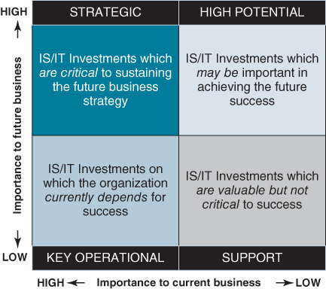
FIGURE 1.4 The application portfolio: understanding and classifying IS/IT investments.
The model proposes an analysis of all existing, planned and potential applications into one of four categories, defined as strategic, high potential, key operational or support, depending on each application's current or expected contribution to business performance and the organization's future strategy. Whilst this portfolio model and its use will be explored in depth later in the book, briefly these ‘contribution’ categories are as follows:
- Strategic applications and investments are critical to future business success. They create or enable changes in how the organization conducts its business, with the aim of providing competitive advantage. Note that, even when the technology used is ‘leading edge’, this does not indicate that the application is strategic; the assessment must be based on its intended or actual business contribution.
- High potential are (risk) investments in innovative applications of IS/IT which may create opportunities to gain a future advantage, but are as yet unproven in terms of either the benefits they produce or the capabilities and performance of the technology, or both.
- Key operational applications and investments sustain the existing business operations, helping to avoid any disadvantage. These are often referred to as the organization's ‘core’ systems. It can be argued that, in many industries, substantial numbers of applications (e.g. EPOS [electronic point of sale], ATMs [automated teller machines] and ERP [Enterprise Resource Planning]) have become so pervasive that they have become ‘mandatory’ for survival. Any unavailability or failure of key operational applications will have a serious negative impact on business performance.
- Support applications and investments reduce costs by increasing business efficiency, or improve management effectiveness but do not sustain the business or provide any competitive advantage. Unlike key operational applications, failure or unavailability does not have an immediate negative effect on performance, but will eventually do so if not corrected. Most support, as well as many well-established key operational, applications are now provided by software packages and are increasingly frequently being outsourced.
Over time, the contents of the portfolio will change and, for any organization, the contents of segments of the portfolio will be influenced by a variety of internal and external factors, as described later in the book. This model has proved effective in providing a framework by which agreement on the portfolio of business applications, available and required, can be reached from the often divergent views of senior management, line managers and the IS/IT specialists. It is a simple concept which enables consensus to be achieved, both as a strategy is developed and later as the business and its requirements evolve. The usefulness of this matrix is borne out by the ease with which management is willing to and can categorize applications according to their perceived business contribution and potential.
The portfolio, as described here, shows some obvious similarities to other portfolio matrices used in other management disciplines, such as the Boston Consulting Group's ‘Boston Matrix’ for product portfolios. Those similarities, concerning balancing the portfolio, life cycles, management approaches, investment justification etc., will be examined in detail in Chapters 8 and 9, when the value of the matrix in the strategic management of IS/IT is explored. At this stage, it is sufficient to point out that the four segments will require quite different strategies to achieve successful planning, development, implementation and operation of the applications – because they fulfil different roles in the business.

What Is an IS/IT or Digital Strategy?
In defining IS/IT strategy, it should be noted that most definitions approach the issue from the IS perspective and in particular IS strategic planning, even though they effectively include IT strategic planning. The term Information Systems Strategic Planning (ISSP) was defined by Boynton and Zmud⁵⁸ as ‘activities directed toward (1) recognizing organizational opportunities for using information technology, (2) determining the resource requirements to exploit these opportunities, (3) and developing strategies and action plans for realizing these opportunities and for meeting the resource needs’. Earl's⁵⁹ definition refers to the ‘long term, directional plan which decides what to do with IT’ that is concerned primarily with ‘aligning IS development with business needs and seeking advantage from IT’. Over time other topics, such as knowledge management, were introduced,⁶⁰ which expanded the domain. Our definition tries to take a broader perspective: ‘thinking strategically and planning for the effective long-term management and optimal impact of information in all its forms: information systems (IS) and information technology (IT)’.
Thinking strategically about IS/IT is not just concerned with the proactive search for potential opportunities to apply IT for competitive advantage but with adopting a strategic approach to all IS and IT investments. As stated earlier, not all investments in IS/IT make the same contribution to business success; the portfolio model provides a classification of the types of contribution, one of which is to create and achieve strategic advantage. Other investments sustain the performance of core business operations or adherence to mandatory compliance requirements, but this does not negate the need to develop a strategic approach to their management. Balancing the often competing pressures to avoid disadvantage and exploit existing or new technologies for advantage is a critical aspect of formulating an appropriate IS/IT strategy for any business. The balance will inevitably need to change over time due to external pressures. In a similar way to how the nature of IT applications and the impact on both businesses and individuals has evolved over the last 40 years, IS/IT strategies have also evolved in terms of purpose, content and relationships with business strategies.⁶¹
As early as 1985 Sullivan⁶² recognized the tensions, due to forces beyond the organization's control, that had to be reconciled in the strategic management of IS/IT. He described two axes within which an organization can consider the implications of these forces (see Figure 1.5):
- Infusion – the degree to which an organization becomes dependent on IS/IT to carry out its core operations and manage the business;
- Diffusion – the degree to which IS/IT has become distributed throughout the organization and decisions concerning its use are devolved.
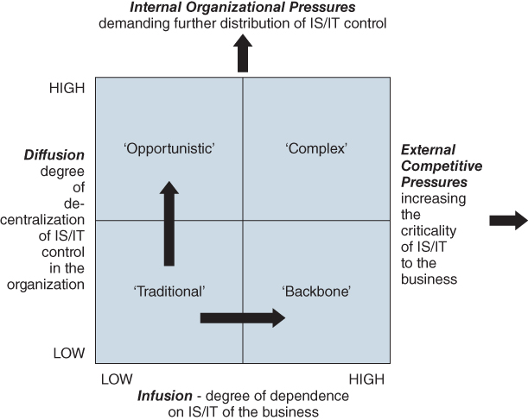
FIGURE 1.5 Environments of IS/IT strategies.
Plotting high and low degrees of infusion and diffusion produces four essentially different environments:
- Low diffusion/low infusion – the ‘traditional’ environment typical of companies using IT solely to improve efficiency on an application by application basis.
- Low diffusion/high infusion – where IS/IT is critical to business operations and control – the ‘backbone’. The business could be seriously disadvantaged if systems fail, leading to highly centralized control of highly integrated applications and infrastructure.
- High diffusion/low infusion – largely decentralized control, giving business managers the ability to satisfy their local priorities and enable ‘opportunistic’ investment, driven by short-term priorities and the desire to create business advantage.
- High diffusion/high infusion – this is a ‘complex’ environment that is difficult to manage: too much central control to avoid poor investments will limit innovation, hence new strategic opportunities may be missed; too little control and the core systems may disintegrate. Most organizations are in this quadrant today.
The implications are that as an organization becomes more dependent on IS/IT, essentially to avoid being disadvantaged, the more centralized and structured the approach to planning and control should become. But, to facilitate the innovative uses of IS/IT to create future advantages, technology control needs to be close to the business user to enable appropriate connections between business need and technology solution to be made. Simultaneously seeking to gain advantage and avoid disadvantage implies both high diffusion and high infusion and hence, a complex, balanced set of management approaches (described by Sullivan as ‘eclectic’). Probably the best interpretation of the word ‘eclectic’ is to say that every organization needs approaches to IS/IT strategy formulation and planning tailored to its individual circumstances, as determined by the industry and business situation and the organization culture.

IS and IT Strategies
Over 25 years ago Earl called for the distinction to be made between IS strategy and IT strategy,⁶³ because he found that most IT strategies, at that time, were strong on technology issues and weak on identifying application needs and business thinking; despite the passage of time, unfortunately this situation is still very common. He suggested that IS strategy is concerned with the organization's required information systems or application set, whereas the IT strategy is about the technology, infrastructure and associated specialist skills – our views of IS and IT strategies are consistent with this argument. He also argued that the most effective route to achieving strategic benefit from IS/IT is to ‘concentrate on rethinking business by analysing current business problems and environmental change – and considering IT as just one ingredient of the solution.’
The IS strategy is firmly grounded in the business, taking into consideration both alignment with the business strategy and the potential competitive impact – the ‘IS demand’. Essentially, it defines and prioritizes the investments required to achieve the ‘ideal’ application portfolio, the nature of the benefits expected and the changes required to deliver those benefits, within the constraints of resources and application interdependencies.
The IT strategy is concerned with how that demand for information and applications will be enabled and supported by technology – essentially, it is concerned with ‘IT supply’. It addresses the provision of IT capabilities, assets and resources (including all hardware, software and telecommunications) and services such as IT operations, application development and user support, plus the skills and competences required by both IS/IT specialists and users. (The components of both IS and IT strategies are considered in more detail in Chapter 3.)
As mentioned earlier, one thing the IT industry is good at doing is relabelling (and recycling) concepts to suggest that they are new. This is the case with ‘digital strategy’, which is an emerging convenient label for what we have traditionally called IS and IT strategies, i.e. a strategy which includes both IS and IT dimensions. Suppliers have long tried to subsume IS into IT strategies to emphasize the importance of their technologies. There is clearly a danger in this – it suggests the solution is technology, not a combination of business changes in processes and information use and appropriate technology, if indeed technology is needed. For us a ‘digital strategy’ has both an IS strategy and an IT strategy component. When building a digital strategy it is imperative to understand how information and systems (IS) will be leveraged and used as well as the underpinning technological (IT) capabilities that will be required. Figure 1.6 summarizes that view.
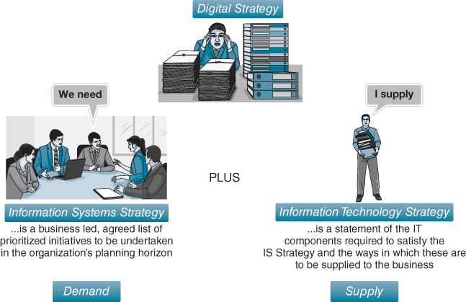
FIGURE 1.6 ‘Digital strategy’ is a convenient label for the combined IS and IT strategies.
Figure 1.7 depicts the relationships between business, IS and IT strategies. It illustrates how the business strategy essentially defines where the business is going and why; the IS strategy determines what is required in terms of IS applications and information to support its execution; and the IT strategy specifies how what is required can be delivered using technology. It also shows that IS/IT can both enable and shape the business strategy.
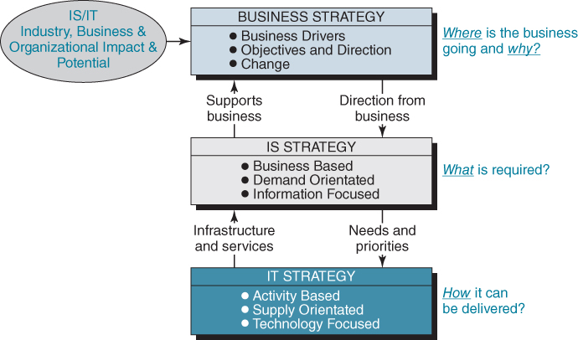
FIGURE 1.7 The relationship between business, IS and IT strategies (after Earl).
In contrast to the IT strategy, we caution against treating the IS strategy in a similar way to functional strategies like marketing, production or logistics and supply chain. Information permeates all organizational activity and is used by all employees in the performance of their jobs. In addition, the internal information network binds the organization together. Whereas organizations tend to plan other resources (e.g. people, money, materials), little effort is generally devoted to planning the type of information needed, where it is to be collected and stored, how it will be used or who is responsible for it. Equally, most employees now use IT applications as part of their role, both ‘formal’ applications and, less formally but probably more frequently, as productivity and communication tools, so that the strategy needs to ensure that individuals' performance is not compromised by under investment in general-purpose or utility applications and the supporting infrastructure. The IT strategy, on the other hand, can be seen in a similar way to functional strategies.
One other concept that needs to be clarified and understood in the context of IS/IT is information management (IM).⁶⁴ There should be a strategy in place to manage underpinning information or the implementation of the IS strategy will be fraught with problems. Information management is essentially concerned with the quality of information, its protection and overall governance and is supported by data management policies and practices which are enforced through application development standards as well as information governance policies. Box 1.5 presents a way of explaining the distinction between IS/IT and IM.

BOX 1.5

Explaining IS, IT and IM
Managers can sometimes struggle to understand the distinction between IS/IT and information management (IM). We have found it useful to use the analogy of water, where water flowing through a building can be seen as information flowing through an organization. Deciding what water will be used for, e.g. to drink, to clean the car, to cook in, to irrigate the lawn etc., is equivalent to determining the organization requirements for information, i.e. how the organization is going to use information and for what purpose. The IS and IT determine how these requirements will be satisfied, i.e. the systems and technology; in our water analogy, the taps, plumbing, piping and filtering that will deliver water to the shower, the kitchen tap or the garden hose etc. Moreover, water supply can be outsourced to a municipality or collected and stored by the homeowner. IM is concerned with the quality of information and its protection, equivalent to the quality of water. Obviously, water that is to be drunk should be of a higher quality than water to clean the car; however, this is a ‘demand’ decision; the homeowner could decide that he or she is willing to use the same quality level for all water needs, irrespective of cost.
The old computing adage ‘Rubbish In, Rubbish Out’ should also be borne in mind. Unfortunately, many managers are totally unaware of the quality of information they use, naively assuming that, because it is ‘in the system’, it is accurate. And poor information quality can have a substantial negative impact on an organization's operating costs and efficiency and even compromise the execution of corporate strategy.ª For example, low quality information in financial systems means that managers may make poor decisions when implementing business plans.
Ensuring the quality of information is a crucial foundation for the effective management of an organization. Data quality refers to the extent to which the data created and used by business operations meets objective criteria that define whether it is fit for purpose by its different users. Information quality is a multi-dimensional concept that can be defined by a number of attributes including accessibility, appropriate amount, believability, completeness, consistent representation, ease of manipulation, interpretability, objectivity, relevance, reputation, security, timelines, understandability and value-added.^{b} A more pragmatic view of information quality is ‘fitness for use’; that is, if users feel that its quality is sufficient for their needs, then, from their perspective at least, the quality of the information available to them is fine. This, of course, may be erroneous.
To ensure quality, governance is usually established around the data resource. Data governance is a set of processes that ensures that important data assets are formally managed throughout the enterprise. It ensures that data can be trusted and that people can be made accountable for any adverse event that happens because of low data quality. The areas usually addressed by data governance are policies in relation to regulatory compliance (e.g. privacy), auditing, retention and life-cycle management, metadata, data cleansing and stewardship.
Information quality is an inexact science. Methodologies for assessing information quality have been proposed,^{c} usable data quality metrics have been suggested,^{d} while information quality benchmarks have also been developed.^{e} Poor quality can result from a range of causes relating to information systems design, business processes and the behaviour of employees.
Notes:
ªG.L. Neilson, K.L. Martin and E. Power, ‘The secrets of successful strategy execution’, Harvard Business Review, June, 2008, 61–70.
^{b}R.Y. Wang and D.M. Strong, ‘Beyond accuracy: what data quality means to data consumers’, Journal of Management Information Systems, 12, 4, 1996, 5–34; O. Kwon, N. Lee and B. Shin, ‘Data quality management, data usage experience and acquisition intention of big data analytics’, International Journal of Information Management, 34, 3, 2014, 387–394; Y.J. Kim, R. Kishore and G.L. Sanders, ‘From DQ to EQ: understanding data quality in the context of eBusiness systems’, Communications of the ACM, 48, 10, 2005, 75–81; S. Watts, G. Shankaranarayanan and A. Even, 2009, ‘Data quality assessment in context: A cognitive perspective’, Decision Support Systems, 48, 1, 2009, 202–211; V.C. Storey, R.M. Dewan and M. Freimer, ‘Data quality: setting organizational priorities’, Decision Support Systems, 54, 1, 2012, 434–442; and P. Woodall, A. Borek and A.K. Parlikad, ‘Data quality assessment: The hybrid approach’, Information & Management, 50, 7, 2013, 369–382.
^{c}Y.W. Lee, D.M. Strong, B.K. Kahn and R.Y. Wang, ‘AIMQ: A methodology for information quality assessment’, Information & Management, 40, 2002, 133–146.
^{d}L.L. Pipino, Y.W. Lee and R.Y. Wang, ‘Data quality assessment’, Communications of the ACM, 45, 4, 2002, 211–218; and D.M. Strong, Y.W. Lee and R.Y. Wang, ‘Data quality in context’, Communications of the ACM, 40, 5, 1997, 103–110.
^{e}B.K. Kahn, D.M. Strong and R.Y. Wang, ‘Information quality benchmarks: product and service performance’, Communications of the ACM, 45, 4, 2002, 184–192.

IS/IT Strategy, Implementation and Delivering Business Value
Building the IS and IT strategies is only the starting point of what is required if the available business value from IS/IT is to be optimized. Recent research suggests that making a strategic choice by itself, even if well understood and broadly bought into, does not impact business performance on its own.⁶⁵ Within the IS strategy, potential investments must be prioritized, selected and authorized. This prioritization and selection should be based not just on desirability but also having the capability to successfully deliver the investment objectives and benefits.⁶⁶ Investments have to be justified; programmes and projects have to be scoped, resourced and managed.
In addition to building IT assets with their requisite IT capabilities, complementary business capabilities will also need to be developed.⁶⁷ This usually requires changes to business processes and practices, individuals' job content or roles, perhaps organization structures and even changes to customers and suppliers' practices. Not achieving these changes is the primary reason IS/IT investments underachieve or fail.⁶⁸ It is only when the programme of changes is successfully delivered, the application is used effectively and the realized benefits of the investment exceed the costs incurred that business value is actually created. While the detailed discussion of managing IS/IT implementation is outside the scope of this book, the strategic management of IS/IT requires that, within any framework, strategy execution is covered. This aspect is addressed in Chapters 8 to 11, however it does point to a fourth era in the evolution of IS/IT in organizations that is introduced later in this chapter.

From Strategic Alignment to Strategy Co-evolution
Strategic alignment describes the extent to which the organization's portfolio of IS/IT investments directly enables and supports its business strategy. Lack of strategic alignment is another of the main reasons organizations fail to realize value from IS/IT investments.⁶⁹ Henderson and Venkatraman⁷⁰ developed a still widely used model that describes the dynamic alignment between the business and IS/IT strategic contexts. Their model is based on the building blocks of strategic and functional integration. They argue that alignment involves – at least – four domains of strategic choice: business strategy, organizational infrastructure and processes, digital strategy and IS/IT infrastructure and processes (see Figure 1.8).
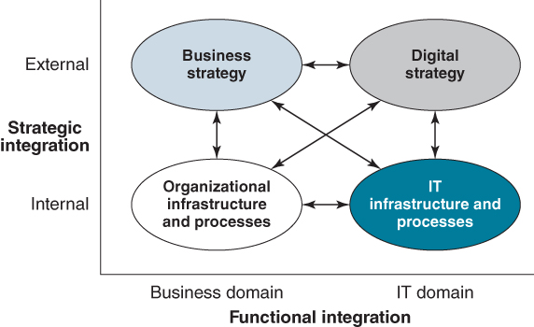
FIGURE 1.8 The strategic alignment model (SAM).
Source: Derived from J.C. Henderson and N. Venkatraman, ‘Strategic alignment: Leveraging information technology for transforming organisations’, IBM Systems Journal, 32, 1, 1993, 4–16.
The Strategic Alignment Model (SAM) assesses the range of strategic choices facing managers and explores how they interrelate. Weak associations between combinations of the domains will lead to omissions or inadequacies in the degrees of alignment between IS/IT and both business strategy and operations. It should be noted that this can be due to poor alignment of the business strategy with internal organizational infrastructure and processes as well as how well IS/IT investment is aligned.
In an empirical study that explored business and IS/IT strategic alignment in the Australian banking industry, Broadbent and Weill⁷¹ reported that central to alignment is the nature of the firm-wide strategy formulation processes of the banks. They noted that a key factor for the banks in developing a realized IS/IT strategy, consistent with business needs, is a flexible and issue-oriented strategy formulation process, with concurrent processes taking place at different organizational levels. In addition, their data indicated that those banks with the most effective management of IS/IT were ones in which IS/IT was managed by those closest to business needs. Other studies have shown that it is often informal organization structures and networks and close business/IT working relationships that enable alignment to be developed and sustained over time.⁷²
Luftman⁷³ has developed a ‘Strategic Alignment Maturity Assessment’ instrument to evaluate the extent of an organization's strategic alignment, based on 12 components or alignment dimensions (see Box 1.6). He notes that achieving alignment is evolutionary and dynamic, requiring strong support from senior management, good working relationships, strong leadership, appropriate prioritization, trust and effective communication, as well as a thorough understanding of the business and technical environments. The challenges of achieving alignment and techniques to help achieve it will be considered later in Chapter 4.

BOX 1.6

The twelve components of alignment
- Business strategy
  - Business scope. Includes the markets, products, services, customers/clients, and locations where an enterprise competes as well as the competitors and potential competitors that affect the business environment.
  - Distinctive competences. The critical success factors and core competences that provide a firm with a potential competitive edge. This includes brand, research, manufacturing and product development, cost and pricing structure, and sales and distribution channels.
  - Business governance. How companies set the relationship between management, shareholders, and the board of directors. Also included are how the company is affected by government regulations, and how the firm manages its relationships and alliances with strategic partners.
- Organizational infrastructure and processes
  - Administrative structure. The way the firm organizes its businesses. Examples include central, decentral, matrix, horizontal, vertical, geographic, federal, and functional.
  - Processes. How the firm's businesses activities (the work performed by employees) operate or flow. Major issues include value added activities and process improvement.
  - Skills. HR considerations such as how to hire/fire, motivate, train/educate, and culture.
- Digital strategy
  - Technology scope: The important information applications and technologies.
  - Systemic competences: Those capabilities (e.g. access to information that is important to the creation/achievement of a company's strategies) that distinguish the IT services.
  - IT governance. How the authority for resources, risk, conflict resolution, and responsibility for IT is shared among business partners, IT management, and service providers. Project selection and prioritization issues are included here.
- IT infrastructure and processes
  - Architecture. The technology priorities, policies, and choices that allow applications, software, network, hardware, and data management to be integrated into a cohesive platform.
  - Processes. Those practices and activities carried out to develop and maintain applications and manage IT infrastructure.
  - Skills. IT human resource considerations such as how to recruit, motivate, train/educate, and culture.
Source: J. Luftman, ‘Assessing business-IT alignment maturity’, Communications of AIS, 2000. Reproduced with permission.
Sustaining alignment when both the business environment and technologies change ever more quickly is complex and difficult. Recently, studies have emphasized the need for IS and IT strategies to adapt quickly to increasingly uncertain and dynamic environments,⁷⁴ calling for approaches such as ambidexterity,⁷⁵ adaptive,⁷⁶ dynamic alignment⁷⁷ and co-evolution⁷⁸ to be adopted. Although these studies articulate the many problems firms face in dynamic environments, they provide few examples of how dynamic adaptability or co-evolution can be achieved. For example, challenging Tanriverdi and colleagues'⁷⁹ argument to abandon the quest for alignment for the quest for co-evolution, Merali⁸⁰ notes that ‘this then raises the challenge of selecting the dimensions for co-evolutionary fit for which they do not propose a solution’. Similarly, Weill and Aral⁸¹ discuss the need to vary the criteria used in IS/IT investment decisions as business conditions and strategies evolve but offer limited advice on when to do so and how changes can be made.
The notion of co-evolution of business and IS/IT strategies signifies clearly that IS/IT not only enables the execution of a strategy but can also shape the strategy,⁸² by providing opportunities for new strategies not possible without technology: Rolls-Royce's ‘Power by the Hour’ engine availability service, for example, is not possible without sensor, satellite, communications and advanced analytics technologies. The implication is that management should not simply seek to identify and adopt the best available technologies to restructure the organization or streamline the business processes, but also consider the distinctive business capabilities and competences and innovative products and services that can be created and shaped by IS/IT.⁸³ The former identifies the potential impact of IS/IT on business strategy with consequent implications for organizational infrastructure; the latter seeks to provide the organization with new business strategic opportunities.
We have been making a strong argument for organizations to have an IS/IT strategy. We shall explore in depth how an organization can go about developing and managing this strategy in subsequent chapters, but it is also worth highlighting the possible consequences of not having an IS/IT strategy. It can lead to competitive disadvantage and even be a cause of business failure, but more generally it results in many ongoing and serious issues and problems in the organization, affecting both its performance and development. A number of such issues are listed in Box 1.7 – issues which many organizations can probably recognize and will admit exist.

BOX 1.7

Some issues and problems caused by the lack of IS/IT strategy
- ♦ IS/IT investments are made that do not support business objectives.
- ♦ Loss of control of IS/IT, leading to individuals often striving to achieve incompatible objectives through IS/IT.
- ♦ Systems are not integrated. This can also lead to duplication of effort and data leading to inaccuracy and no coherent information resource.
- ♦ No means of setting priorities for IS/IT projects, leading to problems in resource allocations and constantly changing plans, delays and lower productivity.
- ♦ No mechanisms for deciding optimum resource levels or the best means of supplying applications.
- ♦ Poor management information; it is either not available, or inconsistent, inaccurate or too slow.
- ♦ Misunderstanding between users and IT specialists leading to conflict and dissatisfaction.
- ♦ Technology strategy is incoherent and constrains options: inadequate infrastructure investments made.
- ♦ All projects evaluated on a financial basis only.
- ♦ Problems caused by IS/IT investments can become a source of conflict between parts of the organization.
- ♦ Localized justification of investments can produce benefits that are actually counterproductive in the overall business context.
- ♦ Applications, on average, have a shorter than expected business life and require replacing more frequently than should be necessary, causing unnecessary business disruption.

Digital Strategies for the 21st Century: Building a Dynamic Capability to Leverage IS/IT
Neither technology nor competition is static: technology continues to advance at breakneck speed and competitor strategic moves and new entrants mean that managers must be continuously vigilant. In fact, parts of the IS strategy are probably obsolete before the ink even dries. Organizations therefore require more than just an IS/IT strategy but a capability to continuously sense opportunities and threats and respond in a timely fashion. We have suggested that this is a new, fourth era in the evolving use of IS/IT in organizations – what we have called the IS capability era.⁸⁴ The challenge with this era is not merely to build an IS/IT strategy (a third era objective) but to develop a more comprehensive capacity in an organization to ensure that any expected value is also delivered.

The External Context
The dynamics of IT, and hence the consequences for both business and IS/IT strategy development, are complex. Figure 1.9 attempts to depict this complexity and capture these dynamics. It first illustrates the duality of technology in that it not only supports the strategy of an organization (arrow a – strategic alignment) but can also define the business, as strategic moves may not be possible without technology (arrow b – competitive impact). Technology also facilitates new ways of organizing process innovations and can enable the creation of innovative ‘network-based businesses’. For example, organizations such as eBay, Uber and Amazon and many others deploy business models that are fundamentally defined by technology. One software company has a development strategy that ‘follows the sun’, where a virtual team works 24 hours a day on a project: the day begins in Dublin, eight hours later the work is handed over to Los Angeles and after a further eight hours the work is moved to Singapore, eventually returning back to Dublin 24 hours after it first began. Some pharmaceutical companies operate their R&D activities in a similar way, which again is critically dependent on technology.
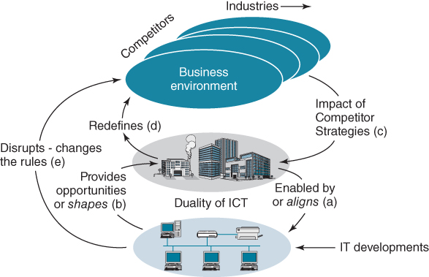FIGURE 1.9 The competitive dynamics of IS/IT.
Most organizations do not exist in isolation but have competitors and are part of a wider industry and business environment. Competitors' moves, including new entrants, affect the dynamics of an industry and, consequently, the organization and its strategies (arrow c); at the same time, strategic plays made by the organization affect competitor moves (arrow d). Technological innovations can have disruptive effects on an industry (arrow e), rewriting the rules of competition and even challenging traditional notions of industry structure. For example, many retailers have entered the financial services industry on the premise that they know more about the customers of banks than the banks know about their own customers.
While this dynamic is driven by new technological innovations, it is less of a technology revolution than a revolution in the economics of information and how information is captured, processed, stored, planned and used in an organization. It is within this context that management must determine how the organization can best utilize technology to leverage information discontinuities, asymmetries and imperfections for business advantage.⁸⁵

The Internal Context
Although organizations may gain some ‘first mover advantage’ with an innovative application, it is very probable that it will be quickly copied and therefore does not produce an advantage that is sustainable.⁸⁶ Furthermore, patent protection for IS applications is almost non-existent and keeping an IS innovation secret is difficult, especially when it is used by customers or suppliers.
While it would be easy to suggest that the ‘classic’ competitive advantage examples – many of which are mentioned in this book – resulted from a formal approach to IS/IT strategy development, more often than not they were the product of excellent exploitation of particular situations that arose in the course of business. Indeed, applications providing a basis for strategic advantage are sometimes due more to serendipity than any prescribed approaches to strategy formulation.⁸⁷
While luck can certainly have a role to play in identifying potential competitive applications, the approach presented in this book together with its tools and techniques should enable organizations to reduce any dependence on luck; but luck should not be discounted. Energy company BP has coined the concept of ‘manufactured serendipity’ to refer to situations that might seem like ‘ah-ha’ moments when a possible IS/IT application is identified, but are actually the result of an orchestrated series of events, workshops and discussions held over many months. The company is very proactive in seeking out opportunities to leverage IS/IT to resolve business problems but also to provide what it calls ‘game changer’ opportunities, where IS/ IT will significantly shape one of its businesses and bring in significant revenue.
One analysis of some of the early examples of competitive advantage from IS/IT concluded that the attainment of sustained IS/IT-based competitive advantage may be more a process of building organizational infrastructure in order to enable what the authors refer to as ‘innovative action strategies’.⁸⁸ Another study⁸⁹ investigated the linkages between IT and the performance of firms in the retail industry, asserting that ‘IT alone is not enough’. These authors conclude that some firms have gained advantage by using IT to leverage intangibles, complementary human and business resources such as organizational flexibility, integrating business strategy and IS/IT strategy, and supplier relationships.
These findings are consistent with the Resource Based View (RBV) of business strategy⁹⁰ that emerged in the early 1990s. While this perspective is discussed in more detail in Chapter 2, it asserts that sustained competitive advantages result primarily from internal firm resources or capabilities; they are valuable, rare, inimitable and not substitutable (the VRIN attributes). RBV can be used to explain the relative success of some firms in using IS/IT and the underpinning competences that create that success⁹¹ – this is discussed further in Chapter 10.
Using the RBV view as a lens to explore IS/IT and competitive advantage, Mata and colleagues⁹² concluded that only IS/IT management skills are likely to be a source of sustained advantage from IS/IT. They described these skills as the ability of IS/IT managers to understand and appreciate business needs, their ability to work with functional managers, their ability to coordinate activities in ways that support other functional managers and their ability to anticipate future needs. Furthermore, they suggest that, in the search for IS/IT-based sources of sustainable advantage, organizations must focus less on IT, per se, and more on the process of organizing and managing IT. Further support for this position is provided by a McKinsey study⁹³ which concluded that what distinguishes organizations with high-performance IT is not technical wizardry but the way they manage their IS/IT activities. Perhaps Keen's⁹⁴ contribution to the debate is most helpful; he wrote that the ‘wide difference in competitive organisational and economic benefits that companies gain from information technology rests in a management difference and not a technical difference. Some business leaders are somehow able to fit the pieces together better than others.’ Our experience would echo this management difference argument.
The challenge is therefore for organizations to build a capability to continually identify and leverage the business and organizational opportunities provided by IS/IT.⁹⁵ This is broader than merely defining the IS/IT strategy but is being able to execute that strategy as well as ensuring the ability of employees to work effectively and creatively with information. We see this IS/IT or digital capability as having three core dimensions working in harmony: fusing business knowledge with IS/IT knowledge, a flexible and reusable IT platform, and an effective use process (see Figure 1.10):
- Fusing IS/IT knowledge and business knowledge to ensure the conception of strategies to utilize technological innovation, to seize opportunities quickly and to implement these strategies successfully, including managing change and making appropriate technology sourcing decisions. It also involves knowing the extent of change that the business is capable of absorbing.
This dimension seeks to overcome an all too frequent occurrence in organizations where those who work in the IS/IT unit are referred to as working in IT or simply given the label ‘IT’ while everyone else is referred to as ‘the business’. This typically results in a ‘culture gap’, creating an ‘us and them’ situation.⁹⁶ While unhelpful, and indeed contributing to many of the problems that organizations have with IS/IT, it is unfortunately the reality. We suggest that it is more helpful to see the difference as one based on different knowledge bases. IS/IT professionals have primarily process, information and technical knowledge; those employees from the business have primarily functional, customer and industry knowledge.
- A flexible and reusable IT platform provides the technical infrastructure and resources needed to be able to respond quickly to competitor moves as well as the capacity to launch innovative applications creating new business products, services or processes. This platform is the ‘supply-side’ component of the capability. Having the knowledge and skills, some of which may be bought in, the organization ‘creates’ an IT infrastructure that influences future options and speed of response and is sustainable. So, if the senior IT management team of an organization changes for example, the infrastructure that they may have been responsible for building remains behind; it is the embodiment of their knowledge.
- An effective use process to link IS/IT assets with value realization, through the application of the technology as well as creating an environment conducive to collecting, organizing and maintaining information, together with embracing the right behaviours, both individually and collectively, for working with information.⁹⁷ Technology by itself has no inherent value; this value must be unlocked, a task that can only be achieved by people. While it might seem unnecessary to restate, technology must actually be used for benefits to be delivered!
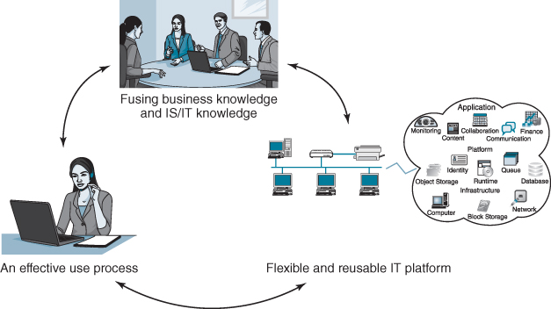
FIGURE 1.10 An organizational IS capability.
These dimensions and how they can be established are discussed in the following chapters.
Building further on the RBV, the concept of dynamic capabilities has been proposed to explain why some organizations are able to adapt more quickly to changing external market and environmental conditions.⁹⁸ There are various definitions of dynamic capabilities, but perhaps the most relevant here is: ‘the firm's processes that use resources … to integrate, reconfigure, gain and release resources – to match and even create market change. Dynamic capabilities are therefore the organizational and strategic routines by which firms achieve new resource (and capability) configurations.’⁹⁹ Others have explored the extent to which a digital capability can or should be considered a dynamic capability as it undoubtedly can enable organizations to adapt rapidly to and even create market change.¹⁰⁰ An IS/IT or digital strategy as described here can therefore also be considered as a dynamic capability or at least its aim is to create such a capability. Established aspects of IS/IT strategic management such as portfolio management, a key component of fusing IS/IT and business knowledge, have been shown to have the characteristics of a dynamic capability.¹⁰¹

Summary
The evolution of information systems and technology in a business and organizational context has been rapid, but erratic, from being seen as improving back-office efficiency to creating completely new strategic opportunities and business models. IS/IT economics, capabilities and ubiquity are increasing the range and complexity of tasks it can perform, at the same time as decreasing the costs: more and more can be achieved for less and less. The impact on most businesses, many industries and people's jobs and lives has been, and continues to be, profound. Although the progress has been fitful and unsynchronized, patterns can be observed.
Although long gone, the DP and MIS eras provided valuable lessons – in particular, regarding how to plan, develop and manage new applications and the associated projects and for the supporting infrastructure, specialist skills and managerial competences needed. Often the secret of good IS/IT planning was only really discovered after initial enthusiasm had turned to frustration – maybe just before disillusion was about to occur? Necessity was perhaps the mother of invention of better approaches?
The SIS era offered bigger prizes and, reciprocally, greater risks. As businesses became critically dependent on their investments in both IS applications and IT infrastructure, not just for success but, in many cases, for their very survival, IS/IT planning also became strategic for many organizations. That does not mean that previous era effective IS/IT strategy formulation and planning practices became obsolete, merely inadequate for the new era. The SIS era implies winners and losers with IS/IT, not just relative success and failure.
Since the millennium, increasing business pressures, in the main due to global competition and the improving capabilities and price/performance of IT, have led to the consideration of more radical strategies than previously. These can require the transformation of business processes, organizational structures and relationships, including outsourcing many non-core activities, to achieve major improvements in business performance. Changes to the organization's IS/IT or digital capability are often an integral component of this business transformation – in creating and implementing the new products and services, re-engineering processes, connecting with customers and suppliers, enabling new types of organization structures to function effectively and employees to perform more productively. Innovations in the use of information and new technologies are also essential ingredients in creating the options for change. Hence, digital or IS/IT strategies, however they are called, will have to be more radical, adaptable and dynamic than they have been in the past.
The last obvious conclusion about the evolution of strategic planning for IS/IT is that it has become difficult to separate aspects of IS/IT strategy from business strategy. Hence, it is important to use the tools and techniques of business strategic analysis and planning to ensure that approaches to IS/IT strategy formulation and planning are, and are seen to be, an essential ingredient of business strategic management. Chapter 2 starts this integration process by considering the nature, processes and tools of business strategic management. Chapters 3 to 6 then address the specifics of the many techniques and issues involved in creating an appropriate, sustainable yet adaptable digital or IS/IT strategy.

Endnotes
1. For example see A. Bharadwaj, O.A. El Sawy, P. Pavlou and N. Venkatraman, ‘Digital business strategy: toward a next generation of insights’, MIS Quarterly, 37, 2, 2013, 471–482; M. Pagani, ‘Digital business strategy and value creation: framing the dynamic cycle of control points’, MIS Quarterly, 37, 2, 617–632; J. Karimi and Z. Walter, ‘The role of dynamic capabilities in responding to digital disruption: a factor-based study of the newspaper industry’, Journal of Management Information Systems, 32, 1, 2015, 39–81; M. Fitzgerald, N. Kruschwitz, D. Bonnet and M. Welch, Embracing Digital Technology: A New Strategic Imperative, MIT Sloan Management Review, Research Report, 2013; The Digital Transformation of Industry: How important is it? Who are the winners? What must be done now? A European study commissioned by the Federation of German Industries (BDI) and conducted by Roland Berger Strategy Consultants, Berlin. Undated; and G. Westerman, D. Bonnet and A. McAfee, Leading Digital: Turning Technology into Business Transformation, Harvard Business Review Press, 2014.2. This definition comes from the UK Academy of Information Systems (UKAIS).3. J.C. Mingers, ‘What is the distinctive nature and value of IS as a discipline?’, Systemist, 17, 1, 1995, 18–22. For ongoing debates on IS and the IS discipline see A.S. Lee, M. Thomas and R.L. Baskerville, ‘Going back to basics in design science: from the information technology artefact to the information systems artefact’, Information Systems Journal, 25, 2015, 5–21; A. Bryant, ‘The future of information systems – Thinking Informatically’, European Journal of Information Systems, 17, 2008, 695–698; R.J. Paul, ‘Challenges to information systems: time to change’, European Journal of Information Systems, 16, 2007, 193–195; R. Baskerville, ‘Reviving the IT in the IS’, European Journal of Information Systems, 21, 2012, 587–590; and W.J. Orlikowski and C.S. Iacono, ‘Research commentary: desperately seeking ‘IT’ in IT research – a call to theorizing the IT artefact’, Information Systems Research, 12, 2, 2001, 121–134; S. Gregor, ‘The nature of theory in information systems’, MIS Quarterly, 30, 3, 2006, 611–642; J-R Cordoba, A. Pilkington and E.W.N. Bernroider, ‘Information systems as a discipline in the making: comparing EJIS and MISQ between 1995 and 2008’, European Journal of Information Systems, 21, 5, 2012, 479–495; A.S. Lee, M. Thomas and R.L. Baskerville, ‘Going back to basics in design science: from the information technology artifact to the information systems artifact’, Information Systems Journal, 25, 2015, 5–21; L. Markus ‘Thinking the unthinkable: what happens if the IS field as we know it goes away?’, in W.L. Currie and R. Galliers, eds, Rethinking Management Information Systems, Oxford University Press, Oxford, 1999, 175–203; I Benbasat and R.W. Zmud, ‘The identity crisis within the IS discipline: defining and communicating the discipline's core properties’, MIS Quarterly, 27, 2, 2003, 183–194; and R.J. Boland, ‘The in-formation of information systems’, in R.J. Boland and R. Hirschheim, eds, Critical Issues in Information Systems Research, Wiley, New York, 1987.4. Often referred to as ‘straight through processing’, particularly in the financial services industry.5. D. Hofman, S. Aronow, and K. Nilles Gartner's 2013 Supply Chain Top 25: Learning From The Industry Leaders, http://www.supplychain247.com/article/gartners_2013_supply_chain_t.op_25_learning_from_the_industry_leaders6. P. Checkland and S. Holwell, Information, Systems and Information Systems: Making Sense of the Field, John Wiley & Sons, Chichester, UK, 1998.7. Surveys and reports continue to confirm that the majority of organizations do not realize significant business value from IT-enabled business projects. One paper reported that 74% of IT projects from 1994–2002 failed to deliver expected value. See D. Shpilberg, S. Berez, R. Puryear and S. Shah, ‘Avoiding the alignment trap in information technology’, MIT Sloan Management Review, 49, 1, 2007, 52. For additional evidence for project failures over the last 15 years, see The Challenge of Complex IT Projects, The Royal Academy of Engineering: London, 2004; National Audit Office Delivering Successful IT-enabled Business Change, Report by the Comptroller and Auditor General, HC 33-1, Session 2006–2007, London, November, 2006; R. Ryan Nelson, ‘IT project management: infamous failures, classic mistakes and best practices’, MIS Quarterly Executive, 6, 2, 2007, 67–78; J. Peppard, J. Ward and E. Daniel, ‘Managing the realisation of business benefits from IT investments’, MIS Quarterly Executive, 6, 1, 2007, 1–11; and D.U. Himmelstein, A. Wright, and S. Woolhandler, ‘Hospital computing and the costs and quality of care: a national study’, The American Journal of Medicine, 123, 1, 2010, 40–46. Most recently the Standish Group Chaos Summary in 2014 reported IT project success rates had declined to about 16% in the US, 31% were complete failures and 53% were ‘challenged’, i.e. late and or overspent.8. J.M. Ward and E.M. Daniel, Benefits Management: How to Increase the Business Value of Your IT projects, John Wiley and Sons, Chichester, UK, 2012.9. Later in the book we question the need for customization of packages, suggesting that in many cases organizations choose to tailor the software without questioning why they are deviating from industry ‘good’ practices.10. See D. Sidwell, Gartner Summit: The Difference between Apps and Applications, May 2013, http://blog.tahoepartners.com/index.php/gartner-summit-the-difference-between-apps-and-applications/11. For example, see the United Kingdom's Government Digital Strategy, Cabinet Office, November 2012.12. M.E. Porter and V. Millar, ‘How information gives you competitive advantage’, Harvard Business Review, 63, 4, 1985, 149–160.13. B. Gates, Business @ the Speed of Thought: Using a Digital Nervous System, Penguin Books, London, 1999.14. Recent research has questioned the advantage that being a multi-national corporation brings in foreign markets. See J.F.P. Santos and P.J. Williamson, ‘The new mission for multinationals’, MIT Sloan Management Review, 56, 4 (Summer), 2015, 45–54.15. R.H. Coase, ‘The nature of the firm’, Economica, 4, 16, 1937, 386–405. Reprinted in O.E. Williamson and S. Winter, eds, The Nature of the Firm: Origins, Evolution, Development. New York: Oxford University Press, 1991, 18–33.16. O.E. Williamson, ‘The economics of organization: the transaction cost approach’, The American Journal of Sociology, 87, 3, 1981, 548–577; ‘The theory of the firm as governance structure: from choice to contract’, Journal of Economic Perspectives, 16, 3, 2002, 171–195.17. Williamson is also credited with the development of the term ‘information impactedness’, which applies in situations where it is difficult to ascertain what the costs to information are. As he explains in his book Markets and Hierarchies, this condition exists ‘mainly because of uncertainty and opportunism, though bounded rationality is involved as well. It exists when true underlying circumstances relevant to the transaction, or related set of transactions, are known to one or more parties but cannot be costlessly discerned by or displayed for others.’ See O.M. Williamson, Markets and Hierarchies: Analysis and Antitrust Implications, New York, Free Press, 1975.18. N. Foss and V. Mahnke ‘Knowledge management: What can organizational economics contribute?’ in M. Lyles, M. Esterby, eds, Handbook of Organizational Learning and Knowledge Management, Blackwell Publisher, 2003. See also R.M. Grant, ‘Prospering in dynamically competitive environments: organizational capability as knowledge integration’, Organization Science, 7, 1996, 375–387; and R.M. Grant, ‘Toward a knowledge-based theory of the firm’, Strategic Management Journal, 17, 1996, Winter Special Issue, 109–122.19. P. Butler, T.W. Hall, A.M. Hanna, L. Mendonca, B. Auguste, J. Manyika and B. Sahy, ‘A revolution in interaction’, The McKinsey Quarterly, 1, 1997, 5–23.20. For a study analysing IT outsourcing through the lens of transaction cost economics, see L.P. Willcocks, G. Fitzgerald, and M.C. Lacity, ‘To outsource IT or not? Recent research on economics and evaluation practice’, European Journal of Information Systems, 5, 1996, 143–160; and M. Lacity, L. Willcocks, and S. Khan, ‘Beyond transaction cost economics: towards an endogenous theory of information technology outsourcing’, Journal of Strategic Information Systems, 20, 2, 2011, 139–157.21. C. Shapiro and H.R. Varian, Information Rules: A Strategic Guide to the Network Economy, Harvard Business School Press, Boston, MA, 1999.22. See S.J. Liebowitz and S.E. Margolis, ‘Network externality: An uncommon tragedy’ Journal of Economic Perspectives, 8, 2, 1994, 133–150, Spring; and T.R. Eisenmann, G. Parker, and M. van Alstyne, ‘Strategies for two-sided markets’, Harvard Business Review, 84, 10 (October 2006), 92–101.23. For a treatise on IT and transformation of industries see K. Crowston and M.D. Myers, ‘Information technology and the transformation of industries: three research perspectives’, Journal of Strategic Information Systems, 13, 2004, 5–28. See also V. Gurbaxani and S. Whang, ‘The impact of information systems on organizations and markets’, Communications of the ACM, 34, 1, 1991, 59–73.24. For disruption of the real estate industry see K. Cowston, S. Sawyer and R. Wigand, ‘Investigating the interplay between structure and information and communication technology in the real estate industry’, IT & People, 14, 2, 2001, 163–183.25. E. Brynjolfsson, J. Hu and M.S. Rahman, ‘Competing in the age of omnichannel retailing’, MIT Sloan Management Review, 54, 4, Summer 2013, 23–29; and D. Bell, S. Gallina and A. Moreno, ‘How to win in an omnichannel world’, MIT Sloan Management Review, 56, 1, Fall, 2014, 45–54. See also E. Brynjolfsson, Y.J. Hu and M.S. Rahman, ‘Battle of the retail channels: how product selection and geography drive cross-channel competition’, Management Science, 55, 11, 2009, 1755–1765.26. See T. Baines, H. Lightfoot, O. Benedettini and J. Kay, ‘The servitization of manufacturing: A review of literature and reflection on future challenges’, Journal of Manufacturing Technology Management, 20, 5, 2009, 547–567.27. Big Data: The Next Frontier for Innovation, Competition, and Productivity, McKinsey Global Institute, 2011.28. For more information on impact of IT on oil and gas production, see S. Martinotti, J. Nolten and J. Steinsbo, ‘Digitizing oil and gas production’, McKinsey Quarterly, August 2014.29.Open data: Unlocking Innovation and Performance with Liquid Information, The McKinsey Global Institute, October 2013. See also V. Kundra, Digital Fuel of the 21st Century: Innovation through Open Data and the Network Effect, Joan Shorenstein Centre on the Press, Politics and Public Policy, Discussion Paper Series, #D-70, Harvard University, January 2012. See also H. Zhu and S.E. Madnick, ‘Finding new uses for information’, MIT Sloan Management Review, Summer, 2009, 18–21.30. See, for example, data.gov and data.gov.uk.31. K. Lakhani, R.D. Austin and Y. Yi, Data.gov, Harvard Business School Case Study, 9-610-075, May 2010.32. See also M. Hirt and P. Willmott, ‘Strategic principles for competing in the digital age’, McKinsey Quarterly, May, 2014.33. J.F. Rayport and J.J. Sviokla, ‘Managing in the marketspace’, Harvard Business Review, November–December 1994, 141–150; and J. Peppard and A. Rylander, ‘Product and services in cyberspace’, International Journal of Information Management, 25, 4, 2005, 335–345.34. P.B. Evans and T.S. Wurster, Blown to Bits: How the New Economics of Information Transforms Strategy, Harvard Business School Press, Cambridge, MA, 2000; see also J. Hagel III and M. Singer, Net Worth: Shaping Markets When Customers Make the Rules, Harvard Business School Press, Boston, 1999.35. Research has suggested that 51% of US and 46% of German labour costs are accounted for by interactive events. See P. Butler, T.W. Hall, A.M. Hanna, L. Mendonca, B. Auguste, J. Manyika and B. Sahy, ‘A revolution in interaction’, The McKinsey Quarterly, 1, 1997, 5–23.36. Also called e-hubs, see S. Kaplan and M. Sawhney, ‘E-hubs: The new B2B marketplaces’, Harvard Business Review, May–June 2000, 97–103; and A. White, E.M. Daniel, J.M. Ward and H. Wilson, ‘The adoption of consortium B2B e-marketplaces: an exploratory study’, Journal of Strategic Information Systems, 16, 1, 2007, 71–103. For seminal research on electronic marketplaces see Y. Bakos, ‘Reducing buyers' search costs: Implications for electronic marketplaces’, Management Science, 43, 12, 1997, 1676–1692; and Y. Bakos, ‘The emergence of electronic marketplaces on the Internet’, Communications of the ACM, 41, 8, 1998, 35–42.37. See, for example, B. Friedman, P.H. Kahn Jr and D.C. Howe, ‘Trust online’, Communications of the ACM, 43, 12, 2000, 34–40; L.P. Pitt, P. Berthon, R.T. Watson and M. Erving, ‘Pricing strategy and the Net’, Business Horizons, March–April 2001, 45–54; and C. Shapiro and H.R. Varian, Information Rules: A Strategic Guide to the Network Economy, Harvard Business School Press, Boston, 1999.38. S. Yousafzai, J. Pallister and G. Foxall, ‘Multi-dimensional role of trust in Internet banking adoption’, The Services Industry Journal, 29, 5, 2009, 591–605; S. Dayal, H. Landesberg, H. and M. Zeisser, ‘Building digital brands’, McKinsey Quarterly, 2, 2000, 42–51; K. Kim and B. Prabhakar, ‘Initial trust, perceived risk, and the adoption of Internet banking’, in Proceedings of 21st International Conference on Information Systems, December 10–13th, Brisbane, Australia, 2000, 537–543; and G. Torkzadeh and G. Dhillon ‘Measuring factors that influence the success of Internet commerce’, Information Systems Research, 13, 2, 2002, 187–204.39. M. Koufaris and W. Hampton-Sosa, ‘The development of initial trust in an online company by new customers’, Information & Management, 41, 2004, 377–397; and D.H. McKnight, V. Choudhury and C. Kacmar ‘The impact of initial consumer trust on intention to transact with a web-site: a trust building model’, Journal of Strategic Information Systems, 11, 3/4, 2002, 297–324.40. S. Jarvenpaa and S. Grazioli, ‘Surfing among the sharks: how to gain trust in cyberspace’, ed. D.A. Marchand, T.H. Davenport and T. Dickson, Mastering Information Management, Pearson, London, 2000, 197–201.41. See C. Anderson, ‘The Long Tail’, Wired, October 2004; and C. Anderson, The Long Tail: Why the Future of Business is Selling Less of More, Hyperion, New York, NY, 2006.42. For an empirical study of the existence and drivers of the long tail phenomenon, see O. Hinz, J. Eckert and B. Skiera, ‘Drivers of the long tail phenomenon: an empirical analysis’, Journal of Management Information Systems, 27, 4, 2011, 43–69.43. See E. Brynjolfsson, Y.J. Hu and M.D. Smith, ‘From niches to riches: anatomy of the long tail’, MIT Sloan Management Review, 47, 4, 2006, 67–71; and E. Brynjolfsson, Y.J. Hu and M.D. Smith, ‘Consumer surplus in the digital economy: estimating the value of increased product variety at online booksellers’, Management Science, 49, 11, November 2003.44. For the first mention of DSS in the literature, see A. Gorry and M.S. Scott-Morton, ‘A framework for information systems’, Sloan Management Review, 13, 1, 1971, 56–79. For a history of DSS see D.J Power, Brief History of Decision Support Systems, DSSResources.COM, http://DSSResources.COM/history/dsshistory.html, version 4.0, March 10, 200745. See D. Marchand and J. Peppard, ‘Why IT fumbles analytics’, Harvard Business Review, January–February 2013, 104–112.46. N. Venkatraman, ‘IT induced business re-configuration’, in M.S. Scott Morton, ed., The Corporation of the 1990s: Information Technology and Organizational Transformation, Oxford University Press, New York, 1991, 122–158.47. W.B. Arthur, ‘The second economy’, McKinsey Quarterly, October, 2011.48. T.H. Davenport, ‘Putting the enterprise back into enterprise systems’, Harvard Business Review, July–August, 1998, 121–131; and C.K. Prahalad and M.S. Krishnan, ‘The new meaning of quality in the information age’, Harvard Business Review, September–October 1999, 109–118.49. M. Broadbent and P. Weill, ‘Management by maxim: How business and IT managers can create IT infrastructures’, Sloan Management Review, Spring, 1997, 77–92; and P.G.W. Keen, Shaping the Future: Business Design Through Information Technology, Harvard Business School Press, Boston, 1991.50. ‘Informating’ is a term first coined by S. Zuboff in her book, In the Age of the Smart Machine, Basic Books, New York, 1988. We use it in a slightly different way in this book.51. J. Jurison, ‘Toward more effective management of information technology benefits’, Journal of Strategic Information Systems, 5, 4, 1996, 263–274.52. P.G.W. Keen, Shaping the Future: Business Design Through Information Technology, Harvard Business School Press, Cambridge, Massachusetts, 1991.53. This is the point that Carr missed in his infamous ‘IT doesn't matter’ article that appeared in Harvard Business Review in 2003.54. A.L. Lederer and V. Sethi, ‘The implementation of strategic information systems planning methodologies’, MIS Quarterly, 12, 3, 1988, 445–461.55. M.J. Earl, Management Strategies for Information Technology, Prentice-Hall, Hemel Hempstead, UK, 1989.56. M. Jeffery, and I. Leliveld, ‘Best practices in IT portfolio management’, MIT Sloan Management Review, 45, 3, 2004, 41–49.57. F.W. McFarlan, ‘Information technology changes the way you compete’, Harvard Business Review, May–June 1984, 93–103.58. A.C. Boynton and R.W. Zmud, ‘Information technology planning in the 1990's: directions for practice and research’, MIS Quarterly 11 (1), 1987, 59–71.59. M.J. Earl, Management Strategies for Information Technology, Prentice-Hall, Hemel Hempstead, UK, 1989.60. R.D. Galliers, ‘Towards the integration of e-business, knowledge management and policy considerations within an information systems strategy framework’, Journal of Strategic Information Systems 8, 3, 1999, 229–234.61. J.M. Ward, ‘Information systems strategy: Quo vadis?’ Journal of Strategic Information Systems, 21, 2012, 165–171.62. C.H. Sullivan, ‘Systems planning in the information age’, Sloan Management Review, Winter, 1985, 3–11.63. M.J. Earl, ‘Information systems strategy formulation’, in R.J. Boland and R.A. Hirschheim, eds, Critical Issues in Information Systems Research, John Wiley & Sons, Chichester, UK, 1987.64. Earl has a much broader definition of information management to include role and structure of IT activities in the organization as well as IT governance.65. A. Quaadgras, P. Weill and J. Ross, ‘Management commitments that maximize business impact from IT’, Journal of Information Technology, Vol. 29, 2014, 114–127.66. J.M. Ward, E. Daniel, and J. Peppard, ‘Building better business cases for IT Investments’, MIS Quarterly Executive, 7, 1, 2008, 1–14.67. S. Gregor, M. Martin, W. Fernandez, S. Stern and M. Vitale, ‘The transformational dimension in the realization of business value from information technology’, Journal of Strategic Information Systems, 15, 3, 2006, 249—270; and A. Vargas, M.J. Hernandez and S. Bruque, ‘Determinants of information technology competitive value. Evidence from a western European industry’, Journal of High Technology Management Research, 14, 2003, 245–268. See also P.L. Drnevich and D.C. Croson, ‘Information technology and business level strategy: towards an integrated theoretical perspective’, MIS Quarterly, 37, 2, 2013, 483–509.68. R. Kohl, and S. Devaraj, ‘Realizing the business value of information technology investments: An organisational process’, MIS Quarterly Executive, 3, 1, 2004, 53–68.69. M.S. Scott Morton, ed., The Corporation of the 1990s: Information Technology and Organizational Transformation, Oxford University Press, New York, 1991; and Y. Chan and H. Reich, ‘IT alignment: what have we learned?’ Journal of Information Technology, 22, 4, 2007, 297–315.70. J.C. Henderson and N. Venkatraman, ‘Strategic alignment: Leveraging information technology for transforming organisations’, IBM Systems Journal, 32, 1, 1993, 4–16. See also N. Venkatraman, J.C Henderson and S. Oldach, ‘Continuous strategic alignment: Exploiting information technology capabilities for competitive success’, European Management Journal, 11, 2, 1993, 139–149; and J.N. Luftman, P.R. Lewis and S.H. Oldach, ‘Transforming the enterprise: The alignment of business and information technology strategies’, IBM Systems Journal, 32, 1, 1993, 198–221. The Journal of Information Technology published a special issue collection of papers in June 2015 titled ‘Revisiting Strategic Alignment 25 Years On’.71. M. Broadbent and P. Weill, ‘Improving business and information strategy alignment: learning from the banking industry’, IBM Systems Journal, 32, 1, 1993, 162–179.72. Y. Chan, ‘Why haven't we mastered alignment? The importance of the informal organization structure’, MIS Quarterly Executive, 1, 2, 2002, 97–112.73. J. Luftman, ‘Assessing business-IT alignment maturity’, Communications of the AIS, 4, December 2000.74. Y. Merali, T. Papadopoulos and T. Nadkarni, ‘Information systems strategy: past, present, future?’ Journal of Strategic Information Systems, 21, 2, 2012, 125–153.75. Z.L. He and P.K. Wong, ‘Exploration vs. exploitation: an empirical test of the ambidexterity hypothesis’, Firm Science, 15, 4, 2004, 481–494.76. Y. Merali, ‘Complexity and information systems: the emergent domain’, Journal of Information Technology, 21, 4, 2006, 216–228.77. W. Oh and A. Pinsonneault, ‘On the assessment of strategic value of information technologies: conceptual and analytical approaches’, MIS Quarterly, 31, 2, 2007, 239–265.78. H. Tanriverdi, A. Rai, and V. Venkatraman, ‘Research commentary – reframing the dominant quests of information systems strategy research for complex adaptive business systems’, Information Systems Research, 21, 4, 2010, 822–834.79. H. Tanriverdi, A. Rai, and V. Venkatraman, ‘Research commentary – reframing the dominant quests of information systems strategy research for complex adaptive business systems’, Information Systems Research, 21, 4, 2010, 822–834.80. Y. Merali, ‘Complexity and information systems: the emergent domain’, Journal of Information Technology, 21, 4, 2006, 216–228.81. P. Weill and S. Aral, ‘Generating premium returns on your IT investments’, Sloan Management Review, 47, 8, 2006, 39–48.82. J. Peppard and K. Breu, ‘Beyond alignment: a co-evolutionary view of the information systems strategy process’, paper presented at International Conference on Information Systems, Las Vegas, 2003; and I. Vessey and K. Ward, ‘The dynamics of sustainable IS alignment: The case for IS adaptivity’, Journal of the Association For Information Systems, 14, 6, 2013, 283–311.83. N. Venkatraman, J.C. Henderson and S. Oldach, ‘Continuous strategic alignment: Exploiting information technology capabilities for competitive success’, European Management Journal, 11, 2, 1993, 139–149.84. J. Peppard and J. Ward, ‘Beyond strategic information systems: towards an IS capability’, Journal of Strategic Information Systems, 13, 2, 2004, 167–194.85. In the strategic management literature, Chakravarthy noted that most of the existing frameworks assume a benign environment that is simple and not very dynamic. See B. Chakravarthy, ‘A new strategic framework for coping with turbulence’, Sloan Management Review, Winter, 1997, 69–82. See also H.G. Courtney, J. Kirkland and S.P. Viguerie, ‘Strategy under uncertainty’, Harvard Business Review, November–December, 1997, 66–97; and G. Hamel, ‘Strategy, innovation and the quest for value’, Sloan Management Review, Winter, 1998, 7–14.86. E.K. Clemons and M.C. Row, ‘Sustaining IT advantage: The role of structural difference’, MIS Quarterly, 15, 3, 1991, 275–292; F.J. Mata, W.L. Fuerst and J. Barney, ‘Information technology and sustained competitive advantage: A resource-based analysis’, MIS Quarterly, 19, 4, 1995, 487–505; and K.H. Goh and R.J. Kauffman, ‘Firm strategy and the Internet in U.S. commercial banking’, Journal of Management Information Systems, 30, 2, 2013, 9–40.87. C. Ciborra, ‘The grassroots of IT and strategy’, in C. Ciborra and T. Jelessi, eds, Strategic Information Systems: A European Perspective, John Wiley & Sons, Chichester, UK, 1994, 3–24.88. W. Kettinger, V. Grover, S. Guha and A.H. Segars, ‘Strategic information systems revisited: A study in sustainability and performance’, MIS Quarterly, 18, 1, 1994, 31–55.89. T.C. Powell and A. Dent-Micallef, ‘Information technology as competitive advantage: The role of human, business and technology resources’, Strategic Management Journal, 18, 5, 1997, 375–405.90. B. Wernerfelt, ‘A resource based view of the firm’, Strategic Management Journal, 5, 2, 1984, 171–180; and J.B. Barney, ‘Firm resources and sustained competitive advantage’ Journal of Management, 17, 1, 1991, 99–120.91. M.M. Caldeira and J.M. Ward, ‘Using resource-based theory to interpret the successful adoption and use of information systems and technology in manufacturing small and medium-sized enterprises’, European Journal of Information Systems, 12, 2, 2003, 127–141.92. F.J. Mata, W.L. Fuerst and J. Barney, ‘Information technology and sustained competitive advantage: A resource-based analysis’, MIS Quarterly, 19, 1995, 487–505.93. R.E. Dvorak, E. Holen, D. Mark and W.F. Meehan, ‘Six principles of high-performance IT’, The McKinsey Quarterly, 3, 1997, 164–177.94. P.G.W. Keen, ‘Information technology and the management difference: A fusion map’, IBM Systems Journal, 32, 1, 1993, 17–39.95. J. Peppard and J. Ward, ‘Beyond strategic information systems: towards an IS capability’, Journal of Strategic Information Systems, 13, 2, 2004, 167–194; J.W. Ross, C. Mathis Beath and D. Goodhue, ‘Develop long-term competitiveness through IT assets’, Sloan Management Review, Fall, 1996, 31–42; and A. Bharadwaj, ‘A resource-based perspective on information technology and firm performance: An empirical investigation’, MIS Quarterly, 24, 1, 2000, 169–196.96. See J. Ward and J. Peppard, ‘Reconciling the IT/Business relationship: a troubled marriage in need of guidance’, Journal of Strategic Information Systems, 5, 1, 1996, 37–65. See also M. Bensaou and M. Earl, ‘The right mind-set for managing information technology’, Harvard Business Review, September–October, 1998, 119–128.97. D.A. Marchand, W. Kettinger and J.D. Rollins, ‘Information orientation: People, technology and bottom line’, Sloan Management Review, Summer, 2000, 69–80.98. See for example: D.J. Teece, G. Pisano and A. Shuen, ‘Dynamic capabilities and strategic management’, Strategic Management Journal, 18, 7, 1997, 509–533; and P.L. Drnevich and A.P. Kriauciunas, ‘Clarifying the conditions and limits of the contributions of ordinary and dynamic capabilities to relative firm performance’, Strategic Management Journal, 32, 2, 2011, 254–279. For a study of the role of dynamic capabilities in the performance of response to digital disruption see J. Karimi and Z. Walter, ‘The role of dynamic capabilities in responding to digital disruption: a factor-based study of the newspaper industry’, Journal of Management Information Systems, 32, 1, 2015, 39–81.99. K.M. Eisenhardt and J.A. Martin, ‘Dynamic capabilities: what are they?’ Strategic Management Journal, 21, 10/11, 2000, 1105–1121.100. See for example: R.S. Chen, C.M. Sun, M.M. Helms and W.J. Jih, ‘Aligning information technology and business strategy with a dynamic capabilities perspective: A longitudinal study of a Taiwanese semiconductor company’, International Journal of Information Management, 28, 3, 2008, 366–378; H. Koch, ‘Developing dynamic capabilities in electronic marketplaces: a cross-case study’, Journal of Strategic Information Systems, 19, 1, 2010, 28–38; and G.D. Bhatt and V. Grover, ‘Types of information technology capabilities and their role in competitive advantage’, Journal of Management Information Systems, 22, 2, 2005, 253–277.101. E.M. Daniel, J.M. Ward and A. Franken, ‘A dynamic capabilities perspective of IS project portfolio management’, Journal of Strategic Information Systems, 23, 2014, 95–111.

UNIT 2
AN OVERVIEW OF STRATEGIC MANAGEMENT AND THE IS/IT STRATEGY IMPLICATIONS

OUTLINE
- ♦ The Evolving Nature of Strategic Management in Organizations
- ♦ Scope of Strategy Development
- ♦ A Framework for Strategy Formulation
- ♦ Where to Compete
- ♦ How to Gain an Advantage
- ♦ What Assets do We Have? What Assets do We Require?
- ♦ How to Change – the Need for Dynamic Capabilities
- ♦ Strategy Implementation
As discussed in Chapter 1, it has become increasingly important that organizational IS/IT investments are seen not only as ways of implementing chosen business strategies but also ways of creating and shaping new strategies-strategies that are not possible without the application of IS/IT. However, even today, a significant proportion of the money spent on IS/IT often has little relationship to those objectives, which is one of the many reasons why the potential benefits from IS/IT investments are frequently not realized. Success in leveraging IS/IT involves both optimizing the return on the money invested in acquiring, processing and using information within an organization – what is often referred to as ‘run the business’ – and enabling the innovative, strategic use of information either to gain advantage or avoid disadvantage – ‘change the business’.
Given the increasing pervasiveness of technology, some people argue that ‘the business strategy is the IS/IT strategy’ or at least that ‘digital business strategy will become the business strategy’.¹ While such statements might grab headlines and attention, they are actually rather meaningless and misleading. In reality, an explicit IS/IT or digital strategy needs to be formulated, investment and resourcing plans developed and sourcing decisions made. We strongly advocate that all this should be determined as an integral part of the business strategy development process, which should include an in-depth analysis of the actual and potential business impact of IT. However, in reality, the process for determining the IS/IT strategy is still often a separate initiative, even though IT can be a powerful disruptive force for industry structure and competition as well as creating new strategic opportunities.
All this implies that business managers should become actively involved in the process of developing IS/IT or digital strategies.² This, in turn, means the strategies must be related to their business issues, with the process conducted using tools and techniques that are familiar to them and in a language that they understand, avoiding the jargon that surrounds IT. While it might seem counter-intuitive, conversations about IT, particularly strategic ones, should rarely be about the technology!
Formal methods for business strategic planning began in the 1950s and, since then, a wide range of approaches, tools and techniques have been suggested to guide the strategy development process. These continue to evolve in response to the increasingly complex, uncertain and rapidly changing business environment. Rather than present yet another methodology, we have structured this chapter around five key questions that have to be considered in any strategy process. We explore the major empirical contributions for addressing these five questions as well as introduce tools that have been developed to help in answering them.
Whilst the emphasis is on organizations in competitive environments, most of the questions, and tools that can help address them, apply to others, such as public sector bodies and not-for-profit organizations. The exceptions to that are probably aspects of the first question – where to compete – but many of the issues of how to compete for the attention of consumers, investors or the public apply to all but monopolistic organizations and even they need to understand their assets and how to change and develop them. In most of these types of organizations, the link between providing services and accruing revenue is discontinuous and the ‘businesses’ can often best be considered as two, connected by the need to balance expenditure in one stream providing services, with income from the funding stream(s). Charities, for instance, raise funds from one group of people to provide services to another quite different group.

The Evolving Nature of Strategic Management in Organizations
The essence of business strategy for companies and corporations lies in creating future advantages faster than competitors. The need to formalize such a strategy resulted from developments in programme planning and budgeting developed during World War II. During the 1950s, another stream of thought, pioneered at the Harvard Business School, highlighted the importance of having an overall corporate strategy to integrate the various functional areas. However, by the mid-70s, there was a recognition emerging of the failure of strategic planning, at that time, to resolve the problems of the firm in the post-industrial era.³ The concept of strategic management was proposed, within which formal planning was only one component of a much more complex socio-dynamic process to bring about strategic changes in an organization.⁴
Exploring the evolution of strategy and strategic planning in organizations, Gluck and colleagues⁵ developed a model to describe its increasing maturity. Although there have been many changes in the business world, particularly since the model was proposed, it still describes how the core issues have evolved, along with the need for new approaches to developing and implementing strategies. The basic model, with some modifications, is depicted in Figure 2.1.
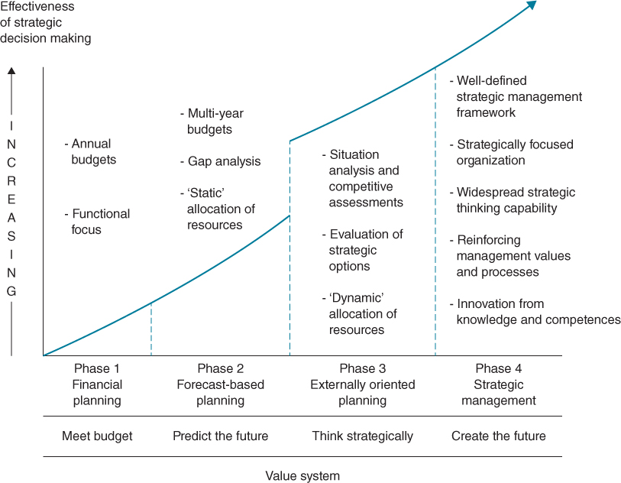
FIGURE 2.1 Evolution of strategic management maturity.
In Phase 1, the focus is on cash flow and annual financial planning and involves relatively simple techniques to develop medium-term budgets. These exercises are usually carried out internally, department by department, and consolidated. The notion of planning is to reduce everything to a single financial issue – meeting the budget.
At Phase 2, the emphasis is on trying to predict what is likely to happen within, say, a one to three year horizon, usually by reference to historical performance, which is analysed and projected into the future using internal trends and external parameters such as economic and market research data. It forecasts sales and market growth and predicts the effect on income and expenses and changes to the balance sheet, but plans are still quantitative and internally orientated, focusing on the gap between targets and the resources available.
Within Phase 3, the organization, for the first time, tries to gain a thorough understanding of the nature of competition in its industry, in order to assess and consider potential threats and position itself to gain advantage. The organization might need to revise its product portfolio to match demands in more attractive market segments, or increase the value-added features of existing products and services, or significantly reduce its unit costs. This also implies the identification of new product development, sourcing or marketing options and their evaluation to find those that suit the organization, but also satisfy the pressures and demands of the competitive marketplace.
By Phase 4, the organization is driven by innovation and becomes capable of creating its own business environment, at least to some extent. This implies that in an increasingly dynamic business environment, when products and services can quickly become obsolete, the only real source of competitive advantage is the ability to either create market changes, or respond quickly to changes caused by other factors, with new products or processes that are superior to competitors. Having ‘dynamic’ capabilities is seen as the prerequisite for achieving this,⁶ where the organization's values, culture and structure reinforce the processes and capabilities required to develop and sustain a leading role in the industry, enabling the company to have significant control over its own destiny. Sustaining this leadership requires continuing innovation⁷ and IT can be a source of this innovation.
While some organizations are capable of truly creative and innovative strategies, at least for significant parts of the business, they also have to monitor the competitive environment, forecast effectively and (usually) deliver an annual profit. Progressing to Stages 3 and 4 implies that Stages 1 and 2 are handled effectively, so that strategic thinking can be converted to the required financial results. The major step change depicted in the move from Stage 2 to 3 reflects the reorientation to adopt an external perspective and for the organization to assess realistically what it does and how well it does it, in the context of its competitive environment. The model is not time dependent; unfortunately, some organizations never move beyond Stages 1 or 2 and others revert to lower levels of maturity, due perhaps to a business crisis, severe economic downturn or even change of ownership.
It is worth making a few observations about the evolving nature of strategic management issues based on this maturity model:
- The approach to IS/IT strategic management is often less mature than the approach adopted for the business strategy. While the organization may well be managing overall in Phase 3 or 4, the approach to IS/IT strategy may still be in Phase 1 (i.e. the current project plan and controlling the annual IS/IT budget) or perhaps Phase 2 (i.e. IT management planning future resource requirements based on a forecast of likely business needs). Where this occurs, the IT unit is often seen by the business as ‘living in a world of its own’ and unable to react to the rapidly changing environment. In many ways, the purpose of this book is to help organizations realign the processes and thinking of IS/IT strategic planning with the real-world pressures and requirements in Phases 3 and 4.
- During the early 1990s and again in the late 2000s, many organizations actually regressed down this maturity curve as recession deepened and they were forced to focus on short-term financial survival. In the UK, government policies saw increasing service privatization, devolvement to agencies and even market trading (e.g. in the National Health Service [NHS]), forcing many organizations to plan on a much shorter time horizon, often based on one-year financial measures. As a result, many public and private sector organizations that had perhaps been planning for the long term had to produce improvement in financial performance year on year. This seriously affected those investment plans, including IS/IT, that cannot often easily deliver demonstrable improvements within a 12-month time horizon.
- Since the start of the new century, the business environment has changed more rapidly than ever before, creating increased uncertainty and making forecasting more difficult. Except in a few, relatively stable industries, it is no longer possible to interpret the past as a reliable indicator of future trends. Even though the period to 2008 saw the longest sustained period of economic growth in history, globalization, rapid technological advances and increasingly sophisticated customers meant that firms unable to cope with the resulting greater uncertainties suffered badly. Over the same period, institutional shareholders have been demanding higher and more certain returns, causing management to focus on shorter term, financial performance but also to change strategies more frequently.
- It is not coincidental that the focus on creating distinctive brands and brand strategies has increased: brand management is aimed at achieving success in Phase 4 – external recognition of real or perceived uniqueness, plus the clarity of strategy required to marshal and align all the internal resources and capabilities ‘behind the brand’.
- The opening up of the Internet for commercial and other activity and the reduced cost and increased capabilities of information technologies offered many opportunities to create ‘new’ strategies – reaching new markets and offering new products, services and value propositions. As is usual in such circumstances, large incumbent companies were often slow (or perhaps just cautious?) to adjust their strategies to become more creative and less risk averse.⁸ Most of the ‘new economy’ developments were initiated by so-called start-ups, which had no legacy of business structure or existing IS/IT environment to inhibit them. Some incumbents set up separate businesses that were allowed the same freedoms as the start-ups.
Many of the start-ups' business models failed while others proved not to have the full set of organizational competences, such as those acquired in Stages 1–3, to succeed in highly competitive markets and industries. However, the speed with which new competitors can now emerge and grow rapidly through innovative applications of IT has meant most organizations realize that astute investment in IS/IT can enhance a business strategy, or at least that a lack of investment can leave the organization at a serious disadvantage. While it is over-simplistic to state that the arrival of ‘e-business’ at last made senior management realize the importance of IT, it was only in the year 2000 that companies' share prices were affected by whether or not they had an e-business strategy!⁹

Strategy, Strategic Thinking and Planning
The concepts of strategy and planning are frequently used interchangeably or conflated as strategic planning. This reflects a confusion that exists in many organizations regarding the two terms that also has implications for IS/IT.¹⁰ Leading management thinker Henry Mintzberg¹¹ has asserted that ‘strategic planning’ is not ‘strategic thinking’. He writes:
“When companies understand the difference between planning and strategic thinking, they can get back to what the strategy-making process should be: capturing what the manager learns from all sources (both the soft insights from his or her personal experiences and the experiences of others throughout the organisation and the hard data from market research and the like) and then synthesising that learning into a vision of the direction that the business should pursue.”
Mistaking planning for strategy is a common trap the executives can fall into.¹² Gary Hamel¹³ emphasizes that planning is about programming not discovering, and given the creative nature of the strategy process, he points out that you ‘cannot see the end from the beginning.’ The inevitable consequence of focusing on planning leads seamlessly to cost-based thinking¹⁴ – a Stage 2 trait.
Furthermore, Michael Porter¹⁵ argues that many organizations confuse operational effectiveness with strategy. Operational effectiveness means performing similar activities better than rivals perform them, whereas strategic positioning means performing different activities from rivals or performing similar activities in different ways.
These views all suggest that ‘strategy’ is not the result of formal planning or the output of any methodology but the product of a number of processes that can contribute to its establishment:
- strategic thinking – creative, entrepreneurial insight into the ways the enterprise could develop;
- strategic planning – systematic, comprehensive analysis to develop a plan of action;
- opportunistic decision making – effective responses to unexpected threats and opportunities.
Achieving each of these requires a thorough understanding of the business environment, pressure groups, stakeholders and the enterprise's resources and capabilities. Consequently, a strategy can be defined as: ‘the direction and scope of an organisation over the long term, which achieves advantage in a changing environment through its configuration of resources and competences with the aim of fulfilling stakeholder expectations’.¹⁶ Having an effective combination of incisive thinking, coherent planning and astute opportunism is probably best described as strategic management, which includes not only setting the strategy but also the creation of an overall framework for managing it, incorporating its implementation and adaptation.

Scope of Strategy Development
A key issue in any strategy process is to determine the scope. Should it cover the organization as a whole, or should the organization be considered in smaller, discrete parts where it may be more appropriate and easier to develop coherent strategies and plans?
For an SME (small or medium-sized enterprise), a strategy would likely be for the organization as a whole, but for larger organizations strategies are often needed at multiple levels (see Figure 2.2). An organization may be composed of multiple businesses which may compete in different industries. For example, Germany's ThyssenKrupp is a diversified industrial company with businesses in materials, component technologies, elevators, steel and automotive. For such companies, there is usually an overall corporate strategy defining the rationale, scope and values of the group and in particular how the corporate centre adds value to the constituent parts – ThyssenKrupp talks about the ‘Premium of Together’ and the ‘patenting advantage’.
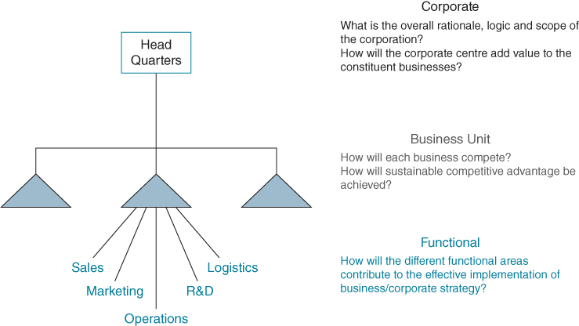
FIGURE 2.2 Levels for strategy development.
These organizational components are usually referred to as ‘strategic business units’ (SBUs), but may also be referred to as divisions or business areas, which in turn may be composed of separate business units. A strategic business unit can be defined as: an organizational unit that sells a distinct set of products or services, serves a specific set of customers and competes with a defined set of competitors. The strategic choices here should reflect the requirement to compete effectively in the chosen market and achieve a sustainable competitive advantage.
Areas like marketing, operations, purchasing, logistics and sales often develop their own functional strategies which they seek to align with the SBU strategy. Traditionally the IS/IT organization similarly looked to develop a strategy aligned to the strategy of the SBU. However, as we have argued, the strategy for IS/IT should be developed not in response to the SBU strategy but as an integral part of it. It is likely that many of the functional strategies will also have a significant IS/IT component, for example, for digital marketing.
An advantage of the SBU approach to developing strategies is that it encourages creativity and innovation and usually results in better responsiveness to markets, greater operational flexibility and clear accountability for results. In the development of strategies, it is important to consider both the enterprise as a whole and the individual business units – some aspects, such as financial investment and control, may be governed centrally while others, such as market development, are left to the discretion of each unit. The extent to which the units trade with each other, collaborate or are dependent on each other adds a further dimension to develop synergistic strategies.

A Framework for Strategy Formulation
Devising a strategy for a commercial business essentially boils down to answering five core questions at the business unit level, which can help in creating a unique and sustainable competitive position:
- Where to compete? – Requires a detailed understanding of the industry, its dynamics and the forces shaping its evolution and then identifying how the firm might position itself.
- How to gain an advantage? – Deciding how to compete in the chosen marketplace so as to be attractive for customers and to gain an advantage over competitors.
- What assets do we have? – Considering what makes the firm successful today and assessing the resources and capabilities to deliver the promises made to customers.
- What assets are required? – Identifying any areas of weakness to overcome or new resources required or capabilities that have to be developed.
- How to change? – Based on the answers to the previous questions, agreeing what to change in order to compete (more) successfully and how this will be achieved.
These questions and the relationships between them are shown in Figure 2.3. While these might seem like relatively simple questions, answering them can take considerable time, effort and knowledge. Fortunately, there are models and frameworks that can help.
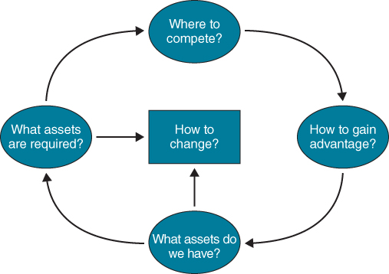
FIGURE 2.3 A framework for formulating strategy.
At the corporate level, the questions are different.¹⁷ The first is to determine the logic behind the construction of a portfolio of different businesses – what are the component parts of the corporate whole and their contribution? The next question concerns how the corporate centre will add value to the businesses in the portfolio. The options range from direct intervention, such as centralizing activities to reduce costs, or indirect, by setting targets and imposing controls to achieve overall economies of scale; or by intervention to ensure knowledge is being leveraged across the group or alternatively facilitating the creation of new corporate know-how to add value to the operating units.¹⁸ All these options can be a source of advantage to both the corporation and the individual business units. The performance of the existing portfolio is then examined to determine how it could be improved and identify changes such as acquisitions, divestments or restructuring to achieve that improved performance and increase shareholder value.

Where to Compete
If an enterprise is to succeed, it must deal effectively with the forces that influence the industry in which it competes. For example, the forces in an emerging industry such as nanotechnology or genetic engineering are quite different from those of a growth industry, say leisure or mobile technologies, or the more mature industries such as financial services, pharmaceuticals or automobiles. In addition, the pressures of operating globally, as in the software industry, are very different from those in localized industries, such as retailing, where there is less international competition (although it is increasing).
The enterprise interacts with its customers, suppliers and competitors, but there are also potential new entrants who could join the industry as well as possible substitute products and services. To survive and thrive in this environment, it is obviously vital to understand these interactions and the implications, in terms of how to avoid being disadvantaged, and to create opportunities to gain advantage. Figure 2.4 presents a model illustrating these five forces.
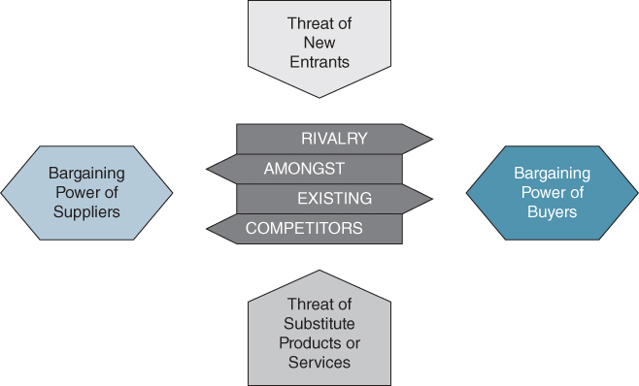
FIGURE 2.4 The 5-forces model: identifying industry structure and the rules of competition.
At any one time, one or more of the forces may be exerting particular pressure on the competing firms. Existing rivals may be competing viciously via a price war and/or introducing new products and services or effective advertising campaigns. Alternatively, competitors may be cooperating to ward off an external threat.¹⁹ The buyers, such as large retailers, or suppliers, such as computer chip producers, may be powerful enough to bargain away much of the profitability available to the firm and also its competitors. New entrants to the industry may be a threat because of low entry barriers, high profit margins or weak competitive rivals. The Internet has enabled the entry of new intermediaries such as price comparison websites to take some of the profit of suppliers of insurance and other financial service products. Substitute products are always possible, not just in terms of replacement products (such as e-books) or services (such as Uber and Airbnb) but also as alternative ways for buyers to spend their money (e.g. holidays versus luxury goods).
If all the forces are exerting intense pressure at the same time, the company faces serious problems! But, if it addresses the forces according to their relative impacts now (on a High, Medium, Low scale, for example) and potential impacts in the future, it can both defend its existing competitive position and establish a better position than its rivals.
The assessment process should identify the forces that are determining the future of the industry and the firm's success. It is also important to understand who is the industry leader or who dominates the industry and what strategy they are following. Typical questions to consider are:
- Who might enter the industry, why and what would the effect be (i.e. extent and scale of disruption)?
- What substitute products might affect the market for existing products?
- On what basis are we currently competing and how might that change?
- What leverage do suppliers exert and how could the control of key resources affect success?
- How much power and discretion do buyers (customers) have and how will these change market/product possibilities?
Box 2.1 lists some of the factors that determine whether the forces will have a major influence on a business and its performance. IS/IT has been shown to have significant effects on all these forces; for example, the Internet has reduced some barriers to entry, mobile apps can increase the bargaining power of consumers and reduce switching costs and ‘smart’ digital products are creating substitutes for traditional ones. These extensive IS/IT implications are considered in detail in Chapter 6.

BOX 2.1

Factors affecting the impact of competitive forces
New entrants will be inhibited by:
- ♦ capital requirements;
- ♦ patents and specialist skills required;
- ♦ distribution channels available;
- ♦ achieved/required economies of scale and resultant cost advantages;
- ♦ learning curve effects;
- ♦ number and size of existing rivals and intensity of competition;
- ♦ differentiation and brand establishment/loyalty;
- ♦ legislation and regulation;
- ♦ access to raw materials/critical resources etc.
Substitute products/services (implies achieving a higher priority for customer spend):
- ♦ customer awareness of needs and means of satisfaction;
- ♦ number of alternatives and customer ability to compare them;
- ♦ customer sensitivity to value for money;
- ♦ existing loyalty of customers – impact of ‘industry’ promotion;
- ♦ ability to differentiate products etc.
Competitive rivalry will be intensified by:
- ♦ market growth slow (or in decline);
- ♦ small number of similar sized competitors dominate;
- ♦ high fixed costs and/or high exit barriers for all rivals;
- ♦ overcapacity and/or capacity increments are large units;
- ♦ commodity or undifferentiated products etc.
Buyers' power will be increased by:
- ♦ concentrated/few buyers making high volume and/or high value of purchases;
- ♦ low switching costs across suppliers;
- ♦ price sensitive and many alternative sources of supply;
- ♦ weak brand identities, products not differentiated;
- ♦ buyers capable of backward integration due to low ‘entry’ costs etc.
Suppliers' power will be increased by:
- ♦ few suppliers – high switching costs for rivals and suppliers deal with many small customers;
- ♦ potential substitute supplier/resources not easily available;
- ♦ supplied goods make up large part of firms' costs;
- ♦ high buyer switching costs;
- ♦ suppliers capable of forward integration or bypass direct to customers etc.

Industry Analysis: ‘PESTEL’
To help in analysing an industry, it is important to understand the wider macro-economic and social context in which it operates. An organization on its own cannot affect these factors, but by understanding them it is possible to increase the opportunities and decrease the threats to the enterprise. Strategic analysis should include scanning these external contexts to detect and understand the broad, long-term trends and implications for both the firm and the industry. If the organization is able to assess its current environment and potential changes accurately, it will be better placed than its competitors to respond to those changes. PESTEL (Political, Economic, Sociological, Technological, Environmental and Legal) analysis is effectively an assessment of an organization's external influences, which can help guide strategic decision making (see Box 2.2). It is a useful tool for understanding the ‘big picture’ of the organization's operating environment.

BOX 2.2

Macro-environmental influences: the PESTEL framework with examples
Political
- ♦ Government stability
- ♦ Taxation policy
- ♦ Foreign trade regulations
- ♦ Social welfare policies
Economic
- ♦ Business cycles
- ♦ GNP trends
- ♦ Interest rates
- ♦ Money supply
- ♦ Inflation
- ♦ Unemployment
- ♦ Disposable income
Sociocultural
- ♦ Population demographics
- ♦ Income distribution
- ♦ Social mobility
- ♦ Lifestyle changes
- ♦ Attitudes to work and leisure
- ♦ Consumerism
- ♦ Levels of education
Technological
- ♦ Government spending on primary research
- ♦ Government and industry focus on technological effort
- ♦ New discoveries/development
- ♦ Speed of technology transfer
- ♦ Rates of obsolescence
Environmental
- ♦ Environmental protection laws, incl. product disposal
- ♦ Waste disposal
- ♦ Climate change and low carbon policies
Legal
- ♦ Monopolies legislation
- ♦ Employment law
- ♦ Health and safety
- ♦ Product safety
- ♦ Minimum wages
- ♦ Intellectual property (IP) protection
Based on a combination of the five forces and PESTEL analysis, the firm can pursue strategies to defend its position or exploit it further or perhaps influence some of the contextual factors affecting the industry, for example:
- Defend – Build product differentiation to reduce direct rivalry and recognize and watch for potential substitutes – both for products and for customer spend.
- Influence – Pursue strategies that will, in time, change the balance of forces driving profitability in your favour. Raise barriers to entry by building brands, influencing legislation and regulatory bodies and protecting proprietary knowledge.
- Exploit – Select or focus on buyer groups that have less power or price sensitivity or increase switching costs with buyers (e.g. loyalty programmes, customized services). Or build switching costs and mutual dependencies with suppliers (e.g. dedicated arrangements, shared inventories).

How to Gain an Advantage
Companies that succeed in an industry in the long term outperform the competitors either by achieving lower costs, usually from high volumes, or by differentiating themselves in the view of the customer, enabling them to obtain a price premium.²⁰ Some companies, for a period of time at least, can achieve both. For instance, Kodak in the 1960s and early 1970s achieved this in the colour photography market, IBM in the 1970s with mainframe computers and Apple in the smartphone and tablet markets in the 2010s. Most companies, however, have to strive for one advantage or the other, at least in the short to medium term. Examples in Chapter 1 of firms gaining and sustaining advantages from IS/IT (see Box 1.4) can be aligned quite clearly with either low cost or differentiation business strategies.
The other critical decision is whether to seek to gain advantage in the whole market or just part of it. The scope can be defined as ‘industry wide’, implying that the company must have a range of products to meet the requirements of the majority of potential customers. Ford, VW and General Motors in the car industry are good examples of companies targeting a range of customers, as are the big four UK banks in the financial services industry. Other companies choose a segment of the market and focus on a particular niche to obtain an advantage by matching their products and services to the needs of a subset of the potential customers. BMW, Mercedes and Jaguar/Land Rover are all examples of companies focusing within the motor industry. The Triodos Bank, while offering similar consumer and business services to other retail banks, aims its services at customers who expect the bank to behave ‘ethically’ and have environmentally and socially responsible policies and practices.

Low Cost Strategy
Cost leadership strategies imply identifying the lowest cost approaches to the direct activities of the business, minimizing the indirect/overhead expenses and providing management with detailed reporting on all aspects of fixed and variable costs incurred. Low cost is normally achieved through structure and standardization: ‘value engineering’ the processes of the business, adopting ‘lean’ and ‘6-sigma’ approaches, plus accurate performance measurement, enabling early identification and action when variances from expected results occur.
In this environment, IS/IT will be required to automate basic business information processes to achieve efficiencies and also link them together effectively, but not necessarily to produce a highly integrated information resource. An alternative approach is to transfer higher cost activities to either the customers or suppliers or both. Low cost airlines' systems are good examples, achieving very low transaction and administrative costs for the airlines by requiring customers to do most of the work when arranging their travel in exchange for lower flight prices. Trading through comparison websites provides low cost companies with opportunities to reduce marketing and business acquisition costs.

Differentiation Strategy
The majority of organizations have to follow a differentiation strategy since, theoretically at least, only one firm can be the industry cost leader for a product or service at any one time. The strategy emphasizes innovation and creativity plus a strong customer and market orientation. Often, the key to differentiation is the creation of a strong brand and corporate image and close, mutually beneficial links with the firm's distribution channels. The strategic use of IS/IT will focus on enabling new things to be achieved or existing things to be done better and gathering knowledge about customers and consumers.
That is not to say that opportunities to use IS/IT to reduce cost should be ignored. But unlike a low cost strategy, building an integrated information resource, together with analytical tools to understand customers, provides the basis for seeking out innovations and developments that customers will value. Where major software suites such as ERP or CRM are implemented for core processes, it is likely that additional functionality will be needed to address the organizational subtleties that lead to differentiation.

Niche/Focus Strategy
Within a market niche, an organization will need to adopt either a differentiation or low cost strategy to achieve and sustain long-term success in that niche. All that has been said in the previous two sections will then apply. However, in addition, IS/IT may be a competitive weapon in identifying and then establishing close relationships with customers, leading to a strong hold on a particular niche.
Some of the major requirements for an enterprise to be able to adopt the two basic generic strategies are shown in Table 2.1. These emphasize the key differences and implies different organizational structures, types of people employed and management styles, resulting in quite different corporate cultures. The most common error that organizations make is to get stuck between strategies by not deciding on their market scope and basic source of advantage – low cost or differentiation. Consequently, costs are too high and prices cannot be sustained, leading to low margins.
TABLE 2.1Characteristics of generic business strategies
Generic strategy | Commonly required skills and resources | Common organizational requirements
Cost leadership | ♦ Sustained capital investment and access to capital  ♦ Process engineering skills  ♦ Close supervision of labour | ♦ Tight cost control, frequent, detailed control reports  ♦ Structured organization and responsibilities  ♦ Incentives based on meeting strict quantitative targets
Differentiation | ♦ Strong marketing abilities and creative flair  ♦ Product engineering skills  ♦ Strong capability in basic research  ♦ Corporate reputation for quality or technological leadership  ♦ Strong cooperation from distribution channels | ♦ Strong coordination among functions in R&D, product development, and marketing  ♦ Subjective measurement and market-based incentives instead of quantitative measures  ♦ Amenities to attract highly skilled or creative people  ♦ Looser, more trusting organizational relationships

Ways of Understanding the Value of the Firm's Existing Products and Services – Tools and Techniques
There are a number of tools that can be used to understand how existing products contribute, or otherwise, to business success and guide decisions regarding the allocation of resources and future investment strategies. Perhaps the most widely used is the Boston Consulting Group's Matrix (or Square), which is essentially based on two precepts – a product life-cycle model and the relationship between market share and profitability. It also reflects the rationale of the ‘experience curve’, whereby the more times something is made, the lower the cost will become due to continuing improvements in the process and the achievement of economies of scale.
The product life cycle (shown in Figure 2.5) describes how the market for a product evolves over time, from ‘testing’ the market acceptance through growth to saturation (maturity) and eventual decline, according to customer demand. In a similar way, the types of customers who buy the products at different stages of the life cycle – the more adventurous at the start and conservative in maturity – can be used to identify market segment strategies for products through time. Not all products follow the same cycle: some never get off the drawing board; others never gain market acceptance, and life cycles can be very different in duration. For example, both Scotch whisky and Guinness are still successful after many centuries, which has been achieved by finding new markets as traditional ones become saturated or consumer tastes change. At the other extreme, mobile phones emerged in the early 1990s and were high growth for nearly 10 years, but the market in the USA and Europe declined during the 2000s as ‘smart’ phones, led by Apple's iPhone, replaced them. Most of the major manufacturers, including Nokia the one-time market leader, have either ceased or plan to cease production. Other ‘fashion’ products, including many toys and clothes, can go through the whole cycle in a few months: the model does not work well in cases where the industry is dominated by consumer fashions or fads, producing very short life cycles.
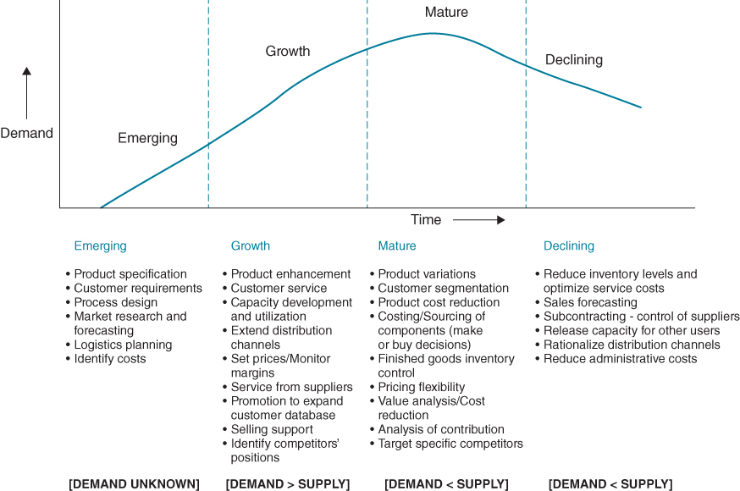
FIGURE 2.5 Industry and product life cycles – information and systems focus.
Source: Derived from an analysis in J.M. Higgins, Strategy Formulation, Implementation and Control, Dryden Press, New York, 1985, 130–135.
Whole industries also go through life cycles of emergence, growth, maturity and decline, although, with improving economic conditions spreading to more and more countries, new markets can provide growth opportunities for products that are mature or even in decline in more advanced economies (e.g. for cigarettes and basic electrical goods).
Figure 2.5 also shows the main information priorities at the stages of the industry or product life cycle, and those key business activities that could be improved by investment in IS/IT. As strategies for a business will be different in emerging, growing, mature and declining industries, IS/IT, like other investments, should be targeted appropriately. For a particular product, investments in its promotion, distribution channels and production capacity would be for different purposes at different stages of the life cycle and will also vary depending on its market position.
Relating the product life cycle to the market position produces a 2×2 matrix (the ‘Boston Square’) that plots market growth against relative market share for an organization's products or services (see Figure 2.6). The four cells in the matrix reflect two of the life-cycle stages (growth and maturity) and the relative success of the product vis-à-vis competitive products. It is important to remember that the matrix considers relative, not absolute market share, and the axes are really continua from very low to very high, so products can be positioned at various points along them.
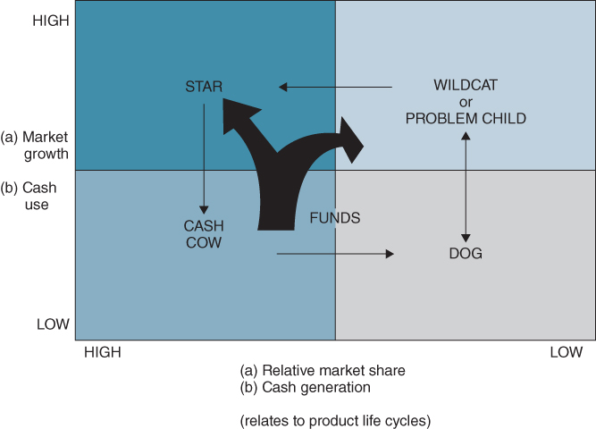
FIGURE 2.6 The Boston Consulting Group product portfolio.
Source: Boston Consulting Group.
In high growth markets, demand exceeds supply and a price premium can be obtained. They also attract many competitors but it is possible for many players to have profitable products with a relatively low market share due to the high prices obtainable. As markets mature, prices are depressed since supply exceeds demand and the less successful companies leave the market. Only those products able to compete on price, due to low costs of production or by providing features valued by customers, still succeed. Maintaining a high relative share, by increasing actual share, is essential to both customers' perception of the product and achieving necessary economies of scale. At the corporate level the matrix can be used to position each of the businesses in the company's portfolio. The position of a product, or a whole business unit, on the matrix gives indications as to appropriate future strategies.
Products in the quadrant where market growth is high but current market share is low are known as ‘problem children’ or ‘wildcats’. The investment funds needed to develop and promote these ‘wildcats’, in the hope that they will achieve higher market share and become tomorrow's stars, are sourced from the cash cows. Those that do not achieve sufficient growth should be disinvested – they will probably never turn into stars, will continue to drain funds and can even become ‘dogs’ if market growth slows down.
The route to eventual success is likely to be through innovation in the general marketplace or selecting a market niche that can be addressed effectively. Thus, the IS/IT strategy is likely to focus on product and/or process development or, alternatively, be used to identify potential customers, segment them and ensure that information about the product/service is made available to those customers. Also IS/IT can be used to help identify their needs and preferences, to enable relevant improvements to be made to the service or product.
‘Stars’ are products with high growth in demand and the best profit potential, provided a high market share is achieved. Star products generate significant revenue, but also require substantial investment in order to establish themselves in the markets and that investment needs to be sustained to provide the capacity to meet demand, maintain the brand image or innovate to meet customers' expectations.
Star products and businesses imply a leading role in the industry for the company. Anticipating, or at least keeping up with, evolving customer requirements and competitors' offerings is vital to success, as well as ensuring sales growth keeps pace with market growth. The IS/IT focus should be towards the customers – identifying them and their requirements – to gain a better understanding of demand than competitors. The applications should be aimed at enabling business growth: handling greater order volumes through a variety of channels, providing customers with flexibility in how they acquire the product (e.g. renting or owning) and types of customer service.
When demand slows down as the market matures, the previous star products require less cash to be injected and should, given a strong market share, generate significant positive cash flow. These are called ‘cash cows’. During this period, the aim is to maintain a level of product and service quality and sufficient marketing to preserve its share of the market, but seek lower costs of supply, production and distribution to maintain the net cash generation for as long as possible.
Matching the details of supply and demand volumes is important to keep customers satisfied, as is organizing resources and processes to obtain maximum capacity utilization and low costs. IS/IT investment should be focused on increasing business productivity and ‘control’ of customers and suppliers to help defend a market position and not allow competitors to gain advantage. The implementation of ERP and CRM software suites provides internal integration and control and also maintains close relationships with key customers. The overall focus is on control of the business and relationships rather than innovation.
If a profitable market share is never achieved or market share is eroded as the product is superseded by new, better or cheaper or just more fashionable products, the company must be wary of further investment producing reduced or negative rates of return. These products are called ‘dogs’ and, ideally, should be disinvested or targeted more precisely at those sectors of the market where demand still exists – a niche strategy. In general, IS/IT investment should follow the business direction – selective, strongly financially justified investments to improve profit performance by reducing costs or securing customers in the target niche. Very little innovative IS/IT use can be expected or be justified.
The model emphasizes a number of key issues:
- the need to manage products and services according to market opportunities and pressures, not internal factors;
- the need to reinvest net cash inflows into future products and services to ensure continuing sources of revenue;
- the need to have a comprehensive and balanced portfolio if the business is to thrive in the long term.
Increasing pressure from shareholders, especially large institutional shareholders such as pension funds, to dispense a greater share of the profits (from the cash cows) in dividends can create problems for even successful companies, by reducing their ability to reinvest in the development of future products and services.
Although the Boston Matrix is a useful analysis and planning model and is relatively simple to understand and use, it does not allow for many of the factors involved in achieving business success. Its underpinning rationale is derived from manufacturing of products and the value of achieving economies of scale and is less valid in many service industries. Growth rate and market share are only two aspects of industry attractiveness and competitive position, respectively, and more variables usually need to be considered.

Other Planning/Policy Matrices
There are a number of other portfolio models that extend the number of variables considered and hence the options available, resulting in a 3×3 or 3×5 matrix, as shown in Figure 2.7. High growth markets are inherently more attractive but other factors that make industries more or less attractive are: size, market diversity, existing competitive structure, prices, profitability, technology development effects, and legal, social and environmental factors. Market share obviously is a reflection of a company's strength, but other factors are important such as technology position, people, brand image, financial structure, capacity and strengths in related markets.
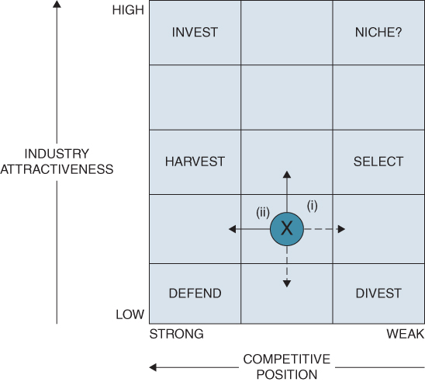
FIGURE 2.7 Policy/portfolio matrices – a typical example.
The first stage in using any of the matrices is to understand the current position of a product or service – X in Figure 2.7. Two options exist for growth: (i) developing the industry, perhaps also to the benefit of others, by product or service innovation or by attracting new types of customer; and (ii) gaining market share from competitors. Equally, strategies need to be considered to defend the existing position against industry decline or competitive pressure. In general, any strategy must enable manageable moves through the matrix – then, new options will open up as the business migrates over time. It is not realistic to jump dramatically across the matrix unless some major innovation is achieved that others cannot copy.
All of the matrices are useful in describing the current position of a business and its products in relation to the market attractiveness and the positions of competitors, and hence some of the key issues the strategy needs to address. They help management to select feasible options from those potentially available, both to improve the position and to counter threats from competitors. They also enable changing positions to be monitored, the causes and implications to be understood and the organization's resources to be allocated or reallocated to achieve the maximum overall benefits to its stakeholders.

The ‘Ansoff Matrix’²¹
During the industry evolution cycle, a firm will vary its business focus from customers to products to customers over time, in order to achieve market growth and improve its market share. Growth is more manageable if either existing products are marketed to a wider customer base or new products are developed for a known set of customer needs (see Figure 2.8). The IS/IT strategy can be expected to follow this pattern, being primarily focused on attracting, and establishing channels to, potential new customers and supporting the logistics of servicing those customers, or enabling the development and delivery of new, better or lower cost products or services to achieve growth through existing market links. At no stage will the other parameter be ignored but, at any one time, the emphasis is likely to be on product or customer ‘development’.
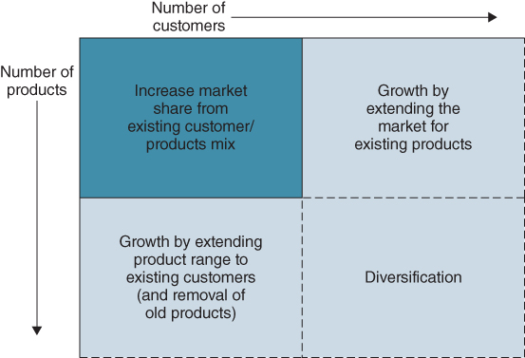
FIGURE 2.8 Dimensions of business growth.
Figure 2.8 only shows products (including services) and customers, whereas the model can have a third dimension – distribution channels, which have become more important with the range and increasing sophistication of the online channels available. Selecting the appropriate channels to serve target customer groups or for delivery of the product or service is a key strategic decision. The newer channels – call centres, the Internet and mobile – are IS/IT based and the development and operation of these customer links is an integral part of both the business and digital strategies. Managing the channel mix (e.g. in a bank with branches, call centre and online and mobile banking) is not just a matter of matching delivery to customers' needs in each channel, but also requires decisions on the extent of cross-channel service integration to be provided. As mentioned in Chapter 1, some retailers are actively developing ‘omnichannel’ strategies to interact with customers through multiple contact points.²²
Once new products or services have been developed for current customers, they will probably attract new customers who were not interested in the original product range. Equally, if a broader market for an existing product range has been established, a wider variety of customers' needs are known, which in turn can be satisfied by further product or service developments.
Historically, diversification – new products to new customers – has usually proved unsuccessful unless achieved in stages, as above, or by acquisition or by the establishment of ‘super-brands’, such as Virgin, Apple and Nike, which has enabled those organizations to develop both new products and target new market segments under the brand ‘umbrella’. In the Internet era it has often proved easier for industry new entrants to develop new consumer products and attract large numbers of customers very quickly, than for incumbents to achieve diversification.

The Customer Matrix²³
Given that attracting or retaining customers is usually a key objective of business strategy, it is obviously important to understand what they really value. The Customer Matrix is derived from the perceptions that customers have of the products or services being offered to them and the prices they are being charged for them. The matrix compares ‘Perceived Use Value’ (or PUV) against ‘Perceived Price’ (PP) to assist in analysing strategic issues and options (see Figure 2.9). PUV and PP are two components of what is often referred to as ‘value for money’. Perceived Price refers to all the price elements of concern to the customer. For example, in purchasing a new central heating system the customer may not only be concerned with the initial cost of the installation, e.g. the price of the boiler, radiators, and installation, but also with the lifetime running costs of the system, including energy costs and system maintenance.
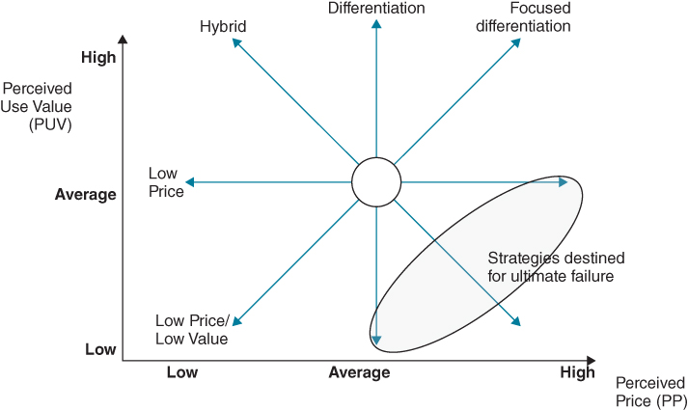
FIGURE 2.9 The customer matrix and basic strategic options.
Source: C. Bowman, ‘Formulating Strategy’, in D.O. Faulkner and A. Campbell, eds, The Oxford Handbook of Strategy – Volume 1: Strategy Overview and Competitive Strategy, Oxford University Press, Oxford, 2003.
A customer matrix can only be derived from the perceptions of a single individual or homogenous customer group. For example, what each person looks for in terms of perceived use value, or utility, when buying a car will probably differ, at least slightly, and the elements of price that matter most would also vary. For example, one type of customer might regard insurance, fuel consumption and running costs as significant cost elements, whereas another might be more concerned about the likely rate of depreciation over the first two or three years of ownership. This means that in trying to understand customer behaviour, we must be prepared to recognize that there may be important but subtle differences between potential customers.
If in Figure 2.9, as far as a particular customer group is concerned, all the competing firms' products are positioned in the central circle, it means they are all offering more or less equivalent products and are charging very similar prices. This situation can be found in many industries, not just those that are supplying obvious ‘commodity’ products. For any firm in the circle, the options available for improving its competitive position are to either cut price by moving ‘west’ (or left) in the matrix, or by moving ‘north’ (up) by raising the PUV of the products or services it offers, or perhaps doing both at the same time, a move ‘north west’.
To improve the competitive position, the strategy could be to move west in the customer matrix, offering the same PUV as the competition, but at a lower price. Such a move should lead to a market share increase and it may not only increase the firm's sales but also expand the market as a whole, if new consumers are attracted by the lower prices. However, other firms are likely to respond to the move by cutting prices to preserve their share of the market, or they may even reduce prices further causing a price war. All other things being equal, the net result of the competitors moving west is to reduce average price and profitability in the industry.
In general, competitors can imitate a price cutting strategy very rapidly, overnight if necessary. The challenge is to figure out how to gain an enduring advantage from competing on price, which normally means being able to continually drive down prices and sustain them for a longer period than competitors. This can only be achieved by having either the lowest costs in the industry, or being able to sustain losses for extended periods, through subsidies from another part of the corporation (this is where being part of a larger corporate group comes into play) or from a government. If a firm is not the lowest cost producer then the competitor that is lowest cost can always cut prices further, or sustain low prices for longer. So if a firm chooses to compete on price, it needs to have lower costs than its competitors.
The second basic strategy indicated in the customer matrix is the move north: gaining advantage through adding more PUV for the same price as the competitors' offerings. The starting point for this strategy must be the target customer, and the target customer's perceptions of value. By systematically exploring customer needs and perceptions through market research and by continually listening to customers (what is sometime referred to as ‘customer discovery’²⁴), firms can identify what is valued in their products and services and also what could be added to them to improve PUV. Many companies today have embraced ‘design thinking’²⁵ to help them do this. Design thinking is a methodology that involves gaining a thorough understanding, through direct observation, of what customers want and need in their lives and what they like or dislike about the way particular products are made, packaged, marketed, sold and supported. Box 2.3 describes a way of mapping the key dimensions driving PUV for a particular product or service.

BOX 2.3

Understanding and mapping PUV
Customers use various criteria to evaluate the extent to which a product or service can deliver a particular dimension of PUV. For example, when evaluating ‘performance’ in a car, some customers rank acceleration as being the critical determinant, which may be assessed by inspecting the 0–60 mph statistics; for others it is the top speed that counts. More interestingly, how ‘build quality’ is assessed can be difficult to ascertain. The customer may make inferences about build quality by interpreting the sound the car door makes when it is closed. Build quality might also be assessed by inspecting the alignment of body panels, or the paint finish. These may actually be very poor indicators, or poor proxy measures of build quality. However, as customer perceptions are paramount, it is essential that the firm understands what criteria the customer does use in making these evaluations, even if the customer is ‘wrong’.
The figure below illustrates a car manufacturer's product benchmarked against its three closest rivals. It shows that this firm's car is seen to be inferior to the competition on the really important dimensions (styling and performance) – which the company believes accounts for 30% of total PUV – but it performs well on the less valued dimensions. If this organization is to move north in the customer matrix then it either has to significantly shift the consumers' perceptions of its car's performance and styling, through changing the product, or maybe through changing perceptions through better advertising. A more ambitious strategy might be to try to shift consumers' perceptions of the dimensions of use value. For example, it may be possible to persuade the target customer that reliability is more important than styling. Either way, unless the organization improves its position relative to the competition on these dimensions of perceived use value, it will lag behind its competitors. In a below average position in the customer matrix, the firm may find itself forced to cut price to try to preserve sales.
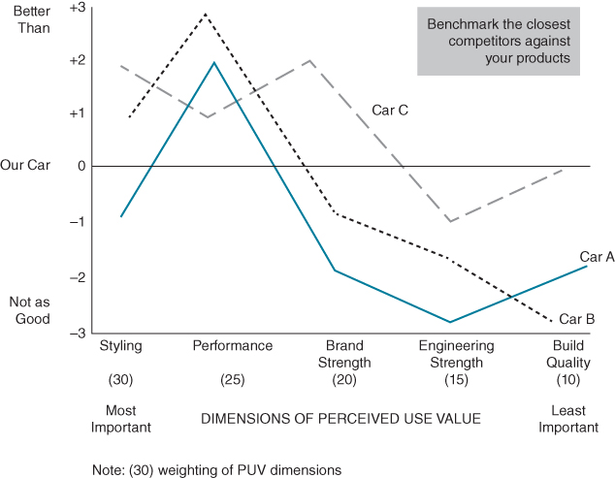
Dimensions of PUV chart.
Source: C. Bowman, ‘Formulating Strategy’, in D.O. Faulkner and A. Campbell, eds, The Oxford Handbook of Strategy – Volume 1: Strategy Overview and Competitive Strategy, Oxford University Press, Oxford, 2003.
Thus in most industries the minimum acceptable standards of PUV are being continuously shifted upwards as competitive moves become imitated: ‘order winning’ features become ‘order qualifying’ features. For instance, anti-lock brakes, CD player and air bags are features of cars that were once order winning, that are now required just to be a player. Thus, the issue of sustainability of competitive advantage needs to be considered against this backdrop of continual northward shifts in the competitive arena. There are two basic options that are open: keep moving north by staying one jump ahead of the competition through innovation, or move west through a cut in price.
As with the price cutting strategy, the key issue in adding PUV is the ease with which competitors can match its move north. As an organization moves north by increasing PUV value ahead of its competitors, it should be rewarded with an increased share of the market. Over time, it is likely that competitors will be able to imitate the move north by either acquiring or developing the required assets and capabilities and, as they follow the innovator northwards, the average level of perceived use value in the market is ratcheted upwards.
Movements in the customer matrix are determined by changes in customer perceptions of price and perceived use value. If a competitor is able to move its product north by adding PUV then this has the effect of pushing other competitors' products south in the eyes of the customer. Products can be repositioned through changes in customer tastes and preferences, which can alter the dimensions of PUV seen to be important by some customers. To explore opportunities for strategy innovation, the following questions can be useful:²⁶
- Which dimensions of PUV, that the industry has taken for granted, could be eliminated?
- Which dimensions of PUV, that are well below the industry standard, could be eliminated or reduced?
- Which dimensions of PUV could be raised well beyond the industry standard?
- Are there dimensions of PUV, that the industry has never offered, which could be created?
The strategic options available when using the customer matrix are illustrated in Figure 2.9 and summarized in Box 2.4.

BOX 2.4

Strategic options using the customer matrix

West: Low Price
Companies competing in this category are the low cost leaders that drive prices down to bare minimums, and balance very low margins with very high volume. If low cost leaders have large enough volume or strong strategic reasons for their position, they can sustain this approach and become a powerful force in the market. If not, they can trigger price wars that only benefit customers, as the prices are unsustainable beyond the short term. Walmart is an example of a low price competitor that persuades suppliers to enter the low price arena with the promise of extremely high volumes.

North: Differentiation
Companies that differentiate offer their customers high PUV. To afford this they either increase their price and sustain themselves through higher margins, or they keep their prices low and seek greater market share. Branding is important with differentiation strategies as it allows a company to become synonymous with quality as well as a price point. Nike is known for high quality and premium prices; Reebok is also a strong brand but it provides high value with a lower premium.

South West: Low Price/Low Value
Firms do not usually choose to compete in this category – it is the ‘bargain basement’ bin and few companies want to be in this position. Rather it's a position they find themselves in because their product lacks differentiated value. The only way to ‘make it’ here is through effectively selling volume, and by continually attracting new customers. Products are inferior but the prices are attractive enough to convince consumers to try them once.

North West: Hybrid (Moderate Price/Moderate Differentiation)
Hybrids are interesting companies. They offer products at a low cost but with a higher perceived value than those of other low cost competitors. These companies build a reputation of offering fair prices for reasonable goods. Good examples of companies that pursue this strategy are discount department stores. The quality and value is good and the consumer is assured of reasonable prices. This combination builds customer loyalty.

North East: Focused Differentiation
These are designer products: high perceived value and high prices. Customers will buy in this category based on perceived value alone. The product does not necessarily have to have any more real value, but the perception of value is enough to charge very large premiums, examples being Gucci, Armani, Rolls-Royce. Highly targeted markets and high margins are the ways these companies survive.

East: Increased Price/Standard Product
Sometimes companies take a gamble and simply increase their prices without any increase to the value side of the equation. When the price increase is accepted, they enjoy higher profitability. When it isn't, their share of the market falls, until they make an adjustment to their price or value. This strategy may work in the short term, but is not a long-term proposition as an unjustified price premium will soon be discovered in a competitive market.

South East: High Price/Low Value
This is classic monopoly pricing, in a market where only one company offers the goods or service. A monopolist does not have to be concerned about adding value because, if customers need what you offer, they will pay the price you set. In a market economy, monopolies are rare and do not last long.

South: Low Value/Standard Price
Companies pursuing this type of strategy will lose market share. A low value product can only be sold based on its price. An old or obsolete model cannot compete with current ones on price, but marked down by 25% it may again be a viable product and appeal to even a sizeable segment of the market.
The last three options are not viable competitive strategies in truly competitive marketplaces. Whenever price is greater than perceived value, there will always be competitors offering better quality products at lower prices.
In a similar way to how it can enable or reinforce low cost, differentiation and niche generic strategies, IS/IT can potentially offer options to enable or support each of the strategic options for the customer matrix. For example, creating a new low cost channel or analysing data collected from a product in use to develop a new value proposition.

Value Propositions and Business Models
The dimensions of PUV and PP can help in framing the value proposition being offered to customers. Defining the value proposition has been central to the marketing discipline for many decades, but has received considerable attention in recent years with the popularity of business models and business model innovation (see Box 2.5).

BOX 2.5

The business model
The term ‘business model’ gained popularity in the mid-1990s during the wide-scale introduction of the Internet in business.ª Despite this passage of time, the term is not well understood by practitioners^{b} and ‘few companies understand their existing business model well enough – the premise behind its development, its natural interdependencies, and its strengths and limitations.’^{c}
The business model concept is still evolving both theoretically and in practice and it has spawned multiple debates around its meaning and use. A key debate is the difference between business strategy and business model. Porter^{d} called the term business model ‘murky at best’ due to its apparent overlap with strategy concepts. On the other hand, Amit and Zott view a firm's strategy, business model and revenue model as three related but clearly separate concepts. They define strategy as ‘the way in which a firm chooses to position itself against competitors in its addressable market spaces’, and business model as ‘a structural template of how a firm transacts with customers, partners, and vendors’. According to Magretta,^{e} ‘while the business model lays out the activities that a company will perform to implement its strategy, it is strategy’s job to define the markets to be served and the kinds of products and services to offer'.
Researchers have proposed a variety of business model definitions and a single definition for the term has not emerged. Definitions can be divided into three categories:^{f}
- Economic Focused – The firm's economic profit model and logic of profit generation.
- Operations Focused – The internal processes and design of the infrastructure than enables the firm to create value.
- Strategy Focused – Overall direction of the firm's market position, interactions across organizational boundaries, and growth opportunities.
A representative sampling of the many business model definitions in the literature demonstrates this combination of economic, operational and strategic perspectives of the term:
- A coordinated plan to design strategy along three vectors: customer interaction, asset configuration and knowledge leverage.^{g}
- The structure, content, and governance of transactions between the firm and its exchange partners.^{h}
- A system that describes how the pieces of a business fit together.^{i}
- A company's core logic and strategic choices for creating and capturing value within a value network.^{j}
- A plan for the organizational and financial architecture of a business.^{k}
- How a firm creates and delivers value.^{l}
- A conceptual framework for identifying how a company creates, delivers and extracts value.^{m}
- The basic architecture underlying all successful businesses.^{n}
The common theme among these definitions is that the business model is a framework that describes the specific structure of how a company creates and captures value within a chosen value network.º With its emphasis on structural choices, the business model facilitates analysis, testing and validation of a firm's strategic choices. Johnson and colleagues^{p} point out that the real importance of business models is not as much about individual components as the ability to holistically envision the inter-relationships of the components.
The figure below illustrates the structure and components of a business model. The right-hand side of the value proposition is focused on the customer. The left-hand side is more concerned with the business operating model (introduced in Chapter 4).
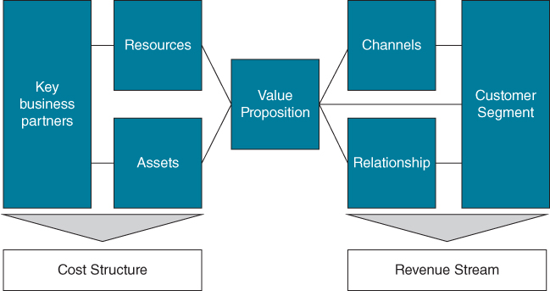
Business model schematic
Classifying business models into types has helped researchers study which business model characteristics fit particular industries and company conditions. Historically, business models have been classified based on two variables: type of assets and asset ownership. Weill et al.,^{q} for example, describe 16 traditional business model types based on a 4×4 grid of four types of asset ownership: creators, distributors, landlords and brokers; and four types of assets involved: financial, physical, intangible and human.
In an examination of many hundreds of business models, Gassmann and colleagues^{r} have identified 55 repetitive patterns. These generic models can be used as an inspiration to trigger ideas for rethinking a company's business model.
Notes:
ªA. Osterwalder, Y. Pigneur and C.L. Tucci, ‘Clarifying business models: Origins, present, and future of the concept’, Communications of the Association for Information Systems, 16, 2005.
^{b}P. Skarzynski and R. Gibson, Innovation to the Core, Harvard Business School Press, 2008.
^{c}M.W. Johnson, C.M. Christensen and H. Kagermann, ‘Reinventing your business model’, Harvard Business Review, 86, 12, 2008, 51–57.
^{d}M. Porter, ‘Strategy and the Internet’, Harvard Business Review, March, 2001, 62–78.
^{e}J. Magretta, ‘Why business models matter’, Harvard Business Review, 80, 5, May 2002, 86–92.
^{f}M. Morris, M. Schindehutte and J. Allen, ‘The entrepreneur's business model: toward a unified perspective', Journal of Business Research, 58, 6, 2005, 726–735.
^{g}N. Venkatraman and J.C. Henderson, ‘Real strategies for virtual organizing’, Sloan Management Review, 40, 1, 1998, 33–48.
^{h}R. Amit and C. Zott, ‘Value creation in e-business’, Strategic Management Journal, 22, 6/7, 2001, 493–520.
^{i}J. Magretta, ‘Why business models matter’, Harvard Business Review, 80, 5, May 2002, 86–92.
^{j}S.M. Shafer, H.J. Smith and J.C. Linder, ‘The power of business models’, Business Horizons, 48, 3, 2005, 199–207.
^{k}D.J. Teece, ‘Explicating dynamic capabilities: the nature and micro foundations of (sustainable) enterprise performance’, Strategic Management Journal, 28, 13, 2007, 1319–1350.
^{l}Johnson et al., 2008, op. cit.
^{m}P. Skarzynski and R. Gibson, Innovation to the Core, Harvard Business School Press, 2008.
^{n}M.W. Johnson, Seizing the White Space: Business Model Innovation for Growth and Renewal, Harvard Business School Press, Boston, MA, 2010.
ºFor more on the value network concept, see J. Peppard and A. Rylander, ‘From value chain to value network: insights for mobile operators’, European Management Journal, 24, 2–3, 2006, 128–141.
^{p}Johnson et al., 2008, op. cit.
^{q}P. Weill, T.W. Malone, V.T. D'Urso, G. Herman and S. Woerner, ‘Do some business models perform better than others? A study of the 1000 largest US firms’, MIT Center for Coordination Science Working Paper, 226, 2004.
^{r}O. Gassmann, K. Frankenberger and M. Csik, The St. Gallen Business Model Navigator, Working Paper, University of St. Gallen, undated.
Defining a good value proposition requires a deep understanding of the customer's ‘job to be done’.²⁷ For example, does the customers want to own a car or are they just looking for mobility? It is also helpful to know what annoys the customer; for example, risk or undisclosed costs. Moreover, any proposition should clearly define the benefits to the customer. This can be achieved by answering the following questions:
- Why should the customer purchase our offering? This outlines all the benefits customers should receive.
- Why should the customer purchase our offering instead of a competitor's? This involves identifying all the favourable points of difference relative to the next best alternative.
- What is most worthwhile for the customer to keep in mind about our offering? These are essentially the one or two points of difference of greatest value to the customer for the foreseeable future.
For example, Hilti, a Liechtenstein-based manufacturer of high-end power tools for the construction industry, reconsidered the real job to be done for many of its customers. A contractor (i.e. the customer) makes money by finishing projects; if the required tools are not available and functioning properly, the job does not get done. Contractors do not make money by owning tools, but by using them as efficiently as possible. Hilti could help contractors get the job done by selling tool use instead of the tools themselves – managing its customers' tool inventories by providing the best tool at the right time and quickly furnishing tool repairs, replacements and upgrades, all for a monthly fee. Thus, Hilti redefined its value proposition from ‘Sales of industrial and professional power tools and accessories’ to ‘Leverage a comprehensive fleet of tools to increase contractors’ on-site productivity.' This new proposition had significant implications for Hilti's revenue profile, its cost structure, resource configurations and processes – a new business model.
For Hilti, moving to a contract management programme required shifting assets from customers' balance sheets to its own and generating revenue through a lease/subscription model. For a monthly fee, customers could have a full complement of tools at their fingertips, with repair and maintenance included. This would require a fundamental shift in all major components of the profit formula: the revenue stream (pricing and payments), the cost structure (including contract management costs) and the supporting margins and transaction velocity. Additionally, leasing required new resources – new people, more robust IS/IT systems, and other new technologies – to design and develop the appropriate packages and then come to an agreement on monthly payments. Hilti needed a process for maintaining large arsenals of tools more effectively than its customers had. This required warehousing, an inventory management system and a supply of replacement tools.
Most industries have a standard definition of what their product is, but by changing their business model some manufacturers have shifted from selling products to selling services. Michelin, a worldwide leader in the tyre industry, launched a comprehensive tyre management ‘solution’ for large European transportation companies, called Michelin Fleet Solutions (MFS).²⁸ With this new business model, the company ventured into ‘selling kilometers’ – instead of tyres. This type of ‘servitization’ strategy has seen traditional manufacturing companies like Rolls-Royce, ABB, Bombardier and SKF become, to some extent at least, service businesses: the product is still required, but the customer purchases the service rendered by the product.
In summary, the alternatives of low cost, differentiation and niche strategies provide the core options for gaining and sustaining business advantages. Product and business portfolio models help assess and understand the performance of existing products and services in their markets and provide guidance in the allocation of resources. The Customer Matrix provides insight into competitive positioning in terms of key success criteria – perceived price and perceived use value. It makes you ask questions of customers about what they really value and how they see the marketplace and competition and facilitates development of a clear competitive strategy – who is the target customer and what is the value proposition you wish to offer? As shown in the figure in Box 2.5, the value proposition is at the core of any business model.

What Assets do We Have? What Assets are Required?
These two questions are considered together as they are obviously related. In order to address the first question we need to understand what makes the company successful today. Entry assets (some authors use the term resources) are those required just to operate in a particular market. These would be typically similar to the ‘barriers to entry’ in Porter's Five Forces model. Strategic assets (or resources) are those (capabilities, processes, knowledge) that provide ‘differential advantage’ to the firm and allow it to sustain competitive advantage and superior profitability. They either create what customers perceive as value in the products or services the firm produces or are the processes, capabilities or competences that are critical to delivering that value to customers.
Examples of strategic assets are Amazon's capability in fulfilment, Apple's capability in meshing technology, product design and marketing, and FedEx's capability in package routing and delivery.²⁹ These have all proved extremely difficult for competitors to imitate. In relation to the Customer Matrix, strategic assets either help the firm to differentiate itself from competitors by adding PUV, or they help to deliver equivalent PUV compared to competitors, but at lower cost. Clearly the same asset could provide both advantages, e.g. a strong brand, or operations that deliver ‘right first time’ quality. When a rival firm successfully imitates a strategic asset, it becomes an entry asset.

The Resource Based View (RBV) of Strategy
As introduced in Chapter 1, until the 1990s the approach to defining strategies was based on analysing an industry, understanding the basis of competition, selecting a viable competitive strategy, creating opportunities and (hopefully) achieving a winning position. In the 1990s, many scholars and practitioners, building on the work of Wernerfelt,³⁰ Barney,³¹ Hamel and Prahalad³² and others, developed new ways of considering strategies. This led to the Resource Based View (RBV) of strategy. The basic premise of the RBV is that some organizations are competitively more successful than others not due to the dynamics of the industry,³³ but because of their processes of resource (i.e. assets, capabilities, knowledge) accumulation and deployment, leading to endowments of proprietary resources and capabilities (i.e. strategic assets).³⁴
Resources that are valuable, rare, inimitable and non-substitutable (the so-called ‘VRIN’ criteria) are sources of competitive advantage:
- Valuable: Does it contribute to revenue generation and/or lower costs?
- Rare: Is it scarce within the industry?
- Inimitable and immobile: Can it be copied or obtained by competitors?
- Non-substitutable: Can a different resource or capability deliver the same effect?
Valuable and rare criteria should help in identifying the key resources or strategic assets of the firm at a point in time. Inimitable and non-substitutable criteria reflect the sustainability of the competitive advantage into the future.
What makes a resource difficult to copy can be its complexity, resulting from linking activities, processes and knowledge which is difficult for others to understand and imitate; or if it is difficult to understand how the advantage is achieved (so-called ‘causal ambiguity’), perhaps due to its tacit nature; or the capability may only provide an advantage in one specific context. Being successful in Stage 4 of the maturity model by creating and sustaining advantages (see Figure 2.1) implies an organizational ability to develop a unique set of resources or competences that others cannot easily acquire or replicate. Inherent in this argument is that the knowledge an organization possesses is a key resource and potential source of advantage.

Capabilities and Competitive Advantage
Creating a sustainable advantage through some form of unique business capability requires a further form of assessment. Porter's generic strategies are a starting point, since he argues that ‘low cost’ or ‘differentiation’ can provide that sustainable advantage. However, these concepts do not seem to address all the options available and also leave many questions about how lowest cost or differentiation can be achieved.
Based on the concept of resource-based strategies, Treacy and Wiersma³⁵ suggest that there are ‘three paths to market leadership’, each of which requires different sets of competences and in each of which IS/IT has a critical role to play. That is not to say that there are only three routes, although the three –‘Operational Excellence', ‘Customer Intimacy’ and ‘Product (or Service) Leadership’ – probably cover a significant range of the possibilities.³⁶ They are simple yet useful concepts in enabling business managers to define a medium-term business strategy and establish relevant IS/IT strategies. They are a succinct way of expressing the necessary alignment between capabilities and ambitions and the requisites for success in a particular environment, at a certain time (see Figure 2.10):
- Operational Excellence – enabling products and services to be obtained reliably, easily and cost-effectively by customers. This implies a focus on business processes to outperform others and can deliver both low costs and consistent quality of customer satisfaction. Examples such as Dell Computers, Wal-Mart and Federal Express are leaders in operational excellence in their industries. In all cases, the companies' information systems investments are a critical component, enabling business simplification and efficient processes that are highly integrated throughout the core activities of the business.
- Customer Intimacy – targeting markets very precisely and tailoring products and services to the needs of particular customer groups. The purpose here is not just to ‘satisfy’ but to ‘please’ customers by understanding, even anticipating, their needs and meeting them on every occasion. This can obviously be expensive but it can build long-term customer loyalty. Examples include Home Depot, a DIY retailer whose purpose is to ‘solve the consumer's home-repair problems’ rather than merely sell products, and Kraft and Frito Lay in consumer packaged goods, who offer extensive product ranges to match the preferences of many different types of consumer. Their information systems enable a retail outlet to tailor the ‘product offer’ to the locality through ‘micro-merchandising’ programmes affecting product range, promotion, pricing and store layout.
Within such a strategy, information systems will focus on collecting and analysing customer information, covering not merely purchases but also other relevant attributes and feedback on products and services. This enables careful segmentation of the marketplace and targeting of the desired segments. In the UK, an example of customer intimacy is RS Components, which sells online, or by mail order, electrical and other components to engineers. The ‘customers’ are the engineers, not the organizations they work for, and RS effectively provides a problem-solving and rapid delivery service for which the engineers, and consequently their organizations, are happy to pay a premium. The extra cost is easily offset by the time the engineer saves in determining what he or she needs to buy and how to get it.
- Product/Service Leadership – continuing product innovation meeting customers' needs. This implies not only creativity in developing new products and enhancing existing ones, but also astute market knowledge to ensure that they sell. The strategy involves delivering a continuous stream of new products and/or services, where what is new is valued by the customers. Apple, 3M and Johnson & Johnson are good examples of ‘product leaders’. A particular instance is Johnson and Johnson's contact lens business, where it pioneered the introduction of disposable lenses. The rapid gain of market acceptance and market share were due not only to the innovative product itself but to new systems to control the manufacturing and distribution of the product, which is more akin to fast-moving consumables than traditional eye-care products.
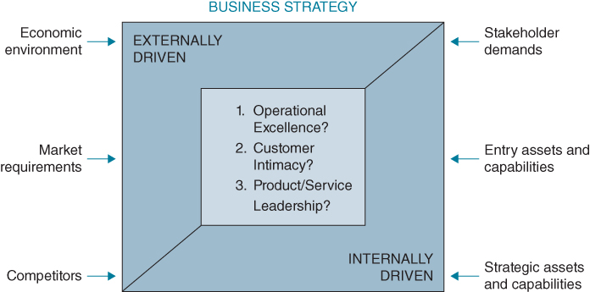
FIGURE 2.10 Forces shaping strategy.
Although these three capability-based strategies are not the only routes to success, they can be used to:
- Understand and agree the main direction, rationale and focus of the business's strategy. Although there are examples of companies succeeding in more than one dimension, organizations are normally successful by excelling in one of them. Most medium-term strategies imply ‘majoring’ on one for the next stage of development while, at the same time, not becoming uncompetitive in the other two. Action may well be needed to (say) ensure that processes do not become markedly less effective than those of competitors while developing new products, or costs will increase too quickly. Alternatively, the company must not dissatisfy its current customers while making major improvements in operational effectiveness. Figure 2.11 attempts to show this in terms of the relative degrees of competence required to achieve advantage (prosper), sustain its position (succeed) or avoid fighting for survival.
- Gain agreement among the business management about what has to improve and why, which can be critical in establishing the ‘themes’ behind both the business and IS/IT strategies, as is discussed further in Chapter 3. The set of planned IS/IT investments should relate to overcoming existing capability deficiencies (avoiding disadvantage) as well as developing the organization's future competences (creating advantage).
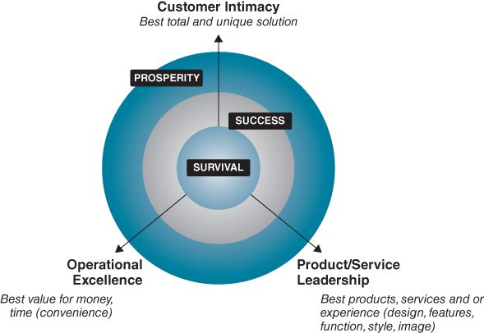
FIGURE 2.11 Advantage and disadvantage – dimensions of competence.
Source: M. Treacy and F. Wiersma, The Discipline of Market Leaders: Choose Your Customers, Narrow Your Focus, Dominate Your Market, HarperCollins, London, 1995.
In summary, to answer the questions concerning what assets we have and what assets do we require, including IS/IT assets, the following steps are helpful:
- Determine whether the current basis of competitive advantage is operational excellence, customer intimacy or product/service leadership.
- Identify both industry entry and organizational strategic assets.
- Assess the extent to which the strategic assets are creating advantage (valuable and/or rare) or helping sustain it (inimitable and/or non-substitutable).
- Identify gaps between the existing assets, resources or capabilities and those required to succeed in all three dimensions of competence.
- Based on where and how the business intends to compete, the business model and value proposition, identify the priorities for additional or improved assets/resources/capabilities required and how they might be obtained or developed.

How to Change – the Need for Dynamic Capabilities
Executing business strategies almost always includes implementing a range of internal and external changes, from developing new products and services, organizational restructuring, revising the business model and value proposition through new processes, business relationships, IT applications and improving competences, employee skills and working practices. Strategic change management is a broad subject and beyond the scope of this book to cover in any detail – elsewhere, there is extensive literature on the subject.³⁷
As discussed in Chapter 1, while some organizations develop resources or assets that enable them to outperform competitors over extended periods, some are able to adapt more quickly and effectively to changes in the business environment than others – it is argued they possess dynamic capabilities.³⁸ Clearly organizations that possess appropriate dynamic capabilities as well as a range of strategic assets are most likely to be successful in both sustaining existing and creating new business advantages. It can be argued that it is an organization's dynamic capabilities that create valuable and inimitable strategic assets and resources.³⁹
Assets, normally entry assets, can be acquired, usually by merger or takeover – Google, for example, paid $3.2bn to acquire Nest. However, such acquired assets need to be assimilated and integrated into the organization and this can be challenging, especially if they are ‘know-how’ assets, dependent on tacit as well as explicit knowledge. Integrating or at least maximizing the benefits from acquired IT assets has proved complex and often unsuccessful following some mergers and acquisitions.⁴⁰
The most challenging assets to develop are strategic assets, which are firm specific, often complex and may involve tacit knowledge and routines. Hence, it is important that an organization knows what dynamic capabilities it has, if it is to develop strategic assets. Whilst the concept of dynamic capabilities is reasonably easy to grasp, describing actual capabilities that can be ‘dynamic’ is more problematic – research and other literature contains a wide variety of suggested dynamic capabilities. New product development, knowledge creation, demand management, resource integration, learning capability, iterative development of customer value proposition and digitized process reach are some examples suggested in various papers.⁴¹ More specifically, the ability to change investment and project priorities (via project portfolio management), then reallocate resources in response to, or even in anticipation of, changes in the business environment, has been shown to be an example of a dynamic capability.⁴²
As we suggest in Chapter 1, in today's technology dependent and fast-changing business environment, having a comprehensive IS/IT capability and an IS/IT strategy approach that achieves both alignment and impact are essential dynamic capabilities for many organizations.⁴³ The purpose of both is to continually improve the organization's assets, resources and capabilities. Achieving those changes through IS/IT investments usually involves creating and managing projects or change programmes and aspects of managing change in the context of those projects or programmes is covered in Chapters 8 and 9. Creating and changing the IS/IT capability itself is discussed in Chapter 10.

Strategy Implementation
We noted earlier in this chapter that there can be a difference between the intended strategy and the strategy that is realized. Strategies are only a means to an end and little has been actually achieved until they have been implemented. This requires adequate resources to be obtained and allocated effectively, capabilities to be leveraged or built, the appropriate organization and responsibilities to be in place and staff to be motivated to help achieve the strategies. As strategies are being implemented, it is obviously important to monitor performance and control activities to ensure actions taken are producing results that will lead to achievement of the overall set of objectives. The results of this performance measurement will be used in a feedback loop to refine the objectives of the organization, depending on whether the strategies are being realized or not.
All organizations have a realized strategy: how it is currently performing in various market segments, delivering products or services and, hopefully, making a profit (or avoiding a budget deficit in the case of non-profit making organizations). However, this realized strategy is frequently not the intended strategy as forces impact any planned implementation. A model developed by Gerry Johnson and colleagues⁴⁴ describes these forces (see Figure 2.12) and reflects this real world, in which strategy ‘formation’, based on an evolving situation (the emergent strategy), prevails over a strategy ‘formulation’ approach (which produces the intended strategy).
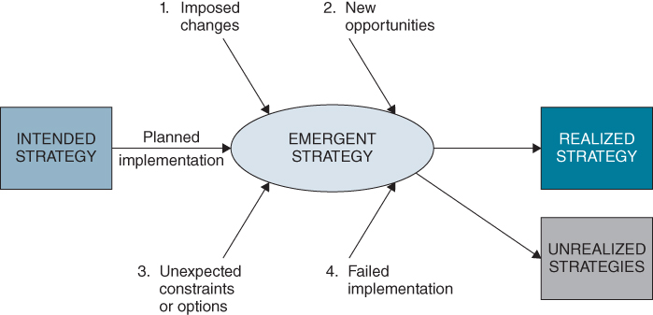
FIGURE 2.12 The realities of strategy formation and formulation.
Source: G. Johnson and K. Scholes, Exploring Corporate Strategy, Prentice Hall, Englewood Cliffs, New Jersey, 2002.
While an organization can use all its knowledge and experience to devise its intended strategy and plan for its implementation, things are unlikely to turn out as predicted.⁴⁵ Unexpected constraints or new options will occur, changes will be enforced by the actions of others, new opportunities will arise that could not have been predicted and some parts of the strategy will fail to be implemented successfully.
By having the combination of strategic thinking, planning and response mechanisms for opportunities and threats, the organization will be more able to ‘craft’ its strategy,⁴⁶ such that a different but realizable strategy can emerge. The organization must also consciously accept that when aspects of the original strategy become unachievable, it must stop pursuing them. This is often easier said than done in large organizations! Having a strategic management process that can adapt in this way to changing circumstances is not a substitute for initial strategic analysis and planning; it is a way of making it work. This approach also enables the talent of the people in the organization to become involved in its strategic development, rather than merely be used to implement a strategy devised by a small group of senior managers.

Summary
There are now a fair number of examples of organizations where IS/IT or digital strategy development takes place as an integral part of corporate strategy formulation and planning. However, the evidence, as quoted in Chapter 1, is that this still only applies to a minority of organizations, despite the impact IS/IT is having on whole industries and the strategies and performance of the competing firms. ‘Digital disruption’ of industries has been a phenomenon for 40 years, but has become increasingly prevalent since the millennium with the creation of not only new business models, but also new types of businesses, such as ‘platform’ businesses, creating new forms of trading and sources of revenue, including from existing but underused assets and resources. This form of ‘sharing’ business is attractive to many consumers and easily rolled out globally via the Internet.
The Internet of Things, smart and connected technologies, informating products and services and the servitization of some products are changing industries and both product and market economics, and hence creating new strategic opportunities and threats at an increasing rate. Few organizations can ignore the implications for their business strategies.
This chapter has described in a structured way how some of the main tools and techniques of strategic analysis can be used to consider strategic options and make choices. Of course the subject is covered far more comprehensively in other texts, and strategic management papers and articles abound. This chapter is just an introduction and overview of commonly used and useful techniques. Each of the tools and techniques described above has been shown to have value in strategy development and planning activities. If there are going to be close links between IS/IT and business strategies, then these same tools and techniques should have direct relevance in IS/IT strategy formulation and planning, if only because they enable business managers to become positively and actively involved.
Traditionally, IS/IT was seen as an instrument of implementation of strategy. In many of its uses, it is still exactly that; however, as described in Chapter 1 and shown in Figure 1.7, the capabilities of IS/IT now have to be considered as an input to business strategy, in terms of their potential to change it or create new strategies. It must be remembered that the same IS/IT opportunities may also exist for competitors and, therefore, IS/IT can constitute a threat, just like a new competitive product.
The next task is to establish the context for IS/IT strategy in more detail, so Chapter 3 considers models and approaches specific to IS/IT strategy development. However all those models and approaches recognize the need to link effectively to the business strategy, its determination and management, both to achieve alignment of the strategies and to take advantage of the strategic impact IS/IT can create.

Endnotes
1. See for example papers in the MIS Quarterly Special Edition on Digital Business Strategy, 37, 2, 2013.2. There is much research and commentary to support this position. See, for example, T.S.H. Teo and J.S.K. Ang, ‘An examination of major IS planning problems’, International Journal of Information Management, 21, 2001, 457–470; C.P. Armstrong and V. Sambamurthy, ‘Information technology assimilation in firms: The influence of senior leadership and IT infrastructures’, Information Systems Research, 10, 4, 1999, 304–327; S. Dutta, ‘Linking IT and business strategy: The role and responsibility of senior management’, European Management Journal, 14, 3, 1996, 255–268; and ‘The end of delegation? Information technology and the CEO’, Harvard Business Review, September–October, 1995, 161–172.3. H.T. Ansoff, R.P. Declerck and R.L. Hayes, eds, From Strategic Planning to Strategic Management, John Wiley & Sons, New York, 1976.4. Interestingly, many of the early thinkers in the strategic management arena were economists: Coase, Porter, Williamson etc. The academic journal devoted to the study of strategic management, the Strategic Management Journal, was founded in 1980.5. F.W. Gluck, S.P. Kaufmann and A.S. Walleck, ‘Strategic management for competitive advantage’, Harvard Business Review, July–August 1980, 154–161.6. D.J. Teece, G. Pisano and A. Shuen, ‘Dynamic capabilities and strategic management’, Strategic Management Journal, 18, 7, 1997, 509–533; and P.L. Drnevich and A.P. Kriauciunas, ‘Clarifying the conditions and limits of the contributions of ordinary and dynamic capabilities to relative firm performance’, Strategic Management Journal, 32, 2, 2011, 254–279.7. W.C. Kim and R. Mauborgne, ‘Blue Ocean Strategy, Expanded Edition: How to Create Uncontested Market Space and Make the Competition Irrelevant, Harvard Business School Press, Boston, 2015.8. There is a joke that sees a board of directors gathered around a large meeting table with the caption ‘we have to rethink our strategy of hoping that the internet will go away’.9. M. Subramani and E. Walden, ‘The impact of e-commerce announcements on the market value of firms’, Information Systems Research, 12, 2, 2001, 135–154; and P.M. Lee, ‘What's in a name.com?: The effects of “.com” name changes on stock prices and trading activity', Strategic Management Journal, 22, 8, 2001, 793–804.10. A. Campbell and M. Alexander, ‘What's wrong with strategy?', Harvard Business Review, November–December, 1997, 42–51.11. H. Mintzberg, The Rise and Fall of Strategic Planning, Free Press, New York, 1994.12. R. Martin, ‘The big lie of strategic planning’, Harvard Business Review, January–February, 2014, 1–8.13. G. Hamel, ‘Strategy as revolution’, Harvard Business Review, July–August 1996, 69–82.14. R. Martin, ‘The big lie of strategic planning’, Harvard Business Review, January–February, 2014, 1–8.15. M. Porter, ‘What is strategy’, Harvard Business Review, November–December 1996, 61–78.16. G. Johnson, R. Whittington, D. Angwin, P. Regner and K. Scholes, Exploring Strategy: Text and Cases, 10th Edition, Pearson Education, 2013.17. For more on corporate strategy see A. Campbell, M. Goold and M. Alexander, Strategy for the Corporate Level: Where to Invest, What to Cut Back and How to Grow Organisations with Multiple Divisions, Jossey-Bass, 2014; and M. Goold, A. Campbell and M. Alexander, Corporate-level Strategy: Creating Value in the Multi-Business Company, Wiley, New York, 1994.18. K. Ward, C. Bowman and A. Kakabadse, Designing World Class Corporate Strategies, Elsevier Butterworth-Heinemann, Oxford, UK, 2005.19. A.M. Brandenburger and B.J. Nalebuff, Co-Opetition, Currency Doubleday, 1997.20. M.E. Porter, Competitive Advantage: Creating and Sustaining Superior Performance, Free Press, New York, 1985.21. H.T. Ansoff, Implementing Strategic Management, 2nd Edition, 1990, Prentice Hall, Hemel Hempstead, UK.22. E. Brynjolfsson, J. Hu and M.S. Rahman, ‘Competing in the age of omnichannel retailing’, MIT Sloan Management Review, 54, 4, Summer 2013, 23–29.23. This section draws on lectures and discussion with Cliff Bowman as well as C. Bowman, ‘Formulating Strategy’, in D.O. Faulkner and A. Campbell, eds, The Oxford Handbook of Strategy – Volume 1: Strategy Overview and Competitive Strategy, Oxford University Press, Oxford, 2003.24. S. Blank, ‘Why the lean startup changes everything’, Harvard Business Review, May, 2013, 63–72.25. T. Brown, ‘Design thinking’, Harvard Business Review, June, 2008, 85–92.26. Adapted from C. Kim and R. Mauborgne, ‘Value innovation: the strategic logic of high growth’, Harvard Business Review, January–February, 1997, 107.27. A. Osterwalder, Y. Pigneur, G. Bernarda and A. Smith, Value Proposition Design, John Wiley & Sons, Hoboken, New Jersey, 2014; and J.C. Anderson, J.A. Narus and W. Van Rossum, ‘Customer value propositions in business markets’, Harvard Business Review, March, 2006, 91–99.28. Michelin Fleet Solutions: From Selling Tyres to Selling Kilometers, Case Study, HEC Paris, 2006.29. Hawawini and colleagues found that a significant proportion of the absolute estimates of the variance of firm factors is due to the presence of a few exceptional firms in any given industry. In other words, only for a few leaders and losers do firm specific assets seem to matter significantly more than industry factors. From their research they suggest that for more firms, the industry effects turn out to be more important for performance than firm specific factors. See G. Hawawini, V. Subramanian, and P. Verdin, ‘Is performance driven by industry- or firm-specific factors? A look at new evidence’, Strategic Management Journal, 24, 2003, 1–16.30. B. Wernerfelt, ‘A resource-based view of the firm’, Strategic Management Journal, 5, 1984, 171–180.31. J.B. Barney, ‘Firm resources and sustained competitive advantage’, Journal of Management, 17, 1991, 99–120; ‘Looking inside for competitive advantage’, Academy of Management Executive, 9, 1995, 49–61; and Gaining and Sustaining Competitive Advantage, Addison-Wesley, Reading, Massachusetts, 1997.32. G. Hamel and C.K. Prahalad, Competing for the Future, Harvard Business School Press, Boston, 1994.33. R.P. Rumelt, ‘How much does industry matter?’, Strategic Management Journal, 12, 3, 1991, 167–185.34. J.B. Barney, ‘Firm resources and sustained competitive advantage’, Journal of Management, 17, 1991, 9–120; D.J. Collis and C.A. Montgomery, ‘Competing on resources: strategy in the 1990s’, Harvard Business Review, July–August, 1995, 118–128; I. Dierickx and K. Cool, ‘Asset stock accumulation and sustainability of competitive advantage’, Management Science, 35, 12, 1989, 1504–1514; M.A. Peteraf, ‘The cornerstones of competitive advantage’, Strategic Management Journal, 14, 3, 1993, 179–191; and B. Wernerfelt, ‘A resource-based view of the firm’, Strategic Management Journal, 5, 1984, 171–180.35. M. Treacy and F. Wiersma, ‘Customer intimacy and other value disciplines’, Harvard Business Review, January–February 1993, 84–93; and The Discipline of Market Leaders: Choose Your Customers, Narrow Your Focus, Dominate Your Market, HarperCollins, London, 1995.36. In their study of digital transformation, Capgemini Consulting and the Center for Digital Business at MIT Sloan School of Management identified similar building blocks of digital transformation: customer experience, operational process and business model. See Capgemini Consulting and the Center for Digital Business at MIT Sloan School of Management, Digital Transformation: A Roadmap for Billion-Dollar Organization, 2011.37. See for example J.P Kotter, Leading Change: Why Transformation Efforts Fail, 2010, Harvard Business Press, Boston, USA; M. Beer and N. Nohria, ‘Cracking the code of change’, Harvard Business Review, 78, 3, 2000, 133–41; J. Balogun and V. Hope-Hailey, Exploring Strategic Change, 2nd Edition, 2004, Pearson Education, Harlow, UK; and G. Johnson, R. Whittington, D. Angwin, P. Regner and K. Scholes, Exploring Strategy: Text and Cases, 10th Edition, Pearson Education, 2013.38. D.J. Teece, G. Pisano and A. Shuen, ‘Dynamic capabilities and strategic management’, Strategic Management Journal, 18, 7, 1997, 509–533; K.M. Eisenhardt and J.A. Martin, ‘Dynamic capabilities: what are they?’, Strategic Management Journal, 21, 10/11, 2000, 1105–1121; R. Adner and C.E. Helfat, ‘Corporate effects and dynamic managerial capabilities’, Strategic Management Journal, 24 (10), 2003, 1011–1025; V. Ambrosini and C. Bowman, ‘What are dynamic capabilities and are they a useful construct in strategic management?’, International Journal of Management Reviews, 11, 1, 2009, 29–49; and P.A. Pavlou and O.A. El Sawy, ‘Understanding the elusive black box of dynamic capabilities’, Decision Sciences, 42, 1, 2011, 239–273.39. K. Ward, C. Bowman and A. Kakabadse, Designing World Class Corporate Strategies, Butterworth Heinemann, Oxford, UK, 2005.40. M. Metha and R. Hirschheim, ‘Strategic alignment in mergers and acquisitions: Theorizing is integration decision making’, Journal of the Association for Information Systems, 8, 2007, 143–174; H. Tanriverdi and K. Du, ‘Disintegrating information technology in corporate divestures: Implications for regulatory compliance risks and costs’, in Proceedings of 30th International Conference on Information Systems (ICIS), 1–15, Phoenix, AZ, USA, 2009; K.D. Johnston and P.W. Yetton, ‘Integrating information technology divisions in a bank merger fit, compatibility and models of change’, Journal of Strategic Information Systems, 5, 3, 1996, 189–211; P. McKiernan and Y. Merali, ‘Integrating information systems after a merger’, Long Range Planning, 28, 4, 1995, 4–5; F. Wijnhoven, T. Spil, R. Stegwee and R.T.A. Fa, ‘Post-merger IT integration strategies: an IT alignment perspective’, Journal of Strategic Information Systems, 15, 1, 2006, 5–28; and C.V. Brown, G. Clancy and R.J. Scholer, ‘A post merger integration success story: Sallie Mae’, MIS Quarterly Executive, 2, 1, 2003, 15–27.41. K.M. Eisenhardt and J.A. Martin, ‘Dynamic capabilities: what are they?’ Strategic Management Journal, 21, 10/11, 2000, 1105–1121; E.M. Daniel and H.N. Wilson, 2003, ‘The role of dynamic capabilities in e-business transformation’, European Journal of Information Systems, 12, 4, 2003, 282–296; S. Maklan and S. Knox, ‘Dynamic capabilities: the missing link in CRM investments’, European Journal of Marketing 43, 11/12, 2009, 1392–1410; L.Y. Wu, ‘Resources, dynamic capabilities and performance in a dynamic environment: Perceptions in Taiwanese IT enterprises’, Information & Management, 43, 4, 2006, 447–454; and H. Koch, 2010, ‘Developing dynamic capabilities in electronic marketplaces: a cross case study’, Journal of Strategic Information Systems, 19, 1, 2010, 28–38.42. C.P. Killen and R.A. Hunt, ‘Dynamic capabilities through project portfolio management in service and manufacturing industries’, International Journal of Managing Projects in Business, 3, 1, 2010, 157–169; and E.M. Daniel, J.M. Ward and A. Franken, ‘A dynamic capabilities perspective of IS project portfolio management’, Journal of Strategic Information Systems, 23, 2014, 95–111.43. N.F. Doherty and M. Terry, ‘The role of IS capabilities in delivering sustainable improvements to competitive positioning’, Journal of Strategic Information Systems, 18, 2, 2009, 100–116.44. G. Johnson, R. Whittington, D. Angwin, P. Regner and K. Scholes, Exploring Strategy: Text and Cases, 10th Edition, Pearson Education, 2013.45. H. Mintzberg, ‘Patterns in strategy formulation’, Management Science, 24, 9, 1978, 934–948; H. Mintzberg and J.A. Waters, ‘Of strategies, deliberate and emergent’, Strategic Management Journal, 6, 1985, 257–272; and J.B. Quinn, Strategies for Change: Logical Incrementalism, Irwin, Homewood Illinois, 1980.46. H. Mintzberg, ‘Crafting strategy’, Harvard Business Review, July–August 1987, 66–75.

UNIT 3
ESTABLISHING AN EFFECTIVE PROCESS FOR DEVELOPING INFORMATION SYSTEMS AND TECHNOLOGY (OR DIGITAL) STRATEGIES

OUTLINE
- ♦ Some Definitional Clarity
- ♦ The Evolution of the IS/IT Strategy Process: From Technology Deployment to Strategic Focus
- ♦ The Business Context for Developing and Managing the Strategy
- ♦ Establishing an Effective Process: Continuous and Flexible
- ♦ Setting the Scope for the Strategy
- ♦ A Framework for IS/IT Strategy Formulation
- ♦ Other Deliverables from the IS/IT Strategy Process
Developing an information systems and technology (or digital) strategy involves thinking strategically and planning for the effective long-term management of the organizational and business impact of all forms of digital technologies. This includes all types of information, information systems (IS) and information technologies (IT): business systems and processes, individuals' productivity and connectivity tools, enterprise systems, the technology embedded in ‘smart’ products and services, applications which link the organization to customers, suppliers, citizens and other ecosystem partners and other applications of digital technologies.
The strategy brings together the aims of the organization and an understanding of the information needed to help achieve those aims. It also incorporates opportunities for innovation and gaining strategic advantages by both exploring and exploiting information. A key output of the process is a required portfolio of prioritized IT-based information, application and technology investments, which is aligned with business unit and corporate strategies and also creates new options for the organization's future success.¹ The strategy also includes some organizational aspects of the management of IS/IT, such as allocating roles and accountabilities, guidance for resourcing and sourcing IT, policies regarding information assets and a future vision of the role and expected contribution of IS/IT in the organization.² These are all part of the wider mandate for the strategic management of IS/IT.
This chapter is concerned with establishing a framework and process for developing IS/IT (or digital) strategies. It assumes they must be closely integrated with business strategy and, to be effective, must be part of a continuous process that dovetails with the activities involved in business strategic thinking and planning. As we have already seen, for many companies, especially those trading in industries that have been severely disrupted by digital technologies, the success of the business strategy will be largely dependent on its digital strategy. Companies such as photography and photographic film company Kodak, book retailer Borders and video rental company Blockbuster failed to understand the strategic significance of digital technology developments and their impact on the organization's products and competitive landscape, rather than just its business activities.³
Where an IS/IT strategy formulation process is not established, it may be necessary to undertake initiatives to create awareness of the benefits to the business of the application of IS/IT in support of its critical business needs, how industries are being disrupted, and the strategic opportunities provided by IS/IT. These might typically include some education events and workshops. The objective of any initiative is to introduce the required analysis and planning disciplines, tools and techniques, to establish good relationships, and to identify roles and responsibilities for developing and maintaining the strategy. As quickly as possible, the IS/IT strategy process needs to become an integral part of the development of business strategy and its subsequent implementation.
One of the main arguments for integrating business and IS/IT strategy formulation is so that the finite resources of the business can be allocated to achievable strategies and plans that will deliver significant benefits to the business. There is strong evidence that having an IS/IT strategy is linked to superior firm performance⁴ and those firms with innovative digital strategies have been shown to achieve stronger performance improvements than those with more conservative strategies.⁵

Some Definitional Clarity
Definitions of IS/IT (or digital) strategy can be a little confusing,⁶ mainly because most of them, such as ‘strategic information systems planning’ (SISP) and ‘information systems strategic planning’ (ISSP), emphasize systems rather than technology and planning rather than strategy. Some extended definitions include the provision of infrastructure and other resources. The appearance of the ‘planning’ label originates from the 1970s and 80s, when IS/IT was portrayed as part of the implementation of the business strategy, i.e. IS/IT investments were planned once the business strategy had been formulated. With IS/IT increasingly shaping the strategy of a business, this view is clearly very dated.
In this book, we make a distinction between IS/IT strategy formulation and IS/IT planning. Formulation is addressed in this book through processes identifying alignment, innovation and competitive impact options – what we, as an organization, want to do and how we can do it, but not when. Once that strategy has been formulated, an implementation plan can then be constructed, based on the best way of resourcing the prioritized demand. While IS/IT strategy formulation drives IS/IT planning, constructing the plan may reveal aspects that cause the initial strategy to be reconsidered (see Figure 3.1).

FIGURE 3.1 T 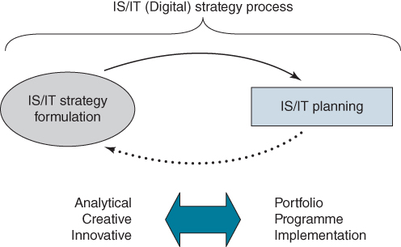he IS/IT or digital strategy process.
As will become apparent later in the book, building the IS/IT strategy incorporates both analytical and creative approaches, with tools and techniques reflecting this. Any strategy must be translated into plans that bring it to life. The focus then is on implementation, and will include definitions of programmes and projects, all managed as a portfolio of investments.

The Evolution of the IS/IT Strategy Process: From Technology Deployment to Strategic Focus
One issue associated with using the term ‘digital strategy’ is that it can place undue emphasis on the technology rather than its application, as was the case in the early days of IS/IT strategy. Failure then was often due to organizations being ‘technology led’, or being led by the technologists, rather than deploying the technology based on the strategy and priorities of the business. The term ‘digital strategy’ may have a similar affect, causing some managers to disengage and not become involved either from ‘techno-fear’ or because they regard it as someone else's job. We noted in Chapter 1 that some companies define their digital strategy in terms of social media, mobile, analytics and cloud. Hence we will mainly use the term IS/IT strategy to ensure understanding that we are referring to applications and technology, but will use the term digital strategy from time to time.
Drawing on the research of others⁷ as well as our own experience in working with organizations, we have constructed an IS/IT (or digital) strategy maturity model, which mirrors the evolutionary journey found in many organizations. In Stage 1 the focus is on planning to deliver technology. By Stage 5, the organization has reached a stage of maturity where the emphasis is on assessing the competitive impact of digital technologies and ensuring the alignment between business strategies and IS/IT investments – IS/IT is now part of the ongoing strategic conversation. This evolution can be summarized as follows:
- Stage 1 sees IT deployed in an ad hoc manner across the organization. The IT organization plans the interfaces between applications developed separately, project by project, in order to make them work effectively and efficiently, both in business operations and in the utilization of technology. Obtaining management understanding of the increasing dependence of the business on its IT-based systems is the key objective, to enable a more coherent, less piecemeal approach to be adopted. Essentially, key operational and support applications are being built and management perceives IS/IT in that limited role, but the dependence is steadily increasing.
- Stage 2 Management, now aware of the dependence (often because of some crisis or critical system failure), initiate a top-down review of IS/IT applications in the light of business dependence and priorities are agreed based on the relative importance of business needs. For example, should the order processing redevelopment take precedence over the new analytics investment for the sales organization? The approaches used are typically very methodological and involve gaining a management consensus of criticalities and priorities. An extended, prioritized ‘shopping list’ of key operational type applications for both operational and management information requirements will usually result.
- Stage 3 This stage is centred on detailed IS/IT planning, to determine the best way of implementing the priority applications and supporting infrastructure or even re-implementing some existing systems in more appropriate, integrated and perhaps less costly ways. Greater attention is paid to the critical, key operational systems, including aspects of online trading, and less resource is dedicated to support applications. An ‘Application Support Centre’ or ‘User Service Desk’ concept may be implemented for support-type systems (which may well be outsourced), and application packages (which now may be provisioned from the cloud) are normally introduced to replace internally developed systems. Stage 3 can take considerable time to implement completely and this can cause frustration for business managers now envisioning innovative opportunities or observing competitors' innovations.
Through Stages 1 to 3 the evolution from separate ‘efficiency-driven’ applications to integrated ‘effectiveness’ systems has been happening – but the purpose has not yet been overt use of IS/IT for competitive advantage; the main intention is to stop IS/IT being problematic and ensure it is not causing disadvantages.
- Stage 4 is when the business users of information, systems and technology take the reins, endorsed by senior management, who do not wish to prevent business led, entrepreneurial use of IS/IT, especially in more varied ways of trading, and using information and systems in new ways to provide business leverage/competitive advantage. This may have started during Stage 3 as frustration built up. It is important that users, unfettered by IS/IT procedures or controls, exercise this freedom to innovate, even if 90% of the ideas have little strategic potential. The other 10% are tested high potential ideas, driven by the business, that can lead to strategic advantage.⁸
So-called ‘shadow IT’ often emerges in response to the perceived inability of the in-house IT organization to deliver. With developments like cloud computing it is also much easier today to bypass the IT organization to obtain IT capabilities. While this can be risky, especially if inexperienced users are dealing with experienced vendors, it is often a sign of a healthy attitude to innovation and presents a valuable opportunity for IT professionals to work with business colleagues to develop new capabilities.
Some functional areas, like marketing and R&D, want to move quickly and are not prepared to work to the IS/IT planning cycle. They want to try things and see what works, but they don't want to run a big ‘IT shop’.⁹ With the amount of technology choice available, plus the speed of change and the ease of using cloud applications, it sometimes makes sense for departments to develop their own IS/IT or digital capabilities. If so, chief information officers (CIOs) should look for ways to harness the user capability and put in place policies that support the users, whilst protecting the organization from implementing flawed or even damaging applications.
- Stage 5 This is the difficult stage to reach, particularly if the organization has spent considerable time in Stage 3, and Stage 4 is more user rebellion than business-stimulated innovation. It requires bringing it all together by integrating IS/IT and business strategy formulation. The innovative ideas of Stage 4 require evaluation in the business context along with the opportunities now made available from the integrated, comprehensive application suite and infrastructure created in Stage 3. Linking IS/IT potential to the business strategy is the main task, and this requires the simultaneous attention of senior executives, line management and IT specialists – the first time in this process that they have all acted together as a coalition. Strategic investments can be identified and agreed upon in the context of the business strategy.
This evolution does not always occur sequentially and there will often be overlap across the stages. In large organizations, different businesses or functional areas may be at different maturity levels. What is in many ways surprising is how often the stages are actually followed sequentially as organizations get more sophisticated in their application and deployment of IS/IT.
Table 3.1 summarizes another view of this evolving maturity, based on the work of Michael Earl. His five approaches to IS planning,¹⁰ or ‘dominant rationales’, can be summarized as:
- Technology led – carried out mainly by IT specialists to establish technology foundations, architectures and capabilities that should satisfy the expected application needs of business users.
- Method driven – the use of techniques (often a consultant's methodology) to identify IS needs by analysing business processes – an ‘engineering’ philosophy based on top-down analysis of information needs and relationships. IS professionals may use analytical modelling and tools (e.g. Unified Modelling Language (UML))¹¹ to produce IS/IT plans in the form of blueprints.
- Administrative – the main objective is to establish IT capital and expense budgets and resource plans to achieve approved IS applications, usually based on a prioritized wish list from users.¹²
- Business led – Business plans, usually at a functional level, are analysed to identify where IS/IT is most critical in meeting short- to medium-term needs.
- Organization led – the development of key themes for IS/IT investment derived from a business consensus view of how IS/IT can help meet overall business objectives, agreed by the senior management team. This stage recognizes that the strategy reflects top management's attitudes to IS/IT and is there to guide future decisions and actions.¹³
TABLE 3.1Increasing organizational maturity with respect to IS planning
Source: M.J. Earl, ‘Experiences in strategic information systems planning’, MIS Quarterly, 17, 1, 1993, 1–24.
 | Stage 1 | Stage 2 | Stage 3 | Stage 4 | Stage 5
Main task | IS/IT application mapping | Defining business needs | Detailed IS planning | Strategic/Competitive advantage | Linkage to business strategy
Key objective | Management understanding | Agreeing priorities | Balancing the portfolio | Pursuing opportunities | Integrating IS and business strategies
Direction from | IT led | Senior management initiative | Users and IT together | Executives/Senior management and users | Coalition of users/ management and IT
Main approach | Bottom-up development | Top-down analysis | Balanced top-down and bottom-up | Entrepreneurial (user innovation) | Multiple method at same time
Summary | ‘Technology led’ | ‘Method driven’ | ‘Administrative’ | ‘Business led’ | ‘Organization led’
An organization can, relatively easily, identify the type of strategy approach or approaches it has in place and hence where it is in relation to the eventual need for integration of IS/IT and business strategy, and which approaches it needs to adopt in the short term to move it towards that eventual goal. A survey of 267 companies found that the Organization led, Business led and Administrative approaches could be identified and clearly distinguished.¹⁴ The researchers, however, could not clearly distinguish between Method driven and Technology led, and suggested that the two, together formed an intrinsically IT-led approach they called ‘systematic’. This is a reasonable conclusion, given that many large application and generic software packages have effectively become part of the infrastructure. Application software and technology plans cannot always be separated, but require highly integrated and detailed planning (i.e. systematic).
The study also showed that an organization believed it was more successful in IS planning if it followed the Organization led approach; of the three, Business led came second and Administrative was third. The authors argued that, based on the survey evidence, the Organization led approach had very similar characteristics to the ‘rational adaptation’ mode of planning that others¹⁵ had observed as the most successful approach to IS/IT strategy formulation.

Problems and Barriers
Despite an understanding of the importance of having an IS/IT strategy, many sensible business-based IS/IT strategies have been left to gather dust, or have been implemented in a half-hearted manner, because they did not have enough management commitment invested in them. Many others were really user ‘wish lists’ that had been renamed ‘strategies’, or were IT inspired information and technology architectures with no business rationale or backing.
A number of surveys have attempted to identify criteria for successful IS/IT strategy development. Perhaps not unexpectedly, research has shown that obtaining top-management commitment is a prerequisite for success, but also that it can be difficult to obtain. Some of the reasons found for senior management erecting barriers preventing the effective development of IS/IT strategies include:¹⁶
- While top management generally acknowledge the disruptive impact that IT is having on industries today, they differ in how they respond. One CEO noted to us: ‘I know IT is critical to our business but I really don't have the time. Anyway, what have I got a CIO for? I just want to concentrate on my core business.’ The tenor of this response, which we have found to be widespread, can be accounted for by the low level of digital literacy both in senior leadership teams and boards.¹⁷ It tends to mean many executives still see ‘computers’ in a purely technical and operational context.¹⁸ Moreover, despite research findings consistently suggesting it should be otherwise, most executives just don't see IT as something that falls within their realm of responsibility.¹⁹ Perhaps the genesis of the problem is that executives are being asked to engage with something that is essentially intangible, i.e. information, using something that they feel they know nothing about, i.e. digital technology.
- They perceive a credibility gap between the ‘hype’ of the IT industry as to what IT can do and how easy it is to do it, and their experiences, particularly difficulties in delivering the claimed benefits. This is the unfortunate reality of the IT industry. Research analysts Gartner have developed what they call ‘the hype cycle’ that maps technologies according to the hype that they are generating in the marketplace.
- Top managers do not view information as a business resource to be managed for long-term benefit. They only appreciate its criticality when they cannot get the information they need when they want it; or when an IT security breach potentially compromises customer, personal and organizational information.
- Despite the difficulty in expressing all IS/IT benefits in economic or financial terms, top management still demand to see a financial justification for investments.²⁰ Many organizations mandate that all IS/IT investment proposals have a return on investment (ROI) in 12 months. This is leading to overstating benefits in business cases to get investment approval, which further reinforces managers' negative view of IT when these unrealistic targets are not achieved.
- Related to points 3 and 4 above: there is an increasing tendency for top managers to have a short-term (often bonus-based) focus that militates against putting much effort into long-term planning, especially of IS/IT, given the other issues highlighted above.
Additional barriers have been identified including:²¹ the difficulty in measuring benefits from the overall plan; the inability to deal with major business issues such as mergers, diversification or growth; and the provision of appropriately skilled user and IT resources. This study also highlighted one or two ‘softer’ issues – politics and middle management's insecurity in the face of change.
Another survey²² of senior IS/IT executives identified problems associated with the IS/IT strategy process. Dividing the process into three phases (the launch phase, the plan development phase and the implementation phase), they reported that, in all three phases, failing to secure top management support is the most serious problem. Not having free communication flow and not having sufficient experienced or skilled people for the task are particular problems in the first phase. In the second phase, ignoring business goals, failing to translate these goals/strategies into action plans and insufficient involvement of business users were highlighted as major problems.
Research exploring the enablers and inhibitors of alignment between IS/IT and business strategies²³ identified the six most important enablers and the six main inhibitors. Not surprisingly, the inhibitors were largely the opposites of the enablers (see Table 3.2). Our research supports these conclusions.²⁴
TABLE 3.2Enablers and inhibitors of strategic alignment
Source: J. Luftman and T. Brier, ‘Achieving and sustaining business-IT alignment’, California Management Review, Fall, 1999, 109–122.
Enablers | Inhibitors
- Senior executive support for IT initiatives  - IT staff involved in strategy development  - IT staff understands the business  - Business – IT partnership  - Well-prioritized IT projects  - IT demonstrates leadership | - IT organization/business lacks close relationships  - IT organization does not prioritize well  - IT fails to meet commitments  - IT does not understand business  - Senior executives do not support IT initiatives  - IT management lacks leadership
Findings from these surveys and others²⁵ indicate that several of the prime requirements for the effective formulation of IS/IT strategy revolve around people and working relationships. These can include relationships with counterparts in suppliers, customers and other trading partners. Undoubtedly, it is essential for knowledgeable, experienced, highly skilled and well-motivated staff to be involved, and for them to be committed to the work and be fully supported by senior management.

The Business Context for Developing and Managing the Strategy
While all the foregoing problems and barriers focus on IS/IT strategy, in some organizations further problems arise due to the lack of comprehensiveness or clarity of the business strategy. For example, many organizations have an impressive array of mission statements, objectives, values, critical success factors and performance targets – what they want to achieve. However, the task of translating the strategy into effective and coordinated action plans (how to deliver it) is often left to functional or process managers and not consolidated and managed as a coherent and integrated business-wide strategy.
The requirement to sustain an appropriate IS/IT strategy over an extended period also requires flexibility to respond to changing business and organizational needs and incorporate new IS/IT options. To do that, the processes used to analyse situations and assess opportunities must be capable of being revisited in part, at any time, to assess the implications without a major rethink of the whole strategy.
In Chapter 1, a simple model relating business, IS and IT strategies was described (see Figure 1.7). In Chapter 2, a view of business strategic management that considered the realities of attempting to plan in an ever-changing environment was also described (see Figure 2.12). Combining this view with the earlier, simpler model, a more comprehensive and pragmatic model can be developed that describes the environment within which IS/IT strategy formulation, planning and management takes place.²⁶
Figure 3.2 shows that while at any one time a comprehensive analysis of the business and IS/IT internal and external environments can be carried out to define an intended set of strategies, it is unlikely that all aspects of these strategies will be realized. Changes will occur in both the business and IT environments, and these will cause changes to be made to the IS part of the strategy. Also parts of the intended IS/IT strategy may not to be implemented successfully (i.e. projects fail or underachieve) and hence it has to be revised either in timescale or content. In addition, changes in the business or IT environments may impose constraints or open up new IS opportunities.

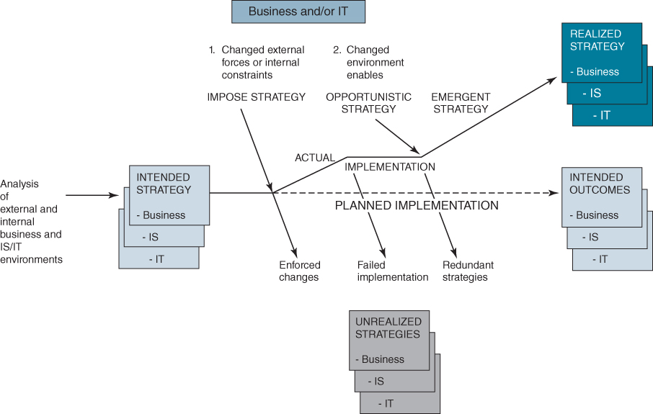
FIGURE 3.2 A revised model for IS/IT strategy, planning and management.
Source: After Johnson and Scholes, 2002.
These factors, which force changes from the intended strategies, will not always occur at convenient moments in the planning cycle! All three strategies, business, IS and IT, must be realigned whenever new opportunities or constraints emerge. Equally importantly (and this is often overlooked), these changes to the strategy may make parts of the old strategy redundant. In many organizations, considerable IS/IT effort and resource can be consumed pursuing effectively obsolete requirements because the existing plans have been overtaken by events – events that have not been interpreted in terms of their effects on the IS/IT investments already under way. This problem can be compounded where very large IS/IT projects or programmes are involved and the majority of the money has been spent²⁷ – ‘we've started, so we'll finish’ often seems to be the logic, even if by finishing the project or programme no actual benefits will now be realized. Even in such circumstances it is best to stop work and redirect the resources to the new emerging needs.²⁸
The necessity to improve return on investments, coupled with the risk of investing substantial sums unwisely, has long been a key objective when developing an IS/IT strategy. The experiences for many companies which, around the turn of the century, spent vast sums of money on ‘e-commerce’ investments that on average delivered little business value, have increased senior executive concerns about large IS/IT investments. At the same time an ever-increasing number of examples, cited as demonstrating competitive success resulting from implementing innovative applications, have also boosted awareness and interest. In the 1980s American Airlines, American Hospital Supplies, Thomson Holidays and in recent years Amazon, Lastminute.com, eBay, Uber, Alibaba and many others have been reported on so extensively they have been elevated almost to legend status. There are many other examples that have so far received less widespread coverage but are equally significant as sources of ideas for other organizations. Many of these are referred to throughout this book.
As the focus on delivering customer value and improving customer experiences becomes ever more critical for so many enterprises, and competitive, economic and regulatory pressures mount, there is recognition that incremental and disconnected improvements will not be good enough. There is also the growing acknowledgement that delivering satisfactory performance is dependent on robust business processes. This is the environment in which gaining control of key processes has become a popular focus of attention, often by implementing a shared service model, and many major change programmes revolve around improving the performance of core business processes. In so doing, managers must avoid ‘paving the cow paths’ with IT, and look for opportunities to redesign processes by utilizing the capabilities provided by IT to do things differently.²⁹
In this context, an initial requirement is for a comprehensive business strategy framework that can encompass the development and implementation of major change programmes, as well as strategies developed in response to medium-term business drivers, and the delivery of a wide range of strategic and tactical projects (see Figure 3.3). IS/IT investments will probably be integral to achieving business objectives in each of these three streams: business as usual (or ‘run the business’), incremental change and breakthrough (or transformational) change.
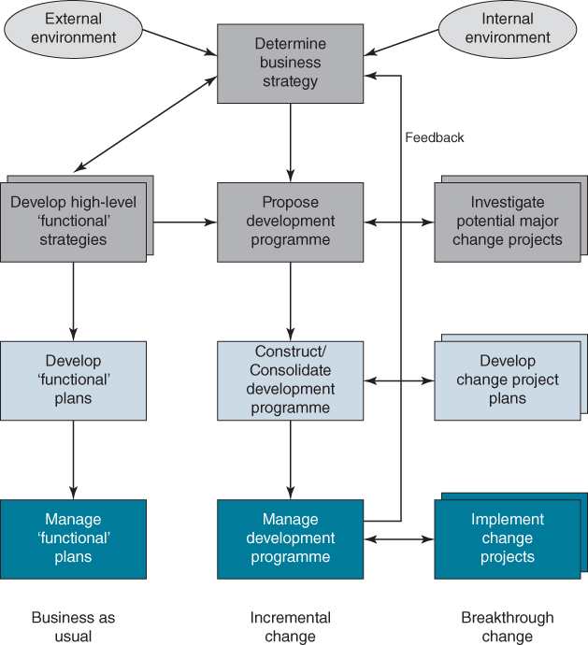

FIGURE 3.3 Integrated business strategy framework.
Therefore while the IS/IT strategy must show how ever-increasing and extending information processing and managerial information needs will be satisfied in future, it must also be clear about its expected competitive impact, either to gain advantage or avoid being disadvantaged. It also needs to explain how, if risks are well managed, significant, long-term benefits could result from the exploration and exploitation of information-based opportunities and the deployment of emerging and new technologies. But above all it must be clear how its objectives and priorities are derived from business imperatives or create new business options.
If the contribution from IS/IT is to be maximized, it is necessary not only for IS/IT specialists to understand business issues but also for business people to have an awareness of the potential offered by technology. This demands a close working relationship between both parties. Unfortunately, this close working relationship does not always exist in organizations.³⁰ In Chapter 10, we explore how an organization can begin to improve this relationship: failure to do so will severely impact any attempt to develop a more strategic perspective of IS/IT.

Establishing an Effective Process: Continuous and Flexible
There is no standard approach for formulating the IS/IT strategy that can guarantee success, and this book is not putting forward a prescriptive methodology. It would be foolhardy to attempt to do so, since each situation and organizational context is unique and requires its own tailored approach. Rather, a framework and ‘tool box’ of techniques are proposed that can be adapted for use in a wide range of organizational contexts, from the least to the most mature, and business environments from the most stable to very dynamic.
The need for flexible and evolutionary approaches was expressed three decades ago by Sullivan.³¹ He proposed a number of key elements that are needed to enable the realization of the competitive potential of IS/IT:
- The proactive search for competitive advantage through the use of information and the application of technology.
- A broader scope for the strategy, which incorporates a wide spectrum of digital technologies, not just the traditional uses of IT for automation, processing data and providing information and communication, but now expanded to include embedding technology in products and processes.
- The development of information, systems and technology architectures to guide the introduction and integration of new and existing applications and technologies.
- Use of flexible approaches, whose aims are to find and implement technology-based initiatives for the benefit of the business. They must:
  - ♦ be responsive and able to shift resources to where they are needed;
  - ♦ enable and capitalize on innovative use of IT by business users;
  - ♦ include knowledge of the digital capabilities of suppliers and customers (current and potential);
  - ♦ be able to identify and evaluate alternative options;
  - ♦ include benchmarking to establish standards of performance of external and competitive organizations.
Even today, as more recent research has confirmed,³² these observations are still valid and are embedded in the approach advanced in this book. The framework and outline of the process for developing IS/IT strategies are described in this chapter, and the techniques for assessing the environment and identifying information needs and future opportunities are covered in Chapters 4, 5 and 6.
Once a process has been established, the strategies and plans need to be refreshed regularly; even frequently in rapidly changing environments. This can be in response to many triggers, both external and internal, including: changes in the economic environment or industry dynamics, emerging business needs and opportunities, competitors', customers' and suppliers' activities, new business products and services, organizational changes, new technologies and also benefits delivered by implementation of the strategy. Some of these factors may also mean adapting the strategy process itself to increase the scope or use more appropriate or insightful tools and techniques.
Over time, if the process is working well, both IS specialists and business staff become more aware of available business and technology options and learn how to identify and exploit opportunities. At best, the cooperative partnership between the IT function and the rest of the organization means information, systems and technology are treated as key strategic assets, essential to business operations and development. Typically, timescales for the planning horizon move out from one to two or more years, and development and provisioning plans are driven by current and future business priorities. Alternatively, there may be no extension of the planning horizon, but the planning process becomes more responsive and flexible to enable the rapid delivery of strategic change.
As stressed earlier, industry changes and the resulting threats and opportunities do not always arrive at times to suit the organization's strategy and planning cycle. Some of these threats and opportunities may be IS/IT generated. An organization aiming to be agile and responsive needs to be prepared to react quickly and change its business plans accordingly – and the IS/IT strategy needs to be able to respond in the same way. Figure 3.4 shows how the pace and degree of change in the external environment can prompt a range of business responses and IS/IT could be critical to responding successfully in all four quadrants.

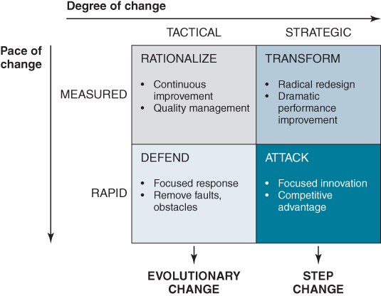
FIGURE 3.4 Dimensions of change.
In addition to revisions due to external business factors, the IS/IT strategy may need reviewing and amending due to internal business changes and technology developments or issues.

Internal Business Factors
Changes in the nature of the business or the structure and organization of the enterprise may result in the need to revisit or reconsider the IS/IT strategy. For example:
- takeover by a new owner(s) or the appointment of a new CEO or management team – this may simply mean a new attitude to technology, or it may herald more drastic change if it occurs as a result of a merger or takeover;
- major rationalization caused by, for example, downturn in the economy, necessitating a severe trimming of both business and IS/IT budgets;
- restructuring – often resulting from corporate strategic planning (e.g. changing from a product-led to a customer-centric business, or establishing Shared Service Centres for the main functional support activities such as HR, Finance and Purchasing);
- new products or markets or channels to market – where there is a recognition that the present infrastructure is incapable of adapting to new requirements.

Technology Factors
For example:
- competitive opportunities and threats (real or potential) based on new IT developments such as Web 2.0, cloud computing, social media, sensors, analytics, mobile and wearable computing;
- new products or markets created by IS/IT;
- technology cost-factor changes, such as those from cloud computing (shifting spend from capital expenditure to operational expense) or new software applications, producing a need to improve productivity via technology or risk losing business;
- recognition that the current infrastructure and legacy systems are starting to ‘creak’ and need replacing. For example, the cutback in IT spending as a result of the 2008 financial crisis has led to existing IT infrastructures becoming both costly to maintain and often unsuitable for developing new strategic applications.
It is important that the organization keeps abreast of technology trends, innovative uses of technology and how competing or similar organizations are applying IS/IT, so that they recognize when significant and achievable opportunities emerge, or when to respond to technology threats.

Initiating the Strategy Cycle
For an organization that has not previously developed an IS/IT strategy, there is the understandable problem of not knowing how to go about it. It is a far from trivial change to go from the tactical planning, based on users' ‘wish lists’ and IT technical infrastructure development, to developing an IS/IT strategy closely aligned with the business strategy. The outcome of such an approach is likely to have far-reaching impacts on the future role of IS/IT in the business and the role of the IT organization. There are many aspects to be considered, so that a clear brief and Terms of Reference (TOR) can be agreed for the initiative. These will not be set in stone, but should provide a sound foundation to build on.
Ideally the decision to initiate the process of ‘formalizing’ the development of an IS/IT strategy should be made by the organization's executive group or the governance mechanism or structure responsible for overseeing such activities. (The complex nature of IS/IT governance is discussed in Chapter 10). However, it is often the CIO, or equivalent, who starts the process and he or she will need to gain the endorsement of the executive team to ensure business resources are engaged effectively. At the same time as embarking on the formulation activities, it is advisable to establish a governance group, composed of business and IT managers, if one does not already exist. The group (in some organizations referred to as a steering group – see Chapter 10) should review and ‘agree’ the strategy, recommend it to the executive team and then make any decisions required to implement it. Once the process and governance mechanisms are established, the organization should be able to update the strategy regularly or as and when needed.
It is crucial that an adequate amount of time and effort is spent in ‘planning for planning’, since it can determine whether ‘success’ is achievable. How to go forward depends on the particular experiences to date, the starting point, the purpose of strategy and planning and the outputs expected, if they can be defined. Box 3.1 contains a list of questions that require consideration before embarking on an IS/IT strategy process. These key questions are examined during the rest of this chapter.

BOX 3.1

Questions that need to be considered before embarking on IS/IT strategy formulation and planning
- ♦ What are the purpose and the main reasons prompting the need for planning, and what are the key business drivers to be addressed?
- ♦ What are the expectations and objectives to be met, and what deliverables are required?
- ♦ What aspects of the current business and technical environment – issues, constraints, underlying problems and risks etc. – are likely to affect the conduct and outcome of the process?
- ♦ What should be the scope of the IS/IT strategy?
- ♦ Where should the strategy and planning be focused: on the corporate organization as a whole, at strategic business unit level or on specific core business processes?
- ♦ How will the IS/IT strategy process be effectively integrated with business strategy?
- ♦ How should the IS strategy be ‘marketed’ and consolidated with the other elements of the business strategy to ensure that optimal support and cooperation are obtained from across the organization?
- ♦ Should the approach employed be prescriptive, tailored or a mixture of both, and how can the organization build on its previous experience of IS/IT strategy (if applicable) and planning?
- ♦ What are the most appropriate and effective approaches, tools and techniques, and which will achieve the best results?
- ♦ Who should be involved, from which areas of the business, fulfilling which roles and responsibilities, and are they available? What skills and knowledge do they need and what training will be required? Do we need external help?
- ♦ What other resources are required (automated tools, administrative support, physical facilities)?
- ♦ How long will the strategy process take and what will it cost?
- ♦ How should the process be steered and managed?
It should be re-emphasized that there is no one ‘best’ way to tackle strategy formulation and planning for IS/IT. It is essential to assess the situation and needs carefully, and then to deploy the best available people, appropriate methods and techniques to suit this context. Each organization's approach will depend on its current circumstances, and the reasons prompting the need for strategy development. Once the questions are answered, the Terms of Reference (TOR) can be created and senior management's role in the process established – their active involvement and visible commitment are essential from the start, as they signal that IS/IT strategy formulation and planning is actually going to happen.

Assessment of the Current Organizational Environment
During the initiation stage the current organizational environment and any pertinent issues will need to be understood, so that activities are set up to deal with them. While the precise issues will be specific to the organization at the time of strategy development, there are some factors which can have a significant effect on achieving a successful outcome, including:
- Having a comprehensive picture of the business strategy, as far as it is available – long-term mission, goals, vision for the future, drivers for change, proposed change initiatives, structure, values, culture, management style, performance monitoring and any short-term critical demands. Detailed analysis and interpretation of all these will take place later on in the strategy process.
- How effective IS/IT has been in supporting business strategy in the past, and the composition, strengths and weaknesses of the current application portfolio and supporting infrastructure. This should include the views held by business managers regarding IS/IT; for example, do they see it as a strategic resource or an administrative expense to be minimized?
- The current role of IS/IT in the organization, its effectiveness, capabilities, structure, skills and maturity, and the role IS/IT is playing in comparable external organizations in the same industry or similar businesses. The role of suppliers should also be included.
- How IS/IT strategies have been developed in the past, their deliverables and the benefits derived from investments.
How each of these can be addressed effectively during the planning process is considered in detail in Chapter 4.

Setting Objectives for the IS/IT Strategy
The objectives for IS/IT strategy development and planning are primarily derived from the business objectives and drivers for change. The objectives will, of course, vary depending on the organizational context but they should be realistic and achievable given the current situation and available resources. A checklist of potential objectives is given in Box 3.2. Even when the primary aims are the alignment of business and IS/IT and the pursuit of competitive advantage, it is likely that the objectives will also include other issues and priorities, such as defining the degree of integration and standardization, the creation of an integrated architecture, stabilizing the information resource and minimizing maintenance costs, among other things.

BOX 3.2

A generic set of objectives for IS/IT strategy formulation and planning
The main task of the IS/IT strategy process is to build a comprehensive and robust capability for the long-term management of information, information systems and information technology and to:
- ♦ Identify current and future digital technology and information applications for the organization that provide maximum benefits in close alignment with the business strategy.
- ♦ Equip the IS/IT organization to be responsive to fast-changing business needs, and to be able to meet urgent requirements.
- ♦ Determine policies and mechanisms for the management, creation, maintenance, control, security and accessibility of the organization's information resources.
- ♦ Determine an effective and achievable organization structure and role for the IS/IT function, with representation at top management level.
- ♦ Ensure that an appropriate, cost-effective, resilient information systems architecture and technology infrastructure is created so that high-quality applications can be built and maintained.
- ♦ Identify the capabilities, competences and skills required to implement the strategy, and define migration plans to develop or acquire them.
- ♦ Ensure that the strategy is externally focused, dealing with trading relationships and the company's products and services and not just focused internally on business and technology issues.
- ♦ Ensure that there is an acceptance of shared responsibility between IS/IT and business people for the successful exploitation of information and technology.
- ♦ Establish the extent to which the organization itself should deliver the elements of the strategy and which elements should be provided by third parties.
It is also wise to state clearly the reverse of objectives, i.e. what the strategy process will not deliver; for example: no recommendations will be made concerning specific hardware and software products; or existing outsourcing contracts that extend beyond the planning horizon will not be reviewed; or it will not suggest priorities beyond the first year.

Establishing Success Criteria
There are two aspects to measuring success – how successful the strategy process itself is judged to be and how successful the resulting strategy proves to be. We have already seen that studies have provided strong evidence that firms with an IS/IT strategy do achieve superior performance, but this may not become apparent until some time after the strategy has been devised and implemented.³³
An initial measure of success is that the governance group established for oversight of the IS/IT strategy process (assuming appropriate membership) agrees and endorses the strategy and, with the explicit support of the organization's executive, accepts any recommendations included and makes any decisions immediately required. Although this is not strictly a measure of success, without this agreement it is unlikely the strategy will be implementable.
Based on a synthesis of the extensive research literature,³⁴ measuring the success of any IS/IT strategy process can be classified under three broad headings: efficiency, enrichment and effectiveness.
Efficiency refers to the efficient use and management of resources, both people and finance, the time required for the IS/IT strategy process and delivery of the expected outputs. This is similar to measuring project performance on Time, Cost and Quality (TCQ) but not the benefits achieved.
Enrichment refers to the ability of the process to achieve ongoing alignment and synchronization with the evolving business strategy, leading to the identification of innovative uses of IS/IT and strategic applications. Research evidence suggests that innovation-focused strategies lead to the greatest positive impact on firm performance.³⁵
Effectiveness considers how well the process achieves the intended goals for both the deployment of IS/IT and the role of the IS/IT function in the organization. This can include the applications and infrastructure capability and reliability, payback or contribution from IS/IT investments, user satisfaction and the degree of strategic alignment.
The research also suggests that, under the second and third of these headings, a number of factors can be used to assess the success of the strategy formulation process. Which will be appropriate depends on the objectives set and the organizational context and issues as listed in the previous section:
- improving the contribution of IS/IT to the performance of the organization, operationally and strategically;
- extent of alignment of IS/IT investment with the business strategy;
- gaining competitive advantage through exploiting information and deployment of digital technologies;
- identifying new strategic and high payback applications;
- increasing top management commitment;
- improving communications with users;
- better forecasting of IT resource requirements and/or improved allocation of IT resources.
Other studies³⁶ have shown that, in practice, very few organizations use any formal criteria to measure IS/IT strategy and planning success. However both IT and business managers agree that they probably used aspects of planning effectiveness, such as successful application implementations, performance of the systems, user acceptance and satisfaction, and meeting project deadlines and budgets, to measure the success of IS planning. One study also found that, based on these criteria, business managers tended to rate the level of success to be lower than IT management.³⁷

Setting the Scope for the Strategy
In establishing the scope for the strategy, it is important to reiterate a point made in Chapter 1. There is a tendency for IS/IT specialists to want to address technology issues and options alongside business needs in such a way that often confuses the demand (IS strategy) and supply (IT strategy) components. IS strategy focuses on achieving maximum value from the alignment of application, information and technology investments with business needs and on identifying and exploiting competitive opportunities provided by IS/IT. IT strategy is about how digital technologies are to be applied in creating and handling information (i.e. capturing, processing, storing, disseminating and presenting) and how technology resources are to be acquired, developed and managed to meet the agreed range of business needs.
Scope also implies the planning horizon. For the IS strategy part this should be the same as the business strategic planning horizon, but may be shorter for some IT aspects due to the rapid changes that can occur in the IT options available. Business planning horizons vary considerably depending on the stability of the industry and economic environment. The financial crisis of 2008 and resultant uncertainties caused many organizations to shorten the horizon considerably and focus IS/IT plans on maximizing benefits, especially cost reductions, in the first year to 18 months and to reviewing the strategy more frequently.³⁸

The Strategic Business Unit (SBU)
In a large organization, with a number of distinct strategic business units, it is probable that each should have its own IS strategy, tightly coupled to that unit's business strategy. The research evidence suggests that organizations that do this achieve a more direct contribution from IS/IT to business performance.³⁹ Another study⁴⁰ has shown that IS/IT is, in general, more effectively deployed in organizational units where vertical integration is between 50 and 75% (i.e. 50–75% of total business costs are under the control of the business unit), enabling management to control the degree of systems integration across functions. The study also showed it is more feasible to develop a coherent IS/IT strategy for an SBU than for any other organizational grouping, which is not surprising given that developing business strategies is most effective at the SBU level, as described in Chapter 2. This aspect is considered in more detail when the value chain analysis techniques are discussed in Chapter 6.
However, it does not necessarily follow that there should be IT strategies one for one with IS strategies. A single IT strategy may be appropriate for the whole organization, especially if there is centralization of other corporate functions (see Figure 3.5). On the other hand, it may be more effective to focus IT support at divisional, regional or even unit level in a diverse and highly distributed enterprise. This latter issue will be addressed in more detail in Chapters 4, 10 and 11.

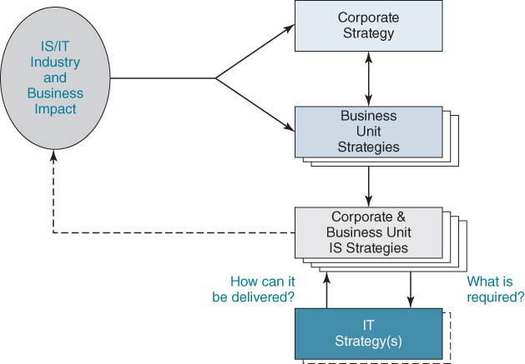
FIGURE 3.5 IS and IT strategies in a multi-unit business context.
The implications of focusing IS strategy and planning activities at the business unit level leads to some immediate conclusions:
- At the corporate level there is a strong temptation by both executive and IT management to attempt to develop a ‘corporate IS/IT strategy’, which may provide economies of scale but few business benefits due to the lack of integration of IS and business units' strategies. It can work where all the individual units are essentially replicas of one another, operating in different locations. Where there is interdependency between the units, for example where they trade with each other or one makes the products developed by another, there is a need for an inter-unit IS strategy. This should provide benefits to each of the interdependent businesses and, as a result, a net benefit corporately.
- There are also potential dangers associated with attempting to develop common systems or implement the same software package across group companies. Unless the whole organization is very similar in terms of its products, operational strategies and markets, then each unit is likely to have very different business needs. Even when the business units are very similar, they may still have quite different IS priorities due to, for example, competitors' activities, their market shares, the nature of the customer base, supply chain structures or available employee knowledge and skills. Even where, as is quite common, corporate organizations have ‘imposed’ common strategies for ERP or CRM applications, the implementation in each unit may vary considerably, although the software suite comes from the same vendor.
- Frequently, common policies for IT across the whole organization are implemented to achieve economies of supply and consistency across internal interfaces. The danger, of course, is to insist on common IS policies which can negatively impact individual SBUs.
- In conglomerates, where the acquisition and selling of businesses is a key part of the corporate strategy, it obviously makes most sense to align the strategy to each business unit, and it is probably impossible, in reality, to do much else. Any attempt at integration can impact divestment decisions.

IS Strategy for the Corporate ‘SBU’
The corporate centre is usually best dealt with as a business unit in its own right – its information and application needs will be based on the way it chooses to manage the component businesses. A financial holding company may only need a few enquiry and modelling systems to enable sharing of financial data with the units and the consolidation of revenues and profit figures for regulatory compliance, reporting and tax purposes. Alternatively, there may be corporate information needs to enable long-term planning and allocation of resources, drawing on a range of consolidated or pooled information from the individual business units. The focus of strategies at the corporate, business and IS/IT levels and the relationships between these levels are illustrated in Figure 3.6.

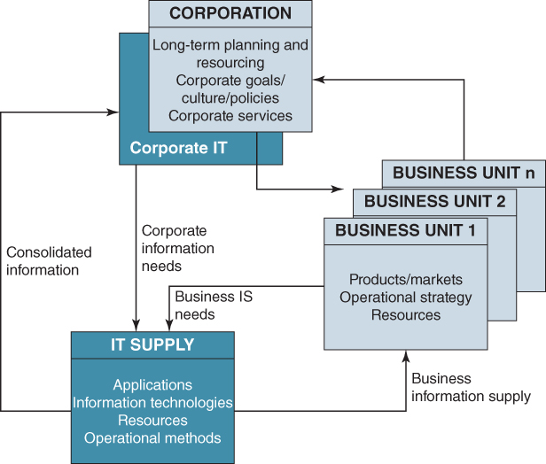
FIGURE 3.6 Relationships between information demand and supply at corporate and SBU level.

Consolidation across Business Units
If more than one unit is engaging in IS/IT strategy formulation, and especially if the units are similar in their business profiles, then sharing knowledge and cross-referencing the conclusions and recommendations is a good idea. Alternatively, activities during the strategy process can be scheduled to build learning from one unit to the next, both in terms of content and the use of techniques and models. Opportunities for mutual activities or sharing with a view to increasing the value of the results and avoiding duplicated or even wasted effort are quite varied:
- Acting as sounding boards during analysis, perhaps holding some joint opportunity identification workshop sessions or at least using common tools for capturing insights and outputs.
- Sharing application portfolios or needs or ideas for individual applications. However, similar portfolios do not necessarily emerge from what, at first sight, are similar businesses. Synergy is most likely to occur when the industry/product/market profiles are at comparable stages of maturity and/or when their competitive strategies or organizational capabilities are similar.
- Building common conceptual models or business information architectures. Even when the application portfolios differ considerably, there may still be substantial overlaps in the information architecture, and benefits from transferring ‘best practice’, as well as saving in cost and time from sharing high-level models.
Some large businesses have well-defined, comprehensive corporate IS/IT management strategies, which impact all their business units. Such strategies can include policies for consolidation (e.g. to combine business data models across the corporation). However, if corporate headquarters are only interested in, say, financial information, then the complex task of rationalizing business operating and information models across the enterprise makes little sense.

A Framework for IS/IT Strategy Formulation
If tackled comprehensively, an approach using a range of tools and techniques is required to satisfy efficiency, effectiveness and competitiveness objectives. Some ‘formal’ techniques are needed to ensure that all important elements of the business are explored in a structured manner and the business drivers are used to achieve effective prioritization. But, informal techniques are also included to encourage creative thinking and capture innovative ideas wherever they arise, both during and after the main strategy process has ended – innovative ideas to leverage IS/IT can occur at any time.
The overall approach put forward in the book consists of a composite model in which business strategy and planning, business analysis, information analysis and innovative thinking all have a part to play. But perhaps the most important ingredient is having a well-balanced team, with experienced members who, between them, have extensive business and IT knowledge, creative and analytical skills, open and inquiring minds and a lot of common sense. An overview model, shown in Figure 3.7, illustrates the building blocks of the strategy formulation and planning framework. Briefly, these are:

Inputs
- The external business environment: the economic, industry, social, regulatory and competitive climate in which the organization operates.
- The internal business environment: current business strategy, products and services, objectives, resources, processes, and the culture and values of the business.
- The external IS/IT environment: digital technology trends and economics plus potential application opportunities from new or emergent technologies and the use made of IS/IT by others, especially customers, competitors and suppliers, but also companies in other industries.
- The internal IS/IT environment: the current IS/IT role in the business, its maturity, business coverage and contribution, skills, resources and the technological infrastructure. The current application portfolio, including those under development, or planned but not yet under way, is also part of the internal IS/IT environment.

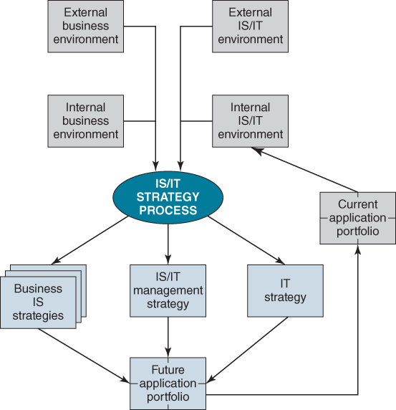
FIGURE 3.7 The IS/IT or digital strategy model.
Assessing and understanding the implications of all these inputs are discussed in more detail in Chapter 4.

Outputs
- Business IS strategies: how each unit or function will use information and IT applications in achieving its business objectives and/or creating new business strategies and options.
- IT strategy: technology investment and service plans and strategies for the acquisition and management of technology, supplier relationships and specialist resources.
- IS/IT management strategy: policies and governance mechanisms to enable the formulation and successful implementation of the strategy and ensure it delivers the maximum available business benefits at acceptable levels of cost and risk.
Whatever the structure and format an organization may choose to document the outputs, the objective is to ensure that users, management and IS/IT professionals all understand the key elements of the strategy and each appreciates those parts of the strategy they have to deliver. The following are general points relating to the outputs:
- The statements of demand, in terms of requirements for information and systems, are contained in the business IS strategy and the accompanying application portfolio. The supply elements are contained in the IT strategy, while the IS/IT management strategy contains the overall approach to satisfying and balancing demand and supply.
- There should normally be one IS/IT management strategy for an organization where consistent policies for IS/IT are applied throughout the corporate body, whether or not IS/IT resources are centralized or distributed. However, there may be several business IS strategies, one for each SBU, or even separate strategies for shared service or particular geographic units. Similarly there may be one future application portfolio or several – one per business – or a composite showing locally selected and centrally mandated applications. Managing this portfolio mix is discussed in Chapter 8.
- Equally there may only be one IT strategy for the whole organization, although there could be separate hardware and IT services dedicated to certain business units.

Defining and Implementing a Practical Approach to IS/IT Strategy Formulation
Having confirmed the scope, the objectives and the deliverables, the next step is to ensure the strategy formulation process is linked effectively to business strategy activities and existing business strategies and plans. This will, in part, depend on the comprehensiveness of the existing IS/IT strategy, how long since it was updated, how much change is needed and how well that earlier strategy was integrated with the business strategy.
The process needs to be understandable and acceptable to all concerned and not be too complex or overwhelmed by bureaucracy. Responsibility for a successful outcome rests heavily with the people involved, provided they have adequate, active support from the IS/IT governance group or structure. It is their responsibility to understand and explain why each step in the process is being done, what it should achieve and the purpose of output documents and other materials. Failure to do this could result in the endless ‘diagram production’ syndrome. This commonly arises because the team diligently produces the documents and diagrams, simply because ‘the method says to do it’.
In any strategy process, a degree of structure in the approach and clear principles are obviously necessary. In essence, the approach chosen should:
- be flexible and modular and each process stage should build on outputs from previous stages or techniques used;
- have the emphasis on the expected deliverables and how the results can be best communicated to the different audiences, e.g. senior executive team, business managers, application users and IS/IT specialists and technology partners and suppliers;
- have clear checkpoints for interim reviews of progress (if requested) by the governance group, but also accept and recognize the interactive and sometimes iterative nature of the process;
- emphasize the importance of engaging all types of people in the process in ways that will enable them to contribute their time, knowledge and experience (for example some people prefer to be interviewed, others to take part in workshops);
- use simple, general-purpose diagramming and documentation tools, such as PowerPointTM or VisioTM, spreadsheets and word processing. There are software packages that purport to help ‘strategizing’ and documenting the results, but they are usually more complex than really needed and tend to use extensive checklists and rigid templates.
Once IS/IT strategizing and planning is established in an organization, the deliverables from the previous cycle will be key inputs, in need of review and update only rather than building the strategy from scratch. For example, the business operating model could be unchanged, except in minor details, unless the business is undergoing a major revision of core processes. Figure 3.8 illustrates the main activities involved in the process and the following sections provide some guidance about how to make them work effectively.

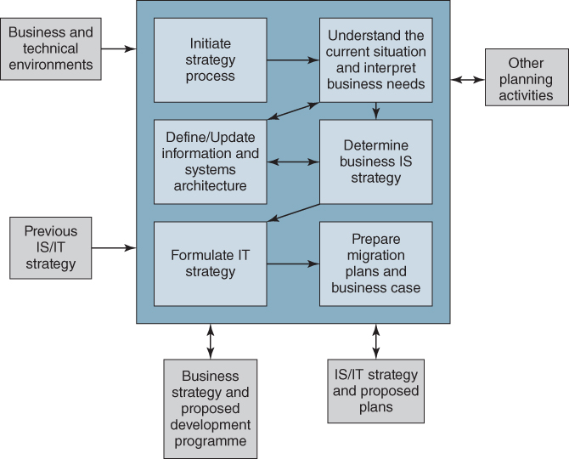
FIGURE 3.8 Framework for IS/IT (or digital) strategy formulation and planning process.

Initiate the Process
Having established the objectives and scope, the first priority, as discussed earlier, is to identify who needs to become involved, especially the business participants, who will undoubtedly have limited time to spare. They will need at least a minimum amount of introductory education about what is involved and maybe training in the terminology, tools and techniques being used. Schedules for one-on-one discussions, meetings and workshops need to be established and physical facilities and technology support tools organized for the members of the team to use, wherever they are located. It is unlikely they will all be co-located and much of the work will be conducted as a virtual team. Box 3.3 provides some guidance on team composition, executive sponsor and steering group roles.

BOX 3.3

IS/IT strategy team composition and associated roles

Strategy Team Composition and Skills
The quality of the output depends on the quality of the team selected. The team leader and members should come from different parts of the organization and have:
- ♦ broad knowledge of the business and its organizational objectives, management styles, culture, processes and people;
- ♦ good communication skills;
- ♦ ability and authority to make and implement plans and decisions that may affect the whole organization;
- ♦ respect of management and staff;
- ♦ an interest in areas other than their own and an ability to analyse objectively;
- ♦ experience of IS/IT strategy formulation and planning in at least some of the team.

Executive Sponsor
Preferably a director or senior executive of the organization should fulfil the following functions:
- ♦ chairing the steering committee and approving the budget and plan for any IS/IT proposals;
- ♦ assuring management participation and commitment, through active backing and allocation of the right resources;
- ♦ representing the interests of the executive team;
- ♦ heading the ‘marketing’ effort (which should not be underestimated);
- ♦ acting as the focal point for decisions about the scope, Terms of Reference (TOR) and conduct of the work.

Steering Committee
This may be an existing IS/IT governance group (such as an IT Steering Committee) charged with overseeing the formulation and implementation of the strategy. A minimum requirement is that the executive sponsor should function as a one-person steering committee and report to the board of directors where necessary. Typical steering committee functions are:
- ♦ providing strategic direction and guidance on business issues and priorities;
- ♦ reviewing and approving the outputs and plans, and taking up risk management issues;
- ♦ conducting checkpoint reviews and agreeing the continuation of work;
- ♦ agreeing the strategy and its recommendations before submission to the executive team.
Depending on the scope of the planning process, it may need to meet frequently, e.g. once every month, or simply at the main checkpoints.
Team members have to be capable of taking decisions that could ultimately affect the whole organization, so both business and IS/IT members need to be as senior as possible because:
- The enterprise, as a whole, needs to be convinced that the strategy and planning exercise is important. If senior executives are actively involved in the strategy process then this message will come across.
- The participants in discussions will also mostly be from senior levels. They must know and respect the team or they will not have confidence in the resulting strategy.
- During discussions or workshops, the strategy team must recognize if they are being deliberately or unconsciously misled or the resultant strategy will be rejected.
- Much of the information requested and given will be sensitive and confidential. This will be more readily given to peer group members than to subordinate group members.
These people, with the qualities mentioned in Box 3.3, are normally those who do not have time to spend on such work! Educating the team members and building an effective modus operandi and communication protocol within the team are crucial to avoid potential confusion and inconsistent quality of strategy outputs. In particular the following will probably need attention:
- ensuring understanding of the approach being adopted and agreeing on individual tasks;
- learning how to use the selected techniques, such as determining critical success factors, information analysis, value chain analysis, organizational modelling and interviewing;
- clarifying and understanding the expected deliverables and allocating responsibilities for specific reporting activities and outputs.
There is an initial and ongoing need to ‘sell’ why an IS/IT strategy and follow-on plan is necessary and the expected benefits, not only to some senior management, but also to operational management and professional staff whose knowledge is vital to the process, but who all have a full-time ‘day job’ to do. Some may see ‘planning’ as a threat to their current independence of action concerning IS/IT. It must be shown how the resulting strategy will address and help resolve any problems which are having serious effects on current performance. Merely promising ‘jam tomorrow’ is unlikely to gain much traction for the process.
It is also important that management accept that the time and costs involved are merited. The cost should be repaid by focusing future investment in IS and IT more precisely on the achievement of corporate objectives, by undertaking projects with clearer deliverable benefits and avoiding doing ‘the wrong projects’, which have no chance of success or are not of any real business value. The costs of undertaking the process are relatively easy to estimate – people costs for the team, consultants or external resources (if they are used) and the time of participants in workshops and interviews. From experience they will easily be recovered if one bad investment is avoided.
A checkpoint might be advisable at the end of this stage to ensure that the timescales and resource commitments needed are clear, understood and acceptable to the senior management and key participants and that consolidation of the resulting strategy and plans with the business strategy and plans will be achievable.

Understand the Current Situation and Interpret Business Needs
The quality and value of any IS/IT strategy is dependent upon the depth of understanding of the business needs and opportunities, their interpretation and translation into appropriate information resources, applications, services and IT infrastructure. To this end, some or all of the techniques or tools listed in Table 3.3 may need to be used. Chapters 4, 5 and 6 describe these tools and techniques and what is involved in gathering and analysing information and interpreting the outputs. What is required is sufficient understanding of the business, information and technology environments to be able to develop justified and realistic strategies – but not the exhaustive analysis associated with detailed design and development of applications.
TABLE 3.3Techniques used in determining the IS ‘demand’
Technique | Deliverables
Analysis of the current and expected business environment and the existing business strategy, including 5 Forces and PESTEL analyses | ♦ Economic and competitive forces influencing the strategic options – drivers for change at industry and firm level  ♦ Business strategy – mission, objectives etc.  ♦ Existing business initiatives  ♦ Known business priorities leading to IS/IT options
Critical Success Factor (CSF) analysis and Key Performance Indicators (KPIs)  Balanced Score Card (BSC) | ♦ Areas of business ‘where things must go right’  ♦ Priority improvement areas and associated IS/IT opportunities  ♦ Performance measures and new information needs
SWOT analysis  Dimensions of competence (or Value disciplines) | ♦ Analysis of Strengths, Weaknesses, Competitive Opportunities and Threats of current strategy Key areas for improvement (Product, Customer, Operations) and how IS/IT can contribute
Business portfolio and competitive strategy analysis | ♦ Options for medium-term IS investment to strengthen competitive position
Value chain/network analysis (external and internal) | ♦ High-level ‘industry’ information flow model  ♦ Model of ecosystem dynamics  ♦ Internal business information flows  ♦ Potential impact of IS/IT on processes and relationships
Business process analysis/process re-engineering | ♦ Identification of core business processes  ♦ Effectiveness of processes in meeting key business drivers  ♦ Process improvement options  ♦ Process redesign blueprints (that deliver significant performance improvement in respect of drivers)  ♦ Resultant IS/IT options
Product and customer life cycles (or ‘customer journey’)  Perceived use value (PUV) | ♦ Understand what the customer values and why; how the customer interacts with the organization and what his/her issues are at each touch point
Business Model and value proposition | ♦ New or extended value propositions  ♦ Options for informating products and services
Organizational modelling | ♦ Assessment of the business and IS/IT environments, capabilities and issues  ♦ Filtering mechanism in assessing options for change
Business modelling – information analysis techniques | Enterprise models:  - ♦ entity and object models  - ♦ process maps and dependency charts  - ♦ functional decomposition diagrams  - ♦ conceptual enterprise architecture
Current application portfolio evaluation | ♦ Profile and business contributions of existing applications and those under development  ♦ Coverage and ‘value’ to business users, costs and technical ‘quality’
Technology assessment and IS/IT infrastructure review | ♦ Inventory of current hardware, software and services  ♦ Assessment of IS/IT organization, capabilities, policies, skills and methods
Gathering all the essential information will need a variety of approaches including studying existing documents, interviewing managers and other stakeholders (including customers and suppliers), and holding workshops and brainstorming sessions with groups of managers, staff and application users.
Although much of the information required is often in the heads of people throughout the organization and needs to be obtained through dialogue and discussion, it will be frustrating for business people if their time is used to establish facts that can be obtained from available documentation. Not only does it waste time but it also means that views and opinions expressed will not be seen in a factual context and insights will be lost. This can be avoided by the team reviewing all available documentation (such as business strategy documents, stated objectives, key performance indicators (KPIs), annual plans, performance reports, budgets and forecasts) before opening up discussions.
Ideally, as noted earlier, the IS/IT strategy should be developed in parallel with the business strategy formulation process, feeding trends, opportunities and ideas into the business strategy, building up a set of achievable business and associated IS/IT initiatives that will deliver the targeted performance improvements and new opportunities. This is becoming an imperative in many industries as IT has fundamentally ‘changed the rules of the game’.
More typically, it is necessary to obtain a complete understanding of the drivers for change and the current situation (‘where we are’), then to uncover, through discussions, the desired future situation (‘where we want to be’) and then consider how the gaps might be closed (‘how to get there’). The aim is to achieve an extensive understanding of the business, its environment and future prospects from which to identify its current, planned and future potential needs for new or improved use of information, systems and digital technologies by:
- Analysis of the business strategy, objectives, critical success factors, performance levels, critical problems and processes, in order to determine the current situation, its strengths and weaknesses, and the resulting information needs and focus short-term investments to meet these needs. This is covered in Chapter 4.
- Evaluation of the current IS/IT capability, including operational performance, services, information provision, resources, competences and skills, organization and relationships with external providers, to determine coverage and contribution and where improvements would be beneficial. This aspect is also addressed in Chapter 4.
- Analysis of the external and internal business environments to identify business and technology innovations that can create new opportunities and potentially business advantage through new strategies derived from applications of IS/IT. This is considered in Chapters 5 and 6.
Business process redesign and re-engineering (often now referred to as ‘business transformation’) is also referenced and, although it is described in overview in this book (see Chapters 4 and 7), as already noted it is too large a topic to cover in great detail here and readers are referred to other relevant sources.⁴¹

Determine the Business IS Strategy
The business IS strategy states how the business will deploy information, systems and technologies in achieving its objectives. Responsibility for its relevance and comprehensiveness lies with the executive management of the business unit. Its purpose is to fuse IS/IT clearly and firmly with the business strategy.
The accumulated, prioritized business IS demand produced from the analyses needs presenting as a set of potential investments in applications, technologies or services, to be evaluated and justified through the organization's normal investment approval processes. It is helpful to provide an outline business argument for each investment, based on the potential benefits, along with some guestimate of the possible costs, resources, timescales and any significant issues or risks. All the investments should be mapped onto the application portfolio, to show the pattern of new investment resulting from the strategy along with the major changes required to existing applications and supporting technologies.
Although demand can have been initially prioritized using the analysis techniques, final decisions on priorities can only be made based on the overall risk/reward pattern of the investment portfolio and the ability to resource the ideal implementation sequence. This outline ‘plan’ is based on the best information available at the time and will inevitably be refined as full business cases are produced for each of the investments and no doubt changed again as implementation proceeds. Box 3.4 suggests a ‘contents list’ for the Business IS Strategy and some of the contents are considered in more detail in Chapter 7.

BOX 3.4

Suggested structure and contents list for the IS strategy
- Purpose of IS Strategy – reasons for new/updated strategy – key changes in business and IT context since last strategy: IS strategy could simply be an update of the previous one.
- Overview/summary of Business Strategy – to provide the context for IS Strategy: Objectives and Critical Success Factors (CSFs) etc. plus analysis of Perceived Use Value (PUV), Business Model(s), Competitive Forces and/or similar analyses (e.g. SWOT, 5-forced analysis, Competences), Operating Model, and resulting issues affecting the IS Strategy.
- The arguments for:
  - ♦ new information, IS or digital technology opportunities (to gain advantage);
  - ♦ critical improvement areas (to avoid disadvantage).
These should be based on 2 above but with further detailed analysis of Competence issues, Value Chains (external and internal) and CSFs/Balanced Score Card to determine the opportunity/problem areas and reasons for investment in them [details of methods, e.g. Value Chains, should be included in Appendices].
- Summary of opportunities/problem issues – A section for each one, explaining the application/opportunity/problem: outline description, the rationale, potential benefits from investment, any critical dependencies and issues to be resolved (if any) in the context of an overall estimated timeframe for the investment (more detailed plans can be included if known).
The opportunities/issues should be categorized into:
  - ♦ Strategic, High Potential, Key Operational (and possibly Support);
  - ♦ and prioritized High/Medium/Low based on business time scales (e.g. H = within 6 months, M = 12 months, L = 2 years).
For each application, the business manager(s) responsible should be identified.
- Review of current application portfolio and status of current projects, i.e. other investments currently in hand and the overall resource implications of:
  - ♦ completing outstanding work and ongoing commitments: major components should be described in Appendices;
  - ♦ when resources are/will be available to address new work from 4 above;
  - ♦ any critical issues requiring resolution within the existing strategy.
- Future application portfolio – incorporating the output from 4 above to show the intended/potential investments, with priorities, and the implications for the rest of the portfolio (e.g. replaced applications, new infrastructure or services etc.).
Initial resource estimates (and costs) of the investments should be appended to the portfolio, with an initial ideal timeline.
- Issues arising from the IS Strategy – these are things that require Senior Management attention to enable decisions affecting the strategy (priorities, resources, organization, other initiatives etc.) to be made in the required time frame. These may also include issues to be addressed by the IT strategy in order to provide the infrastructure to support the future applications portfolio.
How the document is used/ratified will depend on the organizational management processes but it is likely that a ‘draft for discussion’ will be needed, probably its key aspects presented to the governance group and subsequently an agreed version produced as the basis for detailed planning (and budgeting) and progress review.
(N.B. No Executive Summary is suggested here – if one is deemed necessary, it should be at the end, not the beginning, since it discourages busy managers from understanding the real content! The Strategy is the summary of a lot of work and any further summary often loses the important details.)

Define Information and Systems Architecture
This step uses the results of the analysis of processes and information needs in order to build a proposed information and systems architecture to enable and support the current and future business operating model. The operating model specifies the intended degree of process standardization and the nature and extent of information integration required to execute the strategy.⁴² It represents the future ‘ideal’ in terms of process, information and systems, and is necessary in order to plot a direction when developing migration plans to guide the design of new applications and avoid potential incompatibilities and duplicated data resources. Guidance for developing the operating model and related architectures is described in Chapter 4.

Formulate IT Strategy
The IT strategy should not only cover the responsibilities of the ‘central’ IT function but also the responsibilities of technology users throughout the organization. Its prime purpose is to define how technical resources and technologies will be acquired, managed and developed to deliver applications and services required by the business IS strategy or strategies (depending on whether it relates to one business unit or is corporate wide). It should address how suppliers and other external providers of the capabilities are selected and contracted. In addition, it should reflect current trends and developments in IT that could cause future opportunities or constraints. For example, how the cloud can be safely and securely used or the extent to which employees will be allowed to connect their personal devices to company networks (BYOD – Bring Your Own Device).
Many of the elements of the required IT infrastructure may have already been defined separately, or incrementally as applications and services have been approved and implemented, in which case there are also likely to be ongoing procedures for reviewing and updating the strategy. However, these will need to be reviewed, even reassessed based on the new demands from the IS Strategy or issues raised by it. Also, a review of the IT policies, methods and standards in place, and adherence to them, is normally needed. The ‘documented IT strategy’ will then focus on the areas where change is necessary due to business requirements, or where new options are available due to changes in technology, experience or capability, not describe all the technologies in place in the organization (though these should be accurately catalogued elsewhere).
Whether defined during the strategy process or separately, the IT strategy will normally address, in overview, at least the following supply factors:
- organization of IS/IT activities and decision making, including the management of its people, maintaining and developing capabilities and critical resources;
- managing the information resources and provision of information, application and technology services, including security;
- procurement, contracting, outsourcing and supplier selection policies and practices (also see the IS/IT Management Strategy);
- preferred or approved project and application development and implementation methods and best practices.
Each of these is considered in more detail in Chapters 8 to 11.

Prepare Migration Plans
In practice, at this point both the IS demand strategy and the IT supply strategies can be fed back into the business strategy process for consideration, and ultimately for consolidation. Senior business management can then decide on the most beneficial and feasible investment programme, allowing for both demand and supply options and constraints, but also taking into consideration the organization's ability to cope with the resulting changes. This will entail close cooperation with the business areas involved to pull together the IS/IT and business aspects of the ‘approved’ developments to produce an outline migration plan and a high-level business case for each.
Developing outline business cases for the priority investments will provide more details from which budgets and overall resource plans can then be constructed and included in a ‘route map’ with key milestones identified for the main initiatives. Detailed business cases will still need to be prepared for each element of the programme when development funding is actually requested.

Other Deliverables from the IS/IT Strategy Process

The IS/IT Management Strategy
The IS/IT management strategy describes the overall framework for managing both demand and supply across the enterprise. It is more often an output from building the organizing framework and the resultant IS/IT governance activities rather than produced when developing the strategy, but may be revised by changes in the strategy. This organizing framework for the strategic management of IS/IT, which is discussed in depth in Chapter 10, aims to instil the behaviours required from managers, professionals, IT specialists and users in order to gain optimum value from all the organization's IS/IT investments.⁴³
The IS/IT management strategy covers the elements of the strategy that apply throughout the organization, ensuring consistent policies and practices where needed. It is particularly necessary where SBUs develop their own business IS strategies and may or may not manage their own IT resources and supply. In an organization with a high degree of centralization the number of issues addressed in the management strategy will be greater than when the central corporate body is small and each unit operates virtually autonomously. Even then, it is quite likely that the autonomous units will share some centralized support functions, often including IT services and procurement.
Some common issues that will probably be addressed in the IS/IT management strategy include:
- Scope and rationale – providing the business and technology context and reasons for the policies and directives it covers and preferably describing a ‘vision’ of the role and contribution expected of the IS/IT capability and its relationship with business development and operations. If major business, organizational or technology changes are in the offing, it should describe them, the expected impact and when they will happen.
- The formal organization and resource structures plus reporting lines and the allocation of responsibility and authority for IS/IT provision and associated decisions. This includes the roles of any steering, planning, review or other decision-making groups. The allocation of authority and responsibility indicates how much control is retained in the corporate body and how much is devolved into the business as well as between business managers and IS/IT specialists. These topics are addressed further in Chapter 10.
- Investment approval and prioritization policies and practices – the implementation of the strategies will require many separate decisions on a variety of types of investments to be made. Rules and practices must be defined – preferably aligned to the different segments of the application portfolio (strategic, key operational, etc.) – making it clear how investments should be appraised, balancing the need for financial justification and management judgement. They should state how the various expenses (including internal resource costs) and capital items (including technology depreciation) should be treated and how risks should be assessed.
Policies and practices also need to define a mechanism aligned closely with the investment decision-making process, for priority setting and resource allocation to ensure that the best return is obtained from the resources available. Finally the strategy should state how the outcome of the investments and projects will be evaluated after completion. This is covered in detail in Chapter 9.
- Vendor or supplier policies (these may be covered in the IT strategy, but are better addressed in the IS/IT Management Strategy when all procurement does not have to be done via the IT function) – these should cover the relationship with specific vendors, or the parameters that must guide selection of technology suppliers and contracts with any service providers. They should also be clear as to when central approval is needed or where local decisions can be taken. The selection and management of outsourced service suppliers is covered in depth in Chapter 11.
- HR policies, including development and education of both IS/IT specialists and business users and the management of changes resulting from IS/IT implementation. It is easy to jeopardize IS/IT strategies due to mismanagement of the people issues – new job roles and skills required, reorganization, redeployment and even redundancy. Some organizations have ‘technology agreements’ with unions or staff groups. A common set of policies and guidelines must be laid down to avoid evolution by precedent (and even conflict resolution) rather than have consistent, proven ways of managing changes. Each project, in each area, with each new technology should not need separate ‘negotiation’ – progress will become erratic and slow and outcomes uncertain, causing the strategy to be continually disrupted.
- IS/IT accounting policies – strategies can fail due to insensitive or inappropriate accounting policies for the costing of, or charging for, IS/IT resources and services. The objectives of policies such as ‘IT chargeback’ should be clearly stated and understood. While they initially appear to be management accounting systems for cost allocation, once implemented they become ‘transfer pricing’ mechanisms, which will influence how users make decisions. For example, it may appear to be a lower cost option to buy in external resources, even when internal resources are available. The policies are instruments of IS/IT governance as they become a pricing mechanism that can affect investment decisions and hence the contribution of IS/IT. The pros and cons of different chargeback policies are outlined in Chapter 10.

‘Hard’ and ‘Soft’ Outputs
The IS/IT strategy process produces a mixture of what are often referred to as ‘hard’ and ‘soft’ deliverables. The hard outputs are documents defining strategies and plans, and frequently include diagrammatic material – portfolio matrices, business and application models and architectures. Soft deliverables relate to organizational and human factors such as culture, behaviour, awareness and motivation.
The soft outputs consist of an understanding of the organization's values and management style as well as its skills, resources and competences. In the context of defining IS and IT strategies that will impact the business, organizational dynamics play a significant role, since the effects of a strategy may run counter to the culture of the business. In this case, it is necessary to assess whether to implement the recommendations or whether to first focus on changing any overt or underlying contrary behaviours. If they cannot be changed, it may be better to revise the strategy, taking a more incremental approach to change.
Those who have been actively involved in devising the strategy are likely to be highly motivated and have a broad understanding of the business, its people, direction and environment. They should be keen to encourage the organization toward further exploration and exploitation of IS/IT based on the potential benefits they can see from their management or professional perspective.
The other ‘soft’ output should be an enthusiastic and committed senior management. However it may be that one or more senior individuals' attitudes can have a significant influence. One engineering business, managed jointly by two managing directors, embarked on developing an IS/IT strategy. The sponsor – one of the two managing directors (MDs) – was taken ill during the course of the planning process and was forced to retire. Having lost his strong commitment the positive attitude hitherto displayed by the other directors and senior managers collapsed, prompted by the second MD, who had not shared his former colleague's enthusiasm.

‘Marketing’ the Strategy
It is not possible to generalize about who should be informed and kept informed, and at what stage or to what depth, since this depends on so many factors in each individual situation. But it is likely that the audience for the strategy should include:
- executive and senior management plus, probably, major shareholders and non-executive directors;
- IS/IT management and specialists;
- all those involved in strategy and planning activities;
- line and functional management and user area representatives;
- members of existing project teams;
- other interested parties within the organization (e.g. finance, human resources, legal etc.);
- in the public sector, elected representatives and other government departments etc.
- selected customers, suppliers and other trading partners and (perhaps) regulatory bodies;
- some existing IT suppliers and particularly ‘trusted advisers’ and service providers.
There are substantial benefits to be derived from effective communication of the strategy. Foremost is the need to obtain genuine, demonstrable commitment across the organization to implementing the recommendations and providing the necessary resources. It is also important to obtain agreement from all concerned on how the impacts on the organization will be absorbed. Benefits can also be gained by asking for feedback from people who did not participate directly in the process. They may be able to identify problems that were not exposed during the process and perhaps introduce potentially better options than those proposed.
The strategy needs to be communicated in a consistent, sustained fashion so that the right items are emphasized and misunderstanding and false impressions are avoided. It should reach audiences at different levels, with different interests and be communicated in a language they understand. It is therefore worthwhile developing high-quality ‘marketing’ presentation material and collateral that can be tailored to each type of audience. As the CEO of an organization that successfully achieved a major IT-enabled strategic transformation said, when asked what he could have done better: ‘More and better communication – no amount is ever enough’.

Summary
Devising an IS/IT or digital strategy is a major undertaking, and despite a plethora of so-called ‘methodologies’, automated planning tools and brigades of consultants claiming expert knowledge, it is still more of an art than a science. This chapter has focused on creating an overall approach that emphasizes the continuous nature of that process, involving the combined knowledge of key business and IS/IT staff, thus facilitating genuine, lasting and productive partnerships between business and IT. Ideally, it should be a seamless part of the business strategy process.
Experience has shown that the most effective strategy process takes place at the strategic business unit level, with appropriate rationalization and consolidation across the whole organization. In addition, there is no ‘ideal’ approach to IS/IT strategy formulation and planning, but there are a number of factors that could be considered critical for its success:
- ♦ using the ‘best’ people available from the business and IS/IT unit (and, when necessary, external advisers) to provide knowledge of the industry, the business, the capabilities IS/IT can deliver and, above all, creative thinking, none of which can be derived from a methodology;
- ♦ gaining the enthusiasm, commitment and involvement of top management;
- ♦ getting a thorough understanding of the internal and external business and IS/IT environments, the business situation, its culture and the imperatives driving the strategy;
- ♦ setting objectives consistent with the organization's experience and maturity and tailoring the approach accordingly, employing a mixture of analytical and creative techniques.
It should be remembered that having a good strategy is only a means to an end – its implementation is when the value of the strategy is actually realized. A key aspect of the formulation process is ensuring the organization is both willing and able to implement its chosen strategy. This will depend as much on how the strategy is derived, and who is involved, as the content of the strategy.
The next three chapters look in more depth at the tools and techniques that can be used to produce a comprehensive, relevant and feasible IS/IT or digital strategy. Chapter 4 addresses achieving strategic alignment, Chapter 5 is about how to create innovation and Chapter 6 focuses on identifying how to deliver strategic advantages.

Endnotes
1. N.F. Doherty, C.G. Marples and A. Suhaimi, ‘The relative success of alternative approaches to strategic information systems planning: An empirical analysis’, Journal of Strategic Information Systems, 8, 1999, 262–283.2. T.D. Wilson, ‘The implementation of information systems strategies in UK companies: Aims and barriers to success’, International Journal of Information Management, 9, 1989.3. See A. Keen, The Internet Is Not the Answer, Atlantic Books, 2014 regarding the Kodak example. Borders in the UK failed to respond to the challenge of Amazon and online book retailing and filed for bankruptcy in 2011. Blockbuster failed to respond to the threat of Netflix (2000) and Redbox (2002), filing for bankruptcy in 2010 and ceasing trading in 2013.4. D.E. Leidner, J. Lo, and D. Preston, ‘An empirical investigation of the relationship of IS strategy with firm performance’, Journal of Strategic Information Systems, 20, 4, 2011, 419–437; and D.E. Leidner, ‘The benefits of IS strategy and IS strategizing’, Cutter Benchmarking Review, 11, 2, 2011, 5–12.5. This research used Chen et al.'s typology. See D.Q. Chen, M. Mocker, D.S. Preston and A. Teubner, ‘Information systems strategy: Re-conceptualization, measurement and implications’, MIS Quarterly, 34, 2, 2010, 233–259.6. See discussion in: J.M. Ward, ‘Information systems strategy: Quo Vadis?’, Journal of Strategic Information Systems, 21, 2012, 165–171.7. M.J. Earl, ‘Experiences in strategic information systems planning’, MIS Quarterly, 17, 1, 1993, 1–24; M.J. Earl, ‘Information systems strategy … why planning techniques are not the answer’, Business Strategy Review, 7, 1, 1996, 54–67; N.F. Doherty, C.G. Marples and A. Suhaimi, ‘The relative success of alternative approaches to strategic information systems planning: An empirical analysis’, Journal of Strategic Information Systems, 8, 1999, 262–283; and T. Ravichandran and C. Lertwongsatien, ‘Effect of information systems resources and capabilities on firm performance: A resource-based perspective’, Journal of Management Information Systems, 21, 4, 2005, 237–276.8. C. Ciborra, ‘The grassroots of IT and strategy’, in C. Ciborra and T. Jelessi, eds, Strategic Information Systems: A European Perspective, John Wiley & Sons, Chichester, UK, 1994, 3–24.9. The IS organization is often colloquially referred to as the IT shop.10. Notice that Earl used the word ‘planning’.11. General purpose modelling in the field of software engineering which is designed to provide a standard way to visualize the design of a system.12. The work of Zackman is influential here. See J.A. Zackman, ‘A framework for information systems architecture’, IBM Systems Journal, 26, 3, 1987, 276–292; and J.F. Sowa and J.A. Zackman, ‘Extending and formalizing the framework for information systems architecture’, IBM Systems Journal, 31, 3, 1992, 590–617.13. D.Q. Chen, M. Mocker, D.S. Preston and A. Teubner, ‘Information systems strategy: Re-conceptualization, measurement and implications’, MIS Quarterly, 34, 2, 2010, 233–259.14. N.F. Doherty, C.G. Marples and A. Suhaimi, ‘The relative success of alternative approaches to strategic information systems planning: An empirical analysis’, Journal of Strategic Information Systems, 8, 1999, 262–283.15. A. Segars, V. Grover and J. Teng, ‘SISP: Planning system dimensions, internal co-alignment and implementations for planning effectiveness’, Decision Sciences, 29, 2, 1998, 303–341.16. A.L. Lederer and A.L. Mendelow, ‘Information resource planning: Overcoming difficulties in identifying top management's objectives’, MIS Quarterly, 11, 3, 1987, 389–399.17. Digital illiteracy at board level has also been highlighted and discussed. See S.L. Huff, P.M. Maher and M.C. Munro, ‘Information technology and the boards of directors: is there an IT attention deficit?’, MIS Quarterly Executive, 5, 2, 2006, 1–14. See also J. Peppard, ‘Unlocking the performance of the Chief Information Officer (CIO)’, California Management Review, 52, 2010, 73–99.18. Still essentially a DP era view.19. J. Peppard and J. Thorp, ‘What every CEO should know and do about IT’, under review at California Management Review. See also J. Peppard, ‘Der Grosse Treiber’, Harvard Business Manager, January, 2015, 106–111.20. J. Ward, E.M. Daniel and J. Peppard, ‘Building a better business case for IT investments’, MIS Quarterly Executive, 7, 1, 2008, 1–14; and J.M. Ward and E.M. Daniel, ‘Creating solid business cases from start to finish’, Cutter Benchmarking Review, 80, 2, 5–13, 2008.21. T.D. Wilson, ‘The implementation of information systems strategies in UK companies: Aims and barriers to success’, International Journal of Information Management, 9, 4, 1989, 245–258.22. T.S.H. Teo and J.S.K. Ang, ‘An examination of major IS planning problems’, International Journal of Information Management, 21, 2001, 457–470.23. J. Luftman and T. Brier, ‘Achieving and sustaining business-IT alignment’, California Management Review, Fall, 1999, 109–122.24. J.W. Peppard and J.M. Ward, ‘Mind the gap: Diagnosing the relationship between the IT organization and the rest of the business’, The Journal of Strategic Information Systems, 8, 1999, 29–60.25. See also L. Lederer and V. Sethi, ‘The implementation . of strategic information systems planning methodologies’, MIS Quarterly, 12, 3, 1988, 445–461; ‘Critical dimensions of strategic information systems planning’, Decision Science, 22, 1, 1991, 104–119; and Y. Chan, ‘Why haven't we mastered alignment? The importance of the informal organization structure’, MIS Quarterly Executive, 1, 2, 2002, 97–112.26. G. Johnson, K. Scholes and R. Whittington, Exploring Corporate Strategy, Prentice-Hall, Englewood Cliffs, New Jersey, 2008.27. M. Keil, ‘Pulling the plug: software project management and the problem of project escalation’, MIS Quarterly, 19, 4, 1995, 421–447.28. For more on this point see C. Tiernan and J. Peppard, ‘Information technology: Of value or a vulture?’, European Management Journal, 22, 6, 2004, 609–623.29. M. Hammer, ‘Reengineering work: Don't automate—obliterate’, Harvard Business Review, July–August, 1991, 104–112.30. Y. Chan, ‘Why haven't we mastered alignment? The importance of the informal organization structure’, MIS Quarterly Executive 1, 2, 2002, 97–112.31. C.H Sullivan, ‘An evolutionary new logic redefines strategic systems planning’, Information Strategy: The Executive's Journal, 1986.32. As in the ‘rational adaptation’ approach described by A. Segars, V. Grover and J. Teng, ‘SISP: Planning system dimensions, internal co-alignment and implementations for planning effectiveness’, Decision Sciences, 29, 2, 1998, 303–341.33. Research exploring the relationship between IT investment and organizational performance has highlighted that one of the major problems in assessing performance improvements is due to the time lag between making the investment and the actual realization of benefits. See E. Brynjolfsson, ‘The productivity paradox of information technology: Review and assessment’, Communications of the ACM, 36, 12, 1993, 67–77; E. Brynjolfsson and L. Hitt, ‘Paradox lost? Firm level evidence on the returns to information systems spending’, Management Science, 42, 4, 1996, 541–558; and S. Devaraj and R. Kohli, ‘Information technology payoff in the health-care industry: A longitudinal study’, Journal of Management Information Systems, 16, 4, 2000, 1–67.34. W.R. King, ‘How effective is your Information systems planning?’, Long Range Planning, 21, 5, 1988, 103–112; V. Ramanujam and N. Venkatraman, ‘Planning system characteristics and planning effectiveness’, Strategic Management Journal, 8, 1987, 453–468; A.H. Segars and V. Grover, ‘Strategic information systems planning: An investigation of the construct and its measurement’, MIS Quarterly, 22, 2, 139–163; N.F. Doherty, C.G. Marples and A. Suhaimi, ‘The relative success of alternative approaches to strategic information systems planning: An empirical analysis’, Journal of Strategic Information Systems, 8, 1999, 262–283; A.L. Lederer and V. Sethi, ‘Key prescriptions for strategic information systems planning’, Journal of Management Information Systems, 13, 1, 35–62; A.H. Segars, V. Grover and J.T-C. Teng, ‘Strategic information systems planning: Planning system dimensions, internal coalignment, and implications for planning effectiveness’, Decision Science, 29, 2, 1998, 303–345; R. Sabherwal, ‘The relationship between information systems planning sophistication and information systems success: An empirical assessment’, Decision Science, 30, 1, 1999, 137–167; and B.H. Reich and I. Benbasat, ‘Measuring the linkage between business and information technology objectives’, MIS Quarterly, 20, 1, 1996, 55–81.35. D.E. Leidner, J. Lo and D. Preston, ‘An empirical investigation of the relationship of IS strategy with firm performance’, Journal of Strategic Information Systems, 20, 4, 2011, 419–437.36. See M. Mohdzain and J.M. Ward, ‘A study of subsidiaries views of information systems strategic planning in multi-national organizations’, Journal of Strategic Information Systems, 16, 4, 2007, 324–352 and H.E. Newkirk, L. Albert, A.L. Lederer and C. Srinivasan, ‘Strategic information systems planning: too little or too much’, Journal of Strategic Information Systems, 12, 3, 2003, 201–228.37. M. Mohdzain and J.M. Ward, ‘A study of subsidiaries’ views of information systems strategic planning in multi-national organizations’, Journal of Strategic Information Systems, 16, 4, 2007, 324–352.38. E.M. Daniel, J.M. Ward and A. Franken, ‘A dynamic capabilities perspective of IS project portfolio management’, Journal of Strategic Information Systems, 23, 2014, 95–111.39. M. Mohdzain and J.M. Ward, ‘A study of subsidiaries views of information systems strategic planning in multi-national organizations’, Journal of Strategic Information Systems, 16, 4, 2007, 324–352.40. Management Productivity and Information Technology, Overview report, Strategic Planning Institute, 1984.41. D.K. Carr and H.J. Johansson, Best Practices in Reengineering: What Works and What Doesn't in the Reengineering Process, McGraw-Hill, New York, 1995; M. Hammer, Beyond Reengineering: How the Process-Centred Organization is Changing Our Work and Our Lives, HarperCollins, London, 1996; M. Hammer and S.A. Stanton, The Reengineering Revolution: A Handbook, HarperBusiness, Sydney, Australia, 1995; G.A. Pall, The Process-Centered Enterprise: The Power of Commitments, St Lucie Press, Boca Raton, Florida, 2000; J.W. Peppard and P. Rowland, The Essence of Business Process Reengineering, Prentice-Hall, Hemel Hempstead, UK, 1995; A. Uhl and L.A. Gollenia (eds), A Handbook of Business Transformation Methodology, Gower Applied Research, Farnham, UK, 2012; and A. Uhl and L.A. Gollenia (eds), Business Transformation Essentials, Gower Applied Research, Farnham, UK, 2013.42. J. Ross, P. Weill and D. Robertson, Enterprise Architecture as Strategy: Creating a Foundation for Business Execution, Harvard Business School Press, Boston, Mass, 2006; and W. Kettinger, D.A. Marchand and J.M. Davis, ‘Designing enterprise IT architectures to optimize flexibility and standardization in global business’, MIS Quarterly Executive, 9, 2, 2011, 95–113.43. P. Weill and J. Ross, IT Governance: How Top Performers Manage IT Decision Rights for Superior Results, Harvard Business School Press, Boston, 2004; and M. Mocker, J.W. Ross and C. Hopkins, ‘‘How USAA architected its business for life event integration’, MIS Quarterly Executive, 14, 4, 2015, 137–150.

UNIT 4
IS/IT STRATEGIC ANALYSIS: ACHIEVING ALIGNMENT WITH BUSINESS OPERATIONS AND STRATEGY

OUTLINE
- ♦ Understanding the Current Situation
- ♦ The Business Operating Model: Processes, Activities and Key Entities
- ♦ Organizational Environment
- ♦ Examining the Existing IS/IT Environment
- ♦ Information and Systems to Meet Current Business Objectives: the Use of Balanced Scorecards and Critical Success Factors
- ♦ Process Analysis
- ♦ Redesigning Processes
- ♦ Evaluating the Gap between Existing and Required IS/IT Environments
The previous chapters have considered the evolution of IS/IT in organizations from a strategic perspective and outlined approaches to developing business and IS/IT strategies that can enable improvement in the fusion of both. More specifically, in Chapter 3, ‘what is involved’ in establishing an IS/IT strategy process and its deliverables were examined against a background of the main issues affecting the process. This and the following two chapters concentrate on determining the content and deliverables of the IS (or demand) strategy comprising:
- the organization's IS requirements arising from the current business strategy, by aligning these requirements with the business needs and initiatives (this chapter);
- identifying IS/IT-based innovations to create new opportunities and future options for the organization's strategy and development (Chapter 5);
- exploring how the potential from IS/IT opportunities can shape the business strategy and deliver new strategic options that improve its performance or develop new capabilities (Chapter 6).
In pursuing both alignment and impact objectives – i.e. enabling and shaping business strategy – a thorough understanding of the business and technology environments, and of the potential opportunities and threats in both, is required. It also needs a sound knowledge of how IS/IT may be applied to change the business along any one of a number of dimensions – its business model, products, services, customer experiences, processes etc. These enable the build-up of a picture of the changes to be brought about through business and IS/IT initiatives plus the changes to the IS/IT application portfolio, the supporting IT infrastructure and necessary capabilities.
Based on a clear understanding of the starting position, the future business perspective and the identified IS strategy, the gap in terms of IS/IT requirements can be analysed and an achievable migration plan constructed. This is picked up in Chapter 7, where we bring together the approaches considered in this and the next two chapters into an overall framework to determine the priority IS requirements for the organization. The focus at this stage is primarily on the business IS strategy, i.e. what is required – the needs and priorities from a business perspective. Later, the IT strategy (i.e. how to deliver it) will be addressed. Nevertheless, as the requirements are identified, the current ability of the organization to ‘supply’ or satisfy those requirements will inevitably be assessed. Hence, this part of the analysis will also focus on the IT capabilities as reflected in the existing organization and practices and the current applications and information resources of the organization.
Achieving alignment with the business strategy is established through a combination of analytical and evaluative methods,¹ although it should be remembered that relevant, creative ideas can arise at any time during the analysis. The objective is to take the existing business strategy, not to change it but to understand the implications in terms of current and future IS/IT requirements.

Understanding the Current Situation
A framework for developing an IS/IT (or digital) strategy was described in Chapter 3 and illustrated in Figure 3.7. Two of the inputs relate to the business perspective – external and internal. The elements of both these perspectives should be identified and analysed, so that the demands they place on IS can be derived and ways of exploiting opportunities or countering the threats they contain can be determined.

External Business Environment
The key aspects of the external environment were described in Chapter 2 under the heading ‘where to compete’. For the purposes of IS strategy formulation, it is essential to understand and analyse the economic and competitive environment, so ways in which IS/IT can impact the business and its industry and contribute to the shaping of the business strategy can be identified and explored. The analysis of the external environment and the development of new IS/IT initiatives are further covered in Chapters 5 and 6. The main focus of this chapter – achieving alignment – is on the internal business and organizational environments and current IS/IT capabilities.

Internal Business Environment
The elements of the internal environment that need to be identified, analysed and understood, are:
- the business strategy, both the objectives and the intended means of achieving them, including ongoing and planned projects and change programmes;
- existing business processes, activities, systems and the main information entities (e.g. customer, stock item, store, account) and how they interrelate;
- the organizational environment, covering its structure, assets and skills, and the less tangible factors such as knowledge, competences, values, style, culture and relationships.
In Chapter 2 these were considered under the heading of ‘what assets do we have’. From these elements, the information, application and technology needs arising from the existing business strategy, and the main activities and current issues within the business, can be assessed and prioritized. This can be illustrated by considering two types of activity driven by the business strategy, and how they determine information needs:
- Activities that must be performed to contribute directly to the achievement of the business objectives and their supporting information needs have to be identified. For example, the business objectives may include a target of increasing market share and an initiative to achieve this is to launch a new product or service. Associated information requirements would probably include market size, competitor products and services and customer needs and preferences.
- Secondary activities that are needed to measure performance toward achieving those objectives must also be surfaced. For example, once a new product has been launched, it is necessary to monitor the take-up of the product and the effectiveness of associated advertising and promotion and to develop the capacity required to meet customer demand.

Interpreting the Business Strategy
The majority of information needs are internal: for the execution of operations, in pursuit of improved performance and the metrics that are needed to monitor activities and performance. Others relate to external factors especially concerned with customer and supplier relationships, industry economics and competitive activity. In analysing the current business strategy, the main requirements are to:
- define IS needs arising directly from the implementation of the current strategy and identify any new, emergent elements of the strategy that require IS/IT support;
- interpret and analyse the strategy from both business and IT viewpoints and compile and confirm any resulting IS requirements. This is best done by a group with both business and IS/IT disciplines and skills represented.
The business strategy may exist in a variety of forms: in ‘formal’ strategy documents or less formally in other documents or presentation materials and/or exist mainly in the heads of individuals. In the latter case, it needs to be understood and confirmed through discussions with senior management. However, different managers may have contrasting interpretations of what the strategy actually is and the challenge is to explore and reconcile these differing, sometimes even conflicting, views. The main constituents of business strategies are defined and described in Box 4.1.

BOX 4.1

Usual core components of a business strategy

Mission and Values
An unambiguous statement of what the organization believes it is and does and its long-term, overall purpose. Its primary role is to set a direction for everyone to follow. It is normally short, succinct and inspirational. Four examples of mission statements are:
- ♦ ‘To be the world's mobile communications leader, enriching the lives of individuals and business customers in the networked society’ (large global telecommunication company).
- ♦ ‘To eradicate all communicable diseases worldwide’ (World Health Organization).
- ♦ ‘Maintaining a global viewpoint, we are dedicated to supplying products of the highest quality, yet at a reasonable price for worldwide customer satisfaction’ (Honda).
- ♦ ‘Google's mission is to organize the world's information and make it universally accessible and useful’.

Vision
Increasingly found in business strategy deliverables, this portrays what the organization wishes its stakeholders to identify with, what the business will be in the future and how it will operate. It exists to bring the strategy to life and give the whole organization a destination that it can visualize.

Objectives
The targets that the organization sets for a future period in line with its long-term vision. They are usually small in number, but embody the most important aspects of the vision such as financial returns, customer service, manufacturing excellence, staff morale and social and environmental obligations. Ideally, they should be:
- ♦ unambiguous and results orientated;
- ♦ measurable, verifiable and not too numerous;
- ♦ established by those involved in their achievement;
- ♦ relevant, achievable and encouraging high performance;
- ♦ consistent with the organization's mission and values.
Examples are:
- ♦ ‘Reduce manufacturing costs by 10% each year for the next five years’.
- ♦ ‘Achieve zero overdue orders within 12 months’.
- ♦ ‘Reduce staff turnover to less than 5% per annum within 2 years’.
- ♦ ‘To be the leader in each market by customer and brand loyalty’.
Usually, the mission and the organization's objectives are cascaded down through the business, and each business function or unit is given the opportunity to develop its own objectives in response to the higher-level ones. These frequently give rise to shorter term IS requirements.

Strategies
They define the way in which objectives will be met. They may reinforce existing policies or initiatives that will continue to be pursued – like a customer care programme – and also state a new set of policies and new initiatives that will be put into practice – like the redesign of the production processes of the business. As an example, one industrial products company described its strategy as follows: ‘We want to grow to 300m Euro revenues by selling highly reliable fire detection systems and services to systems integrators and value-added resellers. We differentiate by best in class detection, reliability and usability.’
All of the above are normally designed for both internal and external stakeholders to understand where the business is planning to go in the future, to gain commitment from employees and investors and loyalty from customers and suppliers. However some aspects of the strategy are normally for internal consumption only.

Critical Success Factors (CSFs) and Key Performance Indicators (KPIs)
CSFs are the few key areas where ‘things must go right’ for the business to flourish and need to be closely monitored, usually by ‘key performance indicators’. It is very important to identify both and the very act of determining CSFs may help to crystallize objectives and strategies as well as emphasize priority activities. CSF analysis is considered in more depth in this chapter.

Business Area Plans
They are the plans of the various areas of the business, which document their contribution to the business strategy. Although they may describe changes to be made, in many cases they may describe a continuance of business as usual, with a focus on key targets being introduced or reaffirmed.
However, in too many instances, business strategies and objectives are not recorded formally, are imprecise or poorly communicated.² Consequently, they can only be elicited through questioning, prompting and analysis of current actions to derive an implied business strategy. Indeed, one achievement of the IS strategy process may be to focus attention on the incompleteness or inadequacies of the current business strategy and then enable the formulation of one that includes technological opportunities. It can also highlight when there is little consensus across the organization regarding priorities and strategies, which makes achieving alignment more difficult.
Or there may be no business strategy at all and objectives that merely point to the ‘bottom line’. In this case, probably the best that can be achieved is to analyse and record current activities, tactics and operational needs, from a top-down viewpoint. This shorter term IS planning can focus on supporting current high priority business needs and on identifying and alleviating critical problems that threaten the business with competitive disadvantage. The main techniques, in this case, revolve around undertaking a detailed analysis of the implications of current critical success (or failure) factors (CSFs, CFFs).
Information needs may arise from all the elements in the business strategy and they are a significant source of requirements in the compilation of the IS strategy. For example:
- The mission, vision, objectives and key performance indicators (KPIs) set the targets for defining or assessing current initiatives.
- Strategic initiatives are increasingly likely to have an IS/IT content that is essential to achieving the desired results. These usually represent medium-term requirements that may be application specific or point to necessary improvements in IT services and the infrastructure.
- The business area plans usually have short-term IS/IT requirements, often carried forward from earlier cycles, but perhaps with different priorities, based on the current objectives.
- The CSFs, often used in conjunction with KPIs or a ‘Balanced Scorecard’ (see later in this chapter), can lead to two different types of IS/IT requirements: those that will enable success and those that monitor progress (i.e. information provided via dashboards, displays and reports).

The Business Operating Model: Processes, Activities and Key Entities
Another set of deliverables, derived from analysis of the current situation, are models of the processes, activities and main information elements, and how they relate to one another. These define the business operating model and, together with supporting IS models, comprise an IS architecture for the business. Such models offer a number of benefits. They provide:
- A valuable aid to understanding what is happening in the organization and visualizing the business processes and information flows, independent of organizational structures.
- A vehicle for explaining and illustrating them to both IT and business audiences in a way that is easy to comprehend.
- A means of reviewing the merits or otherwise of the organizational structure, when viewed against the operating model. This is important especially when evolutionary development has created anomalies in the structure of the business as, for example, when a particular executive has ‘carried’ a part of the organization with him/her when he/she moved to a different area of the business.
- A basis for highlighting critical issues, such as: the disjointed or inconsistent nature of processes; weak or unreliable interfaces, which inhibit effective operations and damage information flows; opportunities for performance improvement and/or process standardization; high cost or other problem areas or where many CSFs are focused; or process or information redundancies.
- A mechanism for mapping current applications against the processes they support, which indicates the scope of existing application areas and options for the future systems architecture.
An example of an architecture model and its associated organizational and IS model is illustrated in Figure 4.1. The IS model indicates applications and their relationships. The individual models are created to depict:
- Business processes – the sets of interlinked activities or roles that deliver specific outputs to identified customers inside or outside the organization. In many cases, a functional organization inhibits the effective operation of the business processes by placing barriers at the functional boundaries that can, in effect, prevent the timely and smooth flow of information. Nevertheless, the underlying processes may be identified and modelled. Value chain analysis, a technique covered in Chapter 6, is invaluable in identifying and confirming the key processes in the business, and across its external boundaries. It ensures that each process ends at a point when a satisfactory business outcome is delivered (i.e. when value has been delivered to the next partner in the chain). Later in this chapter, we consider how business processes are identified, analysed and designed.
- Activities – the elements of the business processes that the organization undertakes to produce, promote and distribute its products or services, to develop, support and administer its infrastructure and to measure performance.
- Key entities – within an activity, those ‘things’ that are of fundamental importance to the business processes and for which there will be associated information. They may include people (e.g. customers, suppliers, employees), objects (e.g. products, assets, invoices), places (e.g. workshop, laboratory) or abstractions such as events (e.g. sale, order). The models also indicate relationships between the entities.
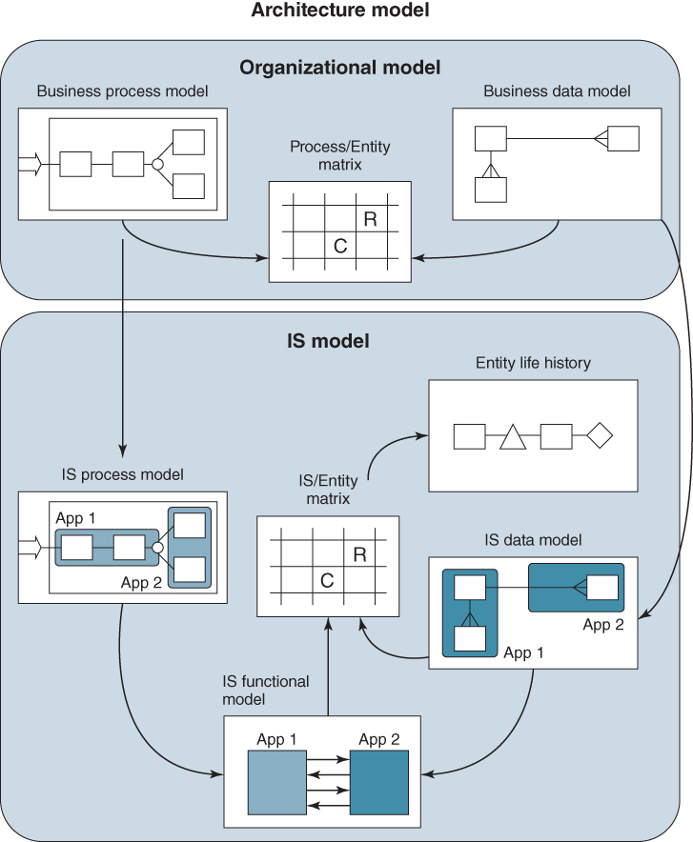
FIGURE 4.1 An example of an architecture model, comprising organizational and IS models.
Source: Adapted from M. Cook, ‘Architecture models’, working papers, Glaxo Wellcome Operations.
These models are obtained from top-down analysis of the business. They should be kept at a reasonably high level and can seem somewhat imprecise, but be capable of successive decomposition to become more precise when undertaking feasibility studies and application developments. The entities are likely to become the focus of the subject databases subsequently developed and maintained. More details about the types of models are given in Box 4.2.

BOX 4.2

Types of IS models used in IS strategic analysisª
- ♦ High-level process maps of all key processes and their relationships.
- ♦ Process flow models or process dependency charts, which show the end-to-end series of information dependencies and actions that deliver business outcomes to external or internal customers, such as ‘develop a new product’ or ‘fulfil customer order’.
- ♦ Hierarchical activity models or functional decomposition diagrams, describing the business units' activities. They are produced by activity analysis and show how the high-level functions of the business are broken down into broad activity categories, defining what it does or wants to do (i.e. sell and produce products etc.) and then into more detailed subordinate activities.
- ♦ Entity relationship models, showing the relationships of the key entities or entity groups relevant to the organization. Their main purpose is to define the underlying information architecture, independent of any functional considerations. They also provide a means of clarifying company-wide business language and are the source of the initial entries into the business unit's data dictionary.
- ♦ Data or information flow diagrams (DFDs), indicating the movement of information around, into and out of the business. A DFD is a network representation of business information systems and shows the logical dependency of one activity upon another for its data. The most significant characteristics of DFDs are that the situation is represented from the viewpoint of data, not a person or organization. The diagrams are graphic and can be partitioned and layered so that rather complex flows can be easily shown.
- ♦ Activity/Entity matrices, providing a tabular representation of the business and illustrating the relationship between information entities, conceptual business activities and conceptual application areas, recording whether the particular activities create, use or modify the entities. This enables a first-pass attempt at matching application areas to important business needs and showing how information will be shared across applications.
Notes:
ªMore details can be found in D.E. Avison and G. Fitzgerald, Information Systems Development: Methodologies, Tools and Techniques, fourth edition, McGraw-Hill, London, 2006; D.E. Avison and A.T. Wood-Harper, Multiview: An Exploration of Information Systems Development, Blackwell Scientific, Oxford, 1990; P. Checkland, Systems Thinking Systems Practice, John Wiley & Sons, Chichester, UK, 1981; and P. Checkland and S. Holwell, Information, Systems and Information Systems: Making Sense of the Field, John Wiley & Sons, Chichester, UK, 1998.
The creation of models is ideally a joint activity undertaken by business or information analysts working with people from the business to obtain the relevant information, often done at workshop sessions held to discuss the business strategy and IS requirements. Even if models already exist, they may need verifying and updating. Many of the large enterprise systems vendors also supply generic industry process models. Some modelling tools such as ARIS³ also have a library of models for different industries that can act as reference models.
Once process maps and models have been developed, the processes can be evaluated for their effectiveness in meeting business needs. An approach for assessing the effectiveness of processes is presented later in the chapter.
Information models may be created for the whole corporate body or at strategic business unit (SBU) level. In a large organization with several business units, it is most probable that separate models will be created for each unit, and there will be no attempt to create a global model for the whole organization. However, where there is a good deal of similarity between the units, or business synergy, then reconciliation between common entities becomes important, particularly when the business relationships are explored. Similarly, when consolidation of information from various units up to corporate level is considered, reconciliation may also be desirable.

Understanding the Business Operating Model
The business operating model is defined by choices made about the degree of process standardization and the extent of information integration across the organization; or, more specifically, how much standardization and integration is required to execute the organization's strategy.⁴ Few organizations give any explicit attention to these critical issues yet their implications are significant and discussion about them can be a valuable exercise.
Inside any organization there is a basic foundation of business processes, systems and information that deal with thousands or even millions of daily transactions that it engages in. Projects and programmes to execute strategies can create new or redesign existing processes and create new IS/IT assets. Thus, without any planning, the organization's operating model is the result of legacy decisions about IS/IT investments that cumulatively define its structure. The complexity that results from legacy investment decisions sees it referred to, in some organizations, as spaghetti! The resultant capability, sometimes referred to as ‘technical debt’, locks in assumptions about internal and external relationships and business processes and determines what an organization can and cannot do, particularly in the short term.
In defining the operating model, two questions require answering in the context of both business processes and information:
- How much process standardization do we need?
- How much information integration do we need?
Standardization offers a number of advantages, including: simplifying operations, reducing costs and increasing efficiency, allowing measurement, comparison and improvement; and providing a platform for innovation. However, standardization has a number of negative consequences, including: limiting local flexibility; requiring local units to replace perfectly good systems and processes with new often more expensive corporate standards; and may be politically difficult to implement.
When considering the extent of standardization, the following questions can be useful:
- What are the core processes and systems for the company?
- Are there compelling business reasons why some processes or systems should be standardized (e.g. global customers, market forces, or regulation)?
- Will local market conditions and regulations allow these processes and systems to be standardized across the different business units?
In deciding on how much standardization is beneficial it can be useful to map the need for local flexibility against how strategically important the process is. Illustrated in Figure 4.2, this mapping suggests four options. In essence, non-standard processes are only permitted with high strategic importance and strong requirement for local flexibility. However, underlying data should be sharable. Obviously, local regulations can also present a strong business case and be a reason for permitting non-standard processes.

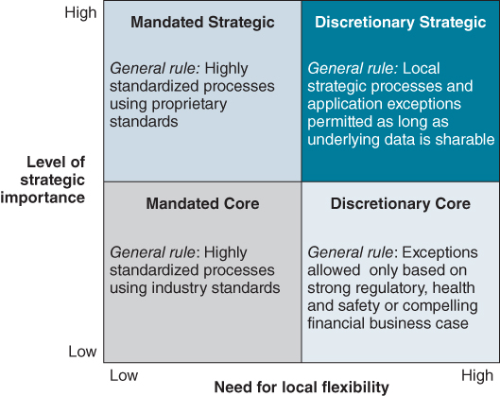
FIGURE 4.2 Deciding between standardization and flexibility.
We are assuming that core processes have already been identified. If not, Box 4.7 later in the chapter describes a way of doing this.
Integration also offers advantages, including: linking activities through the seamless flow of information; allowing an organization to present a single face to a customer, supplier or partner; and providing transparency across the organization. However, it does require common data definitions; can be time-consuming and difficult to implement; and may be unnecessary if units are organized around unique customer groups.
Questions in considering integration include:
- Which of the following require an integrated point of contact: customers, distributors, suppliers, partners or the corporate parent?
- Do transactions (i.e. information flows) need to be connected across the business units of the company?
- Will customer demands and regulations allow data to be transferred and processes to be integrated?
Operating models exists at both corporate and business unit levels. A conglomerate, for example, might have interests in a range of businesses in different industry sectors. The separate businesses can operate autonomously with no requirement for sharing information or common processes. However, individual businesses in the portfolio may mandate standard processes and a requirement for high levels of information integration. Based on choices around standardization and integration, Figure 4.3 illustrates four different types of operating models.
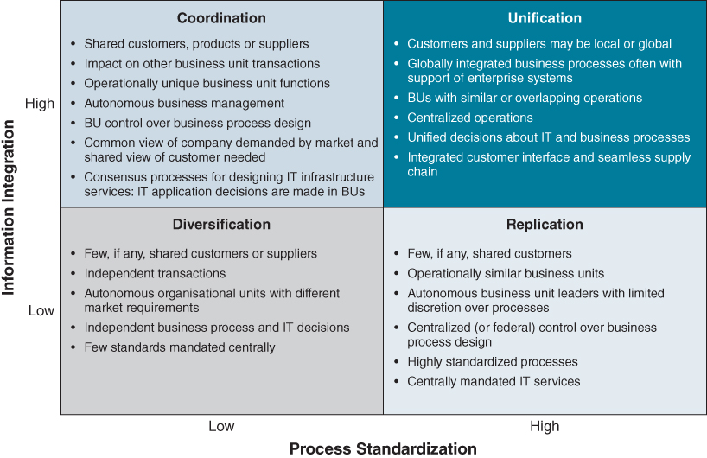
FIGURE 4.3 Defining the operating model.
Source: J. Ross, P. Weill and D. Robertson, Enterprise Architecture as Strategy: Creating a Foundation for Strategy Execution, Harvard Business School Press, Boston, 2006. We have adapted the original model to emphasize information integration.
Diversification is where there is little process standardization and little requirement for integration of information across organizational processes. A company like GE, with businesses in industries including aerospace, financial services, transportation, consumer products and health, has such an operating model; this is a strategic choice. Depending on its strategy, each business will be likely to have a different operating model.
Replication is where there are standard business processes but a low requirement for information integration. An example company is McDonalds. While there is no integration of information across stores necessary for operations (i.e. each store operates autonomously), stores will operate similar processes.
Coordination is where business units are autonomous, operationally unique but sharing customers, products or suppliers. Banks are a good example of organizations that often fall into this quadrant. With operations in retail, insurance, share trading and wealth management, a single view of the customer is required to present a single ‘face’ to the customer.
Unification is where operations are centralized, requiring globally integrated business processes. Airlines, for example, fall into this category as do companies like Apple and Amazon.

Organizational Environment
When considering the process and information needs of an organization, it is also essential to have a clear understanding of the organization's current structure, working relationships and people. These organizational dynamics are an important input into the strategy and planning process. It is necessary to understand the organization's capabilities – its skills, resources, values, culture and social interactions – as well as its management style and its relationships with external stakeholders. These have become increasingly important as the pace and impacts of change have intensified.

A Technique for Organizational Modelling
Organizational modelling is a valuable technique in IS/IT strategy development and, if the business is also conducting any business transformation or re-engineering programmes, a means of obtaining a broadly based understanding of the organization is essential. There are a number of organizational development and modelling techniques that can be used for this analysis. A well-established one based on original work by Kotter⁵ is covered here.
Kotter's model is made up of seven elements (see Figure 4.4): a central ‘process’ element labelled key organizational processes and six ‘structural’ elements – the external environment, employees and other tangible assets, formal organizational arrangements, the internal social system, the organization's technology and the dominant coalition. In his book, Kotter developed a set of questions to understand the nature of the organization, although it is not expected that definitive answers can be obtained for all the questions. What is needed is careful consideration of each element or variable in the model, combined with an understanding of the processes and activities within the organization and the information required to support them.
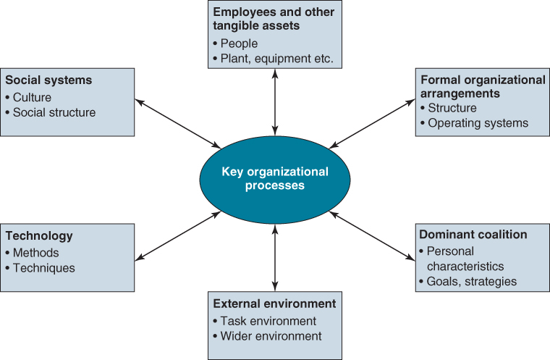
FIGURE 4.4 The organizational model: environment and culture.
Source: Kotter, John P., Organizational Dynamics: Diagnosis and Intervention, 1st, ©1978. Reprinted by permission of Pearson Education, Inc., New York, New York.
We have modified and extended the original work by Kotter for the purpose of IS strategy formulation. Our main focus is on determining objectives, activities and information flows in relation to the model, so that an appropriate representation of the organization and how it functions is developed and understood by the senior management. Aspects to be covered under each of the main headings are:
- The external environment – questions are asked concerning the impact of legislative and fiscal policy, industry and economic trends, the basis of competition in the particular industry, industry standards, competitor practices and products, factors affecting the growth and profitability of the industry as described in Chapter 2. How IT is being used by firms in the industry and its customers and the impact at industry and firm level should be assessed.
- The dominant coalition – these are the key influencers: individuals who are the main driving force behind the organization. Who they are, their values and aims, the source of their power and influence and how they work together to create the future of the organization need to be understood. It is essential to identify this group because they will need to be convinced of the need for and benefits of major IT investments, especially where they affect the business's competitive position. Without their commitment to the strategy, there is little likelihood of successful implementation.
- Formal organizational arrangements and procedures – the policies, plans, budgets, organization charts, job definitions, performance measurement and control and decision-making processes at corporate and unit levels need to be examined to develop and agree an understanding of how the organization manages the ways it operates. The degrees of discretion and autonomy allowed to managers, professionals and staff should be clarified. How decisions about IT are made and who makes them should also be clearly understood.
- Employees and other tangible assets – the quality and quantity of people (managers, employees and key contractors), their qualifications, competences and skills and the level of turnover plus the physical, intellectual property and financial assets of the organization. The IS/IT knowledge and capabilities of business staff should be explicitly identified as well as the comprehensiveness and maturity of the applications portfolio and IT infrastructure.
- Social structure – the formal policies and arrangements for recruitment, staff development, discipline and promotions as well as rewards and incentives are described along with the organization's employee and trade practices (and relationships with trade unions, if applicable). The informal arrangements and customs and practices, staff attitudes to management and to co-workers plus other factors influencing the behaviours of staff and the overall organizational culture, such as attitudes to change, need to be identified.
- Technology employed – the nature of the technology in the organization's products and production processes, and the level or maturity of the use of technology – how sophisticated or leading edge, built internally or bought in. How that compares with the available technology and that used by others in the industry is assessed. (A similar assessment of the IT employed is considered later in this chapter.)
- The key organizational processes – these are the core processes and activities within the organization that obtain resources and convert them into finished products or bring resources together to deliver products or services to customers, plus those processes used to make decisions on the products and services offered, markets served and levels of resources and their allocation. These are explored in more depth later in this chapter and in Chapters 5 and 6.
There are a number of reasons for developing the organizational model:
- Without exploring these organizational dimensions through this or a similar type of model, it is very difficult to develop strategies for information systems that are consistent with the values and culture of the organization. In his book, Kotter described how to use the model to bring about organizational change. As this is now often an essential aspect of major IS implementations, it is another reason for adopting this type of technique.
- The strategy development and planning activities need to be completed quickly so that the enthusiasm and commitment that develop during the process can be sustained and work can start toward achieving the benefits of the strategy. It is necessary, therefore, to have an effective filtering system so that the most relevant, realistic and implementable applications are prioritized. The organizational model provides such a mechanism, since it contains substantial information about the resources that are available to implement systems and the organization's capability to deliver change. It also helps prevent proposals for new investments that would be alien to the culture and values of the organization.
- However, it may be essential to implement new processes and strategies that require changes in behaviour and run counter to the current organization culture. If so, then those behaviours and even, in time, the culture itself needs to be modified. Here, the model is of considerable benefit because the required cultural changes can be compared against the model to determine their impacts and how to achieve them.
- Another important use of the organizational model is to provide a comprehensive, collective understanding of the environment, both external to the organization and internally, when any strategic decisions are taken. When the strategy is revisited, questions may be asked as to why certain options were discarded or certain choices were made. Without this historical perspective, it would be difficult to answer those questions, which could result in work being performed again or, worse, a decision being reversed, to the detriment of the organization.
- It also provides a perspective against which changes can be monitored. There will be a finite elapsed time before revisiting the strategy and, during that time, changes will probably take place concerning competitors, the legal environment, technology and the economic situation, and, internally, due to reorganizations, the ways in which employees work, new salary structures and so on. It is important to know the impact that all these may have on future strategy. The model provides a way of examining these changes to determine their possible impacts. It will enable applications to be implemented that are sensitive to the influences of the various pressure groups and stakeholders.
As a final point, it is worth considering developing a second organizational model for the IS/IT unit itself. This is often necessary because the IS/IT unit can have its own particular culture, values and methods of working, which may be quite different from those of the rest of the organization.⁶ It may be possible to develop a good IS strategy that fulfils all the criteria of supporting the business and being accepted by senior management, but which cannot be implemented successfully due to it being beyond the capability of the IS/IT unit and/or its suppliers. The relationship between the IS/IT unit and the rest of the business is discussed later in this chapter and again explored in Chapter 10.

Examining the Existing IS/IT Environment

External IS/IT Environment
Examination of the external IT environment is needed to take into account trends and opportunities from new and emerging technologies and investigate how other organizations, whether competing or complementary, are applying IT. This will lead to a more objective appraisal of the current effectiveness of IS/IT within the organization, as well as to new ideas for potential applications. This does not mean only seeking ideas for implementing leading-edge technology, but also finding ways of using existing technology at lower cost or in previously unconsidered ways.
Part of this involves looking at what competitors or other comparable organizations are doing. This not only gathers ideas but also provides a view of the relative maturity of the business's own IS/IT use and capability. It may be a deliberate organization policy or strategy not to be a pioneer of any new technology in its own business sector or a leader in innovative use of IT, but to follow at a considered, lower risk pace behind the recognized leaders. Another aspect of this external review may be to identify technologies to evaluate in more detail later, when other aspects of the IS strategy required become clearer.
One retailer uses what it calls a ‘Technology Radar’ to map technologies, the areas they are likely to impact and the possible scale of that impact. They also attach a time dimension, illustrating when in the future the technology is likely to have an impact. Shown in Figure 4.5, the Radar serves as a prompt for a discussion about technologies and the potential impact on the business.
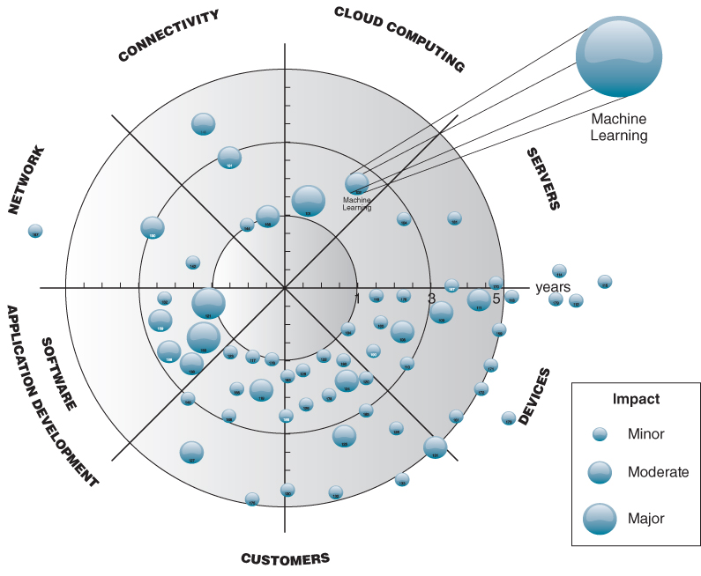
FIGURE 4.5 Technology strategy radar.
In addition to IT product and service vendors, IT research establishments such as Gartner, IDC and Forrester Research are another good source of technology trends and information. However, care should be exercised when reading many of their reports, particularly regarding vendors, as they may not be as independent in their assessment as it might seem. Not only do many of the research organizations charge for providing information but they also charge vendors a fee; failing to pay usually means a vendor is not included in any of their assessments or analysis, despite the fact that they may be providing a superior solution.

Internal IS/IT Environment
In order to identify and prioritize IS and IT actions, it is necessary to examine the internal IS/IT environment to establish the gap between current and future targeted provisions to determine whether or not, or the extent to which, the IS/IT capabilities themselves need changing. Gaps may relate to the provision of the target portfolio, either by enhancement of existing applications or by developing new ones or other aspects in the IS/IT environment, including the IS/IT unit, its competences, its processes, the technical infrastructure or suppliers and supplier relationships.
A further important aspect is to ascertain business managers' perceptions of the role and current effectiveness of the IS/IT deployed and the capabilities of the IT organization. This will enable IT management to decide whether they have to address issues creating the perceptions and also the level of commitment the business is likely to give to any proposals. Assessment of the internal IS/IT environment comprises:
- an evaluation of the current application portfolio and the applications under development to determine their content, coverage and contribution;
- a similar evaluation of current information resources;
- an evaluation of the current IT infrastructure, services and resources.
While this work can be conducted independently from the analysis of the business environment, there are obvious advantages in coordinating the two, to ensure the assessment of IS/IT is relevant to what the business wants to achieve. The most significant aspect is the current application portfolio, since it represents the starting point from which future development will begin. It is also a key determinant of how the business community in the organization perceives the value and contribution of IS/IT.

Current Application Portfolio Evaluation
The current suite of applications includes all centralized, distributed and outsourced systems, web and mobile apps plus the data sources that support various aspects of the business – personal productivity, administrative, operational, control and planning. Having a complete and agreed view of the portfolio, including developments in progress, enables assessment of its business value and the role IS/IT plays in achieving business objectives. This will include a description of the functions performed by each application and an assessment of its technical and functional performance, as well as the users' opinions of its utility, effectiveness and benefits.
Typical deliverables from a systematic assessment are listed in Box 4.3. The likelihood is that key operational and support quadrants will be very well populated, and there may be some strategic uses of IT. Increasingly, organizations are finding that there are a number of high potential applications created by users experimenting independently with innovative ideas – a reflection of how easily low cost applications can be obtained from the ‘cloud’.

BOX 4.3

Deliverables from a current application portfolio assessment
- ♦ Categorization in terms of application portfolio segments – strategic, high potential, key operational and support (or an alternative classification) and how IT resources are used, in relation to the business importance of applications.
- ♦ Assessment of coverage and contribution of applications to business processes and activities, and identification of any gaps or major opportunities to increase business value from them.
- ♦ The extent to which the systems integrate or interoperate and opportunities to improve the integrity and quality of information.
- ♦ Assessment of the applications' effectiveness and robustness and the unrealized potential in their current use.
- ♦ Assessments of the business impact/risks of failure of applications and their strengths and weaknesses assessed against the business CSFs.
- ♦ Duplication of applications or multiple versions of same or similar software – opportunities to reduce maintenance and licensing costs.
- ♦ Differences between current portfolio and required information and systems architecture.
- ♦ Information to enable estimates of potential improvement projects and enable prioritization of enhancements to current systems.
The analysis involves gathering and collating a substantial amount of factual and subjective information for each application, from users about: how well it supports business processes and tasks; its functionality and the business information it provides; quality and the usability of the application; dependence on the application; documentation, training and support available and views on its future potential. And from IT staff about: the structure and interfaces of applications and databases; architectural compliance; their reliability and resilience; their technical quality, age and support from suppliers; as well as ease of enhancement and maintenance. The information may be collected by discussion or questionnaire, or by a mixture of both. A questionnaire may be the only practical method, because there are often multiple users in different geographical regions for major business systems and databases.
This can be a very extensive and time-consuming exercise and care must be taken not to spend too much effort here – a relatively short evaluation may be quite adequate to obtain a broad picture; then later, when the intended initiatives and future projects are becoming clearer, further evaluation of the relevant areas of the portfolio can be undertaken.
The management of the portfolio of existing and current development applications is covered in more depth in Chapter 8.

IS/IT Unit – its Assets, Resources and Processes
This covers a number of aspects that will be more or less relevant, according to how effective the current services are and whether the role of IS/IT in the organization needs to change significantly due to either business changes or the adoption of new types of technology or IT services. Much of the assessment of the IS/IT unit and its processes can be accomplished by using the organization modelling technique, described earlier in this chapter, on the IS/IT unit itself.
This review includes the IS and IT strategies currently in place in terms of how well they are working, the success or otherwise of changes made plus any problematic areas and identifying those that have been superseded by events. In particular, any new policies implemented should be assessed in terms of whether they have been adhered to and how effective they have been. Careful scrutiny of the previous strategy and its business rationale will guard against making further policy decisions that may be difficult, if not impossible, to implement.
It is likely that the following factors will also need review to assess their suitability for the future:
- the IS/IT unit, its size, structure and relationship with the business at organizational, functional, departmental and individual levels and how it is managed;
- the role of the CIO and the organizational level into which the IS/IT unit reports at corporate level and in individual businesses;
- the IS/IT governance structure, including decision-making processes and any steering group structures in place;
- the physical IT assets of the organization in terms of hardware, software, communications capability and any other technology employed;
- the organization for the provision of IT resources and services and managing the suppliers of technology and technology services and the nature of the contracts with them;
- people resources (including recruitment), especially the competences and skills of IS/IT staff and managers, any contracted staff and users in different business areas;
- how business cases and budgets for IS/IT investments and expenditure are prepared and by whom, and how they are authorized.
These topics are covered in more detail in Chapters 9 to 11.

Methods and Training Provisions for IT Professionals and Business Personnel
This includes methods in use for business and systems analysis, business process redesign, application design and development, information and data management, project management and control, benefits management, service management, quality assurance and control, estimating and performance monitoring.
It also covers training and education methods employed and especially any IS/IT awareness programmes directed at the business to raise understanding and develop users' IS/IT competences. Similarly, any awareness or other training available for technical people on business matters is also covered.

Assessing the Business Perception of IS/IT
It is advantageous to have an objective view of the current role and contribution of both IS/IT in the business and the IS/IT unit itself, and also the perception of these by the rest of the business. This is not an exact science, but an objective, if largely qualitative perspective can be drawn by considering a number of different aspects:
- Analysis of the application portfolio can provide a great deal of information. Categorizing applications into strategic, high potential, key operational or support, can indicate how well current and future business strategy is enabled by IS/IT. This is also a key indicator in assessing how IS/IT is perceived by business people; for example, a lack of strategic or high potential applications suggests that management consider IS/IT of little strategic value to the business. The type of portfolio management processes in place are themselves indicative of the nature of the IT/business relationship.⁷
- Consideration of how many of the business functions and processes are underpinned by modern IT systems gives an indication of the level of IS/IT support for the operational and management needs of the enterprise. How many individuals have all the personal productivity tools they need (and can use effectively) is also indicative of how IT literate the organization is.
- Assessment of levels of user satisfaction across the range of IS/IT services gives a preliminary view of the effectiveness of the relationship achieved between IS/IT and the business. (Box 4.4 discusses how to assess user service satisfaction effectively.)
- User roles in managing projects and in developing business cases, together with the IT function, give a measure of the cooperation existing between the business and IT function. Whether or not business managers take responsibility, or are accountable, for the realization of application benefits from new investments is a good indicator of the maturity of the IT/business relationship.
- The level of integration achieved between applications and across different technologies, and the status of information management in the business, provide a good measure of the degree to which information is considered a critical corporate resource.
- A key indicator of the current role and value of IS/IT is the level in the management hierarchy where overall responsibility for IS/IT resides. This is increasingly a board-level appointment in businesses where IS/IT is considered strategic.

BOX 4.4

Measuring IS/IT service quality
Considerable research has been done to develop approaches to defining service quality and measuring both the technical and ‘emotional’ (i.e. how the user experiences the service) quality.ª Effective measurement does rely on the service consumers being able to define the value they expect to obtain from the service – a difficult concept. Often, this has to be in terms of the negative consequences of service failure, unavailability or underperformance, to justify the service cost against failure of the business to operate ‘normally’. Establishing more effective and relevant ways of describing and then measuring the value derived by both individual users and the organization in total is a major challenge for future IS strategy development, as discussed later in the book – see Chapter 11.
Many IT functions carry out customer service satisfaction surveys but, if not well constructed (or carried out too frequently), the results can be misleading. Before asking a user to evaluate a service, or its attributes such as availability or responsiveness, the importance or otherwise of the service to the user needs to be understood. ‘Importance’ is a surrogate for service value in terms of how dependent the user is in carrying out his or her role and tasks on the quality of service received. Evaluating services, in achieving the required performance for those who depend on them, is more important than satisfying those for whom they are of no great consequence. Therefore, any satisfaction survey must first determine the context within which the user is judging performance.^{b}
Regular assessment of service performance is required to detect emerging problems and issues, the causes and consequences, in order to improve the service or establish realistic service expectations. Failure to do so will directly or indirectly impact business performance, resulting in a poor perception of the role and value of IS/IT in the organization, and difficulties for the IT function to obtain resources and investment to deliver the IT strategy. While most assessment of performance is carried out to enable relevant improvements to be made, the assessment may reveal areas of apparent over-performance! If the perceived performance is judged by users to be high but, in reality, compared with similar organizations, actual performance is poor, the business is suffering a degree of ‘delusion’ if it believes it is using IS/IT successfully!
Notes:
ªA. Parasuraman, V.A. Zeithaml and L.L. Berry, ‘SERVQUAL: A multiple item scale for measuring consumer perceptions of service quality’, Journal of Retailing, 64, 1, 1988, 12–40; V. Zeithaml, A. Parasuraman and L.L. Berry, Delivering Quality Service: Balancing Customer Perceptions and Expectations, The Free Press, New York, 1990; J.M. Kohlemeyer III and J. Ellis Blanton, ‘Improving service quality’, Journal of Information Technology Theory & Application, 2, 1, Spring, 2000; L.F. Pitt, R.T. Watson and C.B. Kavan, ‘Service quality: A measure of information systems effectiveness’, MIS Quarterly, 19, 2, 1995, 173–185; and L. Pitt, P. Berthon and N. Lane, ‘Gaps within the IS department: barriers to service quality’, Journal of Information Technology, 13, 1998, 191–200.
^{b}G. Whyte, A. Bytheway and C. Edwards, ‘Understanding user perceptions of information systems success’, Journal of Strategic Information Systems, 6, 1997, 35–68; and T. P. van Dyke, L. A. Kappelman and V.R. Prybutok, ‘Measuring information systems service quality: concerns on the use of SERVQUAL questionnaire’, MIS Quarterly, 21, 2, 1997, 195–208.
Research has indicated that, where the IT function is perceived as making a value-added contribution to the business and there is a close relationship between it and the rest of the business, IS/IT will have a significant positive impact on business performance.⁸ If the relationship is poor, the organization is probably faced with a long struggle, first of all to improve the perception of IS/IT and second, to get business managers involved in IS/IT decision making. Developing the digital strategy will be challenging, particularly when exploring the impact of IS/IT and seeking opportunities for innovative applications (as opposed to alignment).

Information and Systems to Meet Current Business Objectives: the Use of Balanced Scorecards and Critical Success Factors
To position the role of Balanced Scorecards (BSC) and Critical Success Factor (CSF) analysis, it is useful to develop the link between data, information and business results. Figure 4.6 illustrates the DIKAR model (Data, Information, Knowledge, Action, Results).⁹ Viewing the model from left to right represents the traditional IT perspective where the focus is on data processing and the provision of information to the business. Viewing it from right to left, the focus is on business results and the actions and knowledge required to achieve those results.
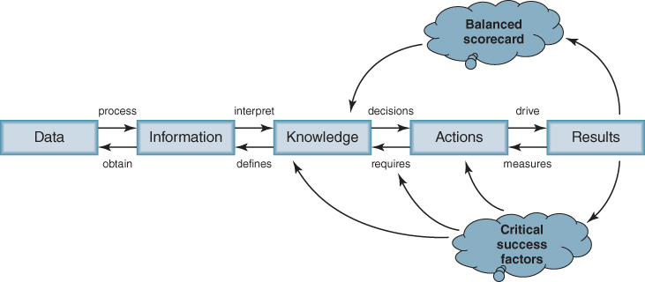
FIGURE 4.6 Information in context.
Source: Based on the work of N. Venkatraman presented at Cranfield School of Management, February 1996.
The Balanced Scorecard identifies the information required to measure performance (often called Key Performance Indicators (KPIs)) against the business objectives. CSF analysis identifies what has to be done, or changed, in order to achieve those objectives, including new or better information. In combination, they provide a way of getting agreement to the priority of the IS/IT investments required to achieve the business objectives, for the next 6–12 months.

Balanced Scorecard (BSC)
The Balanced Scorecard has become a popular framework not only for managing the performance of organizations but as a tool for the development of strategy itself.¹⁰ It is based on the premise that financial measures only report the results of past decisions and that, if performance measurement is to have any meaningful impact, a more comprehensive and balanced set of objectives and measures is required. The BSC promotes the examination of performance from four interrelated perspectives, each seeking to address specific questions (see Figure 4.7). These perspectives are:
- Financial: How do we look to our shareholders and those with a financial interest in the organization?
- Customers: How do our customers perceive us in term of products, services, experience, relationships and value-added?
- Internal business operations: What do we have to excel at if we are to meet the expectations of our employees and trading partners?
- Learning and growth: How will we continue to improve and create future value for our stakeholders?
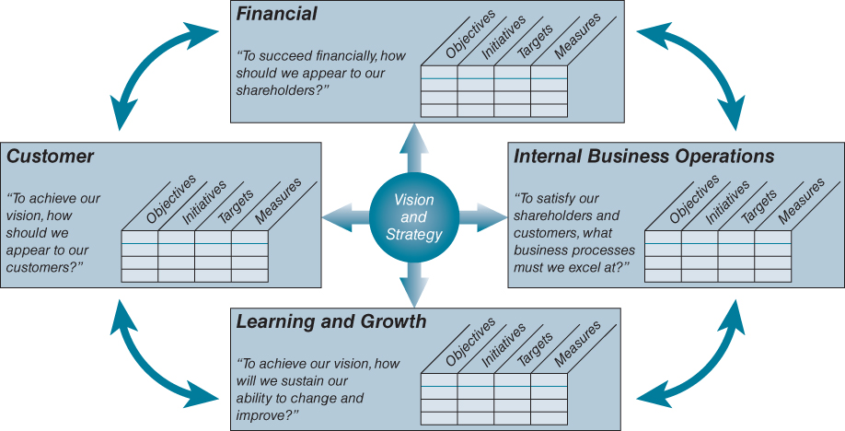
FIGURE 4.7 Information and the balanced scorecard.
For each of the four perspectives, objectives can be established, initiatives to achieve objectives identified and relevant measures – the Key Performance Indicators (KPIs) – assigned, leading to the information needed to measure performance against the objectives. The four perspectives are interrelated, both from the top down – expected financial performance driving decisions about products, services and resources – and bottom up – learning and innovation to improve the customer offers and also business processes leading to creation of more value or reducing business costs.

Critical Success Factor (CSF) Analysis
Critical Success Factors are ‘the limited number of areas in which results, if they are satisfactory, will ensure successful competitive performance for the organization’.¹¹ They are the few key areas where ‘things must go right’ (hence also called ‘do wells’) for the business to flourish. As a result, the CSFs are areas of activity that should receive constant and careful attention from management. The current level of performance in each area should be continually measured and the results made widely available.
CSF analysis is a powerful and popular technique that can be used for both IS/IT and business strategy development. It can be used in a number of ways, for different purposes, as indicated in Box 4.5. As described here, its purpose is to interpret the business objectives in terms of actions or initiatives required to achieve them and the resulting information and new or improved applications needed. They are also useful for assessing the strengths and weaknesses of existing applications and processes, in the context of future business plans.

BOX 4.5

Uses of Critical Success Factor (CSF) analysis
- ♦ It is a very effective technique for involving senior management in developing the IS strategy, because it is rooted in business issues, and in gaining their commitment to proposed IS actions that contribute to achievement in critical areas.
- ♦ It enables linking of IS/IT projects through CSFs to objectives, and thus clearly demonstrates their alignment with the business strategy and provides a compelling basis for gaining agreement by the top-management team.
- ♦ In interviews with senior management, it is a good catalyst in unearthing their information needs.
- ♦ By providing a link between objectives and information requirements, the CSFs play an important role in prioritizing investments.
- ♦ It is particularly useful in IS planning when the business strategy has not progressed beyond setting objectives, by focusing attention on the most critical aspects of the business that need action taken to improve their performance.
- ♦ It is powerful when used with value chain analysis in identifying the most critical processes and enabling ownership of the CSF and associated actions to be allocated.
The technique can be used at the macro-level to examine the overall industry (i.e. define industry CSFs), the organization as a whole or a particular business unit. Every firm in an industry may have some common CSFs – such as access to raw materials and skills or timely delivery – due to pressures within the industry. The whole organization, which could have units in many industries, will have CSFs related to its corporate objectives such as diversification, return on investment and business portfolio mix. We have suggested in Chapter 3 that the key level for determining CSFs as part of IS strategy development is at the level of the business unit. The agreement of the business unit managers to these CSFs is important in obtaining consensus on the major IS/IT investments required. There will also tend to be a structured, cascading relationship in a large organization between objectives and CSFs, as illustrated in Figure 4.8.
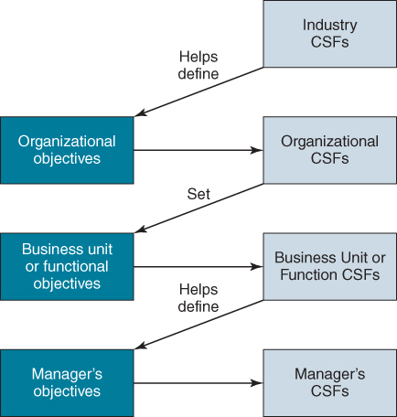
FIGURE 4.8 Objectives and CSFs.
It can also be used at individual executive level to determine which of those activities that he or she performs are the most important for achievement of success against a particular objective. In this way, the CSF process can assist in prioritizing activities and information requirements, both at individual manager and at business unit levels. In both cases, the CSF technique helps to focus attention on the key issues.
The determination of CSFs can only start when objectives have been identified, except as mentioned above at the industry level with questions such as ‘what factors determine survival, market share or profit margins’ in the industry.
The first stage is to identify CSFs against each objective – as a rule of thumb, between five and eight is a reasonable and manageable number. Too many suggest that the objective is unachievable; too few and it is not ambitious enough! Then they should be consolidated across objectives, since CSFs may well recur (see Figure 4.9). Ranking the importance of objectives and/or the number sharing the same CSF will give a relative priority to the achievement of CSFs. By implication, if each CSF is achieved, the probability of achieving the related objectives is increased. In reverse, failure to address a CSF successfully could prevent achievement of several objectives.
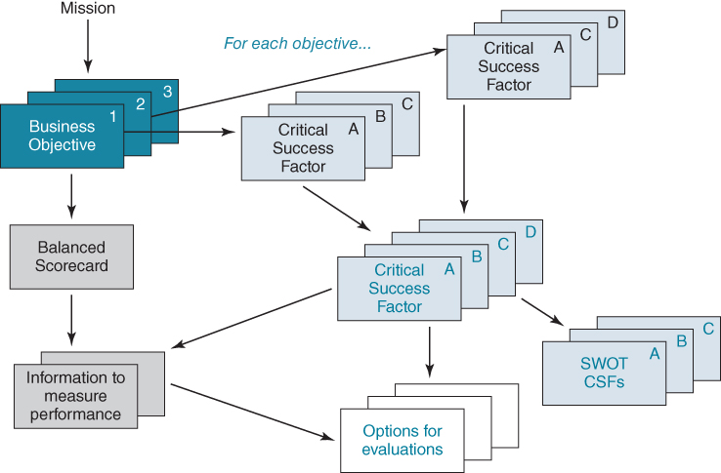
FIGURE 4.9 Critical success factors – basic processes.
Only after this consolidation should the role of information or applications in achieving those CSFs be considered. ‘How can IS/IT help achieve the CSFs?’ and ‘(How) does existing IS/IT inhibit the achievement of any CSFs?’ are both important questions to consider. This implies a type of SWOT (Strengths, Weaknesses, Opportunities and Threats) analysis of existing applications and information resources against the CSFs.
When used effectively, CSF analysis achieves a number of requirements, all of which are important to the strategy process: involving top management and gaining their commitment; developing a consensus view of the importance of IS/IT applications in the business; linking IS/IT activity to strategic objectives and eliciting executive information needs. But it also has some limitations and needs to be used with a degree of caution:
- To be of value, a CSF should be easily and directly related back to the objectives of the business unit. From experience with the technique, it generally loses its value when used below the third level in an organizational hierarchy and use at the individual level can be counterproductive, producing too many CSFs, leading to conflicting actions or competing priorities.
- The nature of CSFs and KPIs reflects a particular executive's management style. The chief executive of one airline judged performance by load factors. His predecessor judged performance on the number of letters of complaint. Both are valid, but reflect different perspectives.
- When used ineptly, the approach can cause frustration, even despondency, and may turn management against the strategy process. The most common cause of problems is that ‘critical’ is not differentiated from ‘important’, resulting in long lists of factors that effectively describe everything the organization does!
The strengths and weaknesses of the CSF approach in IS planning are well documented.¹² In particular they should be used in a formal, structured way; people should be educated in advance about the technique and how it is being used; and they should not be used solely for the derivation of information needs.
Other studies show that eliciting of CSFs works best (and they are certainly identified more quickly) in a group process, in one or a number of workshops, rather than by conducting interviews with numerous individuals and then trying to collate the results.¹³ The process must produce agreement to move in a coherent direction, which is very difficult to achieve by later consolidation of variously expressed CSFs, rather than achieving consensus as the analysis proceeds. This also enables the CSFs to remain focused on the management ‘business agenda’ rather than the personal agenda of an individual and avoids ambiguity or vagueness being left unchallenged.
It can be summarized by saying that the process is as important as the output, since it achieves commitment to the outcome. If well prepared for the process, senior managers find little difficulty in articulating CSFs, as they are often merely overt statements of issues that they are aware of or are already addressing.¹⁴

Consolidating the Balanced Scorecard and CSF Analysis
The outputs from the development of a Balanced Scorecard and CSF analysis can be combined to provide a comprehensive and rigorous assessment of prioritized IS opportunities, in the context of the current business strategy. The BSC links measures to objectives, while CSF analysis identifies what is critical to achieving those objectives.
Box 4.6 describes an example use of the combined BSC and CSF analysis. It illustrates how the combination can lead to the derivation of improvements to operational activities and the identification of both the internal and external information required, and also for performance measurement in relation to business goals or objectives. It is always better to have a crude measure of something important rather than a refined measure of something that does not matter. CSFs help to differentiate the two.

BOX 4.6

Combining Balanced Scorecard with CSF analysis
This example is from a manufacturing company providing a product and parts service primarily to SMEs. It produces a wide range of electrical products that are assembled from mainly imported components. Orders tend to be for unique products configured to customer specification. As far as possible, the company attempts to meet all customer orders direct from component stock. However, this has implications for stock holding costs, both of components and finished products. The time between order placement and fulfilment can be severely impacted by the availability of component parts.
Using the balanced scorecard, the company constructed a set of goals and associated measures for each of the four perspectives. A partial view of the scorecard is illustrated below. For example, from a customer perspective one objective is to increase responsiveness for both firm orders and inquiries. Associated measures to indicate the extent to which this objective is being achieved include order to delivery lead time and enquiry response times.
CSF analysis was then used to identify the actions necessary to enable achievement of each objective. For example, in relation to the objective of ‘reduce stock costs’, CSFs identified were: earlier identification of obsolete items and improved forecasting to reduce safety stock.
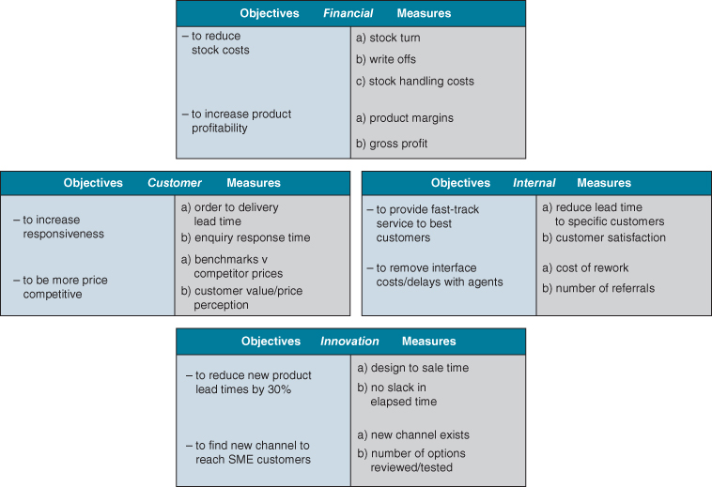
As illustrated in the figure below, working from the CSFs, the most important information and systems requirements to support these CSFs can be identified:
- ♦ New analysis of stock turn to separate fast-moving/slow-moving items (A,B,C based Pareto analysis).
- ♦ Improved stock forecasting based on more accurate sales forecasts/actuals.
- ♦ New stock replacement algorithms for different types of stock.
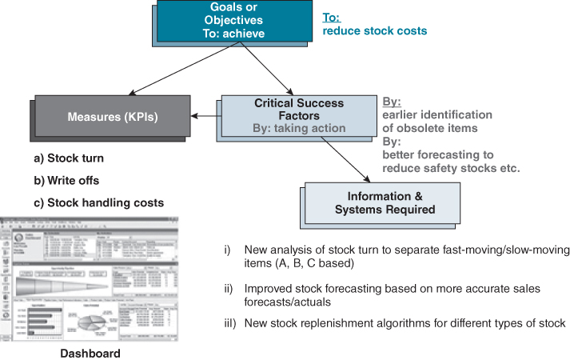
The outputs from the balanced scorecard work and the CSF analysis can then be consolidated, as illustrated below.
Financial Perspective
Objectives | Measure(s) | Action (CSF) | IS Needs
- – to reduce stock costs | - stock turn  - write offs  - stock handling costs | - – by earlier identification of obsolete items  - – by better fore–casting to reduce safety stocks | - new stock turn analysis (ABC)  - improved sales & stock forecasting  - new stock replenishment algorithms

Customer Perspective
Objectives | Measure(s) | Action (CSF) | IS Needs
- – to increase responsiveness | - order to delivery lead time  - enquiry response time | - – by identifying causes of all late deliveries  - – by informing customers in advance of problems  - – by tracking all enquiries/progress daily | - new accurate measure of all order/delivery times  - analysis of all types of delivery failure  - new/dynamic customer/order monitoring system to instigate action  - new enquiry recording/tracking process & system

Process Analysis
Process analysis is a way of assessing how effectively the core business processes support the achievement of business objectives and drivers. As a result, decisions may be made to embark upon major redesign of one or more business processes, which will almost inevitably lead to new or revised IS/IT to enable the new processes. The assessment of business processes is aimed at identifying where the greatest opportunities exist to improve performance. Following this initial analysis, a second assessment can examine how they could and should be improved to deliver the performance levels necessary to achieve business objectives.
IS/IT provides the opportunity for new and innovative ways of organizing and enabling organizational work to be performed – ways that are not possible without the use of technology.¹⁵ Process analysis is not merely concerned with improving existing work practices but seeking opportunities where ways of working can be totally transformed.

Adopting a Process Perspective
Despite the emergence of ‘business process redesign’, ‘process innovation’ and ‘business re-engineering’ in the early 1990s, the majority of organizations are still structured along functional (or departmental) lines. The ‘chain’ of linked departments allows for specialization where the overall task is broken down and people with specific skills and expertise can be applied as required. Such specialization of labour, whether on the manufacturing shop floor or within offices, has been a normal way of working for a long time. ‘Levels’ of seniority evolve within these functions to form a hierarchy. Adopting a process orientation questions this ‘functional’ way of thinking and makes ‘processes’ a central focus for organization design.¹⁶ In short, processes are becoming the building blocks of organizations and seek to capture natural workflows. The top diagram in Figure 4.10 illustrates a customer order as it flows through an enterprise organized along functional and hierarchical lines. The lower diagram attempts to extract the process; the logic of taking a process perspective is that it becomes the focus of attention for redesign.
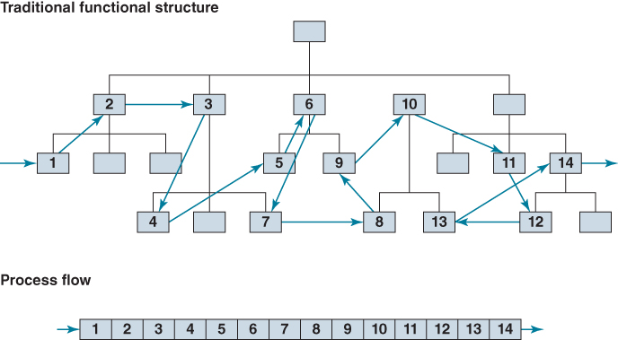
FIGURE 4.10 Adopting a process orientation.
A process focus means, for example, examining the way a customer order is fulfilled, a new product developed or a service is delivered without concern for functional boundaries or specialization. When requesting repair of a heating boiler, the customer is not generally interested in which department the engineer works, whether he or she travels by public transport or buys spare parts in the local hardware shop, as long as the boiler is repaired in an efficient and timely manner.
The Oxford English Dictionary defines a process as ‘a continuous and regular action or succession of actions, taking place or carried out in a definite manner, and leading to the accomplishment of some result; a continuous operation or series of operations’. In its simplest form, a process has an input and an output and is made up of a sequence of individual activities through which this input passes to become an output or outcome.
With this view, the process can be anything that transforms, transfers or merely looks after the input and delivers it as output. Organizations adopting a process approach find that, for example, many of the steps in their order cycles have nothing to do with delivering the required goods to the customer.¹⁷ Indeed, it is sometimes difficult to identify why some steps exist at all – often, it is for no better reason than because they always have! The existing IS/IT often includes the computerization of these unnecessary steps – ‘the cow paths have been paved’. Getting rid of all these unnecessary steps can result in faster throughput, more reliable or quicker customer service and lower costs, including IT costs.
However, this view of a process can be problematic, particularly in information and knowledge intensive industries. In these contexts, it is perhaps more appropriate to consider processes in terms of ‘roles’, with a process portrayed as a number of roles (of people) collaborating and interacting to achieve a goal or outcome. This perspective can also make explicit reference to required behaviours: a process is ‘an organized collection of behaviours that satisfies a defined business purpose, performed according to specific targets’.
This view of a process is of particular relevance in knowledge work or in areas requiring a high degree of interaction between people. For example, specifying the precise activities in customer service processes is difficult, if not impossible. Guidelines as to how individuals are expected to behave can be given, but the attitude of the customer service agent is often crucial in determining whether or not a customer is satisfied or pleased. Increasingly the customer is included in any analysis, particularly when value is co-created or the service depends on how well the customer knows his or her requirements. The ‘customer experience’ is becoming ever more important in the delivery of many services.

Identifying Processes
Before any redesign activity can begin, core business processes must first be identified. Despite the intuitive appeal of processes, identifying and understanding processes is not as simple as it might at first seem. For example, in the delivery of most products and services, companies operate a highly complex set of processes. The challenge is to identify processes and define them at an appropriate level of detail. Evidence suggests that many organizations are redesigning processes that actually make little contribution to business, but they are chosen because they are easy to redesign. Performance improvements may look impressive in the context of the process prior to design, but in reality they have little impact on the organization's overall competitiveness or strategy.
Hammer,¹⁸ whose work has helped promote the concept of business process redesign, acknowledges that process identification is almost certainly the most intellectually challenging component of redesign. Identification is complicated because, as we have seen above, business processes cross departmental and hierarchical boundaries, sometimes even business unit and geographical borders.
In a factory, one can at least follow the flow of incoming material through to the point of departure of the finished product. This may be complicated, with many materials being combined into one; however, the physical flows are visible and can be identified and understood. In services and knowledge work it is much more difficult to understand a process that can include paperwork and other forms of communications such as telephone calls, electronic messages and accessing information combined with the intellectual contribution of people, who may have some discretion in how they work in the process.¹⁹ In addition, people working in the process may have little idea of how the whole process works or how the output they create is used. They often only understand their particular role and set of tasks.
The nature of business processes is such that they can be construed as almost any activity that goes on in the organization – everything can be considered as a process – and consequently processes can exist at any level. An approach to identifying business processes is described in Box 4.7.

BOX 4.7

Identifying processes
One approach to identifying processes is to examine the expectations of stakeholders and then determine the processes required to deliver those expectations.
The figure below illustrates a view of the relationship between strategy, stakeholders, expectations and processes. In this model, the interplay between strategy and stakeholders is critical: the strategy of the business defines who the stakeholders are and stakeholders themselves shape the strategy. These expectations, when consolidated in the context of the business strategy, define the requirements placed upon the organization and the processes that will deliver them. It is these processes, when executed, which deliver these expectations that in turn satisfy stakeholders. In effect, the strategy is defining the required processes but indirectly via stakeholders and expectations.
The technique works by first listing the expectations of each stakeholder, placing a level of priority against each expectation. Then, for each stakeholder expectation, determining whether an already identified process exists to satisfy that expectation. For a new expectation a new process may need to be created: an example may be ‘to educate visitors’ which results from an expectation on the part of zoo visitors to learn more about the animals. For another expectation, management need to decide if it is to be met by the existing process or if a new process is needed. This involves considering if an existing process fully matches the expectation described and then how important satisfying that stakeholder expectation is to the organization. If an existing process only partly meets the expectation and if satisfying it is critical to the strategy, then either a further process will need to be created or the existing process needs redesigning. Each time another expectation is added to a process (or an expectation is removed from it), the performance measures for that process must be updated to reflect its enlarged or amended scope.
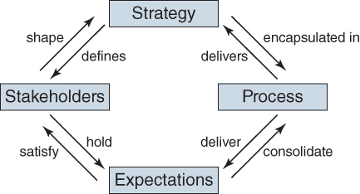
To reiterate, processes are seen as consolidations of stakeholder expectations and reflect what the organization must do. They do not include an indication of how it will be undertaken or who is to do it; this is determined in the design of the process. Processes are a device that enables a grouping of the activities which will be required to be performed to achieve a chosen outcome. In other words a collection of activities are the physical manifestations of a process. For example, the process ‘to educate customers’ visiting a zoo could be satisfied in a multitude of ways; for example, installing a multimedia computer beside each cage, providing human guides or issuing a leaflet for later reading. It is a management decision to evaluate and select the particular set of activities they decide is appropriate to achieve the process.
For more information on this method see C. Edward and J. W. Peppard, ‘Operationalizing strategy through process’, Long Range Planning, 30, 5, 1997, 753–767.

Business Process Maps
Having identified core processes, it is important to understand how they fit together. This configuration or ‘mapping’ of business processes should illustrate the relationships between them and also links to customer and supplier processes, and possibly those of other business partners. Figure 4.11 is an example of a process map that a travel company constructed, showing the organization's core business processes and the relationships between them.
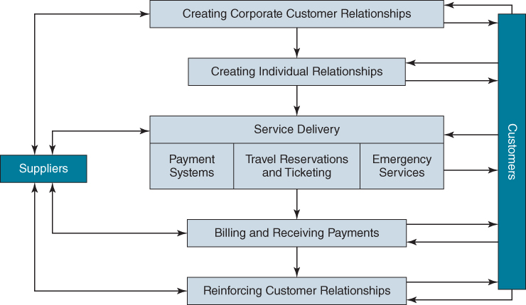
FIGURE 4.11 Process map for a travel company.
It can also be a valuable exercise to overlay the process map on to the organization's formal structure. This will clearly show how these core processes transcend structural boundaries. Figure 4.12 illustrates a generic process map for insurance companies, highlighting (hatched) areas that have the greatest potential benefits from redesign.
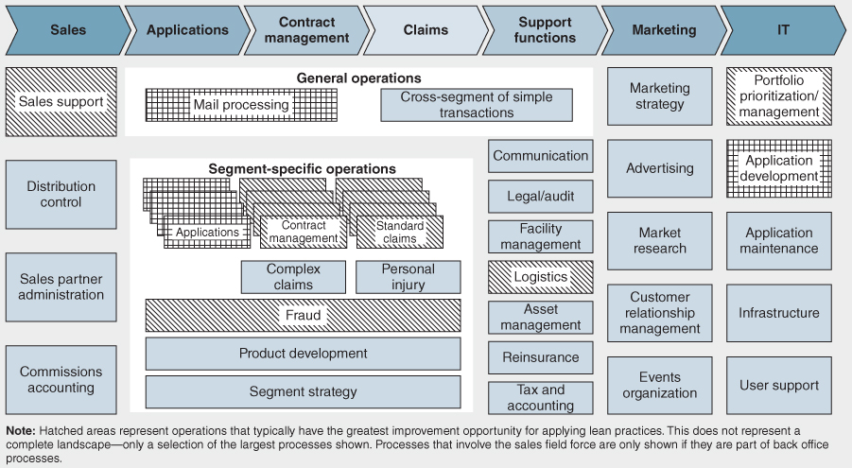
FIGURE 4.12 A generic process map for an insurance company with hotspots that often exhibit most waste.
Source: Less is More: Lean 2.0 Programs in the Global Insurance Industry © 2014, The Boston Consulting Group (BCG).

Redesigning Processes
Business process redesign in essence:
- analyses how work is done independent of organization structure;
- identifies the ideal way to carry out the work;
- develops and implements an improved means of performing the work;
- improves the interfaces and linkages with other business processes;
- provides a basis for measurement and continuous improvement.
Whilst the use of IS/IT is usually integral to the new process design or even makes the new design feasible, the redesign process should not start with IT. Rather the first question should be whether currently performed activities are really necessary to deliver the required outcome. Even if the packaged software to be used has ‘industry standard’ processes, the non-IT parts of the process and the links to other processes need to be designed carefully if significant improvement is to be achieved or, worse still, other processes' performance levels are not adversely affected.
Process redesign has wider implications than just redesigning how a process operates and implementing new technology. Job descriptions will probably need to be rewritten or new roles created, new skills and competences developed, working relationships restructured, performance measurement and reward systems may need to be revised, as well as new information systems designed and implemented. This can entail behavioural and cultural changes within the organization and in many cases closer and more trusting relationships with customers and suppliers, plus consequent changes in management's attitude toward staff, suppliers and even customers! Figure 4.13 illustrates the relationship between business processes, jobs and roles, management and measurement systems and values and beliefs.
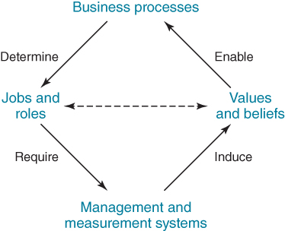
FIGURE 4.13 The business process diamond.

Approaches to Redesign
Once an organization has identified a process to be redesigned, it can adopt one of two broad approaches to redesign: the systematic approach or the clean sheet approach (or a combination of both). In adopting the systematic approach, an organization maps out and attempts to understand an existing process and then works through the activities and tasks involved systematically to create improvements in the delivery of the outputs and achieve the performance level required. The clean sheet approach, on the other hand, demands a fundamental rethink of the way that the product or service is delivered – the old process is scrapped and a new process is designed from scratch.
The choice may be influenced or constrained by other factors such as how the process is accessed and used by outside parties, including, for example, by consumers via mobile technology or comparison websites, or whether other parties can dictate expected performance levels, as supermarkets do with many suppliers.
Redesigning an already existing process is usually about making it better, cheaper, faster and/or more reliable. Better means it delivers higher levels of satisfaction to its stakeholders, particularly for customers; cheaper in that it is more efficient; faster, in that it does so more quickly, thereby also increasing responsiveness. More reliably means fewer process errors or failures. Most redesign is aimed at more than one of these improvements and in many cases all four.
When redesigning existing processes, the emphasis is on the elimination of non-value-adding activities and the streamlining of the core value-adding ones. The rules for doing this can best be summarized using the acronym ESIA: eliminate all non-value-adding activities; simplify aspects of work where possible; integrate elements of the process and automate where appropriate. Table 4.1 highlights the main areas of attention within these four domains.
TABLE 4.1Areas of attention for systematic redesign
Eliminate | Simplify | Integrate | Automate
- ♦ Over-production  - ♦ Waiting time  - ♦ Transport  - ♦ Processing  - ♦ Inventory  - ♦ Defects/failures  - ♦ Duplication  - ♦ Reformatting  - ♦ Inspection  - ♦ Reconciling | - ♦ Forms  - ♦ Procedures  - ♦ Communication  - ♦ Technology  - ♦ Problem areas  - ♦ Flows | - ♦ Jobs  - ♦ Teams  - ♦ Customers  - ♦ Suppliers | - ♦ Dirty activities  - ♦ Difficult activities  - ♦ Dangerous activities  - ♦ Boring activities  - ♦ Data capture  - ♦ Data processing  - ♦ Data transfer  - ♦ Data analysis
With the clean sheet approach, assumptions implicit in the existing process are discarded in favour of a fundamental rethink of the way the process is undertaken, or even its purpose and outputs. It is built on the premise that to achieve significant performance improvement, work within the process must be done differently. The clean sheet approach is about working back from the expected outcome or improvement target to a design that will make this happen.
The main disadvantage of the clean sheet approach is that the required organizational changes can be difficult, though not impossible, to implement incrementally. Overall, with this approach the risk of not achieving a successful new process is higher and the implementation disruption greater. During implementation, a problem faced by many organizations using this approach is that the new processes differ so fundamentally from existing ones that staff (or perhaps even customers and suppliers) can have great difficulty in relating to them. Unless great care is taken and management commitment is solid, key process stakeholders may refuse to switch to the new methods of working.
Sometimes organizations decide a new division or operation is necessary rather than try and change the existing organization. Midland Bank's decision to set up a separate telephone banking company, First Direct, Daimler's creation of a separate company to produce the Smart Car²⁰ and General Motors' Saturn business unit are examples of this strategy. This ‘greenfield site’ approach has a number of distinct advantages, not least the chance to design the facilities, processes and IT applications from scratch, taking into account the latest thinking in business practices and management and exploiting the latest technological innovations without having to deal with legacy systems. Creating the desired culture with a new workforce is also much easier than where significant changes to an existing one are required.
In reality, there is a great deal of middle ground between both methods with many organizations choosing a combination of the two. The choice between the two approaches will depend on what the organization is most comfortable with, and also on the time scales involved. Whichever alternative is selected, it is important to ensure that the analysis of existing processes is not overdone, though the danger of this is higher in the systematic redesign approach. Always remember that the objective, regardless of the approach chosen, is to obtain significant improvement in performance. Redesign of any process is essentially a creative activity and therefore more attention should be paid to the new process rather than the old, which is merely a starting point but if overanalysed can become a constraint to creativity.

Process Importance and Performance Assessment
It is vital in redesigning processes that those selected for redesign are important to the organization if worthwhile benefits, relative to the effort and risk involved, are to be achieved. This also helps prioritize any associated IS/IT investment needed. To identify the best candidate processes for redesign, it is useful to examine the criticality of the processes in relation to the business objectives and drivers, and plot this against the organization's performance in this process compared with competitors or industry averages (using benchmarking wherever possible). This importance/performance matrix,²¹ illustrated in Figure 4.14, helps focus attention on those areas that are in most need of improvement. The matrix can also be used to obtain stakeholder feedback – it is often interesting to contrast the views obtained from internal stakeholders with those from external stakeholders.
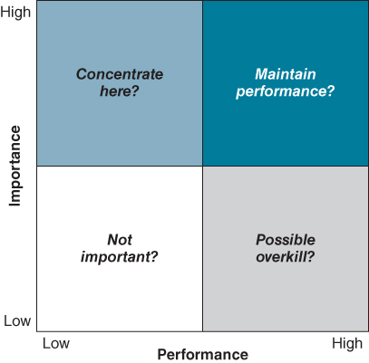
FIGURE 4.14 The importance/performance matrix.
American Express adopted a variant of this approach by selecting processes suitable for redesign: the primary criteria was the gap between their stakeholders' expectations and the current performance level plotted against the potential impact this gap could have on their continued growth.²² On the basis of these criteria, they decided to focus on two processes: travel service delivery (travel reservations and ticketing) and customer relationship management. The travel service delivery process was falling short of the expectations of both customers and shareholders as measured by the company's monthly monitoring of customer satisfaction and profit margins, both of which were limiting growth prospects. The process underlying the management of customer relationships had become so complex that it both hindered employees' ability in meeting customers' needs and was becoming increasingly costly to operate.

Evaluating the Gap between Existing and Required IS/IT Environments
The IS/IT requirements resulting from these analyses of a range of aspects of the current business strategy are in the form of ‘candidate’ proposals to acquire, develop or provision new applications or enhance or replace existing applications, or to upgrade or change the provision of IT services or resources. Unless requirements are due to high priority (strategic) business initiatives that are certain to go ahead, the IS demand and IT supply proposals will need to be prioritized against the business objectives, either on their own merits or in conjunction with the business plans that they support. The IS demand will also always include an ongoing catalogue or backlog of expressed business needs from current operations which need to be included in the prioritization.
By analysing the coverage of systems across the core business processes, it is possible to compare a wide range of information systems requirements across the whole organization and in a context related to their importance or value to the business. For example, the engineering department may wish to invest heavily in design systems that will enable products to be developed more quickly; the marketing department may want to spend money on analytics to support ‘big data’ initiatives to segment markets and develop propensity models; the sales department may want to spend money on the use of mobile IT to increase sales force productivity in managing contacts and generating orders. It would be very difficult for anybody to say which of those three opportunities should take priority for resources without clearly demonstrating how they contribute to the business strategy – ‘strategic alignment’.
The assessment of the current IS/IT environment considers the capabilities of existing IS/IT resources in relation to the known business strategy. There will almost certainly be a gap between the current resources and competences and those needed to satisfy the future IS demand. The gap identifies the requirements for change:
- Business processes in need of elimination, simplification, streamlining or redesign – often with significant IS/IT requirements, which may require new IT capabilities to deliver.
- New, extended or rationalized information resources. The list of information needs can be compared with current systems and databases to determine where the new information will come from or whether new sources must be found. Quite often, new or improved information can be produced by minor modifications to existing systems or consolidating and reconfiguring data from existing databases. While these can be addressed in the short term, other information needs may only be satisfied by developing new applications and business processes.
- Changes in IT services, suppliers, resources and competences to create the IS/IT capability required for the future. To determine priorities amongst these supply-side issues, a variant on the use of Balanced Scorecards and CSF analysis described earlier in this chapter can be used. By establishing objectives and then CSFs for the IT function, priority actions can be identified and a Balanced Scorecard can be used to track progress against the key objectives.

Summary
This chapter has considered one aspect of the process of determining the IS strategy: how to gain a good understanding of the current situation in the business and, by eliciting IS/IT requirements that are important in achieving the existing business strategy, to create a high degree of alignment between the two.
The main purpose is to identify the activities and business processes that support the objectives and strategy of the business, and the associated information requirements. The ‘fact finding’ can result in a large volume of information, which needs to be recorded in a way that facilitates analysis and interpretation. The various modelling and analysis tools described here help with structuring and the comparison of information derived from different sources. While the techniques discussed in this chapter are essentially analytical and logical, rather than creative (with the exception of the clean sheet approach for process redesign), using them will almost certainly generate a number of original and creative ideas. These need to be captured and developed where they are relevant to achieving the business strategy or improving the IT capability.
This chapter has concentrated on interpreting the current business strategy and known business needs, which usually produces short- and medium-term requirements. Chapter 5 will explore the ways in which relevant IS/IT-based innovations can be identified and exploited and Chapter 6 considers how IS/IT developments can impact the organization's industry, as well as its own business, and change the competitive environment. These analyses will produce both short-term and longer-term options to be weighed against the short-term pressures before investment priorities and any significant supply changes can finally be agreed. Chapter 7 discusses how this can be achieved to produce a coherent and comprehensive business information systems strategy.

Endnotes
1. This is usually referred to as ‘intellectual’ alignment. See Y.E. Chan and B.H. Reich, ‘IT alignment: What have we learned,’ Journal of Information Technology, 22, 2007, 316–396.2. Research has also found that most executives cannot articulate the objectives, scope and advantage of their business in a simple statement. See D.J. Collis and M.G. Rukstad, ‘Can you say what your company strategy is?’, Harvard Business Review, April, 2008, 63–73.3. J. Recker, M. Rosemann, M. Indulska and P. Green, ‘Business process modeling –a Comparative analysis’, Journal of the Association for Information Systems: 10, 4, 2009, Article 1; R. Davis and E. Brabander, ARIS Design Platform: Getting Started with BPM, Springer, 2007; A.-W. Scheer, ARIS—Business Process Frameworks, second edition, Springer Verlag, Berlin, 1998; A.W. Scheer and F. Habermann, ‘Making ERP a success’, Communications of the ACM, 43, 4, 2000, 57–61; and T.W. Malone, K. Crowston, J. Lee, B. Pentland, C. Dellarocas, G. Wyner, J. Quimby, C.S. Osborn, A. Bernstein, G. Herman, M. Klein and E. O'Donnell, ‘Tools for inventing organizations: Towards a handbook of organizational processes’, Management Science, 45, 3, 1999, 425–443.4. J. Ross, P. Weill and D. Robertson, Enterprise Architecture as Strategy: Creating a Foundation for Strategy Execution, Harvard Business School Press, Boston, 2006.5. J.P. Kotter, Organizational Dynamics: Diagnosis and Intervention, Addison-Wesley, Reading, Massachusetts, 1978.6. J.M. Ward and J. Peppard, ‘Reconciling the IT/business relationship: a troubled marriage in need of guidance’, Journal of Strategic Information Systems, 5, 1, 1996, 37–65.7. E.M. Daniel and J.M. Ward, ‘Improving the business-IT relationship with IT project portfolio management’, Cutter IT Journal, 28, 1, 2015, 20–24.8. J. Peppard and J.M. Ward, ‘Mind the gap: diagnosing the relationship between the IT organization and the rest of the business’, The Journal of Strategic Information Systems, 8, 1, 1999, 29–60.9. This model is influenced by the work of N. Venkatraman, drawing on a presentation he made at Cranfield School of Management, February 1996.10. R.S. Kaplan and D.P. Norton, The Balanced Scorecard: Translating Strategy into Action, Harvard Business School Press, Boston, Massachusetts, 1996; and The Strategy-Focused Organization: How Balanced-Scorecard Companies Thrive in the New Business Environment, Harvard Business School Press, Boston, Massachusetts, 2001.11. J.F. Rockart, ‘Chief executives define their own information needs’, Harvard Business Review, March–April 1979, 81–92. They are sometimes referred to as ‘do wells’.12. M.E. Shank, A.C. Boynton and R.W. Zmud, ‘Critical success factor analysis as a methodology for MIS planning’, MIS Quarterly, 9, 2, 1985, 121–129.13. The value of such a group approach is demonstrated by Hardaker and Ward from work in IBM. See M. Hardaker and B.K. Ward, ‘Getting things done: How to make a team work’, Harvard Business Review, November–December, 1987, 112–120.14. J.F. Rockart and A.D. Crescenzi, ‘Engaging top management in information technology’, Sloan Management Review, Summer, 1984, 3–16.15. Most of the research into business process redesign/reengineering dates back to the 1990s and early 2000s. See, for example, W.J. Kettinger, J.T.C. Teng and S. Guha, ‘Business process change: a study of methodologies, techniques, and tools’, MIS Quarterly, 21, 1, 1997, 55–80; W.J. Kettinger and V. Grover, ‘Toward a theory of business process change management’, Journal of Management Information Systems, 12, 1, 1995, 9–30; and N. Melão and M. Pidd, ‘A conceptual framework for understanding business processes and business process modelling’, Information Systems Journal, 10, 2, 2000, 105–129. For some recent studies see K. Altinkemer, Y. Ozcelik and Z. Ozdemir, ‘Productivity and performance effects of business process reengineering: a firm-level analysis’, Journal of Management Information Systems, 27, 4, 2011, 129–162; D.M. Attaran, ‘Exploring the relationship between information technology and business process reengineering’, Information & Management, 41, 5, 2004, 585–596; H.A. Reijersa and S. Liman Mansar, ‘Best practices in business process redesign: an overview and qualitative evaluation of successful redesign heuristics’, Omega, 33, 4, 2005, 283–306; and S. Sarkera, S. Sarkerb and A. Sidorovac, ‘Understanding business process change failure: an actor-network perspective’, Journal of Management Information Systems, Volume 23, 1, 2006, 51–86.16. It should be noted that manufacturing has always taken a strong process perspective. Different product types, depending on volume and variety, require differing process configurations.17. For more on the order-to-fulfilment process see W.E. Hoover Jr, M. Tyreman, J. Westh and L. Woolung, ‘Order to payment’, McKinsey Quarterly, 1, 1996, 37–49; and B.P. Shapiro, V.K. Rangan and J. Sviokla, ‘Staple yourself to an order’, Harvard Business Review, July–August 1992, 113–122.18. See M. Hammer and S.A. Stanton, The Reengineering Revolution: A Handbook, HarperCollins, London, 1995.19. For an interesting example of a hospital that was redesigned around patient flows, see J. Teboul and J. Tabet, Karolinska Sjukhust, INSEAD Case, Fontainebleau, Paris, 1995 (European Case Clearing House reference 695-008-1).20. See J. Ward, P. Stratil, A. Uhl and A. Schidt, ‘Smart Mobility: an up and down ride on the transformation roller coaster’, in Business Transformation Essentials, eds: A. Uhl and L. Gollenia, Gower Applied Research, Farnham, UK, 2013.21. The intellectual basis for this matrix is drawn from J.A. Martilla and J.C. James, ‘Importance-performance analysis’, Journal of Marketing, 41, 1, 1977, 77–79. For an extension of this work and its application to operations management, see N. Slack, ‘The importance–performance matrix as a strategic improvement priority tool in service operations’, Warwick Operations Papers, Warwick Business School, University of Warwick, UK, 1993.22. R. Ballou, ‘Reengineering at American Express: The Travel Services Group's work in process’, Interfaces, 25, 3, 1995, 22–29.

UNIT 5
INNOVATING WITH TECHNOLOGY, SYSTEMS AND INFORMATION

OUTLINE
- ♦ Understanding What it Means to Innovate with IT
- ♦ The Process of Digital Business Innovation
- ♦ The ‘push’ and ‘pull’ of Innovating with IS/IT
- ♦ Getting Management Attention for Ideas and Innovations
- ♦ Joining the Dots: the Search for Ideas
- ♦ Innovating by Leveraging Information: Exploration and Exploitation
- ♦ The Big Data Challenge
- ♦ Discovering Strategic IS/IT Opportunities from Information
- ♦ Building an Analytic Capability
The previous chapter presented tools to determine the organization's information and systems requirements, given its current business strategy. The focus is on ensuring the IS/IT strategy and plans are aligned with organizational intentions and management's priorities for a given period, usually one, but maybe two years. The techniques enable the current role that IS/IT is, or should be, playing in the business to be analysed, both critically and constructively. It is always important to understand where you are: a situation appraisal of the existing systems and how well they support and enhance operational performance, management control and the ongoing development of the business. This includes the extent to which the applications enable the separate business activities, processes and functions to perform harmoniously. This implies an understanding of the information relationships of the business, both internal and external, as well as information processing requirements. Often, the analysis reveals areas of deficiency, obsolescence, ineffective linkages and poor utilization of existing information. Dealing with the critical inadequacies – ensuring IS/IT is not hindering current business performance and is not a potential or real source of competitive disadvantage – is a key part of the strategy development process.
As described in Chapters 1 and 2, adept investment and deployment of IS/IT can enable new strategic options to be developed, thus shaping the future strategy of the business. This identification and assessment of new IS/IT application areas requires a degree of creative thinking, as well as analysis of business options, to determine the potential impact of IS/IT on the business. This chapter focuses on innovation in the context of the IS/IT strategy, identifying a number of approaches used by organizations as well as factors that impact the process of identifying innovative applications and new business opportunities.
Potential IS/IT investments identified in the search for sources of competitive advantage or new ideas and innovations to create new business opportunities are positioned in the ‘high potential’ quadrant of the application portfolio introduced in Chapter 1. Such investments are speculative and offer the organization a future perspective. While this and the following chapters are concerned with the generation and evaluation of ideas and technologies, Chapters 8 and 9 will look at the management of ‘high potential’ investments in the context of the overall investment portfolio.

Understanding What It Means to Innovate with IT
Discussions around innovation in the context of IS/IT can often be confusing. Some chief information officers (CIOs) we have spoken to about innovation made references to deploying automated IT service management, virtualizing the data centre or using Amazon's Infrastructure as a Service (IaaS) as examples of recent IT innovations in their organizations. We would characterize these as cases of ‘IT innovation of IT’. This is not to denigrate this kind of innovation; it is important for CIOs to reduce year on year the cost of IT supply, as well as improve the agility and resilience of the IT infrastructure and create ‘digital options’.¹ However, such innovation typically does not result in innovating the organization's products and services, processes, customer experience, capabilities or business models.²
The first decision any organization must make in relation to innovating with IT is whether it actually wants to be an innovator. This might seem obvious, but our experience is that organizations often talk about being innovative but do not fully understand what this actually means. By seeking to be innovative, an organization is, in effect, becoming an early adopter of a new technology or application (see Figure 5.1) as a means of pursuing competitive or strategic advantage from IS/IT.
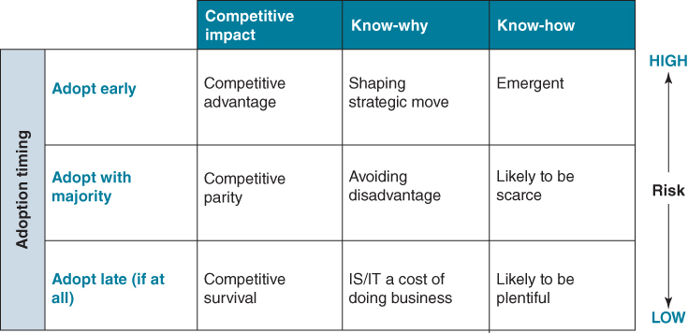
FIGURE 5.1 The adopter's dilemma: balancing opportunity and risk.
There is, of course, some risk attached to being an early adopter. In return for accepting this risk, the organization generally demands a higher return for the investments that it makes than if it merely adopted the technology or idea with the majority in the industry; this return converts to competitive advantage. The high level of risk is essentially due to the lack of know-how in relation to the innovation. As no other organization has previously deployed and used the technology or implemented the idea (if it had, it wouldn't be novel), this know-how ‘to do it’ is only likely to emerge during implementation. Early adopters of new technology may also find it to be immature, with bugs and other deficiencies that may only become apparent with usage. This is all new territory that requires careful assessment and navigation in order to fully understand the risks.
Even if an organization chooses not to be an ‘early adopter’, it must understand the role that technology plays in the industry and how it is shaping industry dynamics. As we saw in Chapter 1, in many industries, technology is changing the ‘rules of the game’ and the basis of competition. Organizations cannot compete in these industries without extensive use of IT, as the industry is increasingly virtualizing and being defined by IT as core processes move increasingly online. We saw in Chapter 1 that few industries, including the public sector, are immune to the disruptive impact of IT. Looking to proactively use IT as a source of competitive differentiation is a strategic choice that the organization's executive must explicitly endorse and actively support.

Cutting-edge versus ‘Old’ Technology: Busting the Innovation Myth
One of the myths that we would like to dispel is the tendency to equate innovation with deploying cutting-edge or ‘bleeding-edge’ technology. This is not necessarily the case and there are many great examples of innovations using technology that had been around for many years. Of central importance is the novelty of the idea. Of course ideas also emerge out of the capabilities provided by newly available technology, but more often it can be an idea that harnesses ‘old’ technology but in novel ways.
For example, London-based men's boutique Social Suicide ran a discount campaign during the store's 2010 winter sales, based on the amount of mentions the shop got across various social media platforms like Twitter, Instagram and Facebook: the more mentions, the greater the discount. The idea was that customers would promote the store through social media in order to increase the percentage discount offered by the store. While these social media technologies had been around at that time for some years, this was the first occasion they supported a campaign in this way.
The applications of ‘old’ IT can also impact process innovation. For example, to tackle the problem of counterfeit drugs in Africa, drug companies have recently begun using mobile phones and text messaging (i.e. SMS), a technology that has been around for over 15 years. When customers purchase a packet of tablets, they can now ‘text’ to a specified 10-digit number that is embossed on the packet, immediately receiving confirmation if the tablets are from a legitimate source.
Organizations also have large investments in IT assets – often referred to as legacy – that can provide opportunities for innovation.³ Indeed, agility can, in part, be defined as the use of existing IT capabilities to rapidly generate new business value, while limiting costs and risks.⁴ IT infrastructures such as Enterprise Resource Planning systems (ERP), networks, business intelligence and analytics capability all offer opportunities for harnessing existing investments for new uses and creating new sources of value. Electricity, companies, for example, can use their existing broadband capability over their power lines to enable entirely new services, like real-time power monitoring and metering of supply. This has led US energy provider Duke Energy to characterize itself as a ‘technology company disguised as a utility’.⁵
Information is also a resource that can provide potential for innovation, particularly when combined with information from other sources.⁶ While websites such as ebookers.com, skyscraper and Expedia disrupted the airline booking business by functioning as self-service travel agencies, more recent start-ups such as Gogobot are introducing new innovations that take advantage of the opportunities of information aggregation. Gogobot users, for example, link up their Facebook and Twitter accounts to crowdsource trip recommendations from people in their social network. Las Vegas Casino Harrah's is using its information about customers to understand the drivers of profitability and to create different value propositions for different customer segments.⁷ Cities are integrating information from a variety of once separate sources, in different agencies and departments, to provide intelligent transport solutions for citizens and visitors. For example the PlanIT Urban Operating System⁸ is a real-time integrated sensing, control and security system designed to support intelligent, sustainable buildings and urban infrastructure.
Information itself can be as a source of innovative opportunities when it generates new knowledge or understanding that can have strategic potential. Using data and information to uncover new knowledge is explored in more depth later in this chapter.

The Process of Digital Business Innovation
While many definitions of innovation can be found, ours is that it is simply the successful exploitation of ideas. Ideas themselves are the result of a cognitive process and represent the combination of business opportunity with the capabilities of information and IT. The challenge, of course, is to identify ideas, nurture those with the greatest potential through to implementation and to appropriate any expected value.
The IT innovation process is no different from the process typically followed in many organizations in relation to product and service innovation. Indeed, continuous successful innovation requires a systematic process – companies reporting a track record in innovation with IS/IT have a defined process, compared to those who either do not or have an ad hoc approach.⁹ Essentially, the task is to capture a large number of ideas, but to quickly filter out those that are unlikely to have any traction for the business and eventually choose the ones likely to have the biggest impact. As one CIO reflected ‘to fail safe, fail fast’ and not devote scarce resources to those that are unlikely to have a chance of success but at the same time not stifle the generation of ideas.
The innovation process itself can be seen as comprising five stages: idea generation, awareness, evaluation, implementation and assimilation.¹⁰ Often depicted as a funnel, these stages are illustrated in Figure 5.2, with multiple ideas coming into the mouth of the funnel with a small number making it through to implementation and adoption.¹¹
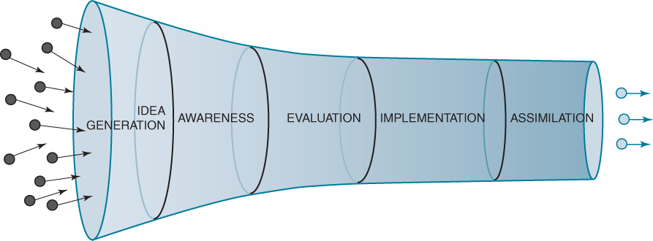
FIGURE 5.2 The IS/IT innovation process.
Idea generation: This stage involves identifying, understanding and appreciating the innovation and the opportunity it potentially offers or the problem it solves. This stage is concerned with generating new ideas, discovering new technologies and envisioning how they could potentially be leveraged. For example, some organizations have instigated formal technology awareness programmes to bring new technologies to the attention of management and foster the generation of ideas. Others have a dedicated individual or a team to proactively seek out new and emerging technologies or run competitions where staff can pitch ideas, the best of which are selected for further development.
Awareness: For those ideas that emerge from the IS/IT unit and deemed to have potential, getting the attention of management can be a challenge. This stage is concerned with ensuring that buy-in for the idea is achieved and might entail developing a prototype to ‘prove’ that it works and demonstrate the potential benefits. It will also probably require the CIO to have strong relationships with his or her peers and the ability to influence colleagues.¹²
Evaluation: This includes deciding whether, how and when to undertake the innovation and make resource commitments, which is normally based on business judgement – managers' opinions of the potential of the ideas, not just quantitative criteria. Those ideas not expected to have a major impact are filtered out. This task can often require conducting a pilot implementation to understand better the innovation, see whether the benefits are actually achievable and identify the risks associated with the further investment.
Companies that have a formal process typically use a number of ‘stage gates’ or filters to assess ideas. For example, a multinational oil and gas company evaluates technologies against business relevance, technological, economic and supplier compatibility criteria although not always in that order. Some of the questions they ask before an idea or technology moves through a gate include:
- Business relevance filter – Is the technology applicable to a current business problem or need? How novel is the new technology? Does it have the potential to provide a new source of competitive advantage, or is its impact likely to be in the areas of improving operational efficiency and cost reduction?
- Technical compatibility filter – Is the technology compatible with existing IT infrastructure and business application investments? How easy or difficult will integration with existing IT components be?
- Economic filter – Is the technology affordable or cost prohibitive within approved IT operational and capital budgets?
- Supplier compatibility filter – Is the technology commercially viable or still in the early stages of development? Is the vendor a viable company and does it meet vendor acceptance criteria? Is this a company we want to do business with?
Once a new technology clears these evaluation filters, the process of business engagement and experimentation with a proposed business solution begins.¹³
Implementation: This stage is concerned with undertaking a project or programme to deploy the technology and managing any change or diffusion that may accompany the implementation, which may include changes to be made by customers or suppliers within their organizations. For example, with the adoption of Rolls-Royce's ‘Power by the Hour’, customer airlines no longer require their own maintenance, repair and overhaul (MRO) operation and the entire infrastructure that this entails.
Assimilation: This final stage is where the new innovation is absorbed into practices and routines within the organization or fundamentally transforms the dynamics of competition within an industry or the structure of its ecosystem. The development, take-up and evolution of mobile phone payment systems for small payments to replace the need for cash is one such example of adoption of a new technology.
Box 5.1 describes the IS/IT innovation funnel at UK retailer John Lewis Partnership.

BOX 5.1

The innovation funnel at John Lewis Partnership
The following figure illustrates the process that UK retailer John Lewis Partnership (JLP) uses to both track and communicate its IT innovation efforts. The funnel was originally conceived and used by the IT organization as a way to report and keep track of the dozens of new information technologies that may have an impact for JLP. The success of this method in IT has caught the attention of the business side, with one business group now using the funnel to track and report business projects.
The funnel is intended to be a living document, reviewed and updated every month, showing at a glance the progress of key current technologies through each stage of the innovation process:
- Identify – A new technology that has been identified by an individual team or group as being of potential benefit.
- Candidate – The Technical Architects Group (TAG) has agreed that the technology is of potential benefit to the business. Usually at this stage they are considering suppliers' offerings in this technology area.
- Propose – A formal proposal has been written recommending the use of the technology and providing a cost/benefit case for it.
- Develop – Produce and test a prototype business application.
- Trial – A limited trial of the technology is under way.
- Deliver – The technology is being used in a live environment, although not necessarily company-wide.
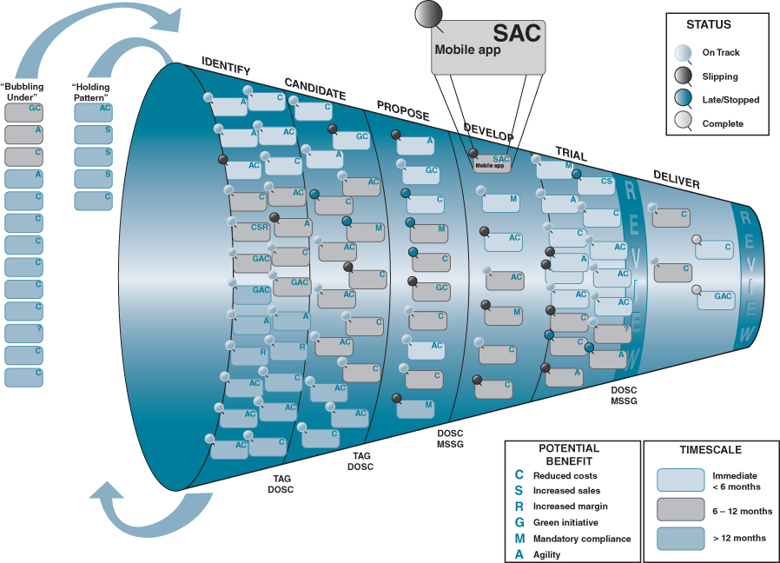
Source: John Lewis Partnership.
Technologies progress from left to right through the funnel and each technology's label is coded and classified to indicate its impact, potential benefit and current status. There are two additional columns outside the Funnel. The far left column contains technologies that are currently ‘bubbling under’, waiting to get into the funnel and the next right-hand column contains technologies that have previously been in the Funnel but are now in a ‘holding pattern’ waiting for re-admittance into the evaluation process, perhaps having being deemed as either immature or that the company is not ready for them. The focus of the funnel is on technologies that are within 12–18 months of delivery. The company also maintains what it refers to as a ‘radar diagram’ – essentially a portfolio – of technologies that are more ‘blue sky’ in nature, anything up to 10 years away from delivery. This radar diagram is illustrated in Figure 4.5.

Open and Closed Innovation
In most organizations, innovation activities have tended to be conducted by people employed by the organization. This approach to innovation has been referred to as closed innovation, as it is conducted inside an organization's boundaries and closed to outsiders. Usually, it is a group of specific employees that are tasked with undertaking innovation activities. Today, however, many are looking to ‘democratize’ innovation and involve staff from right across the enterprise.¹⁴ Some organizations are deploying collaborative platforms to harness the collective knowledge and intelligence of their staff. Others are opening their innovation process – so-called open innovation – and reaching out to customers and business partners in their quest to innovate.¹⁵ While ‘closed’ innovation approaches are internally focused and limited by the resources available within the firm, ‘open’ innovation seeks to access and leverage the abundant knowledge and resources existing outside the firm to co-create value with external innovators.
‘Open’ models enabled by collaborative social media technologies have greatly facilitated innovation through cooperation between organizations and their current and prospective customers. Online company Threadless is an example of a company where its customers do the market research, design the t-shirts and decide which t-shirts should be manufactured and sold. Open models have also resulted in vibrant online user innovation communities such as Dell's Ideastorm, IBM's Innovation Jam and food company Danone's community for its Activia brand. These initiatives are distributing problem solving to an unknown group in an open call for ideas and solutions.¹⁶
There are also websites such as Innocentive and NineSigma where companies can post problems they are currently experiencing in their business, seeking solutions. Sometimes there is a cash award offered to anyone solving the problem. A number of organizations have also begun running ideas contests, offering significant prizes for those judged to be the best. Automotive manufacturer BMW has run an Urban Mobility Services Idea Contest, encouraging the generation of ideas that could be applicable for its business in the distant future. Box 5.2 describes a contest launched by Volkswagen.

BOX 5.2

Volkswagen's App My Ride
Volkswagen's App My Ride community (http://www.app-my-ride.com/) centred on two separate yet interconnected activities: idea generation and app (application) development. Participants were invited to submit ideas to the community idea ‘pool’, where ideas were subsequently adopted and elaborated upon by other developers in the community. This dynamic emerged as a core value within the community and involved not just the sharing of feedback but also the sharing of detailed technical knowledge and ideas for further development. Membership was comprised of a mix of technically minded members and blue-sky dreamers.
Volkswagen representatives, who actively contributed to the community, provided leadership and guidance to participants. This leadership proved to be an additional driving force within the community, with members striving to satisfy the requests of other users or Volkswagen representatives. In the words of the contest organizers: ‘the “App my Ride” contest by Volkswagen seeks Apps and Ideas for possible Apps for a prototype of a future Volkswagen infotainment system. The goal of the contest is not only to gain innovative applications, but also to involve interested users, coders and developers into the process of developing Apps.’ The process generated 389 ideas for apps and 96 were developed by the 600 member community who also evaluated and commented on the apps and ideas.
Website: http://www.app-my-ride.com/index/all-contributions
We noted in Chapter 1 that some governments are now making data freely available for external parties to leverage.¹⁷ So-called ‘open data’ initiatives have seen new digital services being offered to citizens that use this public data. For example, the Department of Transport in South Australia, like many government departments the world over, had been operating under tight budget constraints. The CIO was keen to launch an app for mobile phones enabling public transport customers to look up timetables and check the status of trains and buses but didn't have either the budget or in-house skills.¹⁸ He decided to make the relevant data available (i.e. timetables, bus and train locations, congestion data etc.) in an open data initiative, inviting third-party developers to build applications utilizing this data. These software houses generate revenue by selling the app on the iTunes store while citizens get a service providing public transport information that they value.
Although the innovation process comprises the five interdependent stages described above, the remainder of this chapter focuses primarily on the first two. This requires addressing questions such as:
- How does an organization become aware of new IT and of new innovations that may result from applying these technologies? Where do ideas come from?
- How does an organization make sense of the innovation? How does it assess the capabilities of new information technology from a variety of perspectives, including relevance to the business, commercial impact, and technical compatibility?
- How does the IT organization engage with the business to build IT awareness and promote innovation opportunities? How do the business and IT work together to construct experiments and pilot projects to test the potential of new information technology?
Chapter 9 will address issues around evaluation. Implementation and assimilation are beyond the scope of this book, and although well established and understood, are not without problems in practice.¹⁹

The ‘push’ and ‘pull’ of Innovating with IS/IT
We have already alluded to the challenge that organizations face identifying potential ideas enabled and shaped by IS/IT. While ideas can come from many sources, they can be characterized as being either of a ‘push’ or ‘pull’ variety. Those ideas coming from within the business or from customers or business partners are usually referred to as IT pull. Push is where the idea comes from outside the business, including IT suppliers, or from the IT organization and is ‘pushed’ onto the business.
We have found that those working at the ‘coalface’ of a business often struggle to envision new digital possibilities. Innovative ideas emanating from within the business or from customers tend to be more of an incremental nature: a little better, faster or cheaper. This is not to belittle this type of innovation, and indeed it can be very valuable, but its competitive impact is likely to be limited. Henry Ford captured this dilemma very well when he noted that if he had asked his customers what they wanted they would have said a faster horse! But he was coming with something radically different: a so-called game changer. The new motor vehicle technology that he was promoting was a paradigm shift in relation to personal transportation.²⁰ The Internet was a game changer in the 1990s and continues to be today, particularly with mobile and ‘the Internet of Things’.²¹ There is also a confluence of new technologies like the cloud, smart technologies, analytics, machine learning and social media that provide the inspiration for many of the opportunities for innovation today.
Being an incumbent in an industry can often make an organization blind to an opportunity or threat until it is too late. Why, for example, did the major book retailers not see both the opportunity and the threat that the Internet posed to their business at a time when the media hype around the World Wide Web was at its highest? Or why was it a start-up, Zip Cars, and not one of the global car rental companies that launched a car sharing and car club service? Using a range of technologies (Internet, RFID (radio frequency identification) iPhone and Android apps, text messaging), Zip Cars (and entrants such as CityCars, Cars2Go) are addressing a customer segment – car usage for very short periods of time by urban dwellers – that traditional rental companies have avoided or have not been able to satisfy with their existing value propositions or delivery infrastructure. Unable to compete, Avis Budget Group eventually purchased Zip Cars.
Some organizations that identify an idea first or lead the way in developing a new technology often fail to exploit it. This phenomenon has been referred to as the innovator’s dilemma,²² which suggests that successful companies can put too much emphasis on their success in meeting customers' current needs and fail to adopt new technology or business models that will meet customers' unstated or future needs. This situation is illustrated in Figure 5.3. While prescription typically advises listening to customers, they can sometimes have difficulty articulating what exactly they want. Moreover, what about those potential customers the organization currently doesn't serve?
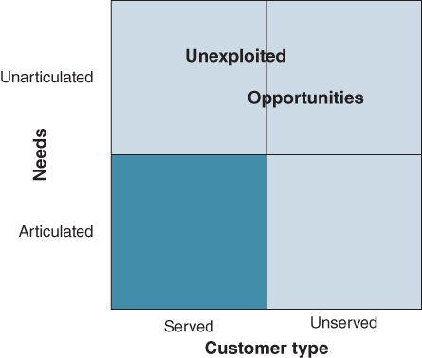
FIGURE 5.3 Going beyond being customer-led.
A disruptive innovation is an innovation that helps create a new market or ecosystem, and eventually goes on to disrupt an existing market and its ecosystem. This can happen over a few years or even decades where an earlier technology is displaced. The term is used in business and technology literature to describe innovations that improve a product or service in ways that the market does not expect, typically first by designing for a different set of consumers in a new market and later by lowering prices in the existing market.
In contrast to disruptive innovation, a sustaining innovation does not create new markets but evolves existing ones with better value products or services, allowing the firms within to compete against each other's improvements. Sustaining innovations may be either ‘discontinuous’ (i.e. what is often referred to as ‘transformational’ or ‘revolutionary’) or ‘continuous’ (i.e. ‘evolutionary’).
For most organizations, IT push innovation leads to more radical or ‘game changing’ innovation. Such game changing innovation does not, however, come without risk; by definition there is usually no reference point. Because of the uncertainty in outcomes, it is often more difficult to obtain funding for technology-push projects and therefore many CIOs simply ignore or minimize such efforts and focus on supporting and aligning with existing demand-pull requirements. Moreover, we cannot overlook the fact that in a considerable number of organizations, the relationship between the IT unit and the business can be strained and its reputation poor, further impacting any real business engagement or appetite to explore ‘push’ opportunities. To address this issue somewhat, research provides strong evidence that a separate budget for IT innovation must be set aside if it is to take hold.²³

Factors Impacting the Process of Business Innovation with IS/IT
In addition to the push and pull factors, there are forces that impact the IS/IT innovation process in an organization. These are summarized in Figure 5.4.
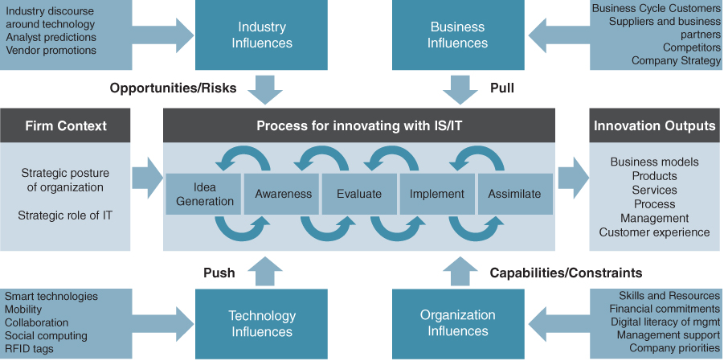
FIGURE 5.4 Process for innovating with IS/IT and factors influencing it.
Firm strategic context: An important determinant of the extent of innovation in any organization is the role that information and IS/IT plays in its strategy. As mentioned earlier, a key choice organizations face is whether to be an ‘early adopter’, which by definition assumes an innovation posture. Essentially, is information or IS/IT seen as a source of competitive differentiation or an administrative expense to be minimized? This is a choice the leadership team must make.
Industry influences: In any industry there are a myriad of different discussions taking place at any one time. Some of these relate to new technologies, others to business challenges, regulation, customers, supply chain, markets etc.²⁴ Typically, the discourse around IT is driven by trade bodies, vendor marketing, consultant promotions, pronouncements of analysts and other IT ‘fashions’,²⁵ many of which have a vested interested in promoting a particular position. As IT has matured, both IS/IT and business managers have become increasingly sceptical about the hype generated around new technologies and are adopting a more cautious stance – perhaps due to having been bitten in the past. It is also difficult to keep an idea secret for very long, particular when it is in production and the innovation becomes the talk of the industry, fuelling its wider adoption and probably lessening its competitive impact. The CIO of a global law firm, for example, pointed out that:
“The legal industry is very incestuous, lawyers are mobile and where clients use the services of many firms and everybody talks to everybody else, lots of conferences and events where everybody goes along and talks and every firm knows what every other firm is doing”.
Organizational influences: The organization itself can both enable and constrain innovation activity. The factors most important for business innovation are: top management support, digital literacy of the senior management team, a dedicated budget and the extent of CIO influence in the organization,²⁶ all of which impact the resources that are made available in support of IT innovation. The relationship between CIO and business colleagues and the reputation of the IS/IT unit are also significant issues affecting the innovation process. Organization culture also influences the extent of innovation, particularly the attitude to risk – innovation is risky. The digital literacy of the leadership team is an important prerequisite. The CIO at the global law firm, which has a reputation for innovating with IS/IT, reflected that:
“I think we are blessed because there are a few key people at the top who really do believe in innovation and really see the value of technology. Our CEO loves technology and sees the potential role it can play and is prepared to spend money on it”.
If IS/IT is outsourced, there are likely to be additional challenges to address. Indeed, many outsourcing deals are predicated by the belief (at least from the client side) that a ‘world class’ strategic partner will also be a source of new ideas. This is where there is usually disappointment. Achieving innovation in the context of an outsourcing arrangement is discussed in Chapter 11.
Despite the obviously critical role of IT, we suggest that if an organization really wants to innovate with IT, responsibility must be taken out of the IS/IT unit. This is not to suggest that it should not also be a focus within this department, but it is more often innovation around IT infrastructure and services – what we earlier referred to as ‘IT innovation of IT’. Some organizations that can point to consistent innovation have established a separate unit dedicated to identifying business innovation ideas that are shaped by IT.
At energy company BP, IT is recognized by senior management as something that can transform the business. The organization has established a dedicated IT innovation team to identify candidate technologies that might have application in the more than 100 businesses that make up the group. This team has the mission ‘to solve business problems that defy traditional IT solutions through adoption of external technology innovation’. Team members meet regularly with business executives to ferret out opportunities for which digital technologies could provide opportunities for innovation. During discussions with business unit executives, they seek answers to the question: ‘What do you wish you could do in your business if technology could be found to create or enable it?’

Getting Management Attention for Ideas and Innovations
While ‘IT push’ opportunities may provide the ‘game changers’, it is often a challenge to get business management attention, particularly if the idea or innovation emanates from within the ranks of the IT unit.²⁷ Reasons for this include the difficulty in getting engagement, as executives are too busy; weak relationships between business and IS/IT managers; the idea is seen as too risky or a reluctance of business management to engage with ideas that challenge deep-seated assumptions and might change the ‘status quo’; and the lack of credibility of the IT unit to deliver.
One word, perhaps more than most, captures the challenge of getting management attention: the proposed innovation lacks ‘legitimacy’. So while an idea might be very relevant and offer significant opportunities, it can still fail to gain any traction in the organization. As discussed in Box 5.3 we are aware of ideas that failed to get much traction, simply because they did not have legitimacy. In some cases the same ideas were subsequently exploited by a competitor. Achieving legitimacy for an idea, no matter how good it may be, can be a challenge.²⁸ What drives legitimacy is the credibility of the person promoting the idea, timing and the understanding of the audience of the innovation and its impact.

BOX 5.3

An idea that initially failed to get attention
One CIO told us the story of how he had been hired by a global medical distribution company. His previous background in supply chain and logistics management and his proven success in previous organizations was one of the reasons that he was hired, as this new company had a history of supply chain ‘glitches’. Not long into his new role, he made a presentation to the executive leadership team about how they could streamline key areas of their product distribution process, with the innovative deployment of RFID tags, mobile technologies, and redesign of aspects of the logistics process. While he considered it was a ‘no brainer’, he failed to convince the executive team, particularly the CEO, of the validity of the idea and its potential.
One morning, about 4 months later, the CEO stopped by his office, reminded him of his earlier proposal and suggested that he begin a pilot as he had recently been giving some consideration to his idea and thought that it was now right for the company. He also announced that he would sponsor a pilot. Later that day, the CIO found out that the previous evening the CEO had had dinner with their biggest customer who suggested the same idea the CIO had raised all those months earlier. His reasoning? The idea now had legitimacy and this legitimacy had been given by the customer.
The CIO reflected that perhaps in presenting his original proposal he lacked credibility, as he was new into the organization and had not yet built up sufficient levels of trust; there was also a history of failed IT investments in the organization prior to him joining. He believed the idea may have had ‘legs’ if it had been presented by someone from the business area that was likely to see the major performance improvement. He also mused that perhaps he had not explained it in a way that his audience understood the innovation. Maybe his timing was just out and the executive team were preoccupied with what they considered more pressing issues.
A CIO at another firm noted that if he had a really difficult business case that he really wanted to implement, all he had to say was that one of their competitors was about to deploy the same technology. Another CIO we spoke to mentioned that one board member would always ask ‘what do Gartner say about this?’ when an IT investment proposal came for discussion or approval.ª As he was always expecting this question, he had a prepared answer, which then gave the proposal added legitimacy. Whatever the reason, without this legitimacy, getting management attention will prove difficult if not impossible.^{b}
Notes:
ª For a sociological study of the influence of Gartner's ‘Magic Quadrant’, see N. Pollock and R. Williams, ‘The sociology of a market analysis tool: how industry analysts sort vendors and organize markets’, Information and Organization, 19, 2009, 129–151.
^{b} For a study of building legitimacy for IT innovations, see E. Kaganer, S. Pawlowski and S. Wiley-Patton, ‘Building legitimacy for IT innovations: the case of computerized physician order entry systems’, Journal of the Association for Information Systems, 11, 1, 2010, 1–33.
Sometimes a prototype, pilot or other form of proof-of-concept can be necessary to give the idea greater credibility. Pushing an idea by creating trusting relationships, understanding the objections and the audience, working towards a win/win situation and using emotion as well as facts to sell the ideas can all help ideas get attention. Box 5.4 suggests a number of possible ways to gain legitimacy for ideas. These suggestions resonate with research that emphasizes the importance of the social dimension (e.g. shared language, common systems of knowing and trust) in achieving alignment between business and IS/IT.²⁹

BOX 5.4

Gaining legitimacy for ideas
Build the trust of those who are likely to be affected. Generally, what this means is that they need to know you and feel that you have the best interests of all stakeholders – most especially themselves – at heart. This is the slow part. In most cases, you need to spend time when formulating your ideas talking to those who are or will be affected; listening to their ideas, exchanging thoughts, getting to know and trust each other. When you are open to stakeholders' input you'll create trust and often develop partners who will support you when it comes time to make the final proposal.
Be honest about upsides and downsides. How many times have you seen someone lose out on persuading decision makers because they downplayed or did not address the downsides? Either they were so wrapped up in the passion they felt about their proposal that they could not see the negatives, or they were just plain dishonest. Everything has a downside, and the decision makers know that. Make sure you know what it is and be honest about the efforts it will take to overcome these obstacles.
Understand your audience well. Audiences are more likely to be interested in the facts of a proposal – how long it will take, what it will cost, what resources will be needed – than how important you think something is, or how passionate you are about it. Other audiences will want something else, and it will be important to understand what that is and to feature it prominently in your arguments.
Work toward win/win. You'll never make everyone happy, but you can minimize the damage or negative reactions from the stakeholders who are most affected by what you're proposing and still remain honest about the hurdles.
Use more than information. Information and facts are very important in presenting ideas. However influence is most effective when you use compelling language and show your beliefs about what you're proposing in a way that is emotionally expressive. If your audience can see your excitement, they are more likely to approve of what you are proposing.
The IT innovation team at BP are aware of the importance of an idea having legitimacy. For emerging technologies they select those to push, not necessarily based on economic criteria, but on the amount of energy or ‘buzz’ they expect them to generate in any business unit. Indeed, the IT innovation team are partly compensated based on the take-up of new technologies, so they are only too aware of not spending time promoting a technology they know will be difficult to ‘sell’ to their business colleagues. They also acknowledge that this may not be ideal, but that they too operate under time and resource constraints. Despite the demonstrated success that has been achieved at BP for innovations shaped by IT, they emphasize the strong advocacy role required with IT push and acknowledge they are constantly fighting to get management attention. The advice of a CIO at a UK government department, based on the lessons that he has learned promoting an IT innovation agenda, is to find the business champion before going too far down the line of deploying the technology.

Joining the Dots: the Search for Ideas
Innovative ideas can come from anywhere in the organization and innovation should not necessarily be seen as the responsibility of a specific organizational unit. The key to generating ideas is the ability to ‘join the dots’; that is, to envision future possibilities due to technology awareness, business understanding and alertness to opportunities. Although there is no doubt that many successful innovative ideas can be put down to luck!
Technology awareness: This requires an understanding of technology and its capabilities, but not necessarily a deep technological knowledge – rather an appreciation of the functions and capabilities of the technology. Also referred to as digital literacy, it is achieved by understanding the information handling capabilities of technology. For example, in the aerospace sector, engineers talk about IVHM (Integrated Vehicle Health Management) which is, in essence, concerned with collecting performance data from the various systems, subsystems and components on an aircraft. For Rolls-Royce, it enabled them to innovate their business model and use this data to add value for customers. The technology involved is indeed very sophisticated – consider the temperatures in which sensors collecting performance data within an engine casing must operate – but the challenge is to derive new ways of harnessing and using information and create new business models.
Technology awareness amongst all employees is improving. For example, most ideas about potential applications of social media now come not from IT professionals but from other employees, who are using the technologies in their personal lives, understand them (although generally not from a technical perspective) and can see potential opportunities for their organizations.
Business understanding: This demands understanding of the organization's strategies and capabilities, the wider ecosystem within which it competes, the industry value chain and market dynamics. In the search for opportunities to deploy IT, the challenge is to recognize problems within the organizations and discontinuities in the industry, particularly those defined by information asymmetries.
Alertness to opportunities: Those charged with leading and managing innovation need to be alert to new opportunities. This can be a conscious effort, but is often a spontaneous reaction. While employees can be given tools to promote creativity, having this opportunistic mindset is often an innate ability of a person – a trait often associated with entrepreneurs. Having an entrepreneurial CIO is one way of ensuring the organization is continually alerted to new ideas and options – see Box 5.5 for some examples.

BOX 5.5

The value of entrepreneurial CIOs and IT professionals
Some CIOs would consider themselves to be very entrepreneurial. For example, the Vice President of Innovation at Owens & Minor, a large wholesale distributor of medical supplies in the United States with over $5 billion in annual revenue, is a technology entrepreneur by background having created several small technology start-ups in healthcare. Owens & Minor bought one of his companies and he became CIO.
The head of the e-business unit at global law firm Allen & Overy, understands the client environment and working with clients, but he also understands technology and how to package the firm's services.
To be hired as a programme manager or senior engineer at Google, an individual must have the right combination of ‘entrepreneurial DNA’, what they define as broad technical talent and intellectual agility.ª
At BP, they are very selective in hiring for their IT innovation team.^{b} The unit seeks people with a strong background in IT technologies, but not in-depth expertise. Members of the team are not expected to be the sources of new technology. Rather, they need to be able to interact with the broad ecosystem the company has cultivated, develop an overview of a given area, and quickly understand trade-offs among the available options. BP also requires most of the team to have experience in a business area of BP, for example exploration, oil and gas production, refining or retail marketing. Other characteristics it looks for include: openness, self-starter, passionate, imaginative and good influencing skills.
Notes:
ª See R.C. Wolcott and M.J. Lippitz, ‘The four models of corporate entrepreneurship’, MIT Sloan Management Review, 49, 1, 2007, 75–82.
^{b} Some of this description is taken from R.C. Wolcott and M.J. Lippitz, BP's Office of the Chief Technology Officer: Driving Open Innovation through an Advocate Team, Case Study, Kellogg School of Management, Northwestern University, 2007.
These three domains of technology awareness, business understanding and alertness to opportunities are interdependent and are the vital ingredients to coming up with ideas. There is no magic formula for generating ideas. The message is that companies have to just persevere with their initiatives or, put another way, to ‘manufacture serendipity’; what might seem a serendipitous idea – the ‘ah-ha’ moment – is actually the result of a more orchestrated process that may have included many activities such as workshops, technology awareness programmes, vendor presentations and advocacy by the innovation team.
Organizations can instigate formal technology awareness programmes for executives, with the objectives of education and triggering ideas due to their deep understanding of the business and industry, as well as knowledge of organizational problems and issues. While they may not understand technology or indeed be aware of the latest advances, such programmes are run to spark ideas. Could we do this? Why can't we do that?
A number of organizations use IT analyst companies like Gartner and Forrester, management and technology consultancies or IT vendors to keep them abreast of technology developments.³⁰ One retailer, for example, has an outsourcing relationship with IBM Global Services. They share their strategy with IBM, while IBM keeps them abreast of emerging technologies, and together they frame new ideas for evaluation. However, another CIO had inherited a large outsourcing contract with a major supplier but found that they were not particularly entrepreneurial and that their contractual vehicles did not encourage them to be. While he questioned whether they actually really understood his business, he also cautioned that outsourcing vendors can be negative about technologies from companies they don't have a relationship with, despite the often obvious potential.³¹
Research highlights the importance of regular conversations between IT specialists and business staff, particularly between the CIO and his or her peers. Such informal discussions have been shown to be a key determinant/indicator of the extent of alignment of an organization's IS/IT investment portfolio and its strategy,³² and also a critical factor for IT innovation. Our research and experience points to the importance of the digital literacy of the CEO and senior leadership team and them having strong relationships with the CIO, if the organization is to successfully leverage IS/IT.³³
It is this ability to ‘join the dots’ where the CIO and IT unit can shine, particularly those who understand an industry and have a deep knowledge of customers.³⁴ Working across the organization they are aware of the problems and opportunities that executives and business units face: where integration is lacking or standardization might reduce costs and increase simplification or how analytics could really help executives in exploring data. Equally, they have the technology understanding that enables them to identify potential game changer technologies. Of course, they must also be able to give legitimacy to any idea.

Balancing the push and pull of Innovating with IT
Figure 5.5 illustrates a framework that maps ‘IT push’ against ‘business pull’, highlighting the specific issues and challenges that must be grappled with when considering business innovation with IT. This has proved to be a useful framework for management teams seeking to give IT a more innovative mandate and helping them to understand the trade-offs that they often unknowingly make. The framework also highlights four specific ‘traps’ that managers can fall into that have profound implications for any organization seeking to promote an innovation agenda.
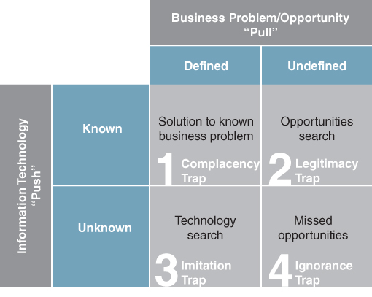
FIGURE 5.5 The push and pull of innovating with IS/IT.
On the push side are technologies that are either a) known to the organization, or b) exist, but are as yet unknown to it. On the pull side are problems and opportunities that are either i) understood and defined, or ii) exist, but have not yet been identified and so remain undefined. Problems tend to be grounded in the existing organization and its strategy. However, the solution is, as yet, unknown (if it was, it would not be a problem!). Opportunities refer to the potential options for doing something different and new, and can often be the game changers. Solving an existing problem, if it is common to other organizations, can also produce game changers.

1. The ‘Known-Defined’ Quadrant
In this quadrant are both problems and opportunities, but with known technology solutions. Many software vendors offer standard vanilla solutions to a variety of business problems. The complacency trap occurs when an organization believes they are innovating, when in fact they are applying a known technology to a defined problem or opportunity. The innovation might be new to them, but it is certainly not providing any competitive differentiation. To avoid this trap, organizations should move ‘east’ and search out opportunities and problems that are as yet undefined, i.e. have to be identified, but that might be enabled or shaped by this known technology.

2. The ‘Known-Undefined’ Quadrant
This captures the situation where a new technology is identified that may have potential for the organization. This potential has yet to be identified and defined and requires an opportunity or problem search to seek out what this might be. The legitimacy trap occurs when a technology with potential application is identified but because of, for example, the poor credibility of the IT unit or lack of appropriate business relationships, it fails to gain any traction in the business. The challenge is to identify a problem that it solves or an opportunity that it provides and move ‘west’. Moving in this direction is a way of giving legitimacy to the idea.

3. The ‘Defined-Unknown’ Quadrant
This is where a problem is highlighted and a search is required to identify potential technology solutions. The imitation trap arises when the organization simply copies what others have done in applying technology to a business problem or opportunity, which solves the problem, but does not lead to innovation.

4. The ‘Undefined-Unknown’ Quadrant
This represents the situation when there are problems and opportunities that have yet to be defined and there are technologies that the organization is currently unaware of. Organizations can fall into the ignorance trap when they fail to acknowledge that there are problems and opportunities still to be defined and technologies to be identified. To avoid this trap, organizations require some sort of technology scanning function. They must also be constantly reappraising their strategy, business model and processes for opportunities, seeking out problems, and searching for the next game changer. Perhaps it was this sentiment that Intel co-founder Andy Grove drew on when he noted that ‘only the paranoid survive’.³⁵
This simple framework can be used by organizations to consider and assess their current approaches to business innovation with IT. A key question to be addressed is whether they have initiatives in all quadrants and how are they moving around the framework. An organization usually needs to operate in all four quadrants, but recognizes that not all its actions will lead to competitive advantage. Ultimately, all innovations end up in the ‘known-defined’ quadrant, as it is difficult to keep any IS/IT-enabled innovation secret for very long. The challenge is to ensure that the organization is operating in the other three quadrants, while simultaneously avoiding the traps.

Innovating by Leveraging Information: Exploration and Exploitation
So far in this chapter we have presented a general description of business innovation with IS/IT. We have emphasized the central role played by information and systems (essentially IS) in determining investments in technology. However, the discussion has strong resonance with the terrain covered in Chapter 1, particularly when we looked at how organizations are leveraging IS/IT both operationally and strategically. Essentially, organizations can produce business innovations by leveraging information in one of two ways; either through exploration or exploitation, the latter of which is through systems.
Exploration is using information to generate new knowledge, for example about customers, operations, the supply network or the marketplace. This information may be internally generated from operational and transactional data or result from direct interactions with customers, suppliers or the wider ecosystem. Sometimes it may come from external sources, such as comments about products or services posted on Facebook or tweets on Twitter. For an electricity provider, the challenge might be to interpret 200 million meter readings per annum to better understand power consumption in order to optimize the production of electricity. While the IT industry refers to this as ‘insight’ or ‘business intelligence’, it is essentially about discovering new knowledge.
Some of the ways that data is being explored include: modelling risk, conducting customer churn analysis, predicting customer preferences, targeting ads, and detecting threats and fraudulent activity. This often requires datasets from diverse sources to be combined and examined. For example, Her Majesty's Revenue and Customs (HMRC) is combining external data from credit and other institutions with its own internal data to identify potential under-declaration of tax liabilities.
The exploration of data is also revealing some unexpected results; however the impetus for these requires some creative thinking. Public health researchers, for example, have found a spike in Google search requests for terms like ‘flu symptoms’ and ‘flu treatments’ a few weeks before there is an increase in flu patients coming to hospital emergency rooms.³⁶ Central banks are currently studying whether keyword searches, reported by Google as soon as the queries take place, can provide lead indicators of consumer demand before official statistics become available.
Sometimes a company may be proactive in gathering data. For example, many companies have implemented Customer Relationship Management (CRM) technologies to glean information about customers (demographic details, choices and preferences) and information from customers (as a result of their interactions and exchanges). One of the things they then look to do is use this information to tailor offerings to customers based on anticipated needs gleaned from historical data. Amazon, for example, claims that 30% of its sales are generated as a result of its recommendation engine: ‘customers who bought this book also purchased. . .’ This collaborative filtering approach analyses the information in the customer interactions to search for patterns.
Data exploration applications are getting ever more sophisticated. Using video, some retailers are now building systems to better understand customer behaviour when they are in the shop. In most cases, this video data is taken directly from a store's existing security camera system. That feed is analysed and correlated with sales data. Some retailers are also integrating this with data from hardware such as radio frequency identification (RFID) tags and motion sensors to track how often a brand of cereal is picked up or how many customers turn left when they enter a store. Using video, luxury retailer Montblanc generates maps showing which parts of the store are most trafficked and to decide where to place in-store decorations, salespeople and merchandise. Such analysis can often throw up insights that refute conventional wisdom. For example, many food manufacturers pay a premium for their products to be displayed at the end of an aisle. But what retailers are finding is that customers actually pay greater attention to products placed in the centre of an aisle.
Exploitation is harnessing information to reduce transaction costs or to take advantage of information asymmetries. In Chapter 1 we discussed the central role that transaction costs actually play in determining many IS/IT applications, particularly in reducing those costs. Similarly, asymmetries arise when one party to a transaction/interaction or potential transaction/interaction has more or better information than the other party. Such asymmetries are well recognized in industries such as financial trading where trading on insider information is a criminal offence. By identifying where these asymmetries exist, an organization can create opportunities to change what the organization does via a system, providing a source of competitive differentiation.
For example, manufacturers often hold stocks of raw materials to buffer against uncertainty in their supply chains – often referred to as ‘safety stock’. This uncertainty is caused by having an incomplete picture of production processes, schedules and stock levels at suppliers. Making this information available to the manufacturer reduces uncertainties caused by these information asymmetries. Armed with this information, manufacturers no longer need to tie up working capital in raw material inventories and can execute a Just-In-Time (JIT) strategy. JIT is essentially about replacing inventory with information.
It is information asymmetries that see many utilities and retailers enter the financial services marketplace. They argue that they have more information about the customers of the banks than banks have about their own customers.³⁷ And while it might be argued that these are examples of unrelated diversification (i.e. moving into another industry), if you define an industry by the amount of information incumbents have about customers, then a different conclusion is reached.³⁸ It is these same asymmetries that see shoppers using their mobile phones to scan bar codes to look for a better deal elsewhere through visiting price comparison websites. Indeed, the Internet has greatly improved price transparency.
Exploration and exploitation can be considered as two sides of the same coin. Many applications of IS/IT actually rest on the interplay between exploration and exploitation. For example, insights from its historical data (exploration) are enabling HMRC to now automatically flag up potentially fraudulent tax returns when citizens submit their tax returns (exploitation) based on common characteristics – or signature – of past fraudulent claims. Banks might use predictive modelling, bringing together customer demographics and transaction data with data from social media to identify potential cross-selling opportunities (exploration) while developing mobile apps to enable customers' transactions while on the move (exploitation).
This ambidextrous capability is illustrated in Figure 5.6: ambidexterity is the term used to describe the ability to be exploring for new opportunities and exploiting available options simultaneously. Exploration can reveal new knowledge which might lead to its exploitation to improve operations or possibly as a new source of competitive advantage. Exploitation itself generates data that, when explored, might expose hitherto unknown knowledge.
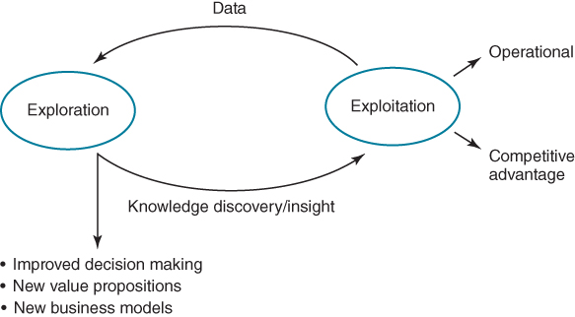
FIGURE 5.6 Developing ambidexterity: the relationship between exploration and exploitation.

Exploring Information to Generate Knowledge and Understanding
In Chapter 4 we introduced the DIKAR (Data, Information, Knowledge, Action, Results) model as a way of understanding the relationships between data, information, knowledge and decision making (reproduced with additions in Figure 5.7). The conventional way of interpreting and using the model is to view it as a value ‘spectrum’ from basic data and progress through a series of transformations, each providing more business value than the previous one, ending with the ‘right’ business results. Viewing the model from left to right the focus is on processing data and providing information to the business, whereas from right to left, the focus is on business results and the knowledge and actions needed to achieve them.
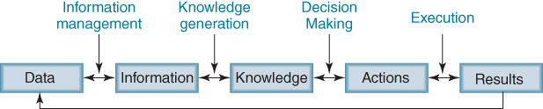
FIGURE 5.7 The DIKAR model.
Although the terms ‘information’ and ‘knowledge’ are sometimes used interchangeably, they are quite different.³⁹ While knowledge and information can be difficult to distinguish, they both involve more human participation than the raw data on which they are partly based. Essentially, information is data that has been given structure, and knowledge is information that has been given meaning.⁴⁰ In essence, knowledge is information that has been interpreted by individuals in a given context. Thus, knowledge can be understood as information combined with experience, context, interpretation and reflection.⁴¹ Unfortunately too many IS/IT investments have been justified by arguing that consolidating information from different sources will provide ‘a single version of the truth’ – in reality they rarely even create a single version of the information.
In the DIKAR model the linkages between each of the stages are just as important as the stages themselves. They represent the activities by which the value is increased, typically including procedures, systems, processes, organizational structures, administration and individuals' skills. These linkages characterize some of the organization's competences and practices and will likely vary even between very similar organizations – due to history, culture, various constraints and, most importantly, management's world view on everything from strategy to competition and customers. Figure 5.7 also illustrates these linkages.
Information management relates to the capture, processing, maintenance, storage and presentation of data and information. Most IT systems are implemented for this purpose. Included also are practices focused on data management plus information governance policies and activities.
Knowledge generation is concerned with the discovery of insight from the information: this is a cognitive and social process, taking place in the minds of individuals and people working within teams. The process of discovering new knowledge may demand that new information/data be acquired to combine with existing current data. Increasingly, new data is likely to come from external sources including social media, search results, blogs and video clips.
Decision making often involves the development and assessment of alternative options before a choice is made. It includes structured formal organizational activities and many informal individual decisions and, as discussed later, may or may not use all the available relevant information.
Execution is about carrying out the actions required by decisions taken and measuring the results of those actions. We know that many organizations struggle to implement what may ultimately be a ‘good’ decision, often because of lack of resources or the capability to carry out the actions implied by the decisions. Whether or not the execution achieves the desired results, there will be results, which in turn become new data.
Within any organization, the nature of the linkages between any two stages will also differ. Basically the further to the left (the data end), the more we can expect to see defined processes, procedures and the extensive application of technology; while to the right (the results end), what occurs will depend much more on people – as individuals, as groups and as directed by management. The link between knowledge and actions is the domain of decision making, but that cannot be isolated from the appropriateness of the information sources that underlie the knowledge or the end results that the actions are expected to deliver.
Using the DIKAR model in left-to-right mode is very informative in understanding how current data is used or could be used and the decisions that it supports. For an organization's core operational processes, managers should have a firm and detailed grasp on how DIKAR applies to those processes. The application of experience, knowledge, technology, and business acumen to the linkages is likely to improve the overall core process in a targeted incremental fashion. Moreover, using the model in a left-to-right mode has been the traditional approach in applying IT to business processes, for enterprise systems and other transaction processing systems.
However, when managers think outside day-to-day processes and routines and instead set themselves new goals or new targets, the left-to-right use of the model cannot explain how to achieve them. Examples of this would be how to launch a new competitive offensive, how to break into a new market, how to innovate or, indeed, to effect any radical change in the organization. In such circumstances, the data–information–knowledge–action chain does not exist. The DIKAR model, however, can still be helpful if we reverse its usage to right to left. In its RAKID direction, a number of fundamental questions are posed: given the desired results, what actions are needed to achieve them? Or given a set of actions, what do we need to know to decide how to perform the actions? Then what information and data are required so that we know enough to design and effect action? Answering these questions all demand knowledge and in some cases acquiring that knowledge will need the analysis of complex sets of information or even gathering new data.

The Big Data Challenge
A challenge for all organizations today is to immerse themselves in the wealth of structured, unstructured and real-time data generated from operational processes as well as that emanating from outside the organizational boundary, from customers, competitors, suppliers, business partners and other ecosystem players, and finding ways to capitalize on this information or so-called ‘big data’. This is not really an IT issue – although there may be technical matters to address – but an issue for all executives as there are likely to be potential strategic implications from the exploration of information. Research strongly indicates that harnessing information requires vision and drive from the very top.⁴² This is particularly so where the widespread use of data for decision making and knowledge discovery (sometimes called ‘evidence-based management’⁴³) is both novel and perhaps even counter-cultural. Indeed, the exploration and consequential exploitation of data may also require recruiting new people with the necessary analytical skills and even reorganization to create structures and processes that can respond to any insight gleaned in a short timeframe – potentially in real time.
Powerful analytical tools can now enable the processing, modelling and synthesis of vast quantities of data, which together with visualization tools can help in the process of discovering new knowledge. But it is important to move beyond merely proposing investing in analytical tools to understanding how they can be used to help in discovering strategic IS/IT opportunities. To this end we first look at the interplay between knowledge discovery and decision making, before presenting techniques that can be used to help in identifying potential opportunities.

Information, Knowledge Discovery and Decision Making
Investment proposals for analytical tools are generally predicated on improving decision making.⁴⁴ This is probably due to the business case process in many organizations that demands specific measurable and quantifiable outcomes or benefits to be specified.⁴⁵ However, this is a very limited perspective of the potential of these tools, particularly in discovering new knowledge, the value of which cannot be predefined. In his model of decision making, Nobel Laureate Herbert Simon⁴⁶ described decision making as a process of intelligence, design and choice, where intelligence is the seeking out of occasions to potentially make decisions. This requires the generation of new knowledge (what is typically referred to as insight in the analytics literature), an understanding of the situation and the interpretation of cues (often referred to as sense making⁴⁷) that may lead to the requirement for decisions to be made. The generation of this new knowledge is usually the result of providing an answer to a question that is posed of the data. Thus we have two interdependent, often iterative, processes. One is where information is one ingredient required to create knowledge; the other is the making of a decision that will result in some action.⁴⁸ These are illustrated in Figure 5.8; both are dependent on information, but their outputs are different.
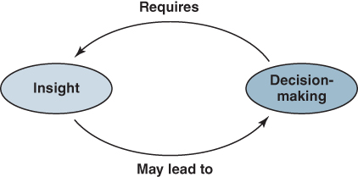
FIGURE 5.8 The interplay between insight and making decisions.
A decision is a mental or cognitive process resulting in the selection of a course of action from several alternatives – decision-making activity involves making a choice or potentially taking action (or not). Thus, it is outcome oriented and goal seeking: for example, to enter a new market, to launch a new product or to grant a customer a free upgrade.
In contrast, the generation of knowledge requires the posing and answering of a question. A question is a device for generating insight – a way of seeking understanding and potentially learning more about a situation or topic. Thus, it is a basis of investigation and the resulting insight may lead to the need to make a decision. For example, discovering a change in customer behaviour may lead to a rethink of the value proposition or business model. This is a process of knowledge discovery through interrogating the data, which may lead to the need to identify additional data that may not be readily available and hence need to be collected. In the example above, the next question may be ‘which types of customer are changing their behaviour?’
While both decision making and knowledge discovery are separate concepts, they can also be interdependent. For example, the discovery of new knowledge (e.g. an insurance company identifying the factors suggesting potentially fraudulent claims) may or may not trigger a decision (e.g. to manually assess all claims with such a profile) which is then actioned (e.g. claims with such a profile are examined). The latter may result in building a new IS/IT application to automatically flag up claims with a particular profile for further scrutiny.
Decision making is often considered as a rational process, where individuals make decisions by collecting, integrating and analysing data in a mechanistic way. Without doubt, IT has greatly expanded opportunities to collect, transmit, process, store and present information. This has generally resulted in decision makers being provided with ever more information, based on the assumption that providing more information, of higher quality, more rapidly will improve decision-making performance. But consider the following two equations:
- (a) Manager + Information = Decision or Insight
- (b) Manager + More/Better Information = Better Decision or Insight
Equation (a) captures the generally accepted relationship between manager, information and decisions or insight. Equation (b) is the logic that typically lies behind investments that most organizations make in analytical tools. It is based on the assumption that the ‘problem’ is with the information that is available (which it sometimes is) and not the decision maker (in this case, the manager or person ultimately responsible for making the decision); technology is deployed to make more information available, perhaps more timely, or improve the quality of information that is already available.⁴⁹ It ignores the fact that the manager may discard any information which may be presented to him or her, no matter how good it is because he or she has particular biases or brings inappropriate assumptions to bear in using the information.
Research has long revealed that people do not make decisions by collecting, integrating and analysing data in a mechanistic way. Decision making is a dynamic, contextual and personal or group activity in which prior knowledge and experience are recalled and combined with information. The sources of information used by decision makers include formal information systems and artefacts (e.g. databases, documents, books, reports, dashboards), but the most immediate and heavily used information is that received in the form of signals (or cues) from the environment (e.g. economic data, news reports, a customer's angry voice or a colleague's suggestion). Decision makers also have individual biases (e.g. confirmatory bias) and carry their own personal assumptions which influence their thinking processes, as well as cognitive filters which shape how information and other cues are interpreted.⁵⁰ Furthermore, the responsiveness of decision makers to environmental signals means that decision making, particularly at senior management level, tends to be more event and issue driven than systematic and evidence-based. ‘Gut feel’ often replaces any rigorous analysis and managers tend to revert to simple heuristics when making decisions, particularly when under pressure.
Moreover, since the 1950s, evidence has been accumulating that the individual's ability to handle large volumes of information is limited.⁵¹ So whilst providing large amounts of information may, in theory, enable better decisions to be made, improved decision-making performance is by no means guaranteed. One study, for example, found that decision makers may not use IT to increase their use of information and, thereby, improve decision quality but instead may use technology to reduce the amount of mental effort needed to make decisions.⁵² Others have found that managers often lack awareness of the existence and relevance of the many diverse and often dispersed information sources available to them and have pointed to the social aspects of decision making as reasons why information and IT are not always used in ‘rational’ ways.⁵³

Discovering Strategic IS/IT Opportunities from Information
It is now regarded as axiomatic that the knowledge contained within an organization is one of its most precious resources.⁵⁴ Some argue that managing an organization's knowledge may be the sole factor that keeps it competitive because all other resources are to a large extent imitable.⁵⁵ It therefore follows that developing and sustaining that resource is crucial, plus creating the conditions for its beneficial deployment. Furthermore, the changing nature of the marketplace has placed even greater emphasis on knowing how to operate and perform competitively. Being competitive in marketplaces that are increasingly global, volatile and uncertain requires companies to be innovative to prosper, not just in their products and services but also in how they compete in their chosen market. They therefore need to know in considerable depth what their customers and competitors are doing or are likely to do, and also how to leverage this knowledge into concrete actions.⁵⁶ As more and more products and services become commoditized, the more ‘know-how’ about customers' and potential customers' needs and preferences becomes the added-value an organization must have in order to be a chosen supplier, rather than straightforward ‘product excellence’.
The investments that organizations are making in IT are generating huge volumes of information. For example, CRM systems generate vast amounts of transactional and content information about customers. A challenge faced is creating insight from this information to inform business decisions. Even with effective information management strategies, most organizations are not succeeding in turning information into knowledge and business results. Even those that do are doing so only temporarily or in a limited area of the business.⁵⁷ In the context of innovation, the recurring questions about knowledge management are ‘how do I ensure that my organization exploits its existing knowledge?’ and ‘what additional knowledge do we need and how do we get it?’
Identifying strategic IS/IT opportunities requires creative and entrepreneurial thinking. However, there is no systematic approach that will automatically lead to a great idea. Exploring information is a voyage of discovery and about being curious and open-minded: it needs to be managed and resourced as such and not driven to deliver against artificial performance targets.

Creating New Knowledge and Learning
In the literature on knowledge creation, all authors recognize the importance of tacit knowledge. One well-known perspective⁵⁸ proposes that creating new knowledge is fundamentally about the interaction between tacit and explicit knowledge, identifying four patterns of such interaction:
- Socialization – sharing of tacit and explicit knowledge by individuals through observation, imitation and practice (i.e. without verbalisation).
- Combination – combining sets of explicit knowledge held by individuals through social processes.
- Externalization – involving interaction between explicit and tacit knowledge through social dialogue to create shared concepts, normally within a team and often involving the use of metaphor.
- Internalization – is seen as closest to traditional organizational learning, although action is seen as an important component.
This characterization of knowledge creation is essentially about conversion of tacit knowledge to explicit knowledge that can then be codified and shared as a resource (and perhaps stored in a repository). Another view is that it is impossible to convert tacit to explicit knowledge⁵⁹ as they are intertwined and inseparable. Nevertheless, most researchers agree about the importance of the following factors for knowledge creation:
- its action orientation or purpose;
- its situation within a specific context and ‘interaction community’ or community of practice;
- the importance of reflection and sense-making activities;
- its social nature and the associated importance of dialogue, language and metaphor for collective learning, sense making and dissemination to occur.
Although closely related to knowledge creation, learning is about how people (and through them teams and organizations) acquire existing and create new knowledge consciously, through education and training or research activity, or unconsciously through observation, action and experience. In addition to the traditional routes to improve the knowledge and competences of staff, there has been a significant increase in the establishment of communities of practice (or interest) and similar mechanisms for exchanging knowledge within and across organizations.
Some communities of practitioners and professionals are often self-forming, without explicit support from management,⁶⁰ but others are created and sustained by the active encouragement of management, especially when the aim is to develop new practices or improve performance through collaboration. As organizations become more geographically dispersed and under pressure to deliver consistent performance everywhere to remain competitive, the use of IT to enable learning and knowledge sharing has become essential. This can include online meeting software, collaborative workspaces, knowledge centres or similar repositories plus the use of professional social network systems, such as LinkedIn and Yammer which establishes connections and acts as a discussion forum, all components of what is referred to as Enterprise 2.0.⁶¹ A well-organized community can not only increase the pace of organizational learning but also, over time, become a source of knowledge creation.⁶²

Techniques for Discovering Strategic Opportunities
To consider the opportunities provided by the exploration of big data and the use of analytical tools to generate new knowledge and insights, a good starting point is to borrow from Donald Rumsfeld's words at his (in)famous 2002 press conference:
“There are known knowns. These are things we know that we know. There are known unknowns. That is to say, there are things that we know we don't know. But there are also unknown unknowns. There are things we don't know we don't know”.
This can be used as a definition to guide the different possible outcomes from exploring data, which can be positioned on a framework that maps question against data (see Figure 5.9) in a similar way to the technology innovation push/pull matrix in Figure 5.5. The reason for the ‘question’ dimension is that knowledge typically emerges from answering questions. The data dimension signifies the potential data source for answering the question.
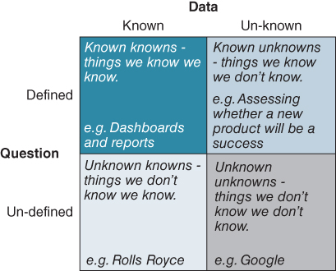
FIGURE 5.9 Exploring data to discover new knowledge.

Defined question/known data.
This is where the questions to be answered are already known and the data needed to help answer the questions have already been identified. These are the known-knowns – things that we know we know. Standard or regular reports can often provide answers to these types of questions. Financial reports, sales reports and reports showing actual performance against target indicators (KPIs) are examples of reports found in most organizations and are used to answer predetermined ‘structured questions’.
Questions can be considered as structured when they are well defined and the data to provide an answer can be determined once the known data is available. Example questions could be:
- What are the factors that indicate a customer is likely to defect?
- Which products did our customers purchase most frequently last month?
- How much inventory do we have of product X?
Critical success factor analysis and KPIs, introduced in Chapter 4, can be used to define the regular information required to monitor performance against strategic objectives and the data needed to provide that information.

Known data/un-defined question.
This situation exists where there is data in the organization that might reveal something about customers, operations, suppliers or even competitors, but the question to uncover this knowledge has not yet been posed. Rolls-Royce, for example, collects terabytes of telemetry data on the performance of its aero-engines. The company knows that in this data there is knowledge that has not yet been revealed about the engines. The challenge is to construct an inquiry to uncover this, as these are the unknown-knowns, by, for example, generating and testing hypotheses or exploring potential correlations to uncover ‘what we don't know we know’, and in the process potentially identify some strategic and operational opportunities.
This is the classic problem in managing knowledge. Former CEO of HP Lew Platt captured the challenge well when, in relation to matching knowledge in the organization to solving problems in the organization, he reputedly said ‘if only HP knew what HP knows, we would be three times more productive’.

Defined question/un-known data.
In this scenario there is something that we wish to know and a reason for wanting to know it – ‘if we knew x, then we could y’. However, the data to provide an answer to this question has not yet been identified; this is the known-unknown – things we know that we don't know. Sometimes this will demand refining the question as well as identifying potential sources of the required data and how it might be obtained or accessed. It may take a number of iterations to find the question/data combination that can deliver an answer that is at least a close approximation to what is needed to be known in order to proceed. This is traditionally the domain of market and consumer research.

Undefined question/un-known data.
This situation acknowledges that there is new knowledge to be discovered but that we have yet to either pose the question or identify the relevant data. These are the unknown unknowns. For example, Google announced some time ago that it was collecting as much data as it could even though at this stage it didn't know how it was going to use it or what it might tell them. The US and British security agencies, amongst others, have apparently been pursuing a similar strategy over recent years.
The framework can also be used to guide the processes involved in the exploration of data. Much of the writing on big data presents examples of companies combining data sets, and doing predictive analytics – more like a production process than satisfying an enquiry. Success with these initiatives demands understanding data, data you have and do not have; thinking about what you could do if the data could be acquired and how that could be done.
Our advice is to start in the top left-hand quadrant: the ‘known-knowns’ in Figures 5.9 and 5.10. This is essentially about challenging existing ways of making decisions and the data used in making these decisions. Look at the reports that managers get or have access to and how, or even whether, they are used. Many may have probably been designed some years ago and may no longer be fit for purpose. The constraints of data available at the time they were developed will also likely have influenced what is presented and how it is presented. Now, even though richer and more comprehensive data may be available, managers may still use the old reports. The content of reports and dashboards is also likely to have been influenced by the particular biases and assumptions of the people who designed them – assumptions that may now no longer be appropriate.
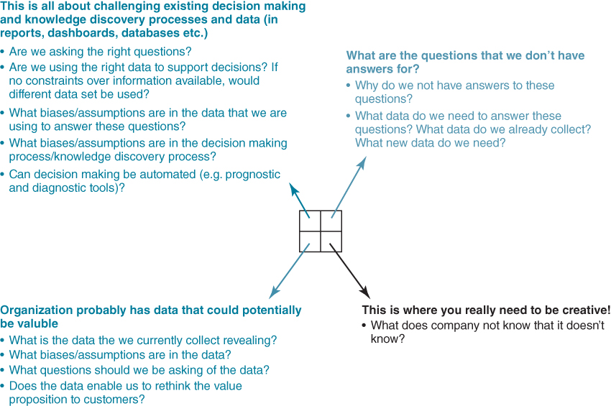
FIGURE 5.10 Mapping a big data initiative to discover knowledge.
Once this has been achieved, by moving to the bottom left quadrant, existing data can be explored to assess whether or not it may be able to reveal new insights or knowledge – the ‘unknown-knowns’. Of course, we need to know what data we already collect and generate. This is not a trivial exercise; most organizations are awash with data, much of it unmanaged, so just cataloguing it and where it is located can be a challenge. However this investment in data management might reveal insights that enable new and important questions to be answered.
We can then move to the top right-hand quadrant, where we have questions but have not determined the data that will help in revealing answers. Sometimes the question posed can be too loose, making it hard to determine the data that might potentially provide an answer. It may require continual refinement in order to be more precise. Achieving this end is usually an iterative process that is, itself, a voyage of learning. Examples of unstructured questions – the ‘known-unknowns’ include:
- What is the demographic and psychological make-up of our potential high-value customers?
- Which hurts the bottom line more: inventory holding costs or hiring staff to handle frequent deliveries?
- How effective was our last marketing campaign?
- How do our customers migrate between segments?
Answering these types of questions usually requires gathering new data, refining the precision of data currently being collected and merging these new sources with other existing data. This may be a very expensive and time-consuming task, so it is probably worth experimenting or piloting the analysis concept on a small subset of the eventual data set required, to test whether the idea is viable, how much it is likely to cost and whether the question is really worth answering. Like any prototype, what is learned even from failure may prove valuable in future, if only in avoiding other wasted investments.
The bottom right quadrant is really where you need to be imaginative: what does the organization not know that it does not know? This quadrant is where data is often collected speculatively on the assumption that it may be useful in the future in addressing as yet unposed questions. These ‘unknown unknowns’ are where often creativity and hunches can signal the beginnings of a knowledge discovery process. One approach here is to expand the options by brainstorming what might be a) future data that might be useful, b) questions that could produce valuable answers and c) how technology could capture new data in the future. In some organizations a crowdsourcing approach has been used to enable a huge variety of ideas to be collected, including some that may be more innovative than senior management could ever imagine. Box 5.6 considers different potential routes through the matrix for a big data/analytics exercise.

BOX 5.6

Migrating between data and questions
It is useful to explore further how we can move between data and questions. The figure below illustrates the routes that thinking processes behind the framing of questions can take. It is only when we have a structured question, where the data that will help in answering that question have been identified, that new knowledge can actually be discovered.
Position A is a common starting point for analytics projects, where the question to be answered is loosely defined but the data required to answer the question is presently unknown or unclear. The question is often framed at a high level that requires some additional clarity before insight can be generated. The challenge here is to reframe the question precisely in order to be able to identify relevant data that will provide the answer.
Position B is another starting point. Here the data that is available for analysis is known or available. The challenge is often to construct the questions that will reveal knowledge that is hidden in the data. Sometimes, the questions can be precisely defined immediately. However, a more likely route is through position A, where an unstructured question is further refined. The data can often be in multiple databases, in multiple formats stored in different areas of the business.
Position C is where potentially the real value of data can have its origins. Starting with a so-called ‘blank sheet of paper’, the potential for data exploration begins with non-specific objectives, perhaps a mere ‘hunch’. Here, the analytics team will be creative and innovative. Two routes can be followed. Following position B, a potentially interesting data set is identified; the challenge is to see if new knowledge can be gleaned from it from analysis. The alternative route is by surfacing potentially interesting questions to be answered, moving to position A.
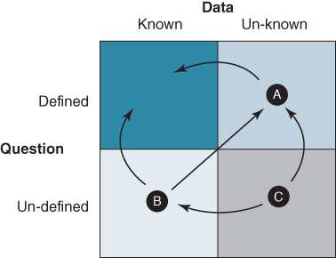
Moving between questions and data

How and Where to Start Identifying or Creating Innovations from Information
Organizations expect to invest both time and resources in developing product and service innovations as well as in their research activities. In pharmaceutical companies, for example, much of the activity and financial investment in the research laboratories is in collecting and analysing data. So one approach to identifying opportunities to do with data would perhaps be by establishing a virtual ‘data lab’. It is not necessary for this lab to start out as a separate organizational unit, although it eventually may become one. Rather, it can begin as a project bringing together a cross-functional team of open-minded people to explore data. Creating an initiative that fosters collaboration is most likely to result in new ideas coming to light.
It may be helpful to obtain the services of a data scientist to work in the lab.⁶³ These individuals represent an evolution from the business or data analyst role, by acquiring skills in mathematical or statistical modelling and the use of analytical tools. Often described as ‘part analyst, part artist’, they are inquisitive, exploring, asking questions, doing ‘what if’ analyses, questioning existing assumptions and processes and surfacing biases in decision making. When combined in a team with others who have a strong business acumen, they can address the business questions that have the most value to the organization.
Box 5.7 suggests some guidelines for the operations of a data lab, or similar organizational concept, based on research and our experience.

BOX 5.7

Guidelines for developing and operating a data lab
- Break down silo mentalities. Many companies have amassed mountains of data in departmental ‘silos’, such as R&D, engineering, manufacturing, or service operations – impeding timely exploitation. Information hoarding within business units also can be a problem: many financial institutions, for example, suffer from their own failure to share data among diverse lines of business, such as retail banking, insurance, wealth management, and lending. Often, this prevents these companies from forming a coherent view of individual customers or understanding links across financial markets.
- Ask second-order questions. Instead of setting out to create a system that can help the sales staff easily find out ‘what stock should we place on shelves today’, an initiative might begin with the question, ‘is there a better way of deciding on stock replenishment?.’ By posing these second-order questions, you are immediately assuming that the way decision makers currently operate could be improved.
- Probe for what information you have and do not have. Avoid being bounded by the data and systems that are available and accessible. They are limited by today's view of what information is relevant and usable. Use experimentation to test the limits of what you know and don't know.
- Lab members should have the freedom to be imaginative in seeking opportunities to harness data. We have observed that creativity and an organization's willingness to try new ways to solve old problems are often missing from big data projects. The lack of creativity is often driven by a myopic view of data and its value to the business. This can be a function of data silos that are highly complex to integrate but, more often, it stems from the reluctance to search for new solutions.
- Identify ‘exhaust’ data and consider how it might be exploited. Data is generated as a by-product of operational, customer and supplier processes; do you know what this data is? For example, insurance companies deploy claims solutions to help them manage their claims management process. In addition to the information about the claim, information about claimants' behaviours, pay-outs associated with particular types of claims etc. may also be automatically generated, but as a by-product to the real purpose of the claim system. Similarly, data from security cameras, used to guard against pilfering, can also be used to track shoppers as they make their way through the store, which can be of use to merchandisers.
- Strive to show relationships between cause and effect. Seek to draw attention to issues of concern and show how factors, particularly those within the organization's control, can result in particular outcomes. It is important to move beyond symptoms, addressing questions like: what's the problem? why did it happen? what can be done? From the data, determine the actions or events that seem to produce certain responses.
- Be ready to reframe the why, what and how of your accepted approaches to business. What do we want to do differently? The team should drive for outside-in, not inside-out thinking. Be willing to expose your assumptions, biases and blind spots to new and different insights.
- Identify the ‘appropriate’ analytical techniques and tools to enable new ideas and counter-intuitive insights. Have a healthy scepticism for analytical tools and techniques whose results are ‘too good to be true’. Big data and controlled experiments are tools to aid thinking, not substitutes for it. Remember, it is people who generate understanding and knowledge not technology, so be prepared to get your hands dirty!
As a starting point, we suggest the process of exploration examines how information, or the lack of it, impacts the strategy and how new or better information might sustain a particular strategic direction. This can be done using the ‘three paths to market leadership’⁶⁴ model introduced in Chapter 2. As discussed in Chapter 2, each path – 'Operational (or Process) Excellence', ‘Customer Intimacy’ and ‘Product Leadership’– requires different sets of competences and information has a critical, yet different role to play in each. Some probing questions are presented in Figure 5.11.
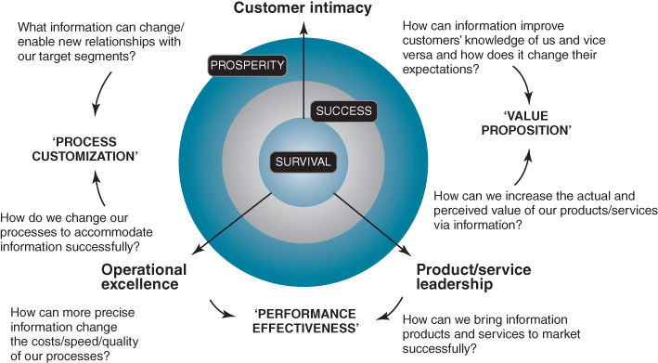
FIGURE 5.11 Identifying opportunities to leverage information to support strategy execution.

Building an Analytic Capability
Companies such as Google, Facebook, Netflix and Amazon were built on a foundation of information exploration and exploitation. More established firms are less endowed with what it takes to harness the power of information yet some have managed to build a powerful analytical capability. Improving the use of information to make informed, fact-based decisions requires a deep understanding of how, through the use of information, new knowledge and insight are created. We have already highlighted that in most organizations the emphasis with analytics and initiatives focused on ‘big data’ is typically on deploying tools and processes, usually seeking to improve the quantity, quality, availability and timeliness of information. The person (or people) side of the equation is all but ignored, apart perhaps from some training to use the new tool set. We have argued strongly for the need to focus on the human dimension: how they process information, learn, create knowledge and make decisions.
Tesco, John Deere and Harrah's Entertainment are more established companies that have built an analytical capability, and demonstrated examples of a clear link between company performance and the effective use of data in their knowledge discovery and decision making. For example, Tesco uses its Clubcard to track which stores customers visit, what they buy and how they pay. This has enabled the retailer to adjust merchandise for local tastes and to customize offerings at an individual level across a variety of store formats and online.
At Harrah's, former CEO Gary Loveman pushed a data-driven agenda when he joined the company.⁶⁵ Once laggard in the industry, Harrah's became the largest and most profitable gaming company in the world, adept at exploiting data that it collects from customers (see Box 5.8). This focus on learning what the data is revealing comes directly from Loveman: ‘I am purely empirical. I am not attached to any romantic notion of how this business should be run. I am only driven where the evidence takes me.’

BOX 5.8

Total Rewards at Harrah's Entertainment
Harrah's CEO Gary Loveman's first big move when initially appointed as COO was to launch a loyalty program called Total Rewards, which became such a success – growing to over 40 million members by 2010, the largest database of probabilities in the industry. Today, the Total Rewards program remains the linchpin of Harrah's success. The first loyalty program in the industry to be applied across every casino in a company, it allowed for a more accurate analysis of betting patterns – probabilities – and a more equitable distribution of ‘comps’ or free rooms, meals, show tickets, and the like. (In the past, such perquisites tended to go to the flashiest high rollers and the noisiest comp-seekers, not necessarily those contributing the most to Harrah's bottom line.) Loveman instituted a similar program for Harrah's staff, who are given points based on customer satisfaction surveys that can be redeemed through a website for products. Even Harrah's executives have their compensation pegged to customer service scores.
To analyze the customer data it collects, Harrah's spends about $100 million a year on information technology, compiling preferences and probabilities that led Loveman to a startling conclusion. Harrah's makes more money from elderly slot machine players than any other demographic in the casino – even the high-rolling millionaires' casinos traditionally spent fortunes luring and flying in by private jet. ‘The slot player was the forgotten customer,’ Loveman says, ‘and the slot player offered us the biggest benefit in terms of collection data . . . I had to be willing to be unsexy in this. I can take you to a casino that would have a lot of young beautiful people in there and you would say, “Man, this is a happening place”. I could take you to another place where there are a lot of people who look like your parents. The latter would be a lot more profitable than the former. My job is to make the latter.’
Although Loveman has remade Harrah's as an old-fashioned service sector juggernaut, the firm does have a newfangled engine room. The motor is the database, maintained in Las Vegas servers and managed out of One Harrah's Court, the old corporate headquarters where the IT and marketing departments now reside. Spend a few days at a Harrah's property and the information the company compiles about you will end up here, analyzed by proprietary software that assigns each and every Harrah's guest a theoretical value. The higher the value given to you – not to be misconstrued as a source of pride – the more likely you are to lose your money to Loveman.
Source: How to Survive in Vegas, Bloomberg BusinessWeek, August 2010; and G. Loveman, ‘Diamonds in the data mine,’ Harvard Business Review, May 2003, 109–113.
The DIKAR model introduced earlier in the chapter can be also used to surface the competences associated with linking data to business results. We saw in Chapter 2 that competences are an organization's ‘capacity to deploy resources, usually in combination, using organizational processes, to effect a desired end.’⁶⁶ In the context of an analytical capability, these competences are ‘manage data’, ‘make sense of information’ and ‘act on the understanding’ and are positioned on the DIKAR model in Figure 5.12. Tesco, Harrah's and others like them have built these three core competences.
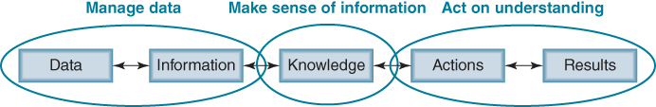
FIGURE 5.12 The three competences for an analytics capability.
Manage data: having accurate, timely and quality data is the foundation of an analytics capability. Without this, its utility and ultimate value is diminished. An analytical capability requires a solid foundation of information, requiring standardized data management practices, common architecture for integration, portability and storage plus strong information governance mechanisms. This competence provides the foundation for sense making.
Make sense of information: within the organization the data/information must be interpreted and meaning ascribed. It is through this process that new knowledge is discovered and understanding given to events and situations. It is people, not technology, who ultimately give meaning to data and assess its relevance. Sense making is also a social process where collaborating employees, often from different areas of the business and with different specializations, together discover new insights.
Act on understanding: the organization must have the ability to act on insights and make appropriate decisions. It must be able to respond to the sense that people make of data and take real action.
Organizations can assess themselves across these three competences to determine the level of maturity of their analytical capability.

Summary
In Chapter 4 we presented tools and frameworks to help determine information and systems requirements given an organization's current situation and chosen strategy – the alignment aspects of IS/IT strategy. In this chapter we have examined IS/IT's innovation potential: how technology, systems and information can be explored to discover potential strategic opportunities and create business innovations.
Increasingly, CEOs are looking to digital technologies to provide innovation for business growth and to improve performance. In most organizations this innovation mandate falls at the door of the CIO and many are struggling with this. The first task must be to take the challenge outside the traditional IS/IT organization. While many of the innovations shaped by IT are due to nothing more than luck, the significance of the triumvirate of technology awareness, business understanding and an almost entrepreneurial alertness or openness to ideas cannot be ignored.
Having a systematic process for IS/IT innovation as well as a dedicated budget is highlighted by those organizations who consistently innovate with IT, yet getting management attention for new ideas can also prove problematic. Equally important is to understand the traps of IS/IT innovation and to avoid falling into them. Perhaps the concept that best captured the success stories we studied was that of ‘manufactured serendipity’. Business innovation with IS/IT is a little inspiration but lots of perspiration.
BP’s model for innovation is an excellent summary of the need to take advantage of both push and pull mechanisms for creating IS/IT-based business innovation (see Figure 5.13). It recognizes that the innovation process can either begin with a particular technology or a business problem or opportunity. The ‘business pull’ emerges from the conversations that executives have with the innovation team as they seek solutions. The ‘informed push’, of technology is driven by the understanding that this team has of the business.
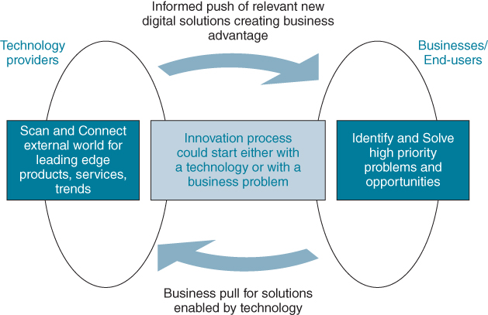
FIGURE 5.13 The IT innovation model at BP.
In the next chapter we discuss and exemplify a number of established tools and techniques that enable organizations to identify and select those new systems and technologies which will have the greatest business impact in both the short and medium term. How they can help address both the current business situation and the future industry environment, in order to maximize the competitive impact and business value from IS/IT, will be explained. In Chapter 7 we bring together the main ideas from Chapters 4 to 6 into a structured framework and suggest an overall approach to applying them in creating a comprehensive and coherent business IS strategy.
Endnotes
1. For more on digital options see V. Sambamurthy, A. Bharadwaj and V. Grover, ‘Shaping agility through digital options: reconceptualising the role of information technology’, MIS Quarterly, 27, 2, 2003, 237–263.2. For general reviews of innovation in these areas see: M.W. Johnson, C.M. Christensen and H. Kagermann, ‘Reinventing your business model’, Harvard Business Review, 86, 12, 2008, 50–59; A. Osterwalder, Y. Pigneur, Y. and C.L. Tucci, ‘Clarifying business models: origins, present, and future of the concept’, Communications of the Association for Information Systems, 16, 2005; S.M. Shafer, H.J. Smith, and J.C. Linder, ‘The power of business models’, Business Horizons, 48, 3, 2005, 199–207; J. Hwang and C.M. Christensen, ‘Disruptive innovation in health care delivery: a framework for business-model innovation’, Health Affairs, 27, 5, 2008, 1329–1335; J. Hedman and T. Kalling, ‘The business model concept: theoretical underpinnings and empirical illustrations’, European Journal of Information Systems, 12, 1, 2003, 49–59; T. Davenport, Process Innovation, Harvard Business School Press, Boston, 1993; G. Hamel, ‘The why, what, and how of management innovation’, Harvard Business Review, 84, 2, 2006, 72–84; and J. Birkinshaw, G. Hamel and M. Moll, ‘Management innovation’, Academy of Management Review, 33, 4, 2008, 825–845.3. For more on leveraging existing IT assets, see R. Kohli and N.P. Melville, ‘Learning to build an IT innovation platform’, Communications of the ACM, 52, 8, 2009, 122–126. For a case study of how United Parcel Services (UPS) has used IT investments to create IT assets and IT competences, which have led to business capabilities, then to new business opportunities see R. Kohli, ‘Innovating to create IT-based new business opportunities at United Parcel Services’, MIS Quarterly Executive, 6, 4, 2007, 199–210.4. See J. Ross, D. Pitteri and C. Beath, Architecting Agility: How IT Creates Opportunities for Profitable Growth Research Briefing, V11, 2A, July 2007, Centre for Information Systems Research, Sloan School of Management.5. See interview with Jim Rodgers, CEO Duke Energy, ‘Duke Energy's plan to take over your kitchen – and take down your energy use’, MIT Sloan Management Review, May, 2011.6. See H. Zhu and S.E. Madnick, ‘Finding new uses for information’, MIT Sloan Management Review, Summer, 2009, 18–21; and for an insightful piece on the challenges posed when data volumes exceed technological capability see Big Data: The Next Frontier for Innovation, Competition and Productivity, McKinsey Global Institute, May, 2011.7. G. Loveman, ‘Diamonds in the data mine’, Harvard Business Review, May, 2003, 109–113.8. See www.living-planit.com for more information.9. See also E. Baldwin and M. Curley, Managing IT Innovation for Business Value: Practical Strategies for IT and Business Managers, Intel Press, 2007.10. For more on these stages see B. Swanson and N. Ramiller, ‘Innovating mindfully with information technology’, MIS Quarterly, 28, 4, 2004, 553–583.11. See M. Hansen and J. Birkinshaw, ‘The innovation value chain’, Harvard Business Review, June 2007, 121–130.12. T. Gerth and J. Peppard, ‘How newly appointed chief information officers (CIOs) take charge’, MIS Quarterly Executive, 13, 3, 2014, 159–173; and J. Peppard, ‘Unlocking the performance of the chief information officer (CIO), California Management Review, 52, 4, 2010, 73–99.13. For more on BP's approach to IT innovation see R.C. Wolcott and M.J. Lippitz, BP's Office of the Chief Technology Officer: Driving Open Innovation through an Advocate Team, Case Study, Kellogg School of Management, Northwestern University, 2007. For more on experimenting with IT see ‘Value creation, experiments and why IT does matter’, an interview with Michael Schrange, MIT Sloan Management Review, Spring, 2010, 57–61.14. E. Von Hippel, Democratizing Innovation, Cambridge MA: MIT Press, 2005.15. H.W. Chesbrough, Open Innovation: The New Imperative for Creating and Profiting from Technology, Boston: Harvard Business Press, 2003; and P.M. Di Gangi, M.M. Wasko and R.E. Hooker, ‘Getting ideas to work for you: learning from Dell how to succeed with online user innovation communities’, MIS Quarterly Executive, 9, 4, 2010, 213–228.16. See E. Von Hippel, ‘Lead users: a source of novel product concepts’, Management Science, 32, 7, 1986, 791–805; F. Piller and D. Walcher, ‘Toolkits for idea competitions: a novel method to integrate users in new product development’, R&D Management, 36, 3, 2006, 307–318; and J.M. Leimeister, M. Huber, U. Bretschneider and H. Krcmar, ‘Leveraging crowdsourcing: activation-supporting components for ideas-based competition’, Journal of Management Information Systems, 26, 1, 2009, Summer, 197–224.17. Open data: Unlocking Innovation and Performance with Liquid Information, The McKinsey Global Institute, October 2013.18. Interviewed by Joe Peppard, in Adelaide, May 2012.19. See: R. Agarwal, M. Tanniru and D. Wilemon, ‘Assimilating information technology innovations’, IEEE Transactions on Engineering Management, 44, 4, 1997, 347–358; C.P. Armstrong and V. Sambamurthy, ‘Information technology assimilation in firms’, Information Systems Research, 10, 4, 1999, 304–327; R.G. Fichman and C.F. Kemerer, ‘The assimilation of software process innovations: an organizational learning perspective’, Management Science, 43, 10, 1997, 1345–1363; J. Peppard, J. Ward and E. Daniel, ‘Managing the realization of business benefits from IT Investments’, MIS Quarterly Executive, 6, 1, 2007, 1–11; R. Ryan Nelson, ‘IT project management: infamous failures, classic mistakes and best practices’, MIS Quarterly Executive, 6, 2, 2007, 67–78; and J. Peppard and J. Ward, ‘Unlocking sustained business value from IT investments’, California Management Review, 48, 1, 2005, 52–70.20. For studies of how technology has transformed the financial services industry see S. Elliot, ‘Technology-enabled innovation, industry transformation and the emergence of ambient organizations’, Industry and Innovation, 13, 2, 2006, 209–225; and Y. Bakos, H. Lucas, W. Oh, G. Simon, S. Viswanathan and B. Weber, ‘The impact of e-commerce on competition in the retail brokerage industry’, Information Systems Research, 16, 4, 2005, 352–371.21. See M. Chui, M. Loffler and R. Roberts, ‘The internet of things’, The McKinsey Quarterly, 2, 2010; and A. Bartels, Smart Computing Drives the New Era of IT Growth, Forrester, December 2009.22. See Clayton Christenson's book The Innovator's Dilemma, Harvard Business School Press, 1997.23. See B. Haas and C. Hagen, ‘Where the money isn't’, MIT Sloan Management Review, 51, 4, 2010, 17.24. Swanson and Ramiller have addressed the issue of social cognition that drives innovation in new information systems. They introduced the concept of an organizing vision and explain how a collective, cognitive view of new technologies enables success in IS innovation. See E.B. Swanson and N. Ramiller, ‘The organizing vision in information systems innovation’, Organization Science, 8, 5, 1997, 458–474.25. See P. Wang, ‘Chasing the hottest IT: effects of information technology fashions in organizations’, MIS Quarterly, 34, 1, 2010, 63–85; P. Wang and E.B. Swanson, ‘Customer relationship management as advertised: exploiting and sustaining technological momentum’, Information Technology & People, 21, 4, 2008, 323–349; and P. Wang and N. Ramiller, ‘Community learning in information technology innovation’, MIS Quarterly, 33, 4, 2009, 709–734. See also L. Valikangas and G. Sevon, ‘Of managers, ideas and jesters, and the role of information technology’, Journal of Strategic Information Systems, 19, 2010, 145–153.26. Other studies that have looked at organizational influences on IT innovation include: C.P. Armstrong and V. Sambamurthy, ‘Information technology assimilation in firms: the influence of senior leadership and IT infrastructures’, Information Systems Research, 10, 4, 1999, 304–328; D.E. Leidner, D. Preston and D. Chen, ‘An examination of the antecedents and consequences of organizational IT innovation in hospitals’, Journal of Strategic Information Systems, 19, 2010, 154–170; and Y. Li, C. Tan, H. Teo and B. Tan, ‘Innovative usage of information technology in Singapore organizations: do CIO characteristics make a difference?’, IEEE Transactions on Engineering Management, 53, 2, 2006, 177–190.27. See H.G. Enns, S.L. Huff and C.A. Higgins, ‘CIO lateral influence behaviours: gaining peers’ commitment to strategic information systems', MIS Quarterly, 27, 1, 2003, 155–176.28. See J. Hall, V. Bachor and S. Matos, ‘Developing and diffusing new technologies: strategies for legitimization’, California Management Review, 56, 3, 2014, 98–117; B.E. Ashforth and B.W. Gibbs, ‘The double-edge of organizational legitimation’, Organization Science, 1, 2, 1990, 177–194; R. Suddaby and R. Greenwood, ‘Rhetorical strategies of legitimacy’, Administrative Science Quarterly, 50, 1, 2005, 35–67; and M.C. Suchman, ‘Managing legitimacy: strategic and institutional approaches’, Academy of Management Review, 20, 3, 1995, 571–610.29. See D. Preston and E. Karahanna, ‘Antecedents of IS strategic alignment: a nomological network’, Information Systems Research, 20, 2, 2009, 159–179; and F. Schlosser, D. Beimborn, T. Weitzel and H.-T. Wagner, ‘Achieving social alignment between business and IT – an empirical evaluation of the efficacy of IT governance mechanisms’, Journal of Information Technology, 30, 2015, 119–135.30. Swanson has examined several different consultancy specializations and how they facilitate an IT innovation process within and across firms. See E.B. Swanson, ‘Consultancies and capabilities in innovating with IT’, Journal of Strategic Information Systems, 19, 2010, 17–27.31. For more on addressing the challenges of vendor innovation see G. Westerman and G. Dodge, Vendor Innovation as a Strategic Option, Research Briefing, VIII, 1C, March 2008, Center for Information Systems Research, Sloan School of Management.32. In their study of IS-business alignment, Tan and Gallupe report that ‘there is a strong link between business IS-alignment and shared cognition between business and IS executives… Business and IS executives in the companies that report a higher level of business-IS alignment do have a set of core beliefs in common regarding IS…’ From their research Reich and Benbasat conclude ‘[t]he one construct that seemed to predict long-term alignment was shared domain knowledge … The most important direct predictor of alignment in this study was a high level of communication between IT and business executives.’ See F. Tan and R.B. Gallupe, ‘Aligning business and information systems thinking: a cognitive approach’, IEEE Transactions on Engineering Management, 53, 2, 2006, 223–237; and B.H. Reich and I. Benbasat, ‘Factors that influence the social dimension of alignment between business and information technology objectives’, MIS Quarterly, 24, 1, 2000, 81–113.33. J. Peppard, ‘Unlocking the performance of the chief information officer (CIO)’, California Management Review, 52, 4, 2010, 73–99.34. This observation also highlights that care must be taken when hiring a CIO from outside the industry. While they may have a great reputation and have demonstrated results in a previous employment, they might have limited short term impact on innovation, particular of the ‘faster horse’ type. On the other hand, they can bring a fresh perspective.35. A.S. Grove, Only the Paranoid Survive, Doubleday, 1996.36. See http://www.google.org/flutrends/about/how.html37. See J.L. Sampler, ‘Redefining industry structure for the information age’, Strategic Management Journal, 19, 4, 1998, 343–355.38. See V. Choudhury and J.L. Sampler, ‘Information specificity and environmental success: an economic perspective’, MIS Quarterly, 21, 1, 1997, 25–53.39. I. Nonaka, R. Toyama and N. Konno, ‘SECI, Ba, and leadership: A unified model of dynamic knowledge creation’, Long Range Planning, 33, 1, 2000, 5–34; and P. Checkland and S. Holwell, Information, Systems and Information Systems: Making Sense of the Field, John Wiley & Sons, Chichester, UK, 1998.40. See R. Glazer, ‘Measuring the knower: Towards a theory of knowledge equity’, California Management Review, 40, 1998, 175–194; and P. Checkland and S. Holwell, Information, Systems and Information Systems: Making Sense of the Field, John Wiley & Sons, Chichester, UK, 1998. In addition, information theory holds information to be independent of meaning. See C.E. Shannon and W. Weaver, The Mathematical Theory of Communication, University of Illinois Press, Urbana, Illinois.41. T.H. Davenport, D. DeLong and M. Beers, ‘Successful knowledge management projects’, Sloan Management Review, Winter, 1998, 43–57.42. J. Petter and J. Peppard, Harnessing the Potential of Big Data: A Guide for CEOs, EMC, London, 2012.43. J. Pfeffer and R.I. Sutton, Hard Facts, Dangerous Half-truths and Total Nonsense', Harvard University Press, 2006.44. A good example of this is the Chartered Institute of Management Accountants publication Improving Decision Making in Organisations: Unlocking Business Intelligence, London, 2009.45. See J. Ward, E. Daniel and J. Peppard, ‘Building a better business case for IT investments’, MIS Quarterly Executive, 7, 1, 2008, 1–14.46. H.A. Simon, ‘Theories of decision-making in economics and behavioral science’, American Economic Review, 49, 1959, 253–283.47. K. Weick, Sensemaking in Organisations, Sage, London, 1995; and K. Weick, ‘Enacted sensemaking in crisis situations’, Journal of Management Studies, 25, 1988, 305–317.48. Davenport and colleagues refer to these as ‘the analytic process’ and ‘the decision-making process’. See T.H. Davenport, J.G. Harris, D.W. DeLong and A.L. Jacobson, ‘Data to knowledge to results: building an analytical capability’, California Management Review, Winter, 2001, 117–138.49. For recent research to support this, see S. Shah, A. Horne and J. Capella, ‘Good data won't guarantee good decisions’, Harvard Business Review, April–May, 2012, 23–25.50. For an excellent book covering these aspects, see D. Kahneman, Thinking, Fast and Slow, Farrar, Strauss and Giroux, New York, 2011.51. H.A. Simon, ‘Theories of decision-making in economics and behavioral science’, American Economic Review, 49, 1959, 253–283; and R. Axelrod, Structure of Decision: The Cognitive Map of Political Elites, Princeton University Press, 1976.52. P. Todd and I. Benbasat, ‘The use of information in decision making: An experimental investigation of the impact of computer based decision aids’, MIS Quarterly, 16, 3, 1992, 373–393.53. B. Vandenbosch and S.L. Huff, ‘Searching and scanning: how executives obtain information from executive information systems’, MIS Quarterly, 21, 1, 1997, 81–107.54. R.M. Grant, ‘Towards a knowledge-based theory of the firm’, Strategic Management Journal, Winter Special Issue, 1996, 109–122; J.P. Liebeskind, ‘Knowledge, strategy, and the theory of the firm’, Strategic Management Journal, Winter Special Issue, 1996, 93–107; D. Leonard-Barton, Wellsprings of Knowledge: Building and Sustaining the Sources of Knowledge, Harvard Business School Press, Boston, 1996; and I. Nonaka and H. Takeuchi, The Knowledge Creating Company, Oxford University Press, New York, 1995.55. R.M. Grant, ‘Towards a knowledge-based theory of the firm’, Strategic Management Journal, Winter Special Issue, 1996, 109–122; and S.G. Winter, ‘Knowledge and competence as strategic assets’, in D. Teece, ed., The Competitive Challenge, Ballinger, Cambridge, Massachusetts, 1987, 159–184.56. J. Pfeffer and R.I. Sutton, ‘Knowing “what” to do is not enough: Turning knowledge into action’, California Management Review, Fall, 1999, 83–108.57. T.H. Davenport, J.G. Harris, D.W. DeLong and A.L. Jacobson, ‘Data to knowledge to results: Building an analytic capability’, California Management Review, Winter, 2001, 117–138.58. I. Nonaka, ‘A dynamic theory of organizational knowledge creation’, Organization Science, 5, 1, 1994, 14–37; and I. Nonaka, R. Toyama and N. Konno, ‘SECI, Ba and leadership: a unified model of dynamic knowledge creation’, Long Range Planning, 33, 1, 2000, 5–34.59. H. Tsoukas, Complex Knowledge: Studies in Organizational Epistemology, Oxford University Press, Oxford, 2005; J. Seely Brown and P. Duguid, The Social Life of Information, Harvard Business School Press, 2000; F. Blackler, ‘Knowledge, knowledge work and organizations: an overview and interpretation’, Organization Studies, 16, 6, 1995, 1021–1046; and H. Tsoukas and E. Vladimirou, ‘What is organizational knowledge?’, Journal of Management Studies, 38, 7, 2001, 973–993.60. E. Wenger, Communities of Practice: Learning, Meaning and Identity, Cambridge University Press, New York, 1998; see also J. Lave and E. Wenger, Situated Learning: Legitimate Peripheral Participation, Cambridge University Press, Cambridge, 1991.61. A. McAfee, ‘Enterprise 2.0: The dawn of emergent collaboration’, MIT Sloan Management Review, 47, 3, 2006, 21–28.62. L. Lee-Kelly, N. Turner and J. Ward, ‘Intentionally creating a community of practice to connect dispersed technical professionals’, Research-Technology Management, 57, 2, 2014, 44–52.63. For more on data scientists, see T.H. Davenport and D.J. Patil. ‘Data scientist: The sexiest job of the 21st century’, Harvard Business Review, 90, 10, 2012, 70–76; and The Field Guide to Data Science, Booz, Allen, Hamilton, 2013.64. M. Treacy and F. Wiersema, The Discipline of Market Leaders: Choose your Customers, Narrow your Focus and Dominate your Market, Perseus Books, 1996.65. For more detail see J. Pfeffer and R.I. Sutton, ‘Hard Facts, Dangerous Half-truths and Total Nonsense’, Harvard University Press, 2006, 15–17.66. R. Amit and P.J.H. Schoemaker, ‘Strategic assets and organizational rent’, Strategic Management Journal, 14, 1993, 33–46.

UNIT 6
EXPLOITING INFORMATION SYSTEMS FOR STRATEGIC ADVANTAGE

OUTLINE
- ♦ Achieving and Sustaining Advantages across the Value Disciplines
- ♦ Exploring New Value Propositions: Informating Products and Services
- ♦ Analysis of Competitive Forces to Identify IS/IT Opportunities and Threats
- ♦ Value Chain Analysis
- ♦ Customer Life-cycle Management and the Value Chain
- ♦ From Value Chain to Value Network
- ♦ The Internal Value Chain
- ♦ The Uses of Value Chain Analysis
In Chapter 4 we discussed how the use of a combination of Balanced Scorecard (BSC) and Critical Success Factors (CSFs) can be an effective way of aligning the portfolio of IS/IT investments with the current business strategy. As frameworks familiar to most managers, their use is designed to put IS/IT onto the management agenda, ensuring that IS/IT strategy and plans support organizational intentions and management's current priorities. No attempt is made to radically alter the existing strategy by leveraging options provided by IS/IT. In contrast, this chapter is about identifying IS/IT impact – either opportunities to gain strategic advantages by using the capabilities of IS/IT to enhance or even change the business strategy, or the need to counter threats created by the use of IS/IT by others.
No organization can ignore the impact of technology. Changes in an industry, triggered by IS/IT investments by customers, competitors and suppliers may affect the organization's intended strategy. Hence, the potential opportunities and threats from IS/IT and its ability to change industry dynamics and relationships must be considered. As discussed in Chapter 5, this includes the capability to be innovative in the use of information and being able to create novel applications from new technologies – applications that may be strategically important. Equally important is having processes that enable effective evaluation and exploitation of the best options by integrating them into viable and worthwhile business developments and changes.
The techniques described in Chapter 4 are not sufficient to complete such an impact analysis but the tools and techniques of strategic thinking and analysis, frequently used in business strategy formulation, offer another approach. These need to be understood and used by executives, managers and business professionals, whose commitment is critical to converting good ideas to actual strategic uses of IS/IT. They are techniques and tools that have often been used successfully in assessing the potential future impact of IS/IT in many industries and on many businesses. But remember these are tools to help thinking and discussions, not a recipe for ensuring the identification of achievable strategic advantages.
In terms of the application portfolio, the focus is primarily on identifying new strategic investments (see Figure 6.1) and evaluating the strategic potential of innovative ideas. However, the techniques are likely to also suggest other ‘high potential’ possibilities that need further investigation before their contribution can be decided. They may also help assess whether existing or planned key operational applications provide a good basis for future business development or could become a constraint and need replacing.
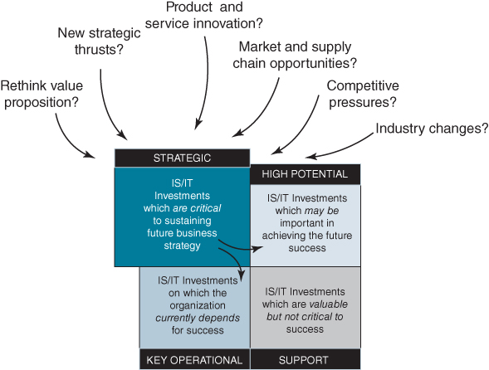
FIGURE 6.1 Developing the IS/IT investment portfolio from a strategic perspective.

Achieving and Sustaining Advantages across the Value Disciplines
As discussed previously, an organization's success can depend on excelling in its chosen ‘value discipline’ – Operational Excellence, Customer Intimacy or Product/Service Leadership (see Figures 2.11 and 5.11)¹ – through which it aims to achieve advantage, and maintaining parity with competitors in the other disciplines. However, if the organization's performance falls behind competitors in either of the other two dimensions, it is likely to offset any potential advantage gained through its chosen value discipline. Some suggested questions of particular relevance to exploring IS/IT options were posed in Figure 5.11 at the end of the previous chapter. They attempt to show how some generic IS/IT opportunities, such as improving the value proposition, mass customization, performance improvements and cost reductions from radical process changes, normally require combinations of the dimensions to be addressed.
For example, a bank that had developed a new and ‘excellent’ mortgage product for younger home buyers (as defined by independent benchmarks) and generally had good customer relationships (or at least as good as any other bank – again via independent surveys), could not understand why sales of the new product were so poor. The reason was the slowness and unreliability of the existing mortgage application process being used, which had been designed for an earlier generation of products. The process could not deliver the ‘service promise’ made for the product and expected by the target customer group, so many of them went elsewhere to obtain an inferior product, but faster and more conveniently.
In contrast, having established ‘personal’ relationships with its customers, Amazon is able to analyse purchase patterns and identify other products likely to be of interest to an individual customer. In combination with ‘1-click’ purchasing, it makes the actual buying process very simple, while order tracking enables the customer to ‘see’ where exactly their order is in the delivery process.
As we saw in Chapter 2, the value disciplines are a powerful way of gaining agreement among managers about what has to improve and why, but especially whether the purpose is to gain advantage or avoid disadvantage. It helps integrate the ‘themes’ inherent in the business and IS strategies and focus resources on medium-term IS priorities. Although the relationship will not always be perfect, the changing content of the application portfolio should reflect the evolving strategic themes. Applying these ideas in a number of organizational situations has proved very useful in clarifying the business rationale for IS/IT investment plans. Generally:
- Strategic investments should relate to the value dimension in which the organization seeks to excel in the next one to three years, with the objectives of creating and gaining advantages.
- Key operational investment is essential in any dimension where performance levels have fallen below those essential to success (i.e. are causing disadvantage).
- High potential projects would normally be ‘prototypes’ or ‘pilots’ related to specific strategic developments or evaluations of ideas in any of the dimensions (i.e. early, tentative steps in finding out how IS/IT might provide future opportunities).
Over a period of time, an organization might pursue advantages in all three dimensions to maintain a leadership position in response to the actions of competitors. But, it is extremely difficult to ‘major’ in more than one at once, and any indecision will cause ever-changing priorities, inconsistency and even confusion within the business – a recipe for failure with IS/IT investments.
Our analysis begins by taking existing products and services and seeking to identify opportunities to rethink the value proposition offered to customers. We then move on to a more detailed industry analysis to identify opportunities, using the five forces model, industry value chain and value network analysis. Then we look at information flows and explore opportunities inside the organization using different internal value chain configuration models. The overall outcome from using these tools and frameworks is a list of strategic options which must then be evaluated and prioritized – something we look at in later chapters.

Exploring New Value Propositions: Informating Products and Services
Informating² is concerned with adding value to existing products and services and potentially changing the value proposition being offered to customers by harnessing information in some way. Since the possibilities of informating products were first promoted, the developments in sensor technologies, miniaturization and communications and huge improvements in IT price/performance have increased the opportunities beyond those anticipated even 10 years ago. The key questions now of relevance for the IS/IT strategy are whether more value can be created by adding technology to the product and/or harnessing information in a new way, potentially changing the company's business model.
We saw in Chapter 1 that through servitization strategies many manufacturing firms are moving from selling products to providing services. This does not mean that the product disappears – the product is still needed to deliver the service – but that the customer buys the services rendered by the product. For example, Rolls-Royce selling ‘thrust’ rather than engines to airlines. To ensure that the engine is available to deliver the service when required by the customer, information on its ‘health’ is collected, usually in real time, to ascertain its integrity and ensure that the service continues to be available to the customer as required.
We also saw in Chapter 1 that some products have now become completely digital – information goods³ – such as magazines, newspapers, insurance, music and books. Capitalizing on the fact that different customers are likely to value such products differently, differential pricing becomes commercially viable, offering the possibility for both bundling and unbundling. In financial services, for example, customers are increasingly moving away from single monolithic banking institutions serving the majority of their financial needs – current accounts, home loans, insurance and wealth management – to selecting the specialized services that work for them from a range of providers.
Start-ups like Simple, Venmo and Robinhood are allowing people to take control of every individualized aspect of their finances. PayPal, Google Wallet, Apple Pay and Snapcash are just a few of the services that allow consumers to pay for goods and services or transfer money to friends and family. Zopa is providing an alternative for saving and borrowing money. Beyond giving consumers control and options, many of these services are removing the ‘friction’ of engaging in financial transactions and lowering the barriers to entry. Bills can be paid, money transferred and investments managed with a few taps from a mobile device.
An analysis of the customer value proposition can be conducted under the following scenarios:
- informating existing products;
- informating existing services;
- informating to improve product availability or reliability in use.

Informating to Add Value to Existing Products
Informating current products implies the intrinsic nature of the product itself is unlikely to change, but additional value is provided to customers. This can mean that the product is repositioned and differentiated from competing products by harnessing information. For example, so-called ‘smart’ electricity and gas meters and remote access to central heating controls, which help consumers manage their energy use, are examples of such product enhancements. Many appliances from televisions to light bulbs can be operated remotely via smartphones or tablets. In turn, the data collected about usage enables the energy companies to adjust prices to encourage consumers to change consumption habits, leading to more efficient use of generating and distribution capacity.
Box 6.1 describes another, quite different, example of how American football helmet manufacturer Riddell has redefined its value proposition by informating a product that has been around since the 1930s. It is an example of a smart, connected product.⁴ A smart product is one with embedded technology, which monitors, controls and adjusts, even optimizes, the product or its performance according to conditions it recognizes from sensors. It may be connected through a network to another product, or the product user or a system and transmits or receives data which causes the product actions to be modified through feedback or external input. Most car engines are now ‘smart’ and the prototype driverless car is an example of a smart, connected product, as is an automated combine harvester being guided by a GPS system to cut crops in the most efficient way. The connectivity enables large amounts of data to be collected easily and be used to either improve the product's performance or identify how to enhance the product's capabilities.

BOX 6.1

Informating American football helmets to redefine the customer value proposition
Riddell is an American company specializing in sports equipment for American football. The company was started by John Tate Riddell in 1927. The function of the helmet, to protect players' heads during tackles, has not changed over the years and is purchased for this purpose. However, recently Riddell has informated the helmet to redefine the customer value proposition.
What look like six marshmallows stuffed between the helmet's padding and the outside shell are actually foam-encased sensors that measure the acceleration of a player's head during a tackle (called a ‘hit’ in football terms). They determine magnitude, direction, location on the head, duration and time of impact. Data shows that some players can receive up to 2,000 head blows each season.
Upon impact, the sensor immediately assesses the collision. A recent example featured a 180-pound ‘gunner’ – a defender who chases down the kick-off returner – tangling with a 250-pound lineman. The smaller player was knocked off his feet, his head accelerating at 158 g. Anything above 100 g is a sign to look for concussion. As the player is still trying to get up, the impact data are transmitted to a computer console at the side of the pitch.
If the hit exceeds a certain threshold, as it did in the gunner impact, pagers held by coaching and medical staff light up and the player's condition must be assessed. New National Football League (NFL) rules state that if a player exhibits any signs of concussion – such as disorientation or losing consciousness – he must leave the field for the day.
All data collected is stored in the cloud. Team coaching and medical staff can later examine the data via a web-based service that helps them zero in on dangerous plays. If it shows a rise in head impacts for a player or a team, coaches can look at whether practice tackles are being done correctly or an equipment change is causing problems. So instead of selling a helmet to provide footballers with protection, Riddell now sells a service that is about both protection and prevention. Moreover, it can charge a premium for this service.

Source: Riddell, 2015. Permission granted.

Informating to Add Value to Services
Services can also be informated. Personal motor insurance, for example, is currently being changed in a number of ways by using smart technologies and the new information they can create. Motor insurance addresses the risk of a person having a road accident and making a claim. Actuaries have traditionally assessed and priced this risk using information such as gender, age, address, number of years driving and history of previous claims. These are all surrogate measures for driving behaviour. Today, in real time, insurance companies can collect data on actual driver behaviour when he or she is driving. They can use this data to assess risk and price premiums and also assess driver performance and adjust premiums accordingly. If the insured person’s driving is improving, the premium is reduced. Customers can see their driving performance on a personal portal with lots of advice and guidance as to how to improve their driving. Box 6.2 describes the ‘pay-how-you-drive’ insurance service being offered by the Co-operative Insurance.

BOX 6.2

The Co-operative Motor Insurance: pay-how-you-drive
With young drivers often facing the highest priced motor insurance premiums, The Co-op has developed a ‘pay-how-you-drive’ solution for 17- to 25-year-olds. The most recent statistics for young drivers in the UK indicate that:
- ♦ One in eight driving licence holders is aged 25 or under, yet one in three drivers who die is under 25.
- ♦ An 18-year-old driver is more than three times as likely to be involved in a crash as a 48-year-old.
- ♦ One in five new drivers has a crash within 6 months of passing their test.
The Co-op's Young Driver motor insurance product calculates premiums based on actual driving behaviours and rewards safe driving. The company monitors a driver's behaviour by using data transmitted from a Smartbox, which is fitted into the policyholder's car, via satellite technology. The behaviours then used to calculate premiums are: braking and acceleration; cornering; speed and time of driving (e.g. day time, night time etc.).
This ‘pay-how-you-drive’ product gives drivers a genuine insight into their driving behaviours. Young drivers are rewarded for safer driving and their driving is assessed every 90 days based on the four driving behaviours. If responsible driving behaviours are demonstrated, they will receive a Safer Driving Discount. However, if a policyholder consistently drives badly, for example repeatedly breaking speed limits or taking corners too sharply, then their insurance premium could increase by 15% of the initial policy price. The Co-op will also cancel any policyholder's insurance if they drive so far above the speed limit that a driving ban would be imposed by the courts (with GPS they know exactly which roads a policyholder is driving on and, importantly, their speed limits).
The product allows customers to log in to a unique online ‘Driving Dashboard’ to see how their driving has been rated against the four driving behaviours. It also gives advice on what they can do to improve. Each behaviour is illustrated by a speed dial and drivers will be rated on green (good driving), amber (generally good but showing some bad behaviours) and red (bad driving). The portal also provides information and guidance as to how to improve driving.
Website: http://www.co-operativeinsurance.co.uk/youngdriverinsurance/smartbox
MetroMile has taken this transformation of the motor insurance industry even further and is now offering a ‘pay-as-you-go’ service. The proposition to the customer is that when your car is not being driven, no premium will be charged. Technology similar to that used by the Co-operative Insurance provides it with the data to know when the car is being driven, and not sitting idle in a garage or driveway, and thus needs to be insured. This is very attractive, given that the average car is only driven for less than 5% of the time that it is available.
But cars are rapidly becoming computers on wheels, with sensors collecting data on the identity and position of the driver, seat belt usage, tyre pressure, sharp breaking, lane changes etc. All this data can be uploaded to the mechanic in the garage or to services like GM's OnStar. This means that automotive manufacturers will potentially own the most detailed underwriting data across all drivers at zero incremental cost.
In a similar type of application, some car hire firms now track their cars' locations via GPS systems and, through a device in the car, can automatically immobilize the engine if the car moves outside a contracted area, for instance across the border into another country. Similar systems can help find, immobilize and recover stolen cars.

Informating Products to Improve Availability and Reliability in Use
Earlier chapters discussed the increasing demands from customers for enhanced utilization of products to ensure the ongoing availability of the service or capability they provide. We also saw that some companies are seeking to offer availability rather than ownership as a new value proposition. Instead of purchasing the product, customers buy availability of the product or, more correctly, the service rendered by the product. This is manifesting itself in new contracting methods that shift the risk of providing availability from the customer back to the manufacturer of the product. This is particularly so for high-value products such as aeroplane engines, elevators and wind turbines.
Delivering the customer a value proposition based on availability rather than ownership generally demands collecting information about the ‘health’ of the product, usually in real time. Then, using prognostic and diagnostic software and advanced analytical tools, knowledge about the performance of the product ‘in use’ can be determined. Analysing historical data can identify the ‘signature’ of potential product failures or performance degradation. This can enable preventative action, hence avoiding unplanned downtime, emergency repair costs and loss of output. For example, SKF provides ‘intelligent ball bearings’ containing sensors to provide direct monitoring of their use and detect and report any damage before it results in failure.⁵

Reliability
Reliability may be considered as the ability of a product to perform a required function under stated conditions for a specified period of time. A Formula 1 racing car may, for example, be considered to be reliable even if it ceases to be functional immediately after it completes a race. In this example, longevity is sacrificed for performance; however, reliability means that the car functioned under the desired conditions for a specified period of time. Feedback about performance and the ability to adjust it immediately to ensure race completion is critical in these circumstances. Formula 1 teams have long been key innovators at the leading edge of smart technologies and many of the innovations are eventually introduced into mass-produced cars, leading to improvements in their reliability.
The reliability of a product may vary considerably depending on the level of technical maturity of the design, quality of design and manufacture. A product designed using new technology may, for example, experience unexpected and unacceptable failures when it first enters service, which may then be subsequently designed out and removed. For example, after the Boeing 747 ‘Jumbo Jet’ was launched in 1970, it required around 1,700 upgrades in its first 6 years of operation.
Using IS/IT, particularly new smart technologies, does not prevent failure occurring and it does little to improve reliability at the early stage of a product's life. Indeed, simulations and tests on small samples may not accurately identify likely causes of failure. It is often only when the product is in use that these manifest themselves. Google's analysis of hard disk drives is an example of this situation (see Box 6.3).

BOX 6.3

Understanding the factors that affect reliability: the Google study
A hard drive may be considered as a mature technology with an embedded capability to monitor and diagnose its health, known as Self-Monitoring, Analysis and Reporting Technology (S.M.A.R.T.). A hard drive consists of complex electronic and mechanical components and, whilst they are generally considered to be reliable, the failure mechanisms are quite complicated. A hard drive manufacturer typically uses accelerated tests on small sample ranges to extrapolate likely failure modes and predict the mean time before failure. Statistics from failed drives returned to the Original Equipment Manufacturer (OEM) provide a larger sample range; however there remains the difficulty to correlate failure modes and how the hard drive was deployed in service.
Google continuously monitored 100,000 hard drives over a nine-month period, providing an unprecedented insight into factors that affected reliability. An analysis of the collected data led to a number of key findings including:
- ♦ Contrary to previously reported results (from much smaller scale studies) it was found that very little correlation existed between failure rates and either elevated temperature or activity levels.
- ♦ Prediction models based on existing S.M.A.R.T. parameters alone were not sufficient.
- ♦ The lack of predictive S.M.A.R.T. signal occurrences on a large percentage of failed drives suggested that they would be unlikely to provide an accurate predictive failure scenario.
The implications of the study findings are that accelerated testing and small scale field testing provided misleading information when compared to large-scale trend analysis obtained whilst the product was in service. It may therefore be concluded from this study that large-scale trend analysis of a product whilst in service would be beneficial to obtain a better understanding of the product and the factors that affect longevity and reliability.
The extensive data collected from large numbers of a product in use can inform product redesign to overcome the causes of problems, which in turn improves the warranty that can be offered to customers and costs of future product servicing.

Capability as well as Availability
The concept of capability is often used in some industries instead of availability, for example by the UK's Ministry of Defence (MoD). Capability can be seen as a measure of a product's ability to be available at a given point in time and its ability to achieve a specific objective (often referred to as a ‘mission’ in military terms). For example, a plane can be on the runway, ready to take off, and yet not be available for the required mission as it may not be capable of mid-flight refuelling and hence not able to perform the required mission. Box 6.4 describes what different levels of availability mean in practice in the context of budget airlines.

BOX 6.4

What different availability levels can mean
It is important also to understand what different levels of availability mean. A 90% availability means that for 16.8 hours an asset or product will be unavailable during a week. In contrast, 99.9% availability equates to 10.1 minutes per week when it may be unavailable.
A good example of understanding levels of availability is EasyJet's challenge to SRTechnics to provide them with 100% availability. When SRT examined this request, the ‘normal’ service (every 3 years) was a combination of a number of small jobs. SRT came up with a proposal that this 3-year service could be carried out over a period of time, overlapping with the aircraft being on the ground. In this way, inspections effectively disappeared from reduced operating time.
Figure 6.2 illustrates a decision tree to help determine whether informating a product will help in improving availability. Working from the question ‘Is the product designed to be inherently reliable?’ the decision tree helps to identify areas where technology might provide opportunities to reframe the customer value proposition. Whether the technology should be mainly embedded in the product itself or provided via connection to the network, or other device, depends on the conditions under which the product operates and whether those conditions would affect the ability of the smart technology to function accurately – extreme heat, cold, air or water pressures for example.
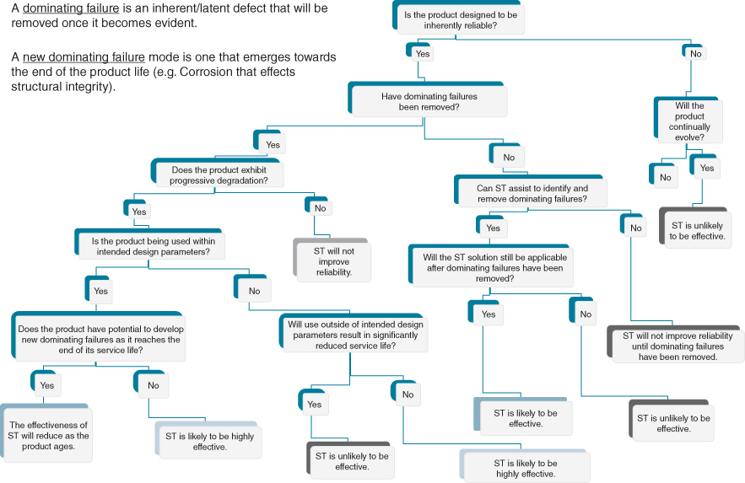
FIGURE 6.2 Will informating help improve availability? Assessing the applicability of Smart Technologies (ST).

Analysis of Competitive Forces to Identify IS/IT Opportunities and Threats
As noted in Chapter 2, the concepts of analysing competitive opportunities, threats and strategies, are well established and have been used as a basis for considering IS/IT and its potential impact.⁶ Porter's models⁷ can be used to examine how IS/IT can impact industries and affect a particular firm in that industry, depending on its competitive strategy. Porter himself has explored the impact of the Internet⁸ and, most recently, the Internet of Things (IoT)⁹ on competition and industry dynamics, arguing that ‘smart’ technologies are changing or will change the competitive landscape in many industries. Although the obvious threat/opportunity is in the dimension of substitute products, all five competitive forces will often be affected by IS/IT.
The opportunities and threats that IS/IT can offer and pose will vary over time in an industry, partly due to the economics and capabilities of IS/IT and partly due to the competitive situation in the industry. As with product innovation, IS/IT innovation can stimulate new industry growth or, in some cases, hasten the decline of certain industries. While the growth of Amazon.com, and the introduction of the e-book and Kindle, has had a serious impact on traditional book retailers, the total sales of books have increased significantly.
In some cases, IS/IT impact can be immediate and obvious but, in others, the effects are secondary and require other changes in business economics or social behaviour, or parallel developments in other fields before they become fully effective. This is the case with e-retailing; the predicted effects being dependent more on costs of distribution and changes in shopping preferences and habits, than on the ability to browse and purchase online – the demise of many online-only stores being indicative of this. The impact of online shopping and delivery or ‘click and collect’ options now available from most supermarkets in the UK is only now being understood. Shopping habits have changed, partly due to online options, reducing the average basket or trolley size through the checkouts at the same time as delivery costs are reducing profitability. In the public sector, digitized services need to get the buy-in of citizens, usually due to convenience and ease of use, if they are to reach a critical mass.
As a starting point, the ‘interrogation’ of IS/IT potential in the industry can focus on products, markets and economics and consider options available to all the firms in the industry and, importantly, to potential new entrants. These include start-up companies, which can exploit new technology to develop and sell new products or services, devise new business models, or create new channels that address the needs of some or all the industry customer base, or all of these. Many of the anecdotes of sustained success derive from companies which have fundamentally changed one of these aspects. These changes are irreversible in that, if the factors for success in the industry and the capabilities required by companies to succeed in the industry are fundamentally altered, the competitive ‘game’ will have a new set of rules.
Each of the five forces described in Chapter 2 should be examined by questioning whether IS/IT can affect the nature and degree of impact that force has on the future of the industry or the balance of power in the industry. These factors were outlined in Box 2.1, while Figure 6.3 suggests questions to consider as part of any analysis.
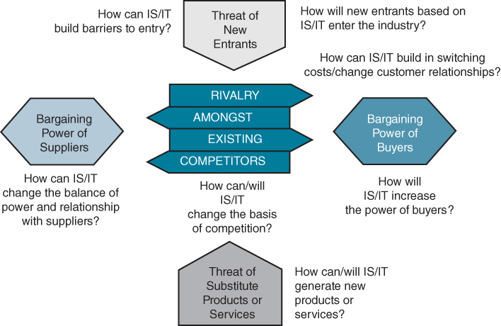
FIGURE 6.3 Exploring IS/IT implications across the five forces.
In the airline industry, all the competitive forces have been and are still being affected by the use of IS/IT, because of the nature of the ‘product’, how it is purchased and the information needed to be exchanged in order to complete a transaction. The use of IS/IT by budget airlines to achieve very low administrative costs has revolutionized the short haul market, increasing the number of carriers, even though some airlines have failed. Other industries such as financial services and publishing are even more information intensive in that the product itself is information. Food supermarkets have built barriers to entry through Electronic Point of Sale (EPOS) systems linked to purchasing and logistics – the size of the investment and control of the supply chains reducing the potential for new entrants. With their loyalty cards, some retailers have increased consumer switching costs as well as obtained valuable information on buying patterns, enabling both higher leverage over suppliers and the tailoring of store layout and product mix to the local market. In addition, by offering basic financial products and mobile telephony by leveraging the information collected from these loyalty cards, some have become new entrants in the financial service and mobile data services industries.
In many industries, the Internet and mobile technologies have changed the competitive landscape and new business and industry models have emerged. In general, three generic effects seem to characterize how industries are evolving, particularly in business-to-consumer (B2C) markets:
- Buyer power increases as more choice becomes available online, through comparison websites and search engines.
- Buying groups, normally based on a common interest, have emerged to produce collective rather than individual buying power.
- Both disintermediation – cutting out existing intermediaries, such as travel agents, by selling direct via online channels, and re-intermediation – new firms, such as comparison websites, ‘platform’ companies and aggregators, providing information-based services connecting buyers and a range of sellers or location-based services – have occurred in a number of industries. Just Eat, an intermediary providing ordering from a wide range of ‘take away’ food outlets based on customer location, does both.
We saw earlier that e-marketplaces, such as eBay and Alibaba, are creating new business opportunities for SMEs and even ‘micro’ companies as well as larger established organizations and may lead to restructuring in some industries. Combined with the inherent global reach of online trading, actual and potential competitors are no longer restricted by geography; these changes imply a wider view of the competitive issues has to be taken. The response in most cases is to tighten the links, especially information sharing, between the sellers and their customers to increase switching costs – for example, through the mobile banking options now available – and prevent ‘gaps’ appearing that new entrants could potentially exploit.
For any firm, the questioning process should first consider business-based issues, such as:
- What forces are determining the future of the industry and potential success?
- Who dominates the industry and why?
- Who might enter the industry, why and what would the effect be?
- What substitute products might affect the market for existing products?
- On what basis are we currently competing and how might that change?
- How much power and discretion do buyers (customers) have and what will influence their choices?
The result of this questioning may be that only one or two of the forces are critical at any particular time. Once that has been established, more specific IS/IT questions should focus on these areas of concern – both opportunities and threats – to identify the potential impact of IS/IT. A final stage should then be to reverse the thinking process by looking at the other, less critical, forces to identify whether IS/IT could change their importance in the future. Another way to analyse an industry is to pose the questions regarding how IS/IT could affect the essential industry dynamics:
- The products/services and their life cycles (as discussed earlier in the section on informating the product or service).
- The markets, distribution channels and customer behaviour. Typical questions to be asked are: can IS/IT enable us to reach more, or more appropriate, customers or to match our different products/services to customers more accurately, or enable the product or service to be distributed or accessed in new ways? Can we use IS/IT to get closer to the marketplace rather than deal through intermediaries? Many companies are now using links via social media to promote products to people with similar interests or creating Twitter accounts to gain product ‘followers’, as well as gleaning insights from customer feedback.
- The economics of production, distribution or servicing. Typical questions would be: can IS/IT enable the product/service to be produced more economically or enable production and associated logistics to be integrated to produce greater flexibility of resource use? Can improved production or logistics efficiency and control change the basic working capital structure of the industry? Can IS/IT enable a higher quality of product or service to be offered at a lower cost than traditionally? Can the higher quality and reliability reduce ongoing servicing, repair and maintenance costs?
These questions are considered again, in more detail, in the context of the industry value chain and the role of information later in the chapter.

Value Chain Analysis
Value chain analysis is another tool that is usually familiar to many business managers. Michael Porter¹⁰ argues that: ‘every firm is a collection of activities that are performed to design, produce, market, deliver and support its products or services. All these activities can be represented using a value chain. Value chains can only be understood in the context of the business unit.’
However, the business unit value chain is only one part of a larger set of activities in an industry – the industry value chain or value system. The value chain of any organization (which we will examine later in the chapter) therefore needs to be understood as part of this ‘network’ of related and interdependent value chains – those of its suppliers, customers, competitors and other industry stakeholders. The actions of those other parties will have a significant impact on what the firm does and how it does it. This is especially true in the area of information systems. For example, the considerable investment made by food retailers in Point-of-Sale (POS) systems and online channels has changed the way information is passed to food manufacturers and has dramatically altered the delivery service required from those manufacturers. This has implications for the information systems within the food processing companies and, in turn, the systems in their suppliers.
For an organization to identify the overall implications for its business in terms of opportunities and threats, the information flowing through the industry – the external value chain – needs to be analysed before the information processes can be optimized inside the business – by considering the internal value chain.

The External Value Chain (Industry Value Chain or Value System)
Figure 6.4 provides a schematic view of an industry value system. In particular, it emphasizes the key roles information plays throughout the chain. The overall performance of the industry, in terms of its ability to maximize revenues and minimize costs, is primarily dependent on how well demand and supply information are matched at all stages by industry players. If poor information means that those resources are wasted or used inefficiently, costs rise and, without increases in revenue, overall profitability falls. In such situations, all that firms can do to improve profit is compete with their suppliers and customers to share out the limited available net profit. This almost inevitably leads to some firms going ‘bust’, the equilibrium is destroyed and the industry has to be reorganized in some way. It is not always the least efficient that suffer; it is often those with the poorest information about what is happening in the industry who go to the wall.
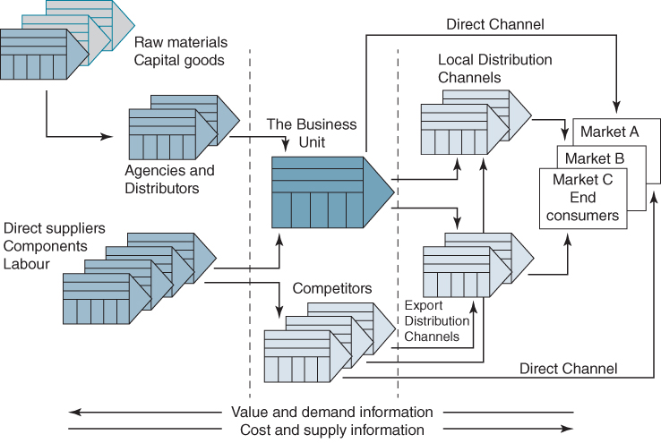
FIGURE 6.4 Schematic industry value chain.
While the above discussion is primarily about ‘profit’, the value chain approach can be used in any industry, since every industry uses funds, incurs costs and uses resources to deliver products/services, of some kind, to consumers. In ‘non-profit’ industries such as government, healthcare and charities, there is always a matching of supply and demand to achieve a break-even, if not a surplus, and avoid a deficit.
The type of industry value chain model depicted in Figure 6.4 is most appropriate for ‘traditional’ manufactured goods. Alternative models more suited for service-based industries are considered later in this chapter. However, the following general issues apply to all the models.
Obviously, if an organization can match the supply of resources to the total demand for its products and services precisely at all times, performance can be optimized and efficiencies maximized. Equally obviously, if the business unit in Figure 6.4 is operating at some distance from both the ultimate consumer and primary suppliers, it can be very difficult to obtain accurate demand or supply information. However, we would expect organizations that have component businesses in different parts of the same industry value chain to be able to exploit their combined information to outperform others. In fact, that is often not the case, especially when the businesses operate as profit centres – the ‘internal competition’ to be the most profitable that often results (or is sometimes intended) means they may cooperate less well than independent firms in sharing information!
When starting to understand how industry information flows affect the firm, how things are done inside the firm should initially be ignored – that will be considered later when examining the internal value chain. The consideration should start at the end-customers or consumers in terms of what information is available about their needs, who they are, where they are, their purchasing capabilities and how they can be influenced.¹¹ Then, the need for information exchange with more immediate customers can be examined in terms of how effective it is for both parties. Eventually, all the flows of information to and from the firm downstream in relation to the consumers and intermediaries can be understood, in terms of critical information the firm needs and the current and potential sources of that information. The same process can be repeated in terms of immediate suppliers and their suppliers of key resources, raw materials and services. Figure 6.5 provides a schematic of the detailed mapping of information flows that might be required; the components of an individual organization's value chain will be explained later in the chapter.
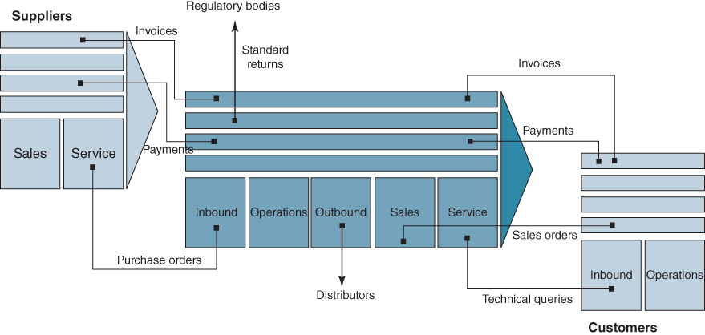
FIGURE 6.5 Detailed mapping of information flows between firms in industry value chain.
Then, each of the key information flows can be examined to see how it could be improved in terms of comprehensiveness, accuracy, speed, cost or timeliness and how that might benefit the business and its trading partners. It might, for instance, be beneficial if a distributor could provide raw sales data directly, rather than consolidate their sales in order to place larger orders. This may enable the firm to optimize its production schedules and the distributor to hold lower stocks, yet still satisfy its customers. At the other end of the chain, it may be possible to do similar things with suppliers. While these are simple examples, they could form the basis of ‘re-engineering’ the way the industry operates to satisfy more demand at lower cost, to the benefit of all involved.
It may be that many of the information exchanges can only be improved with the willing cooperation of trading partners, which may only be forthcoming if there is some mutual benefit – for example, by changing another information flow to provide the partner with a balancing benefit. It could be that, to produce the improvement, existing trading partners have to be bypassed and information exchanged with other parties further upstream or downstream in the chain. This may eventually lead to significant realignment of business relationships.
It is important to understand the type of ‘value’ and ‘cost’ added by each firm or process in the chain (i.e. what is different between the outputs and inputs); for example, a comparison website provides more choice to a customer than one provider, but takes a commission from the providers on sales. That may, in turn, be passed on to the customer, resulting in higher prices via the intermediary than going direct – effectively a fee for having choice. Each key process in the chain should be assessed from two viewpoints:
- How does it add value to the (next) customer in the chain?
- How does it add value to those providing the input?
A retailer adds value to the customer mainly through the range of goods offered and access to them, and adds value to the supplier by providing access to customers, sharing stock costs and administration of low value transactions etc. When assessing changes to the chain, it implies that new value can be added, or existing value-adding and costs will be redistributed, or costs of adding the same value can be reduced, enabling price reduction or increased profit. In online shopping, the consumer's (invisible) search and transaction costs are reduced, but costs may be switched to home delivery. Unless this is offset by another cost reduction (e.g. lower stock holdings), the increased cost of supply will require an equivalent increase in price (payment for delivery) – or the profit in the overall chain will be reduced, as is currently happening in the UK grocery business.
These are relatively obvious examples, but it is necessary to understand the overall ‘chain’ economics if changes are to be successful. Many options will usually present themselves from the analysis, only some of which will prove feasible and beneficial to implement, at least in the short term. However, an understanding of the complete picture may lead to further options emerging in the longer term and it will certainly enable the organization to identify the implications of potential actions by others.

Information Systems and the Value Chain
Obviously, business performance is dependent on effective and efficient processes for gathering and disseminating information. Normal business transactions (invoices, orders, payments etc.) can be addressed by a company with most of its customers and suppliers simply by connection via the Internet – this has already happened in most industries. It not only improves the economics of transaction processing but also enables the whole chain to respond more effectively to real-time demand and supply changes – provided transaction information is shared.
Figure 6.6 depicts two further types of value chain information flow that are being changed by the use of IS/IT.¹² First, the flow of promotional information, which informs customers further down the chain of the products and services available, has been revolutionized by the Internet. It has also given customers the ability to search the whole chain for information directly, or via intermediaries, on whom many firms have become increasingly dependent to provide an electronic ‘shop window’ and ‘virtual shelf space’ for their products and services (for example, Skyscanner for flights and Booking.com for hotels). Consumer demand patterns are changing more rapidly than in the past, influenced by the ease with which companies can contact so many of them at once and personalize promotions, and the speed at which consumers respond to online promotions. Establishing the appropriate level of availability to satisfy a promotion is becoming more difficult – the need is for effective ‘promotion’ linked to the immediate ability to transact the resulting business.
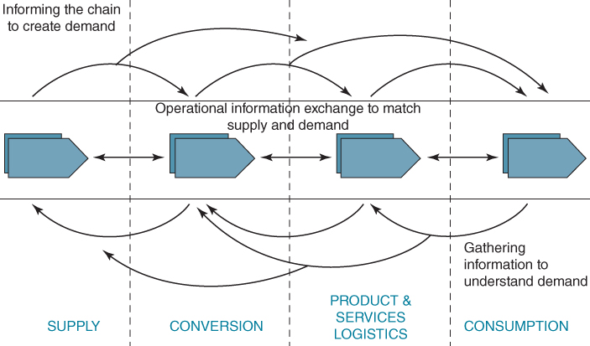
FIGURE 6.6 Understanding the information issues in the industry value chain.
Source: After Rayport and Sviokla.
Second, digital channels offer huge potential to gather information and intelligence about consumer and customer preferences and attitudes online, not just about an individual customer but also, via social media, their friends and other contacts. More importantly, customer behaviour can be tracked in real time with greater accuracy than before and correlated with both the promotional stream and the intelligence gathering stream. Unless each organization and the chain as a whole can assess this information coherently, it is likely that major misinterpretations of changing demand patterns will create serious disruptions in the supply chain. The problems with deliveries following ‘Black Friday’ discounting in November 2014 were caused in part by a lack of shared intelligence about expected demand.
For today's businesses operating in the online environment, these information streams, which could previously have been reconciled ‘off-line’, now have to be reconciled and integrated in real time if the value chain is to function economically. However, even in sophisticated and mature industries, there is often a huge gap between what is possible and the current reality. By whatever means information systems are used to enable better information exchanges through the industry value chain, significant benefits can be obtained from the improved links. These benefits should enable a firm to spend more of its efforts in outperforming its real competitors rather than competing with its trading partners for the available profit. The essence of the argument is:
- At any one time, an industry generates a certain amount of net profit (total sales less total costs). That profit is shared among the organizations contributing to the value chain for the industry. Intermediation increases the number of firms sharing the profit, and the attraction of disintermediation is that the opposite occurs.
- If, in the version of the value chain that includes our firm, the overall net profit can be increased, we can take a share of that increased profit and hence outperform our direct competitors, who are not part of that version of the chain. To achieve this there are essentially three options: (i) create more demand; (ii) satisfy more of the available demand (i.e. gain market share); or (iii) reduce the cost of satisfying the demand. By better information exchange through the value chain, all or any combination of the three can be done at the same time.
For example, earlier feedback on changing tastes may enable the production plan to be rescheduled to meet the new consumer preference. This is particularly important in fashion goods and in very seasonal products such as toys. Like Benetton before it, Zara, the Spanish-based fashion retailer, has developed highly integrated systems that link the franchised shops right through to the subcontractors who make the clothes.¹³ This enables them to respond faster than their competitors to changes in fashion and they are far more profitable than the average clothing company.
- If we can initiate the changes but also share the benefit with customers and suppliers (i.e. they too become more profitable), they will prefer to trade in our more efficient version of the industry. It is very likely that rival firms will be competing for those suppliers and/or customers, but they should give us preference because they are more profitable when they do. This brings about long-term advantages and in due course affects the whole industry structure.
Box 6.5 describes the results of a study of the changes in buyer/supplier relationships caused by the increasing extent of electronic trading in the paper industry.

BOX 6.5

The impact of electronic trading (e-trading) on inter-company relationships in the European paper industry
A study of six dyadic relationshipsª between paper manufacturers and distributors showed that, depending on the level of benefits perceived and received by both parties, over time the relationships between the firms evolved from merely cost saving from transaction automation, through better coordination of operations to strategic alliance. Where one party, usually the buyer, tried to leverage advantage from the relationship, it failed to develop beyond transaction automation. In summary the three phases of relationship development identified were as follows.
- Operational Development Phase
The lowest level of e-trading is typified by the automation of basic transactions (orders, invoices, quotations etc.) but with limited inter-company integration. The use of e-trading and the automation of basic exchanges reduced the need for human intervention, particularly at the sales desk functions of the sellers and the purchasing or procurement functions of the buyers, resulting in reduced interpersonal contact at these levels. At the same time, given the increased ability to coordinate activities, a number of previously separate functions such as IT, logistics and dispatch are brought into closer contact.
With this level of e-trading, companies aim to achieve internal operational improvements by streamlining the transactional aspects of their existing business relationship; the electronic link contributes to improving the coordination of activities but has no influence on the level of cooperation.
- Operational Cooperation Phase
Through the continuing use of e-trading, the realization of each company's internal operational benefits can lead trading partners to agree on a number of shared operational expectations about the electronic relationship, and to share the investment required to further enhance their trading link. This leads to an increase in the diversity of information being shared (inventories, schedules etc.) and levels of integration between the companies. Operational cooperation increases and the level of transactional conflicts reduces, when compared with the previous phase; the use of e-trading contributes to establishing multiple levels of contact across the partners and a closer match between each partner's achieved and expected benefits.
- Strategic Alliance Phase
The previous phase can be developed further by the setting of joint objectives. These allow trading partners to move from a mechanism that achieves more efficient coordination and cooperation at an operational level, to a platform that enables objective sharing across various departments or groups between the organizations. At this level, trading partners mutually acknowledge their interdependence, increasingly cooperating on previously unrelated activities.
Savings due to e-trading are invested back into the same relationship, rather than to other relationships or to all relationships, in order to improve it further. Conflicts and barriers are minimized and companies achieve a number of strategic benefits including growth in volumes of transactions and increased sales of higher margin products.
Notes:
ªE. Redondo, E.M. Daniel and J.M. Ward, ‘Combining the rational and relational perspectives of Electronic Trading’, European Journal of Information Systems, 18, 1, 2009, 79–97.
There are many ways in which better information exchange can reduce costs that occur at the boundaries between organizations. Table 6.1 provides a number of examples, all of which can be seen in a variety of industries, with the effect of reducing inter-organizational costs very significantly.
TABLE 6.1Reduction of inter-company costs due to better information exchange along the value chain – some examples
Cost | Potential IS/IT Impact
Administration | Electronic transmission of orders and invoices etc. directly between customers and suppliers. Automated reconciliation of invoices with orders
Inventory | Sharing information on stocks and demand to avoid both companies carrying unnecessary stock
Transport/storage | Optimizing delivery schedules and routing to ensure transport or storage space is utilized effectively to meet agreed service levels
Design | Collaborative product design to enable faster development of a better product and less ‘rework’
Financing | Electronic payments to improve cash flow and reduce the need for working capital, and reduce accounts receivable and payable costs
Capacity | Matching the use of resources across firms to avoid idle resources in one part of the chain and/or overload in another
Services | Linking third-party service suppliers to service requests to reduce delays in delivering and costs of administration
In summary, an understanding of the industry value chain and the key information flows in the industry can enable an organization to intercept and influence those flows to its advantage and to the benefit of its trading partners. Box 6-6 is an example of a value chain for the ethical pharmaceutical industry (i.e. prescription drugs) showing where information systems applications have had a significant effect on the performance of the industry.

BOX 6.6

Value chain for pharmaceutical company
This value chain example is for an ‘ethical’ drug company where the whole strategy is based on differentiation of the product and its treatment efficacy. Key areas where information flows/relationships are critical to success and provide opportunity to gain advantage or achieve significant performance improvements:
- Provision of drug information to clinicians/doctors who will prescribe the treatment and the influencers – either eminent people in the field and/or ‘panels’ of experts who advise hospitals etc. Traditionally, these were medical people, but now they include health economists and insurers who decide on the financial aspects of the treatment's effectiveness in relation to alternative uses of funds. Approval for use in the UK's National Health Service by NICE (the National Institute for Clinical Excellence) depends on both the drug's efficacy and the economics of prescribing. The same influencers also determine whether pharmacists will ‘stock’ the drug and dispense it. In return, the prescribers and dispensers feed back information on the use of the drug and, particularly importantly, any side effects or adverse reactions encountered. Unless this ‘loop’ is well managed, a new drug can fail.
- The pharmaceutical company relies on forecasts of requirements and then orders from third parties (wholesalers may be the distribution channel for 80% of drugs to dispensers) in order to set schedules etc. for manufacturing. This is a particular problem with new drugs where forecasts rather than orders drive the production scaling/economics. Underestimates lead to lost sales, overestimates to significant waste and cost. The quality of forecasts and, then, consistency with order patterns are key, making online demand and supply information exchange crucial to both parties.
- The skill in pharmaceutical market research is to establish both the nature and size of the market from a variety of particular and statistical data and to determine a development opportunity in a therapeutic area where the company has distinctive skills/competence. Often, today, the opportunities arise from gaps in current treatments, which are known to influencers mentioned in 1 above. Collecting data from diverse sources and interpreting them have been greatly assisted by electronic data input.
- Testing of a drug during development can take many years, and reducing the development time from, say, 8–12 years to maybe 5–6 means more of the patent life (20 years) is unexpired for production, and this affects drug profitability dramatically over its patented life (by hundreds of millions of pounds). Much testing is in-house and controllable, but clinical trials by doctors must be done outside the organization and can take many years. The key to success is organizing the trial – getting the right clinicians to test it on the right population, which requires good information on the test population etc. to avoid delay and wasted effort. Equally, getting the results in is a major data collection/logistics exercise where electronic linkage is essential both for speed and gathering comprehensive/valid trial data. New ‘wearable’ technologies are now being used to speed up the process of collecting necessary data as well as to reduce the overall cost of gathering this data.
- To be able to produce the drug, regulatory approval must be obtained by submitting all the evidence about the drug – this can run to 120,000 pages of data! The most demanding agency is the US FDA (Food and Drug Administration). Once the proposal is submitted, endless questions will be asked and if the information is not well organized, the queries can take months to resolve. Drug companies use IT to develop/store/submit the package of information and enable the regulatory authority to enquire into it electronically. This again can save considerable time and reworking of data to satisfy the regulators and speed up the time to market the drug.
- With the increasing access consumers have to information via the Internet, many ‘patients’ now inform their doctors of the treatment they think they require! In the USA, ‘self-prescription’ is now an option for some drugs. In the UK, the doctor still has to prescribe the drug, but patients can buy some drugs online from international markets, without prescription. Therefore, as information is increasingly available to the public, it is likely the value chain will have to include the patients more effectively, rather than leave them isolated as suggested in this model.
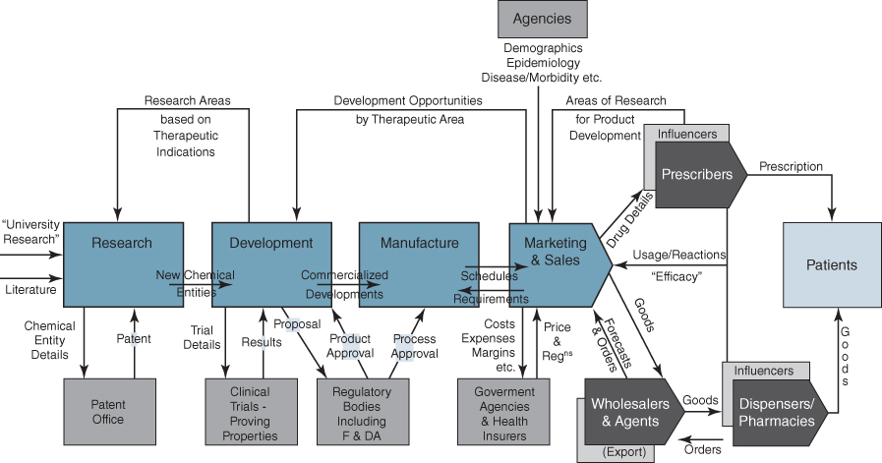

Customer Life-cycle Management and the Value Chain
More focused analysis of the interaction with customers in an industry value chain can be undertaken with Customer Resource Life-cycle Analysis (CRLA).¹⁴ This tool provides a way of examining customer relationships to determine not only when opportunities exist for improved or new information exchanges but also which specific applications should be developed. It is here where digital marketing initiatives tend to be focused. The aim is consider how easy it is for customers to do business with you, how straightforward, consistent and enjoyable experiences are and to prioritize improvements based on a gap analysis.¹⁵
In B2C markets, the modelling of consumer decision making, often referred to as the customer journey, enables managers to understand consumer behaviour, and thereby provides a basis for marketing decisions and potential IS/IT opportunities.¹⁶ The conventional framework for analysing buyer decision processes consists of five key stages, as outlined in Figure 6.7. Of course, iteration exists between the stages and it is not a linear process. Indeed, given the speed at which information is now updated, it could be argued that the loops backward in the model are increasingly important.¹⁷ Nonetheless, the general thrust is forward through the stages.
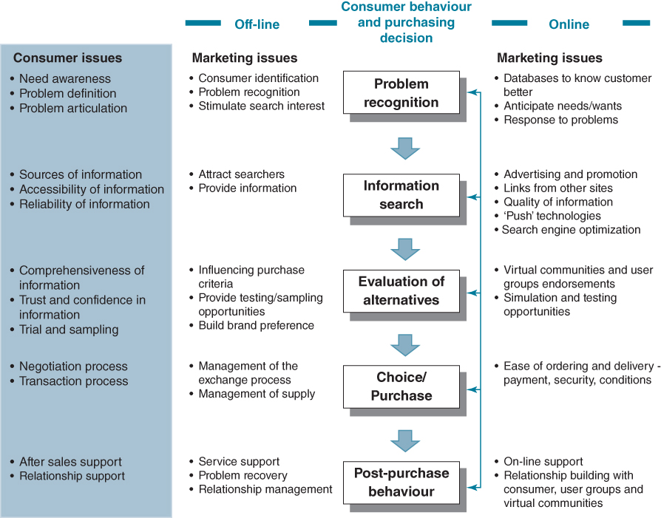
FIGURE 6.7 Consumer marketing issues in the marketplace and online.
The consumer moves initially from a state of Problem recognition to the Search for information on possible solutions. The information gathered, from either internal sources (e.g. memory) or external sources (e.g. discussions, brochures, sales promotions, websites, advertisements) provides the basis for the next stage – the Evaluation of alternatives including the development of purchasing evaluation criteria. The Choice/Purchase stage concerns the activities involved in purchasing, and includes the place and means of purchase as well as the actual decision to buy. Finally, Post-purchase behaviour, as an explicit stage in the process, is critical in the marketing perspective. The degree of satisfaction/dissatisfaction with the product/service and data on how it is used by customers provide information for future product and service development.
Each of these stages involves a number of information exchanges – between buyer and seller – if it is to be completed successfully, thereby ensuring maximum benefit to both. If at any stage the exchange breaks down, either the current transaction or future business will be adversely affected. The further through the life cycle the information exchange has gone, the higher the switching cost to the customer, who will have to retrace the steps at additional cost and inconvenience with another supplier.
Problem recognition may be triggered by a number of external or internal factors. For example, a change in a person's financial situation can trigger a decision; or needing to replace a product that has been used; or marketing stimuli, such as a new product announcement or sales promotion campaign, may create the ‘need’ for a product.
Traditional mass marketing approaches such as advertising on television communicate a common message to many consumers and, as much of the audience will not be interested, there is considerable wastage. We saw in Chapter 1 that the Internet fundamentally changed this: online environments enable identification of individual consumer needs and wants, and the subsequent design and delivery of individual, customized communications. In terms of consumer problem recognition, data from internal and external sources (so-called ‘big data’) can be analysed to predict customer needs and wants. The challenge is to target customers with the right deal at the right time.¹⁸ Moreover, consumers' purchasing activities can be ‘managed’ in similar ways to customers in business-to-business (B2B) markets; for instance, automatic reorder prompts when a specific stock level is reached or automatic upgrades for valued customers. These all make the decision less complex for the buyer, and more manageable and effective for the supplier.
Browser tracking technologies enable ‘click stream’ analysis of individuals' browsing activities, interests and purchase behaviour and the consumer may be contacted on the basis of his or her specific needs and wants, determined by behaviour pattern analysis. Online recommendation systems can tailor e-commerce interactions.¹⁹ In the online environment, the problem recognition stage in the purchase decision process remains essentially the same, but the potential for marketing–consumer relationships is enhanced.
The Information search stage is when the consumer takes action to gain knowledge to support their decision making. Push technologies mean that communications can now be sent routinely to targeted recipients, who are known to be interested by virtue of their earlier visits to the website, their queries and their general Internet browsing and shopping behaviour. That is, the information search stage can be anticipated through the ability of the information provider to proactively locate and inform the interested searcher. Consumers may also register for continual information updates and routinized offer information.
Many consumers today use Google, Bing and other search engines in their initial search for a service or product. In general, the earlier or higher ranked in the search results page and the more frequently a site appears in a search results list, the more visitors it will receive from the search engine's users. Optimizing a website may involve editing its content and coding to increase its relevance to specific keywords and removing barriers to indexing activities by search engines.²⁰
However as information is virtually free, and the costs of accessing information are negligible, given this free flow of product/service information there is the potential for overload, which can increase consumer uncertainty. Information ‘overload’ occurs when customers learn more about the alternatives available, and the search becomes ‘psychologically costly’.²¹ When humans cannot plot or track the totality of information, they deliberately simplify their problem; they develop heuristics, the chief among these being brand loyalty and all that goes with it – identity, reliability and trust. Trust is a crucial factor in e-commerce.²²
In traditional markets, the intermediary function is largely based on information provision and exchange (e.g. travel agent or insurance broker). As communications technologies change and as disintermediation and re-intermediation become more common, matching information content with the consumer's requirement, while continuing to be fundamental to success, will require new approaches to information provision and exchange. This can often mean influencing, or at least being part of, the conversation on social media.
Evaluation of alternatives based on the information the consumer has found. Traditional sources of information for this stage include past experience, marketing sponsored communications, consumer groups, research institutions and word of mouth. Many comparison sites enable quick and easy comparisons across products and services of attributes such as price and performance and some, such as bookings.com and TripAdvisor, provide comments from guests who have stayed at a hotel a customer might be considering.²³ Information technologies allow for more evaluative criteria to be used but, as mentioned above, when consumers experience information overload in the evaluation process, the advantage may be to the ‘safe’ branded or established company.
In the same way that word-of-mouth communication and the references of family and friends are a central influence at this stage of the decision process in the traditional marketplace, new kinds of reference groups are central online. In effect, a discussion group of interested parties in any field serves this role in the new environment. Virtual communities, such as Agriculture Online, Garden Escape and Mums Online, can have the same influence as traditional reference groups but can share an even greater quality and quantity of evaluative information. Ideas and proposals which have been vetted by trusted colleagues in the community can confer enormous credibility on the information source.
Purchase decisions include deciding where and how to buy. Where to buy is a decision regarding the choice of seller. Online competition is driven by sellers attempting to build more exciting and interesting sites than their competitors, attracting the right customers to those sites, and providing superior shopping experiences to induce purchase. How to buy concerns the nature of the transaction, contract and delivery. While digital content can be provided electronically and immediately, physical products raise additional challenges, particular concerning delivery or ‘pick-up’ options. Companies must make the shopping experience easy and enjoyable for their customers; ease of ordering, payment and delivery are critical in this purchase stage. Clear explanations of how to order, how to pay and what to expect on delivery are key.
Post-purchase behaviour. Given the emphasis in marketing on the development of ongoing relationships with customers, the actual sale should be perceived as a starting point rather than an end. So how the customer takes delivery of the product, how the product is used, the degree of satisfaction, quality of the service provided, customer complaints and suggestions are all critical to understanding consumer behaviour.
Whilst consumer groups are influential in many areas of business, the online user groups involved in Internet markets warrant particular attention because of their power of communication. The critical role of virtual communities in evaluating organizations and products before the purchase is mirrored by the actions of user groups in the post-purchase situation. Consumer product organizations can find themselves responding directly to the feedback from its user groups. The ability to draw customers into a conversation in real time confers tremendous powers on the seller, and requires a proactive approach to after-sales relationships. Communications access to and from the customer, and commitment to fostering good relations with the increasingly powerful consumer/user groups are important strategic considerations.
In essence, CRLA forces consideration of the product or service within a customer's value chain. This produces information relationships between buyer and seller over an extended timescale while the product/service is being considered, used or consumed. Some questions to help identify issues and options for online trading within the five stages of the CRLC are shown in Table 6.2. Most of the steps in the five stages, especially gathering information about the customer throughout the relationship life cycle, have become much easier and more economical to implement using technology. Information gleaned ‘post-purchase’ from customers is the most valuable in terms of understanding what they actually value regarding service and product requirements and preferences. Analysis of this data can lead to ideas for product or service innovations as discussed in Chapter 5.

TABLE 6.2Some questions to reflect on customer resource life cycle
Consumer purchasing behaviour | Diagnostic questions
Problem recognition | - ♦ Do you collect information from site visits?  - ♦ Do you use information to anticipate and respond to customer needs and wants?
Information search | - ♦ Do you ensure that your site is designed to attract new visitors and to encourage visitors to return?  - ♦ Do you ensure that the information your site provides is appropriate for visitors' needs? How do you decide what to present? How frequently is your site updated?  - ♦ Do you use ‘push’ technologies to inform and update customers?  - ♦ Is your website optimized for search engines?  - ♦ Do you monitor social media sites for mention of your product/service?
Evaluation of alternatives | - ♦ Do you proactively influence and cooperate with virtual communities and user groups?  - ♦ Do you provide interactive support for evaluation?
Choice/Purchase | - ♦ Is it easy for the customer to order from your site?  - ♦ Do you ensure that your exchange process is simple and risk free?  - ♦ Do you provide a customer-oriented delivery process?
Post-purchase | - ♦ Do you provide online support?  - ♦ Do you collect usage information from customers?  - ♦ Do you actively develop relationships with customers and prospects?  - ♦ Do you actively engage with user communities?
Many firms now help customers establish and specify their needs by providing more extensive information than ever before with easy access. Others provide ‘sourcing’ applications to enable buyers to find the best deal. Comparison or consolidation websites identify prices being charged for similar products across a range of suppliers. This has had a huge impact in markets for information-intensive products, such as insurance, and especially perishable information-based products, such as hotel rooms. New means of trading have been introduced to consumers by companies such as eBay, including auctions and customer pricing against which the supplier can choose to sell. These all decrease customer switching costs, increasing the challenge of how to gain and maintain customer loyalty in this new environment through ‘stewardship’ services that encourage further purchases. This depends on establishing an ongoing dialogue with the customer to learn more about them and tailoring the relationship as individually as possible to their needs. Customer Relationship Management (CRM) systems are designed to cover the whole life cycle, providing a comprehensive view of the customers' patterns of interactions and relationships with the firm, enabling proactive rather than reactive approaches to meeting their needs.

Strategic Option Generator
Another, similar technique for generating information systems ideas during value chain analysis is the ‘strategic option generator’.²⁴ It considers the impact of IS/IT in relation to:
- Suppliers – anyone supplying essential resources. It may be necessary to subset them either by the nature of what they supply or their strength, i.e. their ability to exert pressure on you and other customers.
- Customers – these can include consumers as well as direct customers, if the latter are essentially distributors. The customer PUV matrix introduced in Chapter 2 can be used, as described below, to refine these options. Consideration should also be given to the threat of new intermediaries or options for disintermediation by others.
- Competitors – competitors who sell very similar products or services should be supplemented by actual or potential new entrants into the market and ‘threatening’ substitute products and services should be included as competition.
For each, alternative ‘strategic thrusts’ – offensive or defensive moves – can be made by the firm:
- Differentiation – ensuring that superior quality is delivered and perceived, leading to obtaining a premium price. It could also imply being a ‘preferred customer’ to obtain preferential service.
- Cost – being cheaper or enabling suppliers or customers to reduce their costs (sharing the benefit) and thereby preferring to conduct business with the firm (ways may also be found to increase competitors' costs!).
- Innovation – introduce a new product, service, process or way of doing business that transforms the relationships and competitive forces in the industry. This may require the active involvement and cooperation of suppliers and/or customers.
- Growth – enable volume or expansion in geography or increased flexibility of production and distribution to meet different segments' needs.
- Alliance – forging agreements, joint ventures or joint investments in IS/IT to prevent new entrants or competitors achieving advantage.
Each of the above may be appropriate with different groups of suppliers or customers or even competitors, implying that a wide range of options can be identified, many of which may prove infeasible! To identify what benefits could be achieved, questions such as those suggested in Table 6.3 can be posed to reveal opportunities. Some of the questions imply a degree of lateral thought. For instance, ‘reduce suppliers’ costs' tends to go against the grain! The full question should be perhaps ‘reduce the suppliers’ cost, when doing business with us' (in order to create more profit in the chain and share the benefit).

TABLE 6.3IS/IT opportunity analysis – sample questions
Suppliers: Can we use IS/IT to:
- ♦ Gain leverage over our suppliers (improving our bargaining power or reducing theirs)?
- ♦ Reduce buying costs?
- ♦ Reduce the suppliers' costs?
- ♦ Be a better customer and obtain a better service?
- ♦ Identify alternative sources of supply?
- ♦ Improve the quality of products/services purchased?
Customers: Can we use IS/IT to:
- ♦ Reduce customers' costs and/or increase their revenue?
- ♦ Increase our customers' switching costs (to alternative suppliers)?
- ♦ Increase our customers' knowledge of our products/services?
- ♦ Improve support/service to customers and their needs?
- ♦ Identify new potential customers?
Competitors: Can we use IS/IT to:
- ♦ Raise the entry cost of potential competitors?
- ♦ Differentiate (or create new) products/services?
- ♦ Reduce our costs/Increase competitors' costs?
- ♦ Alter the channels of distribution?
- ♦ Identify/establish a new market niche?
- ♦ Form joint ventures to enter new markets?
The strategic option generator approach relies on a thorough understanding of the state of the industry, the firm's competitive position, the determining factors for success in the industry value chain and having a clear business strategy. It is most helpful in being specific about who will benefit, and how, from the options for change in relationships through the value chain.

Exploring Strategic Options Using the Customer Perceived Use Value (PUV) Matrix
In Chapter 2 we introduced the customer matrix as a way of analysing the features of products and services that really matter to customers. It enables an assessment to be made as to how a product compares to competitors' offerings. Once the current competitive position has been determined, the PUV ‘compass’ enables consideration of alternative strategic moves. From an IS/IT perspective (see Figure 6.8), the task is to explore how IS/IT might be leveraged to create or achieve any of the available strategic options as described in Box 2.3.
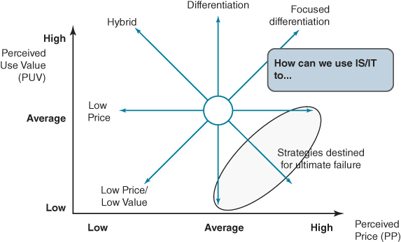
FIGURE 6.8 Exploring competitive strategic options on customer matrix.
The earlier discussion on informating existing products and services offers a number of alternative ways of adding perceived value to the product itself or its use. However, there is a danger that, although it might be easy and tempting to informate a product, customers may not perceive the additional value and the costs incurred cannot be recovered through additional revenue. But there are other options. For example, can IS/IT be used to offer lower prices to customers (moving west on the compass)? This might mean eliminating features of the product that the customer does not value or that can be delivered in a different way; for instance, by eliminating an expensive physical channel for a cheaper virtual one using IS/IT. The provision of user manuals online for phones, cameras and other ‘high tech’ equipment, as opposed to printed ones packaged with the product, is an example.

From Value Chain to Value Network
While the external value chain as both a concept and a tool has been used for the last 40 years to understand and analyse industries, it has proved less effective for industries whose products and services have become ‘de-materialized’ (i.e. defined by information) and whose business processes no longer have a physical dimension.²⁵ This is particularly evident in sectors such as banking, insurance, telecommunications, news, gambling, entertainment, music, advertising and certain areas of the public sector.²⁶ We saw in Chapter 1 that digitization is significantly altering the cost structure of firms such that the cost of transactions, both within and between organizations, is dramatically declining.²⁷ As a result, many of the benefits associated with integrated firms, which primarily arise from their lower transaction costs, are eliminated. This can be seen with the increasing fragmentation of traditional value chains in many industries, from banking to automotive manufacturing.²⁸ In addition, many industries now exhibit strong cooperative behaviour²⁹ with inter-firm relationships playing a significant role in shaping strategic performance.³⁰ Unlike the traditional value chain, where suppliers produce outputs which become inputs to the next firm in the chain, with the value network concept, value is co-created by combinations of organizations in the network. A mobile phone, for example, is valueless without a network to connect to and services for customers to use.
In adopting a network perspective, the focus is not on a particular organization or the industry, but the value creating system itself, within which different organizations – suppliers, partners, allies and customers – work together to co-produce value. Where once individual firms battled against each other, today some competition is between networks of interconnected organizations, in which the well-being of the network and the partners that compose it is as important as its individual members.³¹
For example, chip manufacturer Intel cultivates a huge network of partners and other stakeholders to ensure its continued success. The company recognizes that it is pointless developing and manufacturing a new, more powerful chip set if there is no software that uses its capabilities or hardware with the capacity to deploy the chip. It keeps software developers abreast of progress and provides them with early versions so that, when the chip appears, software will be available to use the new processing capabilities. It also works with hardware manufacturers to ensure, for example, that new generations will have the cooling systems required to accommodate the new chip.
A value network, or ecosystem, consists of relatively autonomous units that can be managed independently, but operate together in a framework of common principles. Although independent, the relationships enjoyed by the firms in the network are essential to their competitive positions. Moreover, the structure of the network plays an important role in firm performance and in industry evolution.³²
Analysis suggests that for some industries, such as telecoms, transport and energy, the present ‘integrated’ company is not sustainable and companies may need to deconstruct around one of three business functions, unless clear strategic benefits can be identified and pursued by keeping these functions within the same organization:³³
- Customer relationships, where competitive advantages come from economies of scope, with each customer treated as an individual.
- Service and content innovation and commercialization, where the focus is on new innovations and on the speed-to-market for new content and services.
- Infrastructure management, providing network access and mediating capability, where economies of scale provide the advantage.
The separation of these three functions can be seen in the mobile communications industry where, for example, MVNOs (Mobile Virtual Network Operators), such as Virgin Mobile, focus on managing a brand's relationship with the customer, but using a competitor's infrastructure.³⁴ Mobile ‘apps’, developed by software developers and content providers, provide a myriad of services.
This results in deconstruction of the industry where complex relationships will need to be formed between different players in order to deliver services to end-customers. These can be represented by a network of connected entities – the value network, as illustrated and discussed in Box 6.7. From a network perspective, relationships are viewed as part of a larger whole – a network of interdependent relationships:³⁵ what happens in one relationship affects others, either positively or negatively. An action by one participant in the network can influence other network members. Or an action by one may require further actions by other participants to be effective. Thus, all aspects of the network must be included in any analysis: customers, suppliers, competitors, allies, regulators and any other players whose presence in the network can influence value creation by the focal organization.³⁶

BOX 6.7

Mobile content/service innovation and provision
It is widely established that content and services will be the drivers of traffic through operator transmission networks. It is also acknowledged that operators themselves will not develop all of these services but that they will be provided by third parties. Some of these will be large media organizations; others will be smaller start-up companies building apps or aggregators. Thus, network participants include MVNO, network operators, content aggregators, content/service creators, software houses, browser developers, infrastructure equipment, marketing companies, regulators etc.
It is the customer who ultimately defines the value delivered by the network. The customer is not interested in the complexity of the IT systems or transmission network. Equally, customers do not want to be concerned with the revenue sharing agreement between content provider and network operator. The customer is seeking choice, service quality, relevance, ease of use, fair and easily understood pricing as well as good support, if required.
Reducing the time to market for new content and services has significant benefits for both the creator and the operator. Content becomes profitable within a shorter space of time. Short lifespan services, such as those associated with particular brand promotions, also become economically feasible. For the marketers, it enables more precise segmentation of the market, with content focused on the particular demographic of the customer. This enables operators to increase their content and services portfolio, thereby driving revenue growth.
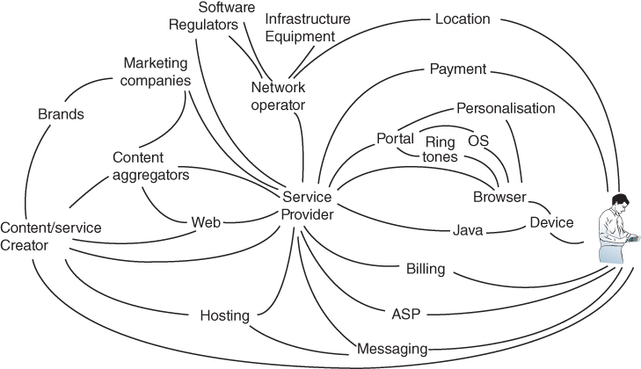
By understanding a firm's relationships with other network members, we can better understand where value lies in the network, how value is co-created, how the firm's activities will affect the network and how other members are likely to respond. For example, are their platform companies attempting to orchestrate ecosystem development?
Taking a network view of a mobile operator, for example, rather than merely asking ‘How can the operator add value to its customers?’, the question should be ‘How can the operator add value to the other members of the network?’ Doing so helps understanding of not only the direct relationships between operators and customers, but also the inter-relationships between all the other members of the network.

Network Value Analysis (NVA)
We have developed an approach, Network Value Analysis (NVA), with the aim of generating a comprehensive description of where value lies in a network and an understanding of how value is created.³⁷ The stages involved in undertaking such an analysis are, in overview, as follows.
- Defining the network and its objectives
The network should contain roles or functions but not specific organization names – these can subsequently be constructed around these functions. For example, in constructing the network for the mobile content and services ecosystem, we have separate roles for transmission network operation and service provision, which may or may not be the same organization. At the centre of the network or ecosystem is the organization or business unit whose business model relies on the success of the network, and whose objectives need to be identified and considered in combination with other major network players, to define the network objectives.
- Identify and define network participants
Network participants include all those organizations that influence the value the network creates and delivers to its end-customers and hence affect our organization's value proposition. Depending on the network objectives, these can include designers, suppliers, competitors, channels, regulators, technology vendors and software suppliers. For example, the mobile health (M-health) ecosystem will include biopharmaceutical companies, medical technology companies, providers, payers, telecommunication companies, regulators and patients.
- Define the value each participant perceives from being a network member
Delivering value requires a clear understanding of exactly what kind of value is desired by each of the network members, i.e. value is as they perceive it now and into the future.³⁸ The objective is to capture the perceived value obtained by the different participants by being part of the network, plus any ‘detriments’ (things that destroy value) or negative perceptions, i.e. asking ‘what are they getting out of the network?’ Perceived value is a driver of behaviour which in turn is a key force of network development – it is the perceived values that guide what people and firms are, or are not, willing to do.
- Identify and map network influences
This involves identifying the nature of linkages between the members of the network. These can take several forms (e.g. financial, dependency, loyalty, route to market, customer) and create different types of influence in network relationships. The nature and level of influence is an important indicator of the amount of attention providers will need to give to that network participant when developing its business. The different types of influences can be categorized as follows:³⁹
  - Exchange of goods and services; for example, new digital content such as a movie or health information.
  - Affective and liking (expressive/emotional); for example, customers attracted to a brand.
  - Information and ideas (cognitive); for example, ideas for new service offerings coming from customers or content developers (what is often referred to as ‘open innovation’).
  - Influence and power (prescriptive); for example, regulators or key patent owner.
Influences can be positive or negative with respect to each participant. A negative influence can be considered as network critical if (a) the network currently depends on the linkage to create value for the users and/or (b) it can alter the current structure of the network significantly if no action is undertaken to address the cause of this influence.
- Analyse and shape the network
The resulting network value map provides an overview which allows some conclusions to be drawn about the roles of the different participants in the network, their perceived value dimensions and how they are influenced by other participants. Any analysis typically covers the roles played by participants, how value is distributed, the current network dynamics and the implications of all these in developing future strategies.

The Internal Value Chain
The main purpose of internal value chain analysis is to focus on what the organization does rather than how it does it, i.e. analysing the activities it performs to contribute to the value-adding processes of the industry, rather than its organization structure or the processes currently in place. Historically, a company's information systems will have often resulted from improving organizational performance at process, functional or departmental level. More recently, large integrated software suites, such as ERP and CRM packages, may well have been used to address a mix of business process and organizational needs, improving some linkages through the chain and reducing information duplication and inconsistencies. As a result, the organization's systems and information resources are better aligned to the core processes the firm carries out to satisfy its customers and also govern the business.
Although this means that the systems tend to fit the functional and process structure well, they are often less effective in ensuring the ideal flow of key information into, through and out of the business to optimize its overall performance. Moreover, software packages provide industry standard processes, delivering competitive parity but limiting the opportunity to create advantage, unless the organization can find ways of building on the benefits of integrated, reliable key operational and support applications.⁴⁰ Standardization and integration of systems can improve process performance and reliability, but tend to reduce flexibility and make any changes complex and costly. As external relationships evolve and develop, the internal processes and systems will also have to change to enable the business model to operate efficiently.
Although the value chain analysis approach is similar to the business process analysis described in Chapter 4, there are a number of subtle differences. First it distinguishes between two types of business activity:
- Primary activities – those that enable the enterprise to perform its role in the industry value chain, produce its revenue-earning goods or services and satisfy its customers, who see the direct effects of how well those activities are carried out. Not only must each activity be performed well, they must also link together effectively if the overall business performance is to be optimized.
- Support activities – those which are necessary to enable, control and develop the primary business activities over time and thereby add value indirectly – the value being realized through the success of the primary activities. The temptation is to minimize the cost of these activities, or even outsource some of them, as their value is less tangible.
Some activities only add value if they are effectively integrated across primary and support parts of the chain. These are often information-intensive activities such as forecasting (estimating demand, planning capacity and scheduling resources and activities) and pricing, which require input from many components in the chain and will have effects on many others.
In a multi-unit business, each operating unit will have a set of primary activities it must perform successfully to satisfy its market. The support activities, or some of them, may be shared by the operating units because it is more cost-effective to do so, or because there are synergistic benefits by having a central or shared service (e.g. Human Resource Management, Procurement, Finance or IT).

The Traditional Value Chain Model
The traditional value chain concept is derived from the work of Michael Porter.⁴¹ He classified the primary activities into five groups, which can be considered in sequence, starting with suppliers and ending with customers:
- Inbound logistics – obtaining, receiving, storing and provisioning the key inputs and resources in the right quality and quantity to the business. This may include recruiting staff as well as buying materials, components, equipment and services and dealing with subcontractors and outsource partners.
- Operations – transforming the inputs into the products or services required by the customers. This involves bringing the resources and materials together to make the ‘product’ (e.g. a car) or provide the service (e.g. a banking current account).
- Outbound logistics – distributing the products to the customers either directly or to the appropriate channel of distribution, so that the customer can obtain the product or service and pay for it appropriately (e.g. a car could go via a dealer to the customer, although it is possible for the customer to buy direct from the manufacturer and have the car delivered from the factory; or the delivery of cash to a bank customer via an Automated Teller Machine (ATM) installed in a grocery retailer).
- Sales and marketing – understanding or creating the market for the products and services and making potential customers and consumers aware of the product or service, its value and how to obtain, pay for and use it. This would apply to a new car model, or a bank account, but also to cancer screening in the Health Service, for instance. Increasingly this also includes obtaining feedback from individual customers on the quality and ‘use value’ of the product itself and the process of obtaining it.
- Services – adding further value by ensuring the customer gets full benefit or value from having and using the product or service (e.g. car warranty, or information on how to use a bank account to avoid unnecessary overdraft charges) and creating additional revenue streams from add-on activities (e.g. car servicing or, for a monthly fee, providing some insurance products with a bank account).
Porter's structuring of the activities fits most easily to product-based manufacturing, distribution or retailing companies but, using the same logic of obtaining resources, transforming them, delivery, getting the customer to ‘buy’ and then gain maximum value from the product or service, value chains can be drawn for almost any business.
Figure 6.9 shows sets of activities grouped in the structure described above for a manufacturing company and also some of the associated support activities we would expect to find in many types of organization. The nature of the primary activities a organization performs is largely determined by the industry, its products, customers and suppliers – its success is determined by how well it performs them. That will decide how much value is derived and how much the activities cost and, hence, the primary profit margin. Software packages to support and integrate the primary activities will tend to be industry specific – it is not what they do but how well they are implemented and used that affects performance and hence the profit margins.
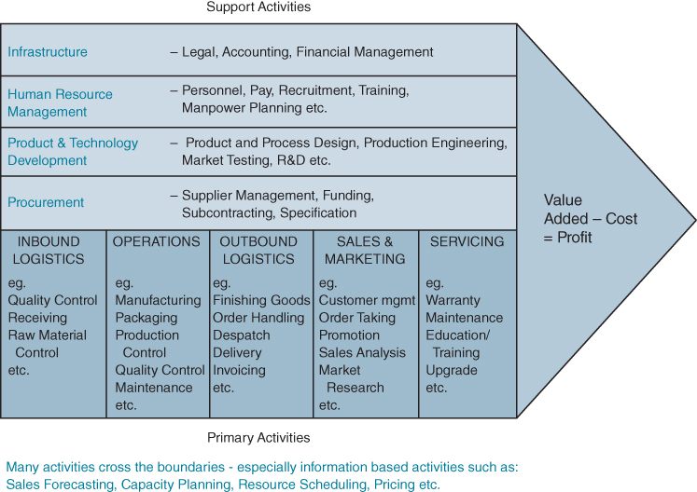
FIGURE 6.9 A typical manufacturing firm's value chain.
Within an industry there is more discretion over how support activities are organized but more similarity across business sectors as they are needed to run an organization rather than produce particular goods or services. As a result, software solutions are often not industry specific.

Alternative Internal Value ‘Configuration’ Models
Although the traditional value chain model can be applied quite successfully to some service businesses and public sector organizations, in many others it does not really represent what the organization does or its relationships with customers and suppliers or other parties. For example, most aspects of insurance and advisory services involve no physical product (except paper and money); nor does the model represent businesses where suppliers can also be customers (e.g. banking) and it is especially weak in describing many not-for-profit organizations or Web 2.0 types of service businesses.
Stabell and Fjeldstad⁴² describe two alternative value models that attempt to address these issues. The focus is on the primary value chain activities since the support activities are often very similar to the traditional model. They call these two alternatives: ‘Value Shops’ and ‘Value Networks’.
Value Shops are essentially ‘problem-solving’ businesses, delivering value by providing solutions for clients. They are characterized by intense and extensive information exchanges, both in setting up the business transaction and delivery of the solution. Examples are as widespread as oil exploration, design engineering, management consultancy, insurance, advertising and hairdressing. They are characterized as being non-flow line, since each problem is, at least for the client, unique and the client is normally involved in both the design and implementation of the solution.⁴³
Figure 6.10 shows an example of such a value chain which better reflects a service business, where the objective is to satisfy the client or customer requirements, by bringing together the appropriate knowledge and resources from inside the firm or by using other external resources.
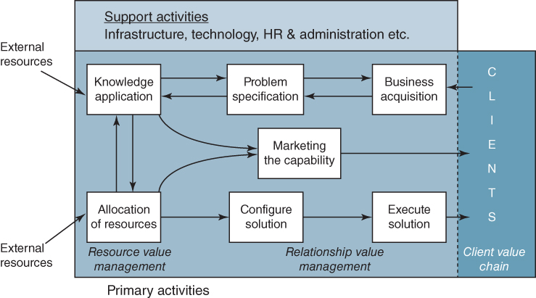
FIGURE 6.10 ‘Value Shop’: service businesses – where the client is actively involved in and affected by the processes.
Source: After Stabell and Fjeldstad.
The chain involves two flows: to determine the client's needs and (assuming they can be met) design and implement a solution that satisfies the requirements. This can be relatively simple (e.g. a new hairstyle) or very complex (a new oil refinery). Considerable information exchange over an extended period is often required in the more complex situations. IS/IT offers capabilities to increase the efficiency, improve the precision and reduce the elapsed time needed for such exchanges, as well as provide a complete record of the exchanges, thus reducing misunderstandings and unnecessary reiterations.
Value Networks are businesses that provide exchanges or platforms and mediation between buyers and sellers, enabling relationships to be established.⁴⁴ They should not be confused with the external value network perspective presented earlier in the chapter, although they may be involved in those networks, e.g. telecommunications operator or a price comparison website.
They can earn revenue from either or both buyers and sellers – ‘everyone's a customer’. Mail and parcel delivery services are typical examples. The services may extend beyond connection to revenue collection, contract management, systems integration, information exchange and insurance, in terms of adding additional value for a customer or customer segment. Many cable and media companies as well as more established telecoms providers are in this group, as well as a range of financial service and investment businesses (e.g. share trading), plus businesses involved in new online trading models and platforms: auctions, clubs, some forms of gambling and dating agencies, including taxi apps Uber and Lyft and room rental company Airbnb.
The primary activities of such firms include infrastructure development and maintenance to provide capacity and access, service provision to cater for the needs of different buyer/seller relationships and promotion to both buyer and seller groups to recover the capacity costs via transaction-based revenues. Figure 6.11 suggests how this model differs from the other two.
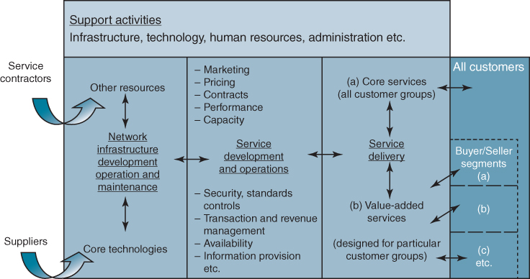
FIGURE 6.11 ‘Value Network’ value chain – service businesses.
Source: After Stabell and Fjeldstad.
In all three types of value chain model, information about what customers want and how that demand can be satisfied should flow freely through the organization, enabling the management of each activity to determine how best to deploy its resources to maximize customer satisfaction in the most effective way. Any action taken would be immediately visible to other activities in the chain, which can then take further action accordingly or report any problems in meeting the requirement. The chain can be continuously rebalanced across all the activities.
In addition to the flow through the organization, each activity or process (e.g. purchasing, customer acquisition) will need information systems to carry out and manage its part of the business. In themselves they may be very extensive but should link into the flow as required. For instance, the warehouse management system must know where every item is in the warehouse, but the rest of the business only needs to know what is in it, and, while the manufacturing department needs to schedule each machine in detail, the rest of the business only needs to know when products will be ready to meet orders from customers. Equally, in a consultancy-type business, resource management activities do not need to know the detail of each assignment, but need to know who is committed and for how long.
Some large organizations, such as the pharmaceutical company described in Box 6.6, consist of more than one type of value chain. In that case, the R&D activities are more like a value shop, whereas the manufacturing and distribution parts are more traditional.

The Uses of Value Chain Analysis
Value chain analysis is essentially a form of high-level industry and business process/activity analysis – a way of describing an industry as a network of interdependent components. As discussed, the original highly structured version concept of the value chain – the ‘big arrow’ – is often difficult to apply to service industries, the public sector and not-for-profit organizations. Bus companies, the police, car hire, banks, estate agencies, the tax collection agencies and education as well as many online businesses are all examples where the five linear components of the internal value chain are difficult to identify. The two other value models – ‘shops’ and ‘networks’ – are more helpful in describing how their activities interrelate to provide the customer with value.
The process of analysis should be relatively flexible, describing ‘freehand’ the relationships among the customers, the service/product and the resources consumed. The main objective in all cases is to represent the main activities performed by the firm, in terms of what it does to add value, to satisfy customers and to obtain resources from suppliers – not in terms of how the organization is currently structured – i.e. to focus on core business process requirements. By considering the organization's value chain as a component of an industry value system or network, a broader view of activities and relationships and the information implications and opportunities can be determined. It is equally important to separate primary activities from support activities that are there for organizational or institutional purposes and only indirectly contribute to adding value. However value chains are drawn, they can enable further analysis of any or all of the following:
- The information that flows throughout the industry and how critical that information is to the functioning of the industry and the success of the firms in it, by determining where and when that information is available, who has it and how it could be obtained and turned to advantage or used against the firm.
For instance, in some industries like fashion goods, ‘demand’ information is the critical factor, but in others, such as confectionery, ‘supply’ data – the price and availability of cocoa beans – can be critical to success. Manufacturers who have good information and can respond to changing demand/supply fastest can outcompete those who lack the relevant information. In the UK timber industry, for example, the price of softwoods is affected over a six-month cycle by the US building industry – housing starts in the USA determining availability and price elsewhere.
- The information that is or could be exchanged with customers and suppliers throughout the chain to improve the performance of the business or lead to mutually improved performance by sharing the benefits (e.g. the information that is required for a distributor to sell on the product/service or a supplier to acquire input resources).
Suppliers of particular components or resources may have longer lead times than appropriate, given the volatility of the company's business. Providing plans for forward requirements, even buying on its behalf to spread both companies' risks, can help. The information links between companies are far more complex than often appreciated and the value chain approach allows them to be studied.
Strategic benefits come from changing the relationships with trading partners and using the information exchange to conduct business in new, mutually beneficial ways, as explained earlier (see Box 6.5). Once the available cost savings from online trading have been ‘shared out’ equitably between buyers and sellers, advantage will only accrue to those who innovate in business processes, provide new value to customers and/or can find significant numbers of new customers to satisfy.
- Understanding how effectively the information flows through the primary processes and is used by them to: (i) optimize the performance of each activity; (ii) link activities together and avoid unnecessary costs and delays; and (iii) enable support activities to contribute to the value-adding processes, not hinder them.
An engineering company, producing and maintaining switching systems, studied how information flowed through its primary activities and was able to simplify and automate the flows from the customer enquiry through to the component suppliers, and back again, to reduce delivery lead times from 27 to 5 days. The result was a 37% increase in sales due to faster responses to customers and a reduction in inventory costs.
O'Sullivan and Geringer⁴⁵ explain how, by understanding the role of information in both internal and external value chains, major business performance improvements can be made by changing how the chain works. They introduced the concept of ‘natural’ and ‘contrived’ value chains. The natural value chain describes the (usually unattainable) optimum structure for the industry's value-adding processes and information flows, based on what needs to be done. The contrived value chain shows how (in far from optimal ways) things are currently done. They identify characteristic differences in natural and contrived value chains, as shown in Box 6.8.

BOX 6.8

Natural versus contrived value chains
Contrived value chain represents how things are done by resources in the industry/organization:
- ♦ driven by organization structures, historical evolution and compromise;
- ♦ is often very complex, confused and ‘messy’, and poorly understood;
- ♦ contains many reconciliation activities and reacts slowly;
- ♦ can take many forms, is continuously being modified to meet business changes.
Natural value chain represents what has to be done to succeed in market requirements:
- ♦ based on value-adding activities and the resources needed to carry them out;
- ♦ defines essential inter-relationships and dependencies and the ideal way to achieve business purposes;
- ♦ contains few reconciliation activities and responds quickly;
- ♦ usually only one ideal exists, and it does not change significantly or frequently.
The first purpose in analysing the value chain in information terms is to reduce the existing complexity either inherent in the current information relationships or caused by them. The second purpose is to identify new, often faster, options for information to flow to where it enables the value-adding processes to be performed more effectively and at the ideal time. In doing so, the way the chain works should change from whatever ‘contrived’ state it has reached through evolution to something more like the ‘natural’ view of the chain. Many business transformation initiatives and implementations of integrated software packages have been focused on eliminating inefficiencies, inconsistencies and rework across primary activity boundaries and between primary and support activities. One insurance company reduced the number of ‘hand-offs’ of new policy details from 14 to 3 without any loss of control.

Summary
This chapter has described a number of approaches that can help in understanding an organization's information-based possibilities and the potential business benefits. The use of each technique has been exemplified by what others have done. The various techniques have been described from the ‘top down’, from the industry down to particular aspects of information exchange with customers or suppliers. Beneficial options can arise at any stage of the analysis or equally by inspiration. The various models used also offer a basis for testing the value of ‘good ideas’ resulting from ad hoc inspiration.
All the techniques have a common theme – they must be used by people with knowledge of the business and its environment, and therefore are not tools for IS/IT specialists alone to use. Senior management and line managers need to become familiar with this type of analysis, which should be possible as all the tools and techniques described in the chapter are really IS/IT variants of business strategic analysis tools.
In planning future information systems and technology investments for an organization, it is important to identify the business opportunities and threats presented by the increasing and developing use of IS/IT in the firm's industry and in the world at large. The objective is to identify strategically important applications – those applications that directly support chosen business strategies or enable new business strategies to be developed and implemented. If the organization is not in a strictly competitive environment, strategic applications will be those focusing on meeting organizational objectives.
Many products and most services are also primarily ‘made of information’ and can be improved, enhanced and frequently created by the capabilities of IT. As IT use has become widespread by consumers as well as organizations, the opportunities to create new products and services as well as transform existing ones have multiplied exponentially. The ever-extending infrastructure provided by technology such as mobile phones and social media enables rapid commercialization of new products and services – high pay-off for relatively low risk ventures. Seeking ways of adding value to products by including an IS/IT component – informating the product – or creating new information only service adjuncts to existing products and services are options for many organizations. In some cases failure to do so allows ‘information only’ intermediaries to take some or all of the additional value available, often at low cost. Use of the competitive forces analysis combined with a sound understanding of what the customer really values about a product or service can help identify these opportunities – and also potential threats from competitors, new entrants and substitute products.
Information systems have always been part of the value-adding processes that comprise any enterprise, whether it be a commercial company, a public service or a charitable body. Historically though, IS/IT has been mainly deployed to improve individual component processes or activities of the enterprise. Initially, this improvement was targeted at reducing the costs of the supporting activities rather than improving the performance of the primary activities of the business. Even when systems became focused on primary activities, they tended to be aimed at optimizing the performance of the main, and probably most costly, operational activity of the business, and only then on activities that directly interact with suppliers and customers, but with a view to not compromising or jeopardizing the effectiveness of internal operations.
The value chain analysis techniques suggest that the firm's information systems should be considered in an extended context – that of the industry value chain or value network – in order to achieve maximum leverage from IS/IT investments and benefits from industry and internal developments. The value chain represents the flow of goods and services and use of resources through the industry, and there are simultaneous, parallel flows of information running through the industry. The value chain analysis tools make the organization consider how those industry information flows affect the firm and where it is worth investing to achieve superiority with respect to others by exploiting the information and its flow, or avoid being disadvantaged by the actions of others. This form of analysis also enables the assessment of existing systems and known requirements to be considered in a broader and longer-term context.
In the next chapter, the ideas of this and the preceding two chapters will be brought together – in terms of how they can be integrated into the process of IS strategy development.

Endnotes
1. M. Treacy and F. Wiersma, ‘Customer intimacy and other value disciplines’, Harvard Business Review, January–February, 1993, 84–93.2. S. Zuboff, In the Age of the Smart Machine, 1988, Basic Books, New York.3. For more on information goods, see C. Shapiro and H.R. Varian, ‘Information Rules: a Strategic Guide to the Network Economy’, 1998, Harvard Business Press.4. M.E. Porter and J.E. Heppelmann, ‘How Smart, connected products are transforming competition’, Harvard Business Review, November, 2014, 1–23.5. R. Parmar, I. Mackenzie, D. Cohn and D. Gann, ‘New patterns of innovation’, Harvard Business Review, January–February, 2014, 1–11.6. See for example G.L. Parsons, ‘Information technology: A new competitive weapon’, Sloan Management Review, Fall, 1983, 3–15; F.W. McFarlan, ‘Information technology changes the way you compete’, Harvard Business Review, May–June, 1984, 98–110; and J.I. Cash, ‘Inter-organizational systems: An information society opportunity or threat?’, The Information Society, 3, 3, 1988, 199–228.7. See M.E. Porter, Competitive Advantage: Creating and Sustaining Superior Performance, Free Press, New York, 1985.8. M. Porter, ‘Strategy and the Internet’, Harvard Business Review, March, 2001, 64–78.9. M.E. Porter and J.E. Heppelmann, ‘How Smart, connected products are transforming competition’, Harvard Business Review, November, 2014, 1–23.10. See M.E. Porter, Competitive Advantage: Creating and Sustaining Superior Performance, Free Press, New York, 1985.11. For an exploration of the linkages between activities, see P.C. Ensign, ‘Value chain analysis and competitive advantage’, Journal of General Management, 27, 1, 2001, 18–42.12. J.F. Rayport and J.J. Sviokla, ‘Exploiting the virtual value chain’, Harvard Business Review, November–December, 1995, 75–85.13. P. Ghemawat and J.L. Nueno, Zara: Fast Fashion, Harvard Business School Case Study, April 2003.14. See P. Butler and J. Peppard, ‘Consumer purchasing on the Internet: processes and prospects’, European Management Journal, 16, 5, 1998, 600–610; B. Ives and G.P. Learmonth, ‘The information system as a competitive weapon’, Communications of the ACM, 27, 12, 1984, 1193–1201; and G. Piccoli, Information Systems for Managers, John Wiley and Sons, Inc, 2008.15. B. Shapiro, V.K. Rangan and J.J. Sviokla, ‘Staple yourself to an order’, Harvard Business Review, July–August, 1992, 113–121.16. For a discussion of business-to-business (B2B) customers see O. Lingquist, C.L. Plotkin and J. Stanley, ‘Do you really understand how your customers buy’, McKinsey Quarterly, February, 2015.17. P. Zellwegger, ‘Web-based Sales’, Electronic Markets, 7, 3, 1997, 10–16.18. See T.H. Davenport, L. Dale Mule and J. Lucker, ‘Know your customers before they do’, Harvard Business Review, December, 2011, 84–91.19. For a study of online recommendation systems see S.S. Si and E. Karahana, ‘Online recommendation systems in a B2C e-commerce context: a review and future directions’, Journal of the Association of Information Systems, 16, 2, Article 2, 2015.20. This is known as search engine optimization (SEO).21. W.L. Wilkie, Consumer Behaviour, 3rd ed. John Wiley and Sons, 1994.22. P. Lowry, V. Benjamin, A. Vance, G.D Moody, B. Beckman and A. Read, ‘Explaining and predicting the impact of branding alliances and web site quality on initial consumer trust of e-commerce web sites’, Journal of Management Information Systems, 24, 4, 2008, 199–224. For a presentation of the research agenda for trust in online environments see D. Gefen, I. Benbasat, and P.A. Pavlou, ‘Research agenda for trust in online environments’, Journal of Management Information Systems, 24, 4 2008,. 275–286.^{23.} Online reviews of services and products are increasingly posted via mobile devices rather than a website. Research shows that opinions posted via mobile devices are more timely, shorter, more ‘to the point’ and more negative than web reviews. See G. Piccoli and Myle Ott, ‘Impact of Mobility and Timing on User-Generated Content,’ MIS Quarterly Executive, 13, 3, 2014.24. See N. Rackoff, C. Wiseman and W.A. Ullrich, ‘Information systems for competitive advantage: Implementation of a planning process’, MIS Quarterly, 9, 4, 1985, 285–294; and C. Wiseman, Strategy and Computers, Dow Jones-Irwin, Homewood, Illinois, 1985.25. R. Normann and R. Ramirez, Designing Interactive Strategy: From the Value Chain to the Value Constellation, John Wiley & Sons, Chichester, 1994; C. Stabell and Ø. Fjeldstad, ‘Configuring value for competitive advantage: on chains, shops, and networks’, Strategic Management Journal, 19, 1998, 413–437; C. Parolini, The Value Net: A Tool for Competitive Strategy, John Wiley & Sons, Chichester, 1999; D. Tapscott, D. Ticoll and A. Lowy, Digital Capital: Harnessing the Power of Business Webs, Harvard Business School Press, Boston, 2000; H. Hakansson and I. Snehota, ‘No business is an island: the network concept of business strategy’, Scandinavian Journal of Management, 5, 3, 1989, 187–200; A.J. Campbell and D.T. Wilson, ‘Managed networks: creating strategic advantage’, in D. Iacobucci, ed., Networks in Marketing, Sage Publishing, London, 1996, 125–143.26. See F. Li and J. Whalley, ‘Deconstruction of the telecommunications industry: from value chain to value networks’, Telecommunications Policy, 26, 2002, 451–472; P. Evans and T.S. Wurster, Blown to Bits: How the New Economics of Information Transforms Strategy, Harvard Business School Press, Boston, 2000; J.E. Ricart-Costa, B. Subirana and J. Valor-Sabatier, Sources of Information Value: Strategic Framing and the Transformation of Information Industries, Palgrave Macmillan, Basingstoke, Hampshire, 2004; F. Li, ‘The Internet and the deconstruction of the integrated banking model’, British Journal of Management, 12, 2001, 307–322; M. Weiner, N. Nohria, A. Hickman and H. Smith, ‘Value networks – the future of the US electric utility industry’, Sloan Management Review, 38, 1997, 21–40; H.R. Varian, Effect of the Internet on Financial Markets, Working Paper, School of Information Management and Systems, University of California, Berkeley, September, 1998; and Ø.D. Fjeldstad, M. Becerra and S. Narayanan, ‘Strategic action in network industries: an empirical analysis of the European mobile phone industry’, Scandinavian Journal of Management, 20, 2004, 173–196.27. P. Butler, T.W. Hall, A.M. Hanna, L. Mendonca, B. Auguste, J. Manyika and A. Sahay, ‘A revolution in interaction’, The McKinsey Quarterly, 1, 1997, 5–23.28. M. Iansiti and R. Levien, The Keystone Advantage: What the New Dynamics of Business Ecosystems Means for Strategy, Innovation and Sustainability, Harvard Business School Press, 2004.29. R.P. Nielsen, ‘Cooperative strategy’, Strategic Management Journal, 9, 1988, 475–492; and J. Bleek and D. Ernst, Collaborating to Compete: Using Strategic Alliances and Acquisitions in the Global Marketplace, Wiley, New York, 1993.30. R. Madhavan, B. Koka and J. Prescott, ‘Networks in transition: how industry events (re)shape interfirm relationships’, Strategic Management Journal, 19, 1998, 439–459.31. M. Iansiti and R. Levien, The Keystone Advantage: What the New Dynamics of Business Ecosystems Means for Strategy, Innovation and Sustainability, Harvard Business School Press, 2004.32. R. Madhavan, B. Koka and J. Prescott, ‘Networks in transition: how industry events (re)shape interfirm relationships’, Strategic Management Journal, 19, 1998, 439–459.33. J. Hagel and M. Singer, Net Worth: Shaping Markets when Customers Make The Rules, Harvard Business School Press, Boston, 1999. These functions are analogous to Treacy and Wiersma's value dimensions of ‘customer intimacy’, ‘product/service innovation’, and ‘operational excellence’. See M. Treacy and F. Wiersema, ‘Customer intimacy and other value disciplines’, Harvard Business Review, January–February, 1993, 84–93; and The Discipline of Market Leaders: Choose Your Customers, Narrow your Focus, Dominate your Market, Harper Collins Publishing, London, 1995. Sabat has suggested a split between upstream customer facing (‘retailing’) and downstream support services (‘network operation’). See H.K. Sabat, ‘The evolving mobile wireless value chain and market structure’, Telecommunications Policy, 26, 2002, 505–535.34. H. Sekino, A. Tripathy and M. DiCapua, Your Brand, Unplugged: A Strategic and Structured Approach to Launching an MVNO, DiamondCluster International Inc., Chicago, Ill., 2005.35. J.C. Andersson, H. Hakansson and J. Johanson, ‘Dyadic business relationships with a business network context’, Journal of Marketing, 58, 4, 1994, 1–15.36. For a study drawing on data from European and US broadcasting industry, see M. Pagani, ‘Digital business strategy and value creation: framing the dynamic cycle of control points’, MIS Quarterly, 37, 2, 2013, 617–632.37. See J. Peppard and A. Rylander, ‘From Value Chain to Value Network: Lessons for Mobile Operators’, European Management Journal, 24, 2–3, 2006, 128–141, for further details.38. R.B. Woodruff, ‘Customer value: the next source of competitive advantage’, Journal of the Academy of Marketing Science, 25, 2, 1997, 139–153.39. N. Tichy, and A. Fombrun, ‘Network analysis in organisational settings’, Human Relations, 32, 1979, 923–965.40. See J. Peppard and J.M. Ward, ‘Unlocking sustained business value from IT investments’, California Management Review, 48, 1, 2005, 52–70; and J.M. Ward, C. Hemingway and E.M. Daniel, ‘A framework for addressing the organisational issues of enterprise systems implementation’, Journal of strategic information systems, 14, 2, 2005, 97–119.41. M.E. Porter, Competitive Advantage: Creating and Sustaining Superior Performance, Free Press, New York, 1985.42. C.B. Stabell and O.D. Fjeldstad, ‘Configuring value for competitive advantage: On chains, shops and networks’, Strategic Management Journal, 19, 1998, 413–437.43. Analysis taken from D. Tapscott, D. Ticoll and A. Lowy, Digital Capital: Harnessing the Power of Business Webs, Harvard Business School Press, Boston, 2000.44. Two-sided markets, also called two-sided networks, are economic platforms having two distinct user groups that provide each other with network benefits. The organization that creates value primarily by enabling direct interactions between two (or more) distinct types of affiliated customers is called a multi-sided platform (MSP).45. L. O'Sullivan and J.M. Geringer, ‘Harnessing the power of your value chain’, Long Range Planning, 26, 2, 1993, 59–68.

UNIT 7
DETERMINING THE BUSINESS INFORMATION SYSTEMS STRATEGY

OUTLINE
- ♦ Business Strategy and IS/IT
- ♦ Tools for IS/IT Strategy Formulation and Their Relationships
- ♦ A Framework for Using the Tools and Techniques Effectively
- ♦ Identifying how IS/IT Could Impact the Business Strategy
- ♦ Establishing the Relative Priorities for IS/IT Investments
- ♦ Large Organizations, Multiple SBUs and Strategy Consolidation
An organization's IS/IT needs, options and opportunities arise from a combination of the business and social environments, competitive pressures, disruptive technologies and applications, its chosen strategy and the ongoing need to improve the performance of the various activities, resources and people in the organization. To enable the required applications and information to be provided and managed successfully, resources, assets and technologies may have to be acquired and then deployed effectively. However, any strategy must not only identify new requirements, it must also take into account what has already been achieved and any resulting constraints that affect the new needs. The IS/IT or digital strategy must be integrated not only in terms of information, applications and technology via a coherent set of actions but also in terms of an adaptable process, which is capable of accommodating, even anticipating, the evolving business needs and emerging technologies. Future uncertainty, both in terms of the business requirements and the benefits various applications and technologies will offer, requires the organization to be able to respond quickly and effectively to unexpected opportunities and problems.
Business objectives and priorities are frequently updated and even radically revised, often soon after their establishment, and this can cause frequent reassessment of investment opportunities and priorities. All this is in a context where applications are already being developed and implemented, or provisioned from the cloud, based on an explicit or implicit IS/IT strategy. Long-term contracts will exist with suppliers and vendors based on strategic circumstances at the time of signing, and legacy infrastructures, the accumulative results of past decisions, may also constrain any strategic change.
To avoid wasted investments and misuse of resources, some aspects of the IS/IT strategy will have to be adjusted quickly and decisively but, equally importantly, much of the strategy may not need to change. Frequent, unnecessary reassessment can waste resources and often causes implementation failures. The approach described in this chapter describes how this can be allowed for, as well as illustrating how the various models, tools and techniques from Chapters 2 to 6 can be blended together into a practical and adaptable IS/IT or digital strategy process.
The approach is designed to enable an organization to identify the applications and information resources it requires and, at the same time, to take advantage of new opportunities as they arise. While the discussion is framed in the context of a commercial organization, the approach is applicable, with minor adaptation, to public sector and not-for-profit organizations. Consequently, when we refer to ‘the customer’ we are also referring to citizens or patients or other recipients of the organizations' products or services.

Business Strategy and IS/IT
In Chapter 1 we discussed the potentially disruptive effects of IS/IT for both organizations and industries. Despite this, and the numerous calls for IS/IT to be an integral part of the business strategy formulation process, determining the IS/IT strategy is still often a separate activity. Those calls suggest that both ‘alignment’ and ‘impact’ are essential considerations when building a comprehensive IS/IT strategy. Alignment is mainly concerned with the immediate and short-term priorities; impact analysis generally has a medium-term horizon.
Seeking alignment between business and IS/IT strategies is essentially about interpreting the business strategy in terms of both the IS demand and IT supply strategies needed to deliver it successfully. Importantly, no real effort is made to change the business strategy. Analytical tools like critical success factors (CSFs), key performance indicators (KPIs), the business operating model, process analysis and organizational modelling can be used to understand business needs and priorities and translate them into short- and medium-term IS/IT requirements. How to use these tools to achieve alignment is considered in depth in Chapter 4.
In Chapter 5 we examined the nature of digital or IS/IT innovation processes and how these can create or identify potential technology-based business opportunities, and how new knowledge discovered from using analytics on ‘big data’ can also reveal strategic opportunities.
Because IS/IT can also be used to shape or even change the strategy of a business – ‘digital business transformation’ in today's language (see Box 7.1) – there is another set of tools and techniques which can help tease out opportunities or explore the potential business impact of innovative ideas, by addressing the first two of the five strategy questions introduced in Chapter 2 – where to compete and how to gain an advantage. These two questions are repeated in Table 7.1 together with the relevant tools and techniques and how they can inform the impact part of the IS strategy. These business-based tools and how they can be used as an aid to strategic thinking were described in Chapter 6.
TABLE 7.1Implications for IS/IT of key strategy questions
Strategy questions | Tools and techniques | Implication for IS strategy process
Where to compete? | - ♦ 5-forces analysis  - ♦ PESTEL analysis | - ♦ Explore how IS/IT can/is affect(ing) industry forces and industry structure and competitive dynamics  - ♦ Identify economic, social, environmental and technology trends affecting industry evolution and customers  - ♦ Identify regulatory and legislative issues IS/IT can address
How to gain an advantage? | - ♦ PUV analysis, Business Model and Value proposition analysis  - ♦ Customer and Product Portfolio and life-cycle analyses  - ♦ Industry Value Chain  - ♦ Analysis and Network Value Analysis  - ♦ Internal value chain (traditional, shop, network)  - ♦ Strategic competences – operational excellence, customer intimacy and product/service leadership | - ♦ Look for opportunities to informate existing products and services  - ♦ Explore how information can be used to refine the business model, particularly value proposition  - ♦ Explore how customers use information in relation to your offering and value proposition  - ♦ Explore how information supports and affects the product life cycle  - ♦ Examine industry information flows for opportunities to share information or potential areas for disintermediation or new intermediaries  - ♦ Identify how IS/IT can help outperform competitors in one or more dimension of competence

BOX 7.1

‘Digital Business Transformation’ – previously known as: ‘IT-enabled Business Transformation’
Since the early 1990s the ability of IT to transform organizations' processes, performance, relationships and even business models has been recognized.ª The use of new information systems and digital technologies was fundamental to the concepts of ‘business process redesign’ or ‘business re-engineering’ as mentioned earlier in the book. In fact many such initiatives focused almost exclusively on the capabilities of the technology, especially on its cost-saving potential, rather than the organizational and people aspects of re-engineering. As a result, many failed and large-scale re-engineering lost favour by the time Y2K and the dot.com boom arrived and management's interest moved elsewhere.
However the ever-improving capabilities and economics of technology continue to offer many organizations the opportunity to radically change large parts of their businesses to achieve a transformation in performance and strategic advantages. As forces of globalization combined with economic pressures increased from 2000 onwards, the need to transform became more intense and immediate for some organizations.
In a study carried out in 2010–12 by the Business Transformation Academy,^{b} 13 case studies of IT-enabled business transformations in major European corporations were undertaken. The organizations studied were in a variety of sectors including: telecommunications, food, financial services, automotive, building and construction, pharmaceuticals, energy and IT. The types of transformations included new product and service developments, organizational rationalization and restructuring, global common systems and processes, post-merger consolidation, sustainability and new business operations and delivery models. The financial investments involved ranged from tens to hundreds of millions of pounds. All the transformations were either only possible due to the availability of new technology or entirely dependent on significant new IT investment.
In terms of achieving their stated objectives, of the cases studied, four can be considered as completely successful, five were partly successful, but four failed to achieve any of the declared objectives or were abandoned part way through. This success ratio of approximately 30:40:30 per cent is consistent with other studies of large projects and programmes. One of the successful cases was the Hilti Corporation mentioned in Chapter 2.
Some of the key findings from the study were:^{c}
- Those transformations that were integral to the future business strategy were all at least partially successful. It could be concluded that the ‘positive’ nature of the intentions meant that there was little stakeholder resistance and hence the organization was able to deploy its most capable resources. Senior management and executive involvement was sustained throughout. Conversely those that had primarily ‘reductionist’ intentions, e.g. restructuring to reduce costs or standardize on common IT to eliminate inefficiencies, were less successful. Executive involvement was weak and stakeholders' commitment quickly waned. In a few cases, what were really operational efficiency issues were expanded (sometimes with the help of the IT implementation partner) to become so-called ‘strategic transformation opportunities’: none of these were successful. There can be a tendency to make operational problems ‘strategic’ either to get them solved or justify the expensive IT investment required.
- Interestingly and perhaps counter-intuitively, in most of the successful programmes the need to change was ‘high’ – clearly recognized as a business priority – but initially the readiness to change was ‘low’. In these the argument for investment and change was endorsed at executive level. Then time and effort was spent at the start to achieve the buy-in of the rest of the organization and develop the ability to undertake the changes. In the majority of those that were partly successful, the readiness appeared to be ‘high’ as well as the need. Why they were not entirely successful is best explained as over-ambition or even over-enthusiasm; rather too many optimistic assumptions were made at the start with little assessment of the potential risks involved.
- The more successful transformations were based on clear, explicit strategic drivers plus strong financial business cases. Those with weaker strategic drivers but good financial cases gained less commitment and were usually less successful. Very often the expected benefits were vague and financial benefits were overestimated, while the risks and the problems in making the changes were underestimated, perhaps because realistic estimates might have made it difficult to secure funds and resources.
- ‘Strategic’ transformations cannot be fully planned in advance and have to adapt to both changing business conditions and achievements to date. This is not necessarily a comfortable position for senior management and requires a knowledgeable, accountable and empowered governance group to oversee and, where necessary, adapt the change programme. Rather than decrease during the transformation, uncertainty can often even increase, especially due to changes in the external environment.
- Some organizations thought they may have ‘over-planned’ things at the start, due largely to the demands of some stakeholders for detailed plans, which were then not really used. However, the planning activities were seen as essential to bring stakeholders together and for reconciling their different priorities and interests. The process of planning was more important than the plans produced and helped address many of the initial uncertainties.
- Having a clear vision of the intended future business and organizational models and how IS/IT enables them, then allowing compromises and trade-offs in the detail of how they are implemented, is more likely to achieve stakeholder commitment than imposition. The successful transformations usually addressed the organizational, people and capability aspects first, before dealing with the process and technology aspects. The less successful tried to do the reverse. In only one case could the technology aspects be considered as a significant factor in the failure – due to a lack of internal IS/IT capability and hence total reliance on an IT provider with little experience in the industry concerned.
- Most ‘strategic’ transformations require the development or acquisition of new business and/or IS/IT capabilities and knowledge in order to be carried out successfully. Management generally underestimate how much has to be learned by the organization and individuals to define, manage and implement a major transformation. Introducing new ways of working may also require considerable ‘unlearning’ by large numbers of people – not easy to achieve without actually removing the old processes. If the programme relies heavily on the capabilities of suppliers (especially IT suppliers), they may exert undue influence over what is done – the scope and achievable benefits – rather than how the transformation can be successfully delivered.
- Most transformations involve at least two distinct and different phases – first to create a new capability and second to exploit it.^{d} In most of the cases the new capability, for example a Global HR Database or Finance & Accounting Shared Service Centre, was created, but not always used effectively; hence the benefits achieved were often fewer than those originally envisaged. While creating a new capability can be done ‘off-line’, separately from business as usual, using and exploiting it often competes with other operational priorities or can have negative effects on other aspects of operational performance, as was observed in some of the cases.
These findings are also relevant to many other major business projects that include both new IS/IT investment and significant business changes.
Notes:
ª N. Venkatraman, ‘IT induced business re-configuration’, in M.S. Scott Morton, ed., The Corporation of the 1990s: Information Technology and Organizational Transformation, Oxford University Press, New York, 1991, 122–158.
^{b} For details of the study see: A Handbook of Business Transformation Management Methodology, ed. by A. Uhl and L. Gollenia, 2012, Gower Applied Research, Farnham, UK; and for some of the case studies see: Business Transformation Essentials: Case Studies and Articles, ed. by A. Uhl and L. Gollenia, 2013, Gower Applied Research, Farnham, UK.
^{c} J.M. Ward and A.Uhl, ‘Lessons learned from the business transformation case studies’ in A Handbook of Business Transformation Management Methodology, ed. by A. Uhl and L. Gollenia, 2012, Gower Applied Research, Farnham, UK, 265–285.
^{d} J. Peppard and J.M. Ward, ‘Unlocking sustained business value from IT investments’, California Management Review, 2005, 48, 1, 52–70.
Later, depending on the answers to the subsequent questions ‘what assets do we have’ and ‘what assets do we need’, there will probably be some iteration back to the opportunities which emerged when addressing the first two questions. This is usually due to the organization lacking the capability and strategic assets to execute any new strategy, and the answer to the ‘what has to change’ question revealing an inability to either acquire or build the required assets and capabilities, making the related strategic options unachievable.

Tools for IS/IT Strategy Formulation and Their Relationships
In earlier chapters, an application portfolio model for categorizing organizational IS/IT investments suggested they can be described in terms of being ‘strategic’, or ‘high potential’, or ‘key operational’ or ‘support’ based on the nature of the business contribution they make (see Figure 1.4). The main factors influencing the balance of that portfolio for any business – which applications are in which quadrants and the relative strategic importance and criticality of each – can be considered as:
- External long term – economic and business environment:
  - the state of the industry in terms of profitability, growth, competitive dynamics, regulation and structure;
  - how IS/IT is, or is capable of, changing the products and services (e.g. by informating them), markets and business relationships (e.g. through new intermediation) of the industry.
- External short term – the IS/IT environment:
  - the actual use of IS/IT by competitors and others in the industry to gain a relative advantage;
  - IS/IT-based opportunities to change the balance of competitive forces in the industry, both in the existing value chain and by new entrants or product/service substitution.
- Internal long term – business and organizational environment:
  - how new applications could more effectively support or enhance the business strategy or enable a new strategy to be followed;
  - how new applications could enable the business model to be changed to improve operational performance or the customer value proposition.
- Internal short term – IS/IT capability and current application portfolio:
  - how well existing applications support the current strategy and either prevent business disadvantages and/or sustain existing advantages;
  - the IS/IT resources and competences the organization has, or can easily acquire, and the effectiveness of the relationship between IS/IT and business management.
At this stage, these factors are considered in terms of their influence in determining what could and should be done rather than how to do it, i.e. establishing the demand part of the IS/IT strategic management model depicted in Figure 1.7. The models in Chapter 3 considered in greater depth the issues of both demand and supply management. There is obviously an iterative relationship; the supply capability can constrain the demand and any change in demand may require different supply strategies. How to achieve the appropriate supply will be considered in depth in Chapter 11, following a discussion of the detailed issues of managing the application portfolio in Chapter 8.
Although it is almost common sense to argue that it is best to determine requirements before deciding how to satisfy them, the ability to identify the requirements can often be coloured by prior experience of the organization's ability to deliver. However, the determination of future demand is the most critical, and often most difficult, aspect of building the IS/IT strategy. Consequently, approaches and methods used need to be brought together to ensure that a comprehensive and coherent set of demands is identified and agreed.
Demand for IS/IT in a particular business unit can be most easily described as a ‘business information systems strategy’ or, as it is being increasingly called, a ‘digital business strategy’,¹ although that implies a technology as well as application strategy. The previous three chapters have described techniques for populating the application portfolio with new, improved or replacement applications, some necessary to deliver the current strategy and others aimed at creating new strategic options. Figure 7.1 summarizes the inputs to the approach to IS/IT strategy formulation and the tools used to populate the portfolio. (The numbers on the diagram refer to the chapters in which the tools are described.) The objective at this stage of strategy formulation is to determine what applications would be most appropriate for the business today and in the foreseeable future.
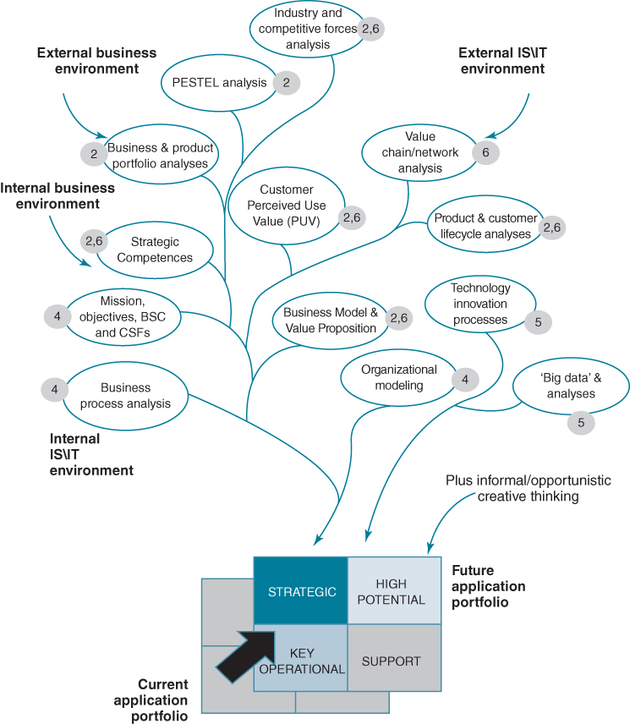
FIGURE 7.1 Building the application portfolio: inputs and toolkit.
Although it might appear that populating the strategic quadrant is most important, appropriate investments in the others can produce worthwhile contributions in terms of improved performance or avoiding potential disadvantages. An inability to maintain effective support or key operational applications will reduce the ability to realize available strategic benefits and will absorb resources on applications of less business value.
The next stage is to consider how the various tools and techniques can be brought together to ensure that the outputs from analyses are consistent and can be reconciled during more detailed planning for implementation.

A Framework for Using the Tools and Techniques Effectively
It would be convenient if a ‘methodology’– a structured, repeatable process – could be proposed for IS/IT or digital strategy formation, but this is not really possible with the need to continuously relate existing situations to new requirements and incorporate new options for future investments. However, a framework within which the techniques and models can be used more effectively, rather than as isolated tools, is essential if the determination of the IS/IT strategy is not only comprehensive but also manageable. Moreover, as circumstances alter and progress is made, any strategy will require updating, without it being necessity to reappraise all the analyses and resulting conclusions.
A key output is a portfolio of required applications, their contributions (i.e. strategic, key operational, high potential, support) and priorities so that it is possible to acquire and deploy resources to achieve them all successfully. The framework depicted in Figure 7.2 illustrates that there are really three separate portfolios, which capture:
- Existing applications – those currently in place or already being provisioned in the near future, which should be aligned closely with the business objectives and CSFs. These should be assessed in terms of their contribution to current business strategy via existing business processes and performance levels and how well they support the achievement of known future requirements. The strengths and weaknesses of each must be understood, but in a future as well as a current context, and any current developments that no longer clearly contribute to the strategy should be stopped.
- Required applications – those investments identified as essential to achieve the existing business objectives and create changes that can achieve required levels of performance or be shown to make a specific contribution to enabling or delivering the future business strategy, probably over a 3 to 12 month horizon.
- Potential applications – those that might be valuable in the future, provided they prove feasible to deliver and can be shown to produce relevant benefits, either to the strategy directly by creating new strategic opportunities or via the valuable indirect effects of business changes the applications make possible, over probably the next 6 to 24 months.
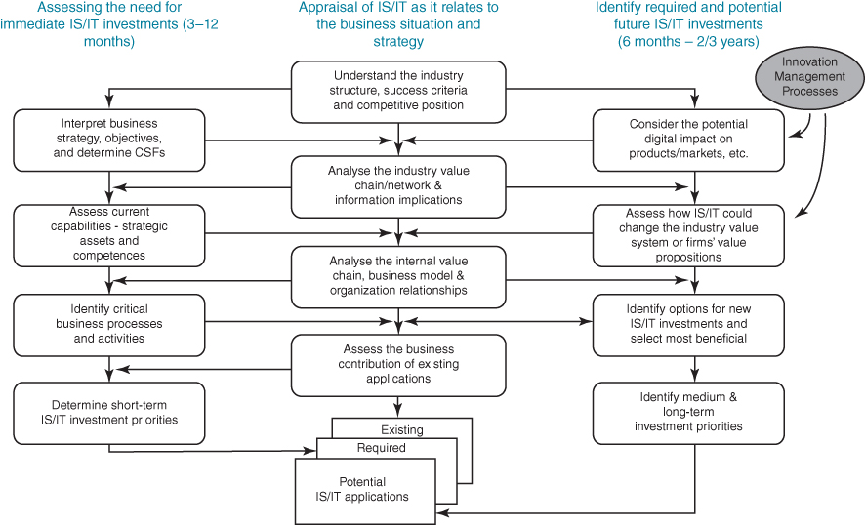
FIGURE 7.2 Overall framework for determining the business IS strategy.
The three columns in Figure 7.2 refer to the need to:
- decide how best to deploy available business and IS/IT resources and services in the immediate future and justify the investments – left-hand column;
- appraise how both the external and internal environments are changing and the role that IS/IT is, or should be, fulfilling in the business's products and services, its relationships and organizational and management processes – the central column;
- identify, monitor and evaluate new or emerging digital innovations and business opportunities to exploit IS/IT with the aim of creating advantages for the organization – right-hand column.
The outputs from each of these ‘columns’ need to be compared, reviewed and consolidated, so the approach will inevitably be somewhat iterative. Ideas, as they crystallize, will have to be reconsidered in relation to each other, the investment funding available and the assets and capabilities, both business and IS/IT, required to deliver the changes needed. The arrows on Figure 7.2 suggest the most effective route through the ‘map’ when the strategy is being formulated, but also indicate what needs to be reconsidered if an external or internal factor means the strategy has to be reappraised.
In the following sections, the overall framework described in Figure 7.2 will be considered in more detail, in terms of the processes, their outputs and inter-relationships and the use of the various tools and techniques that have already been described in previous chapters.

Identifying how IS/IT Could Impact the Business Strategy
This primarily involves the top six ‘boxes’ of the framework, as shaded in Figure 7.3: assessing the implications of the industry environment, competitive forces, understanding the business model, value proposition and customers' perceived use value (PUV), external value chain relationships and information flows and analysis of the existing business strategy. Any innovative IS/IT-based or enabled ideas identified separately from the main strategy development activity, through the innovation processes or informal, creative thinking, should also be included and assessed. Such ideas can emerge at any time and not when most convenient for inclusion in the strategy!
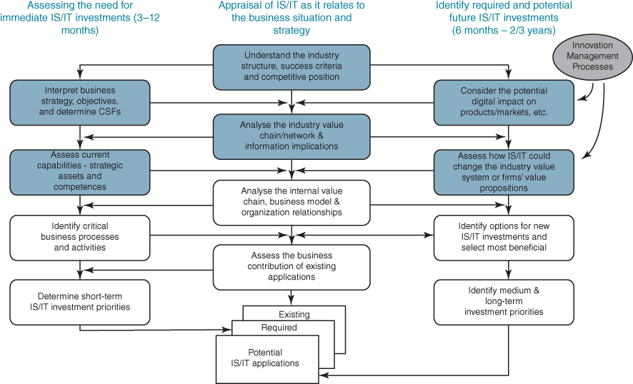
FIGURE 7.3 The steps to define the strategic IS potential and options.

Understanding the Industry, Competitive Forces and the Potential IS/IT Impact
The first task is the assessment of the overall business situation in relation to the external environment. This should normally be done by the business management as an integral part of the business strategy process. The key issues to be considered are:
- the business units and their relationships to each other and to the corporate body (for a business with multiple SBUs);
- the stage of maturity of the industry or industries within which the businesses compete (this will suggest growth potential);
- the product and customer portfolios of the business units, their contributions to revenues and profits and the demands on resources that each group of products/markets makes;
- the competitive forces affecting the business units and the corporation and their current and potential impact on the business's positions, to identify areas of greatest concern and need for action;
- a customer PUV analysis to determine product and/or service attributes that customers most value and the implications for the intended value proposition and supporting business model;
- the key capabilities and strategic assets required to succeed in the industry.
This set of assessments is essentially the initial part of the business strategic analysis process described in Chapter 2 and it leads in two directions:
- to considering the current business strategy and objectives in the established business environment, as discussed in Chapter 4;
- to identifying ways in which IS/IT could impact the industry in terms of products/services/economics and be used to affect the relative strengths of the competitive forces, as discussed in Chapters 2, 5 and 6.
A key output of this stage of analysis is an understanding of the organization in terms of business units, their relationships and the similarities and differences amongst them and the environments in which they operate. For each unit its competitive position and the forces affecting its performance and development should be understood, so that any IS/IT options can be focused on either responding to those forces or creating strategic options that will increase the likelihood of future success.
In the sections below, it is assumed that a single business unit is being considered; the additional implications across business units and for corporate information and applications are considered at the end of the chapter.

Interpreting Business Objectives and Strategy
Business objectives and strategies are the products of a number of considerations:
- what the organization might do, based on the environment within which it operates or by moving into new environments;
- what the organization wants to do, based on the values and views of, chiefly, the senior executives and key stakeholders;
- what the organization must do if it is to survive in its environment, depending on the industry pressures and their effects;
- what the organization can do, based on its resources, assets and capabilities.
Business objectives can be classified in a number of ways for further analysis and formulation of strategies. The Balanced Scorecard (BSC) is one of the best known and most frequently used mechanisms for such classification, as described in Chapter 4. The strategy should define specific objectives for the whole organization, which will then need to be analysed, interpreted and cascaded down to functional groups, and any existing business ‘strategic’ initiatives or change programmes to identify how each will contribute to meeting the overall objectives. The objectives need to be prioritized or ranked – if only into high, medium and low – and measurements (Key Performance Indicators) established against each to complete the scorecard.
Another way of structuring objectives for use in IS/IT strategy development is to consider them at three levels:
- permanent objectives, which reflect the mission, values and long-term aims and intentions of the organization;
- strategic objectives, which it wants to achieve in the foreseeable, medium term;
- tactical objectives, which it must achieve in the short term to make the strategic and permanent objectives attainable in due course.
In terms of usable objectives for IS/IT strategy formulation, the last two are the most relevant and can be assessed in terms of critical success factors (CSFs). The permanent objectives essentially provide the background to ‘why’ the organization needs or intends to do things.
Although objectives should be driven by business requirements and be set primarily in relation to external demands, they are often derived entirely from how the organization's senior management interpret that external world, based on their knowledge and experience. They may not, therefore, consider many potential options or may only address some of the strategic issues. Considerations of IS/IT options may change some objectives due to their potential impact in shaping or disrupting the business environment. Hence, at this point, we need to bring together the possible IS/IT industry impacts and the organization's declared strategy either to revise the objectives, develop new ones or adjust the ranking of existing objectives based on the importance of IS/IT threats and opportunities.

Determining Critical Success Factors
As discussed in Chapter 4, Critical Success Factor (CSF) analysis has been the most commonly used tool in the IS strategies toolkit and its value can be increased if used in conjunction with the Balanced Scorecard (BSC) and Key Performance Indicators (KPIs). Getting senior managers to define CSFs against a set of business objectives and then identify suitable measures within a BSC framework (as described in Chapter 4) is reasonably straightforward, provided there are well-formed objectives and the CSFs produced are really ‘critical to success’, not just important, and are owned by the organization, not just individuals.
The priority for dealing with the CSFs is not determined by the CSF itself (‘critical’ implies that no priority can be set), but by the ranking of the objective(s) from which it was derived and the number of objectives that will be affected by its satisfactory achievement. The next stage in the process is not, however, as straightforward. Interpreting CSFs in terms of information and IS/IT application needs cannot easily be done without reference to the activities of the business and its organizational structure, which is considered below.

Assessing the Potential Impact of Digital Technologies on Industry Products and Services
In Chapters 1, 5 and 6, aspects of ‘digital disruption’ were explored using examples from a variety of industries of new products and services created through the use of IS/IT, and also industries which have been transformed by those digital products and services. In some cases, traditional products are servitized to change how they are procured and used, or informated, to change or enhance the product or service. The Internet of Things and smart, connected products are increasingly discussed in terms of how they could change whole industries, create new ones or eliminate old ones. The rate of introduction of new digital services using the capabilities of networks plus individuals' devices, such as tablets and mobile phones, is increasing. These innovations are often initiated by new entrants to an industry, which means they are not easy to anticipate.
In Chapter 5, the ways organizations can build a capability to innovate with IS/IT were discussed, again using examples from a range of industries. Ahead of that, organizations need to be scanning the external environments, both technological and business, to identify the emergence of new technologies and how and why they are being used, not just in the firm's industry, but in other industries. In particular, new media use is being led by consumer-based industries and also for social rather than business purposes. Keeping abreast of these developments is a task for both IS/IT specialists and business managers.
The indirect effects of digitization also need to be considered and exploited where possible. For example, how product availability has to be more closely matched to demand across channels and how increased customer feedback can be used to identify any product or service issues. Today, negative feedback via other routes can, of course, be very damaging, very quickly. Most organizations now collect, or can collect, and store a wealth of data about their products, customers and even competitors, and astute use of analytics can reveal new business opportunities, enable new trends to be spotted and also assess the implications of unexpected events. The combination of ‘big data’ and analytics is now a powerful business strategy tool.

Analysing the Industry (External) Value Chain/Network and the Information Implications
The industry value chain or value network is essentially a high-level information flow model, which can demonstrate the role that information plays in determining the overall performance of the industry. How suppliers, customers, partners, competitors and other organizations influencing the industry gather, use and disseminate information will have an effect on both formulation and delivery of the enterprise's strategy. The output of such analysis is an understanding of the information relationships and ‘entities’ that the various players in the industry need to manage well to achieve success. This, in turn, can lead to new or revised IS/IT requirements and priorities and even new or modified business objectives.
More focused analysis can be undertaken of information relationships with customers and the role of information in the firm's products or services. The technique of customer life-cycle analysis traces customer information-based interactions with the organization from their recognition of the need through to information search, evaluation of alternatives, making the purchase and support post-purchase. Product or service life-cycle analysis maps show how the product or service is used by customers and can surface opportunities for adding value with information or rethinking the value proposition.
These externally derived, value chain or value network, possibilities need to be considered in relation to the current business objectives and strategies, and decisions made on whether to pursue any of the options further. This could lead to refinement of business objectives and a more focused evaluation of the potential opportunities. It is then important to identify other external organizations which need to be involved in making any changes in relationships and processes required, or made possible, by IS/IT and the resulting business options.
More specific analysis techniques such as data flow analysis and entity modelling can then be used to define the detailed information involved, its potential sources and uses. Process analysis and modelling techniques can produce a first view of how the options might be developed and implemented.

Understanding How IS/IT Could Change the Structure of the Industry Value System and Firms' Value Propositions
The next stage is to consider in more detail how the organization's core business processes (in information and systems terms) relate to and are affected by other organizations' ‘systems’ in the industry value chain or value network. The potential for IS/IT to affect the overall structure and performance of the industry can then be considered.
The refinements of the value chain analysis described in Chapter 6, such as customer and product life-cycle analyses and strategic option generator, enable consideration of what other parties in the industry might also do to improve their competitive positions, performance or value propositions. Further analysis can also reveal opportunities for new intermediaries to enter the industry or for disintermediation between existing players. Recent trends are for new Internet-based intermediaries to ‘capture’ customers and information about them, thereby potentially disadvantaging the traditional product and service suppliers.
This type of analysis/scenario planning may help the organization decide whether and how it could extend its information systems further into the value chain or network, in order to influence or even prevent changes others might make to the industry structure and its core value-adding processes. In the assessment it is important to consider how other parties can benefit from changes in the industry structure and relationships, and identify those where working closely together could produce significant mutual benefits and/or those which would also benefit from the organization's actions. The CSFs define how crucial or urgent it is for the organization to act on the results of the analysis (if at all) in order to achieve its strategic objectives.

Assessing Current Capabilities – Strategic Assets and Competences
The strategic capability assessment is to identify the rationale for IS/IT investment in each of the dimensions of competence – product/service leadership, customer intimacy or operational excellence, as discussed in Chapters 2 and 6. The organization should identify where IS/IT use is to be aimed; at either sustaining its existing advantages or creating new ones, but perhaps more critically, where the immediate IS/IT investment focus should be to reduce or eliminate existing or emerging disadvantages. This analysis provides a basic IS/IT investment stance to be adopted – innovative, aggressive, defensive or survival – and this provides guidance to both the types of opportunity to be sought and the priorities for implementation.
This also includes consideration of the last three strategy questions posed in Chapter 2: ‘what assets do we have, what assets do we require and (hence) what has to change?’ This will include IS/IT assets – infrastructure, information and applications – and how they are used in supporting or creating business assets and also the processes by which IS/IT is acquired and deployed. It may also include consideration of the capabilities and assets of other organizations providing IS/IT services and whether they are still appropriate or if better alternatives are now available, such as provisioning from the cloud.
To summarize the outputs of the process so far, as shown in Figure 7.3, they are effectively a view of the actual and potential IS/IT-enabled opportunities and threats affecting the organization's future, based on its relationship to the business environment, factors affecting industry growth and performance, competitors and trading partners' activities, as well as the organization's overall strategy. The view identifies current and future demands and suggestions for IS/IT investments which could either influence the organization's strategic options or enable successful execution of its strategy. No consideration has so far been given to its ability to deal with these demands and options, either to take advantage or avoid being disadvantaged.
Before proceeding, it is worth reiterating the importance of gaining senior management buy-in to the potential of IS/IT in terms of business opportunities and threats. Given the knowledge required and types of analysis tools involved, a group of senior managers need to get together to enable their knowledge and views to be shared effectively. Their available time will be limited and the work must be done over a short period, since continuity needs to be maintained, to avoid repeated reworking of the analyses and ideas. From experience of working with companies that have undertaken this type of approach, the main work is best done in a series of management workshops, led by a business manager. The role of IS/IT managers and specialists is to facilitate the process, provide the technology input and usually to document the outputs, without attempting to initiate action unilaterally on ideas arising, unless it is apparent that resources are currently being seriously misused or that decisions currently being taken have become unnecessary or inappropriate.

Establishing the Relative Priorities for IS/IT Investments
The remaining steps in the process are essentially to assess the strengths and weaknesses of the existing IS/IT applications and information within the context of the broader business issues and to identify ‘demand-side’ priorities for action and needs for enhancing the capability. So far, the analysis and thinking has taken an external (outside-in) and top-down view of the business. This needs to be counterbalanced by an internal, bottom-up analysis, before selecting which information, application and technology areas need to be addressed and over what timescale. The main component steps for this part of the process are those shaded in Figure 7.4.
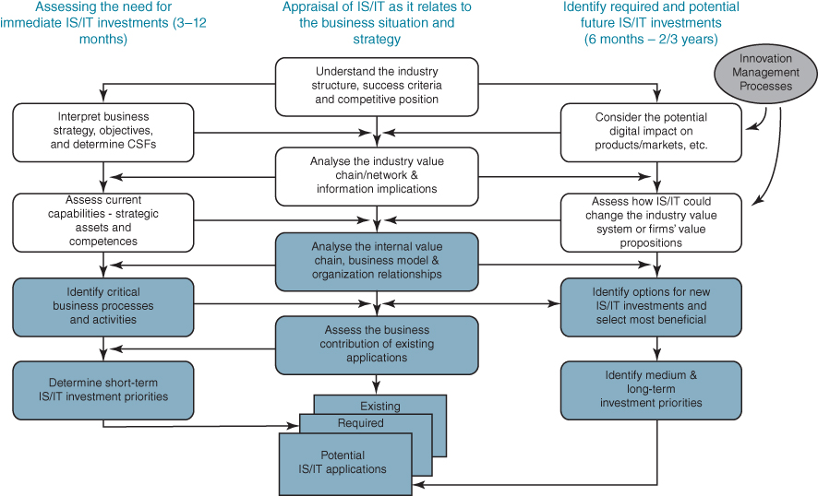
FIGURE 7.4 The steps to establish the relative priorities within the overall demand.

Analysing the Internal Value Chain, Business Model and Organization Relationships
The analysis of the internal value chain and existing business model, to describe what the business does and how it could be improved, and the analysis of the organization, to describe how it is structured to do it, will usually produce a degree of mismatch. When the dynamics of how the organization actually works are considered, this will probably confuse the picture even more! It is likely that existing processes, applications and information resources will have been established more from an organizational than a value chain perspective. In addition, the situation is not static. Even if the business model is still appropriate, the business situation will be changing, developing or retrenching, and the organization and reorganization of functions, people and working relationships will be an ongoing process.
The value chain is a firmer foundation than the current organization structure or relationships, in terms of understanding and analysing the key business processes and activities and identifying information and application requirements. It is critical to be clear which are the primary or core activities of the business – those which define the business model and are essential to the value-adding processes. The next step is to describe the key information requirements of each process and the links amongst them as well as how efficiently, effectively and consistently they are performed. These processes and activities are essential components of the information flows through the industry value chain or network and they need to be described in terms of external relationships with customers, suppliers or other parties.
How to identify which processes need most improvement, most urgently was discussed in Chapter 4, but at a high level IS/IT priorities can be identified from an analysis of the current levels of business competence. For example, if customer intimacy is a potential source of advantage, IS/IT should be targeted at innovation in customer-facing activities. If operational performance is far from excellent or is actually a cause of disadvantages, the underperforming processes need to be targeted with investments to bring performance back to the required levels. Each of the dimensions should be considered in terms of the value chain activities and processes that have the greatest impact on the performance of the business model in that dimension.
Although opportunities for gaining advantage from IS/IT exist in both primary and support activities, problems leading to disadvantages are more obvious and severe in the primary activities. This reinforces the need to establish a clearly understood view of the strengths and weaknesses of existing applications in the context of the primary value chain activities in terms of how they impact business operations and relationships with trading partners. Different types of internal value chain model (e.g. traditional, shop, network) were described in Chapter 6. It is important to understand which type of model, or combination of models, fits the nature of the business most accurately.
The organization structure needs to be examined to identify how the activities of each function or unit contribute to or fulfil a primary role in the business model. Although many organizations have moved towards a process-based structure over the last 20 years, some organizational units will contain both primary and support functions, and they need to be considered separately. Some support activities develop to overcome problems due to poor linkages across primary functions or processes. Others will have evolved due to application or information management weaknesses elsewhere – they are often ‘unnecessary’ reconciliation or recovery activities that need to be corrected at source. The value chain is likely to expose such problems, whereas organizational analysis can obscure them.
The primary value chain activities essentially describe how the business operates, but not how it is controlled or developed. Control and development activities are more dependent on the organization structure and functional responsibilities than the core value-adding processes and so the value chain model is less useful in analysing the support activities and defining the consequent information and systems' needs.
Legitimate support activities generally either assist in managing the primary activities, where integrated and/or consistent planning processes or controls are needed, or are key to business and organizational development, by coordinating the acquisition and deployment of resources, capabilities and organizational knowledge across both primary and secondary functions. They require analysis in terms of the information needed from the primary processes, plus any additional, often external information they need, and to identify how information can be provided to manage the primary activities successfully.
Business objectives, Balanced Scorecards and CSFs, in combination, offer a basis for assessing management effectiveness. A useful step in the analysis is to position each of the CSFs in the value chain to identify which activities, or sets of related activities, need most attention to sustain or improve overall business success. CSFs that cannot be allocated need to be questioned, since organizational ownership of a CSF is important if it is to be dealt with effectively. The external view of the business, developed earlier in the process, offers guidance as to how and where the company adds value in relation to suppliers/customers and in comparison with competitors. This can be transposed into the value chain to highlight areas for enhancing the value-adding aspects of the business.

Identifying Critical Business Processes and Activities and Implications for the Business Operating Model
In Chapter 4 we stressed the importance of having a clear and agreed picture of the business operating model and the need to address two fundamental questions: which processes need to be standardized and the extent of information integration required by the business strategy. As discussed in Chapter 4, process standardization has both advantages and disadvantages, which business managers must understand along with the implications of any trade-offs made in the short term and the longer term, such as with the implementation of a shared services model.
Choices around the extent of information integration must be driven by a clear understanding of the role the information plays in strategy development and execution as well as creating the desired value proposition. For example, a new customer-focused strategy may require both standardization of information aspects of customer-facing processes across different lines of business or distribution channels, plus integration of information across the sales, marketing and customer service activities in each market, or even across markets when dealing with global customers. It is likely that existing systems will not have been designed to accommodate either or both of these requirements and significant IS/IT investment will be needed to enable the new operating model. The business benefits of the new model and how critical it is to future success need to be evaluated before making an expensive and risky IS/IT investment and extensive changes to business practices.
Overlaying the existing operating model on the desired one may also reveal areas where current processes and the underpinning information and systems require a complete rethink due to poor or deteriorating performance or due to significant gaps or mismatches in the two models. It is these areas where IS/IT investment is likely to produce most short-term benefits.
At this stage, it is now possible to identify the critical business processes and activities, based on CSFs and the way in which the company adds value, incurs costs and is managed. To focus attention on where IS/IT can improve performance of both primary and support processes, it is important to identify why and where costs are incurred, and how and where value is actually added. Accounting systems offer a basis for cost allocation, although they will generally reflect organizational rather than value chain or operating model groupings of cost. However, it is possible, via even a rudimentary activity-based costing process, to reallocate the costs of the business to the business processes to identify areas of most potential benefit. This, again, will help separate ‘primary’ and ‘support’ costs.
The nature of the potential for business improvement will vary depending on the relationship between the value-adding, cost and the CSFs associated with activities and processes:
- High cost, low value-adding activities with few CSFs clearly only offer cost-reduction possibilities from IS/IT investment.
- High value-adding activities could be made more effective through IS/IT investment, but this will only be worthwhile if their improvement relates directly to agreed business CSFs. If, however, it is a high cost as well as a high value-adding activity, then IS/IT may still help to reduce the cost.
- Where a number of activities are associated with a CSF, they need to be assessed collectively in terms of options for enhancing the value or reducing the cost of each, via IS/IT, but without cost savings in one reducing value added by another.
- However, if an activity adds little value and is not associated with any of the CSFs, it is more important to question whether it is needed at all than to consider how to improve it! Every organization carries out some activities that actually add no value, and quite a few organizations have even computerized them.
The information and application requirements derived from the analyses can now be categorized into those that are critical to current business success, those that are likely to affect future success and those that merely support the business processes (i.e. key operational, strategic, and support, respectively).

Identifying and Assessing New Options for Investment
From understanding the relationship between the value chain, the organization structure and the criticality of processes and activities, it is now feasible to assess the potential of any IS/IT opportunities developed through the managed innovation processes or ‘creative’ thinking route, in terms of whether they could have an immediate impact or are of longer-term potential – whether they are strategic or high potential in portfolio terms.
The ideas and options need to be considered in terms of whether and how they could provide the organization with specific advantages or reduce foreseeable threats; and whether and how, in the short term, they can contribute to the existing business strategy by improving the current operational and developmental processes. This will depend on how closely they align with the business objectives and CSFs and address known critical business activities.
Because of the rationale of the overall process, the options and their current relevance should not be at odds with the prevailing business issues or strategies. Some, however, may only be relevant beyond the current strategic horizon, but should be kept within the portfolio as high potential ideas, which may become valuable as the business moves forward or the environment changes. It may also be worth some investment to test the ideas, to identify the possible benefits and explore the feasibility of achieving them. That is especially true of ideas that could also be of benefit to competitors. The selection process is essentially a decision on each idea or opportunity in terms of why it should be pursued or not, in the next few months or year.
This innovation-based aspect of the overall approach attempts to answer the following questions:
- What could IS/IT do for all the firms in the industry, in terms of the products and services offered and changing business relationships and competitive dynamics?
- What could IS/IT do for the organization, based on its particular position within the industry and how it intends to achieve advantage? And could IS/IT enable it to use its capabilities to enter new industries or markets?
- Which options offer most immediate benefit in terms of the current business strategy by improving the value proposition, performance or how the company operates and is managed?
It is worth reiterating that good ideas can emerge at any time and not just during a formal IS/IT strategy process, so this part of the approach may need to be revisited quite frequently.

Determining the Future Application Portfolio: Short, Medium and Long-Term Business IS Demand
The current situation analysis may have highlighted the need for investment in new applications in each portfolio quadrant, although they are more likely to be key operational and support, whereas strategic and high potential applications or options will have been derived from the other ‘routes’.
In addition there will probably be a need to address problems in some existing key operational and support systems. Determining which weaknesses to address first will depend not only on current business impact, but on whether it will be increasingly or decreasingly important in the future. For instance, will not integrating key operational information make a further strategic application impossible? CSFs help determine what is of strategic importance, what offers the highest potential and which key operational weaknesses must be overcome in the short term. In contrast, decisions on further investments in support applications should be based on the net economic benefits of investment.
It is worth emphasizing that it is perhaps more important to deal with serious weaknesses first, especially if they could soon result in a real threat to the business or are precluding opportunities being taken. In addition, some new opportunities that are not dependent on anything else should be pursued, in particular where they use existing capabilities, giving more chance of success.
Finally it must be stressed again that this approach to using the models and techniques is not a methodology, but a way of bringing them together to ensure that the organization achieves a comprehensive and coherent statement of IS demand, which can be demonstrated to be directly relevant to its business strategy. No one tool or technique provides a comprehensive view of the business options for IS/IT investment and no one tool or technique can produce certainty of conclusions.

Large Organizations, Multiple SBUs and Strategy Consolidation
Depending on the corporate business model and strategy, multiple business unit organizations can usually benefit from examining not just one business unit but also looking across business units, before deciding on priorities for investment in new applications. Also, as mentioned earlier, the extent to which standardization of applications and information integration across the units would improve unit competitiveness and provide corporate benefits plus the trade-offs that would be involved should be identified. Figure 3.6 demonstrates the basic relationships.
Both synergistic and economic opportunities will be affected by a number of factors, not least of which is corporate management's desire to gain such benefits across business units. It is possible that each business unit is seen merely as part of a ‘portfolio’ that is continually being changed by buying and selling businesses for primarily financial reasons. In such a case, synergistic and economic benefits will at best be short-lived, if desirable or achievable at all. In most other circumstances, however, the overall corporate benefits from consolidating IS/IT opportunities will often exceed the sum of the parts. The factors that can affect the corporate as opposed to purely business unit ‘value-added’ of IS/IT investment are whether or not:
- the units compete in the same or different industries and the similarity or otherwise of their products and services;
- the units are in similar competitive positions in their industries, the maturity of the industries and the types and mix of competitors;
- they have a similar capability in each of the three key dimensions – customer, operations and product;
- they have the same (or similar) customers, distribution channels and/or suppliers, with whom information can be shared and value chain links mutually developed;
- they trade with one another (i.e. are related in a value chain or value network, where IS/IT links could give the company an overall advantage);
- they have internal value chains of the same type which consist of similar primary value chain components in support of similar value propositions;
- they are of similar sizes and scale of operation (e.g. numbers of locations, customers, suppliers or employees);
- they are adopting similar strategies and, as a consequence, have similar CSFs (units with different CSFs will have significantly different IS/IT priorities);
- the parent company requires a consistent, even standard, structure of information from all the units;
- support activities are broadly similar and are, or could be, organized in the same basic structure, such as a shared service, or be outsourced together.
These imply that opportunities for further corporate synergy or economic benefits exist in each of the inputs to the IS/IT strategy process (i.e. external and internal, business and IS/IT environments). A threat or weakness for one business unit may be able to be overcome by transferring knowledge, IS/IT capabilities or even applications from another business unit. It is, therefore, important to compare the results of the analyses and to share ideas. Any of the techniques, at any stage of the process outlined above, could reveal such cross-unit opportunities, so all results should be ‘pooled’ and made available for others to adapt, adopt or join in, if appropriate. An idea from one part of the business, adapted by another, may even offer more benefits. This is considered in more detail from demand and supply perspectives in Chapters 8 and 11 respectively.

Summary
Chapters 3 to 6 described an organizational approach and a set of tools and techniques to enable IS/IT strategy formulation. This chapter has attempted to bring these components together in a framework for developing the business information systems, or demand, part of the IS/IT strategy and providing the business rationale for the information and applications the business must, should and might have to achieve maximum benefit in its business environment. Although not every threat can be anticipated, every opportunity spotted, each strength exploited or every weakness overcome, the framework for using the tools and techniques should enable fewer threats and opportunities to be missed, and IS/IT strengths and weaknesses to be better understood in terms of their business implications.
The framework attempts to bring together both analytical and innovative processes, allowing for new ideas and options to be considered as they arise. Good ideas and insights can occur throughout the process and they need to be assessed and taken advantage of as soon as possible, not put ‘on the shelf’ for later consideration – the potential advantage or opportunity may be lost or be overtaken by other events. There is no point in exhaustive examination when ideas obviously make sense, but many ideas cannot be properly evaluated without consideration and testing from a number of viewpoints.
Although the framework is rather conceptual, theoretical even, it does include most of the tools and techniques that are generally found to be useful, in a logically linked approach. It also ensures that all types of strategic input, both external and internal, are assessed in relation to one another. It does enable an outline business IS strategy to be identified and a consensus of agreement and management endorsement to be achieved in a relatively short period of time – weeks rather than months. It must also be remembered that planning is an ongoing activity and the framework will need to be revisited regularly to ensure that the pattern of IS demands is still relevant to the business strategy. As shown in Figure 3.2, internal and external factors in the business or IS/IT environments will change, sometimes unexpectedly, causing parts of the strategy to require revision. Therefore some paths through the process will have to be revisited to identify the implications and revise the strategy and resulting investment priorities.
The management of the resulting portfolio of existing, required and potential application portfolios is considered in depth in Chapter 8. Chapter 9 considers how new IS and IT investments can be justified and prioritized within the portfolio, taking into account both demand and supply aspects.

Endnote
1. See A. Bharadwaj, O.A. El Sawy, P. Pavlou and N. Venkatraman, ‘Digital business strategy: toward a next generation of insights’, MIS Quarterly, 37, 2, 2013, 471–482.

UNIT 8
MANAGING THE PORTFOLIO OF BUSINESS APPLICATIONS

OUTLINE
- ♦ Conclusions from Various Portfolio Models
- ♦ Classifying the Applications in the Portfolio
- ♦ Reconciling Demand and Supply Issues in the Portfolio
- ♦ Generic Application Management Strategies
- ♦ Portfolio Management Principles Applied to the Application Portfolio
- ♦ Aligning Development Approaches to the Portfolio Segments
- ♦ The ‘Special Case’ of Enterprise Systems
- ♦ Managing Application Portfolios in Multi-unit Organizations
The application portfolio (see Figure 8.1), which was introduced in Chapter 1, is a means of bringing together existing, planned and potential investments in information systems and then managing them according to their business contribution. Gaining business management understanding and agreement on the mix and pattern of contributions expected from current and future business applications is the cornerstone of any digital strategy.¹
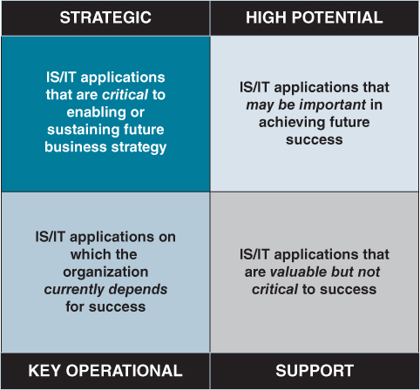
FIGURE 8.1 The application portfolio: segment definitions.
Alternative portfolio models have been proposed, but often these classify IS/IT deployments according to the business activities they perform or the role played by technology. For example, Weill and Johnson² distinguish between what they refer to as four ‘asset classes’: transactional, informational, strategic and infrastructural. However, we believe that these categories are not mutually exclusive. For example, both transactional and informational assets can also be strategic and it combines infrastructure assets, which can be used by multiple applications, with dedicated, discrete business applications.
The application portfolio has similarities with other, perhaps more familiar, business portfolios. As will be seen in this chapter, these similarities are more than superficial – insights from other portfolio models are particularly relevant to key issues in IS/IT management. Its usefulness is borne out by the ease with which management is willing and able to categorize applications in this way and understand the organizational and management implications. Another reason for its usefulness is its simplicity, which also implies that it has limitations and cannot deal with every conceivable situation. But, it can provide valuable guidance in addressing the issues associated with the majority of business applications of IS/IT. Evidence from our research also suggests that using a transparent portfolio management approach, which makes all the plans and resourcing decisions visible to both business and IS/IT management, can increase trust and improve working relationships.³
Two-by-two matrices are very popular ways of describing the implications of unrelated but interacting variables, and a number of such matrices related to the management of IS/IT have been developed. The first section of this chapter suggests how they can be synthesized to produce a set of relevant issues, attributes and options associated with the portfolio segments. The main purpose in classifying applications is to ensure that they are managed successfully and that the expected contribution is delivered. Based on the issues relevant to each segment of the portfolio, appropriate implementation strategies can be adopted. These, in turn, can be related to the strategy formulation and planning approaches, as described in Chapter 3, to provide consistency of management from strategy formulation through to implementation.⁴
From this overall analysis, it is clear that successful management of the whole portfolio depends on making appropriate choices about how applications are built, bought in or provisioned and projects and organizational changes are managed. Drawing on proven approaches from other areas of business management, the options available and the implications for different types of applications are described and discussed. Finally, how the portfolio can be used to improve coordination and the corporate contribution of applications across different business units in multi-unit and multinational organizations are considered.
As noted above, any simplification of a complex situation has its limitations. Precision should not be expected; merely relevant guidance to inform and support management decision making, in what is often an area fraught with uncertainty and even conflict. It is a valuable framework, which helps to bring together and balance the demand and supply components of the digital strategy. It also improves ownership by business managers of their IS/IT applications and the issues that have to be addressed in achieving success.
This chapter discusses many uses of application portfolio management except for investment justification and prioritization, which are covered in depth along with the same issues in relation to individual IS/IT investments in Chapter 9.

Conclusions from Various Portfolio Models
A number of matrices have been produced to help management decision making with respect to IS/IT planning, utilization and resourcing. Some conclusions from the analysis of the early versions are useful to show how the ideas and concepts are generally complementary, even convergent.⁵ More recent versions are also in essence very similar, even if the terminology used is different. A composite matrix, including some key ideas, is shown in Figure 8.2. The main models on which the composite matrix is based are summarized in Box 8.1.
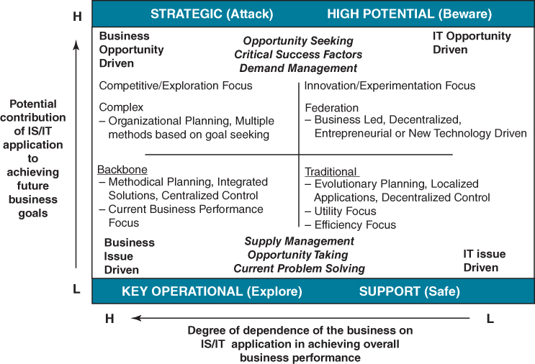
FIGURE 8.2 A composite matrix.

BOX 8.1

IS/IT portfolio models: a review
- The Sullivanª matrix, which has already been described in Chapter 1 (see Figure 1.5), considered the range of IS/IT management issues that depend on the combination of infusion and diffusion of IS/IT in the organization. Infusion is ‘the degree to which IS/IT has penetrated a company in terms of importance, impact or significance’, and diffusion is ‘the degree to which IS/IT has been disseminated or scattered throughout the company’. Sullivan identified the need for new, demand-driven and decentralized planning approaches to improve the management of the strategic and high potential quadrants, in addition to the better understood strategy formulation and planning approaches required for ‘backbone’ (key operational) and ‘traditional’ (support) systems. He expressed the need for an ‘eclectic’ planning method to deal with the strategic developments when IS/IT is considered in establishing the business objectives or is being used to transform business processes (i.e. when there is an interdependent relationship between IS/IT and business strategies).
- Galliers^{b} developed a matrix that, like the Sullivan matrix, considers factors affecting planning methods, but this time in relation to: a) long-term and short-term thinking, strategy or issue driven; and b) business issues versus technology-driven planning. It separates the need for IS/IT to react to current business issues (key operational) from the need to react to changing future objectives (strategic), and compares them to the proactive IS/IT stance required for high potential opportunities. Like most others, he identifies an efficient, problem-solving basis for managing support-type systems.
- Two matrices, developed by Ives and Learmonth^{c} and Galliers,^{d} both considered how the ‘value-adding potential’ of IS/IT in the business and the ‘quality of IS resources’ (i.e. the capability of the organization) affect how IS/IT is deployed and how it is managed. They showed how a vision of what is possible plus strength of resources are essential if IS/IT is to be used as an offensive (i.e. strategic) weapon, and how the two are often interrelated. In many organizations, the lack of vision reduces the ability of even good resources to do more than ‘explore’ opportunities as issues arise. Low quality of resource implies a ‘safe’ support systems only approach, and the organization will become very vulnerable due to its inability to respond to new, high potential or strategic applications developed by competitors. In such a case, ‘vision’ is not enough – the resource must be improved at the same time and the organization must ‘beware’ of IS/IT investments by competitors.
- Curley^{e} describes the Intel IT Business Value Matrix, a 3×3 matrix, which compares the business value of investments – the impact on business strategy – with IT efficiency – how well it uses or enhances the existing IT infrastructure. Infrastructure includes all IT assets, not just technology. This again addresses the issues of maximizing the value achievable from existing capabilities, whilst at the same time investing in creating new capabilities, driven by the need to increase the value that can be delivered.
- The ‘e-business value matrix’, described by Hartman and Sifonis,^{f} maps (a) business criticality against (b) practice innovation, and the four resulting segments equate closely with those of the application portfolio. Low criticality and low innovation are defined as the new fundamentals, and the characteristics are close to support. Key operational is a direct equivalent of operational excellence – high criticality, low innovation. High innovation but low criticality is called rational experimental and the parallels with the high potential segment are obvious. Finally, the strategic part of the matrix equates reasonably well with the high criticality, high innovation combination called ‘breakthrough strategies’. The implications they describe in terms of the best approaches to identifying, justifying and managing e-investments in an organization are similar to the guidance that can be obtained from combining the attributes of previous matrices.
Notes:
ª C.H. Sullivan, ‘Systems planning in the information age’, Sloan Management Review, Winter, 1985, 3–11.
^{b} R.D. Galliers, ‘Information technology planning within the corporate planning process’, in A. Duling and D. Berry, eds, Controlling Projects within an Integrated Management Framework, Pergamon Infotech State of the Art Report, Maidenhead, UK, 1987.
^{c} B. Ives and G.P. Learmonth, ‘The information system as a competitive weapon’, Communications of the ACM, December, 1984, 1193–1201.
^{d} R.D. Galliers, ‘Information systems and technology planning within a competitive strategy framework’, in P. Griffiths, ed., The Role of Information Management in Competitive Success, Pergamon Infotech State of the Art Report, Maidenhead, UK, 1987.
^{e} M. Curley, Managing Information Technology for Business Value: Practical strategies for IT and Business Managers, Intel Press, 2004.
^{f} A. Hartman and J. Sifonis, Net Ready—Strategies for Success in the e-Economy, McGraw-Hill, New York, 2000.
In most of the models, clear differences can be seen in the ways in which applications in each of the four quadrants need to be planned and managed. Not all ideas map precisely onto the application portfolio, and there is not always full agreement on the specific needs of the strategic and high potential segments, perhaps due to their more uncertain and changing nature. However, there is general agreement in the key operational and support areas. The composite matrix in Figure 8.2 attempts to reflect the key ideas from the various matrices in terms of the issues or options for managing the portfolio segments. These are examined in more detail later in the chapter. The axes are derived primarily from McFarlan's work.⁶ The horizontal axis attempts to reflect the ability of an organization to control its destiny, whereas the vertical axis reflects the uncertainty, due to external forces, of future IS/IT impact.
Matrix analysis approaches are attractive because they reduce an apparently infinite continuum of alternatives to a manageable, pertinent number of discrete options from which high-level directions can be determined. They demonstrate relationships that evolve over time, but that will normally have to be managed to success simultaneously in the organization. Like many such models developed to assist management, they are often overly simple, and more complex models would be needed to reflect the diversity of reality. As complexity is added, however, clarity of perception often dims.
Most of the models address the need to accommodate both centralized and decentralized management approaches, the balance of which will depend on the degree of integration required in the business and organizational processes. Particular competitive opportunities and innovative uses of IT will tend to be singular applications and, initially at least, can be exploited most advantageously close to the business opportunity. Applications that produce benefits by business integration or sharing of assets require strong business coordination, competent IS/IT management and sustained investment in resources.

Classifying the Applications in the Portfolio
Classifying an organization's existing and future applications using the portfolio helps resolve many of the issues in achieving a consensus among executive management, line managers and the IT management on the content of the IS strategy. Once the portfolio is understood and agreed, decisions on how best to manage each application, both existing and future, can be made, along with overall decisions on the use of resources across the portfolio and the selection of the most effective sources for supply – which aspects should be managed in-house and which can and should be outsourced.
While agreeing the contribution expected from future investments is important, so is understanding the role and value to the organization of the existing application set, as discussed in Chapter 4 (see Box 4.3). Some applications may be obsolete and no longer required, others may need further significant investment to avoid future business problems, some may be underexploited and others may be consuming undue amounts of resource in relation to their business value. Table 8.1 suggests some criteria that can be used as a basis for a strengths, weaknesses, opportunities and threats (SWOT) analysis of the current applications, to determine the need for action, either to improve their contribution or enable other, related applications to be developed or used better.
TABLE 8.1SWOT analysis of existing portfolio
EXPLOIT STRENGTHS:
- ♦ high future potential, currently underexploited;
- ♦ can be extended, enhanced to be of more value;
- ♦ could be more valuable if integrated more effectively or used more extensively;
- ♦ critical to the business, but data quality is poor;
- ♦ needs to be enhanced, changed or replaced to meet future business needs;
- ♦ is required, but needs to be re-implemented to use fewer resources or overcome technology obsolescence;
- ♦ will be less important in future – needs to be simplified/reduced to meet current needs;
- ♦ is no longer of value – should be discontinued.
OVERCOME WEAKNESSES
Merely classifying current and future applications into a 2×2 matrix is of no great value, unless it causes each application and the overall portfolio to be managed more effectively. The process of classifying the applications is as important as the end result, since the discussion involved will enable different perspectives to be understood (and hopefully reconciled!) and the implications of the decisions made to be appreciated by all parties. If a particular application is considered by one group of users as strategic, due to their uses of the output, but as support by another that provides the input, it is unlikely that the maximum benefits available will be delivered, due to the differing operational priorities and attention to the quality of the information by each group. A realistic and agreed assessment must be made.
A new system to schedule the use of operating theatres in a large general hospital was seen as strategic by the management as it would make more theatre capacity available and hence could increase revenue, but it was viewed as a new (key operational) performance measurement and control system by the consultant surgeons. They argued it reduced their professional discretion and could also reduce the quality of patient care. IT saw it as a replacement for an existing system that was no longer supported by the vendor. The system was implemented, but used only to report operating theatre usage (support) due to the unwillingness of the consultants to use it for scheduling.
Organizations will have slightly different interpretations of the terms used for each segment. Hence, a decision support tool that would fit every organization's criteria for classification cannot be defined, but Box 8.2 contains a starting point for the process by describing basic criteria that can help the analysis. It should only be used to guide the assessment, not as a ‘rule book’. Normally, it is relatively easy to agree and classify most of the applications into the quadrants, although there are always some for which discussion, based on different perceptions of their role and contribution, is necessary.

BOX 8.2

Classifying the applications in the portfolio
An application is Strategic if it does or will a) create a clear competitive advantage for the business or b) enable the achievement of specific business objectives and/or critical success factors.
It is Key Operational if it does or will a) overcome known business disadvantages in relation to competitors or b) avoid known or foreseeable business risks becoming major problems in the near future or c) enable the organization to comply with legal and regulatory requirements (that affect its ‘licence to operate’).
It is Support if it does or will a) improve the productivity of the business and, hence, reduce long-term costs or meet general statutory requirements (that do not affect its licence to operate).
It is High Potential if the impact it could have is as yet uncertain but could be of a Strategic nature.
If the application seems to fit more than one definition, then it should be reassessed by splitting it into its major components or business functions performed and consider each of them in the same way. If this is not done, the risks of failure or the costs are likely to increase significantly due to the mixed objectives and the confusion that they can cause in how it is managed. For example, an Accounts Receivable system may consist of several business processes or sub-processes, some of which may be more business critical than others – bad-debt control may be key operational, whereas statement production is support. Although many applications are often provided via large packages (e.g. ERP or CRM software), the purpose of the analysis is still to classify the business activities that the package covers (e.g. order processing, purchasing), rather than the package itself. An ERP package can deliver applications in all quadrants, depending on the competitive positioning, the business strategy and the maturity of IS/IT development in the organization.
It must be remembered that the portfolio is not a way of classifying technologies – email, portals, social media, cloud computing, mobile communications and analytics can all be used for a variety of applications, making different contributions to a range of business activities. And to reiterate a point made in Chapter 1, an application utilizing cutting-edge technology does not imply that it is automatically classified as strategic – the classification must be based on business contribution.
An example portfolio for a manufacturing company selling mainly to distributors and other businesses, which was produced using the criteria in Box 8.2 and showing a simplified version of the SWOT analysis described above, is shown in Figure 8.3.
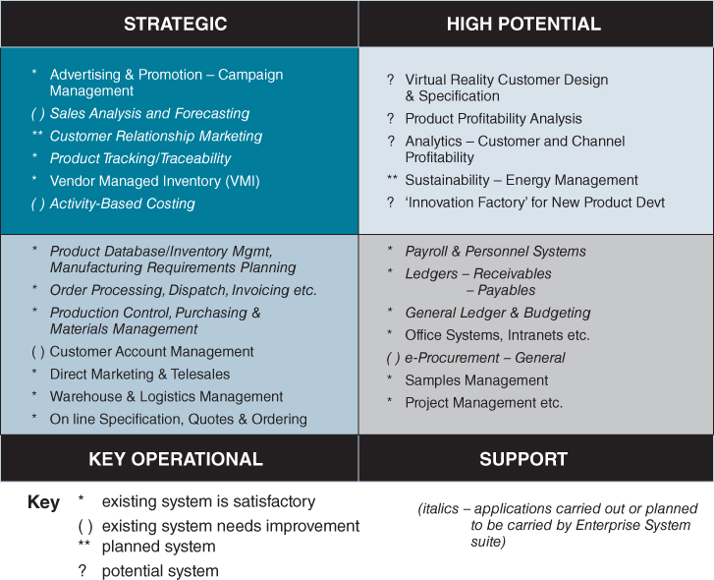
FIGURE 8.3 Example portfolio for a manufacturing company.

Reconciling Demand and Supply Issues in the Portfolio
Before considering the best approaches to managing the applications in each of the portfolio segments, it is important to understand the key differences in the rationale for the types of application and the resulting issues to be addressed in implementation. Discussion in earlier chapters considered what can be described as the driving forces for applications in each segment of the portfolio (i.e. why they are being developed and used and how eventual success or failure will be determined). They can be translated into some critical requirements to be satisfied in the delivery of the application. These key issues are described in Table 8.2.
TABLE 8.2Some key issues in the segments of the portfolio
 | Driving forces | Critical requirements
High potential | ♦ New business ideas or technological opportunities  ♦ Individual initiative – owned by a ‘product champion’  ♦ Need to prove the value or otherwise of the idea or the capabilities of the technology | ♦ Rapid evaluation of prototypes and avoid wasting effort/resources on failures  ♦ Understand the potential benefits in relation to the business strategy  ♦ Identify the best way to proceed – the next steps
Strategic | ♦ Market requirements, competitive pressures or other external forces  ♦ Business objectives, success factors and vision of how to achieve them  ♦ Obtaining an advantage and then sustaining it through a combination of technology and business changes | ♦ Rapid (even iterative) development to realize benefits within the window of opportunity  ♦ Flexible system that can be adapted in the future as the business evolves  ♦ Link to an associated business initiative to achieve changes and sustain commitment
Key operational | ♦ Improving the performance of existing core processes and management activities  ♦ Integration of data and systems to avoid duplication, inconsistency and misinformation  ♦ Avoiding a business disadvantage, preventing a business risk or complying with industry legislation | ♦ High-quality, long-life solutions and effective information management  ♦ Balancing costs with benefits and risks – identify optimum balance of IT and business change  ♦ Evaluation of options (including outsourcing) available, by objective feasibility study
Support | ♦ Improved productivity/efficiency of specific business tasks  ♦ General legislation  ♦ Most cost-effective use of IS/IT funds and resources available | ♦ Low cost, long-term solutions – often packaged software to satisfy most needs – compromise the needs to the software available  ♦ Business Process Outsourcing (BPO) is an option  ♦ Objective cost/benefit analysis to reduce financial risk and then control costs carefully
To ensure overall success, it is important that decisions about how to implement the application (e.g. package, bespoke development or provisioning from the cloud) and then maintain it are directly related to the contribution required. Figure 8.4 poses some simple questions that help managers understand the implications of applications in the different segments and offer guidance on how best to manage each application through its life cycle. It shows how the questions become more complex as we move around the matrix, which inevitably also means it is more difficult to get agreement from all those involved.
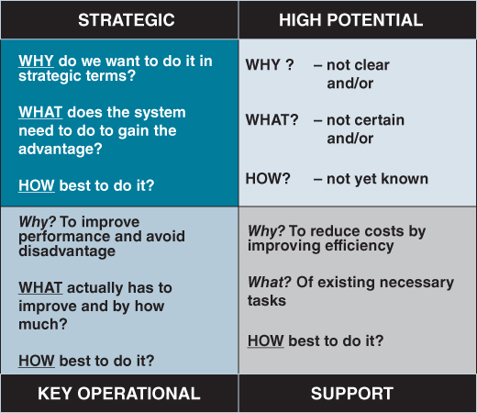
FIGURE 8.4 Key questions for application portfolio investments.
For support applications, the general objective is clear (why = efficiency) and what needs to be improved is determined by existing tasks and activities. The main question is how to do that successfully, in terms of the most cost-effective combination of business changes and use of IS/IT.
For key operational applications, the how question still has to be addressed, but in addition considerable thought may be needed to define specifically what has to be done, and to which business activities or processes, to avoid potential disadvantage (why we need to do it).
Again, both what and how questions need to be resolved in strategic applications, but in addition we need to clearly understand why we wish to do it in terms of the business strategy. Strategic applications require new, creative thinking and will cause business changes, probably externally as well as internally, and the intended benefits of such changes must be identified and agreed. By definition, the strategic uses of IS/IT cannot be copied from others (since we will already be potentially disadvantaged!), hence their rationale has to derive explicitly and coherently from the strategy of the organization.
If any of the why, what or how questions cannot be answered, it implies that the application is high potential, and appropriate evaluation is needed to answer the remaining questions before making a large-scale investment.

Generic Application Management Strategies
Given the variety of factors affecting success in the different segments and the business consequences of success or failure, no single management approach is likely to deal effectively with the range of issues involved. Equally, adopting a unique approach to managing each application and every new development will lead to a degree of chaos and probably result in as many failures as successes. A limited set of approaches that meets the majority of requirements and is well understood throughout the organization is more likely to enable the best one to be selected in each instance and increase the chances of success.
Based on extensive observation of the realities of IS/IT management processes in many organizations, Parsons⁷ described five strategies that were prevalent as the means by which organizations linked the management of IS/IT to the corporate or business management processes. They are ‘the central tendencies which firms use to guide IT within the business.’ From our observations they are as relevant today as when first identified. These ‘linking strategies’ are ‘general frameworks which guide the opportunities for IT which are identified, the IT resources which are developed, the rate at which new technologies are adopted, the level of impact for IT within the firm, etc.’ As they are ‘general frameworks’, the term ‘generic IS/IT management strategies’ is used in the discussion below. They are essentially alternative strategies for managing the implementation of IS/IT, ensuring that the nature of the demand is matched by the appropriate means of supply. How these implementation strategies can be aligned and reconciled with Earl's planning approaches, discussed in Chapter 3, will be considered later in the chapter.
Parsons’ descriptions of the characteristics and implications of each strategy are summarized in Table 8.3. As can be seen from the table, the strategies define different roles and responsibilities for the three key parties involved in enabling successful implementation:
- executive management;
- line management: functional or process managers and users of the systems;
- IS/IT specialists: whether or not they are internal to the organization (centrally located or in business areas) or from external suppliers.
TABLE 8.3Rationale and requirements for generic strategies
Source: After Parsons.
 | Centrally planned | Leading edge | Free market | Monopoly | Scarce resource
Management rationale | Central coordination of all requirements produces better decision making | Technology can create business advantages and risks are worth taking | Market makes the best decisions and users are responsible for business results  Integration is not critical | Information is a corporate good and an integrated resource for users to employ | Information is a limited resource and must be used efficiently
Organizational requirements | Knowledgeable and involved senior management  Integrated planning of IS/IT within the business planning process | Commitment of funds and resources  Innovative IS/IT management  Strong technical skills | Knowledgeable users  Accountability for IS/IT costs at business or functional level  Acceptance of duplicated efforts | User acceptance of the philosophy  Policies to enforce single sourcing  Good forecasting of resource usage | Tight budgetary control of all IS/IT expenses  Policies for controlling IS/IT and users
IT role | Provide services to match the business demands by working closely with business managers | Push forward boundaries of technology use on all fronts | Competitive: (and possibly a profit centre) – intended to achieve a return on its resources | To satisfy users' requirements as they arise, but non-directive in terms of the uses of IS/IT | Make best use of limited resources by tight cost control of operations and projects  Financially justify infrastructure investments
Line managers’ and users’ role | Identify the potential of IS/IT to meet business needs at all levels of the organization | Use the technology and identify the business advantages it offers | Identify, source and control IS/IT developments and (some) operations | Understand needs and present them to central utility to obtain resources | Identify financial benefits and cost-justify projects
The strategies are behavioural and each set of behaviours will cause certain effects. The effects required are determined by the nature of the contribution of applications in the portfolio – these generic strategies are ways of causing the right effects to occur.
The strategies are well titled, since the names evoke a basic understanding of the attitudes and behaviour that each is likely to produce. The key points of each, and their pros and cons, are outlined at the same time as considering how they relate to the application portfolio.
The ill-fated National Programme for IT (later renamed Connecting for Health) in the UK National Health Service provides a good example of what happens when the differing contributions expected from applications, such as digital imaging, electronic patient records, online appointment bookings and automating routine transactions, are not understood and a singular approach to managing the implementations is adopted. In this case, the roles to be played by IT, clinicians and managers were not related to either the contribution expected or the extent of changes to practices required.

Centrally Planned
This strategy implies that senior and executive management need to be fully aware of the application, due to its potential impact on the future business strategy. It is therefore most appropriate for strategic systems. Achieving success in such circumstances demands the close attention of senior management to ensure the objectives are met and the necessary resources are applied to deliver the solution in the time required and then sustain further investment as and when needed. Most strategic applications are likely to span a number of business areas, and while the nature of an application can often be easily defined in outline, it will be its uniqueness and its fit to the business strategy that will deliver the business advantages. To gain those advantages, it is almost inevitable that changes to business practices, capabilities, structures and even an organization's culture will be necessary.
To meet all these requirements, a ‘task force’ approach is best suited. Led by a senior business manager, the team will need dedicated, preferably full-time, high-quality business resources, which have excellent knowledge of the areas affected and the authority to agree to business changes. Equally, it will need good IS/IT skills and knowledge in the team to design or select the application software and manage the technical aspects of its implementation. This dedicated team requires direct access to top management to resolve issues that will undoubtedly arise during the project. Subject to this senior management agreement, the team has the authority to decide both what the system will do and how, in business and IT terms, that will be achieved. It is likely that the design and development will be iterative, comparing possible solutions with emerging or changing requirements. This requires very close working relationships among the members of the team, individuals' contributions depending more on their knowledge than formally designated roles.
Although the idea of a dedicated team is attractive, it is often difficult to achieve successfully in many organizations. The people it requires are often the most valuable in their existing jobs and are not readily given up by their functional management for the duration of the project. Even though it may not be the most efficient use of skilled and knowledgeable people, it is a very effective way of achieving clear objectives in a tight timescale. The need for key people to be dedicated to project teams may also limit the number of strategic developments that can be undertaken at any one time, since such people are often in short supply. It is better to reschedule the projects based on the availability of key resources than to spread the resource too thinly or substitute lower calibre or less experienced people. Although this approach satisfies the needs of strategic applications most effectively, it can also be used in certain circumstances to carry out a short, sharp evaluation of a (very) high potential opportunity or even for a key operational development where the business faces the prospect of being seriously disadvantaged (e.g. compliance with new industry regulations).

Leading Edge
With this strategy, the senior management of the organization believe that, by adopting technology that is ‘leading edge’ in the context of its industry, they should be able to gain some business advantage. It follows that they must be willing to fund some experimentation to evaluate technologies and ideas but accept that not all the experiments will succeed. While the new technologies may be identified by IT specialists, the evaluation should be in relation to some potential business idea or need and carried out in conjunction with the business. The objective is not to understand the technology for its own sake. Alternatively, the lead may come from the business, through seeing a technology in use elsewhere that may be potentially applicable for the organization. While that business ‘vision’ may be appropriate, IT specialists need to be involved in the evaluation to provide an objective assessment of the capabilities of the particular technology and determine the longer-term implications to the organization of adopting it. This is essential, to counterbalance the often enthusiastic business user who has fallen prey to the persuasive pitch of an IT supplier!
While the technology is ‘brand new’ to the organization, it should be confined to the high potential quadrant for evaluation. It is very high risk to apply untried technology in any other segment of the matrix. Once evaluated, it may well be that the technology has significant potential for the business and becomes part of a strategic application. Alternatively, it may not, and it would be prudent, if the technology is only relevant to key operational or support needs, to proceed more carefully in line with the pace of adoption of technology in the industry. If there is no advantage to be gained, it is perhaps best to let others take the risks.

Free Market versus Monopoly
Before considering each of these, it is worth clarifying the key differences between the two in terms of the decision-making roles of the three parties involved. Table 8.4 attempts to do this.
TABLE 8.4Free market versus monopoly strategies – key differences (N.B. In some cases, the monopoly may be a combination of IS/IT specialists and a particular function [e.g. for accounting systems])
 | Free market | Monopoly
Demand: Who decides what is done and whether it is done – the IS decision | Line or functional management | Senior management based on investments proposed by line management
Supply: Who decides how it will be done – the IT decision | Line or functional management – with  or without advice from IT specialists | IT specialists with endorsement of senior management – (IT can veto ‘unacceptable’ solutions)
The philosophy behind the free market strategy is that line managers are accountable for the performance of the business activities within their area of responsibility. As part of that responsibility, subject to their normal degree of authority, they should be able to make decisions about IS and IT and not be hindered in any way by another group in achieving their business targets. The alternative view, expressed by the monopoly philosophy, is that, while line management decide what is needed, subject to senior management agreement to resource those needs, it is best if there is central coordination and control of how those needs are met. These two apparently opposing views can be reconciled by understanding how each satisfies the issues in different parts of the portfolio.

Free Market
The benefits of the free-market strategy are that business problems are resolved by IS/IT solutions close to the problem. This leads to strong motivation to use the application, design solutions that fit the problem better in terms of need, cost and time, and, in some cases, a degree of business-driven innovation in the use of IT. This is very attractive to strong line managers with clear targets and objectives for their business areas, although the longer-term issues and costs of supporting the resulting systems are often overlooked in the drive to deliver short-term results. The downside is clearly that, if everyone pursues such a strategy, integration of information and applications is extremely difficult and the organization will acquire a wide range of often incompatible hardware and software. The long-term costs of such a situation can become unacceptable, but, possibly even more critically, the business overall may be prevented from gaining strategic benefits from IS/IT, many of which arise from the integration of systems and information resources.
Against that background, the free-market strategy, operated within some limits to the types of technology ‘permitted’ in the organization, is most effective in producing many of the support systems needed by the various functions in the organization. It is also an appropriate strategy for some high potential evaluations – those driven by a business idea and that can be tested with limited IT specialist help to the point where the potential benefits can be understood. Beyond these two segments of the portfolio, it can be a dangerous and expensive strategy in the long term.

Monopoly
In many ways, monopoly is the opposite of free market, whereby the influence of the centralized IT management of supply options will standardize on solutions to provide integration of information and applications and also to control the cost of technology to the organization. This may well mean that the most expedient and perhaps ideal option in each case has to be compromised to enable the long-term best set of applications for the organization to be achieved, at an acceptable level of overall cost and risk. Each manager will not necessarily achieve the most cost-effective or timely satisfaction of his or her needs. This may cause resentment, unless there is a general understanding of how the various systems of the organizations interrelate across business and functional areas. Often, this is because the IT monopoly has exceeded its brief and is setting priorities for what is done, probably because no one else will, rather than optimizing how best to achieve all that needs to be done. Senior management must set the priorities to make best business use of the IT resource available or, if that is unsatisfactory to line managers, increase the size of the resource.
The positive attributes of the monopoly strategy are that, if it is well directed in terms of business priorities and if users are competent in specifying their needs, high-quality, integrated and maintainable applications are procured or developed and then supported in an overall cost-effective way. This is what is required for key operational systems: a low risk, controlled approach to reduce the risk of failure and consequent disadvantage. The monopoly strategy can be adopted for support systems, but may produce relatively high cost solutions where cheaper, less comprehensive options would have sufficed.

Scarce Resource
This is essentially a financial strategy that controls organizational spending on IS/IT through a budget limitation, within which those investments that provide the greatest financial return will get priority. Priorities should be based on selecting cost-effective solutions that deliver clear economic benefits. Expenses are then tightly controlled against the agreed budget to ensure that the maximum net financial benefit is delivered. This approach tends to promote ‘point solutions’ to meet local needs, and militates against flexible or integrated solutions, which will always be more expensive.
The emphasis on purely economically justified use of IS/IT is very appropriate for support applications and may produce effective key operational systems in the short term, but at the expense of longer-term maintenance costs and increase the costs of future opportunities derived from integration. It does not encourage innovative or speculative uses of IS/IT, and precludes many strategic investments due to the demand for quantified financial benefits to be detailed in advance. However, a limited budget for research and development (R&D) or high potential activities, allocated from the centre to innovative ideas, is a version of scarce resourcing to reduce overall R&D risks.
On the other hand, setting priorities on the basis of financial ‘return on investment’ criteria forces both users and IT to find the lowest cost solution, based on long-term economics, and hence encourages the buying, or perhaps even renting, of packaged software that is normally available for most support applications. To reduce those long-term costs and avoid the need for internal resources and skills to maintain such applications, many organizations outsource them to companies providing the same or similar applications to many users.
It is more cost-effective to modify business practice to use available software than to develop new software to satisfy non-critical tasks. The generic strategy does focus for good reason on the IT costs, and it should be complemented by an equally strong drive to ensure that all the claimed efficiency and economic benefits are realized. Often this is not the case, and a full audit of many apparently financially justified investments would reveal a very poor actual return.
The above outlines are meant to describe the key attributes of each generic strategy sufficiently to differentiate them and explain why each is more appropriate in a particular segment of the portfolio. In each case, the strategies can be seen to correlate closely with the application driving forces and requirements described in Table 8.2. Figure 8.5 summarizes the relationships.
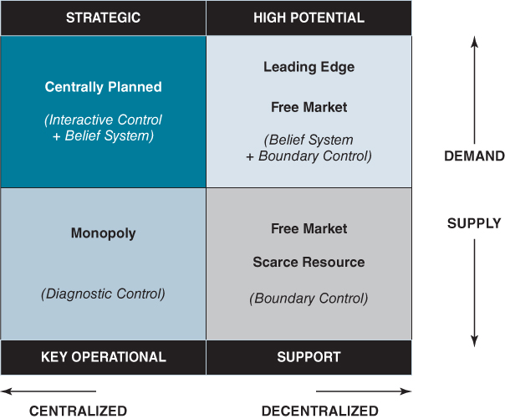
FIGURE 8.5 Relationship of application portfolio and generic strategies.
Overall, the strategies address the range of IS demand and IT supply issues in all segments and offer the balance of centralization and decentralization needed. Central planning is a demand management strategy, whereas monopoly is essentially a supply management approach; both obviously mean strong centralization of control. Free market and leading edge are demand management approaches, letting users decide and/or new technology initiate demand. Free market can also be used to determine supply and is obviously decentralized, and leading edge is dependent mainly on external supplies of technology. Scarce resource is a supply management strategy and is decentralized in that, once the justification rules are set, the ability of any user function to satisfy them will determine what is done. Clearly, an organization with a comprehensive portfolio will use most of the strategies simultaneously.

The Generic Strategies and Management Control
There are many similarities between these generic strategies and the types of management controls proposed by Simon⁸ to address the nature and degree of change involved in projects. Most IS/IT developments involve business change of increasing extent and complexity and uncertain outcome as applications become more strategic. Simon considered two particular dimensions – the balance of prescription versus discretion that the project team has in determining what to do and how, against the level of explicit knowledge in the organization of how to achieve success. From his research, Simon proposed four types of change control or management: boundary control, diagnostic control, interactive control and belief system. These should be used in different circumstances, depending on whether the intention is to encourage (respectively) contribution, performance, innovation or initiative.
Achieving these different intentions requires the organization to apply varying degrees of control to the change activities, based on the need for senior management to contribute their knowledge and influence and the extent to which decision making can be safely delegated. This will of course vary across organizations and depends on the nature of the application, the type of business and the organization's culture. For example, in retail organizations with many branches or stores, there is usually little discretion allowed in new systems implementations in the branches, whereas the organization's market researchers would be expected to demonstrate their initiative to use analytics to glean information about customer behaviours from its EPOS systems. In summary, as shown on Figure 8.5:
- Boundary control is appropriate when the objectives and constraints are clear, but allows the project team discretion about how best to achieve the required outcome. This matches the change requirements of the support segment and correlates with aspects of free market and scarce resourcing.
- Diagnostic control, which implies a clear, prescriptive control based on sound knowledge of what has to be done to achieve performance targets, is most appropriate for key operational projects and implies similar levels of prescription as monopoly.
- A combination of interactive control, which is appropriate when there is a vision of the potential ‘end point’ but much to learn in order to define, scope and develop an appropriate solution, and belief system, where the project team is expected to create a new and innovative application that will be closely congruent with the business strategy, relates to needs of strategic developments. The uncertainties, change issues and learning required are very similar to the concept of central planning.
- Trust in the organization's belief system moderated by a degree of boundary control is probably the most effective combination for managing the balance of initiative required and the risks involved in deploying a leading-edge strategy in the high potential segment.
Similarly to the generic implementation strategies, these different forms of management control are closely related to both the different contributions expected and the types of changes and risks to be managed across the four portfolio segments. Consistency in the approaches to managing the IS/IT implementation and business change aspects of the project are needed if all the benefits are to be delivered.

Using Generic Strategies in Developing the Strategy
The generic strategies have two main uses in the process of developing the IS/IT strategy:
- Diagnostic. They are a way of understanding and describing the current strategies being used – a clear way of expressing how applications and investments are actually being managed. There is a strong correlation between the application success and the strategies adopted. Equally, the failure of many application investments can be simply explained: the wrong strategy was adopted! The generic strategies can encapsulate the apparent complexity of the existing situation and, by describing it succinctly, explain it.
- Formulative. Once a future portfolio of applications has been identified and the strengths and weaknesses of the existing applications assessed, the strategies can be used to identify a migration path toward the mix of approaches required in future. It is superficially attractive to say that central planning is needed, but it might be inappropriate for many investments and it is impossible to centrally plan everything. Allowing more freedom, using new technology or tighter, monopolistic control may be more appropriate in the short term. More rigorous scarce resourcing of support systems might release resources to be deployed on strategic systems.
No definitive mixture can be prescribed for every situation, but the generic strategies provide a limited number of basic options from which to select the set that best matches the range of application portfolio requirements. This avoids the requirement to ‘invent’ the strategy entirely from the ‘ground up’ – it is easier to define the approach by modification from proven approaches to suit the particular need.
In a single business unit company, these concepts are reasonably easy to apply and, as is discussed later in the chapter, comparisons of portfolios and strategies can be made across business units to gain further benefits.

Relating Approaches to IS Strategy Formulation with the Generic Implementation Strategies
It would appear that there should be a logical relationship between how an organization plans its IS/IT investments,⁹ as introduced in Chapter 3 (see Table 3.1), and the approach it adopts for the implementation of the resulting applications. Although the two concepts of ‘planning approaches’ and ‘generic strategies’ are derived from different sources, there are some clear connections that can be drawn between the two. The correlation is not perfect and there are some anomalies:
- Organization led planning implies cross-functional views of IS/IT to ensure that investments are targeted on the business objectives and key themes implied by these objectives. It follows that the centrally planned strategy for implementation would best maintain that strategic view. However, it can be a challenge to organizations who reach this level of ‘maturity’ in IS/IT planning to select a less centrally dominated implementation strategy for the many projects that would be better managed in other ways.
- Business led investment, driven by the plans for the particular business areas, should lead to uncovering high potential opportunities and, in due course, perhaps to strategic investments. But this can also lead to a plethora of applications that, in the overall business context, are actually support. This aligns closely with the free-market strategy, which is good for enabling innovation but also appropriate for many support applications. However, because of the purely functional view taken, the organization can fail to realize the full benefits available and only localized, support-type benefits materialize.
- The systematic approach involves a highly analytical and structured method of determining the needs and priorities for investment, and it would seem prudent to follow through with the consistent, quality-based, highly structured implementation process that monopoly brings. Both the planning approach and the implementation strategy are risk averse and work well where a long-term plan to improve the performance of relatively stable business activities is needed and feasible (i.e. key operational applications).
- The administrative approach to planning implies that the main objective is budgetary control of IS/IT, which can result in a scarce resource approach to implementation, whereby each investment is asked to justify a budget allocation via a financial case. Alternatively, one way of ensuring overall effective administration is to bring all the resources and costs together in one place, to plan and control the whole investment programme through one budget centre, normally the IS/IT function. This effectively creates a monopoly channel through which all investments are vetted. This does not imply financial constraints, merely centralized budgeting and monitoring of expenditure.
None of the planning approaches correlate directly with the leading-edge strategy for implementation.
Those organizations that succeed in the longer term are those who can understand, accommodate and use the required combinations of planning approaches and implementation strategies most effectively.

Portfolio Management Principles Applied to the Application Portfolio
The obvious resemblance of the application portfolio to the better known product portfolio of the Boston Consulting Group and customer/channel management portfolios has already been mentioned. The similarities are important, since products and IS/IT applications must be managed according to their contribution to the business over an extended life cycle. That contribution is determined by both internal and external factors – in the case of IS/IT, the external market and socially driven factors are becoming increasingly important. The lessons from ‘other portfolios’ have become more pertinent still as IS/IT becomes integral to digital products, services and relationships with customers and suppliers. Comparisons will be drawn directly with portfolios of products and services, though similar parallels exist with customer portfolios.
First, both applications and products have life cycles, and move around the matrix over time. High potential applications and wildcat products are both risk investments that need to be carefully assessed as to whether or not they are of strategic importance or can become ‘star’ products. As the competitive balance is restored and the application is commonly in use across the industry, it becomes key operational, as a star product should become a cash cow when the market matures. Finally, as the industry moves on to a new competitive basis, applications may become of support value only, and, similarly, many products eventually move from cash cows to dogs. It is important in both cases to prevent high potential or wildcat investments from drifting straight down into the support or dog quadrant as a result of indecisive management or an inability to capitalize on any knowledge gained.
Second, both applications and products require investment funding. This is easily seen with products, where the cash generated by today's profitable products is reinvested in cash-hungry future products. For applications, this implies reinvesting the benefits derived from today's systems into new applications. These benefits are:
- skills, knowledge and experienced resources;
- the organizational capability to develop and manage complex business systems and the evolving IT supply chain;
- management commitment to the use of IS/IT in the business, based on successes achieved and a perception of the value of those investments;
- the data and information held in the existing applications which, when well organized, is a potential source of advantage if exploited through its use in strategic applications.
Third, both applications and products need to be managed and have resources allocated in accordance with their business importance, not their technical or operational peculiarities. Management capability and resources are normally in short supply and need to be continuously reallocated to obtain the best business results and maximum benefits from the overall portfolio. Dynamically matching the available resources and expertise to the evolving portfolio priorities is essential to maximize the business benefits and sustain investment success.¹⁰
Overall, the main reason the product portfolio model offers useful input to application portfolio considerations is that it reflects the realities of the economic and business environments. The model was developed to assist in managing and planning in an uncertain, market-driven environment, where management decisions can influence but not determine the future. IS/IT is also subject to the forces of the marketplace – external parameters now define the effectiveness of an organization's IS/IT management. Of the various analyses and conclusions that can be drawn from business portfolio models, some have particular relevance and provide valuable insights for managing the business application portfolio.
Maximizing the long-term contribution of products depends on successful management in the relevant portfolio quadrant and successful transition management across quadrants. Successful IS/IT application management depends on the same two factors. The particular parallels will be drawn by following the evolution of an application around the matrix.

High Potential (Wildcats)
High potential applications resemble wildcat products due to the degree of uncertainty of success and hence the amount of risk they involve. Many will fail. Identifying and then transforming the successes into the next phase of the life cycle is the objective. This implies dealing effectively with the failures and not pouring good money and resources after bad. Three particular approaches to management are appropriate to achieving this:
- Process R&D – not ‘product’. From the business lessons: how to make, market, distribute and service the new product, not just achieve the ultimate in product design. A weakness in many firms is ‘over-engineering’ products – satisfying the designer rather than the customer. A similar problem exists in IS/IT – satisfying the technical professional, not the user. Any prototyping or pilot implementation of an application should be undertaken to find out how the organization, and/or its trading partners, can benefit most from a new use of IT, not to discover all that the technology can do. Many prototypes of electronic commerce, knowledge management and CRM systems have failed – not because there were no benefits to be gained from the technology, but because the organization failed to discover how to implement it in the way that would deliver those benefits.
- Minimal integration. While being evaluated, risky ventures should be separated from mainline activities. Should they fail, aspects of the business should not have become dependent on them and, at low cost, the prototype can be aborted. This also prevents the evaluation being confused by issues not directly relevant to it. A key part of the evaluation is to decide how any necessary integration can best be achieved – therefore, any initial integration could preclude the most effective options. Non-separation of new products has caused similar problems – contribution to the business being impossible to assess, and commitments having been made that make decisions to pull out expensive. Many early e-commerce ventures, especially in financial services, were set up as new businesses, even new brands, with new IS/IT and then later integrated when online services became the norm in the industry.
- Cost control. The only common factor that applies across different pilot or prototype projects is money. A budget is the only consistent link with conventional management processes, where the unknown is being explored. This requirement for strict budget control reinforces the need for non-integration to ensure that the specific financial implications can be assessed. To improve the cost control further, it is usually worth restricting the time allowed for evaluation, even though it is difficult to predict how long it will take when it is a unique R&D project. Most new application evaluations can be made in three to six months – which should be sufficient time to gather evidence that further investment is worthwhile, or if it should be stopped. Strong cost-based management is the most effective control available, and it must be understood that the ‘investment’ may have to be written off. It is better if these evaluations are funded from an R&D budget – either specific to IS/IT or a business R&D fund – and do not compete with funds required for the rest of the portfolio.
As new technology options are now emerging faster than ever, even relatively conservative organizations realize they need to experiment more in the high potential segment to avoid falling behind their competitors. Successful management of digital innovation is becoming an increasingly important aspect of most firms' strategies, but one with which many are unfamiliar.

Strategic (Stars)
A star product or strategic application is one that the company is dependent upon for future success in a competitive, changing marketplace, where any advantage gained can be eroded quickly. Again, particular approaches should be adopted:
- Continuous innovation – this applies to what the application does and how it does it, to keep providing value as an integral part of the business. These improvements will be business driven, based on the need to sustain or increase the perceived benefits or competitive advantages. Whether to spend more money will be a business manager's decision, based not simply on return on investment calculations, but on the risk to the business if it fails to stay ahead of the competition. A website simply enabling customers to buy catalogued products may become obsolete very quickly if a competitor offers virtual reality or configuration features that the customer finds more valuable or easier to use.
- High value-added and vertical integration – the business manager has to understand how the application can enhance the business process and then have the capability to make further changes to increase the value created, or improve process performance, as and when required. This implies vertical integration: i.e. business control of IS/IT resources and the ability to satisfy the unique needs of the particular situation without prevarication or accepting lower value-added compromises. Most applications in the strategic box are normally associated with highly information-intensive parts of the business, and the business manager will not be able to take full advantage if he or she has insufficient discretion over IS/IT deployment.
As the application ceases to deliver any particular advantage, it becomes important to reduce the rate of investment and contain the costs, consistent with avoiding being disadvantaged (i.e. it has become key operational). But admitting that competitors have caught up is often difficult when the organization has previously been ahead.

Key Operational (Cash Cows)
As with its cash cow products and services, an organization expects its key operational applications to make a significant and lasting contribution to the business. This depends on keeping the product or application in line with current market and business demands in the most cost-effective way. The particular business lessons in this case are:
- Defensive innovation – further investment should only be in response to changes in the business, or sometimes technology, that threaten to put the business at risk through a reduction of operational or management capability (i.e. avoiding disadvantage). This risk should be quantified, as far as possible, to ensure that the expenditure involved gives a net benefit over time. Deciding on further investment now requires a joint evaluation – users deciding the benefit of action versus the risk of inaction and IT professionals identifying the costs and consequences of any chosen action.
- High quality – compromises on technical quality will reduce the effective economic life of an application, due to increased user costs for ‘workarounds’ to overcome application deficiencies or increased IT ‘maintenance’ costs due to increasing numbers of problems. In the long term, the low cost of support depends on strong quality management, including data and processing integrity and accurate integration with other key operational applications and related business processes and procedures.
- Effective resource utilization – key operational applications cannot be afforded the dedication of resources given to strategic systems – it is not justified. This implies the integration of the support for the application with others – sharing resources and expertise to reduce the costs. This is a familiar lesson from application development – transferring the management from a dedicated development team to a general support group after implementation. This reduces the cost, improves quality control and discourages continuing poorly justified ‘enhancements’. In the longer term this will also allow opportunities to reduce costs further from general improvements in IT infrastructure capacity and capability, whose justification is based on the number and range of applications that use it.
The overall approach to managing key operational applications is to reduce costs while sustaining the business value derived from their use.

Support (Dogs)
Support applications, like dog products, are not critical to an organization's future, unless they waste valuable resources or the marketplace changes unexpectedly. The business lessons are therefore:
- Disinvest/rationalize – reducing the organization's commitments to applications can be achieved in a number of ways: by using software packages, provisioning from the cloud, outsourcing their operation and support or even outsourcing the business processes themselves. The last of these is becoming increasingly common for non-critical aspects of finance and human resources and for a wide range of activities in the public sector. Each involves the substitution of resources – money for scarce skills – and the decision is essentially a financial one, which often gives very good returns. Alternative solutions are available for these applications, because they offer no competitive advantage and business and IT service providers as well as software companies can make a profit from the volume of similar applications in many companies.
- Sustained quality and efficiency – the quality of the application should be maintained in proportion to the costs of failure and, if necessary, calculated risks should be taken, based on the efficiency of resource use involved. In general, it should not be enhanced unless there is a very demonstrable economic case – to ensure that resources are only consumed where a return is certain. The disinvestment process discussed above will automatically reduce the pace of enhancement to that of the generally available service or package upgrades. The general rule is to adjust the business activity to fit the package, not the other way round – or costs will increase dramatically, not reduce.¹¹
A couple of immediate observations can be made from the above analysis:
- The rate of enhancement to any application should reduce as it progresses around the life cycle. Equally, the justification for investment becomes more quantifiable over the evolution, and financial evaluation becomes both more meaningful and more decisive in the key operational and support quadrants.
- To achieve the appropriate balance of resource use to business contribution, different management approaches are required in each of the quadrants. The application may have to be rebuilt or at least re-implemented when it crosses the boundaries to optimize the net organizational benefits. For instance, the degree of enhancement and probable expediency of change control in the strategic quadrant can militate against effective resource utilization when it becomes key operational, unless some consolidation or rationalization is undertaken during the transfer.
While the evolution from high potential via strategic to key operational is the most common sequence and delivers the maximum contribution over time, mismanagement in the early stages can reverse the logic and outcome. This occurs most frequently when applications using a new technology are allowed to evolve without effective management. Box 8.3 gives one such example.

BOX 8.3

The problems created by the mismanagement of some Intranets – lessons relevant to other technologies and applications
Based on studies of a range of Intranet applications,ª several showed a different evolution from that expected and as a consequence caused significant business problems:
- ♦ Initial experimentation (high potential) enabled knowledge-sharing applications to be developed, saving time etc., but the benefits were not ‘strategic’. Therefore, they soon became support applications; they were still used, but the costs of support were minimized.
- ♦ Over time, due to their ease of use, the applications were relied upon as a source of operational information, even though the ‘content’ was not managed in a disciplined way – there were no procedures for maintenance or clear ownership of the contents of the information base. Eventually, a major operational problem or failure occurred due to incorrect or out-of-date information content. Only then was the key role that the ‘informal’ information system was now fulfilling realized and appropriate disciplines, procedures and support resources put in place.
In one example, salespeople were selling services to customers based on information from the (informal) Intranet catalogue. The company no longer offered some of those services, but no procedure or control existed to remove the out-of-date information. Only when contracts were about to be signed did the customer (and salesperson) discover the problem. Several valuable contracts were lost! This is an issue that is not particular to Intranet-based systems. It can happen when informal, free market management of applications occurs in the key operational segment due to a change in the business role of the system.
These problems were not new then, but had been common 15 years earlier with the introduction of personal computers and especially spreadsheets. And they are recurring 15 years later with the business use of social media and other apps available on mobile devices or that can be easily obtained from the cloud.
Notes:
ª J.M. Ward, K. Breu and P.N. Murray, ‘Success factors in leveraging the corporate information and knowledge resource through Intranets’, Knowledge Management and Virtual Organizations, Idea Group Publishing, Hershey, Pennsylvania, 2000, 306–320.

Aligning Management Styles to the Portfolio
Another useful concept developed from the product portfolio is how the management style should change during a product's life cycle in response to the evolving issues to be addressed. Since managers are not totally adaptive in style, this often implies changing the manager. Equally, different styles of management are required to successfully deliver the different types of application in the portfolio. The lessons of product portfolio management, again, offer helpful guidance.
High potential applications require a similar, entrepreneurial, style to wildcat products, to champion the application through phases of doubt or decide to stop if the potential is not realizable. Entrepreneurs are highly motivated but expect their success to be seen as personal rather than organizational. At the same time, they recognize that they must not be judged to have failed by others and will either be adept at avoiding failure or be the first to decide when the idea is not worth pursuing. Also, they do not obey ‘the rules’ and so will cause change and innovation, which implies challenging preconceived ideas or ignoring or bypassing accepted custom and practice. This mode of operation is very appropriate for the high potential situation, but is quite dangerous elsewhere in the portfolio.
Strategic applications require more nurturing, to gain organizational acceptance through demonstrated contribution to future strategy. A style of ‘developer’ best describes the type of manager required: someone who will build a team and develop the resources necessary to achieve the task objectives. Other terms to describe this are ‘organizational climber’ – someone whose career ambitions will be met by being related to the achievement of organizational success. A developer is a planner who achieves results through others, a team manager who moulds the resource to match what needs to be done to achieve the objective and who can be flexible to changing circumstances – adapting the means to achieve the end result. Research suggests these characteristics are also those required by ‘programme managers’, for major change initiatives, rather than the more traditional skills and abilities of good project managers.¹²
Key operational applications require a different style of management entirely: that of a ‘controller’ who is risk averse, wanting everything to be done correctly and failure never to occur. Assurance of success implies reducing risk to a minimum via strict adherence to procedure and standards, and building an organizational structure and mentality that is self-checking and control conscious. The best way of achieving quality control is to build it into the organization structure through job responsibilities and procedures. The controller approach is relatively inflexible and resistant to change, since change causes uncertainty and errors.
Support applications are ideally best managed by ‘caretakers’, who get their satisfaction from achieving ‘the impossible, with no resources, repeatedly’ and delight in telling everyone! It is a reactive, problem-solving approach, where planning and resource management are less important than getting the job done expediently and efficiently. This implies a multitasking, flexible approach to achieving results that are not of any strategic impact, but will cause a major distraction from more important matters if not dealt with in a timely and adept manner. Support applications have no great future potential impact, but can be a constant source of irritation if mismanaged.
These management styles reflect the generic strategies required to manage the various components of the portfolio:
- An entrepreneur is a free marketeer, who pays little attention to established procedure.
- A developer is a central planner, close to the organizational goals, who builds resources to achieve results.
- A controller is a monopolist, uncomfortable with anything outside his or her control.
- A caretaker is a scarce resourcer, proving that he or she can achieve as much with less!
The strategy will not be achieved by managers who are ‘square pegs in round holes’ – a developer managing in the support segment will produce ever larger, more significant versions of relatively inconsequential systems; a controller expected to evaluate a high potential opportunity will never take the first risk, and so on. It must be remembered that all these roles are important and each has a major part to play in managing a complex portfolio over time. Figure 8.6 summarizes the key lessons that can be learned from successful management of product portfolios.
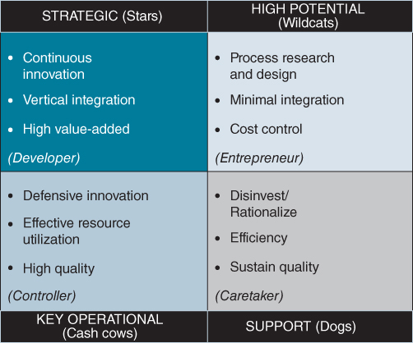
FIGURE 8.6 The business/application portfolio matrix.

Aligning Development Approaches to the Portfolio Segments
Within the principles already described, this section considers differences across the portfolio in the approaches that are appropriate for provisioning the applications. For all applications, research shows that when systems disappoint the users, it is usually due to inadequate analysis or reconciliation of users' requirements or not understanding users' expectations.¹³ Therefore in all the sections below, professional approaches to business requirements analysis, systems design and testing are considered essential to success, even where the technology has already been extensively used by other organizations for similar activities and processes.

High Potential
The term ‘applications’ is perhaps inappropriate in the high potential segment, since it is the research and development (R&D) activity enabling new technology to be tried out to identify possible applications for the organization, or to explore how technology might enable the implementation of an innovative business idea. The main objective is to evaluate the business potential of applying any technology, but in some cases the potential may not only be where the initial use of a new technology is tried. This may mean splitting the prototype or pilot study objectives into those that are application specific and those that are for more general learning. The potential uses of RFID (Radio Frequency IDentification) tags were explored by many organizations for tracking items and have been successfully used in distribution systems and libraries, where the item value is high or it is reused many times. However, as yet the cost of the tags is too high to use on most consumer items, where retail automation could produce significant operational cost savings.
The most obvious danger is that users and even senior management become so enthusiastic about a successful prototype that it becomes a fully operational system, even though it is made of ‘string and glue’ and has not been designed for use on a large scale. Many good ideas have proved less than successful when implemented, since the required performance or reliability could not be achieved in full-scale operation. A well-known example was boo.com's clothing website, which was far too slow in loading complex graphics.¹⁴ This frustrated potential customers and probably contributed to the company's demise.
Often, the organization will have to acquire or develop new technological skills to carry out the evaluation. Some skills may have to be acquired via the vendor or other outside experts, but it is important that effective knowledge transfer occurs during the evaluation phase, to avoid future dependence on technical skills only available externally.
For a new idea, it may be that different types of technology could be appropriate. It can be advisable to carry out parallel, competing R&D projects focused on one business application, especially if the potential benefits appear very high, if speed is of the essence and/or competitors are carrying out similar evaluations. However, in this case the eventual decision criteria must be clearly spelled out or the process will only leave more uncertainty at the end than there was at the start!

Strategic
When the goal is gaining and sustaining competitive advantage, speed of development and adaptability of design are essential, and cost is less important. The ‘window of opportunity’ may be short-lived or uncertain and there is often a need for incremental or phased development and implementation, since new options and needs will be discovered as the project proceeds.
Strategic applications frequently use information from a number of different existing systems and databases and they may also import information from outside sources. An example is from some financial institutions, which offer integrated current, savings and loans (like mortgages), netting off the interest accrued in each and minimizing the amount held in the current account. This requires taking data from the underlying different product systems, which are account oriented, and linking all the accounts together by individual customer. This sounds easy, except that often the underlying product systems have evolved in a piecemeal fashion with relatively little thought toward the total view of the relationship with the customer. However, the new ‘online’ banks were able to design the integrated applications and create new products and services to match customers' needs and preferences. The traditional banks and building societies had to invest heavily to catch up and some are still struggling to do so.
Strategic applications are likely to be complex, or will become complex, as functions are added incrementally and the application is adapted in response to changing or evolving requirements and the identification of further benefits.¹⁵ They are also required to be developed quickly, and the application may have to be ‘generated’ many times as it is changed. An ‘Agile’ or Dynamic Systems Development Methodology (DSDM) incorporating prototyping is most effective in clarifying needs and options, and building components and applications.¹⁶ Speed, flexibility and complexity all lead to problems of controlling the development, and these methods combine time boxing and deliverables/version management to avoid subsequent expensive rework or maintenance. This also argues for the use of integrated development environments employing Rapid Application Development (RAD) and Graphic User Interface (GUI) tools. The initial analysis and design can be performed using automated tools that produce code which, though not particularly efficient, will at least be very quickly developed and tested and enable changes to be identified and implemented rapidly.
However there are risks with this approach as found in the development of the UK Department of Work and Pensions (DWP) Universal Credit System, when the scale and complexity of the application was underestimated at the start and the organization had no previous experience of agile development methods. In combination this resulted in the write-off of many millions of pounds of software costs.
It is unlikely that software packages or a cloud service will provide all the requirements for this type of application as significant advantage cannot accrue from generally available software, unless the business adds value to the package, e.g. by considerable enhancement, finding a new use of the package or changing business practices in an innovative way. In these cases, the package becomes a unique application and, as such, it must be supported as if it were tailor made. Alternatively, a short-lived advantage could accrue from being the first user of a new package, but success could be very quickly and easily copied. It is also high risk to be the first user of new software, so it should normally be evaluated in the high potential segment rather than assume it will work for a strategic application.
Continuity in terms of the development team, both business and IT members, will be critical to managing the evolving knowledge in an environment that will not encourage accurate documentation, adherence to standards or the best in quality control processes. Those should not be ignored, but business expediency will tend to overrule technical standards and controls in many cases, to avoid extending the development time and even missing the business opportunity altogether. The speed of implementation of the application is, on balance, more important than its cost of operation, but high performance, especially if it is used by customers, could be a critical success factor.
Inter-connectivity, often via middleware rather than full integration, may suffice initially, in order to assess the value of the strategic system while protecting the installed base of key operational systems. Many consumer Web applications were initially interfaced with core processing systems to ‘test the market’ and reduce risks, but the most successful were those that were quickly integrated with those core processes to deliver end-to-end responsiveness to the customer. The Internet flight-booking systems of EasyJet and Ryanair, compared with those initially developed by more traditional airlines, are good examples.
These applications will often require or create new business processes, competences or operational skills as well as technical knowledge. For example, in the use of analytics, knowledge of advanced statistical analysis techniques will be required and this is in short supply. A Customer Relationship Management (CRM) system may require customer service staff to develop selling skills. Many CRM applications are labelled as failures because management did not ensure that the essential new business skills were developed and so the new opportunities were not exploited.¹⁷

Key Operational
These are generally the applications that carry out the main operational processes of the business (e.g. customer order capture and fulfilment, product manufacture or service delivery) and should be well designed both in business process and technical terms. Key operational systems need to be efficient and resilient, to deliver cost-effective and problem-free use over an extended period. Since they often have to be integrated with other primary business process systems, they should always adhere to information management standards and comply with the chosen applications, technology and information architectures.
They can often be met by application packages, but further development may be needed to provide effective integration, resource sharing and information management. By selecting a comprehensive package (e.g. ERP), the additional work can be avoided, but some user needs may have to be compromised. In most cases, new key operational ‘developments’ are replacements for combinations of (or individual) existing systems and there is always a trade-off to be made between the new functionality provided and the extent of the business change that can be made to reduce process complexity, especially with large software packages. Therefore, it is important to understand which core processes are most critical to success and how comprehensively and effectively the software will carry out those processes. This suggests formal structured methods (e.g. SSADM – Structured Systems Analysis and Design Methodology), complemented by a proven project management methodology (e.g. PRINCE2 – Project Management in a Controlled Environment), should be adhered to throughout the development, even when a package is used. When developed in-house, the quality and performance needed usually require the use of automated software and information engineering tools.
Often, bringing in a package is the best way of achieving integration of application requirements among the various departments or functions, who would otherwise attempt to satisfy their own needs without regard to the effects on others. ‘Making the package work’ can often override localized objectives, although, if badly managed, it can become a target for every department to engineer its failure!
Key operational applications will tend to be functionally complex, have many interfaces and dependencies and should satisfy requirements with minimum compromise of the users' main needs. Even where a package is selected, it may have to be customized, despite the risks involved. This will require a thorough technical understanding of how the package works as well as what it does. Whether a system is developed or a package modified, an accurate specification of what it has to do and how it has to do it is essential. Strict change control and version management procedures must be in place to prevent errors being introduced when amendments and upgrades are implemented. These errors may not be easy to predict since they may only manifest themselves in downstream systems.
Because this type of application will require ongoing modification in order to avoid falling behind the business requirements, there should be a high level of business and technical support skills available for both emergency action and changes. If a package is used, it can present difficulties to the organization when new releases need to be implemented (i.e. changes may have to be made even if the business does not require them). Worse still, if the package has been heavily customized, valuable new functionality that becomes available may not be able to be adopted. For large, enterprise-wide applications, a dedicated support team is probably required after implementation, consisting of both users and IS/IT professionals. Releases of new versions of the system software must be thoroughly tested, and updated user training carried out and reviewed in terms of the effective use of the new functionality.

Support
If new support applications are required or existing ones are to be replaced, the most appropriate solution is to buy in, or provision from the cloud, commonly used proprietary software packages that match the business requirements as closely as possible. The package should not be customized: business processes and procedures should be amended to fit the way tasks and processes are performed by the software. Very rarely can an organization justify the allocation of valuable skills and resources to developing support systems for themselves or the future costs of modifying every new package release to satisfy their business idiosyncrasies due to earlier customization.
The resources required to implement a package for both key operational or support environments are frequently underestimated. Requirements still need to be carefully analysed and documented, and alternative options evaluated against the business needs to select the most cost-effective option that produces the most benefits. Even if no tailoring of the package is necessary, there are often interfaces to be built to existing systems and databases, and there may be considerable work needed to configure package parameters, undertake user training programmes, develop adequate testing material, convert existing data and implement the system. An allowance of resources may also be needed for the work involved in vendor management relating to supply and service activities.
Even if the databases in the packages are not ideally suited to the organization's information architecture, integration is often less critical in support applications than the ability to transfer information. User needs are paramount in the final choice, but the IS/IT function's veto of certain options must be allowed, if they cannot provide support for the required technical environment, otherwise overhead cost build-up will offset the efficiency benefits. Equally, it is best to adopt a low risk or conservative approach; only selecting packages with a well-established base of customers, rather than being the first user of a new package, however good its apparent features. A package selection checklist can easily be drawn up to help users to define requirements and decide on options.
Support applications and associated processes, because they are not critical to success, are prime candidates for outsourcing to a third party, especially if they are using up resources that are needed on more important applications or when the organization needs to develop new IS/IT skills.
Table 8.5 summarizes some of the key aspects of managing application developments in each of the segments of the portfolio in relation to the critical requirements.
TABLE 8.5Some key aspects of managing application developments
 | Critical requirements | Application development: key aspects
High potential | ♦ Rapid evaluation of prototypes and avoid wasting effort/resources on failures  ♦ Understand the potential benefits in relation to the business strategy  ♦ Identify the best way to proceed – the next step | ♦ Prototypes and pilots to test performance, scalability and user acceptance. Independent – low integration.  ♦ Evaluate potential benefits and how to achieve them through low cost, iterative developments – maybe multiple, competing pilots.  ♦ Acquire new skills/transfer knowledge from outside expertise.
Strategic | ♦ Rapid (even iterative) development to realize benefits within the window of opportunity  ♦ Flexible system that can be adapted in the future as the business evolves  ♦ Link to an associated business initiative to achieve changes and sustain commitment | ♦ Dedicated joint IS/IT and user development teams using Agile methods to share knowledge and create new business processes.  ♦ RAD and GUI tools to produce and test pilots for functionality and performance. Design for future adaptation.  ♦ Executive sponsorship and senior management leadership of the team.
Key operational | ♦ High-quality, long-life solutions and effective information management  ♦ Balancing costs with benefits and risks – identify optimum balance of IT and business change  ♦ Evaluation of options (including outsourcing) available by objective feasibility study | ♦ SSADM and Project Management methodologies, process redesign and apply corporate information management standards and policies.  ♦ Use industry-specific packages with minimum customization, but integrated with other systems. Strict specification and change control processes.  ♦ Combined IS/IT and business team: select for performance of core processes and application reliability as well as functionality and costs.
Support | ♦ Low cost, low risk, long-term solutions – often packaged software to satisfy most needs – compromise needs to the software available  ♦ Process and IS outsourcing is an option  ♦ Objective cost/benefit analysis to reduce financial risk and then control costs carefully | ♦ Design procedures to use software package efficiently. Interface not integrated. No customization.  ♦ Take advantage of the external capabilities available – and used successfully by others.  ♦ User makes final selection of package, using package checklist to ensure compliance with IT strategy.

The ‘Special Case’ of Enterprise Systems
The best known Enterprise Systems (ES) are probably the Enterprise Resource Planning (ERP) software suites provided by a range of vendors, initially for the manufacturing sector, but versions of them are now available for other industries such as logistics, utilities, healthcare, retail and even higher education. Other ES applications have been developed for other activities and in other sectors, ranging from Customer Relationship Management (CRM), Call Centre Management, Supply Chain Management (SCM), Policy Administration and Claims Management (in insurance) to Electronic Patient Records (EPR) in healthcare. Their chief characteristic is that they affect a large number of organizational processes and functions, standardizing and integrating information, processes and activities.
Few are truly enterprise wide in the sense that they deal with all the business information needs, but all are a significant part of the overall IS/IT strategy of the organization. ES do not normally fit into any one of the four portfolio segments, given the activities covered and the range of potential benefits available. Therefore, they often involve a combination of most of the portfolio issues, the mixture being dependent on both the intent of the investment and the current situation across the affected processes and business activities.
While part of the reason for the growth in their use has been the availability of comprehensive packages from software suppliers and consequent ‘buy or rent’ cost advantages, other issues have accelerated their adoption:
- Replacement of non-integrated legacy systems by integrated business applications and databases to reduce long-term costs and provide higher quality systems that incorporate industry ‘best practices’¹⁸ in internal processes and e-trading.
- Increasing legislation and regulation in many industries has made ‘compliance’ a major issue, and buying comprehensive, ‘compliant’ software can help avoid the serious consequences of failure to satisfy the regulators.
- In multinational or global organizations, the need to expand the business by rapid replication of existing business models, to use resources and knowledge flexibly across products, services and markets as well as to deal consistently and effectively with large global customers or suppliers.
Overall, whatever the particular type of ES, the main differences from more traditional IS developments are the ambitious intentions, the application complexity and cross-functional scope, the range of different stakeholders involved and the extent of business and organization changes needed to accommodate the new business models inherent in the ES. And, of course, the possibility of bringing the business to a grinding halt if it fails!
A major pharmaceutical company implemented an ERP system worldwide across all its manufacturing units, but allowed considerable degrees of freedom to each unit in how it ‘customized’ and utilized the package. As a result, the major supply chain benefits that were expected did not accrue. The reimplementation was more standardized and required the units to change their practices to improve the performance and agility of the supply chains for all the main products. The manufacturing company whose portfolio is shown in Figure 8.3 implemented all the ‘head office’ functions of the ERP package, such as accounting and HR, before implementing the key operational components across all its manufacturing sites, to reduce the risks. More recently is has extended the deployment to include newer customer management related functions that are now available from the same supplier.
Research¹⁹ into successful ES implementations has shown this two (or even three) phase approach is common. Often the initiation of the project involves creating a coherent link between the future business vision and how the ES either creates that vision or enables it to happen. Unfortunately, that vision often ignores or minimizes the current problems and constraints that limit the organization's ability to implement the entire ES successfully. Trying to achieve the vision in one ‘phase’ often leads to expensive failure. A more appropriate approach is to establish an overall vision for how the business will operate once the full benefits of the ES can be realized, but set an initial intent that delivers a ‘new baseline’, where the problems and constraints have been removed, usually by replacing the relevant legacy support and key operational applications. Phase I implementation should deliver this new baseline, often via a basic (or ‘vanilla’) implementation of the software with associated essential business practice changes.
Studies²⁰ also show that business performance can deteriorate immediately after implementation, and contingencies to allow for this are needed – increased inventories, more resources and informing customers and trading partners of expectations. A ‘shakedown’ phase normally follows in which an understanding develops of how to optimize performance through further changes to business practices or software reconfiguration. This, in turn, enables further benefits to be achieved by using more capabilities of the software or by more radical business and organizational changes.
A revised vision is then needed, with new objectives and plans to achieve strategic innovations in business processes and practices based on the ES capability now available. A two-stage implementation model,²¹ based on the results of a number of studies but using much of the terminology of Markus and colleagues,²² is shown in Figure 8.7. The two stages can be summarized as ‘problem based’ to achieve a new starting point from which ‘innovation-based’ development can be launched. At the start of such a large, ambitious project, it is difficult to get sufficient consensus on what the future will look like and how to get there, when a wide variety of current issues and problems are the focus of day-to-day management attention. Removing those problems releases the organizational ability to envisage and agree how new ways of conducting business can be created.
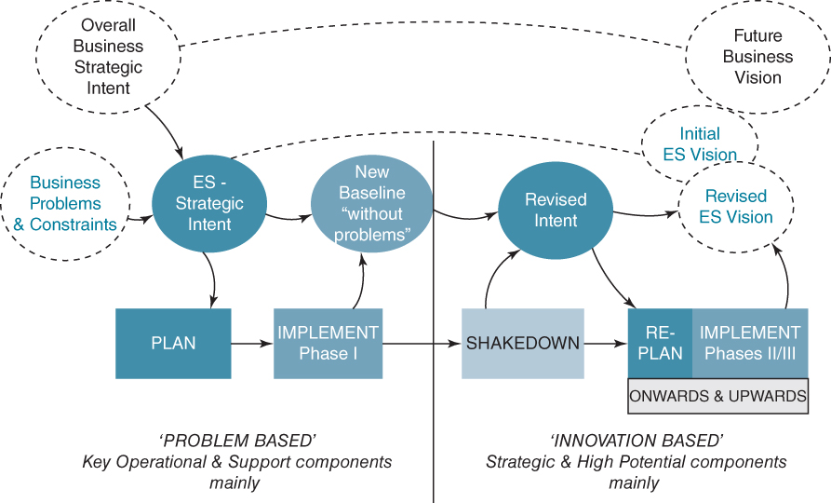
FIGURE 8.7 Multi-stage Enterprise Systems implementation.
The implementation of an ES is a ‘business transformation programme’, not an IS/IT project. Very few fail because of the inadequacies of the technology. When they do fail, the reasons are organizational²³ and, in many cases, due to different perceptions of the benefits and extent of changes required between senior executives and operational line management and among the line managers in different functions or units.²⁴ This produces uncertainty about how to manage the implementation: as a single strategic project or as phases which address the support, key operational, strategic and even high potential components in the most appropriate way.

Managing Application Portfolios in Multi-unit Organizations
Once IS/IT or digital strategies for each business unit can be described in terms of the application portfolios, it becomes easier to identify a range of further benefits across the organization, from taking advantage of successful innovations to meeting similar needs more economically. The rationale is in part based on the extent to which the organization operating model emphasizes process standardization and/or information integration, as discussed in Chapter 4 (see Figure 4.3).
In the support segment, even if the businesses are diverse, the applications are likely to address similar administrative requirements, and packages are a common choice. At worst, a limited number of packages should be used; at best, a single, common suite of applications could be used, although the latter would be unlikely in a diverse conglomerate For example, manufacturing and financial services organizations will require different administrative systems, but several types of retail companies in different market sectors could easily use common accounting systems.
The same logic applies throughout the matrix, but the benefits of commonality of specific applications are likely to decrease in the key operational and strategic segments, although in the strategic quadrant benefits may be realizable through different implementations of the same idea. Transferring the knowledge gained from one organization to another may accelerate the development of strategic applications. This implies business-based sharing of how to achieve the benefits available, even if the details of the applications vary. For instance, e-procurement with suppliers is likely to achieve similar benefits for both manufacturing and service companies.
It could well be that, due to the different stages of development of the different industries in which the units operate, a key operational system in one business could provide a competitive advantage in another. One company was able to transfer a system that was well established for managing consumer goods inventories and distribution to a chemical industry business. The approach was new to the chemical industry and enabled that business to gain an advantage through better customer service levels and lower stock holdings.
These types of opportunity can only be identified if the existing and required future portfolios of the different businesses are compared, within the context of the competitive environments and strategies of those businesses. However, there is an inherent danger in this approach if business units are ‘forced’ to accept systems from other units for largely economic reasons, without due recognition of their differing business situations, competitive priorities and organizational resources and competences.
The main objectives are to ensure that opportunities are not missed or that time, resources and funds are not needlessly wasted. This can only be achieved if a similar rationale has been used to define the portfolios. If the effort of the strategy process is worthwhile, then additional work to build on or share ideas could yield significantly greater benefits and avoid considerable duplication of effort across the overall business.
There is consistency between the rationale for the degree of orchestration advised for each segment and the planning and implementation approaches described earlier. The generic implementation strategies can be used to summarize the actual or required relationship between the corporate body and the business units, and amongst those units. In a diversified conglomerate, evolving through acquisition and divestment of businesses, the corporate IS/IT strategy is likely to consist of a minimal central (monopolistic) component – perhaps for financial control systems – with an otherwise free-market philosophy. This is appropriate to the business.
However, if the company is predominantly in one industry where synergy is a potential source of advantage, the business unit strategies are likely to be supplemented at a corporate level by some central planning of applications and a monopolistic control over the ways of meeting many key operational needs, to avoid proliferation and incompatibility of solutions. Where the organization cannot benefit from vertical synergy, but consists of like types of company (e.g. manufacturing, retail or financial services), similarity of functional requirements might be more effectively or economically satisfied from a central utility or shared service (monopoly) or by centralized management of outsourced supply, for those applications that are needed by many companies.
A study of IS/IT planning in nine multinational organizations, which looked at the interdependency and distinctiveness of the units,²⁵ found evidence that business managers deemed IS planning to be more successful when an organizational/central planning approach in each unit was in place. But the study also found a trend to increase centralization of control and standardization of applications in the majority of the corporations, even where there was little unit interdependency and high distinctiveness. IS/IT planning was mainly addressed through an administrative/monopoly approach from the corporate centre – this was the case irrespective of the type of industry or country in which the multinational was based. This actually led to greater domination of the decision making by the corporate IT unit and a reduced role for all business managers. The main rationale was to (reduce or) increase control of IT costs and achieve economies of scale from IS/IT investments and only in a minority was there any focus on transferring knowledge across the units.
Figure 8.8 depicts the minimum gains to be made by an orchestrated approach across the organization, when the application portfolios are compared across business units.
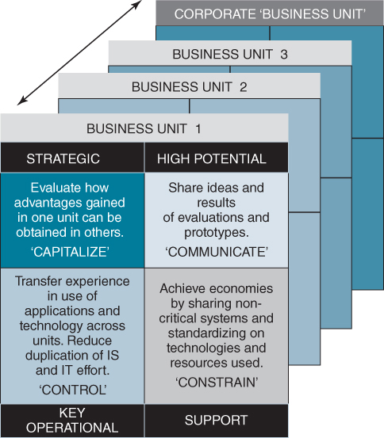
FIGURE 8.8 Portfolio management in a multi-business unit organization.
In Figure 8.8, the term constrain in the support segment implies corporate scarce resourcing for applications that are not unique in any of the units. Control is suggested for key operational applications to reduce unnecessary diversity over time to enable both a reduction in costs through effective resource use and the development and sustaining of expertise in application operation and use. Capitalizing on strategic application success requires some (business) central planning across the units to determine whether and how the same benefits can accrue across the organization. Finally, while any corporate ‘interference’, however well intended, can stifle innovation in the units, sharing knowledge of new technology, its capabilities and limitations – by ensuring the results of R&D work are made available to others – could increase the speed of exploitation and reduce wasted effort. The communication facilitation is probably best established at the corporate IT centre, via a Project Management Office (PMO) or similar unit.

Summary
This chapter has tried to demonstrate the rationale behind adopting an application portfolio management concept as a core framework within the development and management of IS/IT or digital strategies. The basic 2×2 matrix model has been explored from a variety of perspectives to identify the potential advice and guidance it can offer business and IS/IT managers in defining, selecting and implementing the variety of applications required by the organization. While not all the advice is identical – after all, it has been derived from many sources – it is never contradictory and the patterns that emerge are generally consistent. It must be remembered that a simple model cannot reflect the full complexity of the IS/IT strategic management environment, but it does allow much of the complexity to be analysed to enable the issues and alternative solutions to be understood better.
We have also tried to show that managing the portfolio of IS/IT application assets is similar to managing other business assets, such as products and customers and therefore lessons can be transferred from those areas, which are more familiar to business managers. All products in the product portfolio do not make the same contribution to business success or performance, likewise customers, and they need to be segmented according to those contributions if they are to be managed and invested in appropriately.
It follows that, due to the variety of approaches needed to deal with the implementation of applications in the different portfolio segments, the organizational governance and management of IS/IT is inevitably complex. It is not just a matter of having policies and standards that ‘define how things will be done’. The discussion above can help inform guidelines and policies that balance discretion and compliance, but adoption in practice requires leadership, not just from IS/IT management but also senior business managers. It also requires IS/IT professionals and line managers to use their experience and judgement to ensure that the policies enable rather than inhibit the value derived from the investments.
The following chapters address the organizational aspects of ensuring that good practices are adopted and sustained. In particular, Chapter 9 considers how different types of investments are justified, prioritized and evaluated. Chapter 10 then discusses IS/IT governance as well as IS/IT organizing structures, capabilities and competences, before Chapter 11 looks at managing the technology infrastructure services and sourcing strategies required to enable the applications to be provisioned and operated successfully.

Endnotes
1. See R. Kumar, ‘Information technology portfolio management: literature review, framework and research issues’, Information Resource Management Journal, 21, 3, 2008, 64–87.2. See P. Weill and A. Johnson, Managing the IT Portfolio: Where did Infrastructure Go? Research Briefing, Centre for Information Systems Research, Massachusetts Institute of Technology, Boston, December, 2005.3. E.M. Daniel and J.M. Ward, ‘Improving the business-IT relationship with IT project portfolio management’, Cutter IT Journal, 28, 1, 2015, 20–24.4. Based on the work of M.J. Earl, Management Strategies for Information Technology, Prentice-Hall, Englewood Cliffs, New Jersey, 1989; M.J. Earl, ‘Experiences in strategic information systems planning’, MIS Quarterly, 17, 1, 1993, 1–24; M.J. Earl, ‘Information systems strategy … why planning techniques are not the answer’, Business Strategy Review, 7, 1, 1996, 54–67; and N.F. Doherty, C.G. Marples and A. Suhaimi, ‘The relative success of alternative approaches to strategic information systems planning: an empirical analysis’, Journal of Strategic Information Systems, 8, 1999, 262–283.5. J.M. Ward, ‘Information systems and technology: application portfolio management—an assessment of matrix-based analysis’, Journal of Information Technology, 3, 3, 1988, 205–215.6. F.W. McFarlan, ‘Portfolio approach to information systems’, Harvard Business Review, 59, 5, 1981, 143–150. See also McFarlan's later article on using the portfolio in the content of the governance of IT, R. Nolan and F.W. McFarlan, ‘Information technology and the board of directors’, Harvard Business Review, October, 2005, 1–10.7. G.L. Parsons, Fitting Information Systems Technology to the Corporate Needs: The Linking Strategy, Harvard Business School Press, Boston, Teaching Note 9-183-176, 1986.8. R. Simon, ‘Control in an age of empowerment’, Harvard Business Review, March–April, 1995, 80–88.9. M.J. Earl, ‘Experiences in strategic information systems planning’, MIS Quarterly, 17, 1, 1993, 1–24; and N.F. Doherty, C.G. Marples and A. Suhaimi, ‘The relative success of alternative approaches to strategic information systems planning: An empirical analysis’, Journal of Strategic Information Systems, 8, 1999, 262–283.10. E. Daniel, J. Ward and A. Franken, ‘A dynamic capabilities perspective of IS project portfolio management’, Journal of Strategic Information Systems, 23, 2014, 95–111.11. For more on these issues, see C. Soh and S.K. Sia, ‘The challenges of implementing “vanilla” versions of enterprise systems’, MIS Quarterly Executive, 4, 3, 2004, 373–384.12. D. Partington, S. Pelligrinelli, M. Young, ‘Attributes of programme management competence: and interpretive study’, International Journal of Project Management, 23, 2, 2005, 87–95.13. J. Procaccino, J. Verner and S. Lorenzet, ‘Defining and contributing to software development success’, Communication of the ACM, 49, 8, 2006, 79–83.14. E. Malmsten, E. Portanger and C. Drazin, Boo Hoo: A Dot.com Story from Concept to Catastrophe, Random House UK, 2002.15. H. Tanriverdi, A. Rai, and V. Venkatraman, ‘Research commentary – reframing the dominant quests of information systems strategy research for complex adaptive business systems’, Information Systems Research, 21, 4, 2010, 822–834; and Y. Merali, ‘Complexity and information systems: the emergent domain’, Journal of Information Technology, 21, 4, 2006, 216–228.16. For more information about types of development methodologies see: D. Avison and G. Fitzgerald, Information systems development: methodologies, techniques and tools, 4th Edition, McGraw-Hill Higher Education, Maidenhead, UK, 2006.17. S. Maklan, S. Knox and J. Peppard, ‘Why CRM fails – and how to fix it,’ MIT Sloan Management Review, 52, 4, 2011, 77–85.18. However, it is not always clear how these best practices are identified: see G. Piccoli, Information Systems for Managers, John Wiley and Sons Inc, USA, 2008.19. Achieving the Benefits from Software Package Enabled Business Improvement Programmes: Best Practice Guidelines, The IMPACT Programme, London, 1998; J.M. Ward, C.J. Hemingway and E.M. Daniel, ‘A framework for addressing the organisational issues of enterprise systems implementation’, Journal of Strategic Information Systems, 14, 2, 2005, 97–119; and J. Peppard and J.M. Ward, ‘Unlocking sustained business value from IT investments: Balancing problem-based and innovation-based implementations’, California Management Review, 48, 1, 2005, 52–70.20. See for example: M.L. Markus, S. Axline, D. Petrie and C. Tanis, ‘Learning from adopters' experiences with ERP: Problems encountered and successes achieved’, Journal of Information Technology, 15, 2000, 245–265.21. J. Peppard and J.M. Ward, ‘Unlocking sustained business value from IT investments’, California Management Review, 48, 1, 2005, 52–70.22. M.L. Markus, S. Axline, D. Petrie and C. Tanis, ‘Learning from adopters’ experiences with ERP: Problems encountered and successes achieved', Journal of Information Technology, 15, 2000, 245–265.23. T.H. Davenport, Mission Critical: Realizing the Promise of Enterprise Systems, Harvard Business Press, Boston, MA, 2000.24. J.M. Ward, C.J. Hemingway and E.M. Daniel, ‘A framework for addressing the organisational issues of enterprise systems implementation’, Journal of Strategic Information Systems, 14, 2, 2005, 97–119; J.M. Ward and A.Uhl, ‘Lessons learned from the business transformation case studies’, in A Handbook of Business Transformation Management Methodology, ed. by A. Uhl and L. Gollenia, Chapter 12, 265–285, Gower Applied Research, Farnham, UK, 2012; D. Marchand and J. Peppard, ‘Why IT fumbles analytics’, Harvard Business Review, January–February, 2013, 104–112; and D. Marchand and J. Peppard, ‘Is paradigm paralysis choking your IT Investments?’, MIS Quarterly Executive, forthcoming, 2016.25. M.B. Mohdzain and J.M. Ward, ‘A study of subsidiaries’ views of information systems strategic planning in multinational organizations', Journal of Strategic Information Systems, 16, 2007, 324–35.

UNIT 9
JUSTIFYING AND MANAGING INFORMATION SYSTEMS AND TECHNOLOGY INVESTMENTS

OUTLINE
- ♦ Investment and Priority Setting Policies
- ♦ Justifying and Evaluating IS/IT Investments
- ♦ Justifying Business Applications
- ♦ Justifying Infrastructure Investments
- ♦ Assessing and Managing Investment Risks
- ♦ Managing the Portfolio of Investments
- ♦ Setting Priorities amongst IS/IT Investments
- ♦ Organizational IS/IT Portfolio and Investment Management Maturities
The future IS/IT investments an organization intends to make are likely to be of many different types including various business applications and new infrastructure, plus probably significant enhancements to (or replacement of) existing systems and technology. Before funds are allocated, resources are assigned and development, acquisition or provisioning begins, several steps need to be taken, including establishing the expected benefits, costs and risks of the technology and business changes involved and assessing their relative priorities. Normally such investments and changes are managed through projects or programmes and the focus should be on evaluating all that is involved in the projects, not just the IS/IT components, as they should really be considered as business projects involving IS/IT.
The decisions involved in these steps can all be aided by understanding the new investments in the context of the overall application portfolio and the types of contributions expected from them in relation to current and future business strategies. Investment appraisal, setting priorities and delivering the benefits expected are key ingredients of successful IS/IT strategic management and governance. Otherwise, any strategy will become distorted over time by inconsistent, even arbitrary, investment decision making.
This chapter considers some of the main issues relating to decision making and management of IS/IT investments and ways of addressing them:
- justifying investments in business applications and the associated technology, using various approaches to assessing expected business value;
- managing the investment and the associated risks based on the characteristics of the application, technology and project involved;
- setting priorities and managing the portfolio of investments, taking into account the range of economic, strategic and other types of business benefits plus resource constraints and dependencies.
The previous edition of this book included a description and discussion of the Benefits Management approach developed from our research and which is now used by many organizations. Since then, the approach and many other aspects of managing the benefits from investments have now been covered in depth in the ‘sister’ book to this one: Benefits Management: How to Increase the Business Value of Your IT Projects, by John Ward and Elizabeth Daniel.¹ As a result, this chapter only includes a brief overview of the approach (see Box 9.1). Readers should refer to this other book for a detailed description of the Benefits Management rationale, processes, tools, techniques and examples, which show how organizations can increase the benefits delivered through using the proposed approach.²
However, some findings from our studies into current practices in IS/IT investment management which were, in part, based on the Benefits Management rationale are discussed in this chapter. These studies included two international surveys providing a total of over 250 responses.³ The responses from both surveys were remarkably similar, the second survey reinforcing the findings from the first. As a result, we were able to split the organizations involved into two distinct groups – the more successful with over 50% of their projects delivering the expected benefits and the less successful which included those in which less than 50% of projects delivered the benefits, plus those who did not know. In both surveys exactly 43% were in group one and 57% in group two!
Key differences between the two groups are discussed throughout the chapter but, as shown in Table 9.1, at the highest level, differences in management satisfaction with investment management practices show why some are much more successful than others. It does also show a) the relatively low levels of satisfaction for these practices in most organizations and b) that post-implementation investment evaluation and review is the factor that differentiates the two groups most. The overall levels of satisfaction with both business case development and benefit identification are about 30%. It is not surprising that this is very similar to the percentage of IS/IT projects deemed successful in our research and many other studies over the last 30 years.⁴
TABLE 9.1Overall practice satisfaction for the two groups
Practice | Average management satisfaction – more successful group | Average management satisfaction – less successful group
Portfolio management | 49% | 33%
Business case development | 44% | 19%
Identifying and quantifying benefits | 44% | 20%
Identifying and quantifying costs | 69% | 46%
Evaluation and review | 36% | 7%
Portfolio management is concerned with the evaluation, selection, monitoring and ongoing adjustment of a set of investments, in this case IS/IT projects and programmes, to achieve defined business results within funding and resource constraints. The reason for taking a portfolio perspective of IS/IT investments is to evolve from making individual investment decisions in isolation to a situation where value delivered from the total set of investments is optimized. Moreover, it emphasizes that investment selection and prioritization are not one-time events but a process that demands continual review and adjustment in response to changing business and economic conditions.⁵

Investment and Priority Setting Policies
Investments in information systems and technology compete with alternative investments such as buildings, plant, equipment, research and development (R&D) and advertising, for funding. IS/IT investments have traditionally been evaluated like capital projects such as plant and equipment, assuming a fixed cost offset against net revenue over the life of the application. However, many IS/IT investments are now more like ‘new business ventures’ or business initiatives where the financial aspects of the outcome can only be guessed and the technology is only one component of a major change programme. Increasingly organizations do consider IS/IT investments within the overall business investment or project portfolio, although many never actively compare the value of IS/IT options with other business investments.
There is no simple answer to the question: how should IS/IT investments be assessed against other investments? If an organization was able, at any one time, to make all the IS/IT investments demanded by business users, inconsistent evaluation would not really matter. The overall return on investment might be poor, but at least the worthwhile would get done as well as the worthless! However, in most cases not all demand can be satisfied and priorities must be set. If no consistent justification approach is followed, the more beneficial investments may well be deferred, allowing those that make a lesser contribution to proceed. Assuming that does not mean an opportunity completely forgone, which may occur with delay, the resources and funds invested will have provided a poorer return than could have been achieved – hardly good management practice!
An obvious conclusion from the above is that the same principles and practice should govern the ‘go/no go’ decisions for individual investments and deciding priorities amongst projects competing for funds and resources. The only additional factor, assuming that they are not sequentially dependent, is the amount of ‘limiting’ resource consumed. The limiting factor is normally either funds or people, in quantity or quality (particular skills or knowledge): priority setting should enable the maximum return from the use of that limiting resource.
The issues and challenges associated with the justification and evaluation of IS/IT investments, in general, are considered before discussing the arguments for funding business applications and infrastructure.

Justifying and Evaluating IS/IT Investments
Much has been written about how investments in IS/IT should be assessed, but most of that considers the ex-ante justification of proposed investments rather than the ex-post evaluation of the business value delivered from the investments. Even then there is little, if any, consensus on how IS/IT investments should be justified, but there is a consensus that the methods used frequently are often inappropriate! Our research shows that in over 90% of large organizations, some form of business case was required to justify the funding of IS/IT investments, but in only 59% was this subjected to a formal investment appraisal. Overall, organizations stated they are far from satisfied with the techniques and processes they have for IS/IT investment appraisal. Although over 90% of organizations use business cases, satisfaction levels with their effectiveness are quite low: around 60% felt that they were valuable in gaining funding approval, but less than 40% were satisfied that the case identified the appropriate benefits, secured commitment to deliver the stated benefits or was a sound basis for reviewing the benefits realized at the end of the project.
Others⁶ have suggested that, given the wide variety of types of IS/IT investment and the increasing range of benefit types, which can be quantified to greater or lesser degrees, a multiplicity of methods for justifying investments is needed. But they also recognize that selecting the right approach in any situation can itself be fraught with organizational and political problems. Farbey, Land and Targett provide a detailed assessment of the range of issues involved and how different approaches to justification can accommodate them. Some studies referenced suggest that traditional financial analysis techniques are still commonly in use, but that organizations are finding it increasingly difficult to use them as the types of benefit available become less easy to quantify adequately. Other authors⁷ suggest ways in which different techniques can be used to evaluate different types of application development or infrastructure investments.
Our surveys also revealed that nearly 40% admitted they often overstated the benefits in order to gain approval. This is not a new phenomenon – Grindley⁸ summed up the mistrust of conventional justification methods in two insights from his research:
- 83% of IT directors admit that the cost–benefit analyses supporting IT investment proposals are a fiction.
- A quote from a CEO: ‘It's like there is a spontaneous conspiracy to exaggerate the benefits.’
Many others have made similar observations about the reliability of the cases made for investment. Strassmann has written, perhaps cynically, that ‘the approval of a proposed investment is only the starting point for a continually widening gap between the stated objectives and the capacity to deliver results’.⁹ However, it is clear from studies elsewhere that this issue is not peculiar to IS/IT investments. According to Lovallo and Kahneman,¹⁰ management do not generally demand rigorous evidence to support major investment decisions, which can lead to ‘delusional optimism’, due to an overestimation of the benefits and an underestimation of the costs of achieving them.
As discussed above, there are different types of IS/IT investments and they are made for different reasons, not merely economic ones. A pure technology investment cannot strictly give a return on investment, unless it replaces an older technology and carries out the same functions more efficiently. Most such investments are justified on the back of applications. Even when capacity and infrastructure components have to be purchased in advance of the need, the justification should be primarily based on their subsequent use in business applications and the resulting benefits. However, it is difficult to justify all infrastructure investments based on the financial benefits of future applications. Alternative approaches to developing the case for investing in infrastructure are considered later in the chapter.
Another problem which makes accurate financial appraisal difficult is estimating the ‘life’ of the application or technology. How long it will remain in use, before being replaced, is difficult to predict. Many applications have a life of many years, during which they are enhanced or amended, but are still contributing benefits to the organization. Most accounting evaluation practices are conservative, expecting the worst and mistrusting the best, and it is normal to assess the return over a relatively short period, even when evaluating systems with 5, 8 or 10-year lives.
Equally frequently, the full costs of the investment are not included. Normally, the procurement costs for hardware, software licences and purchased services are included in some detail, and the costs of internal IS/IT resources are often counted too. But the costs incurred by business departments in specifying, testing and implementing the system are rarely treated adequately. Even less often included in business cases are the costs of making the business changes essential to realizing the benefits. Given that other research suggests that these ‘hidden complementary investment costs’ can be up to five times the cost of the technology,¹¹ this is a major inadequacy of many business cases. However, from our surveys almost 60% of organizations are satisfied with how the costs are included in business cases, although many of them only include direct or ‘out of pocket costs’ – which, of course, means fewer benefits are needed to justify the investment!

Financial Appraisal of IS/IT Investments
Despite the many problems with including accurate data in financial appraisals, many organizations have a strong or even exclusive focus on the financial returns from IS/IT investments.¹² While the aim of any business case should be to express as many of the benefits as possible in financial terms, an exclusive focus on such benefits can result in a number of issues, for example:
- ‘creative’ calculations of financial benefits based on inadequate evidence;
- making unrealistic assumptions that enable sufficient financial benefits to be claimed to provide the necessary return in relation to the costs;
- only declaring enough of the available financial benefits to offset the expected cost of the technology;
- lack of innovative uses of IT since the financial benefits of innovation are likely to be less certain;
- a focus on purely efficiency gains from IT, which improve individual processes, but often at the expense of overall organizational effectiveness;
- minimizing the costs of the technology either by reducing functionality, especially that which is not deemed immediately essential (e.g. integration of processes or information resources);
- understating the organizational costs of implementation, such as process redesign, training and changes to structures and roles.
Even if these limitations are understood and addressed so that the financial information in the business case is acceptably accurate, there are still alternative ways of calculating the economic value of the investment. How this is done can also effect the decisions made, both for a particular investment and more importantly when making decisions on alternative investments. In this section the strengths and weaknesses of the most commonly used alternatives are considered:
- Payback. The payback method calculates how long it is expected to take to recover the original investment. It is very simple to calculate and does measure the financial exposure for the organization. But it does not take into account the timing of cash flows or the cost of financing the investment over time or the value accruing after the payback period is over. It is a simple test of whether the organization is willing to ‘risk’ the original investment.
- Accounting return on investment (ROI). Based on the expected life of the investment, the overall average return is calculated as a percentage, which can be compared with alternative investments of the same funds such as the interest on a deposit account. It is a simple calculation which can be used to test whether the investment is above a minimal ‘hurdle rate’, but it makes no allowance for the timing of cash flows and cannot be used to compare different investments. By using a ‘standard life’ for all investments, such as three years, the latter issue can be addressed to some extent.
- Discounted payback. This is similar to simple payback but allows for the reducing actual value of the cash flows over time by applying a discount rate (a negative interest rate) to the future years to represent them as present values. This tends to reduce the benefits relative to the initial costs, but enables the calculation of comparable payback periods for different investments, irrespective of the timing of the cash flows. It therefore overcomes some of the limitations of simple payback.
- Discounted cash flow – internal rate of return (IRR). In this case a range of discounted rates are applied to find the rate that produces a break-even over the life of the investment – the higher the IRR the better the investment. This is a more realistic assessment than simple ROI, but is not valid when comparing different investments, since it assumes that the IRR calculated can be obtained by reinvesting the net benefits elsewhere, which is not always feasible.
- Discounted cash flow – net present value (NPV). A rate of discount is selected to apply for all investments, as with discounted payback, and the net result of applying this to the cash flows over the investment life produces the residual value of the investment or ‘net present value’ – the higher the better. This is a good way of both deciding on investments and comparing alternative uses of funds, but does not allow for the different financial exposures of investments of significantly different sizes, e.g. £5 million versus £100,000.
- Discounted cash flow – profitability index. When comparing investments this is an improvement on NPV, which overcomes its limitations in comparing investments of different sizes. The NPV for the project is calculated as before, but it is then divided by the cost of the original investment to produce a percentage which is the profitability index for the project. This can be compared across projects of different initial costs to identify those which provide the highest values from the funds available.
Of course all these are dependent on reliable cost and benefit data, but with each of them sensitivity or ‘what if’ checks can be carried out on elements that are considered less certain. Some newer techniques based on ‘Real Options’ can be used to calculate the potential values and set priorities for investments where many of the costs and benefits are, as yet, uncertain. These are discussed in the sections on justifying infrastructure investments and setting priorities.

Classifying IS/IT Investments: in Terms of How they Can be Justified
One conclusion from the earlier discussion is that there are different types of IS/IT investments and they cannot therefore be justified in the same way. We have demonstrated in earlier chapters that the application portfolio is one such classification and it is discussed again later in this chapter. There are other approaches to classification that are also helpful in management decision making. Some of these focus on the different types of benefits that are expected and others are more associated with the role of IS/IT in the business. In all cases it can be argued that the approaches are designed to provide evidence to support the benefits that can be expected or explain why the benefits claimed are likely to be delivered.
Following the many expensive misadventures into e-business during the dot.com boom of the early 2000s and overestimation of the value of many ERP, CRM and other large enterprise system programmes, it now appears that at least in some organizations senior management are requiring better evidence of the business value they can expect from their organization's IS/IT investments.¹³ There is also greater understanding that those benefits are not generic but depend on the context of the organization.¹⁴ Identifying and quantifying the benefits can be a difficult task, as many organizations admit, but it is a factor that differentiates the more successful organizations from the less successful as shown in Table 9.2. This evidence suggests that the confidence management have in the extent and viability of the benefits does affect whether or not the business case is approved.
TABLE 9.2Business case effectiveness (from our surveys)
In addition to obtaining funding, preparation of a business case often or always… | More successful group | Less successful group | Total
Identifies all available benefits | 50% | 27% | 37%
Gains commitment from the business to realizing the benefits | 64% | 44% | 53%
Attains an ROI above a required hurdle rate | 56% | 33% | 43%
Establishes appropriate measures for the benefits | 36% | 17% | 25%
Adequately quantifies the benefits | 47% | 21% | 32%
Overstates the benefits to get approval | 25% | 46% | 37%
As a result, what % of business cases are approved? | 78% | 44% | 58%
Parker, Benson and Trainor¹⁵ suggested ways in which information and systems benefits accrue as a basis for how they can be quantified to help in justifying investments. They consider three main types of application:
- Substitutive – technology replacing people, with economics being the main driving force, to improve efficiency. These are very similar to most support and some key operational applications.
- Complementary – improving organizational performance, productivity and employee effectiveness by enabling work to be performed in new ways; again overlapping with key operational and some strategic applications.
- Innovative – achieving a competitive edge by changing trading practices and business relationships, creating new markets etc., as with many strategic applications.
They then suggest ways in which each of the different types of application should be justified and define five basic techniques for evaluating benefits:
- Traditional cost–benefit analysis, which allows for efficiency improvements in organizational processes and individual tasks, resulting from automation (e.g. energy companies installing smart meters to reduce labour costs associated with direct reading of meters).
- Value linking, which estimates the improvement in business performance, not just savings made, from improving the linkages between processes or activities (e.g. automatic reconciliation of orders, invoices and payments to enable accounts staff to spend more time resolving customer queries and issues, leading to fewer bad debts and less dissatisfied customers).
- Value acceleration, which considers time dependence of benefits and costs in other areas of the organization of system improvements (e.g. giving sales data to buyers on a daily basis, improving their ability to respond to changes in demand and negotiate more effectively with suppliers). This implies that benefits can occur in other parts of the business, not just where the system is actually implemented.
All of these can be benefits of each of the three types of application, whereas those below refer mainly to the complementary or innovative applications.
- Value restructuring, which considers the productivity improvement resulting from process and organizational change and change of job roles (e.g. information-intensive tasks such as forecasting and planning can often only be improved by a combination of better information and a change in organizational responsibilities).
- Innovation evaluation attempts to estimate the value to the business of new business models or new business practices leveraged from IS/IT (e.g. the launch of a mobile banking service to change the company image, to attract new types of customers as well as provide a better service to existing ones).
By analysing costs and benefits using these techniques, the authors suggest that the overall ‘economics’ of an application can be assessed. The ideas are certainly more creative in interpreting information's long-term value than traditional accounting views of IS/IT investments. Others have argued similarly for considering the ‘transformational’ uses of IT, producing benefits through process re-engineering, redefining business relationships and even changing the scope of the business.¹⁶
Ross and Beath¹⁷ identify four types of IS/IT investments which deliver different types of benefits:
- Renewal – to replace outdated infrastructure or applications to reduce costs or overcome obsolescence, which should deliver clear financial benefits or obviate specific business risks.
- Process improvement – ‘low risk’ investments to improve performance of existing processes, which should be justified by ‘provable’ outcomes of changing how the processes are carried out.
- Transformation – investments to support a new business model, which will be complemented by significant changes in the organization and the IS/IT investment cannot be justified in isolation from these other changes.
- Experiments – investments in learning about new IS/IT-based opportunities or potential new business models. These are essentially the same as high potential investments in the applications portfolio when considering funding and prioritization.
A number of other authors have derived their rationale for IS/IT investment mainly from alignment with the organization's business strategy. For example, Tallon and colleagues¹⁸ suggest there are essentially two types of investments aligned to the organization's competitive focus, either operations or market, of which one will be more important than the other at any time. Operations focus implies reducing costs, improving quality, effectiveness and speed of processes, whereas market focus involves extending the firm’s geographical or customer reach and changing industry or market practices. This approach seems to be heavily organizationally biased and says little about the potential benefits that can accrue at the team or personal level. A slightly more balanced perspective is provided by Weill and Aral¹⁹ who consider the types of ‘assets’ that are created as a result of IS/IT investment and the different types of benefit they can deliver. They suggest four types:
- Transactional IT assets, which are typically used to cut process costs or enable increases in volume hence delivering a lower unit transaction cost.
- Informational IT assets, which are mainly used to provide information to managers and communication and analytical capabilities.
- Strategic IT assets that enable advantages to be gained by supporting entry into new markets or creating new products, services and processes.²⁰
- Infrastructure IT assets are those that are shared by many applications, which can lead to reduced costs through consolidation and a flexible base for future business initiatives.
In a similar vein, Curley²¹ argues that each investment business case can consist of business value benefits which can be of many types and ‘IT efficiency’ benefits resulting from the provision of more efficient technologies and new capabilities, rather like the infrastructure IT assets discussed above. Whilst this is important in justifying investment, it can become a more significant factor when setting priorities across investments in order to maximize the overall return.
There are many more variations on these classifications, but the issues raised by them all are similar to those which arise when using the application portfolio to understand and then manage a portfolio of investments that deliver different contributions to the organization. These and how they can be addressed are considered later in the chapter.
No matter how investments are classified and whatever types of benefits they are expected to deliver, there are a number of issues which need to be addressed to increase the likelihood that sufficient benefits will be achieved to justify making the investment. Table 9.3 lists the top 10 factors from our survey that differentiated the more successful from the less successful organizations. Many of these (*) are concerned with the development of the business case or the evaluation of the investment after implementation, the latter only being possible if the initial investment justification was based on a realistic assessment of the expected benefits.
TABLE 9.3Top 10 most differentiating practices between the more and less successful organizations (Note: all these differences are statistically significant)
Top 10 factors differentiating the more successful from the less successful organizations | Less successful (<50% project success) | More successful (>50% project success) | Difference
1 Transferral of lessons learned* | 32% | 73% | 41%
2 Quantification of benefits* | 14% | 52% | 38%
3 All benefits identified* | 19% | 56% | 37%
4 Organizational change evaluation and review | 30% | 62% | 32%
5 Overstating benefits to obtain funding* | 51% | 22% | -29%
6 Benefits delivery planning | 19% | 45% | 26%
7 Organizational change planning | 21% | 44% | 23%
8 Benefits delivery evaluation and review* | 39% | 62% | 23%
9 Use references sites to identify and quantify benefits* | 24% | 45% | 21%
10 Use external benchmarking to identify and quantify benefits* | 16% | 35% | 19%
As mentioned at the start of this chapter, a Benefits Management approach is used by many organizations to address these common issues in identifying and realizing benefits. A brief overview of the main steps in the process is given in Box 9.1. Examples of business cases based on the Benefits Management rationale and resulting from use of the tools and techniques can be found in other publications by the authors.²²

BOX 9.1

Benefits Management overview
Benefits Management is defined as: ‘The process of organizing and managing such that potential benefits arising from the use of IT are actually realized’.
The rationale for this and other benefits management approaches involves treating IS/IT investments as business projects, in which both business and IS/IT stakeholders need to jointly plan and manage the implementation of technology alongside the necessary business changes required to leverage business value from these investments. Without those changes, an organization will not obtain many of the benefits enabled by the investment in IS/IT assets and resources. Such business changes include both process changes in the flow of work and information, as well as organizational changes required to create and institutionalize the new ways of working.
The approach requires active, integrated business and IS/IT management attention throughout the IS/IT investment life cycle. Developing this ability within an organization also requires bringing together knowledge from many specialist areas such as change management, risk management, project management, systems development, investment appraisal and portfolio management. To help organizations focus on benefit delivery from their investments, the benefits management process was introduced in 1996 to complement existing good practices and methods in implementing IS/IT investments. The process and the associated tools and techniques have been further developed by working with organizations in many sectors in the following years.
The process model accommodates a life cycle emphasis that includes not only pre-investment appraisal and post-investment evaluation, but also how organizations can actively manage the claimed benefits towards realization. It draws on models for managing strategic change as well as on Total Quality Management approaches. It consists of five stages organized in an iterative process as shown in the figure below.
The first stage of the process involves creating the initial business case and an understanding of the changes needed to make the investment successful. This means agreeing the investment objectives and how they link to the organization's strategy, identifying the potential benefits and the changes needed to realize each of them. It also includes identifying the main stakeholders' commitment to both achieving the benefits – ‘what's in it for them?’ – and their ability and willingness to undertake the changes needed to realize each benefit. Ownership of each of the benefits and changes should be assigned to an appropriate business manager. This is achieved by developing a Benefits Dependency Network (BDN) that brings together the knowledge of the key stakeholders to create a network that shows how each of the benefits will be delivered through a combination of IS/IT and business changes – see the example below of part of a BDN developed for a marketing project. It also identifies accountable individuals for making each of the changes associated with each benefit as well as evidence of achievement.
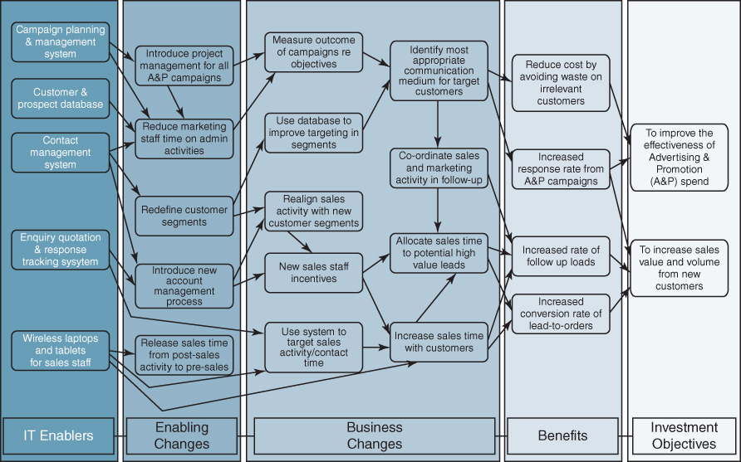
The second stage, planning the implementation, focuses in more detail on the specific actions required to achieve each benefit. This means ensuring that the technology delivery is synchronized with the organization's ability to exploit it successfully. The business case defines how each benefit will be measured and provides evidence for the expected level of improvement that will result from the changes. This step includes making an assessment of the accompanying cost (technical and non-technical) required to realize these benefits. It also includes an assessment of the financial, technical and organizational risks of the investment, including a detailed stakeholder analysis to identify further actions needed to overcome potential resistance that would jeopardize the project. As a result of the risk assessment, both the business case and implementation plans may need revision.
The third stage in the benefits management process is to implement the benefits realization plan, as an integral part of the project plan. The final steps are to evaluate and review the results of the IS/IT investment. This consists not only of assessing the value delivered, but also includes identifying and transferring lessons learned, defining actions to recover any missed benefits, and identifying further potential benefits that could now be achieved.
The key differences between the Benefits Management approach and more traditional implementation approaches are also shown in the figure below.
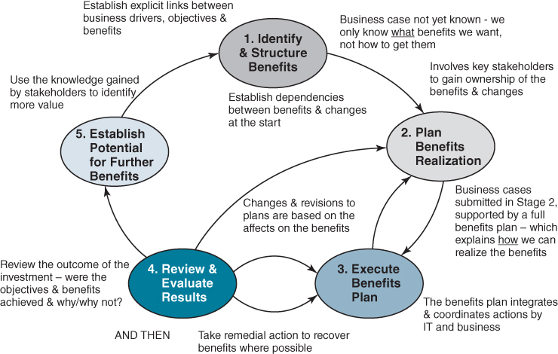
The Benefits Management Process Model and the key differences between the Benefits Management approach and more traditional approaches to IS/IT investment management.

Justifying Business Applications
Although it is important to quantify and express in financial terms as many of the costs and benefits as possible, it is simply not feasible to express all the benefits in financial terms, and it serves no useful purpose to develop spurious calculations to quantify the unquantifiable! Most organizations require business cases, in which as many aspects as possible are expected to be expressed financially, and have ‘gateway’ or ‘stage-gate’ and review processes to assess the investment at key points in the life cycle. As more is known, more can usually be interpreted and expressed in financial terms, but some benefits will always prove difficult to legitimately translate into money.
What is important is to base the assessment of application investments on the overall nature of the contribution they are expected to deliver to the business. The application portfolio segments can offer help in making such judgements. Since the rationale for implementing applications or investing funds and resources in each segment of the matrix is different, the justification ‘rules’ should allow for these differences. The arguments used to justify a prototype system to model and predict customer online buying behaviour are not the same as those used to justify a replacement of the general accounting system. Equally, the response to a competitor's new delivery tracking service, which is causing customer attrition, and a decision to consolidate data from disparate applications to enable the use of analytics are based on quite different types of benefits.
The risks and consequences of failure in the various segments are also different. This can be allowed for by requiring a higher predicted rate of return where the risk is higher, although this may in turn merely lead to creative accounting for the benefits! It is perhaps better to analyse the inherent nature of the risks and take appropriate action to deal with them, as far as possible, as will be outlined later in this chapter.
In essence the application portfolio approach suggests that:
- Quantified, financial justification of applications is easier in the key operational and support quadrants, where most aspects of the application will be better known.
- A singular approach to investment justification will tend to produce one type of application to the exclusion of others. This argument is particularly strong where a scarce resource approach has been adopted and pure financial return on investment decides investment priorities; in such scenarios, support applications will always be easier to justify financially than strategic ones.
Figure 9.1 highlights some of the key points to be considered in the justification of applications in each segment.
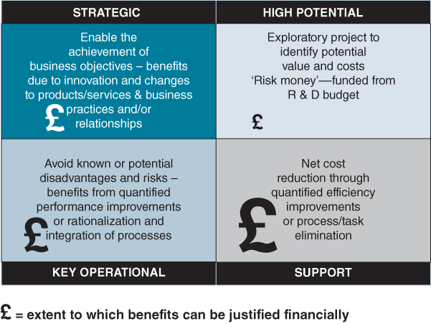
FIGURE 9.1 Some key differences in the main arguments for investment in each segment.

Support
The main purpose of support application investments is improving efficiency, which should be possible to quantify and convert into a financial argument. Additional justification may revolve around technology obsolescence and staff productivity/time saving. The latter may be difficult to identify accurately in advance and therefore to quantify. In this segment, it is reasonable to expect potential benefits to be estimated before resources and costs are incurred to identify the most economic solution within the benefits achievable.
Again, if a new application is competing with others for a limited resource, then a support application must show a good economic return for the allocation of that scarce resource. If, however, the project can be carried out within the user department's control and budget and requires no other resources, then it is reasonable that the ‘go/no go’ decision is made by local user management. The IS/IT investment is an alternative use of funds to other investments locally and is not competing with alternative use of scarce IS/IT resources. It is to be hoped that user management will expect the case to be argued in predominantly financial terms, but if not that is their responsibility.
In summary, assuming a scarce resource strategy is being adopted ‘centrally’ for most support applications, any allocation of that resource should be argued primarily on economic, return-on-investment grounds. At the same time, some discretion can, without great risk, be left to local management via a free-market strategy.

Key Operational
While, as far as possible, all costs and benefits of a new development, replacement or major enhancement of a key operational system should be subjected to a financial evaluation, this may not allow for all the arguments involved. The most economic solution in the short term may not be the most effective over the long term, given the role such applications play in the core business processes. This is the area for a strict ‘feasibility study’ to find the best solution from a range of alternatives, each with differing costs, benefits and risks.
The business may suffer a serious disadvantage if a key operational application fails or becomes inadequate in terms of matching the business needs as they evolve. It might be worth spending more to achieve a more adaptable or integrated solution that not only meets the current needs more effectively, but also makes it easier for future strategic applications to be developed. Normally, this will increase the cost and make the overall benefits difficult to express financially. An argument often used to support a business case is ‘what will happen to the business if we do not invest in improving this key operational application and associated processes?’ and therefore ‘can we afford the risk of not doing it?’
The implementation strategy that works best for key operational applications is monopoly, which implies a central control and vetting of all applications and enhancements. This enables a standard checklist of questions to be considered in the justification of any new project. Factors that are important (other than economic return) from either a business or IS/IT perspective can be allowed for and, if necessary, changed over time. The monopoly approach should also avoid implementing solutions based solely on economic expediency rather than long-term business benefits, although it may mean that a particular application costs more in the short term.
In conclusion, it should be stressed that, for key operational investments, the business unit management should be the final arbiter. It is their business that will suffer by lack of investment and they should (provided they can afford to pay) be allocated the necessary resource to meet such systems' needs. It is clearly untenable to allow competitive disadvantages to develop due to lack of investment in IS/IT. Many of the examples of systems failing in recent years (e.g. at NatWest Bank or United Airlines) usually occurred because of the lack of investment in key operational applications.

Strategic
The fact that an application is deemed strategic implies that unless the investment is made, the organization will be unable to achieve some aspects of its business strategy. Obviously, it is important to cost the investment and, where possible, put figures to the potential benefits, even if the latter are only ranges or orders of magnitude, not estimates suitable for a discounted cash flow calculation. However, some reasons for proceeding are likely to remain primarily non-financial – expressed as the business opportunity that is being created or the business objectives that the application specifically addresses.
The strategy most appropriate for this part of the matrix is central planning, whereby IS/IT opportunities and threats are being considered along with the business issues and strategies. Hence, an application will get the ‘go/no go’ decision based on how directly it relates to the business objectives and particular strategies. The benefits will derive from achieving those objectives by enabling the required business changes or innovation, not from the IS/IT application investment alone. Whether this will actually happen is partly a question of luck (that the target does not move), partly of judgement (the quality of business acumen of senior managers) and partly good management of the application development and associated business changes.
A key issue is whether the management team, steering group or whoever makes such decisions is unified in endorsing the project and that the ‘organization’ deems the investment worthwhile. The critical factor is then resourcing the task sufficiently to achieve the objectives in the optimum timescale. This may need repeated senior management intervention to ensure that both user and IT resources are made available. The budget for such investments and financial control of actual expenditure should perhaps reside with the steering group, rather than line managers or IS/IT, to ensure that progress and resourcing are centrally monitored as well as planned.

High Potential
The very essence of high potential investments is that the benefits are unknown and the objective is to identify the possible benefits and how they could be achieved. They should be justified on the same basis as any other type of research and development (R&D) investment, and preferably from a general R&D budget rather than IS/IT funds. In practice, where the money comes from – R&D budget or IS/IT or user budgets – is important, but not critical. What does matter is not pouring money down the seemingly bottomless pit that R&D can become, if not properly monitored. It must be remembered that many high potential ideas tend to arise informally based on individuals' creative thinking, rather than from formal planning, and it is important not to stifle creativity through excessive bureaucracy. However, many of the ideas simply will not work! Some control is essential to avoid significant waste of resources.
The idea of ‘product champions’ being responsible for such projects, given a budget against agreed general terms of reference to deliver results or otherwise, is the most effective way of initiating and managing the high potential stage in application life cycles. No investment should stay in this segment for too long or have too much money spent on it. When initial allocations are used up, further sums have to be justified based on the evidence of the possible benefits, not just allocated in the vague hope of eventual success. Some organizations fund projects in this quadrant in much the same way that venture capital companies fund start-ups.
This approach fits the leading-edge and free-market strategies for the experimentation and assessment that high potential applications need. However, it should be obvious that those responsible for ensuring that central planning works for strategic applications must be aware of what is being evaluated in the high potential segment and by whom and over what timescale.
The above approaches to application justification in the various segments may lack the precision ideally required. But, this is no more than is true of other investments in research and development, advertising, reorganization, building new plant or facilities, or launching new products and services. IS/IT investments should be considered just as objectively and just as subjectively as other business investments.

Justifying Infrastructure Investments
The main aims of investments in infrastructure technologies are to enable the business applications to perform successfully and create appropriate capabilities for the general-purpose use of IT tools in the short and medium term and to anticipate, as far as possible, longer-term but uncertain organization and business needs. Unlike application investments where the costs can usually be offset against specific business benefits, the business benefits of infrastructure investments are often difficult to identify and use to justify the costs of the technology.
Defining IT infrastructure and its components is becoming more difficult as technology evolves and becomes increasingly a business utility. Perhaps the best definition is ‘the enabling base of shared IT capabilities which provide the foundation for other business systems’.²³ Some authors²⁴ include ‘services’ in the IT infrastructure. The costs of some infrastructure investments will include the provision of services, and in many cases it is the associated services that enable benefits to be realized from the technology. Increasingly, organizations are outsourcing the provision of both infrastructure and associated services, partly to substitute operational expenses for capital investment and reduce the risks of making inappropriate investments by buying incrementally. It also removes the need to have scarce technical expertise in-house.

Linking the IT Infrastructure with the Business Strategy
In response to business drivers influencing the infrastructure investment needs, such as cost-effectiveness, agility, remote working, globalization and employee productivity, there will usually be a number of specific IT objectives to be met, for example:
- Provide sufficient integration and consistency to minimize costs, provide resilience and enable internal and external connectivity.
- Facilitate user productivity by proving desktop and remote access to a wide range of software applications and information resources and adequate capacity and bandwidth for their effective use.
- Reduce complexity and non-standardization to ensure responsiveness to organizational change and development and enable staff mobility.
- Be able to accommodate major changes such as mergers, acquisitions and divestments without excessive costs and business risks.
- Be compatible with other organizations in the industry to be able to take advantage of IS/IT innovations and developments in the industry and communications with suppliers and customers.
However, it may not be possible, for financial, technical or human reasons, to be able to provide an ideal infrastructure at any given time. At best, the technology infrastructure can evolve at the rate demanded by the business and IS plans, but, if necessary, these plans may have to be modified to a rate determined by the evolution of technology or the economics of acquiring and using it.
Managers responsible for planning, developing and managing the infrastructure are expected to provide a continually improving and expanding service to the business, in response to the demands of the business strategy and organizational evolution. Additionally, they need to keep abreast of new and emerging technology and current competitive usage of IT, and put forward suggestions as to how technology might be deployed to gain advantage or create new business options. Two particularly enduring problems of IT infrastructure management, in combination, create a number of difficulties in justifying significant infrastructure investments:
- It must be developed as a base for future, uncertain use of applications rather than merely matching current business functionality (i.e. keeping ahead of the needs).²⁵
- It is difficult to define the value derived from IT infrastructure (i.e. it is seen as a cost).
Renkema²⁶explores these issues and potential ways of addressing them in some detail from the operational and strategic perspectives, arguing that both need to be considered for most investments. Therefore, it is important to link infrastructure development and investment as explicitly as possible to relevant parts of the business strategy, even if this has to be ‘indirect’ via applications and people using the infrastructure. Most organizations can identify current business problems that would result from inadequate infrastructure, but it is more difficult to foresee the future problems that would result from failure to invest in its development. One media company, having to make major IT investments as the business moved from print to online, required ‘benefits maps’ (of the kind referred to in Box 9.1) to be produced showing how new infrastructure supported applications and other changes in IS/IT use and the benefits they provided or were expected to deliver. Those in turn had to show how their benefits were contributing to business objectives and strategies. These maps enabled business managers to understand the likely consequences of infrastructure investment decisions.

Building the Infrastructure Business Case
Infrastructure contributes to the delivery of business benefits in a number of different ways and the justification of expenditure, either for procurement of capital items or purchasing software licences or network or hardware capacity from third-party suppliers, needs to be presented on the basis of the particular contributions being made. These can be described under five headings as depicted in Figure 9.2.
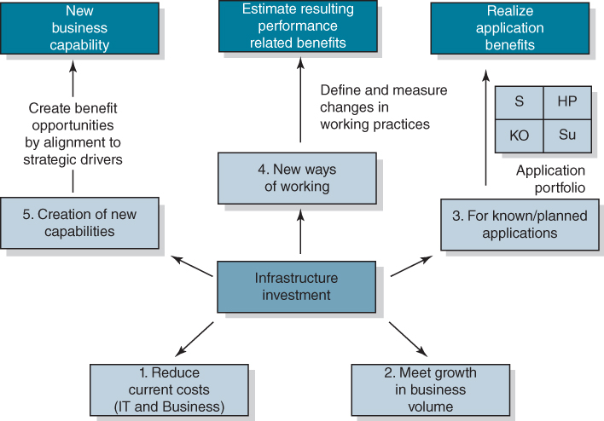
FIGURE 9.2 Arguments to justify infrastructure investments.
- To reduce business and IT operating costs of running and supporting existing applications by using more cost-effective technology. This includes personal productivity tools and communications. The justification will mainly depend on cost savings, usually in the IT budget, but there may be direct business cost savings, especially by providing lower cost communications, for example desktop video conferencing and VoIP (Voice over Internet Protocol). Included in this category is the ‘forced’ need to replace a technology that is or is becoming obsolete or unsupported (‘burning platforms’). As with any technology investments that involve supporting existing applications, it is prudent to question whether each application is still necessary to the business. If it is, then unless it can be migrated to another existing technology, the choice is usually either:
  - redeveloping or buying a newer version of the application;
  - identifying the essential functionality of the application and buying or developing a replacement application that meets the reduced needs.
- To enable or even create growth in the volume of business. This case may be reflected in increased transactions, both internal and external, or the changing mix of transactions (e.g. more customers buying online). However, the growth in transaction volume may be due to changing business practices rather than genuine business volume increases. Customers are tending to move to just-in-time satisfaction of requirements and more single-line ordering rather than consolidating purchases – causing further increases in internal transactions – but still expect rapid response and high service levels. In combination, these create increasingly high peak loads as well as overall increases in transaction volumes to achieve the same value of business. At the same time, more information is being transferred in many of the transactions (e.g. in the form of multiple large attachments to emails, complex images and video), requiring significant bandwidth, processing and storage capacity increases. In terms of benefits, it is important to consider three different types of argument for increased capacity:
  - To deal with increased business activity (i.e. real growth), which leads to increased revenue.
  - To accommodate the changing mix of transaction types, which should be offset by savings to be made elsewhere. The increasing move to electronic as opposed to paper transactions should (but does not always) produce cost savings associated with printing and paper handling.
  - Due to increasing use of capacity for purely internal activities. Whether this is of net benefit to the organization needs to be determined in terms of the changes in business practices that result. For example, centralizing corporate information on an Intranet can produce reduced costs and benefits due to accuracy and consistency, provided its content is managed effectively. However, if every user is still extracting and storing the information they require, demands for increased network and server capacity are not justified costs.
- New or planned applications. Some infrastructure costs can be justified in part on the basis of the benefits delivered by applications that will use it. Then the relevant costs should form part of the business justification for those applications. This implies demonstrating the links between the planned application developments and the infrastructure required to enable them. This can be done using techniques such as the ‘benefits maps’ mentioned above, which are variants of the Benefits Dependency Network concept,²⁷ showing infrastructure components as the enablers of the applications, business changes and benefits.
- New working practices. These are usually deliberate changes, but are sometimes emergent or informal changes to improve practices which can then be extended and built on, based on the observed benefits that have resulted. Such changes may be associated with specific applications, in which case the benefits should be related via the application to the associated infrastructure. However, increasingly, changes in processes and practices can be made via the use of the infrastructure without major application investment. For example, using messaging services and social media to keep sales and service staff up to date with issues or even news affecting the company, so that no one need be uninformed when talking to customers.
Another significant area of potential benefit is associated with knowledge sharing within and across organizations. Although knowledge sharing is driven by people not technology, communities of interest and/or practice²⁸ – the main organizational conduit for knowledge sharing – work best when the management encourages and facilitates their development and provides the necessary resources, including technology.²⁹ Again, where new infrastructure is put in place to enable organizational knowledge management, for example knowledge centres, discussion forums and online meeting facilities, the resulting benefits can and should be specifically identified and measured. Equally, findings from other research³⁰ suggest that ‘workforce agility’ or organizational flexibility, to respond quickly and effectively to changes in the marketplace, is increased by the provision of a consistent, high-quality, integrated IT infrastructure supporting all users and all applications.
- To create a new business capability, that is essential for the future business strategy – either an explicit strategic intent or a particular strategic initiative. While the details of how the intent will best be met may as yet be unclear, an obvious connection between the IT infrastructure identified and aspects of the strategy can often be made. For example, an energy company stated that one of its strategic intentions was ‘to become location independent’, enabling its technical and professional staff to perform their jobs wherever in the world they happened to be. This was the main justification for a major investment in network capacity and portable workstations, although benefits in other categories, such as new working practices and volume growth, were also identified and delivered.
In the UK, the concerted move to e-government – the electronic access and delivery of government services to the public and others – led some local authorities to justify the major IT investments required as an integral part of their future strategies. The argument was that the IT infrastructure is, over the long term, a replacement for the traditional infrastructure of local government – offices and other service buildings at hundreds of sites across the authorities' geography. As the infrastructure to enable online access and mobile working by professional staff is extended, savings in the operating costs of existing offices and other buildings are used to offset the IT costs. The reduction in these traditional delivery channels is then planned and implemented to realize the savings as early as possible, and the net cost reduction achieved is continuously monitored by both management and the elected councils.
Some authors have proposed the use of Real Options Analysis to address the inherent uncertainties in investments in IT infrastructure, especially in the last of the categories above. (For further explanation of the use of Real Options in the context of IS/IT investments see Box 9.2.) Sandberg and collaborators have proposed the concept of digital options when considering investments in IT capability and present a digital options life cycle.³¹ Bulasubramarian and colleagues³² have developed a formal methodology based on real options to evaluate and compare different IT infrastructure investments along with other alternative investments. Their experience in using the approach is that it not only influences the outcome of the decision but also improves understanding of how to align business drivers with the capabilities that can be developed from an appropriate IT infrastructure. This is likely to be increasingly important as more aspects of IS/IT, for example ERP software suites, become part of the infrastructure, either purchased as an integrated set or provided by technology and services suppliers.

BOX 9.2

Using ‘Real Options Analysis’ in justifying and prioritizing IT investments
Often the benefits from strategic applications and infrastructure investments are uncertain and depend on future events, making justification and priority setting especially difficult. To address this issue, it has been suggested that a version of ‘real options analysis’ is more appropriate for assessing and prioritizing some major IS/IT investments, especially strategic applications and large infrastructure investments.ª Essentially, an option is the right, but not the obligation, to act at some future date. The choice whether or not to act is dependent on specific situations occurring in the future, but it is usually uncertain as to which of the potential situations will actually happen. By taking an option (i.e. making an IT investment today), the possibility is provided to take some action(s) in the future when less uncertainty exists.
While many writers have shown how real options can be used to make investment decisions, the approach is more helpful in making choices among investment options available. The approach is best used for large, strategic, key operational or infrastructure investments where future uncertainty can be expressed in terms of a range of scenarios with different probabilities of occurring, over different timescales. These can then be prioritized in terms of the potential value of the investments, the downside risk of not investing and when a decision will have to be made. The assessment should include a clear understanding of the further knowledge required to be able to decide on any option. It is then possible to estimate how much is worth investing to obtain further knowledge by, for example, experimenting with a new technology, to get a better estimate of the potential value or reduce the future risk of a particular option. This is very similar to carrying out a high potential evaluation, although the rationale for doing so is primarily financial.
Working with a mid-sized Austrian auto-parts manufacturer, Taudes et al.^{b} applied real options to the problem of deciding whether to migrate from SAP ERP system R/2 to a new version R/3. Even though the initial set of applications to be run under R/3 were the same as currently running under R/2, the real options analysis demonstrated that the future opportunities to introduce applications based on workflow management, document management and e-commerce justified the introduction of R/3. The higher implementation costs could be related to higher future benefits and the additional value provided by R/3 could be explained. Using similar opportunity analysis, Maklan and colleagues^{c} show how decisions about whether and how to invest in a CRM system can be made more objectively using a real options approach, in spite of the uncertainties associated with anticipating future customer behaviours.
Notes:
ªA number of writers have suggested how this might be done. See for example: A. Taudes, ‘Software growth options’, Journal of Management Information Systems, 15, 1, 1998, 165–185; M. Benaroch and R.J. Kauffman, ‘A case for using option pricing analysis to evaluate information technology project investments’, Information Systems Research, 10, 1, 1999, 70–86; M. Benaroch, ‘Justifying electronic banking network expansion using real option analysis’, MIS Quarterly, 24, 2, 2000, 197–225; P. Cornelius, A. Van Der Putte and M. Romani, ‘Three decades of scenario planning in Shell’, California Management Review, 48, 1, 2005, 92–109; R.G. Fichman, M. Keil and A. Tiwana, ‘Beyond evaluation: ‘options thinking’ in IT project management’, California Management Review, 47, 2, 2005, 74–96; and M. Benaroch, M. Jeffery, R.J Kauffman, and S. Shah, ‘Option-based risk management: a field study of sequential information technology investment decisions’, Journal of Management Information Systems, 24, 2, 2007, 103–140.
^{b}A. Taudes, M. Feurstein and A. Mild, ‘Options analysis of software platform decisions: A case study’, MIS Quarterly, 24, 2, 2000, 227–243.
^{c}S. Maklan, S. Knox and L. Ryals, ‘Using real options to help build the business case for CRM investment’, Long Range Planning, 38, 2005, 393–410.
Overall, any infrastructure investment should be assessed against all of these five criteria to identify the contribution, if any, it is expected to make in each and the direct or indirect benefits that should be realized. This reflects the need for organizations to consider their IT infrastructure more as a business capability than merely a utility, or cost of doing business, in order to link the investments in technology with creating or achieving the business strategy. Outsourcing of IT infrastructure and service provision does not absolve management of the responsibility for defining its role in the strategy or justifying the investment involved.

Assessing and Managing Investment Risks
As part of the appraisal of investment viability, it is essential to assess the potential risks: the risks both of failing to deliver anything at all and, more commonly, of failing to deliver some or all of the benefits. Surveys already mentioned suggest that up to 70% of IS/IT projects fall into one of these two categories and in many cases this was due to inadequate assessment or management of the risks involved.
In the case of abandoned projects – those that delivered nothing at all – a study by Ewusi-Mensah and Przasnyski³³ concluded that economic and technical factors were not major factors in contributing to management decisions to abandon projects before completion. Most were abandoned due to organizational factors such as loss of management commitment and political and interpersonal conflicts (i.e. these are serious areas of potential risk in a project). Interestingly, for the majority of projects they studied, of which 40% were considered ‘strategic’ and 60% were ‘urgent’, 85% were not seen as high risk at the start and 64% were expected to deliver considerable benefits. There have been many recorded examples of abandoned projects in both public and private sectors. In recent years, perhaps the most publicized has been the BBC's Digital Media Initiative (DMI), which was scrapped in 2013 and wasted nearly £100million.³⁴ Its characteristics generally fit the profile of other failures in the earlier study and in particular the lack of agreement about its scope, why it was strategic and the specific benefits it would deliver.
In another example, in 2000, the US Federal Bureau of Investigation (FBI) launched a project to automate its case management. What was initially conceived as a mere upgrade of an obsolete system turned out to be an entirely new endeavour – the Virtual Case File (VCS). At the beginning of 2003, the FBI required an additional investment of roughly $149 million, but the complexity of the changes introduced during development had produced a badly structured and unmaintainable system. The project was finally cancelled in 2005.³⁵
Studies of project failures (which included some more very expensive abandonments) and the problem areas that caused few if any benefits to be achieved and/or projects to be significantly late or overspent, suggested the main causes were more organizational than technical.³⁶ Not surprisingly, one of the ‘classic mistakes’ was ‘insufficient risk management’ and the majority of the risks not considered or addressed were associated with managing stakeholder interests and organizational change.³⁷ In many cases risks are assessed at the start of the project, but inadequate actions or contingencies are put in place to deal with them. Equally, risks that emerge during the project are not always identified and addressed. Recent studies have suggested some reasons why risks are not managed effectively including managers believing they either will not happen or are outside their ability to control, and, perhaps more importantly, admitting the project has risks suggests a lack of competence or poor management.³⁸
A large pharmaceutical company introduced project ‘health-checks’ to assess the continuing viability of investments, in terms of whether the expected benefits would be delivered. These health-checks particularly focused on how known risks were being addressed and whether new or emergent risks had arisen and needed to be dealt with. The checks were mandatory and carried out by peer level project specialists not involved in the project under the auspices of the Project Management Office (PMO). In this and many other organizations the PMO plays an important role as an ‘independent risk assessor’, thus overcoming some of the issues mentioned above and enabling knowledge of risks, their causes and resolutions to be shared across projects. Comprehensive and practical sources of understanding the causes of risks, frameworks for assessing IS/IT project risks and approaches to managing them can be found in Jordan and Silcock³⁹ and, for business projects in general, the UK's Office of Government Commerce publication Management of Risk: Guidance for Practitioners.⁴⁰ Most investment appraisal and project management methodologies also have tools and techniques for assessing and analysing risks.
From a business or investment management perspective, the risks can be considered under three main headings:
- Technical risks are those associated with the chosen technologies and suppliers and their ability to deliver the functionality, resilience and performance required. Whether the organization has the internal knowledge, skills and required infrastructure, and is using the most appropriate process to implement the technologies, must also be considered. Approaches to assessing and then managing technical risks, and risks associated with processes of development and implementation, are built into most systems development and implementation methodologies via risk registers.
- Financial risks concern the predictability of the costs and confidence in the financial benefits. Such risks can be estimated by conducting sensitivity checks on the financial case, assuming higher costs and reduced or delayed benefits. As mentioned above, other techniques including scenario planning and real options analysis can be used to compare the relative financial risks of alternative investments.
- Business change and organizational risks include the capability of the organization, and in some cases external stakeholders, to carry out the enabling and business changes that are essential to realize each of the benefits. A ‘capability analysis’⁴¹ plus detailed assessments of stakeholder perspectives and concerns is the most effective way of taking action to reduce organizational risks, mitigate their effects or adjust the scope of the project to avoid them.
A checklist of the main risk factors under each of these headings, derived from a review of the risk management literature, is shown in Figure 9.3. The factors have been included in the category where they are likely to have the most impact, but clearly many will have secondary effects in the other categories. For example, the longer the duration of the project, the more likely it is that key personnel will change, new requirements will emerge and resources will be required for other projects. The shading in Figure 9.3 shows how it can be used to show significant known risks requiring action (darker blue), potential risks that should be monitored (lighter blue) and aspects which appear not to be risky in this project (very pale blue). In practice, red, yellow and green traffic light coding is normally used.
Technical risk factors | Financial risk factors | Business Change and Organizational risk factors
Complexity of the system functionality | Size of the investment | Senior Management commitment to the project
Technical novelty – to the organization and the supplier | Project duration | User commitment of resources and knowledge
The number of system interfaces and systems being replaced | Degree of confidence in all the elements of project cost | Stability of the organization and key staff
Certainty and stability of the business requirements | Confidence in the evidence for the investment benefits | The extent of changes to business processes and practices
Technical skills of the project team | Appropriateness of project cost control mechanisms | The number of departments, functions and business staff involved and affected
Business knowledge of the project team | Reliability of external suppliers' estimates and enforceability of contract conditions | The degree to which organizational and role changes are needed to realize the benefits
The degree to which formal methodologies and standards are adopted | Rate of change of the external environment | Other change initiatives which will affect the same areas of the business
The extent of changes needed to the IT infrastructure | The business criticality of the areas affected by the system | Existing change management capability and experience
The degree to which the system can be prototyped or piloted | Dependence of the benefits on other projects | Existing user IT and information skills and knowledge of 'how the business works'
FIGURE 9.3 Checklist of the most commonly significant risk factors in IS/IT investments.

Variations in Risk Patterns for Different Types of Application Investments
The table in Figure 9.3 can be used for assessing risks of all types of IS/IT investment, although some of the business change and organizational risks may not be applicable to many infrastructure projects. All, however, can apply to application investments, but the balance and mix will vary across the different types in the application portfolio.
High potential investments are, by definition, high risk and the risks are mitigated by controlling the time and costs allowed for the evaluation. This usually implies a limit on the scale or scope of the evaluation. It has to be accepted that in many cases the right outcome of the evaluation is not to proceed further, due to technical, financial or organizational risks being too great.
Strategic investments normally involve significant innovative change and the implementation of new ways of conducting business or using resources. Neither the costs nor the financial benefits can be predicted with certainty at the outset. The IS/IT requirements and business changes will evolve as it becomes clearer how the benefits can be best achieved and perhaps some potential benefits will prove impossible to deliver. If deploying new technology is integral to the project success, this, in turn, will introduce additional risks. Therefore the number of risk factors across all three categories is likely to be high.
Key operational investments are normally undertaken to improve existing essential processes and systems. Technical risks should be reduced by using established, proven technology, as far as possible. However, many key operational applications are complex and have multiple interfaces to other systems. The strict application of systems development, quality assurance and project management methodologies, including risk registers, is needed to ensure that the system design and operational performance meet the business needs. Any financial risks should be relatively low, since the expected benefits should be financial or quantifiable and the costs associated with known technology should also be relatively easy to determine. However, such investments often require significant simplification of processes, resulting in widespread changes to organizational roles and responsibilities and the development of new skills and/or performance measures. Since these investments are at the core of the business, changes have to be carefully controlled to avoid deterioration in performance during the implementation.
Support investments are intended to improve organizational efficiency and eliminate unnecessary costs. Given that the benefits should be achievable using proven technologies, the investments should be relatively low risk. However, the achievement of many of the benefits will rely on changing and standardizing organizational practices to make effective use of the technology available. Many of the efficiency savings rely on individuals or groups changing their ways of working, and changes may also result in reducing the number of staff required. Consequently, the main risk factors are organizational, due to the unwillingness of some users to change their previous ways of working and concerns about the loss of jobs.
Figure 9.4 summarizes these differences.
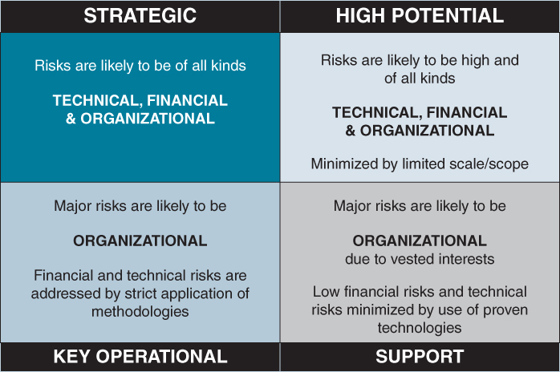
FIGURE 9.4 Summary of the variation of risks across the portfolio.

Managing the Portfolio of Investments
The majority of IS/IT investments are managed as projects or programmes and hence IS/IT portfolio management shares many characteristics with Project Portfolio Management (PPM). Several definitions of PPM exist, each emphasizing a different aspect. For example, the Association of Project Management⁴² defines PPM as ‘the selection and management of all of a firm's projects, programmes and related business-as-usual activities taking into account resource constraints’. The UK Office of Government Commerce⁴³ adopts a more process perspective: ‘[PPM] is a corporate, strategic level process for coordinating successful delivery across a firm's entire set of programmes and projects.’ The UK's National Audit Office⁴⁴ definition emphasizes the aspects of prioritization and strategic alignment: ‘Prioritisation of all a firm's projects and programmes in line with business objectives and matched to its capacity to deliver them.’
Our research suggest that about 90% of organizations perform some form of PPM for their IS/IT investments, but only 40% of those are satisfied with how well they do it. Interestingly, there is an equal split between those who perform PPM for all projects, including IS/IT, and those who restrict it to IS/IT projects alone. Our studies showed no significant difference in satisfaction levels in the two groups. Looking at the different themes in PPM in more depth, the reasons expressed for doing PPM and the levels of satisfaction in achieving each purpose, in our surveys, are shown in Table 9.4.
TABLE 9.4Purposes of PPM and levels of satisfaction with performance
Reasons for doing PPM | % giving the reason | % satisfied with performance
Align project objectives to business strategy | 92% | 60%
Avoid overcommitment of (limited) resources | 87% | 53%
Set priorities across different types of investments | 82% | 62%
Maximize the benefits of the whole portfolio | 70% | 38%
Balance risks across different types of investment | 39% | 34%
Notwithstanding their good intentions, the majority of organizations appear to fall short of using project portfolio management effectively to maximize the business value they achieve from their collections of IS/IT investments. This is consistent with findings from other studies in terms of both why organizations adopt PPM and those aspects that they believe they address effectively. More recently, our in-depth study of five organizations' approaches to PPM suggested that the financial crisis of 2008 increased the importance of IS/IT PPM. Even greater emphasis was being placed on linking investment explicitly to the business strategy and making more effective use of decreasing funds and other resources as business uncertainties increased and economic conditions deteriorated.⁴⁵ Priority setting was becoming increasingly difficult compared with more stable times and maximizing the overall benefits and balancing risks were still proving problematic for most of the organizations.
PPM has long been recognized as an integral component of IS strategic planning. For example, Earl⁴⁶ argues that IS strategic plans should be treated as portfolios that ‘consider the trade-offs [of] risk and return … and the allocation of IS resources’.
PPM approaches have aspects in common with financial portfolio management, such as balancing risk and reward, but there are also significant differences that make PPM, and especially priority setting, particularly challenging including:
- the constraints on certain resources (e.g. experienced project managers);
- the difficulty and costs of stopping ongoing projects for reasons that include ‘escalation of commitment’;⁴⁷
- the wide variety of project types, both applications and infrastructure and dependencies amongst them;
- the difficulty of identifying and valuing many of the benefits and accurately attributing both costs and benefits to specific investments.
Our studies suggested three areas which organizations found problematic in managing the portfolios:
- How many projects to include and on what criteria to base that decision. Too many projects and the portfolio becomes unmanageable, too few and resourcing decisions can become meaningless. Most organizations base the threshold for inclusion on financial value, but this can produce a plethora of projects just under the limit that reduce the availability of resources. The answer seems to be to consider the resources first and ensure the portfolio includes the use of at least 80% of the resources to be allocated.
- Whether to include future planned investments as well as current ones or those now being assessed through the authorization process. This really depends on the planning horizon of the portfolio and the normal duration of the projects. Many organizations try to limit project durations or at least project-phase durations to 12–18 months, within a 2–3 year planning horizon, to reduce risk and provide the flexibility to change priorities if necessary. This, however, is one reason that research by us and others shows that introducing portfolio management can result in a shorter term focus. This may be more appropriate in times of business and economic uncertainty.
- Mixed portfolios of projects and large multi-project programmes can be problematic, especially if the large programmes are fully authorized as a single investment and effectively pre-empt the prioritization process by appropriating or ring-fencing resources, making them unavailable to other projects. This can cause ‘game-playing’: projects are accumulated into or become attached to larger programmes to exclude them from being compared with others for priority purposes. Again to avoid this, some organizations only look at priorities in terms of resource allocation for the near future, often 3 to 6 months, and do not pre-allocate or assign resources to anything that starts after that – this of course means resetting priorities at least every 3 to 6 months!
In general, the greater the confidence senior managers have in their business strategy, the calibre of governance group members and the ability of business users and IT professionals to deliver the projects successfully, the easier it is to make priority decisions that everyone understands. This is a critical indicator of an organization's maturity of regarding how it plans and manages IS/IT.

Setting Priorities amongst IS/IT Investments
It is important to introduce a consistent, practical approach to priority setting if any strategy is to be implemented successfully. Short-term business pressures will change, projects will not proceed as planned, resources will not be available as expected, and new opportunities and requirements will emerge. Each of these can cause changes to priorities and, unless a consistent rationale is employed, ‘crisis management’ will repeatedly override the strategy. Priorities need to be set in the short term to enable the best use of resources within the acquisition lead time for further resources, assuming these are actually obtainable. They also need to be set within the context of the longer-term business strategy or investments which create new business capabilities may never be resourced, because the payback is uncertain or too far off. Priority setting is at the core of effective strategic management of IS/IT – selecting the best investments to pursue and, perhaps even more importantly, those to defer or abandon. Box 9.3 describes the priority setting process at a European logistics company.

BOX 9.3

Establishing priorities at a European logistics company
A European logistics company established a cross-functional decision-making process to support both business prioritization and IT resource allocation for IT development requests. The figure below illustrates the process they designed.
A ‘Demand Review Board’ (DRB) prioritized incoming requests for IT development work cross-functionally. The DRB consisted of Managing Directors (MDs) from all business areas in the region (e.g. Marketing, Finance and Engineering). They prioritized based on criteria such as strategic value, business process impact, economic value, and business and IT risks. An IT development work justification template was specifically designed to summarize the relevant information for each request in a standardized, thus consistent, format. The agreed-upon prioritized list of requests would then be passed on to the Supply Review Board (SRB) for a further systems architecture and resourcing feasibility review.
Business area: A generic term for an organizational unit. The DRB/SRB process dealt with all business projects with IT implications. Ideas could originate from any functional department (e.g. Marketing) or any operational unit (e.g. hub operations at CDG airport in France) in the region.
Business representative: The business person who was in charge of completing and submitting an IT development justification document.
Business sponsor: Someone, at minimum an MD-level person, who could sign off the submission of a request for expenditure releases. If required, he/she would help the business representatives with their justification documents.
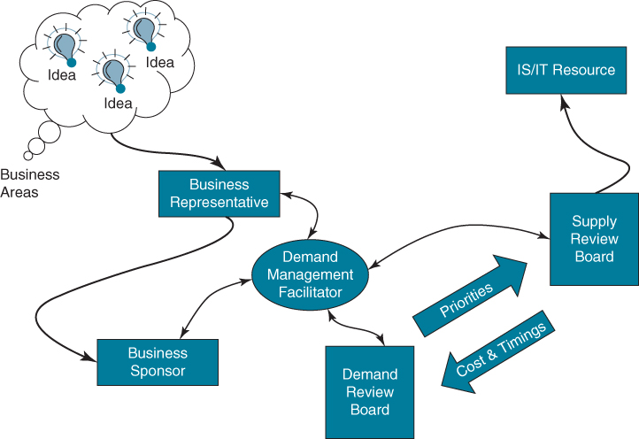
Demand management facilitator: A senior person from IT who would collect all justification documents from the different business areas, and prepare, organize and chair the DRB meetings.
Demand review board: The DRB was expected to meet at least monthly. It was chaired by the Group CIO. The DRB was asked to reach an agreement on a single prioritized list of IT development requests. This list would then be handed over to the SRB for the required feasibility and resource allocation review.
Supply review board: The SRB consisted of the MDs from all the countries and the members of the Technical Architecture Advisory Board (TAAB). The SRB would review the prioritized list of requests handed down from the DRB. The SRB informed the DRB members on the expected costs and timing for realizing the IT work. This also included feedback on the systems impact of the proposed solutions. The DRB could then adjust their priority list accordingly.
There are many variants on portfolio approaches to assessing priorities across investments, but almost all are based on what the organization is capable of doing and the relative risks versus rewards of current and potential investments. This implies three factors need to be included in any assessment of priorities:
- What is most important to do, based on the identified benefits.
- What is capable of being done, based on the resources available.
- What is likely to succeed, based on the risks of failure of each investment.
In our research around 80% of organizations considered the first of these; i.e. priorities were set based on ‘desirability’ factors or the rewards expected, including:
- alignment with the business strategy;
- return on investment;
- functional or business unit operational priorities to avoid disadvantages.
Most (60%) also included the ‘size’, usually meaning cost or duration, of the investments to avoid committing to one large project and precluding carrying out a range of smaller projects, which is a consideration of both capability and some aspects of risk. However, the less successful organizations did not take into account other factors associated with the capabilities needed or risks of intended investments, i.e. ‘feasibility’ factors. Those commonly included by the more successful organizations, but not by the others, were:
- balancing the risks across different investment types (commercial, technical and financial);
- availability of infrastructure;
- the use of shared resources;
- project interdependencies;
- IS/IT skills and business resources and knowledge available.
In summary, the more successful organizations in delivering benefits from IS/IT investments considered both desirability and feasibility factors when setting priorities, i.e. reward and risk, whereas the less successful mainly considered desirability and paid little attention to feasibility, i.e. reward but not risk. It was one of the core reasons that many of them were relatively unsuccessful: they selected too many investments that could not be delivered successfully.

Setting Priorities across the Different Types of Investments in the Portfolio
Figure 9.5 combines reward/risk dimensions⁴⁸ with the contents of the application portfolio plus infrastructure investments. In practice, most portfolio management approaches consider all IS/IT investments, not just applications, and, from the portfolio models that include them, infrastructure investments are usually considered as similar to or the equivalent of key operational application investments. New infrastructure, of itself, cannot deliver competitive advantages or achieve business objectives, but it may be essential for the development of applications that will (Chapter 11 picks up on this point again). As before, many relative priorities will be due to application and infrastructure interdependencies
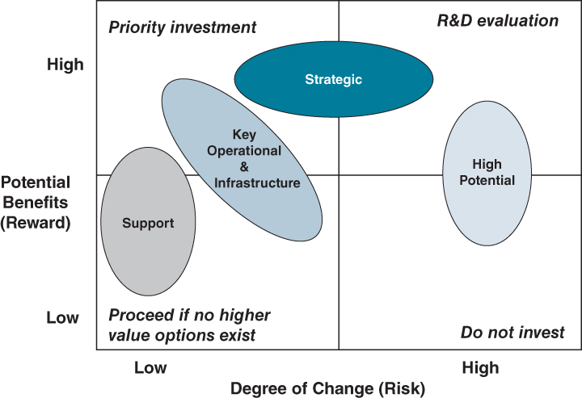
FIGURE 9.5 Risk/reward and application portfolios combined.
Source: Adapted from Jeffrey and Leliveld.
Most other models we have seen are variants on these two views, classifying investments in terms of a combination of the expected contribution and feasibility of achievement. Many of the organizations that we have studied have found that categorizing or classifying investments into different types is very helpful in enabling management to visualize the pattern of investments and in raising the discussion from the level of individual projects to the overall portfolio.⁴⁹
To complement the earlier parts of the chapter, the discussion that follows uses the application portfolio categories to exemplify the options and issues in priority setting across IS/IT investment types.
Given that the rewards and risks of investments are relatively similar within each segment of the application portfolio, setting priorities within a segment (i.e. support, key operational etc.) is not too difficult. After ranking the investments on similarly expressed benefits, the priorities will be modified by assessing the expected use of funds and/or resources to maximize the potential return from available resources – sometimes known as ranking by profitability index, when the benefits are largely financial. Resources usually implies specialist IS or IT staff as they are normally the constraining factor, but in some cases it could be business specialists, although these are likely to constrain options for one or two applications rather than several. Finally this ranking should be modified by consideration of the risks affecting each project to ensure that not just high-risk projects are tackled, which could result in nothing being achieved! Risk can then be included either as contingencies in time, cost and resources, or by reducing the expected benefits, or in some cases both, and then the priorities recalculated.
Within the support segment, setting priorities is relatively straightforward. Those with the greatest economic benefits that use the least resources should get the highest priority. This will encourage users to express benefits financially and look for resource-efficient solutions, like software packages or provisioning applications from the cloud, to obtain a priority. Most organizations are experienced in delivering support applications and, consequently, they tend to be relatively low risk. The main consequence of failure is money wasted rather than significant business disadvantages, hence the final ranking should allow for the relative financial risks of the investments.
At the other extreme, for the strategic segment, the main rationale is to give priority to those investments that will contribute most to achieving business objectives, and use the least resources in the process. To assess this, many organizations use some form of simple decision matrix in assessing the relative strategic contribution of different investments against a weighted scale (of 1–5, for instance) or ranked business objectives (High, Medium, Low for example) and then describing the degree to which the potential investment is relevant to achieving each of the objectives (often H, M, L again). It produces a ‘score’ or value for each potential investment based on the level of expected contribution to the business objectives. Like all decision support tools, it should not be used mechanistically: a score of 25 is not necessarily better than 24; it means they are about equally important. Again, by dividing the ‘score’ by the amount of resource – funds or people – required, the relative contribution from the capability available can be maximized, especially in the short term. Once more the relative risks of each investment can be used to modify the ranking by considering the likelihood and severity of the identified combination of financial, technical and organizational risks.
In some cases the strategic application investment is only one, perhaps minor, part of a larger business strategic initiative or transformation programme, which sets the priority for the IS/IT part based on the criticality of the initiative in achieving its expected contribution to the business strategy.
Setting priorities among key operational applications and most infrastructure investments is more complex than support, but involves less uncertainty than strategic applications. The arguments for (i.e. main benefits of) will essentially be based on some or all of the following:
- expected financial return;
- achieving specific business objectives (either directly or by enabling other developments);
- risks to current business performance addressed by the investment – including regulatory compliance;
- new capability through infrastructure improvement.
Each of these benefit areas must be given some form of ‘preference weighting’ in a similar way to strategic investments, but based on the current business situation, to decide the preferred mix of benefits before looking at resource constraints. Then, the costs and/or resources used by each project should be compared against its cumulative importance across each of the four categories to establish overall priorities. Applications scoring highly in all four categories are obviously higher in priority than those scoring highly in one, two or three categories, and those at similar levels in the ranking using fewer resources should get priority. It is a subjective method, but it does allow for the strategic, financial, business and IT perspectives to be included.
High potential applications are difficult to prioritize and many will tend to be driven in the opposite way to strategic applications: what resource is available to do it and then which application might best employ that resource? As discussed in Chapter 8, high potential applications are often ‘individually’ driven, a champion usually exists; it is the secondary resources that are the problem. While it sounds wrong to suggest that ‘he who shouts the loudest’ or ‘has the most influence’ will obtain priority, in this segment it may be the best way to allow priorities to be set because:
- the results will depend not just on the value of the idea, but also on the force with which it is pursued;
- trying to prioritize based on limited evidence is not very reliable anyway.
If a high potential evaluation is needed to decide how to proceed with a strategic application or investment in a new type of infrastructure, then the priority for resources can be decided based on a simplified version of the real options analysis described earlier. Otherwise, if a new idea potentially impacts many business objectives, it should be elevated above the general scramble for R&D-type resources. In the discussion below, high potential applications are not considered as being in competition for IS/IT funds, but are funded from R&D general budgets. But, of course, they may well compete for key skills or resources.

Setting Priorities across the Whole Portfolio
The remaining task is to set priorities across the segments of the portfolio to decide how much resource or funds to devote to the different types of investment. This is not simple as the rationale for investment in each segment is quite different. However, the logic discussed for key operational applications can be used to some extent to cover the whole portfolio. Strategic applications will align closely with business objectives, whereas support applications should deliver a good financial return. Management must decide the overall weighting they wish to attribute to each type of benefit, which will be influenced by economic and business conditions, both prevailing and expected.
One of the companies we studied soon after the financial crisis of 2008 required investments in the first year to deliver sufficient savings in the second and third years to fund the majority of projects in those years. The strategy was about 80% successful, enabling the balance of the weightings to be adjusted after the first year to concentrate on objectives other than cost saving. An insurance company was less concerned about costs, but had serious reservations about the amount of change implied, the work pressure on key professionals and the consequent risks to business performance, so scheduling projects to minimize disruption became a major weighting factor. In another example in the newspaper industry, over-emphasis on cost-saving projects became an issue when a competitor introduced charges for online news. The organization realized that, despite the difficult industry economics, it needed to invest in potential new revenue streams as well as reduce costs in traditional, declining sectors. The weightings affecting priorities were adjusted accordingly to encourage revenue-generating applications and the infrastructure required to enable them.
All these examples emphasize the need to adjust the parameters used to prioritize as business conditions evolve. This can be done as a type of investment assessment ‘formula’ such as the Business Value Index (BVI), described by Curley,⁵⁰ which allows for a multivariable approach to deciding priorities amongst different types of IT investments. Or it can be left to the judgement of the governance or executive group responsible for overseeing the portfolio to flex the parameters as both the situation evolves and the levels of project success or failure change, i.e. taking into account both desirability and feasibility aspects of the portfolio contents. This latter approach can be risky if the governance group resets the priorities too frequently, resulting in low resource productivity, or becomes inconsistent in the application of weighting factors and effectively returns to an ad hoc approach.
If the overall IS/IT strategic plan is developed, maintained and communicated with the investments in an order of priority that reflects the maximum potential benefits that can be achieved (adjusted for risk) from the limiting resource available, then it helps both in short- and long-term planning decisions because:
- resources can be reallocated where necessary from lower to higher priority investments on a rational basis, with the understanding and agreement of line managers;
- appropriate resourcing levels for the future can be set, and action taken to obtain the right type of resources to meet the demands, based on a full understanding of the benefits achievable.
It is quite possible then to produce a ‘planning system’ that keeps the plans and resource utilization up to date. It is important that the portfolio is visible to all involved to aid understanding of the reasons for the relative importance of any particular investment and why priorities and resource allocations change – uncertainty and lack of transparency are far more destructive of strategies than the discussion and reconciliation of real problems.⁵¹

Organizational IS/IT Portfolio and Investment Management Maturities
It can be helpful to understand the maturity of the organization in relation to how it manages both its portfolio of investments and its overall approach to investment management.

A Maturity Model of Portfolio Management
Jeffrey and Leliveld⁵² identify four levels of ‘IT portfolio management maturity’ in organizations:
- Level 0 – Ad hoc. Decisions made about individual investments with no coordination.
- Level 1 – Defined. Consolidated view of investments and consistently applied project evaluation and prioritizing processes, often enabled through a PMO.
- Level 2 – Managed. IT investments individually linked to the business strategy in justification and total IT spending reviewed in relation to expected contribution.
- Level 3 – Synchronized. Portfolio aligned with business strategy, with metrics to assess performance and the reward/risk ratio continuously assessed to prioritize projects and ‘weed out underperforming initiatives’.
Only 17% of the organizations in their study had reached Level 3 and our slightly later surveys would suggest a figure of about 23% at Level 3, with organizations spread relatively evenly across the four levels.
The IT Governance Institute⁵³ proposes a similar model but with five levels, the first two combined being similar to Ad hoc. The other three align closely with Defined, Managed (and are called the same) and Synchronized (Optimized in the ITGI terminology).
The most ‘advanced’ organizations vary the criteria used to select and prioritize investments as economic and business conditions and strategies evolve. Some also use variants of ‘real options’, (see Box 9.2) to compare the potential values and risks of future opportunities with each other and with current projects to optimize the return on investment of the portfolio overall.⁵⁴ Achieving this level of sophistication relies on all other investment and project management practices being comprehensive and used consistently and effectively across all types of projects and programmes. In addition to ‘best practices’ in managing the projects, the following are essential:
- A defined IS/IT or digital strategy and medium-term plans derived from and aligned to the business strategy – ‘co-evolving’ is the term sometimes used.
- Mature IS/IT Governance structures and processes, involving senior business executives and managers and meeting (at least) quarterly.
- Stage-gate approval processes and rigorous business cases used to assess and evaluate all types of IS/IT investments, from project conception to post implementation.
- Business manager accountability for benefit identification and delivery, including responsibility for change management.
- Accurate, regular reporting of project progress and changes affecting the intended outcome, using leading indicators rather than lagging metrics in assessing performance.
These are challenging for most organizations and often need to be performed or supported by a dedicated organizational unit, normally a type of PMO sometimes called a ‘Strategic’, ‘Executive’, or ‘Enterprise’ PMO,⁵⁵ to distinguish it from a PMO whose main tasks are exclusively project related. Its role is advisory rather than executive – essentially a support for investment governance that has a strong demand-side role in ensuring the organization's investment decision making will deliver the greatest benefit from the resources available. This includes custodianship of the portfolio and involvement in project and programme identification as well as business cases and gateway processes, resource planning and allocation. It should be able to optimize the allocation of resources to match business priorities by having complete information on all projects – current and planned – and to provide a forecast of the overall business value that will be delivered by the portfolio, as well as report regularly on overall benefits actually delivered.⁵⁶ In organizations we have studied, this type of PMO is usually a small team of two to four experienced project or resource managers, reporting directly to the head of the IS or IT department or function. In some cases the PMO remit is for all the organizational investments, not just IT, and it reports to a member of the business executive.

A Maturity Model of Investment Management
From our surveys of investment and benefits management practices, we have developed a maturity model which helps organizations identify how they can improve the value delivered from their IS/IT investments. The surveys identified:
- the levels of success in delivering benefits from IS/IT and management satisfaction with the business value derived from IS/IT;
- the comprehensiveness and effectiveness of organizational practices related to the benefits management process model over the whole investment life cycle. This includes the extent to which decisions and accountability lie jointly with business and IT management.
The organizational practices included were:
- project appraisal and selection and portfolio management;
- identifying and quantifying benefits and costs;
- business case development (including risk assessment);
- delivery planning (including technology, process, organizational change and benefits);
- evaluation and review of results (including time, cost, quality plus changes and benefits realized).
From detailed statistical analysis, it was possible to identify the relationships between the practices listed above and project success in terms of benefit delivery and management satisfaction. The resulting model has four levels of investment practice ‘maturity’ and the related success level, as summarized in Figure 9.6 and described in more detail below.
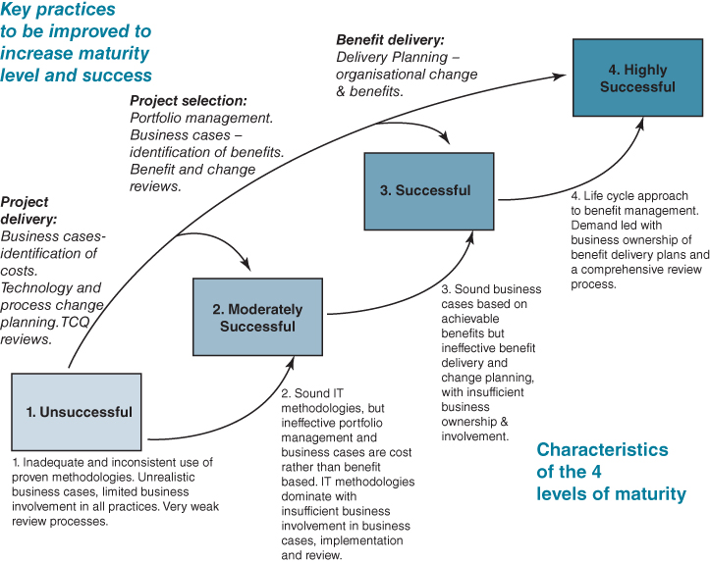
FIGURE 9.6 The four levels of organizational IT investment success and practice maturity.

Level 1 – Unsuccessful
In these organizations, the majority of projects fail to achieve time, cost, quality (TCQ) and benefit targets. As a result, there is little management confidence that IS/IT investments will improve business performance.
To become more successful at this low level of maturity, the priority is to manage the IT supply-side activities more consistently and professionally by adopting and using proven project methodologies so that the IT function can cope better with meeting the business needs. Introducing the rigour of the benefits management process at this level of maturity is likely to be unsuccessful, since business managers will be reluctant to get involved in projects that will probably fail. To improve performance at this level, organizations should:
- ensure they can deliver most projects to time, cost and quality targets – this might include not undertaking projects that are risky or difficult to estimate;
- mandate and police the use of project management and other methodologies;
- review how successfully they achieve the TCQ estimates;
- improve the approach to costing to include more of the actual costs that will be incurred, not just direct expenses.
This can be summed up by saying that before organizations can expect greater success, they must improve project delivery. The introduction of a Project Management Office (PMO) can help ensure that proven methods are not only in place, but also used appropriately.

Level 2 – Moderately Successful
At this maturity level, the majority of IS/IT investments fail to deliver the expected benefits, even though they are normally delivered close to time, cost and quality targets. As a consequence, management are comfortable that IS/IT projects are well managed, but will not risk making the business changes needed to deliver the benefits available.
Once the organization has achieved a high level of supply competence and is delivering projects successfully in terms of TCQ, the focus has to change to become more responsive to the business demands by selecting and prioritizing projects based on business benefits. The benefit management tools will help improve the early stages of managing the investments and in enabling IT and business managers to work together more effectively. To improve performance, these organizations should:
- develop a comprehensive portfolio management approach that takes into account both demand and supply-side factors when selecting which investments to approve (equivalent to level 2 of portfolio management maturity above);

- develop more rigorous business cases, which are realistic in terms of deliverable benefits;
- change how IT and the business work together, involving the business managers more in prioritization and identifying the benefits and costs in the business cases;
- extend the review process to include the benefits and changes – if business cases are not realistic, reviews serve little purpose.
This is mainly about improving project selection in order to deliver more business value from the capability in place. The existence of a PMO can help in this through enabling consistency of approach in investment decision making, which is a key aspect of this stage of development.

Level 3 – Successful (but Inconsistent)
In these organizations, many projects deliver the expected benefits but there are inconsistent levels of success across the investment portfolio. This is mainly due to inadequate approaches to implementation management in some projects, leading to failure to achieve the benefits in the business case. Ownership of the benefits by the business managers becomes possible when the business cases are realistic in terms of both the benefits expected and the required changes.
Having improved project selection, prioritization and investment decision making, the emphasis should move to improving the implementation processes that realize the benefits. This means increasing the involvement of the business managers throughout the investment life cycle, rather than just in the pre-implementation decisions. The temptation is to assume that the improved business cases will actually be delivered by following proven methodologies, but this is not the case unless business managers take responsibility for those parts of the process that affect benefits delivery. To further improve performance, organizations should:
- develop process and organizational change plans that are integrated with the technology delivery plan;
- extend the range of benefit types that are included in the business cases, to increase the business commitment to achieving investment success;
- develop benefit delivery plans with accountability for each benefit assigned to individual business managers;
- increase the scope of the review process to consider not only benefits realized, but also the changes that were required to achieve them;
- have an effective process that ensures lessons from all completed projects are passed on to future projects.
This can be summarized as the need to improve the management of benefit delivery to achieve the potential value created through better investment selection.

Level 4 – Highly Successful
At the highest level of maturity, the majority of projects deliver the expected benefits. Achieving ongoing success in terms of both benefits realized and management satisfaction implies not only delivering to the business cases of the selected projects, but also responding objectively to all types of management demands for new investments. (This implies achieving Level 3 maturity in portfolio management, as per Jeffrey and Leliveld.)
Being willing to undertake more risky projects, on the understanding by senior management that some might fail, is a sign of a mature organization. This relies as much on the degree of confidence the business managers have in their specialist colleagues as the presence of comprehensive practices. It also implies that the organization is willing to stop projects that are heading for failure, before it occurs. To sustain this level of performance, comprehensive practices, strong working relationships, collective, consistent decision making and the ability to learn from previous investments are essential to ensuring business value drives the investment programme.
In most organizations the level of success is easy to identify and, through a set of diagnostic questions, the maturity of each of the main practices can be determined. This normally shows that for an organization at a particular success level, most practices will be at the expected level of maturity, but a few will probably still be underdeveloped and preventing progress.
Carrying out this assessment should identify both the priority areas for improvement of the practices and what should happen as a result. As with most maturity models, it is almost impossible for organizations to jump from low to high levels without developing the knowledge and competences involved in the intermediate stages. However, from experience of working with many organizations, improvements from one level to another can often be achieved within six months to a year. But a word of warning: our experiences with some suggest that it is also possible for careless, inconsistent or inept management behaviour to reduce the level of maturity quite quickly, causing an inevitable reduction in the level of success achieved.

Summary
The purpose of all investments in IS/IT is to deliver improvements in aspects of organizations' activities. Some may be in response to legislative or regulatory requirements and must be done for ‘compliance’. Most, however, are discretionary – the money could always be spent on other things – and IS/IT investments compete for the funds available and, perhaps more significantly, the time and capabilities of people in the organization. If the benefits are to be delivered, the commitment of resources and skills over an extended period is required.
Most of the literature in the field focuses on ‘appraisal’, not ‘management’. IS/IT investments are inherently risky; the majority fail to deliver the expected benefits – some because the benefits were never achievable, others because the risks were not identified or understood and many because the implementation was badly managed. IS/IT investments are becoming increasingly complex in terms of the ways in which they impact an organization's performance, and gaining the benefits is increasingly dependent on changes in business practices and even in organizational roles and structures.
Applications are the primary channel through which infrastructure investments deliver business benefits, other than lower IT costs. Applications, therefore, must explicitly or implicitly justify most of the costs of infrastructure through the business value they deliver. Since the applications make a wide range of different contributions to a business, they need to be justified and evaluated in different ways or at least on different criteria. This is well understood but, as yet, many methods of investment appraisal do not adequately reflect this complexity and the subtleties involved. The approach described here offers some practical guidance to the most appropriate ways of assessing the different types of investment.
The importance of post-implementation reviews should be reiterated as they are the main means by which organizations can learn from experience, both good and bad, and become more successful with their IS/IT investments. The value of strategic planning is mainly in selecting the right things to do, but poor implementation, which fails to deliver the benefits of these ‘right things’, can easily negate the value of planning.
In addition to rigorous justification and assessment processes for new investments, consistently applied, each investment need to be viewed in the context of other commitments, options and opportunities – the investment portfolio, which may be just for IS/IT projects or all types of business projects. Portfolio management processes, supported by effective governance and up-to-date information on all projects, are being seen as increasingly important in most organizations as the means to increase the business value derived from spending on IS/IT. Priority setting, while allowing for logical precedence of development and key resource availability, should be based on the same principles as investment appraisal to maximize the benefit stream from the plan. And perhaps most importantly of all, application priorities should be set by business managers, not the IS/IT specialists, if the digital strategy is, and is seen to be, integral to the achievement of the business strategy.

Endnotes
1. J. Ward and E. Daniel, Benefits Management: How to Increase the Business Value of your IT projects, John Wiley and Sons, Chichester, UK, 2012.2. Some of our research findings have also been published in journal articles, see J.M. Ward, E.M. Daniel and J. Peppard, ‘Building better business cases for IT investment’, MIS Quarterly Executive, 7, 1, 2008, 1–14; and J. Peppard, J.M. Ward and E.M. Daniel, ‘Managing the realization of business benefits from IT investments’, MIS Quarterly Executive, 6, 1, 2007, 15–25.3. The results of these surveys have been published and explored in a number of papers including: J.M. Ward, S. de Hertogh and S. Viaene, ‘Managing benefits from IS/IT investments: an empirical investigation into current practice’, Proceedings of the HICCS Conference, Hawaii, 2007; J.M. Ward, E.M. Daniel and J. Peppard, ‘Building better business cases for IT investment’, MIS Quarterly Executive, 7, 1, 2008, 1–14; and J.M. Ward and E.M. Daniel, ‘Creating solid business cases from start to finish’, Cutter Benchmarking Review, 80, 2, 2008, 5–13.4. See for example the Standish Chaos Summary 2009 Report (The Standish Group International, 2009) in which 32% of projects were successful, 44% were ‘challenged’ or only partly successful and 24% were complete failures. These figures had varied little over a 10-year period, but in 2014 the Standish Group Chaos Summary reported IT project success rates had declined to about 16% in the US, 31% were complete failures and 53% were ‘challenged’, i.e. late and/or overspent.5. For some background research on portfolio management in the context of IT investments, see M. Jeffery and I. Leliveld, ‘Best practice in IT portfolio management’, Sloan Management Review, 45, 3, 2004, 41–49; R. Kumar, ‘Information technology portfolio management: literature review, framework and research issues’, Information Resource Management Journal, 21, 3, 2008, 64–87; and P. Weill and M. Vitale, ‘Assessing the health of an information systems applications portfolio: an example from process engineering’, MIS Quarterly, 23, 4, 1999, 601–624.6. See B. Farbey, F. Land and D. Targett, ‘Evaluating investments in IT’, Journal of Information Technology, 7, 2, 1992; B. Farbey, F. Land and D. Targett, IT Investment: A Study of Methods and Practice, Butterworth-Heinemann, Oxford, 1993; L. Willcocks and S. Lester, ‘Evaluating the feasibility of information systems investments: Recent UK evidence and new approaches’, in L. Willcocks, ed., Information Management: the Evaluation of Information Systems Investments, Chapman & Hall, London, 1994; J.A. Ballantine, R.D. Galliers and S.J. Stray, ‘Information systems/technology evaluation practices: evidence from UK organisations’, Journal of Information Technology, 11, 1996, 129–141; P. Costello A. Sloane and R. Moreton, ‘IT evaluation frameworks – do they make a valuable contribution? a critique of some of the classic models for use by SMEs’, The Electronic Journal Information Systems Evaluation, 10, 1, 2007, 57–64, available online at www.ejise.com; Y. Chan, ‘IT value: the great divide between qualitative and quantitative and individual and organisational’, Journal of Management Information Systems, 16, 4, 2000, 225–262; S. Ryan and D. Harrison, ‘Considering social subsystem costs and benefits in information technology investment decisions: A view from the field on anticipated pay-offs’, Journal of Management Information Systems, 16, 4, 2000, 11–40; P.E.D. Love, Z. Irani, C. Standing, C. Lin and J.M. Burn, ‘The enigma of evaluation: benefits, costs and risks of IT in Australian small-medium-sized enterprises,’ Information and Management, 42, 7, 2005, 947–964; S.D. Ryan, D.A. Harrison and L.L. Schkade, ‘Information-technology investment decisions: when do costs and benefits in the social subsystem matter?’, Journal of Management Information Systems, 19, 2, 2002, 85–127; K.E. Murphy and S.J. Simon, ‘Intangible benefits valuation in ERP projects’, Information Systems Journal, 12, 4, 2002, 301–320; T-Y Choua, S.T. Choua and G.H. Tzeng, ‘Evaluating IT/IS investments: A fuzzy multi-criteria decision model approach’, European Journal of Operations Research, 173, 3, 2006, 1026–1046; and W. Yen-Tsai and J. Campbell, ‘IT investment practices in large Australian firms’, Australian Accounting Review (Supplement), 15, 3, 2005, 20–27.7. See for example: B. Hochstrasser, ‘Evaluating IT investments: Matching techniques to projects’, Journal of Information Technology, 5, 4, 1990, 215–224; G. Peters, ‘Beyond strategy-benefits identification and management of specific IT investments’, Journal of Information Technology, 5, 4, 1990, 205–214; L. Willcocks and V. Symons, ‘Evaluation of information systems: Towards multiple perspectives’, in L. Willcocks, ed., Information Management: The Evaluation of Information Systems Investments, Chapman & Hall, London, 1994; G. Hogbin and D. Thomas, Investing in Information Technology, McGaw-Hill International, Maidenhead, UK, 1994; T. Renkema, The IT Value Quest, John Wiley & Sons, Chichester, UK, 2000; and G. Piccoli, Information Systems for Managers, John Wiley & Sons, Danvers, USA, 2008.8. K. Grindley, Managing IT at Board Level, Pitman Publishing, London, 1993.9. P.A. Strassmann, The Squandered Computer: Evaluating the Business Alignment of Information Technologies, Information Economics Press, New Canaan, CT, 1997.10. D. Lovallo and D. Kahneman, ‘Delusions of success: how optimism undermines executives’, Harvard Business Review, July, 2003, 56–63.11. E. Brynjolfsson and L.M. Hitt, ‘Beyond computation: information technology, organisational transformation and business performance’, Journal of Economic Perspectives, 14, 2, 2000, 33–48.12. J. Ross and C. Beath, ‘Beyond the business case: new approaches to IT investment’, MIT Sloan Management Review, 43, 2, 2002, 51–59.13. J. Peppard, J.M. Ward and E.M. Daniel, ‘Managing the realization of business benefits from IT investments’, MIS Quarterly Executive, 6, 1, 2007, 15–25.14. See C. Avgerou, ‘The significance of context in information systems and organizational change’, Information Systems Journal, 11, 1, 43–63, 2001; R. Kohli and S. Devaraj, ‘Measuring information technology payoff: a meta-analysis of structural variables in firm-level empirical research’, Information Systems Research, 14, 2, 2003, 127–145; and J. Peppard and J.M. Ward, ‘Unlocking sustained value from IT investments’, California Management Review, 28, 1, 2005, 52–70.15. M.M. Parker and R.J. Benson, with H.E. Trainor, Information Economics, Prentice-Hall, Englewood Cliffs, New Jersey, 1992.16. N. Venkatraman, ‘IT enabled business transformation: From automation to business scope redefinition’, Sloan Management Review, Winter, 1994, 73–87.17. J. Ross and C. Beath, ‘Beyond the business case: new approaches to IT investment’, MIT Sloan Management Review, 43, 2, 2002, 51–59.18. P. Tallon, K. Kraemer and V. Gurbaxani, ‘Executive perceptions of the business value of information technology’, Journal of Management Information Systems, 16, 4, 2000, 145–173.19. P. Weill and S. Aral, ‘Generating premium returns on your IT investments’, Sloan Management Review, 47, 2, 2006, 39–48.20. We contend that informational assets and strategic assets are not mutually exclusive, rendering this distinction somewhat confusing but nevertheless useful.21. M. Curley, Managing Information Technology for Business Value: Practical Strategies for IT and Business Managers, Intel Press, 2004.22. See J.M. Ward and E.M. Daniel, Benefits Management: How to increase the business value of your IT projects, John Wiley and Sons, Chichester, UK, 2012; and J.M. Ward, E.M. Daniel and J. Peppard, ‘Building better business cases for IT investment’, MIS Quarterly Executive, 7, 1, 2008, 1–14.23. D.T. McKay and D.W. Brockway, ‘Building IT infrastructure for the 1990s’, Stage by Stage, 9, 3, 1989, 1–11.24. See for example, M. Broadbent, P. Weill and B.S. Neo, ‘Strategic context and patterns of IT infrastructure capability’, Journal of Strategic Information Systems, 8, 1999, 157–187.25. N.B. Duncan, ‘Capturing flexibility of information technology infrastructure: A study of resource characteristics and their measure’, Journal of Management Information Systems, 12, 2, 1995, 37–57.26. T. Renkema, The IT Value Quest, John Wiley & Sons, Chichester, UK, 2000.27. J. Ward and E. Daniel, Benefits Management: How to Increase the Business Value of your IT projects, John Wiley and Sons, Chichester, UK, 2012.28. E.C. Wenger, Communities-of-practice: learning, meaning and identity, 1998, Cambridge University Press, Cambridge, UK.29. L. Lee-Kelley, N. Turner and J. Ward, ‘Intentionally creating a community of practice to connect dispersed technical professionals’, Research Technology Management, 57, 2, 2014, 1–10.30. K. Breu, C.J. Hemingway, M. Strathern and D. Bridger, ‘Workforce Agility: The New Employee Strategy for the Knowledge Economy’, Journal of Information Technology, 17, 1, 2002, 21–31.31. J. Sandberg, L. Mathiassen and N. Napier, ‘Digital options theory for IT capability investment’, Journal of the Association for Information Systems, 15, 7, Article 1, 2014.32. P. Bulasubramarian, N. Kulatilaka and J. Storck, ‘Managing information technology investments using a real options approach’, Journal of Strategic Information Systems, 9, 2000, 39–62.33. K. Ewusi-Mensah and Z.H. Przasnyski, ‘Factors contributing to the abandonment of information systems development projects’, Journal of Information Technology, 9, 1994, 185–201.34. The Guardian, Jan 29, 2014.35. J. Wildman, ‘The Tech Disaster Awards: What You Can Learn from IT's Biggest Project Failures’, www.cio.com, 2008.36. See R. Nelson, ‘IT project management: infamous failures, classic mistakes and best practices’, MIS Quarterly Executive, 6, 2, 2007, 67–78; and L.M. Markus, A. Axline, D. Petrie and C. Tanis, ‘Learning from adopters’ experiences with ERP: problems encountered and success achieved', Journal of Information Technology, 14, 4, 2000, 245–265.37. See C.F. Gibson, ‘IT-enabled business change: an approach to understanding and managing risk’, MIS Quarterly Executive, 2, 2, 2003, 104–115; and L.M. Markus, ‘Techno-change management: using IT to drive organizational change’, Journal of Information Technology, 19, 1, 2004, 4–20.38. E. Kutsch, D. Denyer, M. Hall and L. Lee-Kelley, ‘Does risk matter? Disengagement from risk management practices in information systems projects,’ European Journal of Information Systems, 22, 2013, 637–650.39. E. Jordan and L. Silcock, Beating IT Risks, John Wiley and Sons, Chichester, UK, 2005.40. OGC, Office of Government Commerce, Management of Risk, Guidance for Practitioners, The Stationery Office, London, 2007. Note: The OGC has been renamed the Major Projects Authority (MPA).41. See for example: ‘Programme Assessment Matrices’, International Centre for Programme Management, Cranfield School of Management, 2012.42. Association of Project Management, APM Body of Knowledge, 5th edition. Association for Project Management, High Wycombe, 2006.43. Office of Government Commerce, Managing Portfolios of Change, The Stationery Office, London, 2007.44. National Audit Office, Report by the Controller and Auditor General: Delivering Successful IT-enabled Business Change, The Stationery Office, London, 2006.45. E. Daniel, J. Ward and A. Franken, ‘Project Portfolio Management in Turbulent Times’, CIMA Research Executive Summary Series, 7, 2, 2011, 1–8; and E. Daniel, J. Ward and A. Franken, ‘A dynamic capabilities perspective of IS project portfolio management’, Journal of Strategic Information Systems, 23, 2014, 95–111.46. M.J. Earl, Management Strategies for Information Technology, Prentice Hall, Hemel Hempstead, UK, 1989.47. M. Keil, ‘Pulling the plug: software project management and the problem of project escalation’, MIS Quarterly, 19, 4, 1995, 421–447.48. These are taken from the portfolio view of M. Jeffrey and I. Leliveld, ‘Best practices in IT Portfolio management’, Sloan Management Review, 45, 3, 2004, 40–50.49. E. Daniel, J. Ward and A. Franken, ‘A dynamic capabilities perspective of IS project portfolio management’, Journal of Strategic Information Systems, 23, 2014, 95–111.50. M. Curley, Managing Information Technology for Business Value: Practical strategies for IT and Business Managers, Intel Press, 2004.51. E.M. Daniel and J.M. Ward, ‘Improving the business-IT relationship with IT project portfolio management’, Cutter IT Journal, 28, 1, 2015, 20–24.52. M. Jeffrey and I. Leliveld. ‘Best practices in IT portfolio management’, Sloan Management Review, 45, 3, 2004, 40–50.53. IT Governance Institute, Enterprise Value Governance of IT Investments: The Val IT Framework 2.0, IT Governance Institute, Rolling Meadows, IL, USA, 2008.54. I. Bardhan, S. Bagchi and R. Sougstad, ‘Prioritizing a portfolio of information technology investment projects’, Journal of Management Information Systems, 21, 2, 2004, 33–60.55. See S. Pellegrinelli and L. Garagna, ‘Towards a conceptualisation of PMOs as agents and subjects of change and renewal’, International Journal of Project Management, 27, 7, 2009, 49–656; and K.C. Desouza and J.R. Evaristo, ‘Project management offices: A case of knowledge-based archetypes,’ International Journal of Information Management, 26, 5, 2006, 414–423.56. J. M. Ward and E.M. Daniel, ‘The role and contribution of PMOs to IT project performance’, Journal of Enterprise Information Management, 26, 3, 2013, 316–336.

UNIT 10
AN ORGANIZING FRAMEWORK FOR THE STRATEGIC MANAGEMENT OF IS/IT

OUTLINE
- ♦ The Strategic Management Requirement
- ♦ Positioning and Managing IS/IT in an Organization
- ♦ From a Functional View of IS/IT to an Organization-wide Perspective – Capability and Competences
- ♦ IS/IT Governance and Why It is Important
- ♦ What Decisions Need to be Governed?
- ♦ Creating the Organizing Framework for IS/IT Decision Making
- ♦ Instruments of Governance
It has been noted that it is the ‘organizational issues in the strategic management of IT that matter most’,¹ and research highlights that what distinguishes organizations that are successful leveraging technology is not technical sophistication, but how they manage IS/IT.² Moreover, we would argue that what Peter Keen referred to as the ‘management difference’ (see Chapter 1) in explaining why some organizations are better at harnessing IS/IT than others, is primarily due to how they have organized resources, established appropriate governance and created IS/IT capabilities.³ If the organizing aspects are not addressed, it is likely that the enterprise will struggle, not just with its IS/IT strategy but also in optimizing the value delivered from IT. Getting the digital strategy right is just the beginning.
This chapter presents models and frameworks for guiding action to address the development of IS/IT competences and strategic capabilities and the organizational dimensions of the strategic management of IS/IT. This ‘organizing’ strategy cannot be prescriptive and must evolve over time as the organization becomes more dependent upon and demands more from IS/IT. More freedom of action in terms of greater discretion or tighter control of resource use will be appropriate at different stages of that evolution. It also depends on the ‘digital savvy’ of the leadership team and the willingness of business managers to either make decisions, or at least be involved in decisions, they may incorrectly consider as falling within the remit of IT. This organizational context exerts both enabling and constraining influences that shape the IS/IT strategy and its execution.
In addition to defining processes, policies, accountabilities and responsibilities for all the IS/IT decisions that need to be made, any IS/IT governance structure must be able to deal with conflicts and inconsistencies to ensure overall coherence in decision making concerning IS/IT. This is not a trivial undertaking and, because it is a challenge for many organizations, a significant part of this chapter is concerned with IS/IT governance issues and options.

The Strategic Management Requirement
The strategic management of IS/IT incorporates strategy formulation and planning but is also concerned with its implementation: managing programmes and projects, acquiring and using new applications, achieving business change, deploying technology, delivering IT services etc. This requires the development of competences which in combination provide an IS/IT or digital capability, and the resources and structures to use that capability effectively. What is also needed is an overall governing framework: from strategy development through to the realization of the intended business outcomes from IS/IT investments and expenditure. Moreover, the strategy process does not take place in a vacuum, but within an organizational context, and needs to be continually updated to reflect changing business and IS/IT environments. We have strongly recommended in Chapter 3 that the IS/IT strategy is co-created by both business and IS/IT executives. This will typically require some form of cross-organizational forum to bring relevant individuals together.
The basic IS/IT or digital strategy development model, shown in Figure 3.7, makes no reference to the inevitable ‘refinement’ of strategy during planning and implementation, and its continuing adaptation as achievements (or otherwise) occur or any environmental input changes. As noted in Chapter 2, strategy formulation is a combination of creativity, innovation, informal thinking, formal planning and opportunism, all of which must be effectively harnessed and integrated. Feedback or control mechanisms are also required to ensure that plans and their implementation are appropriate for the strategic direction or to enable changes of direction should achievement prove impossible. Figure 10.1 depicts these relationships.
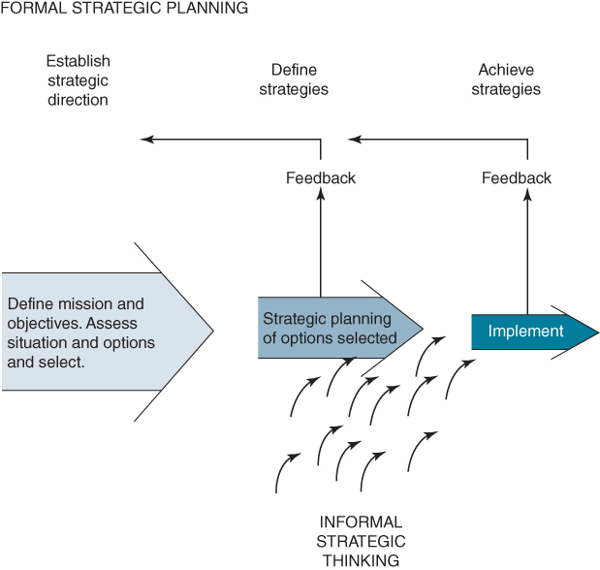
FIGURE 10.1 Strategic management processes.
In order that the formal IS/IT strategy process does not reduce the ability to adapt or even change the strategy during implementation, an operating framework should be established to avoid slowing up business progress. Moreover, many organizations have suffered the consequences of lack of coordination in IS/IT management, which can cause the existing (and potential) application portfolios effectively to disintegrate. Figure 10.2 considers how this might happen: the strategic direction is disregarded as localized opportunistic developments and/or uncoordinated business initiatives effectively disable the overall IS/IT strategy.
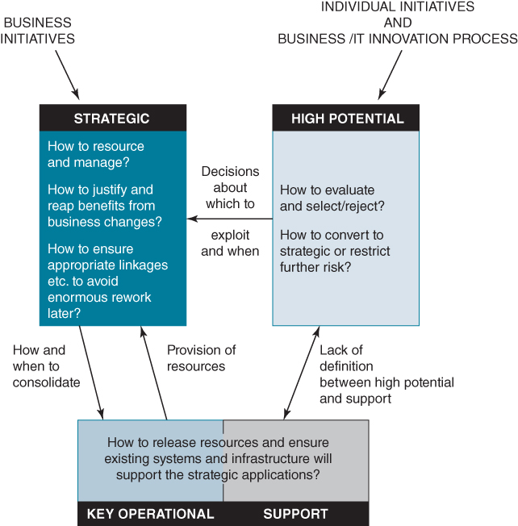
FIGURE 10.2 Avoiding the disintegration of the applications portfolio.
In the longer term, this failure of governance regarding application portfolio management can have three major effects:
- The applications acquired, developed and implemented do not meet overall business needs and priorities.
- Resources are misused, even wasted, or their use is sub-optimal.
- Strategy formulation is essentially a retrofitting process, producing enormous rework.
Any or all three often occur, usually due to three main reasons:
- lack of alignment between the business and IS/IT strategies;
- uncoordinated management of IS demand and IT supply;
- over-centralization or decentralization of responsibilities for IS/IT with lack of mechanisms to ensure coherence across centralized and devolved IS/IT decisions and activities.
It is the effectiveness of the overall IS/IT management strategy and resulting policies and practices that determines whether all other aspects of strategy development and implementation succeed. This IS/IT management strategy must not only deal with the ‘rational’ aspects of strategy, such as investment appraisal, but also with behavioural and cultural considerations; implementing the IS/IT strategy successfully will inevitably require appropriate behaviours throughout the organization.
The main objectives for the strategic management of IS/IT are listed in Box 10.1. These are requirements that senior management must ensure are dealt with by clear definition of responsibility and/or appropriate organizational and governance processes. The rest of this chapter will consider how these can be addressed in practical terms and in conjunction with the need to manage the development of the application portfolio and supporting technologies and resources.

BOX 10.1

Requirements for the strategic management of IS/IT
- ♦ To ensure IS/IT strategies, policies and plans reflect business objectives and strategies.
- ♦ To ensure potential business advantages from IS/IT are identified and exploited.
- ♦ To ensure strategies, changes, investments and costs are viable in terms of business risks.
- ♦ To ensure the organization has the capability and supporting competences to gain maximum benefit from IS/IT investment, either in-house or via external partners.
- ♦ To establish appropriate resource levels and reconcile contention/set priorities.
- ♦ To create a ‘culture’ for the management of IS/IT that reflects the corporate culture.
- ♦ To monitor the progress of business-critical IS/IT activities.
- ♦ To achieve the best balance between centralization and devolvement of IS/IT decision making.
The increasing dependence of most businesses on IS/IT not only involves developing the organizational ability to meet new demands, but also reducing the resource commitment to old demands. The emotive picture of the disintegrating portfolio, as illustrated in Figure 10.2, is often due as much to the organization failing to manage its applications legacy, as the need to satisfy new business and technology demands.

Positioning and Managing IS/IT in an Organization
A fundamental question to address in considering how best to organize for IS/IT is where should IS/IT resources be positioned within the organization. Perhaps the most obvious response is ‘in the IS or IT unit (depending on the preferred abbreviation)’. While it might seem obvious, IS/IT is not something that can be managed from a box on the organizational chart. Unfortunately, this is not the view in many executive teams and in many organizations; a Chief Information Officer (CIO) is appointed and given a budget and a mandate to ‘get on with it’ (including, usually, the construction of an IS/IT strategy), often because, as one Chief Executive Officer (CEO) said to us: ‘I just want to forget about IT and concentrate on my core business.’
This response might be all right if the challenge was merely to deploy technology (on time and to budget) and ensure it functions without causing business problems. Outsourcing to a proven technology provider would also be a legitimate response to perceived problems with IT; get someone with more experience and knowledge to run it for you. Or perhaps ‘the cloud’ could now be the remedy for an IS/IT unit's perceived inability to deliver? Portraying IT as a business utility like water and electricity,⁴ with apps on demand, a pay-as-you-use model and unparalleled scalability, sounds very attractive to many business managers.
However, many CIOs are also being held to account for the benefits and value delivered from IT spend. This raises the prospect of a CIO and the IS/IT unit being held accountable for something that only happens when their business colleagues change working practices and use the applications effectively. For example, successfully deploying CRM software on time and to budget will deliver little unless sales, customer services and fulfilment processes are redesigned, staff trained to have the right conversations with customers, data quality improved, and marketers build the competences to use all the data now available to them.⁵
Even if IT infrastructure, applications and services are provisioned and delivered directly from the cloud, many issues associated with IS/IT will not go away, particularly the challenges around delivering business value. Many of the problems enterprises experience with IS/IT have generally little or nothing to do with technology. What cloud computing does, for example, is make the technology supply side more efficient and perhaps more agile. It may make costs more predictable and shift investments from CapEx to OpEx budgets and provide access to leading-edge technologies.
But these are generally not where the challenges lie when we look at the situation in most companies regarding return from IT spend. Even with total outsourcing of IT services and infrastructure the organization will still require an IS/IT strategy, to make choices around process standardization, the degree of integration required and to define innovations enabled by IT, whether they are process redesign, new business models, or innovations in the customer experience. Additionally, the organization still needs to prioritize IT spend, run programmes and projects, manage the investment portfolio and orchestrate the organizational changes needed to deliver expected business benefits.
Box 10.2 captures this trend: decisions which may traditionally have been made, but wrongly, by IT management – demand decisions – are being devolved into the realm of non-IT executives.⁶ At the same time, some of the supply-side activities which may have been performed in-house are now being outsourced to external providers. Organizations therefore require an organizing framework to provide effective decision making about IS/IT.

BOX 10.2

The retained IS/IT organization
In the early days of enterprise computing, all resources and decisions related to IS/IT were usually made in the organization's IT unit, separate from other functional areas. Over the decades, technology has advanced and the role of IS/IT has evolved. This is leading to a sharper demarcation between centralized and decentralized IS/IT activities; specialization in centres of excellence, process-based work and outsourcing are leading to a new kind of IS/IT organization (see Figure).ª With this structure for the management of IS/IT, much conventional IS/IT work is either outsourced or embedded in the business, with the IS/IT organization remaining as an intermediary to perform an important value-adding service between suppliers on the one hand, and users on the other. In addition, the IS/IT function concentrates on driving IS/IT-based innovation in the business.
Venkatraman and Loh^{b} examined the changing role of the IS/IT function in terms of its relationships rather than its activities, especially given the wide range of sourcing options now available. They suggest that it needs to define its ‘locus of competency’ clearly in terms of its value-adding capability, and then focus on managing three key relationships:
- With outside IT suppliers, who will increasingly do more of the work. They also argue that a simplistic approach to outsourcing IT supply will leave a ‘competency gap’ in the organization, which could disable its ability to ensure that IS/IT fulfils its strategic role. Even where IT supply is fully outsourced, there are certain competences that should never be outsourced.
- With the business managers and application and service users, to enable the business to identify and realize the benefits from the application investments and to obtain maximum value from the services provided.
- With IT specialists in other companies, especially trading partners, as increasingly more systems become inter-organizational through extended and critical use of e-commerce and the Internet and even shared systems.
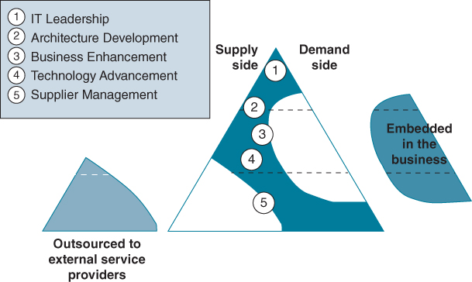
The retained IS/IT organization.
Source: Influenced by IS Lite: The Future, Research Report, Gartner Group, Egham, Surrey, 1999.
This retained IS/IT organization is likely to require five key competences:^{c}
- IT leadership, which includes IT envisioning, fusing IT strategy with business strategy, and managing IT resources.
- Architecture development, which is concerned with developing a blueprint for the overall IT application and technical design.
- Business enhancement, which includes business process analysis and design, project management and managing relationships with users.
- Technology advancement, including application design and development.
- Supplier management, which includes managing and developing relationships with vendors and suppliers, negotiating and monitoring contracts and purchasing.
Notes:
ªInfluenced by IS Lite: The Future, Research Report, Gartner Group, Egham, Surrey, 1999.
^{b}N. Venkatraman and L. Loh, ‘The shifting logic of the IS organization: From technical portfolio to relationship portfolio’, Information Strategy: The Executive's Journal, Winter, 1994, 5–11.
^{c}Evolving Competences for IS Lite, Research Report, Gartner Group, Egham, Surrey, September 2000.
Accountability for some decisions will reside with the CEO and the other members of the executive team,⁷ others with SBU or Line of Business (LOB) managers, and some will be shared. What is clear is that they are not solely the responsibility of the CIO. As accountability, consultation and input into IS/IT decisions become distributed across the organization, what is then required is strong governance of IS/IT. Essentially this means being clear about the decisions that need to be made, who should make them, how they are to be made, and providing the supporting management processes, structures, information and tools needed to ensure that the decisions are effectively complied with, implemented and achieve the desired business results.
However the resources and activities associated with IS/IT are to be organized or governed, the aim is to build and sustain an organization capability and supporting competences that enable IS/IT acquisition and deployment to deliver value to the organization and enhance its strategy. The next section considers the nature of that capability and the competences that need to be developed and managed effectively.

From a Functional View of IS/IT to an Organization-wide Perspective – Capability and Competences
We have emphasized on numerous occasions that the value from IT rarely comes directly from the technology itself, but from the business changes that IT both shapes and enables.⁸ It is these changes – ranging from changes to the enterprise's products and services, its business model or individuals' work practices – that increasingly represent by far the greatest, and the more difficult, part of the effort required to realize value from IS/IT investments. While technology delivers the ability to transform the way information is captured, processed, stored, managed and leveraged, to harness this capability, complementary capabilities must also be developed.⁹
As discussed in Chapter 1, the necessary knowledge to achieve success with IS/IT is distributed throughout the organization, not located solely in the IS/IT organization and under the jurisdiction of the CIO. In fact, much of the knowledge required is under the control of other executives and unless that knowledge can be harnessed, it is unlikely that the maximum business value from IT will be generated.
The concept of organizational competences provides a way to focus attention on the integration and coordination of organizational knowledge for particular purposes: a competence represents an organization's ability to utilize and mobilize resources, in this case ‘bundles’ of knowledge and skills, to affect a desired outcome.¹⁰ From our research we have identified six interrelated ‘macro-level’ competences that all organizations must possess if they are to be successful with IS/IT.¹¹ These can be linked together as shown in Figure 10.3, producing a model or framework to structure the competences that create the organizational capability to deliver business value from IT consistently over an extended period.
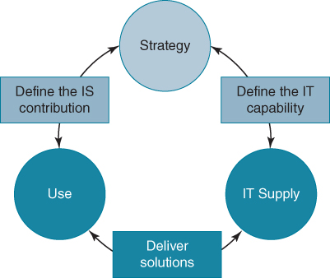
FIGURE 10.3 A framework for positioning organizational IS/IT competences.
The six macro-level competences are defined as follows:
- Strategy: the ability to identify and evaluate the implications of IT-based opportunities as an integral part of business strategy formulation and define the role of IS/IT in the organization and its products and services.
- Define the IS contribution: the ability to translate the business strategy into processes, information and application investments, and change plans that match the business priorities (i.e. the IS strategy).
- Define the IT capability: the ability to translate the business strategy into long-term information architectures, technology infrastructure and resourcing plans that enable the implementation of the strategy (i.e. the IT strategy).
- Use: the ability to maximize the benefits realized from the implementation of IS/IT investments through effective exploration and exploitation of information, applications, technology and services.
- Deliver solutions: the ability to deploy resources to devise, provision, implement and operate IS/IT business solutions that exploit the capabilities of the technology.
- Supply: the ability to create and maintain an appropriate and adaptable information, technology and application supply chain and resource capacity.
Each of these ‘macro’ competences consists of several specific ‘micro’ competences which are at a level where actions can be put in place to develop them and their effectiveness can be assessed. They are listed and defined in Table 10.1. These competences were developed from research involving large organizations: further research using this model suggested that a variation on this list of micro competences was more appropriate for small and medium-sized organizations (SMEs).¹²
TABLE 10.1Definitions of IS/IT competences
Macro IS/IT Competence | Micro IS/IT Competence | The ability to…
1. Strategy | 1.1 Business strategy | … ensure that business strategy formulation incorporates the most advantageous uses of information, systems and technology.
1. Strategy | 1.2 Technology innovation | … incorporate the potential of new and emerging technologies in long-term business development.
1. Strategy | 1.3 Define investment criteria | … establish appropriate criteria for decision making on investments in information, systems and technology.
1. Strategy | 1.4 IS/IT governance | …. define information management policies for the organization and the roles and responsibilities of general management and the IS/IT function.
2. Define the IS contribution (IS strategy) | 2.1 Prioritization | … ensure that the portfolio of investments in applications and technology produces the maximum return from resources available.
2. Define the IS contribution (IS strategy) | 2.2 IS strategy alignment | … ensure that IS development plans are integrated with organizational and functional strategic plans.
2. Define the IS contribution (IS strategy) | 2.3 Determine operating model | … determine how IS can deliver value in operational processes, products, services and other organizational activities.
2. Define the IS contribution (IS strategy) | 2.4 Business performance improvement | … identify the knowledge and information needed to deliver strategic objectives through improved organizational processes.
2. Define the IS contribution (IS strategy) | 2.5 Systems and process innovation | … carry out relevant R&D into how IS/IT can be used to create new ways of conducting business and new or enhanced products and services.
3. Define the IT capability (IT strategy) | 3.1 Infrastructure development | … define and design information, application and technology architectures and organization structures and processes to manage the resources.
3. Define the IT capability (IT strategy) | 3.2 Technology analysis | … understand technology trends and make appropriate recommendations for organizational acquisition of technology and associated resources.
3. Define the IT capability (IT strategy) | 3.3 Sourcing strategies | … establish criteria and processes to evaluate supply options and contracts with suppliers.
4. Use | 4.1 Benefits planning | … explicitly identify and plan to realize the benefits from IS/IT investments.
4. Use | 4.2 Benefits delivery | … monitor, measure and evaluate the benefits derived from IS/IT investments and the use of information and applications.
4. Use | 4.3 Managing change | … make the business and organizational changes required to maximize the benefits without detrimental impact on stakeholders
5. Deliver solutions | 5.1 Applications provisioning | … develop/acquire and implement information, application and technology solutions that satisfy business needs.
5. Deliver solutions | 5.2 Service management | … define service arrangements and performance criteria to match the business requirements (including project management).
5. Deliver solutions | 5.3 Information asset management | … establish and operate processes that ensure data, information and knowledge management activities meet organizational needs and satisfy corporate policies.
5. Deliver solutions | 5.4 Implementation management | … ensure that new processes, ways of working and other business changes are designed and implemented effectively in conjunction with new technology.
5. Deliver solutions | 5.5 Apply technology | … deploy new/changed technology in the most cost-effective way to deliver business benefits, at an acceptable level of risk.
5. Deliver solutions | 5.6 Business continuity and security | … provide effective recovery, contingency and security processes to prevent risk of business failure.
6. Supply | 6.1 Supplier relationships | … manage contracts and develop value-added relationships with suppliers.
6. Supply | 6.2 Technology standards | …. develop and maintain appropriate standards, methods, controls and procedures for the use of IT and associated resources.
6. Supply | 6.3 Technology acquisition | … develop and apply procurement policies and procedures for the organizational acquisition of infrastructure components and specialist technologies/services.
6. Supply | 6.4 Asset and cost management | … ensure technology, information and application assets are effectively maintained and costs of acquisition and ownership are understood and managed.
6. Supply | 6.5 IS/IT staff development | … recruit, train and deploy appropriate staff and ensure technical, business and personal skills meet the needs of the organization.
These competences transcend traditional functional boundaries and are spread right across the organization. For some, particularly ‘IT supply’, the required knowledge is primarily located within the IS/IT function but, for ‘use’ competences, the knowledge will be primarily located within the operational areas of the business. For many of the others a ‘50/50’ combination of knowledge is necessary and this balance is not always easy to achieve without well-designed and effectively executed IS/IT governance structures and mechanisms, as discussed in the next section of the chapter.
Exploring this model with a cross-section of IT directors/CIOs and business managers, from a range of industries at a series of workshops, identified which competences were most problematic in their organizations. While not generalizable, the results were unerringly consistent across all the organizations that took part, and also in later use of the framework with combined groups of business and IS/IT managers from individual organizations. The eight areas of ‘incompetence’ (or ‘the inability to’) – where 50% or more respondents deemed them inadequate or problematic (80% in the case of the top three) – are:
- Business strategy
- Benefits delivery
- Managing change
- IS/IT governance
- Benefits planning
- Business performance improvement
- Information asset management
- Prioritization
Interestingly, all the competences in the framework under the macro heading ‘Use’ were deemed to be inadequate (i.e. Benefits Planning, Managing Change and Benefits Delivery). All but one of the inadequate competences are within the three macro competences of Strategy, Define the IS Contribution and Use, where the critical knowledge required is heavily biased towards the business management. That this is often a serious weakness is a view held by many business managers and executives, as well as IS/IT managers.
This perhaps explains why some IS/IT units are good at defining a technical infrastructure and providing applications, but the organization is not delivering benefits from the investments. Maybe the ‘wrong’ applications are being implemented, or maybe they are being used ineffectively? Whichever is the case, it emphasizes the importance of creating a strong business–IS/IT partnership and appropriate responsibilities, behaviours and values regarding information and its use in the organization.

The IS Capability, Competences and Resources
These six macro competences make up what we can call an organization's ‘IS/IT (or digital) capability’, i.e. its ability to continually optimize the value derived from IS/IT, in terms of both strategic and operational contributions.¹³ The term capability in this context refers to the strategic application of competences,¹⁴ i.e. their use and deployment to accomplish given organizational goals.¹⁵ From our research we developed a model of the components of this IS/IT capability and how we believe they are related.¹⁶
The model has three levels (see Figure 10.4):
- The resource level denotes the knowledge and know-how that are the key ingredients of the IS/IT competences: the skills, specialist and business knowledge, experience and behavioural attributes and attitudes of both employees and external providers.
- The organizing level is concerned with how these resources are mobilized and orchestrated via structures, processes, routines and roles to create the IS/IT competences.
- It is, however, only at the enterprise level that the IS/IT capability actually manifests itself as a strategic resource that delivers value and improved performance for the organization.
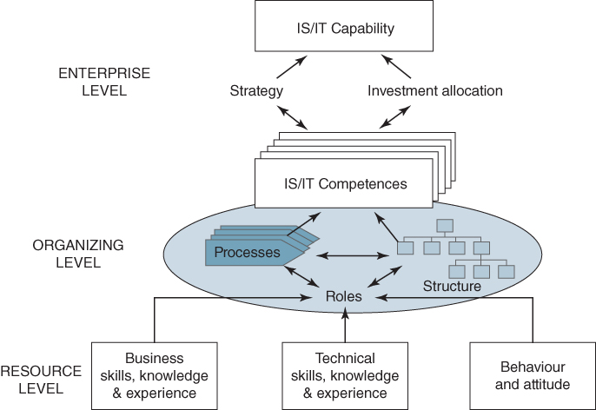
FIGURE 10.4 A model of the IS/IT capability.
All organizations have an IS/IT capability, but when it is weak, it severely affects the organization's ability to achieve IS/IT-related strategic changes. When it is well developed, the organization can both leverage IS/IT-enabled business advantages and also respond rapidly to changes in the business environment. The strength of the capability is dependent on the components and the links in the model, which need some further explanation.

From Resources to Competences
The existence of a particular competence in an organization depends on people applying their knowledge, integrating their knowledge, interacting with others and coordinating their actions – which they do by performing roles in organizational structures and processes. Individuals can, and normally do, contribute to a number of the IS/IT competences.

Processes
The process perspective can be very helpful in understanding many aspects of managing the supply of IT and the delivery of information and systems. Methodologies for application design and development, project and service management for example, define good practices for some key processes. Less well defined are the processes that derive benefits from the IS/IT investments and applications. These include formulating strategies, investment decision making, managing the organizational and business changes required to deliver value, and assigning responsibilities and accountabilities for realizing specific benefits. These activities essentially involve using collective, often tacit, knowledge to address context-specific tasks that cannot be performed according to a prescribed process.

Roles
The concept of roles and role theory is useful in understanding the behaviour of individuals in groups and organizations. Building on the sociological roots of role theory, Graen¹⁷ developed a ‘role systems model’ in which behaviour in a particular role is the result of organizational demands, social demands and personal demands. Katz and Kahn¹⁸ applied similar ideas to their organizational role theory, which emphasizes organizational factors, interpersonal factors, and attributes of the person.
In an organization, an employee's primary role is indicated by a position or title and specified by a ‘job description’,¹⁹ although employees are likely to perform different roles at different times. While roles can be tightly or loosely defined and have different degrees of discretion associated with them, they do encompass the expected behaviours attached to a position or job. For the organization to achieve its goals and objectives, individuals' work must be part of a coherent pattern of activities and relationships, which is achieved through the ‘role structure’ of the organization.²⁰
The range of attributes that distinguish the ability of an individual to perform a particular role²¹ as shown in Figure 10.4 are:
- Skills – know-how of the job, which implies the ability to produce some action. This might be the ability to program in Java or draw data flow diagrams.
- Knowledge and experience – know what of the job, the ability to understand what the role demands of the person; for example, knowing what is involved in constructing an IS strategy, managing the investment portfolio or building relationships with vendors.
- Behaviours, values and attitude – the personal attributes or aptitudes that make knowledge useful and enable skills to be acquired in the first place. Personal characteristics are important and may be crucial in service-oriented roles; for example, IT staff having empathy with users when delivering IS/IT services. Willingness to engage, interact and collaborate with colleagues is also critically important.

Structures
Structure is traditionally seen as being concerned with the systematic arrangement of people, departments and other subsystems in the organization. The structure of the organization can ultimately affect the performance of processes, particularly those that cross departmental or functional boundaries. The concept of business process re-engineering emerged as a consequence of the problems of functional organization structures and argued for more focus on work processes in designing organizations.

From Competences to Capability
The extent to which competences contribute towards the IS/IT capability is dependent on two aspects that should normally be closely related: the organization's strategy and investment decisions. Together they determine whether the IS/IT capability is a source of competitive advantage or merely a necessity for competitive parity, or is causing the organization to be at a competitive disadvantage. Different organizations may choose to resource the capability (i.e. source and harness the underpinning knowledge and skills) in different ways, but most will rely on a combination of internal and external resources to create the required competences.
The critical link between the organization's strategy and IS/IT investment decision making is the IS/IT strategy, so we take the view that the IS/IT capability is the organizational characteristic that enables it to conceive, select and implement successful IS/IT strategies. For example, an organization could identify an advantage from an innovative IT-enabled strategy but be unable to implement it quickly due to the current status of the IT infrastructure. The ‘capability’ is the organization's ability to successfully deploy appropriate IS/IT resources as well as to design, implement and operate new processes and applications and unlock the expected business value.
Establishing governance is a way for creating the blueprint for coordinating and integrating knowledge. However, as confirmed by our study of competences, IS/IT governance is problematic in many organizations. This is likely to become even more challenging as IS/IT use pervades almost every aspect of business activity and as individuals can more easily acquire and use ever more powerful technology and a wide range of applications. The next section discusses what is involved in IS/IT governance and how it can become an organizational strength rather than a weakness.

IS/IT Governance and Why It is Important
The concept of governance is well established as a key component of corporate management, partly due to the frequency of corporate scandals, particularly since the turn of the century. A breakdown in corporate governance is seen as the root cause of many of these debacles. Not that the concept of governance is new; it has been around ever since there has been the separation of the ownership of a company – essentially the shareholders – from its day-to-day management.²² Corporate governance structures exist to ensure that executive management act in the best interest of shareholders and not merely to maximize their own self-interests.
Through effective governance structures, processes and mechanisms, management are encouraged to display decision-making behaviours that reflect the interests of shareholders and, increasingly, to behave in an ethical fashion towards a wide range of stakeholders that also includes employees, customers, regulators and government (for example, legislative requirements such as Health & Safety and Data Protection). The Sarbanes–Oxley Act essentially asks them to prove that they are. The Board of Directors is an instrument of governance; shareholders elect non-executive members to represent their interests and provide oversight on the decisions and activities of the executive members and the company as a whole. This includes IS/IT as companies become ever dependent on technology, and poor decision making or implementation can have serious implications.²³ Box 10.3 describes the consequence of lack of board oversight of IS/IT at the Co-operative Group.

BOX 10.3

Board governance of IS/IT at the Co-operative Group
In April 2014, Sir Christopher Kelly, a former British senior civil servant, produced a damning reportª that reviewed the events which led to the £1.5 billion capital shortfall announced by the UK's Co-operative Bank in June 2013. Running to 158 pages, it describes what happened, identifies the root causes and draws out lessons.
One section highlights the problems encountered as the bank attempted to replace its core banking systems, a transformation programme that was cancelled in 2013 at a cost of almost £300 million. The report underlined a series of significant leadership and management failings that were to blame for the spiralling IT costs which contributed to the bank's capital shortfall. This shortfall resulted in the Co-op Group ceding control of the bank to bondholders, including a number of U.S. hedge funds.
The report noted that the investment objectives of the IT-transformation programme were laudable; leapfrogging the competition and gaining an advantage, through improved customer relationship management and quicker delivery of new products. The age and complexity of the legacy systems meant that the bank's technology platform was unstable, expensive to maintain, complex to change, and ill-equipped to support its current and future business requirements. There were particularly severe problems with the functionality of the online business banking platform. These weaknesses resulted in high running costs, upgrading to comply with new regulatory requirements eating up considerable resource and significant operational risk. It appeared to be an attractive investment.
However, Sir Christopher wrote: ‘The weight of evidence supports a conclusion that the programme was not set up to succeed. It was beset by destabilizing changes to leadership, a lack of appropriate capability, poor co-ordination, over complexity, underdeveloped plans in continual flux, and poor budgeting. It is not easy to believe that the programme was in a position to deliver successfully.’ The bottom line – the benefits of the investment may have been attractive, but they were not achievable.
Not set up to succeed is a key phrase. More worryingly, the factors identified in the report as contributing to the failure are ones that are all too frequently encountered when failed projects are reviewed. All of the reasons identified by Sir Christopher are well known and serve to highlight a low level of digital literacy at board level, and the failure of corporate governance and leadership to make informed IT investment decisions.
The report noted: ‘If the programme was ever to have had a chance of succeeding it would have had to have been robustly managed by people with the right capabilities and experience using the best possible project management discipline.’ It went on to emphasize: ‘It would also have had to be subject to searching challenge and scrutiny at Board, Executive and programme management levels. The Bank did not provide any of these things to the extent necessary to ensure success.’
Non-executive directors were also in Sir Christopher's cross-hairs. He wrote: ‘It is unreasonable to expect non-executive Board members to audit information provided to them in detail. But it is their responsibility to question it. [Our emphasis.] It is difficult to avoid the conclusion that both Board and Executives failed to interrogate the programme sufficiently closely and paid inadequate attention to its obvious difficulties until it was too late.’ Moreover, he found that former members of the Board's Banking Transformation Programme Sub-Committee who, he noted, ‘should have been better placed than other directors to understand the programme, described being surprised that it failed.’ His damning critique: ‘They should not have been.’
Notes:
ªSir Christopher Kelly, Failings in Management and Governance: Report of The Independent Review into Events Leading to the Co-operative Bank's Capital Shortfall, 30th April, 2014.
IS/IT governance is concerned with promoting consistent and coherent decision-making behaviour across an organization regarding information systems and technology in order to maximize the value the organization derives from IS/IT. This is not just in relation to decisions made by IS/IT management. Business executives also need to be aware of the IS/IT impact of their decisions, to ensure they are in the best interests of the whole organization, not just for their department or business area. A business decision to move into a new geographic region has significant IS/IT implications; for example, more bandwidth and infrastructure capacity, an increase in the number of software licences, and software may need to be modified to accommodate local legislation and tax requirements. Similarly, the decision to launch a new product can have profound implications for legacy administrative systems.
Establishing a governance framework for IS/IT entails the allocation of accountabilities and responsibilities, defining processes, setting policies, establishing committees and other cross-organizational forums, determining appropriate metrics, and creating mechanisms to bring business and IT managers and users together in decision-making processes. It also requires the establishment of mechanisms to ensure conformance to decision outcomes and any policies or standards that are developed. According to research ‘effective IT governance is the single most important predictor of value an organization generates from IT’.²⁴ Research has also reported on the efficacy of IS/IT governance mechanisms to improve business–IT alignment.²⁵
Most organizations do have some form of governance structures and mechanisms for IS/IT decisions. However, too often governance mechanisms are put in place in response to problems or a crisis, or have evolved in an uncoordinated way. For example, a security lapse may see the establishment of a security or Internet policy; a poor IS/IT investment decision may see stronger accountabilities established for IT expenditure; a project failure often results in business managers becoming more closely involved during IT implementation. As a consequence, however, these mechanisms may be sub-optimal or even conflict with each other.
Designing and implementing a governance framework for IS/IT requires a concerted effort via a partnership of senior business and IT executives. We have seen occasions where a CIO and his team construct a framework to govern IS/IT, but business executives and managers fail to accept their accountabilities and responsibilities and do not engage in decision-making processes.²⁶ This can be accounted for by low levels of ‘IT savvy’ or ‘digital literacy’ in the executive and managerial ranks and members not understanding their role. Nearly 30 years ago Jack Rockart advocated that line managers need to show leadership if their companies are to succeed with IS/IT;²⁷ unfortunately, despite the passage of time, this is still too often not the case.
In such instances an education process will often have to be established,²⁸ at the very least to provide managers with a language to discuss IS/IT issues and to explain how IS/IT creates value and the central role of the business manager in that process. Without getting the buy-in and involvement of management at the top of the organization, it is unlikely much progress will be made on developing an appropriate governance structure and even less likely that it will be effective and achieve the desired objectives. Getting the right governance in place can be a slow process.

The Logic of IS/IT Governance
The IT strategy needs to address questions concerning scale, infrastructure planning and risk,²⁹ and most people can recognize the need for technology components to interoperate easily and accept the need for certain technical standards to be adhered to throughout the organization. The problems technical incompatibilities pose for integrating systems become all too apparent when attempts are made to link disparate technologies.
However, for IS demand decisions, there is generally less appreciation of the need for consistency and coherence. For example, how investment priorities are decided, whether applications should be common across all operating units or, if business units can develop their own applications, how much freedom they should have. Again, when implementing an ERP system across a number of business units, how much leeway should be given to units in customizing the application or is it a case of ‘one size fits all’? We often find that responsibility for technology supply is more centralized, usually in a specialist IT organization unit, than organizational responsibility for managing and coordinating IS demand.
Decision making for IS/IT is becoming progressively distributed throughout the organization, including being devolved to local IT units. Moreover, decisions traditionally seen as within the remit of IT management are rightly shifting to business management; so-called ‘shadow IT’³⁰ is an example of this. As more and more employees throughout the organization become involved in decision making about IS/IT, this has implications for coordination, control and identifying opportunities for synergies. These employees may be located in geographically disparate locations, operating across different time zones with different cultures and may hold contrasting views and beliefs about IS/IT and how it should be leveraged and deployed.³¹ There may also be different levels of IS/IT maturity and differing national communications infrastructures. The requirement for IS/IT governance becomes increasingly critical due to this devolution, to ensure there is coherence and consistency in decision making across an organization. Figure 10.5 illustrates this devolution of decisions from a central IT organization out to local IT units: it assumes an organization structure based on multiple business units (BUs) or lines of business (LOBs).
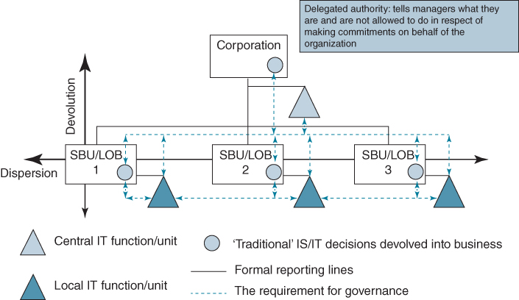
FIGURE 10.5 Devolving and dispersing IS/IT decisions.
Activities can also be devolved and not just to users of some applications, productivity tools and even their own devices, but also to third-party providers, such as Indian off-shore companies engaging in application development. Outsourced activities can include requirements gathering, application design, software development and testing as well as tasks involved in IT operations, such as maintenance, security and help desks. It is a complex environment within which to operate and manage. It also raises some fundamental questions about which decisions should be devolved and to whom, if coherence is to be achieved and sustained. The challenges resulting from this complexity include balancing diversity of need with integration; local innovation and responsiveness with scale and scope; and empowerment with control.
Figure 10.6 summarizes the main structural alternative arrangements for IS/IT decision making in an organization. It considers the advantages and the critical management issues that each raises. For most organizations the optimum choice will be a mixed environment where some decisions are centralized some decentralized; there will also be shared responsibilities. This situation has been referred to as a federal IS organization.³² With such a structure, business units receive a responsive service from decentralized IT units, whilst at the same time a corporate unit provides group-wide IT services and exerts some degree of central leadership and control of IT activities (see Figure 10.7).
Structural arrangements for IS/IT decision making | Philosophy for decision making | Advantages | Critical management issues
Independent IS/IT decisions made in business units – 'Multi-local' | ♦ Business units pursue independent IS/IT initiatives | - ♦ Business units have ownership  - ♦ Users control IS priorities  - ♦ Responsive to business unit's needs | - ♦ Integration of information  - ♦ Variable standards of IS/IT competence  - ♦ 'Reinvention of wheels'  - ♦ Little synergy  - ♦ Managing cost
Centrally driven IS/IT decision making | ♦ Corporate-wide IS/IT solutions imposed on business units | - ♦ Scale economies  - ♦ Control of standards  - ♦ Critical mass of skill  - ♦ Cost | - ♦ Politics  - ♦ Unresponsive to local needs  - ♦ Does not meet every business unit's needs  - ♦ Effect on customer
Informal co-operation in IS/IT decision making across business units | - ♦ Informal social networking between centre and units  - ♦ Movement of key personnel | - ♦ Awareness of IS/IT issues across the enterprise  - ♦ Relationships | - ♦ Co-ordination and direction setting  - ♦ Leaving too much to chance
'Federalism' (Integrated IS/IT decision making) | - ♦ Balancing central control and business unit autonomy | - ♦ Group-wide IS/IT strategy and architecture with devolution where appropriate | - ♦ Complexity (defining 'where appropriate’)  - ♦ Execution and timing
FIGURE 10.6 Different structural arrangements for IS/IT decision making.
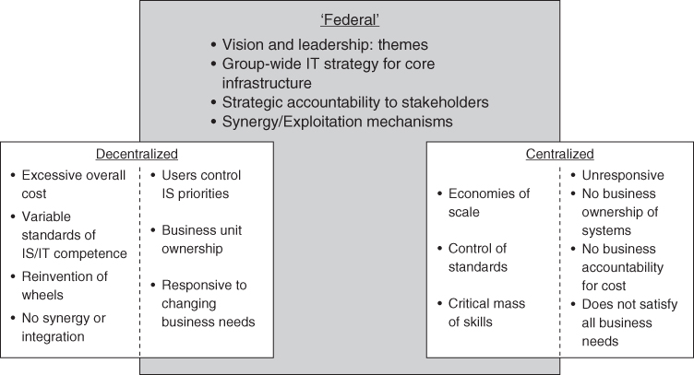
FIGURE 10.7 The Federal model of organizing for IS/IT.
The model shown in Figure 10.7 allows for significant autonomy at the local level but at the same time provides the necessary economies of scale, scope and other advantages. It attempts to achieve the benefits of both centralization and decentralization while avoiding the very obvious potential disadvantages of both. It is tied together by a clear IS/IT vision, effective leadership, and group-wide IS/IT strategy and architecture. But it still leaves issues about which specific decisions should be best made from the centre and those that are best devolved to be made locally.

What Decisions Need to be Governed?
In designing the organizing framework for the strategic management of IS/IT, there are essentially three issues to address:
- What are the critical governance decisions, both demand and supply decisions?
- How are the decisions to be made – the process, will they be unilateral or shared?
- Who makes the decisions – senior management, business managers, IT management, a committee or perhaps external partners (or various combinations)?
The framework should also define any desired decision-making behaviour and specify appropriate instruments and processes to be followed. Following the philosophy of this book, decisions can be usefully divided into ‘demand’ decisions and ‘supply’ decisions. Examples of demand decisions include deciding how much to invest in IS/IT and how investment options are prioritized; supply decisions include deciding on required IT capability, how projects and programmes will be managed, and IT services delivered. Many of the decisions on the supply side can follow best practice processes, such as PRINCE2³³ for project management and COBIT³⁴ for IT management or ITIL for IT Service Management.³⁵ Each of these sets of guidance includes the aspects of governance relevant to the practices involved: for instance the COBIT 5 framework includes VAL IT 2.0,³⁶ providing guidelines for the governance of IT investments.
For each decision, the desired decision-making ‘behaviour’ can usually be captured in a one sentence description as exemplified in Figure 10.8. The next stage of the process is to decide on the most appropriate instruments or mechanisms to effect the desired behaviour.
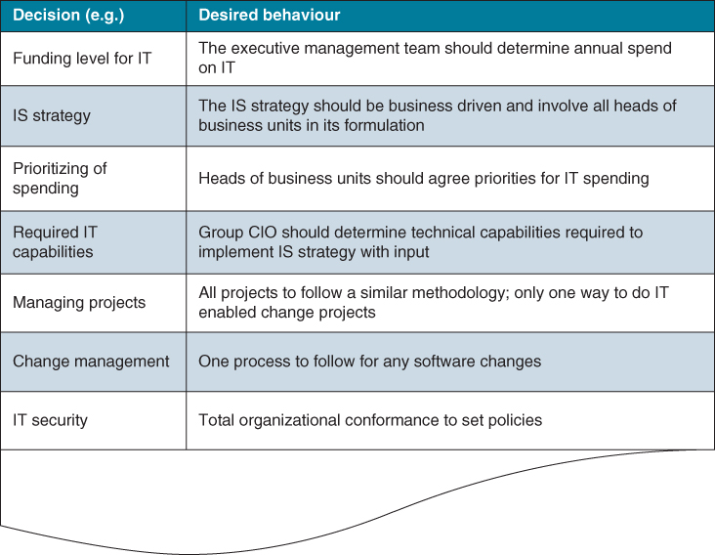
FIGURE 10.8 A framework for mapping decisions against desired behaviours – with examples.

Influences on Employee Behaviours
In every organization there will be any number of instruments impacting employees' decision-making behaviour, perhaps most significantly (as per the old adage, ‘what get measured gets managed’) performance measures, as this is what they will be evaluated against. Other instruments include those focused on organization structure, finance and legislation/compliance and some professional disciplines, such as accountants, have codes of conduct defining how they should behave.
IS/IT governance is adding another layer to the overall governance structure of the organization (see Figure 10.9). Before selecting appropriate IS/IT governance instruments, it is therefore crucial that an assessment is made of other governance instruments in these domains and the behaviours that they promote. Figure 10.10 lists some questions that can be useful in teasing out other enterprise governance instruments.

FIGURE 10.9 Enterprise governance: influences on employee decision-making behaviour.
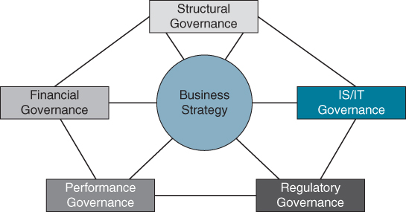
FIGURE 10.10 Questions to elicit influences on decision-making behaviours.
Any areas of misalignment, or even conflict between the different areas of governance, should be addressed before embarking on designing an IS/IT governance framework. Box 10.4 recounts the situation the CEO of the UK subsidiary of a global retailer faced when acquired by a US retailing giant. It starkly illustrates the misalignment between the global operating model, the performance expectations of the corporate centre and the constraints imposed by how IS/IT was governed and managed at a corporate and business unit level (the UK subsidiary was a separate business unit).

BOX 10.4

Misalignment between enterprise governance and IS/IT governance at a global retailer
As a result of its acquisition strategy, a large US retailer acquired a UK retailer with 450 stores located throughout the country. In the months following the acquisition, with a clear corporate ‘rip and replace’ policy, the UK operations replaced all its own systems with those of the US headquartered company. In contrast, the UK CEO was given free rein to run the business as he saw fit as long as he achieved market share growth, and met bottom-line and margin targets.
This centralization of IS/IT decision making had both advantages and disadvantages for individual country businesses – the retailer had operations in other countries, including Canada, Mexico and Japan. On the positive side, IT was cheap (the UK company benchmarked itself against competitors), reliable and well supported. The systems worked well and were globally consistent. On the down side, they frequently didn't meet local business requirements, both operationally and strategically, severely affecting the agility of local units. Any tailoring and customization of applications was not permitted unless it was to meet a regulatory or legislative requirement. Prioritizing of IS/IT activity was essentially determined by the US company.
However, the biggest impact was on strategy. The CEO's plans to grow the business were thwarted by IS/IT and it proved to be a major constraint on the business. For example, it was impossible to roll out new store formats that would be more amenable to the UK customer as the centre did not either provide or support the required IS/IT. The US IT organization was also slow to respond to requests from the UK business; not helped by the 6 hour time difference. This led to serious frustrations and to a situation where the local IT organization was known as ‘the department of No’. The reality was that the governance of IS/IT did not mirror overall enterprise governance: local CEOs had total control over all aspects of their business except IS/IT. A change in leadership at the US parent company saw a rethink of this organizing framework to one that was more responsive to local country requirements while still providing low cost IS/IT systems and services.

Creating the Organizing Framework for IS/IT Decision Making
Once choices have been made regarding how decision making should be, the next task is to select the most appropriate instruments to promote and support the required behaviours. A tool to help in mapping out these is presented in Table 10.2. The column headings of the table are defined as:
- Authority – the individual, group or forum that should make the decision and is ultimately answerable for the outcomes of the decision. For example, some decisions may be made directly by the CIO, others by business managers, but others may require the agreement of a ‘committee’ or other cross-organizational forum.
- Process – how the decision will be made to enable consistency in decision making and resource allocation. For some IS/IT decisions, a policy or standard may be specified, defining the degrees of discretion decision makers have and which other individuals or groups have input into a particular decision.
- Responsibility – the individuals or bodies responsible for day-to-day execution of the decision. The definition of responsibility should be integral to each person's job role and function, whether technical or non-technical. (Note: a person or role that carries responsibility does not necessarily carry authority; for example, the Head of IT Security may be responsible for IT security but the CIO is accountable if there is a security breach.)
- Coordination – the mechanisms (e.g. steering committees, strategy teams etc.) and processes, including the roles to be played by both individuals and groups, for ensuring coherence across all IS/IT decision areas.
- Monitoring – the approaches to policing decisions, ensuring conformance across the organization to decisions made; this should include the consequences or implications and procedures for non-conformance to policies or decisions.
TABLE 10.2Designing the framework for the strategic management of IS/IT: some examples
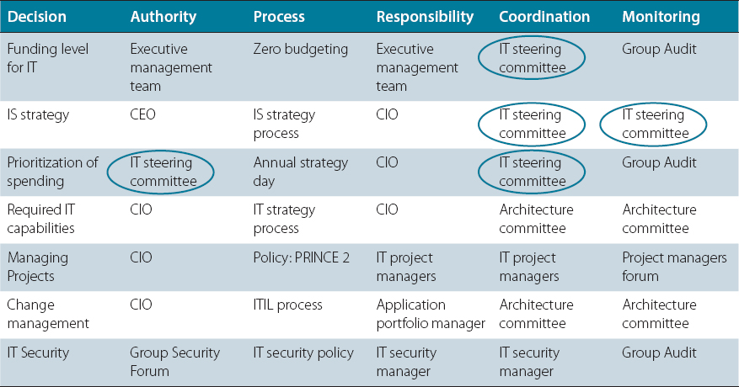
Some decisions, such as which project management methodology to use across the whole organization, are infrequent, even one-off decisions, that become company policy or standard. Others are more ongoing, like issues concerning changing business priorities or the evolving technology landscape and a key task is defining how these situations are to be dealt with. This exercise can also be used to define the remit of committees or individual role accountabilities. For example, Table 10.2 highlights the role and remit of the IT steering committee to include authority for prioritizing IT spend, coordinating the determination of funding level for IT, IS strategy and prioritization of IT spend as well as monitoring conformance to the IS/IT strategy.
Box 10.5 describes the overall governance structure at a European automotive manufacturer. It illustrates that the company distinguishes between IS demand and IT supply decisions, specifying the different governance bodies and the major outputs from decisions made by them.

BOX 10.5

IS/IT governance at a European automotive manufacturer
The figure below shows the activities that are both coordinated and managed by the central IS/IT unit (IS/IT strategy and planning, programme control, programme delivery and IT standards and policies) and the related governance bodies. It also highlights the major outputs of these mechanisms.
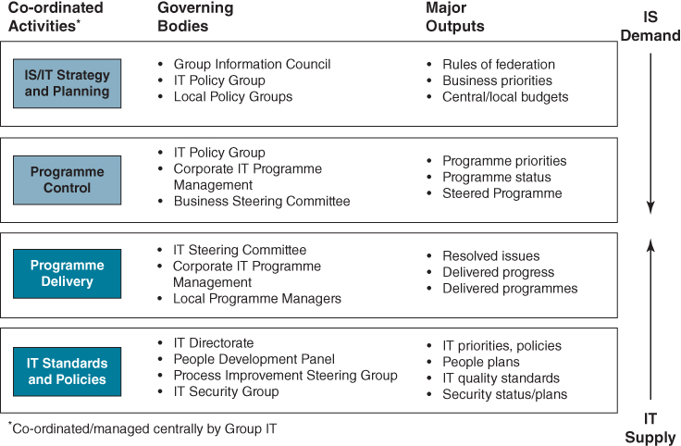
For example, the IT Policy Group is chaired by a board member and its membership is composed of senior business managers from the main business areas and the CIO. It focuses on:
- ♦ setting the level of company-wide and local IT spend;
- ♦ ensuring IS/IT investments support business priorities;
- ♦ approving proposed IS/IT investments;
- ♦ agreeing balances between types of IT spend: e.g. applications v. infrastructure;
- ♦ validating IS/IT direction and policies (e.g. outsourcing);
- ♦ monitoring performance against plans.

Instruments of Governance
Governance instruments help in achieving the desired decision-making behaviours; they are essentially the ‘levers to pull’. They include: formal organizational structures, liaison and relationship roles, procedures, committees, decision-making processes, standards, principles and policies. The choice of governance instruments can be categorized under four headings: structural, horizontal, functional and social.
The interrelatedness of instruments and mechanisms must also be recognized. Establishing an IS/IT steering group (a mechanism for horizontal integration) brings together relevant people. However, the achievement of shared understanding amongst its members depends on their values and beliefs and creating that shared understanding within the group may require some education events (a social integration mechanism). There may also be a prescribed decision-making process associated with particular decisions to be taken by the group (a functional integration mechanism). It is also important to remember that governance is not management, and that managers may choose to ignore policies or operate outside of the formal governance structure.

1. Structural Instruments
These are formal organizational structures or roles; for example, reporting relationships, direct line supervision of staff, liaison and full-time integrating roles. Formal organizational roles (e.g. CEO, COO, CIO or line management) have particular accountabilities and responsibilities assigned to them and these can include accountability for aspects of IS/IT.
Organizations often establish formal job roles in order to bring the IT organization and the business closer together – with labels such as relationship manager, account executive or demand manager. Incumbents usually have the objective of working with business managers and users to help them articulate their business requirements in terms of information and applications. These ‘boundary spanning’ roles often play a significant part in improving the relationship between the IT unit and the rest of the business. They can perform a number of roles including communicator, educator and trust builder, translating business needs into technical requirements, communicating progress on projects and passing back the concerns and issues of business managers to IT management.
Iacono and colleagues³⁷ studied the work practices of relationship managers. They found that while they spend less time communicating with users than one would expect, they are leaders, often mavericks, in the entrepreneurial work practices necessary to build partnerships with clients and to make the infrastructure more responsive to client needs. On the negative side, they can often reinforce an ‘us and them’ situation between the IT organization and business units. Operating around the periphery of the IT organization, they typically report into IT management and may be seen as favouring technical arguments over business priorities – a perception that can influence how others outside the IT organization behave towards them, their willingness to share information and the extent of trust.

2. Horizontal Instruments
These are ‘structural overlays’ (such as governance groups or councils, steering committees and other cross-organizational forums) and non-structural devices, such as physical co-location of employees, designed to facilitate collaboration, knowledge sharing, communication and awareness. These mechanisms promote the contribution and involvement of employees from different parts of an organization in decision-making processes, where appropriate. Table 10.3 provides more detail about some ‘formal groups’ that have been implemented in various organizations: these are illustrative only and it is not suggested an organization should establish any or all of these forums or use the remits as outlined. The important point to note is that formal groupings of individual managers can be a powerful device for encouraging involvement in making decisions and achieving coordination, as well as identifying synergies across decisions.
TABLE 10.3Sample horizontal mechanisms
Source: Based on work from CISR, MIT.
 | Membership | Role | Pros | Cons
IT Executive Committee | Senior executives and/or board members | To identify key business processes and strategies to be supported by IT; perform risk/investment analysis of proposed large IT projects; measure IT value; review IT sourcing, security and architecture policies | CIOs don't have to guess what the CEO wants from IT | Other C-level execs can be bored to death by IT details!
IT Council | IT and/or business unit executives | To monitor and evaluate ongoing IT projects for risk/value/cost; identify shared service opportunities across BUs and IT; evaluate and approve IT architecture | Enables the enterprise to share best practices and avoid duplication of effort | May suffer from a lack of strategic direction
Architecture Committee | CIO and direct reports | To create and enforce standards for IT across the enterprise and to assess exceptions to the rule | Saves money | Too much standardization may quash innovation
Business process teams | Business and IT people | To improve process speed and quality and reduce cost | Focuses IT directly on business unit needs | May lack enterprise focus; difficult to coordinate efforts enterprise-wide
As executive ‘steering groups’ are one of the most popular of these overlays, they are discussed here in more detail before considering the remaining instruments.

The Role of Steering Groups in IS/IT Strategic Management
Many organizations in both public and private sectors have established some form of ‘steering group’ or other executive governance or coordinating mechanism for overseeing the development and implementation of the IS/IT strategy. They are called many things, but usually have the words ‘policy’, ‘strategy’ or ‘planning’ in the title. According to Earl,³⁸ ‘steering committees appear to be an obvious necessity in managing IT’.
There is general agreement that the reasons for establishing such groups are to:
- ensure top management involvement in the IS/IT strategy and planning process;
- ensure alignment between IS/IT and business strategy;
- improve communication with top and middle management;
- change user attitudes to IS/IT.
Successful steering groups not only address all of these but also introduce a process of reaching decisions by consensus – something which can otherwise prove difficult with respect to IS and IT. One survey of US companies concluded that steering committees were one of the most effective ways of improving organizations' IS/IT strategic planning, by assisting the integration of the IT function with the business and by coordinating planning activities.³⁹ Some other reasons for the establishment of such a grouping of senior managers, focused on the management of IS/IT, can be identified:
- In Chapter 3, the model of the evolving nature of IS/IT strategy showed how, in the most mature stage when the objective is to link IS/IT to business strategy, a coalition of users, senior management and IS/IT staff needs to be established to co-develop the strategy. However, involving all these parties in the steering group would make it too big and unwieldy. This may imply that a steering or policy group may not be enough to involve all necessary parties to the strategy process. This is considered below.
- A number of issues in application portfolio management point to the need for strong coordination and a means of making decisions across the different types of investment proposed and required. In particular, strategic applications, which are normally expensive cross-functional investments, need executive management agreement and endorsement of the business benefits and commitment to the normally extensive change programme needed to realize them.
- Perhaps the most compelling reason is that the formal organization structures for IS/IT activities are never seen to be satisfactory by all the parties involved, and additional governing instruments become necessary, whether IS/IT resources are centralized or decentralized. If IS/IT resources are centralized, there is a need to assess and prioritize demand and set an appropriate resource level. If the resources are decentralized there is a need to coordinate applications and infrastructure planning to ensure that incompatible, or even disadvantageous, developments are not undertaken and that IS/IT resources are employed where the greatest business benefit can be obtained.
While these arguments perhaps explain the importance of steering groups, some of the points made above may also explain why many of those groups fail to steer IS/IT in a beneficial or even consistent direction. Criticism of steering groups is often the only thing that users and IT specialists can agree on, especially if they introduce delays, increase bureaucracy and fail to make decisions. The list of comments is almost endless:
- ‘wrong people/too many people attend; the right people don't attend’;
- ‘wrong terms of reference’;
- ‘discuss the wrong things’;
- ‘meet too infrequently/too often’;
- ‘make too many/not enough decisions’;
- ‘do not understand the real issues’;
- ‘are too remote from reality’.
In practice, a common failing is that although nominally the right people are members of the group, some may not attend meetings or may delegate attendance. Decisions are then not made or, if they are, not accepted by those who were absent. Non-attendance can be a way of ensuring the decision-making process is slowed down. But there are ways around this situation. The CIO of a European insurer outlined the following decision-making process at the company:
“Information technology is central to our business, so it is logical that IT policy not be set in a decentralized manner. We created a new board for IT decision making. The board is composed of CEO-CIO teams from the various company groups: ten CEOs sitting around the table making the major information technology decisions, each accompanied by their CIO. The rule is if the CEO cannot attend, the CIO is not allowed to attend. This emphasizes that IT policy is business driven, and that the major IT strategy decisions are taken by the business leaders and not by the IT people.”
One reason for lack of attendance is that some executives feel ‘incompetent’ if asked to discuss and decide on subjects beyond their area of knowledge, which can occur if the agenda is dominated by technology as opposed to business matters. Another reason steering groups can be ineffective is that there is no infrastructure to support it, to inform its decision making and carry out its actions which, as and when agreed, become the strategy. The executive steering group needs to address three basic areas, ensuring that:
- applications and technology that are strategic in business terms are identified, funded, developed and implemented successfully;
- the organization has the IS/IT capabilities it needs to realize its business strategy;
- policies for managing IS/IT as a key business resource are defined and adhered to.
This implies effective communication to and from the steering group amongst everyone who is involved in devising and implementing the strategy. Using the strategic management model mentioned earlier in this chapter (see Figure 10.1), the role of the steering group becomes a key part of the formal strategy process: to establish the strategic direction, aligned to the business strategy. Two further stages exist, which no grouping of senior managers can expect to carry out personally:
- converting the strategy into viable plans for delivery of the applications and services and the allocation/procurement of the required resources;
- implementing the plans by delivering the applications and supporting technology and services, through the actual deployment of the required resources.
Others will undertake these activities, but obviously there have to be strong links to and from any executive steering group, which cannot achieve much in a vacuum. It must both obtain relevant inputs from somewhere and have the means to ensure that its decisions are actioned. Moreover, most good ideas will originate lower down the organization. The steering group role is to evaluate opportunities resulting from those ideas in the context of the business, judge their worth, initiate appropriate action and then monitor whether success is achieved.
Interpreting this in terms of the IS/IT strategic model defined earlier and shown in Figure 10.1, and considering the need to balance supply and demand effectively, a structure for a steering organization for IS/IT strategy is proposed in Figure 10.11. It reflects the need for continuity, overlap even, and feedback between developing and implementing the strategy, which should as far as possible be done by the same organizational groupings. It is very difficult in terms of knowledge and motivation to implement someone else's strategy. The main roles and responsibilities are outlined in Box 10.6. In general, business planning itself is rarely a weak link in this overall structure, but the inclusion of IS in that planning is often done with reluctance and without great effect, if the earlier-mentioned surveys are to be believed.⁴⁰
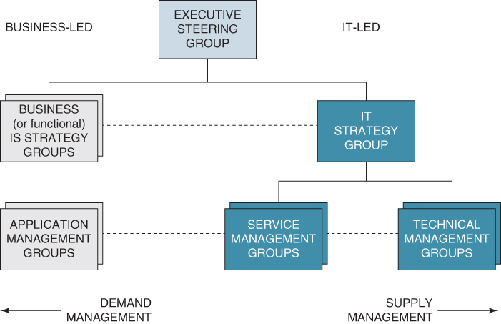
FIGURE 10.11 Steering organization for the strategic management of IS/IT.

BOX 10.6

Responsibilities for IS/IT within the governance structure
Executive Steering group
- ♦ Interpreting business strategy and agreeing overall IS/IT policies.
- ♦ Establishing priorities, agreeing resource and expense levels, authorizing major investments.
- ♦ Ensuring that strategic applications are identified and achieve their objectives and business benefits.
- ♦ Establishing the appropriate organizational responsibilities and relationships.
- ♦ Ensuring the IS/IT capability is aligned to the needs of the future business strategy.
Although it should include senior IT managers, it is critical that an IT person does not chair the group. Leadership must come from the business, preferably from the chief executive or a highly respected nominee. The group should meet regularly, but not too frequently – probably four to six times per year and they must be willing to stop activities and cancel projects as well as initiate them. Its processes should be open not secret and it should ensure both successes and failures are recognized.
Business Unit (or Functional) IS Strategy groups
- ♦ Identifying business needs, assessing opportunities and threats and IS implications in that business area and producing and managing the IS strategy for the business area.
- ♦ Prioritizing, planning and coordinating IS activities, budgets and expenditure in the area and ensuring planned benefits are delivered, by carrying out project progress and post-implementation reviews.
- ♦ Ensuring appropriate user resources are allocated to projects and appoint business project/programme and application managers.
Depending on the organization's structure, they may be established for each business unit or major function. The group must ensure that IS/IT investment business cases include all relevant costs, benefits and risk. It should also ensure that all the related business and organizational changes required are feasible and acceptable and that investment stakeholders and others affected understand what is expected to happen. Box 10.7 gives an extract from the terms of reference for such a group, established in one division of a global telecommunications provider.
Application Management groups (sometimes called Programme Management group)
- ♦ Identifying and specifying the needs, benefits, business resources and costs of applications and developing business cases to justify the investments.
- ♦ Managing the provisioning, development, implementation and ongoing use of applications and associated IT services to ensure benefits are maximized.
- ♦ Ensuring all business changes necessary to get the benefits are carried out.
- ♦ Ensuring that user resources are made available as needed and used effectively on projects.
One of the commonest reasons why projects fail in a business sense is that the project or programme manager is not a heavily committed, knowledgeable and able user.
IT Strategy group
- ♦ Interpreting IT trends and developments in the context of the organization's business.
- ♦ Ensuring resources are deployed to meet business priorities.
- ♦ Developing IT capabilities, resources and services in line with business IS plans and monitoring the performance of those resources.
- ♦ Planning and managing the supply of technology and specialist bought-in services.
- ♦ Ensuring technical risks are minimized.
- ♦ Producing and managing the IT strategy for the organization.
The IT Steering group should direct the activities of the service and technical groups, which are probably line functions or departments rather than ‘groups’, and should be responsible for determining the appropriate sources of supply for technology and other resources. The management of the IT strategy and technology supply is considered in more detail in Chapter 11.
Service Management groups
- ♦ Translating business needs into technical requirements and resource implications.
- ♦ Selecting the optimum means of meeting the business needs.
- ♦ Monitoring performance against budgets/service levels agreed with the business.
- ♦ Ensuring technical solutions are tested and quality assured to avoid application failure.
- ♦ Planning the development of services and resources to meet evolving demands.
- ♦ Monitoring the performance of external suppliers of applications and services.
The quality of the relationship between user-biased application management and IT-biased service management groups will determine not only how well applications are managed during development and implementation but also whether the best application provisioning approach is adopted. The ability of service and technical management groups to work together will determine whether technology is employed on the basis of what it does for the business, rather than just what it does!
Technology Management groups
- ♦ Monitoring and understanding technology developments, formulating options and communicating the implications.
- ♦ Assessing the capabilities and risks of new technologies and IT service providers against known and potential needs.
- ♦ Planning and managing infrastructure developments and migrations to minimize the risk to business applications.
- ♦ Resolving technical problems and contractual issues with suppliers and ensuring service groups are effectively supported.
- ♦ Establishing technology policies and best practices to prevent potential failures and consequent business risks.
Even when much of the infrastructure and IT service provision is outsourced, technical specialists can have a very important role in the organization, but they and business-oriented users often fail to communicate. The service groups are the interpreters in both directions, capable of understanding the languages of both business and technology.

BOX 10.7

Extract from the terms of reference for Systems Strategy Control Board in a division of a Global Telecommunications provider

1. Purpose
The primary purpose of the Systems Strategy Control Board (SSCB) is to ensure that the Division's business objectives are effectively supported by systems and processes. It also reviews the proposals and business cases of all projects requiring computing and systems development expenditure over 100,000 euro, as defined in the Division's Business Case process. Project Managers and Financial Controllers are jointly responsible for ensuring that all business cases of projects requiring information systems related expenditure over 100,000 euro have received SSCB concurrence.
In addition the SSCB:
- ♦ sets the overall Systems Policy, where there needs to be a subset of the corporate Systems Policy as set by the Group Information Board* (of which the SSCB Chairperson is a member);
- ♦ determines the criteria for the prioritization of the Division's Systems Budgets, including recommending and allocating the budgets across the Divisional units in conjunction with the Finance Division;
- ♦ ensures that the computing operations and systems development requirements are fed into the 5 year business planning process; and
- ♦ reviews internal trading agreements with our Group IS and systems suppliers and evaluates their performance.

2. Scope
The Systems Strategy Control Board has a Division-wide remit to address all aspects of information systems owned by or on behalf of the Division. This covers all IT systems charged to the Division by the central IS Group via Computing Operations Revenue Apportionment (CORA) and information systems development. The SSCB is complemented by the Service Development Forum, which should identify the impact on systems of the product and service portfolio and of marketing campaigns.

3. Responsibilities (Examples)
The main responsibilities of the Board are as follows:
- ♦ to determine the strategic direction for systems and business processes;
- ♦ to ensure our information is owned and managed as a corporate resource, to defined standards;
- ♦ to validate major system project proposals, including the business cases;
- ♦ to identify links and dependencies between projects and so recommend programme structures;
- ♦ to continually review the validity of the systems investments made (start, stop or amend); and
- ♦ to monitor and report on the performance of Group IS and [name of outsourcing vendor] computing systems and development suppliers on behalf of the Division.

4. Representation (Examples)
The SSCB is chaired by Division's Head of Systems, with representation from those within the Divisional units responsible for systems delivery and/or systems expenditure, including Business Planning. The individual responsibilities include:
- ♦ representing their specific unit and ensuring that Board decisions are implemented in the unit;
- ♦ participation in priority setting and budget allocation; and
- ♦ supporting the Supplier Evaluation process.

5. Meetings

Frequency
The Systems Strategy Control Board meets bi-monthly unless otherwise agreed.

Attendance
It is anticipated that attendance by the specified representatives will be given a high priority and that wherever possible the requirement to attend should be embodied within the representatives' job descriptions. Where absence is unavoidable, a representative will send their nominated deputy, fully briefed, including the status of any action points outstanding. The deputy will be fully empowered to represent their Control Board member.
Decisions taken at the Board will be fully binding where absence results in no representation.
The Control Board members will invite appropriate Project Managers to attend meetings to assist in decision making or to obtain a full progress report.
* Another coordinating mechanism, at Group level
This structure or model brings together a number of facets of IS/IT strategic management:
- top management involvement where it is most useful (i.e. adds most value);
- business and IT balance in determining strategy;
- demand and supply management;
- strategy, planning and implementation requirements;
- exploitation of ideas generated from anywhere;
- command and control in effecting policy decisions;
- an organization-led approach to developing strategies and portfolio management;
- consistency over time in developing and implementing strategies;
- an ability to learn from and transfer experience.
Using the model in evaluating the strategic management of IS/IT in many organizations, it is clear that if one or more of the ‘boxes’ is missing, ineffective or not linked properly to related functions, then either strategies are not being developed or they are not being implemented. Organizations will typically need variations of this model, depending on size, diversity or otherwise of the business, degree of corporate control exercised, the stage of IS/IT maturity and the variety and sophistication of applications and technologies deployed.

3. Functional Instruments
These instruments outline the degree to which IS/IT decision making follows specified processes, rules and procedures. Formal organizational and managerial processes determine how decisions are to be reached, who should be involved and timescales. In a devolved environment, there is a particular need to define policies for decision-making rules and options, including the amount of discretion managers have when making decisions.
The key to defining a workable set of policies is to recognize that there are two categories of policy: restraining policies, which define the parameters within which decisions are made, and enabling policies, which essentially relate to the dissemination of best practice. Table 10.4 presents examples of each.
TABLE 10.4Restraining and enabling policies
Restraining policies | Enabling policies
- ♦ Technical compatibility standards  - ♦ Standards for buying equipment and services  - ♦ Common systems mandate  - ♦ Disaster recovery, security and quality  - ♦ Group systems standards  - ♦ Group job specifications  - ♦ Any conformance to industry standards  - ♦ Outside revenue earning ability of IS function  - ♦ Charge-out and benefit reclaim  - ♦ Ergonomic standards  - ♦ Staffing levels | - ♦ Making group-resourced services available to business units  - ♦ Negotiating volume discounts  - ♦ Managing supplier relationships  - ♦ Influencing behaviour through charge-out rules  - ♦ Setting criteria for selecting common systems  - ♦ Funding shared assets  - ♦ Establishing tendering procedures  - ♦ Developing common systems  - ♦ Using consultants  - ♦ Carrying out post-implementation reviews  - ♦ Negotiating group-wide technology agreements
Box 10.8 describes the ‘restraining’ security policy at a UK energy company.

BOX 10.8

Information security policy at a UK energy company
The Information Security Team of a UK energy company, part of the Information Management Department, established 12 ‘Golden Rules’ of information security. These are:
- Never share your accounts or passwords with anyone else.
- Report any suspicious activity to your manager or Information Security Team or the IM Service Desk.
- Observe the information security policies and standards and if in doubt ask a manager or contact the Information Security Team.
- Change your passwords regularly and avoid using obvious words.
- Handle information according to its classification.
- Observe a clear desk policy and lock up sensitive files when away from your desk.
- Never leave your PC/iPad without applying the password/lock screen saver.
- Always use virus-checking facilities when taking media (CDs, USB sticks, etc.) on to sites before use and prior to removing them from site.
- Never modify the configuration of any equipment without prior authorization.
- Never discuss the security arrangements of system to unauthorized staff or anyone else not connected with the company.
- Make sure you store your information on network servers that are being automatically backed up. If not, you must arrange back-ups yourself.
- Do not leave portable equipment or documents in your car. If you must leave them unattended, ensure that they are locked away in the boot.
Where IT infrastructure and services are provided from a central resource, one decision that will often need to be made is how users will be charged for these – a charge-back policy. Charge-back is effectively a pricing mechanism that can be used to influence how managers and users behave regarding the usage of IT resources and services. It is based on the premise that if IT services are perceived as being ‘free’, managers and users may not understand or be concerned with the cost to the organization of providing these services, particularly in relation to the value gained from using them. However, if users are ‘charged’ for using services, the implication is that they will be ‘dissuaded’ from unnecessary or careless usage. Table 10.5 illustrates the different types of charge-back strategies and their pros and cons. However, one of the key challenges in implementing a charge-back system is the time and cost involved, which can often far exceed the benefits being sought.
TABLE 10.5Comparison of common charge-back strategies
Charge-back strategy | Pros (+) and Cons (−)
No billing for services | + Minimal negotiation required
No billing for services | − Minimal customer pressure to reduce costs or to use outsourced services
No billing for services | − No limit on demand for services
No billing for services | − No user consequence for unrealistic expectations since no visible impact on costs
Allocation of service costs | + Easy to administer
Allocation of service costs | + Controlled by service provider
Allocation of service costs | − User affected by service inefficiencies but no visibility of impact
Allocation of service costs | − No relationship between services used and cost to user
Fixed price based on past usage | + Easy to administer
Fixed price based on past usage | + Minimal negotiation required
Fixed price based on past usage | − Minimal relationship between current services used and costs to users
Fixed price based on past usage | − Limited incentive for service provider to reduce costs
Fixed price based on past usage | − Changing or unpredictable volumes can create problems for service provider
Direct charging based on usage | + Establish direct relationship between services used and costs to users
Direct charging based on usage | + Users share accountability for service costs
Direct charging based on usage | + Increased pressure on service provider to reduce costs and ensure they are in line with alternative providers
Direct charging based on usage | − Pricing and billing can be complex and expensive to administer
Direct charging based on usage | − More complex relationship between provider and users
One study of IT charge-back systems at 10 organizations looked at their impacts on business managers' economic decisions and on evaluations of IT and business unit performance.⁴¹ Respondents in just 4 of the 10 firms reported that charge-back significantly influenced IT investment decisions. In addition, the business unit respondents at those firms offered more positive assessment of IT than their counterparts at other sites. What was different in these four firms was that charge-back was being used to foster communications between the IT function and the business units. This communication was generating a shared understanding for both parties of the cost and benefits of alternative IT investments and service offerings.⁴² The analysis suggests that IT units in just 4 of the 10 firms were tapping into the potential of charge-back to facilitate the development of a partnership with their business unit counterparts.

4. Instruments for Social Integration
These instruments seek to achieve a shared understanding amongst stakeholders. They focus on developing a common language, mutual understanding and awareness across all employees in the organization. Mechanisms include education events and other measures which bring together IT and non-IT staff. Communication processes are also a key mechanism of social integration. All are an important part of facilitating the integration and coordination of knowledge that is dispersed throughout the organization.
Social integration is primarily about the active participation of key stakeholders in IT decision-making processes, which requires a shared understanding between business and IS/IT professionals and managers. For example, if senior management believe that IT is a cost to be minimized, this will greatly influence their willingness to be involved in IT decision-making processes and assume responsibility for IT decisions. Similarly, if business managers believe it is the role of the IT function to deliver IT projects and the attendant business benefits, then they will take little, if any, responsibility for IS/IT implementation.
Attitudes about IT, particularly among executive managers, can set the tone for the nature of business engagement and involvement in IS/IT-related matters, including decision making. Education events can be a powerful mechanism in shaping attitudes and thus facilitating social integration. The experiences of one airline are illustrative of the usefulness of educational events. According to the CIO:
“It goes back to a former company chief information officer, who created a large number of educational events bringing in top external speakers to talk to the management community of the company and explain what could be done with information technology. It was called ‘The Catalyst Program’. To win senior executive understanding of IT the CIO must take the initiative and show their senior managers what can be achieved.”
Working relationships also play a key part: both business and IS/IT specialists must work in harmony, not only in developing the IS/IT strategy but also in its implementation and the delivery of business benefits.⁴³ Based on his research work, Henderson⁴⁴ suggested two types of ‘partnerships’ that can be developed to achieve effective working relationships between line managers and IS/IT managers and specialists. The partnerships are based on the argument that performance can be significantly improved through joint, mutually dependent action. The two types of partnership are:
- Partnership in context: in which the partners believe that the partnership will be sustained over time, which depends on the extent to which they see mutual benefits from working together, and have shared goals and assumptions leading to mutual trust.
- Partnership in action: which is the ability of the partners to influence policies and decisions that affect the operational performance of the partnership and the key factors that create good day-to-day working relationships, such as understanding how others work, shared processes, interdependence of resources, skills and knowledge and personal relationships.
Actions that can help build and sustain these partnerships include:
- education: skills transfer and training; general education; social events;
- joint planning: ongoing, iterative; negotiate mutual benefits; create common goals;
- measurement and control: jointly designed and implemented; effective benchmarking; provision of operational and performance data;
- effective use of teams: coordinate diverse knowledge; create social networks; create stability;
- multilevel human resource strategy: actions address all levels of the organization; select and assign key personnel.
As organizations increasingly outsource IT supply, the quality of relationships with vendors also becomes paramount in ensuring continued success. This is a critical risk factor associated with outsourcing and requires continual management attention, an issue that is considered further in Chapter 11.
A frequently encountered phenomenon is the ‘culture gap’ between the IS/IT organization and the rest of the business. Organizations are not culturally holistic – they contain subcultures often associated with functional specialism or geographic location. Information technology as a functional specialism has been introduced to most organizations during the past 40 years or so, and with it a new subculture – one that is often difficult to reconcile or integrate with the dominant culture in the organization.⁴⁵
The culture gap is a deep-rooted, even intractable, problem in many organizations. From a rational perspective, the approaches to creating the IS/IT capabilities and coordinating structures outlined in this chapter are attempts to close or bridge the gap. Matching IT services to the different nature of business requirements and application use in the portfolio segments can also reduce gaps at an operational level. The steering group structure attempts to allocate the decision-making and planning processes to the most appropriate place and level in the organization, and provide the means for reconciling contention.
However, cultural issues are as much about beliefs and perceptions as about rational views and intellectual consensus. Before the ideal congruence of shared values between IS/IT and business managers and professionals can be achieved, the reasons for lack of congruence need to be understood. One way of doing this is to use a mapping technique known as ‘the cultural web’.⁴⁶ The purpose is to enable business and IT people to describe their perceptions of the relationship as a starting point for reconciliation, through changing either the way business people work with IT specialists or, more commonly, vice versa. In most situations, change is required on both sides: business people understanding the need for structure and discipline in IS/IT to avoid expensive failure; IT specialists appreciating the importance of responsiveness to external pressures and accepting the degrees of uncertainty and the often ambiguous nature of business decisions. Box 10.9 describes the dimensions of the cultural web and illustrates how it was used by one pharmaceutical company.

BOX 10.9

The cultural web and its application to exploring the culture gap between IS/IT organization and rest of the business
The cultural web is a tool devised by Gerry Johnsonª to assess the culture of an organization. While individuals may hold different sets of beliefs, there is at some level a core set of values, beliefs and assumptions commonly held throughout the organization. This is referred to by Johnson as ‘the paradigm’. The paradigm governs and influences an organization's view of itself and its environment. It is through this paradigm that an organization creates a relatively homogeneous approach to business. As it evolves through time and is reinforced by history, it sets out a repertoire of actions and responses that can be made in certain situations. The paradigm is protected by a ‘web’ of what Johnson refers to as cultural artefacts. These are described as follows:
- Stories and myths: In every organization there are stories, some true, others either variations of the truth or simply myths. Examples are the big IT failures, the products that flopped, the legendary leaders and mavericks. In particular, new employees hear stories about those who broke the cultural norms and the consequences of their actions. Most have evolved over the years and have become part of the organization's folklore. What stories do is legitimize types of behaviours and are devices for telling people what's important in the organization. Like the fisherman's stories of ever larger fish, these stories can be rapidly distorted by the workings of the grapevine.
- Symbols: All organizations have their symbols, although they are often so ingrained that they may not be recognized. The dress code, the furniture, executive parking spaces are all symbols. At one particular insurance company there were different levels of staff canteen and more senior staff were allowed to travel first class on trains and business class on planes. Symbols also include company-specific language which reinforces entrenched attitudes, like not addressing senior managers by their first names.
- Rituals and routines: Rituals are those aspects of organizational life that hold special significance and may include the monthly board meeting, the annual company barbecue, even singing the company song! Routines refer to ‘the way we do things here’ and incorporate the core activities which the organization traditionally undertakes.
- Control systems: Organizations have particular control systems to monitor and encourage performance. Pay, incentive and reward systems, budgetary control systems and the management hierarchy are all examples of such systems. They serve to highlight what is valued by the organization.
- Organizational structures: Functions, departments, geographically based business units, product-based business units, flat management hierarchies or large bureaucratic hierarchies are all examples of how the structure of an organization impacts the paradigm.
- Power structures: Power lies with influence, particularly where such influence can reduce uncertainty. The power structures tend to reinforce the paradigm and hence they are often targets for change. This is particularly difficult given that those who may be required to change often hold the power.
In attempting to change their culture many organizations manipulate the ‘hard’ elements of the web, i.e. the power structures, the control systems and the organizational structures, neglecting to address the less tangible elements. This is a mistake. All elements of the web must be examined and acted on if culture change is to take place and this change translated into tangible action and results.
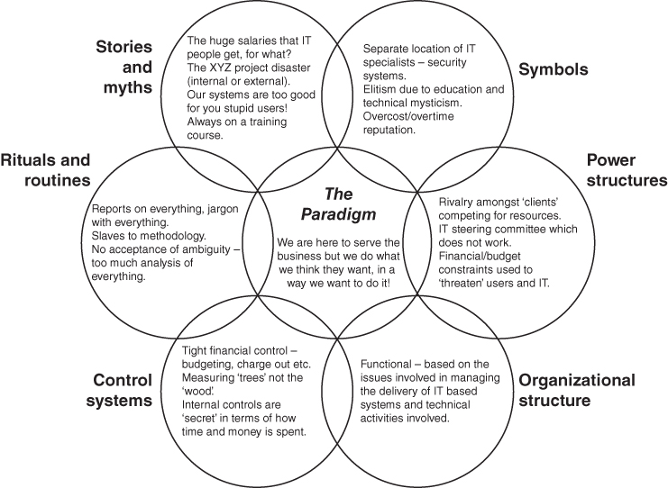
The cultural web of the IS/IT organization at a global pharmaceutical company.
Source: from J.M. Ward and J.W. Peppard, ‘Reconciling the IT/business relationship: A troubled marriage in need of guidance’, Journal of Strategic Information Systems, 5, 1, 1996, 37–65.
The web illustrated above was derived from data collected from a global pharmaceutical organization that had sought to bring both IS/IT staff and business staff closer together.^{b} From the analysis, it was evident that the organization had worked hard at restructuring its IS/IT function, improving the control of activities and getting line managers involved in decision making about IS. However, the symbols, stories and rituals, the ‘softer’ elements as perceived from ‘the business’ viewpoint, had changed little over this time. Senior management were unaware of this and the impact that it had on the ability of IS, and in particular the IS function, to work effectively in the organization.
Notes:
ª G. Johnson, ‘Managing strategic change – strategy, culture and action’, Long Range Planning, 25, 1, 1992, 28–36.
^{b} Detailed coverage of cultural web analysis can be found in G. Johnson, ‘Mapping and re-mapping organisational culture’, in V. Ambrosini with G. Johnson and K. Scholes, eds, Exploring Techniques of Analysis and Evaluation in Strategic Management, Prentice Hall, Hemel Hempstead, 1998.
Outsourcing has introduced an additional set of issues. One all too frequently used solution to an unsatisfactory IT/business relationship is to outsource the IS/IT organization in significant part, or in total, to an outside supplier. While a complex set of issues are trivialized by simple generalizations, it can be observed that many IS/IT units that have been physically outsourced were effectively ‘culturally outsourced’ (i.e. not considered as an integral, strategic component of the organization) long before a convenient event, offer or excuse caused the actual severance. This observation is verified to some extent by research⁴⁷ that shows that, although organizations quoted many reasons for outsourcing IT, a main reason for selecting a particular supplier was ‘cultural fit’.

Summary
It is obviously important to devise appropriate business-based IS strategies and then appropriate IT supply strategies. But, merely having these strategies is not going to lead to business success. Implementing and then updating them as the business progresses is essential to success and structures, capabilities and mechanisms must be put in place to ensure that happens. A number of these are considered in this chapter – primarily those concerning the positioning of IS/IT resources in the business, understanding the competences required to have a strategic IS/IT capability and ways of ensuring that decisions about both demand and supply options are made by the appropriate people – IS/IT governance. Given the complex and important issues involved, a range of governance instruments may be necessary, as described in this chapter.
One conclusion is that, except perhaps in the simplest businesses, there is as yet no ideal organization structure for IS/IT strategic management or position for IS/IT resources within the business structure. This should perhaps not be surprising given the rapidly changing nature and business importance of IS/IT. Many general managers perhaps wish the IS/IT strategic management ‘problem’ might go away or could be outsourced, but it will not, even if the organization relies on the capabilities of others to deliver most of its applications, IT services and infrastructure. Aligning the IS/IT strategy with the business strategy, choosing the most beneficial applications, making changes to the conduct of the business to exploit their potential and using them effectively cannot be outsourced.
Other issues concerning IS/IT that senior management would perhaps prefer went away are those due to the specialist people IS/IT involves, who often do not fit comfortably with the culture of the company. But experienced, capable people with the requisite knowledge and skills are becoming in ever shorter supply, and without them business objectives may become unachievable. Strategies for ensuring that these critical resources are retained and developed are an essential part of the management strategy.
Establishing the organizing framework for the strategic management of IS/IT is not an event but needs to be an ongoing evolving activity to keep up with the accelerating rates of change both in technology and competitive dynamics. Some large organizations have even established ways of continually monitoring the suitability of the IS/IT organization arrangements and governance and addressing any oversight issues or adjudicate conflicts. A number of organizations have established IT Governance Councils or an Office of IT Governance for this purpose. At the European automotive manufacturer described in Box 10.5, it is the Group Information Council.
These organizational and resourcing issues in IS/IT strategic management are those that become very critical during strategy implementation. If they are ignored or dealt with ineffectively by the senior management of the enterprise, it can lead to the failure to achieve what was a perfectly feasible strategy.

Endnotes
- 1. M.J. Earl, ‘Integrating IS and the organization: A framework of organizational fit’, in M.J. Earl, ed., Information Management: The Organizational Dimension, Oxford University Press, Oxford, 1996, 485–502.2. R.E. Dvorak, E. Holen, D. Mark and W.F. Meehan, ‘Six principles of high-performance IT’, The McKinsey Quarterly, No. 3, 1997, 164–177; T.C. Powell and A. Dent-Micallef, ‘Information technology as competitive advantage: the role of human, business and technology resources’, Strategic Management Journal, 18, 5, 1997, 375–405; J.W. Ross, C. Mathis Beath and D. Goodhue, ‘Develop long-term competitiveness through IT assets’, Sloan Management Review, Fall, 1996, 31–42.3. P.G.W. Keen, ‘Information technology and the management difference: A fusion map’, IBM Systems Journal, 32, 1, 1993, 17–39.4. N.G. Carr, ‘IT doesn't matter’, Harvard Business Review, May, 2003, 5–12.5. There is much written about how the benefits from IT investments come about from the organizational and other changes that are enabled and shaped by IT. See M.L. Markus and R.I. Benjamin, ‘The magic bullet theory of IT-enabled transformation’, Sloan Management Review (38:2), 1997, 55–68; and A. Hughes and M.S. Scott Morton, ‘The transforming power of complementary assets’, MIT Sloan Management Review, Summer, 2006, 50–58. For an illustration of an organizational process for realizing the business value of information technology, see R. Kohli and S. Devaraj, ‘Realizing the business value of information technology investments: an organizational process’, MIS Quarterly Executive, 3, 1, 2004, 53–68. For empirical evidence see S. Devaraj, S. and R. Kohli, ‘Performance Impacts of Information Technology: Is Actual Usage the Missing Link’, Management Science, 49, 3, 2003, 273–289.6. See J.W. Ross, and P. Weill, ‘Six IT decisions your IT people shouldn't make’, Harvard Business Review, November, 2002, 85–91.7. For a study exploring CIO position in the organization and company performance see R. Banker, N. Hu, P. Pavlou and J. Luftman, ‘CIO reporting structure, strategic positioning, and firm performance’, MIS Quarterly, 35, 2, 2011, 487–504. See also Q. Hu, A.A. Yayla and Y. Lei, ‘Does inclusion of CIO in top team impact firm performance? Evidence from a long-term event analysis’, in Proceedings of 47th Hawaii International Conference on Systems Science, 2014.8. Soh and Markus have presented a useful theoretical model explaining the steps involved in linking IT investment to business performance. The model captures the major ingredients of the recipe for transforming IT investments into improved organizational performance and highlights the criticality of the ‘use process’. See C. Soh and L. Markus, ‘How IT creates business value’, in Proceedings of the 16th Annual International Conference on Information Systems, Amsterdam, The Netherlands, 1995, 29–41.9. See A. Hughes and M.S. Scott Morton, ‘The transforming power of complementary assets’, MIT Sloan Management Review, Summer, 2006, 50–58; and J. Peppard, J. Ward and E. Daniel, ‘Managing the realization of business benefits from IT investments’, MIS Quarterly Executive, 6, 1, 2007, 1–11.10. R. Amit and P.J.H. Schoemaker, ‘Strategic assets and organizational rent’, Strategic Management Journal, 14, 1993, 33–46. Resources themselves can be defined as ‘stocks of available factors that are owned or controlled by the firm’. Despite being essentially a theory concerned with organizational resources, it is perhaps indicative of the lack of clarity within the RBT literature that even at the level of resource confusion reigns, with statements like ‘…a valuable resource may be an organizational capability…’ (Collis and Montgomery, 1995, p. 120); or portraying a firm’s resources as including ‘all assets, competences, organizational processes, firm attributes, information, and knowledge that enables a firm to conceive of and implement strategies that improve its efficiency and effectiveness’ (Barney, 1991). See D.J. Collis and C.A. Montgomery, 1995, Competing on resources: strategy in the 1990s, Harvard Business Review, July–August, 118–128; and J.B. Barney, ‘Firm resources and sustained competitive advantage’, Journal of Management, 17, 1991, 99–120.11. J. Peppard, R. Lambert and C. Edwards, ‘Whose job is it Anyway?: organizational information competences for value creation’, Information Systems Journal, 10, 4, 2000, 291–323.12. P. Cragg, M. Caldeira and J.M. Ward, ‘Organizational IS competences for SMEs’, Information and Management, 48, 8, 2011, 353–363.13. J. Peppard and J. Ward, ‘Beyond strategic information systems: towards an IS capability,' Journal of Strategic Information Systems, 13, 2, 2004, 167–194.14. K. Kangas, ‘Competency and capabilities based competition and the role of information technology: the case of trading by a Finland-based firm to Russia’, Journal of Information Technology Cases and Applications, 1, 2, 1999, 4–22; and B. Moingeon, B. Ramanantsoa, E. Métais and J.D. Orton, ‘Another look at strategy – structure relationships: the resource-based view’, European Management Journal, 16, 3, 1998, 298–304.15. R.G. McGrath, I.C. MacMillan and S. Venkatraman, ‘Defining and developing competence: a strategic process paradigm’, Strategic Management Journal, 16, 1995, 251–275; and D.J. Teece, G. Pisano and A. Shuen, ‘Dynamic capabilities and strategic management’, Strategic Management Journal, 18, 1997, 509–533.16. Adapted from M.M. Caldeira and J.M. Ward, ‘Using resource-based theory to interpret the successful adoption and use of information systems and technology in manufacturing small and medium-sized enterprises’, European Journal of Information Systems, 12, 2, 2003, 127–141.17. G. Graen, ‘Role-making processes within complex organizations’, in M.D. Dunnette, ed., Handbook of Industrial and Organizational Psychology, Rand McNally, College Publishing Company, Chicago, Il, 1976, 1201–1245.18. D. Katz and R.L. Kahn, The Social Psychology of Organizations, 2nd Edition, John Wiley & Sons, New York, NY, 1978.19. D.J. Cherrington, Organizational Behavior: The Management of Individual and Organizational Performance, 2nd Edition, Allyn & Bacon, Massachusetts, 1994.20. L. Mullins, Management and Organisational Behaviour, 3rd Edition, Pitman Publishing, London, 1993, 186.21. R.M. Belbin, Team Roles at Work, Butterworth-Heinemann, Oxford, UK, 1993; D. Katz and R.L. Kahn, The Social Psychology of Organizations, 2nd Edition, John Wiley & Sons, New York, NY, 1978; A.H. Maslow, Motivation and Personality, 3rd Edition, Harper & Row, New York, 1987; B.M. Staw, ‘Dressing up like an organization: when psychological theories can explain organization action’, Journal of Management, 17, 4, 1991, 805–819; and K.E. Weick, The Social Psychology of Organizing, 2nd Edition, Addison-Wesley, Reading MA, 1979.22. The notion of governance is not new. In his classic article on the nature of the firm, the economist Ronald Coase conceived of the firm as a governance structure, breaking with orthodox accounts of the firm as a ‘black box’ production function. See R. Coase, ‘The nature of the firm’, Economica, 4, 1937, 386–405. The concepts of principal and agent, bound up in agency theory, presents a theoretical treaties of the distinction between owners and managers. See M.C. Jensen and W.H. Meckling, ‘Theory of the firm, managerial costs and ownership structure’, Journal of Financial Economics, Vol. III, 1976, 305–360.23. See S. Huff, P.M. Maher and M. Munro, ‘Information Technology and the Board of Directors: Is there an IT Attention Deficit?’, MISQ Executive, 5, 2, 2006, 1–44; and M. Parent and B. Horner Reich, ‘Governing information technology risk’, California Management Review, 51, 3, 2009, 7–25.24. P. Weill, P. and J. Ross, IT Governance: How Top Performers Manage IT Decision Rights for Superior Results, Harvard Business School Press, Boston, 2004. See also, R. Peterson, ‘Crafting information technology governance’, Information Systems Management, Fall, 2004, 7–22.25. F. Schlosser, D. Beimborn, T. Weitzel and H.T. Wagner, ‘Achieving Social alignment between business and IT – an empirical evaluation of the efficacy of IT governance mechanisms’, Journal of Information Technology, 30, 2015, 119–135.26. The case study of FedEx illustrates this starkly. See S. Viaene and S. De Hertogh, ‘Enterprise-wide business-IT engagement in an empowered business environment: the case of FedEx Express EMEA’, Journal of Information Technology, 25, 2010, 323–332.27. J. Rockart, ‘The line takes the leadership: IS management in a wired society’, Sloan Management Review, 29, 4, 1988, 57–64.28. For an example of such a programme and an assessment of its impact see B.C. Wheeler, G.M. Marakas and P. Brickley, ‘From back office to boardroom: repositioning global IT by educating the line to lead at British American Tobacco’, MISQ Executive, 1, 1, 2002, 42–62.29. M.J. Earl, B. Edwards and D.F. Feeny, ‘Configuring the IS function in complex organizations’, in M.J. Earl, ed., Information Management: The Organisational Dimensions, Oxford University Press, New York, 1996, 201–230.30. Shadow IT is a term often used to describe IS/IT systems and IT solutions built and used inside organizations without explicit organizational approval. It is also used, along with the term ‘Stealth IT’, to describe solutions specified and deployed by departments other than the IT department.31. M.B. Mohdzain and J.M. Ward, ‘A study of subsidiaries’ views of information systems strategic planning in multinational organizations', Journal of Strategic Information Systems, 16, 2007, 324–35.32. S.L. Hodgkinson, ‘The role of the corporate IT function in the federal IT organisation’, in Information Management: The Organisational Dimension (ed. M.J. Earl), Oxford University Press, New York, 1996, 247–269.33. An acronym for a project management methodology: Projects IN Controlled Environments.34. COBIT stands for Control Objectives for Information and Related Technology (COBIT), a framework created by ISACA for information technology (IT) management and IT governance. It is a supporting toolset that allows managers to bridge the gap between control requirements, technical issues and business risks. The COBIT 5 Framework covers most aspects of IT supply management.35. ITIL (formerly known as the Information Technology Infrastructure Library) is a set of practices for IT service management that focuses on aligning IT services with the needs of business. In its current form (known as ITIL 2011 edition), ITIL is published as a series of five core volumes, each of which covers a different ITSM life cycle stage.36. IT Governance Institute, Enterprise Value Governance of IT Investments: The Val IT Framework 2.0, IT Governance Institute, Rolling Meadows, IL, USA, 2008.37. C.S. Iacono, M. Subramani and J.C. Henderson, ‘Entrepreneur or intermediary: the nature of the relationship manager's job’, in Proceedings of the Sixteenth International Conference on Information Systems, 1995, 289–299.38. M.J. Earl, Management Strategies for Information Technology, Prentice-Hall, Englewood Cliffs, New Jersey, 1989.39. Y.P. Gupta and T.S. Raghunathan, ‘Impact of information systems steering committees on IS planning’, Decision Sciences, Fall, 1989, 20, 4, 777–793.40. For example, R.D. Galliers, Y. Merali and L. Spearing, ‘Coping with information technology? How British executives perceive the key information systems management issues in the mid 1990s’, Journal of Information Technology, 9, 3, 1994, 223–238.41. J. Ross, M. Vitale and C. Beath, ‘The untapped potential of IT chargeback’, MIS Quarterly, 23, 2, 1999, 215–237.42. Research that has studied alignment between business and IS/IT strategies also reports that when high levels of communication between business and IT executives were observed, alignment was assessed as being high. See B.H. Reich and I. Benbasat, ‘Factors that Influence the social dimension of alignment between business and information technology objectives’, MIS Quarterly, 24, 1, 2000, 81–113.43. See J. Peppard, J. Ward and E. Daniel, ‘Managing the realization of business benefits from IT investments’, MIS Quarterly Executive, 6, 1, 2007, 1–11; and R.R. Nelson, ‘IT project management: infamous failures, classic mistakes and best practices’, MIS Quarterly Executive, 6, 2, 2007, 67–78.44. J.C. Henderson, ‘Plugging into strategic partnerships: the critical IS connection’, Sloan Management Review, 31, 3, 1990, 7–18.45. E.H. Schein, Organizational Culture and Leadership, Jossey-Bass, San Francisco, 1992 (Chapter 12, ‘Management and information technology: Two subcultures in collision?’, 276–294).46. For a description of how this can be done see J.M. Ward and J.W. Peppard, ‘Reconciling the IT/business relationship: A troubled marriage in need of guidance’, Journal of Strategic Information Systems, 5, 1, 1996, 37–65.47. G. Fitzgerald and V. Mitchell, ‘The IT outsourcing marketplace: Vendors and their selection’, paper presented at The Management Challenges of IT Conference, Cranfield School of Management, Cranfield, Bedford, UK, July 1994.

UNIT 11
STRATEGIC MANAGEMENT OF IS/IT SERVICES AND IT INFRASTRUCTURE

OUTLINE
- ♦ Creating and Sustaining Business Change: Projects and Services
- ♦ The Need for the Strategic Management of IS/IT Services and IT Infrastructure
- ♦ IS/IT Service Categories
- ♦ Managing Operational and Value-enabling Services
- ♦ Strategies for Managing IT Infrastructure and Infrastructure Services
- ♦ Understanding and Managing IT Risks
- ♦ Sourcing of IS/IT Resources and Services
- ♦ Business Process Outsourcing
- ♦ Innovation and Outsourcing
- ♦ Back-sourcing and Switching Suppliers
While this book is primarily about IS strategies, it is important that appropriate managerial frameworks and models guide decisions about the IT strategy. There are a number of critical aspects of the IT supply strategy that should not be made by the ‘techies’, but unfortunately many business managers shy away from discussion about IT, as they do not consider themselves as ‘technical’ or technically competent. However, the fundamental decisions regarding the IT supply strategy should not be driven by technological choices but by business imperatives. The increasing popularity of the use of ‘Digital Strategy’ for the combination of IS and IT strategies can compound this problem and increase the scope for potential opt out by managers who do not see themselves as ‘tech-savvy’. This chapter addresses the business issues that need to be considered in developing and managing the IT strategy, including making critical sourcing decisions.
IS/IT services and IT infrastructure can be provided by an in-house organization – or an external supplier or, most commonly today, by a combination of the two. Almost any aspect of IT supply can be outsourced and the marketplace for such services is both considerable and influential. Indeed, an ever-increasing percentage of most organizations' IS/IT services and infrastructure is being provided by external parties in order to improve IT economics (often by shifting spend from a capital expense to an operating expense), provide flexibility, deliver IT capabilities and obtain skills, competences and resources that cannot easily be provided in-house.
While outsourcing has been a major topic over the last 25 years, it has actually existed since organizational computing began in the 1960s. Primarily due to the high cost of early computers, many companies started using IT via bureau services provided by computer manufacturers. Using application software packages is a form of outsourcing, not only of the development of the software but also the design of the process models for the business activities and functions covered. Subcontracting of both programming and specialist design and implementation skills (including for integration) has long been a common practice and many organizations have employed IT consultants in a range of roles. Today, cloud computing offers a whole new range of outsourcing options ranging from applications to infrastructure.
One development over the last decade has been the rise of business process outsourcing (BPO), where companies outsource complete, normally ‘non-core’, business processes, such as policy administration in insurance and even cheque processing in some banks. BPO is typically categorized into back-office outsourcing, which includes business functions such as human resources or finance and accounting, and front-office outsourcing, which includes some customer-related services such as product and service reviews. Related is the ‘shared service’ concept – the provision of a centralized service, sometimes from an off-shore location, to all the companies or units in an organization. The funding and resourcing of the service is shared and the providing department effectively becomes an internal service provider.¹ The key here is the idea of ‘sharing’ within an organization or group, which includes shared accountability of business results by both the users and the provider of the service.
In this chapter IS/IT services are explored, leading to the development of a categorization scheme which enables a strategic, business-driven approach to their management to be developed. We also look at how the usefulness and quality of service can be assessed, in terms of the business contribution of IS/IT services, enabling decisions on investment and sourcing to be made more objectively. Later in the chapter, some of the business issues of importance in infrastructure management are discussed, before considering the strategic issues involved in making sourcing decisions and the management of outsourcing relationships, particularly in achieving innovation.

Creating and Sustaining Business Change: Projects and Services
We saw in Chapter 1 that an objective of the IS/IT strategy is to identify the portfolio of IS/IT investments, particularly applications, that will create strategic change as well as those that enable the business to continue to perform successfully (often referred to as ‘business as usual’ or ‘run the business’ investments). Some of the applications will already be in place; others will need to be developed or provisioned and any resultant organizational change managed if the expected benefits are to be achieved. A project or programme (a set of related projects and other activities) will usually be established for this purpose.
Any changes made during the project phase will have to be sustained by the services provided by the IS/IT assets and resources that were either in place or created by the projects. Figure 11.1 illustrates the relationship between projects and services. The right-hand side of the diagram shows the project cycle. Projects are initiated from the investment portfolio, normally based on a business case and expected overall contribution to the success of the organization. This assessment should also include an evaluation of the organization's capability to successfully deliver the project being proposed.
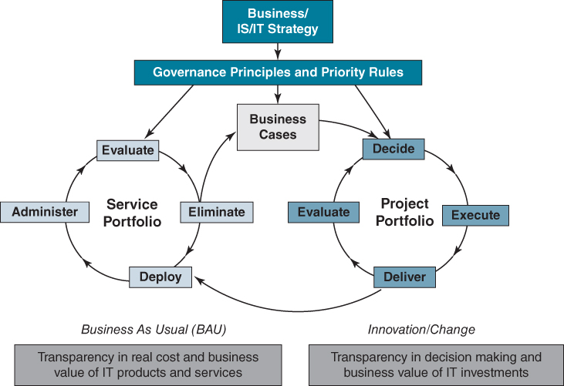
FIGURE 11.1 The relationship between IS/IT projects and services.
Source: S. De Haes, J. Peppard and W. Van Grembergen, ‘Theorizing enterprise governance of information technology through the lens of the viable systems model: the case of KLM’, manuscript under review.
A project is a structured set of activities – concerned with delivering a defined capability to an agreed timescale and cost. Delivering this capability generally requires both organizational and IS/IT changes to produce the business benefits that justified the investment and initiated the project. An IS/IT investment has a life cycle that sees it move from the project phase, where the focus is on delivering changes, to the services phase, where the emphasis is on embedding and sustaining the changes and the realization of expected benefits.

The Need for the Strategic Management of IS/IT Services and IT Infrastructure
That the IS/IT unit or external supplier provides a range of services has long been recognized in Service Level Agreements (SLAs) for aspects such as network uptime, availability, response times and help-desk support. However, two issues have driven the need to be more explicit about the management of services and infrastructure. First, most businesses now deliver some aspects of their product or service to customers via IS/IT, implying that the quality and performance of IS/IT services are visible, not only internally but externally, and directly affect the business performance and customer relationships. Second, as more and more aspects of service delivery are being outsourced, contracts with suppliers defining service availability, performance and cost are becoming integral to the management of IS/IT. If outsourcing decisions are to be based on objective, comparative data, then it is essential to apply the same rationale for measuring service performance levels delivered by in-house resources.
There is also the frequently encountered phenomenon, particularly with outsourcing, where all SLA metrics are reported as ‘green’² yet users are clearly unhappy. This highlights another set of issues with services: assessing services is not simply about comparing what is delivered against the SLA but is much more complex and multi-dimensional. The problem is often due to the difficulty in understanding and measuring the organizational benefits delivered from services – it is much easier to measure service deficiencies and costs. It can also arise because in many cases the service is more than a transaction or exchange (i.e. what SLAs typically measure) and the value derived is often dependent on how the user actually uses or experiences the service. The strategic management of IS/IT services and infrastructure requires an approach that focuses on both utility of service, as perceived by the user, and the value of the service to the organization.³ It has a number of key requirements:⁴
- to understand the utility end users receive by consuming or using the service and how this contributes to the value which the organization derives from the service;
- to understand how the service provider (i.e. personnel, technology and physical resources) and users can co-produce and deliver this utility and value;
- to understand how the supply strategy should be executed and managed so that the intended utility and value is achieved;
- to provide a blueprint for the operations of the IT organization so that the utility and value are achieved from all services provided or commissioned.
For the Chief Information Officer (CIO) and IT management, some of the peculiarities of services in an IS/IT context also need to be recognized as these can have a significant impact on user expectations and consequently their strategic management:
- There is often no competition (even when the service is outsourced). This can have implications for the quality of service provided, as the impetus for excellence may be absent. However, if the service fails to meet users' needs or is perceived as expensive, users may themselves look outside for future service provision – so-called ‘shadow IT’, where business areas bypass the existing service and go direct to an (or another) external provider.
- There is a general expectation of availability and high levels of service quality whenever required. This is particularly true when the service is provided by an in-house function and seen as a ‘corporate good’.
- Users can often be reluctant to pay for IS/IT services. Charging for internal services is an emotive issue, but as we saw in the previous chapter, mechanisms may be needed to ensure that they are not used inappropriately.
- Users often don't appreciate what is required in delivering the service – knowledge, skills and resources. We have previously noted that users also have a role to play in the successful delivery of many services and their lack of understanding of what is involved can impact not just the delivery process but also the ultimate outcome.
- Those who pay for the service, those who benefit from the service and those who participate in the service delivery process may be different. There may be a number of different stakeholders involved in the provision and use of any service, each with different expectations and requirements. Often it is the senior business management of organizations that negotiate and agree particular levels of service but it is the ‘front-line’ users who depend on these services in the performance of their jobs. In other instances, the IT organization may negotiate with a third-party supplier for a particular level of service, while the business user actually expects another. Later in the chapter a way of assessing critical gaps in service delivery is introduced.

Understanding Services in the Context of IS/IT
It seems that in the IT industry today, everything is a service!⁵ Yet, the few definitions or descriptions that can be found are imprecise at best. Even in service industries, few scholars or practitioners actually define what a service is, usually portraying a service as something that is not manufacturing.⁶ Our research and experience indicates that both business managers and IS/IT managers do have difficulty in articulating what exactly they mean and understand by IS/IT services, presenting obvious challenges for their management.
The concept of IS/IT services, as typically encountered in the IT industry and literature, includes configuration management, change management, release management, access control, security management and capacity management. There are also established industry frameworks for managing these types of services. For example, the ITIL⁷ IS Service Management framework has become an established platform for designing and managing IT services in an increasing number of organizations. It includes best practice processes for security management, service reporting, availability and contingency management, release management and incident management. But there are also other kinds of IS/IT service, such as those rendered by software and consulting, design, analysis and troubleshooting.
There are a number of distinguishing aspects of services in general and IS services (those associated with applications) and IT services (those associated with technology) in particular:
- IS/IT services are largely intangible. They are generally something one cannot touch or feel, although they may be associated with something physical, such as the provision of information through a computer screen, phone or tablet. There are other services that are even less tangible, such as advice and support from a help desk, IT training, contingency planning, consultancy, systems design, or upgrading server software.
- There can be high involvement of people in the delivery process. This involvement extends not just to those delivering the service but also to the users of the service. For example, developing software depends on users accurately defining their requirements as well as on the skill and competence of the development team in interpreting these requirements. Users may have to work through instructions relayed to them over the telephone from a help desk in order to resolve their problem. While people can be unpredictable in their behaviour, the design of the delivery process can influence the degree of discretion that both parties have within the process. In addition, the expectations of those involved in the delivery of the service, as well as those using it, can have a strong bearing on the quality and level of user satisfaction.
This has implications for the recruiting and training of IT staff that will be involved in the delivery of the service. For some services, like support or training, the delivery process can be just as important as the actual end result. This applies both internally and externally: outsourcing clients are not just ‘buying a service’ but are also making an implicit commitment to be involved in the delivery process. However, this aspect of outsourcing is often neglected.
- Many IS/IT services are at least to some extent produced and consumed simultaneously. For example, support from a help desk is generally provided and utilized immediately. Poor delivery, often referred to as a ‘bad customer experience’, can leave the recipient frustrated and create an impression that can affect any assessment of satisfaction and influence their perception of the service, long after the experience.
- Inability to place in inventory. Unlike physical products, services cannot be stored in an inventory and called off during busy periods. The management of demand and capacity is therefore of crucial importance in the provision of many services and ultimately in managing costs. Some services, such as maintenance, can be scheduled to take up the time of staff between projects.
IS/IT services can also be either visible or invisible from the user perspective, which can have implications for their management. The direct provision of a service such as a help desk can be highly visible when the service is being used, although relatively invisible when not used. Maintaining the network, upgrading hardware, backing up servers, security, incident resolution, systems administration or contingency management are generally invisible to the user and considered as back-office activities. That is, until there are problems. Consequently, business executives may be reluctant to pay for such services and this is an issue addressed later in the chapter.

IS/IT Service Categories
IS/IT services should not be treated as homogeneous. One way to classify IS/IT services is based on their relationship to the supply and delivery of IT components such as hardware and application software to the business. Such an approach describes the service in terms of the activities involved, rather than the type of value derived by the business or the service process required to meet users' needs. Classifying services according to the technical similarities of activities (e.g. technology delivery and maintenance, application development, strategy and planning) is helpful from an IT resourcing and sourcing perspective.
However, it tends to reinforce any user perceptions that, to obtain an effective service, the user has to know how and where to find the solution as well as how to define the problem! It is a view that considers the efficiency and organization of the IT unit first and the effectiveness of service provision and the needs of the user second. We find it more useful to categorize IS/IT services under one of four headings: applications services, operational services, value-enabling services and infrastructure services. This view helps to create an understanding of the range of service attributes needed, enabling the service to be designed and then operated to meet business requirements.
Applications services: refers to those services delivered via software applications, which directly impact business performance. As we saw in Chapter 1, these are derived from the ‘information handling’ abilities of software and technology, and include services around information processing, information sharing, information storage and information access. The IS strategy essentially determines the applications services needed to support the business strategy. While organizations traditionally custom-developed or purchased ‘packaged’ application software, today cloud service providers deliver a variety of information handling services – known as ‘Software as a Service’ (SaaS) – direct to the desktop or other device via both the fixed and wireless Internet. As noted in Chapter 1, application services support both the exploration and exploitation of information.
Operational services: are those services that relate to assembling and operating the core IT environment. Such services include the specification and installation of hardware and software, monitoring and maintaining the communications network and servers, upgrading software, configuration management, software change management, troubleshooting hardware and software problems, and activities involved in running the data centre. Many of these services are addressed by the ITIL Service Management framework.
Value-enabling services: are services that are provided to enhance the value of information assets or identify opportunities provided by IS/IT to better manage information. Examples include IS/IT strategy development, business analysis, systems and process design, application provisioning, enterprise architecture, network design, user support, and purchasing and vendor management.
Infrastructure services: are those services that are derived directly from the infrastructure investment, essentially the technology itself. These ‘services’ are probably better described as technical capabilities rather than services in the true sense of the word – the capabilities are provided by the hardware, software and communications infrastructure.⁸ On their own, these services provide little direct value to an organization but without them applications cannot be run. They include processing capacity (bandwidth and storage), connectivity, scalability, back-up and flexibility. Security is often included in this category. As discussed in Chapter 9, investments in infrastructure services can be hard to justify using traditional financial criteria as their value is often in the options they provide for the future.
Figure 11.2 shows the relationship between the four categories of IS/IT services and how they support business operations and strategy execution. It illustrates that both the application services and value-enabling services interface directly with users and they can be considered as ‘front-office’ services. Operational and infrastructure services are ‘back-office’ services, usually carried out outside the users ‘line of vision’ and perhaps even without their direct knowledge. Such services are often only recognized when something goes wrong, such as a server crashing, an app being unavailable or a security breach. Problems reported at a help desk (a value-enabling service) may be escalated to a network team for resolution (an operational service). Value-enabling, operational and infrastructure services all exist in part to support the application services.
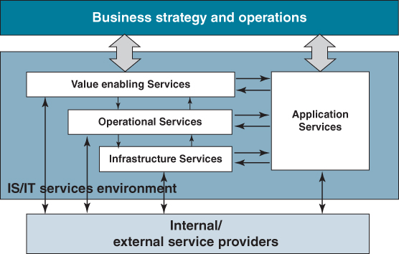
FIGURE 11.2 Relationships between the four IS/IT service categories and business strategy and operations.
It seems reasonable to assume that investments are made in IS/IT services in order to deliver some value to the organization. As already noted, despite the large sums of money involved, in addition to investments in applications and application services (which were considered in Chapters 8 and 9), the majority of organizations treat IS/IT services as an administrative expense or cost and not as an investment, and manage them as such. This situation is partly due to the intangible nature of services, as discussed earlier, making it difficult to appraise the value the business derives from any spend. Consequently, most organizations do not even attempt to quantify their value. Box 11.1 presents a meaningful way to consider the ‘value’ from IS/IT services and engage management in a dialogue.

BOX 11.1

Understanding the value of IS/IT services
To assess the value of IS/IT services, it is often helpful to make a distinction between the user or community of users who avail themselves of the services and the benefits which they receive and the benefits derived by the organization as a whole. Benefits of a service do not necessarily flow from the user to the organization, and a trade-off generally has to be made in assessing value. For example, a user may be very satisfied with receiving immediate support from a help desk, yet the cost of providing such a prompt service when compared to the benefits the organization receives from such immediate response can mean that it is a loss-making investment. On the one hand, users are looking to get their work done as efficiently and effectively as possible, minimizing any disruption. On the other, the organization wants to optimize the value of the investment it makes in IS/IT services. Consequently, in exploring value in the context of IS/IT services three concepts must be considered: utility, benefit and value itself.
Drawing on the concept of utility from economics, this term represents the satisfaction a user receives in availing themselves of a particular service.ª This utility can be through problem reduction or resolution, the avoidance of disbenefits, through increased reliability or perhaps through the fact that having the service available may be a comfort factor providing an emotional benefit. Utility, however, should not be confused with value. The term value is used to capture the overall benefits from the service which the organization receives from investing in that service. This value has two components: organizational benefits and user utility. Thus value is assessed based on the extent to which it supports the organization in the achievement of business objectives and the utility that users receive from the service. For example, the activities of systems analysis and design themselves do not provide any direct benefits to the organization: the benefits are those provided by the application implemented as a result of the analysis and design.
For applications, the benefit is generally derived through business change or innovation enabled by the application, for example performing work at lower cost, quicker or more accurately. Traditionally, investment proposals will include these benefits in any return on investment (ROI) calculations. A benefit to an organization might also be through opportunity realization. Applications themselves can also cause changes in the organization, which may or may not be beneficial.
The value from operational and infrastructure service categories is more difficult to calculate. This is because they provide no direct utility to users. The utility provided to users from application and value-enabling services is a mixture of soft and intangible benefits as well as more concrete outcomes such as improvement in productivity. The figure below maps utility and benefit against the four service categories, illustrating the nature and source of possible benefits.
The overall value (v) which is derived from an investment in a service is therefore a function of the utility to the user (u) and the benefit to the organization (b), which can be written as v = f(u,b).
The marginal increases in utility and benefit are likely to decline beyond a certain level of spend as shown in the figure below. For a service such as help desk, as more resources are made available to support the user, the cost of providing the service increases, while one would also expect that the utility increases although this is unlikely to be a linear relationship. To determine the optimum level of spend for any service, ‘marginal analysis’ will need to be conducted. The figure below shows that, at point ‘b’, the level of spend delivers greater value to the business than at point ‘a’. However, beyond ‘b’, the difference between benefits and costs decreases. From its analysis, one company found that the 24×7 ‘Gold Standard’ IT support it provided employees was excessive and that a ‘Silver Plus’ level of service – 6 days a week for 18 hours – would be adequate.^{b}
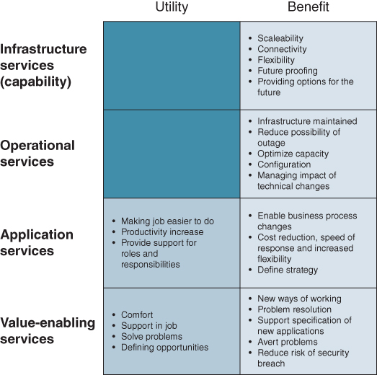
Example sources of value from IS/IT services
Collecting the necessary data for such calculations can be difficult. However, it is often the richness of the conversation that occurs between business and IT management around the curves that is more valuable than the actual figures, for instance in getting business management to understand the trade-offs involved. Of course, the profile of the curves will vary in every organization as they are likely to have different cost bases and begin from different positions.
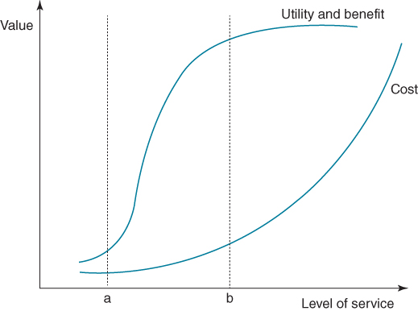
Cost, value and level of IS/IT services
This, however, is not the complete story. In the delivery of many IS/IT services, the empathy which the provider has with the user can also be a critical determinant of user utility. So there could be a situation where a smaller help desk, staffed by friendly service staff, is perceived as providing a better service to users than a larger desk with unfriendly staff. The expectations of users are also involved in determining utility. If expectations of users are low, a given level of investment can result in a higher level of utility than if expectations are higher, where the same level of service will deliver a lower utility. This analysis also has implications for the conduct of user satisfaction surveys. It raises the question of whether it is ever realistic or prudent to strive for users to rate a particular service very high, when the cost of achieving such a score many not ultimately deliver the requisite level of business benefit.
Notes:
ªFor third-party vendors and external service providers (ESPs), the service being provided is the ‘product’, and is the prime source of revenue and therefore should be treated as such.
^{b}Example taken from M. Grebe and E. Danke, Simplifying IT: Six Ways to Reduce Complexity, The Boston Consulting Group, March, 2013.
Services in each of the four categories should be managed in a different way. In the sections that follow, a number of frameworks are introduced that can help in guiding the management decisions for services in each category. Guidance for the management of applications services is included in approaches to managing the applications portfolio, as discussed in detail in Chapter 8. Before looking at these other frameworks, we review how the quality of IS/IT services can be assessed.

Assessing the Quality of IS/IT Services
Assessing service quality is a central aspect of the management of all services. Quality is usually assessed based on conformance to expectations and there are two dimensions that determine whether or not the actual service meets user expectations:⁹
- Technical quality: what exactly the user receives and when.
- Emotional quality: how the customer experiences the delivery of the service.
Technical quality is essentially about the specification of the service: defining what the user can expect – often called the ‘service task’. For example, a service might be defined as the help and support provided when users have problems using an application or it can be the functionality inherent in an application. Emotional quality, or user experience, is generally concerned with how they want the service provider to treat them. Therefore, emotional quality is directly related to the process of service delivery and the nature of user involvement in that delivery process. Whilst a user with a problem in using an application may be dealt with on immediate contact with the help desk and their problem resolved, how they are treated by the help-desk staff member while their problem is being solved can influence their overall assessment of quality. In terms of application functionality, emotional quality often depends on the application's ease of use.
The challenge with many IS/IT services is to recognize this emotional aspect, particularly in situations where there is a high degree of user involvement in the delivery of the service. For example, one energy company had a practice of ‘blooding’ their new IT staff recruits on the help desks. Although they had technical skills, they generally did not understand the business and often had little empathy with users. Consequently, users consistently rated the service as poor until this practice was changed. Even in organizations where experienced IT staff are used, they have generally been recruited because of their technical skills and not based on how they interact and communicate with users. In contrast, service industries have long recognized the importance of recruiting staff with the appropriate service mentality and attitude.
In considering IS/IT services, we must also address the service encounter; that is, where users and staff from the internal or external service provider come into contact and interact with each other. This may be face-to-face in meetings, over the phone, by email or perhaps through a corporate collaboration platform. More passive encounters occur when the user observes the provision of the service, for example installing a PC. Secondary encounters occur through user conversations with staff in the IT organization or with other users. Operations managers often refer to these encounters as ‘moments of truth’ as, through them, users can form a lasting impression of the IS/IT function or external provider which can be difficult to change.

Gaps in Service Delivery
However services are assessed or measured, users will continually expect improvement, even for it to be ‘perfect’ on every occasion. There will usually always be ways, at a cost, of improving any aspect of the service but it may not be worthwhile to expend more resources to deliver the ultimate expectations. An assessment is required of whether ‘gaps’ in service delivery are worth overcoming or whether actions to change user expectations are more valid. Work by a number of researchers¹⁰ studying the nature of gaps that can occur in IT service delivery, based on general service management, is very helpful in understanding why the gaps exist and selecting the best options for closing them. Figure 11.3 shows the basic model for assessment.
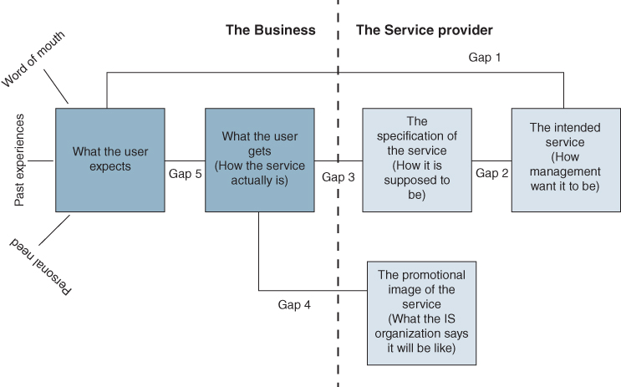
FIGURE 11.3 The gaps in IS/IT service delivery.
Source: Based on the work of Parasuraman, Zeithaml and Berry.
Much work has been done in identifying the source of ‘gaps’ between the user and provider that can occur in service delivery. It is perhaps easy to recognize the gap between user expectations and their perception of what is actually received. But there is research that has identified other possible reasons why gaps can occur¹¹ and some attempts have been made to extend this work into the domain of IS/IT management.¹² The greatest difficulty in dealing with user satisfaction is that the factors which create satisfaction will vary from user to user, and a user's assessment of service quality will be based upon their expectations of the service to be provided.
This model illustrates that there are five possible gaps in service delivery. The causes of these gaps (listed as 1–5 in Figure 11.3) are as follows:
- Not understanding what users expect or what contributes to utility or value due to:
  - a lack of analysis of user needs;
  - ineffective communication by either or both parties;
  - excessive bureaucracy in the IS/IT unit.
- Setting the wrong service standards due to:
  - lack of commitment to IS/IT services by IS/IT management;
  - perceptions of infeasibility among IS/IT staff in meeting user demands;
  - inadequate task definition and standardization or inadequate resourcing to achieve standards set;
  - absence of objectives for the service to achieve and/or inappropriate performance measurements.
- Underperformance of the service due to:
  - role ambiguity in delivery processes, including a lack of clarity or understanding of the user's role in the service delivery process;
  - lack of resource availability to deliver the service;
  - lack of actual or perceived controls;
  - lack of teamwork and inappropriate resource use, or inappropriate use of the service.
- Poor communication of what the service is and can be expected to deliver due to:
  - a propensity to over-promise and/or overreact to ‘complaints’;
  - inconsistent communication across the user communities;
  - lack of visibility of the service process.
- Expectation versus perception gap due to:
  - not understanding user requirements and reasons for them;
  - users not understanding the service process and the implications of their demands;
  - user expectations actually being impossible to satisfy!
The difficulties in carrying out meaningful measurements of user satisfaction with services was described in Chapter 4 – see Box 4.4 – where the importance of knowing the context within which the user is judging performance was discussed.¹³
In the context of outsourcing decision making for IT services, Lacity and Hirschheim¹⁴ provide a simple yet effective matrix for summarizing perceptions of the inevitable trade-off between the service delivered and the cost to the organization of the service provision (see Figure 11.4). Senior management will pay attention to the costs of IT, but are probably minimal users of services, whereas users themselves are very aware of the quality of services, but probably unaware of costs. Ideally, to satisfy both, providing a premium service at minimal cost is the objective, but rarely achievable in every aspect of service. The matrix is equally applicable to internally provided services.
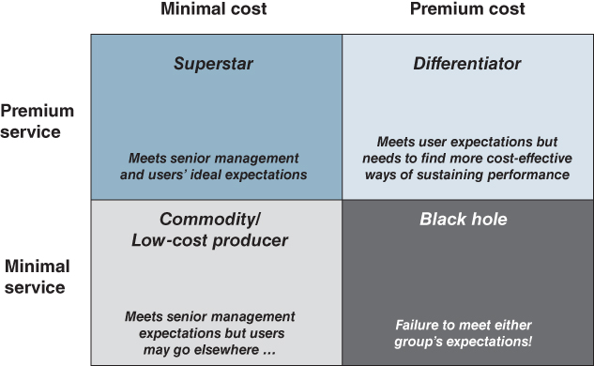
FIGURE 11.4 IT cost/service trade-off.
Source: M.C. Lacity and R. Hirschheim, Beyond the Information Systems Outsourcing Bandwagon: The Insourcing Response, John Wiley & Sons, Chichester, UK, 1995.
Choices have to have been made on objectives for each of the other segments – whether to maintain the services at existing levels and find more cost-effective means of meeting them or whether to improve the services by justifiable investment. This must be made explicit to both business users and senior management or once more expectations will not be aligned. If users perceive a service as poor and management deem it expensive – the Black Hole – it may be too late to retrieve the situation and alternative service suppliers may be considered without reference to IS/IT management!

The Dimensions of IS/IT Services
Outside the service task, which provides a high-level description of what the user can expect of the service, IS/IT services can be ‘unpacked’ into a number of dimensions of service quality.¹⁵ What is important about these dimensions is that they are used by users in assessing the overall quality of services delivered. Each dimension is, in turn, influenced by factors involved in the provision of the service. If we can identify aspects users rate as problematic, it should be possible to improve either the user view of the service quality, the service quality itself or the assessment of quality, by addressing those factors. These dimensions can be categorized under the headings of value, form, level and delivery system. Service level agreements usually capture the form and level of service.
The value of the service. As we have already demonstrated, the cost of providing a service should be matched against users' utility and organizational benefit, with the overall value being a function of the utility plus benefit. While users may only be interested in their personal utility in assessing the benefit to them of any service, it is important not to lose sight of overall value to the organization.
The form in which the service is available, has two aspects:
- Nature: the definition of the expected service (i.e. service task) and how this relates to its value.
- Responsiveness: how flexible is the service? Is the service to be customizable or is it a case of ‘one size fits all’?
The level of service, has three aspects:
- Access: How easy is it for the users to access the service? Can the service provider be contacted by phone/online? Can it be accessed remotely?
- Availability: Is the service available when required? Is it offered on a 24×7 basis?
- Reliability: (in terms of consistency): Is the service ‘experience’ similar every time it is delivered?
The delivery system by which the service arrives. Aspects to consider in the design of the delivery system are:
- Assurance: confidence of users in IS/IT staff and in their ability to deliver the service.
- Empathy: friendliness of IS/IT staff and their ability to identify with the problems which the user is experiencing.
- Involvement: degree of expected user involvement in using the service.
Figure 11.5 illustrates these dimensions of IS/IT services and maps them against the provider's perspective. In the right-hand column, these dimensions are matched up with the issues that addressing these service dimensions raise from the provider perspective.
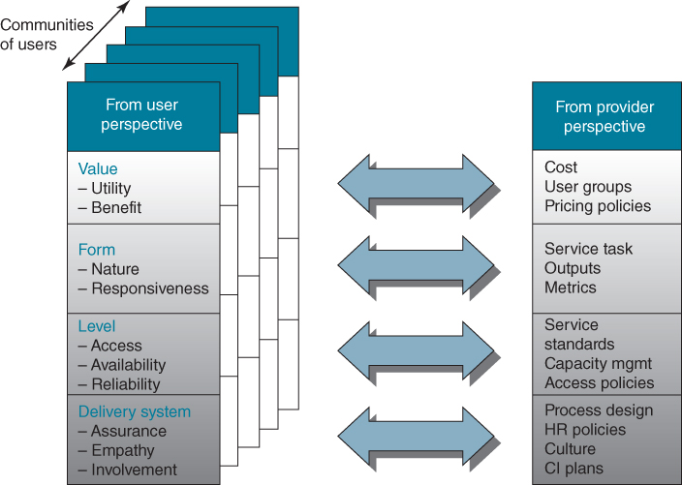
FIGURE 11.5 Balancing user and provider perspectives (provider options are illustrative examples).
These dimensions of service quality, as assessed by the user (left-hand side of Figure 11.5), can inform the provider perspective in a number of ways. For example, in terms of value, it may be that different user groups derive a different level of utility from the service. This suggests that it would be beneficial to segment the user base to reflect this differing utility. The value dimension and level of service expected can also influence charging or pricing mechanisms such as no billing for services, fixed price based on past usage or direct charging based on usage. In assessing the service, it may also be that there are conflicts between the utility, form, level and the delivery system. For example, the definition of the form may position the service as a standard service to all users, but the different levels of service expected may indicate that it needs degrees of customization.
Figure 11.6 illustrates the relationship between investment and value and the mechanisms through which this value is created. It illustrates that an organization invests in a service through the acquisition of knowledge, skills and resources, including technology, which are then deployed through effective resource allocation in organizational processes. These processes can be supported by technology, such as call centre software used by help desks to log calls, keep track of outstanding faults and provide a database to collect and analyse fault patterns. The performance of the service is to a large extent determined by the design of the delivery system, which includes defining the role of both the user and provider. For most services, performance is ultimately judged by the user based on the nature and responsiveness of the service together with the availability, ease of access and reliability of the service as discussed above.
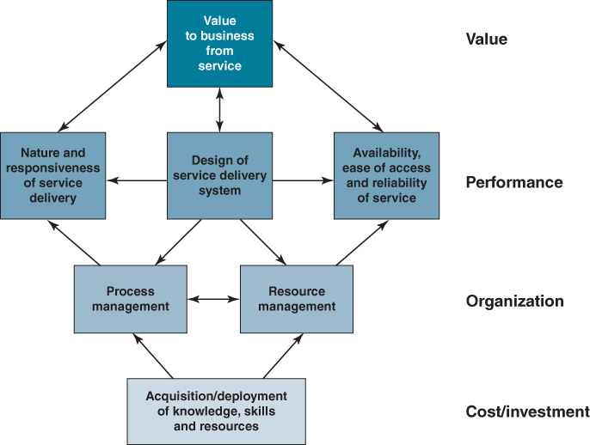
FIGURE 11.6 An overall framework for managing IS/IT services.
This framework can be used in developing IS/IT services and can also form the basis for measuring the service components in terms of performance to specification and perceived performance as assessed by the users. It does, of course, rely on being able to define the value of the service which, as we have seen, can be difficult to do. Often, this has to be in terms of the negative consequences of unavailability or underperformance, to justify the cost against failure of the business to operate ‘normally’.

Managing Operational and Value-enabling Services
It can be helpful to view operational and value-enabling services in terms of the degree of user involvement in their provision and the degree of customization of the service for the user (see Figure 11.7). The quadrants roughly define four fairly distinct service delivery processes:¹⁶ ‘Service Factory’, ‘Service Shop’, ‘Service Mall’ and ‘Service Boutique’.¹⁷ Each type has different requirements, design criteria and management issues to be addressed. Service processes with a high degree of customer contact are more difficult to control and standardize than those with a low degree of user contact. In a high-contact system, the user availability and priorities affect the timing of demand, the efficiency of resources used in delivering the service and the quality, or perceived quality, of service since the user is involved in the process.
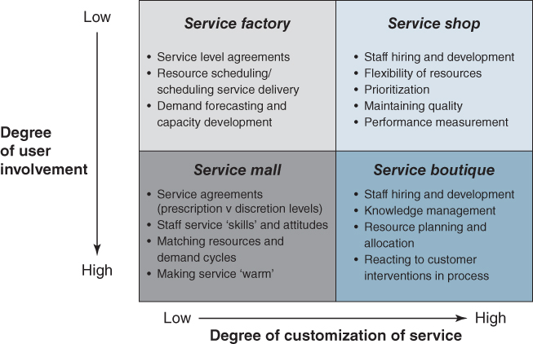
FIGURE 11.7 Generic service models for operational and value-enabling services: some key management issues.
Service Factory: Low involvement and low customization. Obvious examples are many of the ‘back-office’ services such as security, capacity and network maintenance, general software release/upgrades and installation of basic desktop facilities. Changes to applications to deal with statutory or compliance requirements would also be included in this category.
Performance measurement can be relatively objective, based on supply-side delivery to agreed service levels, rather than the perceptions of particular service recipients. Key management issues in providing the service are: defining service level agreements, scheduling service delivery and forecasting demand to avoid overload and promote ‘off-peak’ usage. Clearly, these types of service are the most amenable to outsourcing.
Service Shop: Low involvement but high customization. Again, much of the work is done in the back office, but in response to particular, and possibly one-off, user needs or requests. Software acquisition, infrastructure design, technical product evaluation and vendor assessment would be typical of this segment. While the service requests will vary in nature, some consistency in the approach is needed to estimate the time and resources involved and evaluate performance and quality of service across the range of tasks performed.
User perceptions of satisfaction with the outcome of each request will be in relation to the ‘contract’ agreed for the particular request. Accurate estimating of the work involved and ensuring schedules, as well as output quality, are met are essential to achieving user service expectations. Aspects of services can also be outsourced, but only after the task and service requirements are clearly defined for the eventual supplier. Management issues include: task prioritization and resource scheduling, flexible resourcing (internal and external), quality and consistency of ‘back-office’ service processes and methods and defining meaningful performance measures.
Service Mall: High involvement but low customization. Typically, help desks and essential IS/IT skills training would be in this quadrant, given the ‘one size fits all’ rationale to deliver consistent quality of service economically, either from internal or external resources. The attributes of the service staff are critical to the user perception of the performance; hence the development of appropriate interpersonal and communication skills will be as important as their ‘technical’ knowledge. Given the high degree of user interaction, it has to be clear to both recipient and provider how much of the service is prescriptive and how much discretion is allowed to vary the delivery to the needs and circumstances of the recipient. It is important that the individual providing the service understands the level of knowledge of the person they are dealing with; is he or she an expert user or a relative ‘novice’?
Measurement of service performance has to be a balance between actual performance against the ‘contract’ plus the recipients' perceptions of the service received. While, once more, these can be outsourced, softer, cultural issues, rather than just economic and technical, need to be considered in choosing the service supplier. The management issues include those for the service factory but, in addition, involve establishing service parameters and boundaries (degrees of discretion versus prescription), developing staff with the necessary combinations of personal and technical competences and matching resource levels to the cycles in demand.
Service Boutique: High involvement and high customization. They are typified by relatively few, but complex, ‘transactions’ with any particular user. Considerable judgement and discretion is implied in the provider, to understand and respond to the user requirement and identify the best way to satisfy the needs, or not, if the requirement does not justify this type of service. To a large extent, how the ‘transaction’ evolves will rely on either the service user being able to articulate their needs or facilitation to enable the articulation. Equally, the availability of user resources and the knowledge they have about how to use the service effectively will have a significant effect on the service provision. Strategy development, consultancy, business analysis, and systems and process design are services that are normally in this category.
Measurement of service performance is essentially subjective, based on how well the perceived need was met, the effectiveness of the process and the nature of the interaction with the service provider. It is not really feasible to set Service Level Agreements in this area, but each ‘transaction’ will need agreement on schedules, deliverables, costs etc. if perceptions of performance are to be satisfactorily reconciled with expectations. The management issues in this quadrant include those of the service shop but, in addition, the knowledge, personal skills and resourcefulness of the individual staff involved will be crucial to satisfying the users. Obviously discretion, rather than prescription, will generally be required, implying staff with the understanding and experience of accurately eliciting and then translating requirements through planning to delivery, probably using a range of resources, are essential.
Although it is tempting to allocate each of the IS/IT services to a ‘box’, the organization has choices about the way it wishes the services to be operationalized. Training, for example, can be bespoke and tailored to an audience and considered a professional or boutique-type service, or provided as a standard training course, in essence as per the service mall concept or, if the course is delivered online, it is more akin to the service factory model.
The service process matrix also has implications for outsourcing. Outsourcing services with a high degree of user involvement and/or high level of customization can be problematic. One way around this problem is to examine whether it is possible to specify the service in a way that is suitable for categorizing as a service factory. Most operational services, but fewer value-enabling services, tend to be types of service factories and are therefore more suited to direct outsourcing as the service process and outcome can be defined precisely, making the establishment of performance metrics and SLAs much easier.

Application Development and Provisioning Service Strategies
As noted earlier, the management of applications was discussed in some detail in Chapter 8 but a few key points are worth reiterating here in the context of IS/IT services.
Although less application software is now produced in-house, most large software packages (i.e. ERP-type implementations) require extensive configuration and even some customization when they are implemented. The trend for more and more of an organization's applications to be designed and developed by external software houses or ‘business solutions’ companies is likely to continue. The emergence of cloud providers is the latest development in this area, eliminating the requirement for implementation of the software and the need for any additional hardware.
There are many good texts covering systems design and development methods, software engineering, database design and project and benefits management.¹⁸ The intention here is to note a number of strategic issues that have to be addressed in the context of an ongoing IS/IT service for acquisition, provision and support of business applications, enabling the applications to be implemented successfully, leading to the delivery of the expected benefits.
The challenges for application development or provisioning have become more demanding as IS/IT has become integral to business performance. At the same time, the business environment has been changing more quickly and dramatically, producing increased uncertainty and the need for flexibility and adaptability of processes and systems. The main issues for the management of application development and support services can be summarized as:
- providing new applications more quickly and replacing old applications in response to changing business demands;
- more cost-effective production or acquisition of more types of application and reduction of ongoing maintenance costs;
- increasing the quality and reliability of the software as it becomes integral to the business processes and used by external parties;
- implementing more customer-focused applications that can be used easily by untrained people, including customers, citizens and suppliers;
- devising more flexible or adaptable applications than can be enhanced or modified quickly at low incremental cost;
- providing efficient, seamless integration of business activities across different applications from the desktop and portable devices.
In other words – faster, cheaper, better, more flexible and easier to use! Few of these are new demands, except perhaps more customer- or user-centric systems, but the history of IS/IT has been one of increasing expectations of what can be done ‘relatively easily’, promoted largely by the IT industry and raised consumer expectations due to the availability of many easy-to-use apps for mobiles and tablets. But there are still inherent difficulties in designing and implementing complex IT systems in rapidly evolving businesses and uncertain industry and market conditions.

Strategies for Managing IT Infrastructure and Infrastructure Services
Defining IT infrastructure and its components is becoming more difficult as technology evolves and becomes increasingly a business utility. Perhaps the best definition is ‘the enabling base of shared IT capabilities which provide the foundation for other business systems.’¹⁹ This definition includes the managerial expertise to provide IT services as well as the technology itself. Many authors²⁰ include ‘services’ in the IT infrastructure, since it is difficult to separate the issues of infrastructure management associated with its procurement from those affecting its use in services and applications. In this book, IT infrastructure is considered to comprise:
- Physical infrastructure, including a range of network, hardware and software products and services, deployed to enable applications and the general-purpose use of technology to function successfully. A component is considered as being part of the infrastructure if it is used by more than one application or by a wide range of people. Hence, software such as groupware to enable knowledge sharing and collaborative working is part of the infrastructure, since it has many applications. It can be argued that Enterprise Systems software packages, once installed, are essentially part of the infrastructure, given the range of activities they support, the number of users and the influence they have over the business and IT architecture.
- Architectures, which describe the physical infrastructure, where it is located, how it is configured, what it is used for in application and business process terms and who in the organization uses it. As well as the physical infrastructure, these also include models of information, processes and business and organizational relationships. The technology architecture is a representation of the set of hardware and software components, described in terms of how they support the applications and information requirements of the business.
- Policies and standards, which cover how the acquisition, deployment and support of the technology infrastructure are managed. These address matters such as sourcing, contracts, service levels, back-up and recovery, contingency plans and, increasingly importantly, security and access controls. These are instruments of governance and were discussed in Chapter 10.
- Management processes to ensure investments in infrastructure are coherently planned and justified, and relationships with technology suppliers and outsourcing providers are appropriate for their role in enabling the business strategy. The issues associated with justifying infrastructure investments were discussed in Chapter 9.

Business Basis for Technology Management
The main business purpose of strategies for the IT infrastructure is to provide an appropriate set of technology, resources, processes and services to meet the evolving needs of the business. This includes sustaining the application portfolio and general-purpose use of IT tools in the short and medium term, and making improvements to the infrastructure to meet longer term, but often uncertain, organizational and business needs. This implies a continuous migration plan to move from the current technology infrastructure to the most appropriate set of components to support planned application and information architectures and demands for ever-improving performance.
In order to manage technology effectively, it is not necessary for business managers to get deeply involved in technical details. Technology changes so quickly; it is beyond even most technical people to keep up to date, and even more difficult and less valuable for business managers to attempt to do so. However, business managers are often required to have enough understanding of the strategic issues to improve their decisions concerning technology. This involves having the ability to understand and assess the various issues in terms of the business implications. Therefore, it is important to link infrastructure development to relevant parts of the business strategy. Most organizations can identify current business problems that would result from inadequate infrastructure, but it is more difficult to foresee the future problems that would result from failure to invest in its development. So some of the issues to be faced are:
- Linking technology investments to business needs – how to describe requirements for investment in technology in terms of the business implications. While per unit costs of technology are still going down, spending on IT is still increasing, with the implementation of new applications for both business activities and individual or group working. This seems to be acceptable because of the belief and some evidence that an effective IT infrastructure enables improved productivity, organizational responsiveness and employee flexibility²¹ – all critical requirements for most of today's businesses. At the same time, employees expect the organization to provide technology and Internet access at least as good as they enjoy at home or wherever they are. However, not all the evidence points to realized productivity gains in all uses of IT. Reports suggest²² that white-collar productivity has not actually improved during the ‘desktop’ era and there is some evidence that misuse or inadequate skills have caused negative effects on productivity.
- Identifying technical opportunities. Business managers need sufficient understanding of how IT capabilities can improve or radically change the products and services of the business, develop digital trading capabilities, improve the productivity and effectiveness of business processes and people and impact the economics and performance of the organization.
- IT investments by others – how existing and potential competitors, customers and suppliers are using or could use technology to improve their competitive positions, and the likely consequences in terms of: (i) impact on the products, markets and customers, (ii) changing relationships and cost structures and (iii) threats or opportunities created by new IT-based entrants in the industry. Business managers need the knowledge to assess the situation, understand the implications of the options available and be able to respond accordingly.
- Technical implications and ‘hype’. Most business managers need to be able to ask sensible questions and not to be confused by the advice of technical experts, consultants, IT suppliers, ‘in-flight’ magazine articles or even TV adverts! Technology managers also need to be sufficiently business aware to extract the relevant, factual information from the ‘hype’, so that they do not effectively become agents of technology vendors in promoting ‘solutions looking for problems’, based on technically irresistible offerings, rather than real business opportunity and need and sound assessments of feasibility, performance, cost and risk.
- Business and technical awareness. The CIO or IT director has a responsibility to instil business judgement and awareness in his or her technology experts and also to create a sound, if high-level, understanding of technology issues in general management, so they can make strategic decisions about IT resources, including the sourcing and, where appropriate, outsourcing of infrastructure provision and associated services.
One issue for senior management to address is the degree to which the organization needs to function as an integrated whole or as separate entities. This will have a significant influence on the type of infrastructure that is developed and its overall cost, especially in multi-unit organizations. A model developed by Keen²³ and shown in Figure 11.8 can help management form an opinion on the need for commonality and connectivity across the IT infrastructure. Keen describes two dimensions:
- reach – the extent to which the infrastructure must enable connections across processes, applications and platforms among internal and external users;
- range – the breadth of services, and variety and volume of different types of information, documents, images etc. that will be shared among internal and external parties.
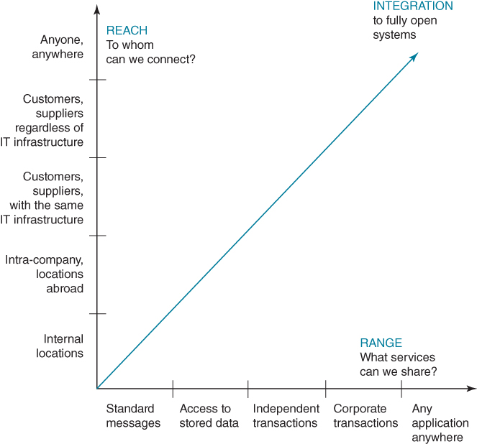
FIGURE 11.8 Reach and range.
Source: from P.G.W. Keen, Shaping the Future, Harvard Business School Press, Boston, 1991.
A study of 26 major international firms²⁴ confirmed that those achieving inter-unit business synergies had invested in infrastructures that produced high levels of reach and range. This also tended to include common application packages using common databases. The study also found that the firms that had integrated business, IS and IT planning processes had more extensive IT infrastructure capabilities in both of Keen's dimensions. The study also confirmed, as perhaps expected, that generally the firms where information was a major component of the product or critical to the value-adding processes, such as oil exploration, financial services or research, had invested most in IT infrastructure, recognizing it as an organizational ‘capability’.

Technology Strategies in a Multi-business Unit Organization
Most corporations consist of a number of businesses and there is a need to consider the strategic management of technology supply and services across the businesses to obtain the maximum corporate and business unit benefits. This corporate dimension has been considered in previous chapters in terms of the factors driving the extent of beneficial central coordination and control over and above the business units. The business factors affecting the corporate technology strategy include:
- degree of inter-company trading or inter-unit working (e.g. in new product development);
- similarity of products and business processes or scale of operation;
- coherence of markets served, channels of distribution used and main suppliers;
- industry maturity and competitive situation of business units;
- geography, especially in international companies;
- how corporate management exercises its control over the units' business strategies and activities – a factor that has tended to increase centralization since the millennium;²⁵
- the rate of business and organizational change.
There are also a number of IS/IT supply-side factors, including:
- economies of scale in technology costs;
- availability of skills and human resources;
- availability of technologies and vendor services in different locations;
- existing IS/IT investments in the different units.
However, these ‘logical’ factors can sometimes become obscured by organizational and political factors due to the way the business units have been developed or acquired and/or the degree of trust that exists between the corporate centre and the units. This desire for conformity or independence often manifests itself more emotionally over the control of IT than many other aspects of business. Based on the above factors, there appears to be a way of addressing these issues which is consistent with the earlier discussion of achieving application, information and organizational coherence and synergy to the degree required by the business relationships. It is important that the degree of IT conformity or divergence reflects the business, organizational and cultural characteristics of the corporation, not the preference of IT specialists, or it will fail in the long term to deliver corporate benefits.
The extent to which the corporate centre should direct the technology architecture and the selection process cannot be prescribed, but there is perhaps an escalating scale of corporate intervention that can be considered. As described in Box 11.2, at the lowest level this can provide benefits even if the organization is a conglomerate, buying and selling businesses and operating in many industries with companies of varying sizes and differing business situations. At the highest level, the benefits will be far greater in a corporation that has a number of companies in the same or very similar industries or which have common customers.

BOX 11.2

Managing technology in a multi-business unit organization

Level 1: Lowest Level of Control by the Corporate Centre over the SBUs – Technology Economics
Centralization of technology control will be mainly an economic issue to exploit corporate buying power and ensure that resources are not unnecessarily duplicated. This will have most effect at the ‘commodity’ end of technology – in hardware, communications networks, processing power and operational software and related technical skills to support IT operations.
Establishing a target environment based on supply economics can also enable application selection decisions in each unit to consider a preferred set of options. These will not be mandatory, but will be expected to be adopted, unless the local economics are poor, perhaps due to the unit's size or because its business needs cannot be adequately satisfied. This can make the preferred solutions more attractive to the units, provided the charge-out of costs from the centre is equitable. The central resource can also act as the main point of contact with suppliers to ensure that the corporation obtains the best value from group purchasing, and monitor centrally the supplier performance against agreed service levels as and when problems arise anywhere in the organization.

Level 2: Moderate Level of Control by the Corporate Centre over the SBUs – Application Benefits
If the corporation has a number of businesses operating in different industries, but of a limited number of types (e.g. manufacturing businesses as well as distribution and/or service companies), there may be further opportunities for corporate and unit benefits, over and above those mentioned at Level 1. For instance, manufacturing companies may all need some form of Enterprise Resource Planning (ERP) system or operate in similar supply chains or trade in similar ways. There will probably be some similarity in the applications required due to comparable internal and external processes, leading to benefits if application knowledge and even resources are shared among the units. This also adds weight to the need for consistency of basic operating environments; otherwise the benefits will be reduced by the need to support diverse implementations on different hardware and operating systems, and/or deal with a large variety of suppliers.
The benefits are not purely economic and also accrue by enabling companies of different sizes and IS/IT capabilities to implement strategic applications ahead of the local competitors. Similarly, applications can be run centrally and be able to be upgraded as the hardware and software base changes with less cost and disruption to the units. However, too much centralization of IT control can lead to reduced innovation at business unit level and limited local capability can result in merely satisfying the ‘lowest common denominator’ of business needs across the units.

Level 3: Highest Level of Control by the Corporate Centre over the SBUs – Information Asset Management
Where companies are in the same industry, trade with one another or deal with similar customers or suppliers, there are probably business advantages to be gained from strong corporate coordination of IS and IT management. Not only are there economic and application supply-side benefits but also significant benefits from sharing information and knowledge as well as its consistent processing throughout the company and with its trading partners. For example, they may use a common Customer Relationship Management (CRM) system and share a common customer database. Here, it is worth ensuring that the technology environments are consistent to the level of data management software, communications standards and some application software, even if to any one unit company the ‘overhead’ may appear uneconomic.
But again, the benefits of central direction and support in terms of skills and resources may be negated if innovation is stifled. A corporate mechanism to deal with strategic and high potential areas of development must be in place. Equally, the corporation may need to fund part of the cost of technology in the units to encourage commonality. This implies that the units may have to compromise some requirements, and the business consequences of such compromises must be understood.
This three-level view is somewhat simplistic, but it is an attempt to reflect the likely business and corporate cultures prevailing across the spectrum from a financial conglomerate to a highly focused and organically developing corporation. The progression, in terms of increasing corporate intervention, follows the rationale, described in earlier chapters, of different types of benefits resulting from corporate intervention in the support, key operational, strategic and high potential quadrants of the portfolio. It also reflects the need to transfer technology knowledge across the organization to gain the greatest and earliest return from IS/IT competences possessed by the organization, wherever they exist.

Understanding and Managing IT Risks
As part of the IT supply strategy, it is crucial to identify risks to IT systems and information, to reduce or manage those risks, and to develop a response plan in the event of an adverse situation occurring. According to the Certified Information Systems Auditor Review Manual:²⁶
“Risk management is the process of identifying vulnerabilities and threats to the information resources used by an organization in achieving business objectives, and deciding what countermeasures, if any, to take in reducing risk to an acceptable level, based on the value of the information resource to the organization.”
Risk management encompasses not just the negative impact of operations and service delivery, which can bring destruction or reduction of the value of the organization. It also includes the benefit/value-enabling risk associated with missing business opportunities to use technology and the IS/IT project management risks such as overspending or late delivery with adverse business impact.²⁷
The requirement to manage risk pervades decision making in all areas of business, as risk is an inevitable part of business. Developing strategic applications is risky, as return on investment expectations cannot be guaranteed, and as we saw in Chapter 5, innovation automatically incurs a level of risk. IT risk management can be considered a component of a wider enterprise risk management system.²⁸ Boards and company owners also have legal obligations in relation to privacy, electronic transactions, and staff training that influence IT risk management strategies.²⁹
Events or incidents that compromise IT, in some way, can cause adverse impacts on the organization's business processes or capabilities, ranging from inconsequential to catastrophic in scale. General threats to IT systems and information include:
- hardware and software failure – such as power loss or data corruption;
- malware – malicious software designed to disrupt computer operation;
- viruses – computer code that can copy itself and spread from one computer to another, often disrupting computer operations;
- spam, scams and phishing – unsolicited email that seeks to fool people into revealing personal details or buying fraudulent goods;
- human error – incorrect data processing, careless data disposal, or accidental opening of infected email attachments.
Specific or targeted criminal threats to IT systems and data include:
- hackers – people who illegally break into computer systems;
- fraud – using a computer to alter data for illegal benefit;
- password theft – often a target for malicious hackers;
- denial-of-service – online attacks that prevent website access for authorized users;
- security breaches – includes physical break-ins as well as online intrusion;
- staff dishonesty – theft of data or sensitive information, such as customer details.
Natural disasters such as fire, cyclone and floods also present risks to IT systems, data and infrastructure. Damage to buildings and computer hardware can result in loss or corruption of customer records/transactions or affect transactions and customer interactions.
To help protect IT systems and data, options include:
- Securing computers, servers and wireless networks.
- Using anti-virus and anti-spyware protection, and firewalls.
- Regularly update software to the latest versions.
- Using data back-ups that include off-site or remote storage.
- Secure passwords.
- Training staff in IT policies and procedures.
- Understanding legal obligations for online trading and the protection of information assets.
If, as is very likely, the business has an online presence, it is important to assess website security, email accounts, online banking accounts and social media profiles. For example, Secure Socket Layer (SSL) technology is used to encrypt transaction data and to send customer and card details to the acquiring bank for authorization. Any web hosting solution considered should be capable of supporting the SSL protocol.
Over the years there have been many cases where IT systems have either failed or have been compromised, resulting in business impact. Stories of personal data being stolen due to hacking have become increasingly regular. The unavailability of Point-of-Sale (POS) systems can mean that customers are unable to check out and pay for purchases, impacting revenue. Denial-of-service attacks can render a website unavailable for customers. Some ERP system implementations have resulted in making certain processes unworkable until fixed.
Legacy systems pose particular challenges. Many banks have IT systems that have been built up over several decades through acquisition and new product launches to form a costly and complex patchwork of systems. This has been referred to as ‘technical debt’, and it becomes costly to maintain these aging systems. The majority of a bank's entire IT budget can be spent in keeping up with ever-changing regulation, leaving little to invest even in minor system enhancements, let alone large-scale re-architecture of creaking, ancient infrastructure. Moreover, many were not built with the security provisions expected today. Box 11.3 presents the case of an IT failure at Royal Bank of Scotland that lasted for several weeks.

BOX 11.3

IT risk at Royal Bank of Scotland (RBS)
In November 2014, the UK's Financial Conduct (FCA) and Prudential Regulation Authorities (PRA) fined the Royal Bank of Scotland (RBS) £56 million for ‘failing to put in place adequate systems and controls to identify and manage their exposure to IT risks’.
The fine was for an IT failure that occurred in June 2012 affecting 6.5 million customers for several weeks – ‘over the course of that period customers could not use online banking facilities to access their accounts or obtain accurate account balances from ATMs; customers were unable to make timely mortgage payments; customers were left without cash in foreign countries; the Banks applied incorrect credit and debit interest to customers’ accounts and produced inaccurate bank statements; and some organisations were unable to meet their payroll commitments or finalise their audited accounts.'
The £56 million fine was in addition to RBS internal recovery costs of £104 million and £71 million paid out in compensation to affected customers – a total cost of £231 million!
The report associated with the fine made some interesting points:
- ♦ The cause of the incident was a failed change to a batch processing system – very routine activity carried out many times every year in financial, retail, and industrial IT organizations around the world. The change hadn't been correctly researched or tested and when it was backed out, left the customer databases unusable and requiring weeks of manual intervention to fully recover.
- ♦ The approach to risk management for IT continuity was focused on recovering from ‘doomsday’ low probability scenarios such as loss of a data centre and did not sufficiently address IT resilience in terms of systems design and operational processes in more probable day-to-day incident situations.
- ♦ Organizationally, the different groups responsible for management of IT risk and audit did not work together or communicate effectively as a team, had an unclear understanding of responsibilities, and lacked the skills and resources to identify or challenge the weaknesses in the approach to risk management.
- ♦ Of particular concern was that the IT Continuity Policy Standard had been reviewed by an external party and found to be ‘at an adequate overall level and were comparable with similar policies among the RBS Group's peers’.
IT risks can be managed by undertaking a business risk assessment. There are a number of risk management frameworks, such as COBIT³⁰ and COSA,³¹ that when used effectively, can help management identify appropriate controls for providing essential security capabilities.

Understand legal requirements
As a first step in managing IT risks, it is important to be aware of the legal and legislative requirements, such as for spam, electronic transactions and privacy laws.

Risk assessment
Such an assessment will identify risks to the business, where they lie, how big they are, and perform a business impact analysis. An effective IT risk assessment identifies serious risks, based on the probability that the risk will occur, and the costs of business impacts and recovery. Outsourcing to external suppliers and vendors can present additional risks and these are considered later in the chapter.
Assessing the likelihood of various types of event/incident, with their predicted impacts or consequences should they occur, is a common way to assess and measure IT risks. Alternative methods of measuring IT risk typically involve assessing other contributory factors such as the threats, vulnerabilities, exposures and asset values.

Risk mitigation
Identifying areas of risk that are unacceptable and estimating countermeasures, costs and resources to be implemented as a measure to reduce the level of risk. Prior to developing mitigating strategies, it is important to determine the organization's ‘risk appetite’. This can then facilitate prioritizing, evaluating, and implementing appropriate risk-reducing controls. Because elimination of all risk is impossible, organizations should consider using the least cost approach and implement the most appropriate controls to decrease risk to an acceptable level, with minimal adverse impact on the organization's resources and objectives.

Develop response plans
Having identified risks and likely business impacts, the development of a business continuity plan can help a business survive and recover from an adverse IT event. A business continuity plan identifies critical business activities, risks, response plans and recovery procedures.

IT risk management policies and procedures
IT policies and procedures explain to staff, contractors and customers the importance of managing IT risks and may form part of risk management and business continuity plans. Security policies and procedures, for example, can assist staff training on issues such as:
- safe email use, including handling of infected mail;
- setting out processes for common tasks;
- managing changes to IT systems;
- responses to IT incidents.
A code of conduct can provide staff and customers with clear direction and define acceptable behaviours in relation to key issues, such as protection of privacy and ethical conduct. Training new and existing staff in IT policies, procedures and codes of conduct is an important component of IT risk management strategies. Training can cover key business processes and policies, such as protecting the privacy of customer details and priority actions in the event of an online security breach.

Evaluation and Assessment
The process of risk management is an ongoing iterative process. Assessment must be repeated frequently as the business environment is constantly changing and new threats and vulnerabilities emerge almost every day. Moreover, any choice of countermeasures (or controls) used to manage risks must strike a balance between productivity, cost, effectiveness of the countermeasure, and the value of the informational asset being protected.
As it is impossible for a business to prevent or avoid all IT risks and threats, business insurance is an essential part of IT risk management and recovery planning. It is important to regularly review and update insurance policies, especially in light of new or emerging IT risks, such as individuals increasingly using their own mobile devices (known as Bring Your Own Device (BYOD) options) for work activities.

Sourcing of IS/IT Resources and Services
While most IS/IT resources and services were traditionally provided by an in-house IS/IT organization, a wide range of external sourcing options are now available. For a variety of reasons, many organizations use ‘the market’ to provide them with the IS/IT resources and services they need – generally referred to as outsourcing: ‘the delegation, through a contractual arrangement, of all or part of the technical resources, the human resources and the management responsibilities associated with providing IT services, to an external vendor’.³² Outsourcing is further distinguished by either off-shoring (outsourcing performed outside the client home country) or on-shoring.³³
As mentioned in the introduction to this chapter, IT outsourcing is not new, but until the late 1980s it was largely peripheral to the main IT activities taking place in medium-sized and large organizations. It was probably the Eastman Kodak–IBM outsourcing deal of 1989 that marked the beginning of the current outsourcing revolution.³⁴ This saw Kodak outsource the bulk of its IT operations in the USA. Never before had such a large, well-known corporation, with an extensive investment in IT contracted so much of its IT provision to one supplier. About the same time, all UK government departments and agencies were forced to put IS/IT services out to tender, so that suppliers could bid in competition with the existing in-house services.
The arrival of the Internet and the rush to e-commerce and, more recently, the demand for mobile apps, has seen many companies look to outside vendors to supply necessary skills and competences, as these are often not available in-house. Managers often conclude that the only way to meet short deadlines for new technology projects is to contract for specialist services.

Classifying Sourcing Options and Strategies
There are a number of sourcing options available and Figure 11.9 illustrates a framework that can be useful in classifying them. This framework maps purchasing style and purchasing focus. A purchasing style can be characterized as either a transaction or relationship. A Transaction style refers to one-time or short-term specific contracts; a Relationship style refers to less detailed, often incentive-based contracts, with the expectation that the customer and supplier will do business for many years. The purchasing focus can be characterized as either a resource or a result. With a Resource focus, organizations buy vendor resources such as hardware, software or expertise, but manage the use of the resources in-house, whereas with a Result option, suppliers manage the delivery of the IT activity, using whatever resources are necessary, to provide the customer with specified results. This analysis leads to four distinct contract types or sourcing strategies:
- Contract out – the supplier is responsible for delivering the results of IT activity.
- Buy-in – the organization buys in resources from the external market, usually to meet a temporary requirement. Contracts often specify the skills required and cost, with the resources then managed in-house.
- Preferred contractor – the organization contracts long term with a vendor to reduce risk, with the supplier responsible for the management and delivery of an IT activity or service. To ensure supplier performance, an incentive-based contract is generally constructed.
- Preferred supplier – this takes the buy-in approach further, with an organization seeking to develop a long-term close relationship with a vendor in order to access its resources for ongoing IT activities. The organization, not the supplier, takes responsibility for managing these resources.
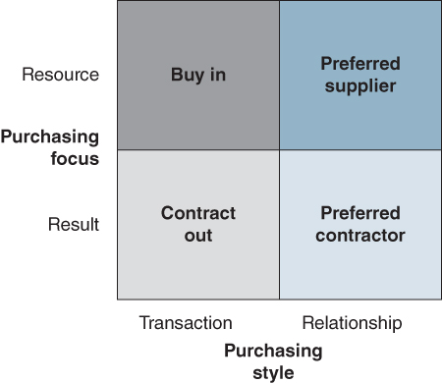
FIGURE 11.9 Classifying sourcing options.
Source: Derived from M.C. Lacity, L.P. Willcocks and D.F. Feeny, ‘The value of selective IT sourcing’, Sloan Management Review, Spring, 1996, 13–25; M.C. Lacity, L.P. Willcocks and D.F. Feeny, ‘IT outsourcing: Maximizing flexibility and control’, Harvard Business Review, May–June 1995, 84–93.
While in the past organizations often outsourced the bulk of the IS/IT requirements to a single vendor, there are a number of possible sourcing options that should be considered (see Table 11.1). As the table indicates, each option has associated risks as well as some specific management issues which have to be addressed.
TABLE 11.1Provider options
Source: S. Cullen, P.B. Seddon and L.P. Willcocks, ‘IT outsourcing configuration: Research into defining and designing outsourcing arrangements’, Journal of Strategic Information Systems, 14, 2005, 357–387.
Option | Rationale | Risks | Management Issues
Sole provider (one supplier) | ♦ Sole accountability  ♦ Potential to pass on economies  ♦ Streamlined contracting costs and processes  ♦ End-to-end key performance metrics | ♦ Monopolistic provider behaviours  ♦ Compromise quality where the supplier is not best of breed (in services, industries or geographic locations) | ♦ Extensive contract flexibility rights due to the dependence on provider  ♦ Independent expertise to avoid solution channelling and ensuring value for money (quotes are market values)
Prime contractor (Lead provider that subcontracts) | ♦ Single point of accountability  ♦ Allows best-of-breed subcontracting  ♦ Streamlined, but a bit more complex, contrasting costs and processes  ♦ End-to-end KPIs | ♦ Prime must be expert at subcontracting (selection, management, disengagement)  ♦ Clients may desire different subcontractors  ♦ Clients often required to resolve issues between the prime and subcontractor/s  ♦ Primes and subcontractors often encroach ‘territories’ | ♦ Contract ensuring various rights over the subcontracting (access, selection, veto etc.)  ♦ Compliance auditing ensuring the prime passes obligations to the subcontractors  ♦ Oversight ensuring all parties are operating as an efficient and united front
Best of breed (two or more providers) | ♦ Greater control  ♦ Flexibility to chop and change  ♦ Promotes competition and prevents complacency | ♦ Attracting the market for small ‘slices’ of work  ♦ Keeping providers interested, giving management focus, and allocating staff  ♦ Interdependent services and contracts  ♦ Integration complexity  ♦ Tracing accountability | ♦ Designing interdependent contracts between independent providers  ♦ Multi-party interface and handover management  ♦ End-to-end process management is more difficult  ♦ Multiple lifecycle management
Panel (preferred providers) | ♦ Buy services and assets when required  ♦ Promotes ongoing competition  ♦ Prevents complacency | ♦ Attracting the market when panel is a pre-qualification and does not guarantee work  ♦ Adding new panel members or wanting to use suppliers not on the panel | ♦ Panel bidding process for work  ♦ Ongoing ranking of panel members based on performance  ♦ Managing and evaluating the total program
A selective or ‘smart sourcing’ approach using multiple providers is an increasingly popular strategy to minimize risks, maximize benefits and reduce costs³⁵ and is likely to be the preferable choice of the future. Many organizations have chosen this so-called ‘best-of-breed’ approach, contracting with a variety of vendors for the delivery of IT services. For example, one energy company contracted with three suppliers under an umbrella contract obliging the suppliers to work together. According to the company's CIO, they decided against receiving all their IT needs from a single supplier because they believed such an approach could make it vulnerable to escalating fees and inflexible services. Instead, the company sought a solution buying IT services from multiple suppliers but having pieces delivered as if they came from a single supplier. The company reported that this strategy reduced IT staff by 80% and IT operating costs by 60%.
Most large public sector outsourcing deals are now multi-supplier. There is also evidence to suggest that selective and in-house sourcing has success rates twice as high as when compared to total outsourcing deals (80% or more of IT activities outsourced).³⁶
While the risks of using a single provider are mitigated with a multi-sourcing strategy, they are replaced by the additional time and resources (transaction costs) required to manage multiple providers. The key to a successful multi-sourcing arrangement is vendor coordination and management.³⁷ To achieve this requirement for seamless service delivery, the energy company, mentioned above, appointed one of its three suppliers as the primary contractor at each of its eight business sites. The role of the lead vendor was to coordinate the services provided by all three suppliers to the businesses supported by that site.
Some outsourcing providers offer ‘co-sourcing’, referring to contracts where there is a strong element of ‘win–win’ between the parties. Payment to the provider is based in part on the performance achieved by the customer. These performance-based contracts (as opposed to fee-based) are proving popular, particularly as experience with outsourcing has been mixed. Possible commercial relationships with vendors are summarized in Table 11.2. All have some element of risk associated with them; how these risks might be mitigated is addressed later in the chapter.
TABLE 11.2Commercial relationship options
Source: S. Cullen, P.B. Seddon and L.P. Willcocks, ‘IT outsourcing configuration: Research into defining and designing outsourcing arrangements’, Journal of Strategic Information Systems, 14, 2005, 357–387.
Options | Rationale | Risks | Management issues
Arms-length (independent parties) | ♦ Distinct accountabilities  ♦ Transparency | ♦ Can result in a more adversarial approach | ♦ Delivery of accountabilities
Value-add (shared business initiatives) | ♦ Ability to derive greater mutual value from the relationship | ♦ The value-added component can get left behind in the need to deliver the ‘core contract’  ♦ The risk/reward sharing of potential initiatives are difficult to implement | ♦ Delivery of accountabilities plus planning and executing initiatives
Co-sourced (integrated resources and accountabilities) | ♦ Both parties contribute valuable expertise  ♦ Co-location facilitates shared commitment of field staff  ♦ Client tends to maintain directional control | ♦ Shared accountability decreases ‘answerability’  ♦ Often means client bears majority of risk  ♦ Disengagement turmoil | ♦ Establishing and ensuring shared values when supplier wants profit and the client wants to control costs  ♦ Costs savings and over-run sharing
Equity (related entities) | ♦ Shared governance and often board representation  ♦ Can facilitate the transition – asset, facility and staff transfers  ♦ Both parties receive a return on investment if profitable | ♦ Partners with different agendas – supplier to make profit and client to have low cost  ♦ Unwinding equity to cancel contract or vice versa  ♦ Make use of alternative suppliers politically difficult and could be contractually prevented | ♦ Managing the contract as well as the entity or equity investment  ♦ Ensuring a balance of political, economic and legal power such that one party is not more dominant than the other
Even with ‘complete outsourcing’, there are vital competences that need to be maintained in-house in order to mitigate risks inherent in outsourcing. These have been identified as the abilities to:³⁸
- track, assess and interpret changing IS/IT capabilities and relate them to organizational needs;
- work with business management to define the IS/IT requirements over time;
- identify appropriate ways to use the market, specify and manage IS/IT sourcing;
- monitor and manage contractual relations.
In fact, IS demand decisions should never be outsourced and always retained in the organization, or the IT supplier is effectively determining aspects of the business strategy. The risks associated with outsourcing are discussed later in the chapter.

Outsourcing Rationales and Decision Guidelines
The decision to outsource IT is not an easy one to make and one that is further complicated by the fact that some variables in the decision can be viewed as an advantage by the proponents of outsourcing and a disadvantage by others. Either way, the switching costs associated with getting the outsourcing decision wrong can be significant.³⁹
At the outset, it is important to be clear about the strategic intent for IS/IT and the role that outsourcing can play, before making any decision. The three main strategic intents driving outsourcing have been identified as:⁴⁰
- IS/IT improvement – doing IS/IT better;
- business impact – achieving better business results from IT use;
- commercial exploitation – exploiting IS/IT assets externally.
Each requires different approaches and tactics to be successful, including the type of contract, payments and incentives, pricing provisions and performance measures. Deciding on a sourcing strategy should be based on a combined assessment of economic, business and technical factors,⁴¹ the relative importance of each being determined by the strategic intent.

Financial and Economic Reasons
Cost savings are generally assumed to result from vendor economies of scale. When an organization contracts with professional IT service providers, reduced costs can also be realized in the area of technology acquisition. The outsourcing vendor is able to distribute any fixed costs of technologies over a broad base of customers. In addition, the vendor is seen as having all the relevant technology and experience. Outsourcing can provide an opportunity to liquefy the client organization's capital assets, thus strengthening its balance sheet and avoiding capital investment in the future. One viewpoint is that outsourcing shifts expenditure from the capital budget to the operating budget, which can provide some flexibility. However, this shift may have an adverse effect on the tax liability of the organization.
In addition, outsourcing the total IT operation is reported to increase an organization's return on equity. Complete outsourcing reduces equity because computer hardware is transferred to the vendor, increasing the return on equity. Outsourcing arrangements can also involve upfront payments from the vendor to a client organization. In effect, this is selling the IT assets of the client to the vendor, which in turn generates cash.
But there are examples of costly outsourcing failures. For example, UK retailer Sainsbury and Accenture's 7-year, £1.7 billion contract covering designing, building, implementing and running all the retailer's IT systems and networks was signed in November 2002 but terminated in October 2005. The result was that IT and supply chain systems valued at £260 million were written off in the 2004 accounts with further material impact on the 2005 results.
The cost-efficiency of vendors largely depends on adoption of efficient management practices and, to a lesser extent, economies of scale.⁴² In addition, the internal IT organization often possesses equivalent or superior economies of scale to vendors for many activities. A longitudinal study of evaluation practices in 26 organizations in making IT sourcing decisions⁴³ found that existing internal IT evaluation processes often made it difficult to make objective economic comparisons with outsourcing vendor bids. Difficulties in evaluating and comparing in-house performance include: evaluating total IT contribution, identifying full costs, benchmarking and external comparisons, the role of charging systems and the adoption of service level agreements by the in-house operation. While it is important to make the most beneficial economic choice, it is even more important to ensure the outsourcing decision is in alignment with the overall IS/IT strategy.
There are also pricing issues to consider in making the outsourcing decision. Table 11.3 lists the main options available together with the risks and management issues associated with each option.

TABLE 11.3Pricing options
Source: S. Cullen, P.B. Seddon and L.P. Willcocks, ‘IT outsourcing configuration: Research into defining and designing outsourcing arrangements’, Journal of Strategic Information Systems, 14, 2005, 357–387.
Option | Rationale | Risks | Management issues
Lump sum, fixed price (single consolidated fee) | ♦ Potential to lock in cost  ♦ Predictable costs within the specified volume bands  ♦ Explicit financial goal | ♦ Misinterpretations over what is ‘in’ and ‘out’ of scope  ♦ Negotiating requirement changes  ♦ Lose track of individual cost drivers, when lumped into one sum  ♦ Difficult to reduce price when lower volumes are required  ♦ Portion of the fixed price relates to the supplier's risk in terms of the volatility of cost to supply | ♦ Forecasting against fixed-price limitations such as volume constraints  ♦ Explicit scope definition required, and agreeing charges for ‘out-of-scope’ work  ♦ Unbundling lumped prices to assess cost drivers or benchmark
Unit pricing (price per specific transaction unit) | ♦ Ability to ‘chop and change’ services  ♦ Volume discounts  ♦ Can reduce costs by reducing demand  ♦ Can track unit costs  ♦ Assist charge-back | ♦ Premium if supplier does not have a base guaranteed workload  ♦ Exceeding budget as supply is effectively ‘unlimited’, particularly if there has been pent up demand or latent demand created | ♦ Demand tracking and management, as price is directly related to usage
Cost based pricing (at cost plus a management fee or % mark-up) | ♦ Full knowledge of costs  ♦ Retain knowledge of operations  ♦ Can track unit costs, in particular when calculating TCO (total cost of operations) | ♦ Costs are known, but in the control of the provider  ♦ Costs incurred prior to scrutiny, can only correct future behaviour, not recoup past ‘losses’  ♦ Provider is reliant upon directions and does not have an inherent motive to reduce cost | ♦ Understanding of cost drivers and market prices  ♦ Directing provider's efficiency  ♦ Auditing and benchmarking costs and efficiency

Business Reasons
There are a number of business reasons why an organization may decide to outsource some or all of its IT activities. Occasionally, it may be to eliminate an ineffective and ‘burdensome’ IT function or as a catalyst to restructure how it is organized and resourced. It can also be used to reduce the applications backlog, particularly when strategic applications are being delayed. Fluctuating demand for IS/IT services can cause problems for an in-house IT organization, which can be solved by using outsourcing to meet some of this demand. Provisioning applications and infrastructure from the cloud, for example, provides clients with the opportunity to quickly respond to a changing demand situation, often on a pay-as-you-go basis.
In assessing the business factors relating to the outsourcing decision, two separate dimensions of business contribution should be considered: competitive positioning and business operations.⁴⁴ The competitive positioning view considers the type of contribution made by an IS/IT activity, whether it is a ‘commodity’ or a ‘differentiator’. An IS/IT activity will be a commodity if it is not expected to distinguish the business from its key competitors, whereas differentiators are activities that are expected to provide the capability for the business to achieve competitive advantage. The absence of competition in many public sector organizations implies IS/IT activities are often seen as commodities, which may explain their frequent preference for outsourcing IT. The business operations dimensions can be assessed as either ‘useful’ or ‘critical’.
Critical differentiators. IS/IT activities and services that are not only critical to business operations but also help to distinguish the business from its competitors should not be outsourced, although organizations may avail themselves of third-party expertise. These activities would normally be those that are directly related to creating and sustaining strategic applications, plus the related R&D activity required to identify and prove that differentiation can be achieved.
Useful differentiators. These are IS/IT activities and services that differentiate the business from its competitors, but in a way that is not critical for business success.
Critical commodities. IS/IT activities and services that are critical to business operations, but fail to distinguish the business from competitors (mainly key operational application areas). Here, organizations should ‘best-source’ but, because of the risks, assessment should be based on clear evidence that the supplier can meet stringent operational requirements.
Useful commodities. The myriad, mainly support, IS/IT activities that provide incremental benefits to the business, but fail to distinguish it from competitors. The strategy here is generally to outsource, as third-party vendors are likely to have achieved low cost through economies of scale and standardization.

Technical Reasons
Typical technical reasons include: gaining access to technical talent and expertise not available in-house and to new technologies. Third-party contractors may also deliver applications more quickly because the existence of a contract puts pressure on the supplier, compared with internal development, to deliver a quality product on time and within budget.
Technical factors should also guide the choice of supply source and the form of supply arrangements. Two issues need assessment: the level of maturity in the use of technology, and the extent of technology and IT service integration needed. The latter often limits the options for multiple sourcing if highly integrated services are essential. If the organization is mature or advanced in its technologies, there may be fewer vendors capable of providing services to match the in-house alternatives, even where costs are high. It may not be possible to achieve cost reductions without reductions in the technical quality obtained.
Managers should not make a one-time decision whether to outsource or not. Instead, they should create an environment in which potential suppliers, external vendors as well as the internal IS/IT unit, are constantly competing to provide services. This is seen as one of the key enablers if innovation from outsourcing is being sought – a topic which is discussed later in the chapter. Organizations should choose to outsource carefully selected, non-core activities that can be accomplished quicker, cheaper and better by vendors. Earl⁴⁵ argues that companies should first ask why they should not insource IT services. Actual outsourcing, or just the threat of outsourcing, is often the symptom of the problem of demonstrating the value of IS/IT.⁴⁶
In selecting suppliers, companies must begin by assessing their requirements and the level of service they seek.⁴⁷ They must decide if they are looking to fix an existing function, free up management time or establish a long-term partnership. A common mistake is choosing a supplier through a procurement process that encourages a bidding war. This often leads to a ‘winners curse’, in which the successful supplier, usually selected for having lowest price, immediately looks to identify how they can restore profitability.⁴⁸ It is also important to understand cultural differences across suppliers. Feeny and colleagues⁴⁹ suggest evaluating suppliers based on:
- Delivery capabilities: Competences to enable the supplier to respond to client requirements for day-to-day operational services.
- Relationship capabilities: Competences that determine the supplier's willingness and ability to align with client needs and goals over time.
- Transformational capabilities: Competences that determine the supplier's ability to meet the client's needs for service improvement.

Risks Associated with Outsourcing
Despite the growing maturity of vendors and their clients, many organizations are disappointed with the results of outsourcing large parts of their IT activities and service provisioning, suggesting it is still a risky strategy;⁵⁰ for example, less than a quarter of CIOs would use their main outsourcing supplier again. Tables 11.1, 11.2 and 11.3 list specific risks associated with supplier options, options around the different commercial relationships and the different pricing options. Research⁵¹ has identified the following more general risk factors:
- Treating IT as an undifferentiated commodity to be outsourced. This is mainly due to management failing to see the contribution or potential contribution that IS/IT could make through competitive applications. Proponents often see outsourcing as an opportunity to offload headcount, but as IT evolves rapidly, the economics of supply continually change, switching costs are high and reinstating internal capabilities can be very difficult.
- Incomplete contracting. This risk is a reflection of the environment within which IT outsourcing takes place, particularly the difficulties in constructing and agreeing long-term contracts in the face of rapid business and technical change. There is also evidence that most companies that outsourced emerging technologies experienced disastrous results because they lacked the expertise to negotiate sound contracts and evaluate suppliers' performance.⁵²
- Lack of active management of the provider on (a) contract and (b) relationship dimensions. Provider performance must be continually monitored; it has been known for suppliers to devote their attention to winning other new business once a contract has been signed. Relationships with providers require continual development if they are to add value – this requires considerable management time. As mentioned earlier, it is also important that the organizational culture and work practices are compatible with those of the provider.⁵³
- Power asymmetries developing in favour of the supplier. Suppliers may attempt to reinterpret the contract, particularly to recoup investments in the later years of the contract and seek opportunities to make higher charges for services not covered in the original contract. Suppliers may themselves subcontract work to reduce their costs and may not manage the relationship any better than the client could, but at a significantly higher cost.
- Inexperienced staff. Even the biggest external providers experience problems in recruiting experienced staff. And the reality of many outsourcing deals is that the original staff of the organization's IT function (or another organization's outsourced IT employees), outsourced to the supplier, often end up working for the client. In addition, it is important to ensure that supplier staff skills and knowledge are continually updated rather than be allowed to remain relevant to the ‘legacy’ applications and technologies that have been outsourced.
- Hidden costs. Proponents of outsourcing argue that IT costs are more clearly defined with outsourcing. However, there can be many hidden costs, for example the severance packages for terminated or transferred employees. A survey of 76 organizations⁵⁴ found that hidden costs were the biggest outsourcing problem. One recommendation to address this problem is to establish how and where the supplier makes its profit.⁵⁵
- Compliance. While large-scale outsourcing may appear to be a way to address the cost of compliance, for example with the Sarbanes–Oxley Act (SOX), outsourcing contracts can actually increase the likelihood that a firm will fail to comply with both the detail and the spirit of compliance legislation. Specifically, outsourcing can increase the risk that top management and boards will be unable to fulfil their oversight duties; that firms will employ ineffective internal controls over financial statements; that financial reports will be inaccurate and/or misleading; and that shareholder value will fail to be protected.⁵⁶
- Managing multiple providers. The management of multiple providers adds additional complexity, particularly regarding coordination, as each has its own agenda and intention to increase their business with the client.⁵⁷ Some strategies adopted by companies to minimize this risk were highlighted earlier.
- Distance and location of supplier. National cultural differences, language and time zone can all present a challenge in outsourcing relationships. All the evidence suggests that success with outsourcing still requires face-to-face interactions between client and supplier teams.⁵⁸
- Loss of innovative capability. Once a significant part of IT has been outsourced, there is a danger that the organization can lose the competence to identify innovation-based opportunities from IS/IT. Earl⁵⁹ notes that much of the development of IS/IT capabilities in organizations is experiential, which is particularly important when exploring its competitive impact. Outsourcing itself has a learning curve associated with it.⁶⁰ How to achieve innovation from outsourcing arrangements is considered later in the chapter.
From their research, Willcocks and Sauer⁶¹ developed an outsourcing risk analysis framework which is illustrated in Figure 11.10. It highlights the contextual risk factors, risks associated with contract construction and post-contractual risks, which organizations should consider when making an outsourcing decision. Generally, selective sourcing to multiple suppliers, on relatively short-term, detailed and regularly revisited contracts, has been the most effective approach to mitigating the risks of IT outsourcing.
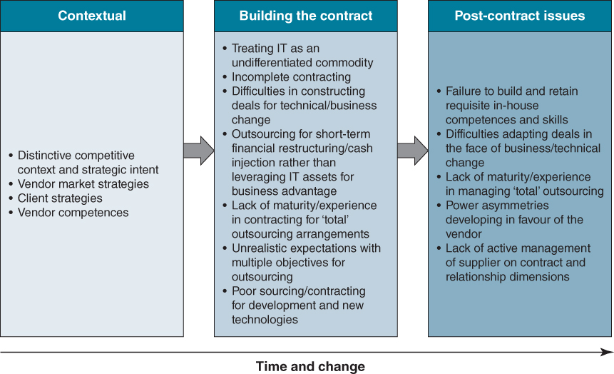
FIGURE 11.10 Outsourcing risk analysis framework.
One of the biggest mistakes organizations make is signing suppliers' standard contracts, which often contain details that not even a company's legal staff can always understand, especially if it involves a technology with which the supplier (and perhaps the client) is not familiar. Interestingly, research indicates that detailed contracts were more likely to be successful than relational contracts.⁶² Should it ever come to a dispute, only three things matter: the contract, the contract and the contract! In negotiating any contract, a team should be formed, headed by senior business and IT executives, and a variety of specialists, including an in-house technical expert and a contract lawyer specializing in IT who can detect hidden costs and clauses in contracts. Box 11.4 outlines some of the main outsourcing contractual and contract management issues:

BOX 11.4

Outsourcing: contractual issues
Length of contract. An organization should try whenever possible to sign short-term contracts because they ensure that the prices stipulated will not become out of step with market prices. For economic reasons, companies often look to contract for 10 years or more and to establish a strategic relationship with the supplier. However, contracting for IT services for such a length of time is very risky: in the course of five years it is possible to experience two generations of technology.
Service definition. Services should be defined according to their purpose and critical business factors, including the aim and scope of the service and, if applicable, any elements specific to the client's organization. The contract should include regular reviews of service definitions according to changing business needs and technical imperatives.
Service level requirements specifications. Service level requirements, performance metrics and targets should be expressed in both business and technical terms, wherever possible, to ensure their relationship to business success factors is clear to both parties.
Service level measurement and verification. In short-term contracts, the client or a third party should carry out measurement, verification and reporting of the service levels delivered. In long-term contracts, the vendor should also report the achievement of service level targets. Escalation procedures for disputes about performance should be clear.
Penalties for non-performance. Penalties for failing to meet minimum standards must be sufficiently meaningful to prevent complacency and sloppy work. However, the reason for penalties is not to punish, pay less for poor service or to recover costs incurred as a result of problems. Rather, penalties should prevent problems from occurring in the first place and, failing that, should result in action that fixes the problems and increases the likelihood of success in the future.
Incentives for service level attainment. The purpose of incentives is to ensure that performance targets are met. Long-term relationships between client and vendor are characterized by stronger reputation effects, which is in itself an effective incentive mechanism for the vendor. Positive, reward-based incentives can be employed when the target is volatile (indeterminate in advance) or when it is hard to achieve. Deterrent incentives and penalties, including financial penalties, can be employed when the service is critical to the business or when the target is easy to achieve. The conditions for extreme situations such as termination and/or change of vendor should also be clearly specified.
Coordination and communication mechanisms. A steering committee and/or review board should be set up to govern the contract. This should comprise membership from both parties for top-level direction and corrective adjustments to the relationship and the contract. The information collected through monitoring and measurement must be fed to the decision-making bodies for continuous review of performance and to set relevant targets for improvement. It may be advisable to involve an independent third party in the review board to advise or even arbitrate where problems arise, or, perhaps more importantly, to pre-empt disputes.

Post-contract Management
Collect fines for non-compliance. Some companies see a vendor performance shortfall as an opportunity to extract non-monetary payback, extracting some free service on the side in lieu of penalty charges. While such a compromise may be expedient, it sends the wrong message to vendors and undermines the company's position.
Don't be afraid to confront the provider. Conflict avoidance is one of the most common reasons for failure of outsourcing relationships. Ultimately, the client organization is responsible for user satisfaction; so when a vendor doesn't deliver, it's the client's responsibility to let them know. Involving the senior management of the vendor is often the easiest way to resolve disputes that can otherwise become bogged down in ‘technical’ arguments.

Business Process Outsourcing
Business process outsourcing (BPO) is transferring the primary responsibility for executing and managing a business process to an external organization. Often, this involves outsourcing the infrastructure supporting the business process, including the IT infrastructure. As with IT, organizations outsource business processes to reduce costs, to focus on core capabilities and to obtain new resources, such as skills and expertise to improve business process performance, scalability, and delivery speed.⁶³ Researchers have found patterns suggesting that BPO arrangements stand a better chance of generating the desired benefits if companies evaluate an outsourced process on several dimensions and then tailor the contract to fit those dimensions.⁶⁴ These patterns are:
- Complexity: The extent to which the people performing the process must adopt different methods or procedures and the degree to which these individuals lack immediate, established solutions to process problems.
- Independence: The degree to which a process can be changed without affecting other processes in the organization.
- Strategic importance: The extent to which the process affords the organization a competitive advantage.
While any process can be a candidate for outsourcing, to improve the chances of a successful arrangement, the approach to relationship governance should reflect the nature of the process in question. For example, where the outsourced process is characterized by low complexity, high independence and low strategic importance, a company would want to establish a BPO governance model that included an arm's-length contract with best-of-breed specialty providers, in which the company has little operational involvement in the management of the outsourced process.
Box 11.5 lists some questions to ask in assessing the three key process attributes before outsourcing any process.

BOX 11.5

Questions to ask about the three key process attributes

Process Independence
- To what extent does the process have standard interfaces with other organizational processes?
- To what extent do changes to the process affect other organizational processes?
- How difficult is it to assess performance of the process independently of the performance of other organizational processes?
- To what extent can the process be disaggregated into sub-processes that can be executed independently?

Outsourcing Challenges of Interdependent Processes
- ♦ Changes in the outsourced task may affect multiple functions and processes – requiring coordination among several departments.
- ♦ As the breadth of provider involvement in organizational processes increases, the risk of losing strategic information increases.
- ♦ Interdependent components create problems of shared ownership, requiring a skilled integrator to assume ownership and management of the interrelated components.

Process Complexity
- To what extent does a clearly defined body of knowledge guide the effective functioning of the process?
- During the course of their work, how often do process managers and workers come across difficult problems that they don't know how to solve immediately?
- On average, how quickly do managers know whether or not the process has executed successfully?
- In doing their jobs, how often do members of an organizational unit have to adopt different methods or procedures to do their work?

Outsourcing Challenges of Complex Processes
- ♦ Costly, incomplete contracts – contracts do not capture outputs and desired behaviour.
- ♦ Lack of industry standards and performance benchmarks.
- ♦ Increased coordination and communication costs.

Strategic Importance
- To what extent does the process contribute to creating a distinctive brand proposition?
- How significant is the contribution of the process to the perceived customer benefits of the firm's product(s)?
- To what extent does the process play a key role in any of the following?
- ♦ Linking the organization to customers or suppliers or integrating internal business processes.
- ♦ Enabling the development of new products and services based on information.
- ♦ Providing information for executive management to develop strategies.

Outsourcing Challenges of Strategically Important Processes
- ♦ Information ‘poaching’ and strategic information loss.
- ♦ Costly, incomplete contracts, relatively higher learning costs, and lower scale economies for the provider.
- ♦ Larger relationship-specific investments by both client and provider.
Source: Drawn from D. Mani, A. Barua, and A.B. Whinston, ‘Successfully governing business process outsourcing relationships,’ MIS Quarterly Executive, 5, 1, 2006, 15–29.

Innovation and Outsourcing
When organizations outsource IT services, there is often an expectation that the provider will bring innovation. Indeed, during the negotiation of the contract, vendors often say they want to provide it, but it is an aspect that continues to disappoint clients.⁶⁵ In essence, although providers may meet their Service Level Agreements (SLAs) and keep the client IT costs under control, if there are no new ideas coming from the outsourcer or guidance about emerging technologies the client should pursue, this can lead to overall disappointment.
This situation is not always the fault of the service provider. One of the root causes behind a lack of innovation in outsourced environments is an over-emphasis on stability from both buyers and service providers. After the contract is signed, the client executive does not want any unexpected disruption and the provider's executives want all their dashboards to have green indicator lights. Actions taken by both parties will focus on sustaining stability, which will inevitably hinder, or even suppress, innovation.
It is important to remember that IT service providers make money when they can standardize processes across their customer base. Vendors will innovate to the extent it saves them money or helps them introduce new products or services, but they are loath to do anything that might affect their ability to meet their service level obligations or reduce their margins. They are delivering to a contract, and it is difficult to build any kind of innovation into the language of the contract. Often, the reality is that once the provider's sales team and the buyer's procurement group part ways and day-to-day management begins, what the outsourcer is, and is not, legally obligated to do suddenly become crystal clear. Operational profit and loss issues become critical to the supplier and talk of innovation is overtaken by the realities of the contract.
Ironically, contracting for innovation has little to do with the contract itself. In the most successful and innovative IT outsourcing relationships, the contract quietly gathers dust after the ink is dry. The contract is one consequence of a more important negotiation that establishes a relationship between the customer and provider that will produce innovation, while the legal documents sit on a shelf.⁶⁶ In contrast to what one might expect, research has found that organizations are likely to start a relationship with high levels of trust since they have mutually concluded a successful contract negotiation phase.⁶⁷
Innovation can only succeed when the relationship between client and suppliers is based on and sustains trust between all the parties.⁶⁸ Trust can be categorized into three types: personal, competence and motivational.⁶⁹ Personal trust is the confidence an individual has that someone else will work for the good of the relationship, based on that person's integrity and adherence to moral norms. Competence-based trust exists when one party has confidence that the other will be able to successfully deliver their allocated tasks and responsibilities. Motivational trust is where both parties believe the rewards and penalties they experience are geared toward the achievement of joint goals – a ‘win–win’ situation.
Moreover, clients should spend more time with suppliers upfront, before the contract is signed, examining and modelling precisely how innovation will be achieved. Both parties should discuss the processes that will need to be put in place to further innovation, the investments that each party will need to make and the change management measures that will be required. One organization established an innovation board jointly populated by client and provider executives who met quarterly to review and select new initiatives from the ideas put forward from either side of the relationship. If an organization wants a provider to innovate, it must first define what it means by innovation in the context of its corporate objectives. It might mean continuous process improvement, emerging technology implementation, new best practices, IT transformation or competitive advantage. A clear definition of innovation is required so that the contract will reflect the appropriate financial and other terms associated with it.
The rationale for provider selection also has an impact on innovation. If the services provider is chosen solely on cost, it is unrealistic to then expect them to bring significant innovation. Cost-cutting and innovation can coexist, but not easily. The concept of gainsharing – rewarding the supplier when the client benefits from lower costs, increased revenue or improved efficiency – has always been a controversial one among outsourcing customers. Another option is to set up a jointly funded pool to pay for agreed innovation initiatives or sharing of savings generated by particular innovation projects. Outsourcers are starting to move away from traditional IT service metrics that are easier to collect and meet, to more complex business outcome metrics.

Back-sourcing and Switching Suppliers
After the outsourcing contract is awarded and an initial transition period, the client begins to experience the services and deliverables specified in the contract. The contract may proceed as expected and reach the natural end of its term uneventfully. Alternatively, several types of change can occur during the contract, such as: a change in the management team, or key individuals, economic environment or business strategy changes and technology evolution. These can cause a re-evaluation of the contract with the supplier. Box 11.6 describes the reversal of a major outsourcing decision after only two years. Although not made public in the announcement, the attitudes and preferences of the new management team were clearly a factor in the decision by the newly merged JPMorgan Chase/Bank One to back-source. The newly appointed CIO of the merged corporation had previously been CIO of Bank One and had back-sourced their operations from IBM Global Services and AT&T.

BOX 11.6

The outsourcing/back-sourcing merry-go-round
On 30 December 2002, JPMorgan Chase & Co. announced a 7-year outsourcing deal with IBM, stressing the advantages of IBM managing its IT infrastructure:
JPMorgan Chase & Co. today finalized with IBM a ground breaking seven-year outsourcing agreement, in excess of $5 billion, the largest of its kind. The agreement will enable JPMorgan Chase to transform its technology infrastructure through absolute costs savings, increased cost variability, access to the best research and innovation, and improved service levels.
‘We view technology as a key competitive advantage. Our agreement with IBM will create capacity for efficient growth and accelerate our pace of innovation, while reducing costs, increasing quality and providing exciting career opportunities for our employees,’ said Thomas B. Ketchum, vice chairman, JPMorgan Chase. ‘IBM's global strength and computing capabilities, delivered “on demand”, will help us create significant value for our clients, shareholders and employees’.
Less than 2 years later, the company cancelled the deal. The press release announcing the ‘back sourcing’ decision stressed the importance of the bank managing its own IT infrastructure:
JPMorgan Chase & Co. (NYSE: JPM) and IBM today announced JPMorgan Chase's plans to reintegrate the previously outsourced portions of its technology infrastructure, including data centers, help desks, distributed computing, data networks and voice networks. Beginning in January, 2005, the approximately 4,000 IBM employees and contractors currently supporting the JPMorgan Chase account will be transferred to JPMorgan Chase.
‘We believe managing our own technology infrastructure is best for the long-term growth and success of our company as well as our shareholders. Our new capabilities will give us competitive advantages, accelerate innovation, and enable us to become more streamlined and efficient,’ said Austin Adams, JPMorgan Chase's Chief Information Officer.
Source: JPMorgan Chase Signs With IBM For IT Infrastructure Services Transformation (30 Dec 2002); JPMorgan Chase and IBM Announce Changes to Technology Infrastructure (15th September 2004), IBM Press Releases.
While organizations can usually expect to encounter ‘normal growing pains’ with the outsourcing contract, the evidence is that many have significant negative experiences and problems emerge that ultimately lead to re-evaluation of the outsourcing decision.⁷⁰ At that point, the main options for this decision are:
- To renew, extend, or renegotiate some or all of the contract with the original outsourcing supplier for better terms in the light of experience and/or expected new needs;
- To re-tender some or all of the IT outsourcing contract to the market to establish whether a different supplier can meet the needs of the organization better;
- To ‘back-source’ some or all of the previously outsourced activities and carry them out in-house.⁷¹
In the case of the first two of these options, organizations opening or re-opening discussions with suppliers will negotiate from a different starting point in the light of their learning and experience from the previous contract. New requirements may be included at this stage, as well as the opportunity to include technology changes since the last contract was negotiated. Some organizations may also consider the formation of alliances or partnerships, even involving the establishment of joint ventures with suppliers and clients taking shareholdings in the new company.
From our research we have identified the following reasons why organizations choose to back-source and bring back in-house what they had previously outsourced:⁷²
- Problems arise during the contract or failure to achieve specific objectives. Such problems can quickly lead to accusations, counter-accusations and a legal dispute. For example, Cable & Wireless signed an outsourcing contract with IBM in December 2000 for the bulk of its critical management systems including customer care and billing. After a relatively short period, in February 2002, both parties engaged a consultant to review the benchmarking provisions in the agreement. Based on the outcome of that review, Cable & Wireless (C&W) initiated legal action in June 2003 against IBM for alleged overcharging. IBM disputed the allegation and stated that it would ‘contest the case vigorously’.⁷³ The outsourcing contract, which had been agreed in December 2000, was cancelled on 30 June 2003, under half-way through its 10-year term. In September 2003, the legal action was settled and, in an agreed statement, both companies said that C&W would now take the outsourcing contract back in-house as a result of ‘business changes’ within C&W. Settlement terms were confidential.
- IT now seen as strategic and a desire to regain control. This arises in three main ways: with a realization that the previous decision to outsource was based on the assumption that IT was a commodity whereas it is now realized to be strategic; or, as a result of a merger or acquisition where significant new or enhanced skills and capabilities are now available to the organization; or, (as additionally in the JPMorgan Chase/Bank One case), the merged enterprise can exploit significantly greater economies of scale. After its merger with Halifax Building Society in 2001 to form Halifax Bank of Scotland (HBOS), Bank of Scotland decided to terminate its 10-year £700 million outsourcing arrangement with IBM. When the contract was signed in June 2000, it was seen as one of Europe's biggest outsourcing deals. The decision to terminate the contract cost HBOS tens of millions of pounds both in transition costs to back-source the activities, and for penalties to IBM for terminating the contract early without sufficient cause.⁷⁴
- Changes in the business or economic environment and business strategies. Contracts negotiated during the depths of the 2008–10 global financial crisis tended to have a focus on cost reduction. The upturn in business in later years can obviate the need for such cost-oriented outsourcing deals. Extension into new product areas or new markets, or the reverse – contraction due to poor business performance can lead to a decision to outsource functions, or to cut back on existing outsourcing contracts when the need is no longer evident.
- Technology change. The rapid and widespread adoption of mobile technologies over the last few years is an example of a sea change that can take place in the technologies deployed by organizations. Such technologies may not be prominent when the contract is signed. Overby⁷⁵ quotes a JPMorgan systems engineer who had survived the initial outsourcing, and then back-sourcing at Bank One, who said that ‘once they signed the [outsourcing] contract we didn't move at all beyond that date as far as picking up new technologies that would give us competitive advantage. Technology was not refreshed, and new projects were not rolled out.’ New technologies and the associated dramatic price/performance changes can also eliminate any cost advantages which existed when the contract was signed.
- Management change. A new management team, or individual changes, particularly at CEO or CIO level, have also led to a decision to reconsider the value being obtained from the IT outsourcing contract. Some new management teams, as in the case of JPMorgan Chase/Bank One, have reconsidered the contribution of information technology in a strategic context – that which was previously considered a commodity may, on reflection, be considered a core function.
Where clients switched suppliers, research studying application development suggests that service and product quality did not influence the decision to switch. Rather, organizations that made the decision to switch suppliers reported high levels of service and product quality but assessed their relationship with the outsourcer as poor and there were low switching costs.⁷⁶

Summary
This chapter has attempted to outline organizational strategies for managing IT services and technology, including issues associated with the acquisition, sourcing and application of technology and related services. The IT strategy should never become the exclusive domain of technologists, although obviously their input to the management process is very valuable and must be able to be incorporated effectively. The focus of the technology strategy should always reflect how it can be deployed to add value to the business. Future business success depends on today's technology being well managed and it is dangerous to assume that future technology will resolve current problems in due course – it is more likely to exacerbate them.
The management of IT infrastructure and services is often seen as less glamorous or exciting than the development and implementation of new applications, but while they create business benefit opportunities, it is the IT services that ensure they can be sustained.
Some services are purely operational or infrastructural and are well understood, and established frameworks such as ITIL can govern their management. Others can be considered as value enabling, including IS/IT strategy development itself, and need to be designed to fit the organization context. But in all services there are trade-offs to be made in balancing the value of the service to individual users and the organization with the costs of providing the level of availability and performance ideally required. Regular reviews of service quality, to identify gaps and areas where performance improvement will produce a positive business impact, should be used to guide the deployment of resources and investments in existing services.
Although most publicized cases of IT failure involve new developments, operational failure can be more devastating to a business. The number of business risks associated with IT operations has increased as more and more business activities have become IT dependent and risk assessment, prevention and management are critical components of an IT strategy. It is beyond the scope of this book to cover risk management strategies in detail, but we have provided a brief overview aimed at increasing general management's understanding of what is involved and why it is important.
The majority of organizations now use outside suppliers to provide some or most of their IT services and this trend is continuing. The rationale is both economic, to save cost, and strategic, to obtain new capabilities and reduce business risks. Deciding on which aspects of IT to outsource and to whom is a complex process and needs to be considered carefully in terms of what is intended, how the outsourcer will be able to achieve it and finally whether the contract is appropriate, both in content and timescale. Additionally, most outsourcing decisions, and subsequent decisions to back-source or change suppliers, are made on subjective as well as objective criteria, especially regarding the match of business ‘cultures’ between supplier and client. This is particularly important if part of the rationale is to achieve innovation through the relationship, which is difficult to write into a contract and relies on mutual trust and close working arrangements at operational and executive levels.

Endnotes
- 1. Usually referred to as captive provider when an organization uses a wholly owned subsidiary instead of a third-party vendor.2. Performance against agreed service levels is often reported using colours. ‘Green’ signals that performance is at the agreed level or better; ‘Amber’ indicates that the service is problematic in some areas or may cause a problem in the future; and ‘Red’ indicates that performance is below agreed levels.3. K. Albrecht, At America's Service, Dow-Jones Irwin, Homewood, Ill, 1988.4. Adapted from C. Gronroos, ‘From scientific management to service management: a management perspective for the age of service competition’, International Journal of Service Industry Management, 5, 1, 1986, 5–20.5. For example, software as a service, service oriented architecture, infrastructure as a service, managed service, cloud service etc.6. See, for example, R.W. Schmenner, Service Operations Management, Prentice-Hall, Englewood Cliffs, New Jersey, 1995.7. ITIL is the IT Infrastructure Library and part of the services provided by the UK's Office for Government Commerce (OGC). See A Code of Practice for IS Service Management, British Standards Institute, London, 1999.8. Some scholars, such as Weill and colleagues, see infrastructure as including a ‘human’ aspect. In our categorization, these human aspects would be categorized under value-enabling services or operational services. See P. Weill, M. Subramani and M. Broadbent, ‘Building IT infrastructure for strategic agility’, MIT Sloan Management Review, Fall, 2002, 57–65.9. For another perspective see P. Pharati and D. Berg, ‘Managing information systems for service quality: a study from the other side’, Information Technology & People, 16, 2, 2003, 183–202.10. J.M. Kohlemeyer III and J. Ellis Blanton, ‘Improving service quality’, Journal of Information Technology Theory & Application, 2, 1, 2000, Article 3; L.F. Pitt, R.T. Watson and C.B. Kavan, ‘Service quality: A measure of information systems effectiveness’, MIS Quarterly, 19, 2, 1995, 173–185; and L. Pitt, P. Berthon and N. Lane, ‘Gaps within the IS department: barriers to service quality’, Journal of Information Technology, 13, 1998, 191–200.11. A. Parasuraman, V.A. Zeithaml, and L.L. Berry, ‘SERVQUAL: a multiple item scale for measuring consumer perceptions of service quality’, Journal of Retailing, 64, 1, 1988, 12–40.12. L. Pitt, P. Berthon and N. Lane, ‘Gaps within the IS department: barriers to service quality’, Journal of Information Technology, 13, 1999, 191–200; and L. Pitt, R.T. Watson and C.B. Kavan, ‘Service quality: a measure of information systems effectiveness’, MIS Quarterly, 19, 2, 1995, 173–185.13. G. Whyte, A. Bytheway and C. Edwards, ‘Understanding user perceptions of information systems success’, Journal of Strategic Information Systems, 6, 1997, 35–68; and T.P. Van Dyke, L.A. Kappelman and V.R. Prybutok, ‘Measuring information systems service quality: concerns on the use of SERVQUAL questionnaire’, MIS Quarterly, 21, 2, 1997, 195–208.14. M.C. Lacity and R. Hirschheim, Beyond the Information Systems Outsourcing Bandwagon: The Insourcing Response, John Wiley & Sons, Chichester, UK, 1995.15. R. Sylvestro, L. Fitzgerald, R. Johnston and C. Voss, ‘Towards a classification of service processes’, International Journal of Service Industries Management, 3, 3, 1992, 62–75.16. This framework is usually applied at an industry level, with organizations choosing to position themselves in a particular quadrant. For example, the delivery processes of McDonalds are different to those of a high-class French restaurant; or a full-service broker has different delivery processes to an execution-only broker.17. J. Peppard, ‘Managing IT as a portfolio of services’, European Management Journal, 21, 4, 2003, 467–483. See also R.W. Schmenner, ‘How can service businesses survive and prosper’, Sloan Management Review, Spring, 1986, 21–32.18. D.E. Avison and G. Fitzgerald, Information Systems Development: Methodologies, Techniques, and Tools, 4th Edition, McGraw-Hill, London, 2006; W.S. Humphrey, A Discipline for Software Engineering, Addison-Wesley, New Jersey, 1995; J.M. Nicholas, Project Management for Business and Technology: Principles and Practices, 2nd Edition, Prentice-Hall, New Jersey, 2001; K. Schwalbe, Information Technology Project Management, Prentice-Hall, New Jersey, 2001; and J.M. Ward and E.M. Daniel, Benefits Management: How to increase the business value of your IT projects, 2nd Edition, John Wiley and Sons, Chichester, 2012.19. D.T. McKay and D.W. Brockway, ‘Building IT infrastructure for the 1990s’, Stage by Stage, 9, 3, 1989, 1–11.20. M. Broadbent, P. Weill and B.S. Neo, ‘Strategic context and patterns of IT infrastructure capability’, Journal of Strategic Information Systems, 8, 1999, 157–187.21. K. Breu, C. Hemmingway, D. Bridger and M. Strathern, ‘Workforce agility: The new employee strategy for the knowledge economy’, Journal of Information Technology, 17, 2002, 21–31.22. P.A. Strassman, The Squandered Computer: Evaluating the Business Alignment of Information Technology, The Economics Press, New Canaan, Connecticut, 1997, and Information Productivity: Accessing the Information Management Costs of US Industrial Companies, The Economics Press, Conn, 1997; Productivity in the United States, 1995–2000, McKinsey Global Institute, October, 2001.23. P. Keen, Shaping the Future, Harvard Business School Press, Boston, 1991.24. M. Broadbent, P. Weill and B.S. Ned, ‘Strategic context and patterns of IT infrastructure capability’, Journal of Strategic Information Systems, 8, 1999, 157–187.25. M.B. Mohdzain and J.M. Ward, ‘A study of subsidiaries’ views of information systems strategic planning in multinational organizations', Journal of Strategic Information Systems, 16, 2007, 324–335.26. ISACA, 2015. As an independent, non-profit, global association, ISACA engages in the development, adoption and use of globally accepted, industry-leading knowledge and practices for information systems. Previously known as the Information Systems Audit and Control Association, ISACA now goes by its acronym only, to reflect the broad range of IT governance professionals it serves.27. For more comprehensive coverage of IT risks see: E. Jordan and L. Silcock, Beating IT Risks, John Wiley and Sons, Chichester, UK, 2005.28. G. Dhillon and J. Backhouse, ‘Risks in the use of information technology within organizations’, International Journal of Information Management, 16, 1, 1996, 65–74.29. M. Parent and B.H. Reich, ‘Governing information technology risk’, California Management Review, 51, 3, 2009, 134–152.30. Control Objectives for Information and Related Technologies – developed by the IT Governance Institute (ITGI) for the Information Systems Audit and Control Association (ISACA).31. Committee of Sponsoring Organizations of the Treadway Commission.32. T. Clark, R. Zmud and G. McCray, ‘The outsourcing of information services: Transforming the nature of business in the information industry’, in L.P. Willcocks and M.C. Lacity, eds, Strategic Sourcing of Information Systems, John Wiley & Sons, Chichester, UK, 1998, 45–78.33. W.R. King and G. Torkzadeh, ‘Information systems offshoring: research studies and issues’, MIS Quarterly, 32, 2, 2008, 205–225.34. L. Loh and N. Venkatraman, ‘Diffusion of information technology outsourcing: Influence sources and the Kodak effect’, Information Systems Research, 3, 4, 1992, 334–358. For a historical review, see J. Dibbern, T. Goles, R. Hirschheim and B. Jayatilaka, ‘Information systems outsourcing: a survey and analysis of the literature’, The DATABASE for Advances in Information Systems, 35, 4, 2004, 6–102.35. W.L. Currie, ‘Outsourcing in the private and public sectors: An unpredictable IT strategy’, European Journal of Information Systems, 4,1996, 226–236; W.L. Currie, ‘Using multiple suppliers to mitigate the risks of IT outsourcing at ICI and Wessex Water’, Journal of Information Technology, 13, 3, 1998, 169–180; M.C. Lacity, L.P. Willcocks and D.F. Feeny, ‘The value of selective IT sourcing’, Sloan Management Review, Spring, 1996, 13–25; M.C. Lacity, L.P. Willcocks and D.F. Feeny, ‘IT outsourcing: Maximizing flexibility and control’, Harvard Business Review, May–June 1995, 84–93; and A. Kakabadse and N. Kakabadse, Smart Sourcing, Palgrave, Basingstoke, UK, 2002.36. L. Willcocks and C. Sauer, ‘High risks and hidden costs in IT outsourcing’, in Financial Times Mastering Risk, May 2000.37. L.P. Willcocks and M.C. Lacity, ‘Introduction—the sourcing and outsourcing of IS: Shock of the new’, in L.P. Willcocks and M.C. Lacity, eds, Strategic Sourcing of Information Systems, John Wiley & Sons, Chichester, UK, 1998, 1–41.38. L.P. Willcocks and M.C. Lacity, ‘Introduction—the sourcing and outsourcing of IS: Shock of the new’, in L.P. Willcocks and M.C. Lacity, eds, Strategic Sourcing of Information Systems, John Wiley & Sons, Chichester, UK, 1998, 1–41.39. D. Whitten and R.L. Wakefield, ‘Measuring switching costs in IT outsourcing services’, Journal of Strategic Information Systems, 15, 3, 2006, 219–248. See also D. Whitten, S. Chakrabarty and R. Wakefield, ‘The strategic choice to continue outsourcing, switching vendors, or backsource: do switching costs matter’, Information & Management, 47, 3, 2010, 167–175.40. A. DiRomualdo and V. Gurbaxani, ‘Strategic intent for IT outsourcing’, Sloan Management Review, Summer, 1998, 67–80.41. See M.C. Lacity, L.P. Willcocks and D.F. Feeny, ‘Sourcing information technology capability: A framework for decision-making’, in M.J. Earl, ed., Information Management: The Organizational Dimensional, Oxford University Press, New York, 1996, 399–425. The discussion that follows draws on this paper. For a study of the determinants of sourcing decisions see B. Watjatrakul, ‘Determinants of IS sourcing decisions: A comparative study of transaction cost theory versus the resource-based view’, Journal of Strategic Information Systems, 14, 4, 2005, 389–415.42. M. Lacity and R. Hirschheim, ‘What problems are organizations solving with IT outsourcing?’, in W. Currie and R. Galliers, eds, Rethinking MIS, Oxford University Press, Oxford, 1997, 326–360.43. L. Willcocks, G. Fitzgerald and M. Lacity, ‘To outsource IT or not? Recent research on economics and evaluation practice’, European Journal of Information Systems, 5, 1996, 143–160.44. T. Kern and L. Willcocks, The Relationship Advantage: Information Technologies, Sourcing and Management, Oxford University Press, Oxford, 2001.45. M.J. Earl, ‘The risks of outsourcing IT’, Sloan Management Review, Spring, 1996, 26–32.46. M.C. Lacity and R. Hirschheim, Beyond the Information Systems Outsourcing Bandwagon: The Insourcing Response, John Wiley & Sons, Chichester, UK, 1995.47. Cullen and colleagues have developed a 4-phase outsourcing life-cycle model with 54 key activities. See S. Cullen, P. Seddon and L. Willcocks, ‘Managing outsourcing: the lifecycle imperative’, MISQ Executive, 4, 1, 2005, 229–246.48. L.P. Willcocks, T. Kern, E. Van Heck, ‘The winner's curse in IT outsourcing: strategies for avoiding relational trauma’, California Management Review, 44, 2, 2002, 47–69.49. D. Feeny, M. Lacity and L.P. Willcocks, ‘Taking the measure of outsourcing providers’, MIT Sloan Management Review, Spring, 2005, 41–48.50. M. Lacity, S. Khan, A. Yan and L. Willcocks, ‘A review of the IT outsourcing empirical literature and future research directions’, Journal of Information Technology, 24, 4, 2010, 395–433; and M.C. Lacity, A. Shaji, A. Khan and L.P. Willcocks, ‘A review of the IT outsourcing literature: insights for practice’, Journal of Strategic Information Systems, 18, 3, 2009, 130–146.51. C. Koh, S. Ang and D. Straub, ‘IT outsourcing success: a psychological contract perspective’, Information Systems Research, 15, 4, 2004, 356–373; L. Willcocks and M. Lacity, Global Sourcing of Business and IT Services, London: Palgrave Macmillan, 2006; L. Willcocks and M. Lacity, Outsourcing Practices Reconsidered: From IT to Cloud Services, London: Palgrave Macmillan, 2012; J. Dibbern, T. Goles, R. Hirschheim and J. Bandula, ‘Information systems outsourcing: a survey and analysis of the literature’, Database for Advances in Information Systems, 34, 4, 2004, 6–102; M.C. Lacity and L.P. Willcocks, ‘An empirical investigation of IT outsourcing practices: Lessons from experiences’, MIS Quarterly, 22, 3, 1998, 363–408; M.C. Lacity and R. Hirschheim, Beyond the Information Systems Outsourcing Bandwagon: The Insourcing Response, John Wiley & Sons, Chichester, UK, 1995; F.W. McFarlan and R.L. Nolan, ‘How to manage an IT outsourcing alliance’, Sloan Management Review, Winter, 1995, 9–23; L.P. Willcocks, M.C. Lacity and T. Kern, ‘Risk mitigation in IT outsourcing strategy revisited: Longitudinal case research at LISA’, Journal of Strategic Information Systems, 8, 1999, 285–314; and L.P. Willcocks and M.C. Lacity, ‘IT outsourcing in insurance services: Risk, creative contracting and business advantage’, Information Systems Journal, 9, 1999, 163–180. For a study identifying preliminary measures of IT outsourcing risk factors, see B. Bahli and S. Rivard, ‘Validating measures of information technology outsourcing risk factors’, Omega, 33, 2005, 175–187.52. M.C. Lacity and R. Hirschheim, ‘Information systems outsourcing bandwagon’, Sloan Management Review, Fall, 1993, 73–86.53. A. DiRomualdo and V. Gurbaxani, ‘Strategic intent for IT outsourcing’, Sloan Management Review, Summer, 1998, 67–80.54. L.P. Willcocks and G. Fitzgerald, A Business Guide to IT Outsourcing, Business Intelligence, London, 1994.55. L.P. Willcocks, G. Fitzgerald and M. Lacity, ‘To outsource IT or not?: Recent research on economics and evaluation practice’, European Journal of Information Systems, 5, 1996, 143–160.56. See J.A. Hall and S.L. Liedtka, ‘The Sarbanes-Oxley Act: implications for large-scale IT outsourcing’, Communications of the ACM, 50, 3, 2007, 95–100.57. See N. Levina, ‘Collaborating on multi-party information systems development projects: a collective reflection-in-action view’, Information Systems Research, 16, 2, 2005, 109–130.58. For a study of proximity and IT outsourcing see A. Arora and C. Forman, ‘Proximity and information technology outsourcing: how local are IT services markets’, Journal of Management Information Systems, 24, 2, 2007, 73–102.59. M.J. Earl, ‘The risks of outsourcing IT’, Sloan Management Review, Spring, 1996, 26–32.60. J.W. Rottman and M.C. Lacity, ‘Proven practices for effectively offshoring IT work’, Sloan Management Review, 47, 3, 56–63.61. L.P. Willcocks and C. Sauer, ‘High risks and hidden costs in IT outsourcing’, Financial Times: Mastering Risk, 23 May, 2000.62. M. Lacity and R. Hirschheim, ‘What problems are organizations solving with IT outsourcing?’, in W. Currie and R. Galliers, eds, Rethinking MIS, Oxford University Press, Oxford, 1997, 326–360.63. M.C. Lacity, S. Solomon, A. Yan and L. Willcocks, ‘Business process outsourcing studies: a critical review and research directions’, Journal of Information Technology, 26, 2011, 221–258.64. D. Mani, A. Barua and A.B. Whinston, ‘Successfully governing business process outsourcing relationships,’ MIS Quarterly Executive, 5, 1, 2006, 15–29.65. M.R. Weeks and D. Feeny, ‘Outsourcing: from cost management to innovation and business value’, California Management Review, 50, 4, 2008, 127–146.66. M.R. Weeks and D. Feeny, ‘Outsourcing: from cost management to innovation and business value’, California Management Review, 50, 4, 2008, 127–146; and J. Rottman and M.C. Lacity, ‘Proven practices for effectively offshoring IT work’, MIT Sloan Management Review, 47, 3, 2006, 56–63.67. D.H. McKnight, L.L. Cummings and N.L. Chervany, ‘Initial trust formation in new organizational relationships’, Academy of Management Review, 23, 3, 1998, 967–985; and M.R. Weeks and D. Feeny, ‘Outsourcing: from cost management to innovation and business value’, California Management Review, 50, 4, 2008, 127–146.68. E.A. Whitley and L. Willcocks, ‘Achieving step-change in outsourcing maturity: towards collaborative innovation’, MIS Quarterly Executive, 10, 3, 2011, 95–107.69. M.R. Weeks and D. Feeny, ‘Outsourcing: from cost management to innovation and business value’, California Management Review, 50, 4, 2008, 127–146.70. See N.F. Veltri, C.S. Saunders and C.B. Kavan, ‘Information systems backsourcing: correcting problems and responding to opportunities’, California Management Review, 51, 1, 2008, 50–76.71. Other authors have used the terms ‘re-insourcing’. See P. Buxbaum, ‘Bringing IT back home’, Computerworld, Issue of 29 July, 2002; S. Overby, ‘Bringing I.T. back home’, CIO Magazine, 1 March, 2003; and C. Tiernan, ‘The three ‘R’s – Renegotiating, Retendering, Reinsourcing’, IMIS Journal, October, 2002, 21–22. Another issue is the inconsistent use of the terms ‘insourcing’ and ‘backsourcing’.72. D. McLaughlin and J. Peppard, ‘IT backsourcing: from ‘make or buy’ to ‘bring IT back in-house'’, Proceedings of the European Conference on Information Systems, Gothenburg, Sweden, 2006.73. ‘Cable & Wireless: Lawsuit against IBM alleges overcharging for Tech Services’, The Wall Street Journal, 23 June 2003.74. Computer Weekly, 29th August 2002, http://www.computerweekly.com/Articles/2002/08/29/189257/Bankbins%c2%a3700mIBMdeal.htm75. S. Overby, ‘Backsourcing Pain’, CIO Magazine, 1 September, 2005.76. D. Whitten and D. Leidner, ‘Bringing IT back: an analysis of the decision to backsource or switch vendors’, Decision Science, 37, 4, 2006, 605–621. See also D. Whitten, S. Chakrabarty and R. Wakefield, ‘The strategic choice to continue outsourcing, switching vendors, or backsource: do switching costs matter’, Information & Management, 47, 3, 2010, 167–175.

UNIT 12
THE STRATEGIC MANAGEMENT OF INFORMATION SYSTEMS: QUO VADIS?

OUTLINE
- ♦ The Evolution of IS/IT Strategy in Theory and Practice
- ♦ A Brief Résumé of some Core Ideas
- ♦ Building an IS/IT or Digital Capability
- ♦ From Creating IS/IT Assets to Improving Organizational Performance: Joining the Means to the Ends
- ♦ Achieving Alignment: a Multi-themed Perspective
- ♦ The Co-evolution of Business and Digital Strategies
- ♦ The Opportunity for CIOs to Have a Key Strategic Role
- ♦ Conclusion
Thanks primarily to the continued attention that ‘tech’ receives in the media and stories of how digital technologies are visibly reshaping industries and changing the basis of competition, IS/IT or digital strategies are receiving significant management attention in most organizations. Technologies like analytics, social media, mobile, the cloud and the Internet of Things have attracted the interest of managers and executives. Companies such as Google, Facebook, Alibaba, Uber, Apple and Amazon have come to signify a new type of company that emphasizes not just technology but the ability to harness information and launch new business models. How more established organizations like GE, the UK's tax and revenue agency (HMRC), Tesco and Harrah are leveraging ‘big data’ has also increased interest in the possibilities of IS/IT.
Moreover, the rapid increases in connectivity available through IT at all levels – global, industry, inter-organization and within organizations and between people – has made providing, accessing and exchanging information very easy (i.e. frictionless) and almost ‘free’, opening up new options for every organization and creating opportunities for completely new businesses to enter industries and provide new information-based products and services.
IS/IT has also become increasingly pervasive in the daily lives of people; even governments are digitizing many of their services for citizens. New ‘wearable’ technologies are opening up new concepts in healthcare and well-being. Industries from automotive to media to take-out food to real estate are being significantly disrupted by IS/IT. Of course, the big challenge for business management is understanding what this all means for their organization and figuring out where, when and how to invest in IS/IT. This book focuses on answering these questions as we know that astute investment in IT has a positive impact on profitability¹ and growth.²
By now it should be clear that we are strong advocates of all organizations having a strategy for information systems (IS) and information technology (IT): what we have referred to collectively as the digital strategy. Even if an organization's executive team decides that it does not seek to gain advantage from IS/IT opportunities, there is still the need for a strategy just to avoid disadvantage. Either way, a more strategic approach will help optimize the return from any spend on IS/IT. This book is concerned with providing guidance on developing the IS/IT strategy – one that is both aligned to and shaping business strategy – but also that investments in IS/IT are managed strategically. This is why we changed the name of the fourth edition of this book to The Strategic Management of Information Systems, to emphasize that the requirement is not just to build the IS/IT strategy but to incorporate a more strategic perspective into its management and implementation, so that expected business outcomes are achieved.
Although digital technologies open up new business opportunities and competitive options, there is the risk that the pursuit of opportunity will be driven by what is technologically feasible, rather than what is strategically desirable. This is often what causes the problems that many organizations have been experiencing regarding their IS/IT investments. Buying technology solves no problems;³ in fact, it can often create many more. The IS/IT strategy is implemented through programmes and projects that both create IT assets as well as build new business capabilities; these capabilities being enabled and shaped by IS/IT assets. This will inevitably require business changes which have to be managed effectively if expected benefits are to be delivered. Unfortunately, as mentioned earlier in the book, the failure rate of IS/IT investments continues to be at an unacceptable level.
Equally, rapid developments in the IT ‘supply chain,’ particularly in respect of cloud computing, are enabling more and more of organizations' requirements for IS/IT to be sourced more easily from external suppliers. Moreover, IT spend can be shifted from CapEx (capital expense) to OpEx (operational expense), with applications and infrastructure capable of being purchased ‘on demand,’ as a service, when required. However, increasing the options available is only an advantage if the organization knows what it is trying to achieve and why; otherwise, how it does it will be a constraint to its strategy, whether its IS/IT requirements are sourced internally or externally. As discussed in Chapter 11, ‘smart’ sourcing is easy to prescribe but as research and practice continues to report, not that easy to achieve successfully.
There was a time when it was enough for IS/IT investment to keep up with business and environmental change and for the IT organization to provide effective support services to the business. In the mid-1980s, the strategic information systems era arrived with the emergence of the use of IT for competitive advantage. Yet achieving strategic advantages from the use of IS/IT has proved elusive for many organizations and many more, through lack of IS/IT investment, are actually at a competitive disadvantage. Moreover, as we have illustrated throughout this book, the roles of the IS or IT unit, however labelled, and the IT Director or chief information officer (CIO) have also changed significantly during this time to accommodate new expectations they must not only keep up with business strategy but are increasingly expected to inform, and even drive, strategic thinking.
We have argued that the conventional view that business strategy drives IS strategy, which, in turn, drives IT strategy, is not sufficient for this expanding role of IS/IT. Such a perspective effectively ensures that IS/IT investment will always lag behind business strategy. It can also limit strategic options by denying senior managers insight into either the opportunities offered by new technology or the reality of what IS/IT can actually deliver. If it is to make a genuine contribution to business strategy, a different logic is required that allows the capabilities of IS/IT to be an intrinsic component of corporate and business unit strategy rather than one of its consequences. While we have presented an approach and toolkit for IS/IT strategy development and emphasized that it is a continuous process, there is still a danger that it is seen as a once-off activity and that, once completed, senior managers can get on with their ‘real’ jobs. However, even with well thought out IS/IT strategies, we have seen organizations fail to deliver many business benefits. This again is why we strongly promote a broader strategic management perspective of rather than a sole focus on formulating an IS/IT strategy and associated plans.
Before looking to what the future might hold for IS/IT strategy in this broadest sense, we want to first explore the evolution of the concept of an IS/IT strategy, reflecting on what has been learned from both practice and academic research. We then reprise some of the key messages from this book before elaboration on where academics and practitioners need to focus their attention if we are to advance our understanding of both the theory and the practice of strategic management of IS/IT.

The Evolution of IS/IT Strategy in Theory and Practice
In studying IS/IT strategy, we have an immediate problem in that there is a lack of a clearly defined IS/IT strategy concept.⁴ Furthermore, there is some confusion about whether we should refer to the noun ‘strategy’, the outcome of some process; or the verb ‘strategizing’, where the concern is more about an ongoing process.⁵ It does not help that the many research studies do not define what they mean when they refer to IS strategy and assume the reader understands what the strategy contains and the process of producing it involves. As discussed in Chapter 1, there are various definitions and the terminology used is often inconsistent: IS planning, IT planning, strategic IS planning (SISP), IS strategy, and IT strategy have all been used, referring to seemingly similar notions.⁶ And, of course, we now have the new label of ‘digital strategy’.
Perhaps not unexpectedly, the research agenda in the academic IS and IT strategy literature has tended to follow developments in the strategic management discipline, albeit lagging some years behind. We noted in Chapter 2 that the notion of strategic management was introduced in recognition of the failure of planning in the post-industrial era. Formal planning is only one component of a much more complex socio-dynamic process that brings about strategic change in an organization. Consequently, it is widely accepted today that strategy and planning are different concepts,⁷ a distinction we make very clear in Chapter 3. An organization's strategy does not specifically provide the detail of execution; that's where the plan comes in.
As we saw in Chapter 1, it was the emergence of ‘competitive advantage from IT’ cases such as American Airlines, American Hospital Supplies and Otis Elevators in the late 1970s that raised information systems to a potential source of strategic advantage. Consequently, many companies sought to emulate these early pioneers and proactively seek out opportunities to use information systems as a competitive weapon.⁸ The label of strategic information systems entered the vocabulary of management⁹ and ‘Strategic Information Systems Planning (SISP)’, emerged as a practice.¹⁰
SISP approaches recognized that IS/IT could shape the strategy of a business, and tools, techniques and methodologies were suggested to help organizations in identifying potential opportunities to deploy IT with greater competitiveness in mind – the more useful of these have been described in this book. IS strategy was also promoted as a business management issue, as opposed to falling solely within the realm of the IT organization and the responsibility of the CIO.¹¹ At the same time, ‘alignment’ was elevated to ‘strategic alignment’.¹²
Recognizing the power of IT to provide opportunities to do things differently, the business process re-engineering (BPR) movement¹³ emerged. Warning against ‘paving the cow paths’ and overlaying IT on existing processes and work practices, managers were advised to seek out opportunities to rethink and redesign processes, taking into account the capabilities of the new IT. This period also saw the appreciation that business changes and their effective management¹⁴ were critical to the success of most IS/IT investments and the emergence of benefits management¹⁵ approaches, to engage business managers in the delivery of the expected benefits from IS/IT investments.¹⁶
At the same time, research was also highlighting that, while some companies were achieving competitive advantage from IT, many were unable to move beyond the ‘one hit wonder’ syndrome. Indeed, there was a strong suggestion that many successful strategic applications were due more to serendipity than any formal approach to planning.¹⁷ Research on the sustainability of competitive advantage from IS/IT emphasized that it requires an ‘organizational infrastructure’,¹⁸ an ‘IS strategic platform’,¹⁹ stressing that ‘IT alone is not enough’²⁰ – messages that we have also highlighted on many occasions in this book.
In parallel, the strategic management field was also grappling with the issue of sustainability of competitive advantage and the Resource Based View (RBV) was proposed as an explanation. IS scholars have explored factors affecting sustainable competitive advantages from IS/IT from this perspective,²¹ leading to a call for organizations to move beyond the search for strategic information systems and develop an IS capability²² – an ‘ability to mobilize and deploy IT-based resources in combination with other resources and capabilities’.²³ It is an ongoing and continuous process (or ‘dynamic capability’) that has seen the notion of strategic alignment be replaced by arguments that business and IS/IT strategies should ‘co-evolve’.²⁴ We discuss the implications of this view in more depth later in the chapter.
The published academic research includes many studies focusing on the techniques, tools, frameworks and methodologies of IS strategy; many of these we have presented in this book. For example, there are studies of the use and implementation of SISP methodologies;²⁵ evaluating the relative success of alternative SISP approaches;²⁶ of the organizational characteristics of IS planning;²⁷ of the effectiveness of SISP under environmental uncertainty;²⁸ of anatomy and procedural justice in SISP;²⁹ comparing methodologies for identifying strategic information systems opportunities.³⁰ Studies have also reported on success factors of IS strategy and barriers to success,³¹ investigated the enablers and inhibitors to alignment³² and identified those factors influencing the achievement of the social dimension of alignment between business and IT objectives.³³
However, there has been much less attention paid to IS/IT strategy implementation issues.³⁴ Research has explored (post) implementation experiences, particularly of enterprise systems,³⁵ but this has not been tied back to the IS/IT strategy. There is obviously a gap in our knowledge concerning strategy implementation as other research reveals that many projects defined as part of the IS strategy are not implemented,³⁶ and those that do go ahead have a high failure rate in achieving expected business outcomes.³⁷ Why this is the case is not well understood and deserves further study.
The emergence of the ‘strategy-as-practice’ stream of research offers a new approach to studying IS/IT strategic management. The basic premise behind research using this lens is that strategy is something that organizations do rather than have. Consequently, studies focus on strategizing or the ‘doing of strategy’,³⁸ attempting to uncover the actual day-to-day activities, contexts, processes and content that relate to strategic outcomes. This move towards a more micro perspective is in response to growing frustration with the lack of relevance to practitioners of much of the contemporary strategic management literature.³⁹ Strategy-as-practice research emphasizes how people engage in the ‘real work’ of developing strategies: the focus is on strategy praxis (the work), strategy practitioners and strategy practices, including the tools and techniques actually used.⁴⁰ The Journal of Strategic Information Systems has published a special issue that had a number of articles, each viewing aspects of IS/IT strategic management from this perceptive.⁴¹ Hopefully these articles will pave the way for further studies uncovering more of the practices involved in developing and implementing digital as well as business strategies.

Evolving IS/IT Strategic Influences in Practice
In a similar way to how the impact of IT applications on both businesses and individuals has evolved over the last half century, IS/IT strategies have also evolved in terms of purpose, content and relationships with business strategies.⁴² Table 12.1 suggests a way of summarizing this evolution by considering the effects of the major influencing factors, especially the balance of ‘technology push’ and ‘business pull’, the economic cycle and the power of suppliers and vendors.
TABLE 12.1Summary of evolving IS/IT strategic influences and trends from the 1970s to post 2007 financial crisis
Source: The table is adapted from J. Ward ‘IS Strategy, Quo Vadis?’, Journal of Strategic Information Systems, 21, 2012, 165–171.
 | In the beginning – 1970s | Competitive Advantage – 1980s | Disintegration, RBV and Y2K – 1990s | Dot.com boom and bust – over the millennium | Business as usual – 2000–2007 | Global Financial crisis – 2008 onwards
Economic situation | Low growth | Strong growth and deregulation | Weaker, but growth later in 1990s | Strong | Illusions of strength but then much weaker | Financial uncertainty impacting IT spend
New technologies | Few | Many | Few (apart from emergent Internet) | Many | Few, except mobile and Web 2.0 | Many – including IoT, the cloud and analytics
Power of main suppliers | Dominant | Weaker | Strong, especially IT service suppliers | Weaker | Stronger again as capabilities increasingly outsourced | Strong, as they have learned lessons of past – now selling ‘digital’
IT function position and role | Strong | Strong | Weakening, due to outsourcing options. Regained control for Y2K? | Disregarded by business  managers | Regaining some influence | Weakening. In danger of being bypassed with the emergence of shadow IT and use of the cloud
Business interest in IS/IT | Low | High | Strong during BPR era then steadily reducing as Y2K approached | Strong to exploit new e-options | Weak and sceptical  ‘IT doesn't matter’ | High, particularly regarding ‘digital’ and big data
The focus of IS/IT strategy | Sustained growth in IS/IT investment | Innovation  and competitiveness | Consolidate IS via packages and reduce costs | Innovation at all costs – the arrival of ‘e-business’ | More consolidation and cost reduction – IT focus | Two camps: one focuses on deploying technology (like social media, mobile, cloud); the other on leveraging business opportunities
From the table we can see that the balance of influences on the nature of IS/IT strategies has changed repeatedly. Inevitably the economic cycles have been a major cause of changes in focus and priorities, as well as the stimuli for innovation and new entrants to the IT industry or for consolidation through mergers and acquisitions. Throughout that period, the IT organization has fought to retain its influence, despite being gradually squeezed into becoming largely a purchasing and implementation agency as the suppliers and sometimes even business managers have taken over decisions affecting IS/IT. We cannot overstate the power and influence that suppliers and vendors have in shaping IS/IT strategies. Consequently, digital strategies are, perhaps, in danger of becoming more collections of short-term investments which can be related back, albeit loosely, to business strategies or options, rather than coherent sets of investment plans which are driven by the strategy. This is perhaps inevitable, given the increasing rates of market and industry change and the uncertainties and short-term thinking that causes.
Interest from within the ranks of business management has also waxed and waned over the years. Sometimes this is driven by economic cycles such that during a downturn cost becomes more of a focus, with IT spend often seen as an easy target for pruning. In many organizations this is manifested by the CIO changing reporting line, often moving from reporting directly to the CEO to reporting to Finance Directors or Chief Financial Officers.⁴³ During such periods, spending on IS/IT is often postponed, limited to that which is sufficient to ‘keep the lights on’ and meet regulatory requirements. Of course technology itself does not stand still and continues to advance during this time, often at breakneck speed. When investment does begin again, there can be not only considerable pent up demand but also significant spending required to deal with the consequences of legacy issues and the possibly years of underinvestment, just to avoid disadvantage.
As mentioned in the preface to the book, Nicholas Carr's 2003 article ‘IT doesn't matter’, published in the Harvard Business Review, also had a devastating impact on business management interest and involvement in IS/IT.⁴⁴ Coming soon after the year 2000 ‘millennium bug’ or ‘Y2K’ problem, the article reinforced many of the prejudices that business managers often hold in relation to IS/IT. Because it was published in such an influential outlet, those managers now felt they had strong support in arguing that the requirement for a strategic perspective was no longer necessary. The consequence was that in many organizations it set back the progress that had been made over many years.
In terms of IS/IT strategies in organizations, the continuing economic forecasts for low growth suggest that the recent trends are likely to continue for several more years, but perhaps with separating themes: the ‘formal’ use of IS/IT in business processes and ‘informal’ connectivity amongst individuals, using personal mobile devices and social media applications. The former is being governed increasingly closely to avoid downside business risks and will be developed and supported in association with IT suppliers. The latter, including Bring Your Own Device (BYOD) strategies, are evolving very quickly, presenting a new set of risk and security challenges as well as new opportunities. Both these challenges also apply to the ‘Internet of Things’, which is opening up many more technology-based business options – so another phase of technology push is under way. This is being reinforced by some academic gurus echoing the suppliers' and consultants' sales pitch that ‘digital business strategies’ are now essential for many organizations – much the same as they (often the same people) claimed business strategies were now e-business strategies around 1999!
These two trends will make it increasingly challenging to produce a coherent, integrated digital strategy as new low cost applications, available from the cloud, provide ‘point solutions’ for many business tasks. Individuals will increasingly be using their own personal devices for work activities, and some employers will expect employees to be available for work communications ‘24/7’, blurring the lines between their working and social lives. At the same time, the core activities of the business will be totally dependent on the IS/IT ‘formal’ applications, which cannot be allowed to fail and must become even more secure, or the business could suffer irreparable damage. As in each previous era of ‘technology push’, this is likely to cause organizational tensions and make managing the IT unit more difficult, with both its role being questioned by business managers and its position being undermined by IT suppliers.

A Brief Résumé of some Core Ideas
Whatever processes or approaches are being successfully developed and adopted today to develop a digital strategy have to be considered against the backdrop of an erratic evolution of IS/IT in most organizations, the increasing business pressures faced, and the opportunities and constraints presented by the technology and our understanding of how to use it.⁴⁵ All these are changing faster than ever before; hence, how the strategy for IS/IT is constructed needs to evolve and respond to a more challenging environment. Organizations must also learn from experience how best to develop an IS/IT strategy and execute the resultant plans. Carrying out an IS/IT strategic initiative can help reorientate the role and contribution of IS/IT but, to reiterate once again, IS/IT strategy formulation and planning need to become an ongoing and continuous process.
Comparing the development of IS strategies to the development of business strategies offers some insight. Tools and techniques of business strategy are continuing to develop and processes are changing – especially in devolving to and involving more of the business expertise and knowledge that is spread throughout the organization.⁴⁶ For all the understanding of the need for fusion with the business strategy, it seems it may still be some time before matters of IS/IT become intuitively incorporated into day-to-day strategic thinking of senior business executives. The IS/IT strategy process must continue to evolve to become a natural part of the strategic management of an organization, both in concept and in practice. This is becoming more crucial, given that, in most industrial, commercial, not-for-profit and public sector environments, IS/IT is steadily but surely changing the products and services, trading structures and relationships, business models, organizational structures and how people work and are managed.
It is unrealistic to attempt to summarize all the contents of the preceding 11 chapters. However, there are some basic ideas and models that are core concepts in any approach to building a digital strategy. Foremost is its relationship with the business environment and business strategic management. The key relationships, described in Chapter 1 (see Figure 1.9), can be summarized as follows:
- Technology is now an essential enabler of most organizations' strategies – leading to the need for alignment of business and IS/IT strategies.
- Technology can also shape the business strategy, often providing opportunities not feasible without IS/IT – the competitive impact of technology.
- IS/IT-based competitor activities, new products and the arrival of new entrants can have a significant effect on the organization and the markets in which it operates.
- Digital innovations can have a disruptive impact on whole industries, often redefining traditional industry and market boundaries or changing the bases of competition.
Chapter 1 considered the evolution of IS/IT deployment in organizations, explaining how it had become more ‘strategic’ over time and how the need for closer integration with the business strategy had been recognized and gradually achieved – the first two points above. It also discussed and exemplified the increasingly important phenomenon of ‘digital disruption’ – the second two points above – and how organizations now need to be aware of technology-based developments beyond their own industries. The creation of new types of business models and networks is spreading across more traditional industries and changing how consumers behave. It is within this dynamic context – that is additionally volatile, uncertain and complex – that investments in IS/IT now have to be determined.
Engaging business managers, especially board-level executives, in IS/IT strategy formulation has been an enduring challenge and lack of commitment from them has been shown repeatedly to be a ‘critical failure factor’.⁴⁷ One reason has been the terminology or tools used by IS/IT specialists to elicit the business requirements and priorities for investment, which are more to do with defining what to supply than determining what is wanted. The logic and tools of business strategic thinking and formulation can help enable the strategic needs for IS/IT to be established at least in outline, and their use ensures that the ‘conversation’ is in a language business managers can easily understand. In reverse, if IS/IT professionals cannot understand what the business strategy is aimed at achieving and why, they cannot identify where and how technology might be best deployed. The view of business strategic thinking and planning described in Chapter 2 was designed to help bring the two parties into a discussion using, at least in part, a common language and toolkit.
To enable an ongoing IS/IT or digital strategy process that allows for evolving circumstances, the main inputs – the external and internal business and external and internal IS/IT environments – have to be reviewed continually. Understanding the implications and achieving the appropriate impact is obviously a complex and difficult process due to the need to react quickly to a range of changing circumstances, and to plan ahead to actually obtain and implement the applications and supporting infrastructures. Organizations have limited resources and the key to effective strategy is deploying them on the activities that deliver most value to the organization. The implications were discussed in Chapter 3. While we do not wish to be prescriptive, we have presented tools and techniques to help the IS/IT strategy development process as well as a framework to guide its logic and content. Chapter 4 focused on describing those tools that aid achieving alignment – translating the existing business strategy into prioritized IS/IT requirements.
Chapters 5 and 6 emphasized the shaping power of technology, enabling the pursuit of strategies not possible without IT. Again, approaches, tools and techniques were presented to promote innovative thinking about the business potential offered by information and technology. While alignment is a process of translation that can be somewhat analytic, discovering innovative opportunities and achieving business impact is a much more creative endeavour. In both chapters, the ability of IS/IT use to create new business models and evolve industry structures as well as change products, services, relationships, structures and organizational performance was described, along with ways of identifying the potential implications for a particular enterprise. We also demonstrated in Chapter 6 that digital developments are leading to a shift in many industries from a value chain logic to a value network logic, where organizations become players in wider ecosystems which are themselves in a constant state of flux. This is causing organizations to enter mutually dependent relationships that, without effective support from IS/IT, will not be successful.
Any IS/IT strategy must be capable of being adapted to accommodate, or even anticipate, changes in any of the inputs and therefore a framework is required which enables quick and accurate interpretation, in information and application terms, of changes in the environment. This framework is effectively the ‘logical’ steps in the strategy process whereby techniques can be adopted and applied in a coherent yet focused way. Following discussion in Chapters 4, 5 and 6 of the various techniques, such a framework was described in Chapter 7.
A key outcome of the strategizing process is the application portfolio, assessing the current value of previous IS/IT investments and identifying those required for the future. The rationale of the application portfolio is that applications should be managed according to their value or contribution to the business, as described in Chapter 8. The portfolio logic also allows for the way the contributions of applications can change over time (i.e. by taking a life-cycle view) or as business circumstances change. One important feature of the portfolio approach is that it can accommodate the outputs from both ‘top-down’, formal strategic analysis and creative, informal strategic thinking and innovation. In practice, this reconciles the views of those who argue the merits of strategy ‘formulation’ (by analysis) or strategy ‘formation’ (by emerging synthesis).
The future portfolio merely represents a target for the business; how it can be delivered needs to be expressed in more detail, in terms of the development and beneficial operation of applications, and the provision of resources and technology. The various management challenges involved with applications in each segment of the portfolio were outlined in Chapter 8. High-level, ‘generic’ IS/IT application management strategies were also described, which provide the guiding principles that lead to consistent decision making and ways of managing applications appropriate to their existing or intended organizational contribution.
The justification and evaluation of IS/IT investments is a complex subject which has been researched and written about for over 40 years, but one which is still problematic in many organizations. Chapter 9 discusses the issues involved and the implications of different options for making investment business cases and prioritizing those investments. Since writing the previous edition, ‘benefits management’ is an approach that has been adopted by many organizations trying to improve the value achieved from their IS/IT investments. It has since become a topic in its own right, which is briefly introduced in Chapter 9 but is now covered in depth in a ‘sister’ text to this one.⁴⁸
How an organization chooses to organize and govern its IS/IT activities and how roles and responsibilities are allocated will have a significant effect on whether or not it can devise, deliver and successfully utilize the optimum set of applications, as discussed in Chapter 10. Having the capability to do so requires the organization's IT specialists, business professionals and managers to possess a range of competences which enable their collective business and technical knowledge to be used in concert. As we have emphasized on many occasions throughout this book, it is addressing these organizational issues in the strategic management of IS/IT that probably matters most.
Since the first edition of this book was published in 1990, three particular trends have caused major changes in how IS/IT supply is managed in organizations – the move from IT products to IT services, outsourcing and IT security. As well as a portfolio of applications, organizations need to use a portfolio of IT services – enabling, operational and infrastructural – to make effective use of technologies and information. These have to be developed, adapted and sustained as core components of the IS/IT or digital strategy as described in Chapter 11. Services, like applications, can be provided from an in-house capability – insourced – or obtained externally – outsourced (described as such even if they were never provided in-house!). Making sourcing decisions is a key aspect of IS/IT strategic management, as is having the capability to manage external suppliers successfully. IT risks and security are major subjects that we have not covered in depth, but we have tried to provide some high-level guidance on the most critical issues and how they can be addressed.
An organization's IS/IT strategy will be the result of many compromises, due to both external and internal factors, and the processes of IS/IT strategic management must ensure that the net effect of these compromises is not detrimental to the business strategy. As organizations become more dependent on IS/IT for business success, continued growth and development, the compromises should be made less than in the past due to supply-side issues, although the problem of compromising long-term ambitions to satisfy short-term business issues will remain. The decisions are business decisions, but the IS/IT strategy should at least provide an understanding of the implications and guidance as to the best trade-off.

Building an IS/IT or Digital Capability
Technology companies such as eBay, Google and Facebook were born digital and one lesson that can be learned from them is that they see the competitive environment and digital opportunities differently from established companies. In Chapter 5 we mentioned examples of industry incumbents with a long (and successful) tenure either failing to spot an IS/IT opportunity or being unable to respond to a new entrant with a strategy shaped by IS/IT. Traditional energy companies, for example, are today concerned that companies like Google and Apple will challenge the privileged position that they currently have in the industry value chain. Google has purchased Nest Labs for $3.2 billion in cash – Nest designs and manufactures sensor-driven, WiFi-enabled, self-learning, programmable thermostats and smoke detectors. Google is seeking to position itself in pole position in the future ‘smart home’, as the expectation is that the future domestic energy markets will be about new information-based business models and customer-centric value propositions.
The challenge for established companies is to build a similar capability that enables them to leverage digital opportunities as well as deliver real operational and strategic performance from IS/IT investments. We have long advocated that this ‘capability’ is the essence of a fourth era in the evolution of IS/IT in organizations.⁴⁹ We have suggested that this capability is made up of 26 micro competences (see Table 10.1), which are structured around a model that comprises 6 macro competences, which is reproduced below in Figure 12.1.
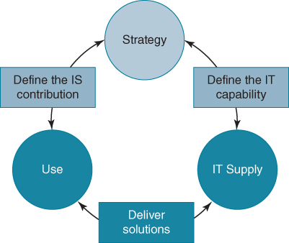
FIGURE 12.1 A framework for positioning organizational IS/IT competences.
We strongly believe that organizations need to move the agenda forward, away from one that focuses on improving the management of IS/IT (which usually focuses on the technology artefacts) to one where the emphasis is on building this IS/IT or digital capability.
The notions of what is involved in ‘IT management’ date mainly from an era when computers were large, complex and expensive, requiring specialist facilities and knowledge. The practice of IT management has thus became associated with the activities needed to keep the computer and network functioning, plus the design, implementation and maintenance of applications and the provision and ‘warehousing’ of information. Today, the scope of IS/IT management has expanded to include strategy formulation and execution, service management, project management, supplier and outsourcing management, and, in some organizations, the delivery of benefits from IS/IT investments.
If we take a contrasting perspective, where the focus is not to manage IS/IT per se, but to optimize business value from IS/IT, then a somewhat different agenda emerges. This perspective acknowledges that optimizing value from IT is a multifaceted and complex challenge. It requires understanding how IT impacts the business, including:
- identifying new strategic opportunities;
- assessing and assimilating technological innovations;
- deriving new technology-enabled business models and organizational blueprints;
- prioritizing investment opportunities;
- managing IT-enabled change;
- managing risk;
- selecting and managing suppliers;
- exploiting investments in technology, by ensuring the appropriate use of information and applications;
- creating the environment for staff to develop the right behaviours and values to work with information;
- ensuring that the value delivered from an application is captured by the organization and does not become a source of competitive disadvantage.
All these are organizational-wide concerns and responsibilities. Moreover, these requirements are underpinned by the application of knowledge: knowledge that different employees possess.
What is increasingly obvious is that the knowledge necessary to generate business value from IT is distributed throughout the organization, across functional, process, divisional and geographical boundaries. Crucially, it is not located solely in the IS/IT unit and under the jurisdiction of the CIO. For example, we have already seen that an effective IS/IT strategy process demands the involvement of executive management if it is to be effective. Similarly, project teams created to implement new information systems are typically composed of both IS/IT specialists and managers and users from ‘the business’. Indeed, one study noted that ‘[a] project team, set up to design and implement a large-scope IT system, is essentially tasked with integrating distributed knowledge’.⁵⁰
Generating value from IT thus becomes a task of bringing together relevant knowledge that is distributed organization-wide. The organization must have the capability to coordinate and integrate this knowledge.⁵¹ The conundrum for many CIOs is that they are held accountable for delivering value from IT investments without having access and authority over necessary knowledge resources.⁵²
The notion of ‘social capital’ offers some explanations of how distributed knowledge can be integrated and coordinated.⁵³ With its origins in sociology, it highlights the importance of networks of strong, personal relationships, developed over time across groups that provide the basis for trust, cooperation and collective action: or the ‘goodwill that is engendered by the fabric of social relations and that can be mobilized to facilitate action’.⁵⁴ Social capital theory suggests ‘that actors are motivated by instrumental or expressive needs to engage other actors in order to access other actors’ resources for the purpose of gaining better outcomes'.⁵⁵ In the context of value generation through investments in IS/IT, these ‘resources’ are knowledge, and ‘better outcomes’ are increased business benefits.
Access to knowledge is dependent on an individual's network of contacts and ties as well as the nature and content of the relationship between parties.⁵⁶ Recognition of the value of collaboration is based on the ties that people have together with a shared language and cognition to aid mutual understanding.⁵⁷ The motivation to share and combine knowledge and collaborate is underpinned by trust as well as obligations that can be defined by the role and position that individuals have in the organization. Figure 12.2 presents a schematic of this, illustrating that it is through people coming together that knowledge is shared and competences manifest themselves.
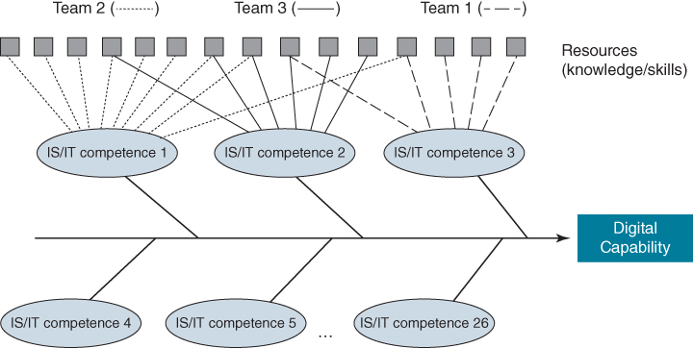
FIGURE 12.2 Building the digital capability.

From Creating IS/IT Assets to Improving Organizational Performance: Joining the Means to the Ends
One aim of creating a digital capability is to ensure IS/IT investments selected, funded and implemented are successful in terms of the business benefits realized. While the assumption is that organizations want to obtain ‘value for money’ from IT, the focus of management has, historically, been on the money spent, rather than the value of the business benefits derived. There has been considerable study of the ‘total cost of ownership’ of IT, but recently the emphasis has shifted to attempt to understand the ‘total benefits of ownership’. We have already noted that organizations are spending an increasing percentage of their IT budgets on sourcing IT services and infrastructure from third parties, rather than on procuring hardware and software which they then manage themselves. However, calculating the business value derived from these services still proves elusive. Further research is needed in this area if we are to be able to understand and assess benefits and the total value of the opportunities that IS/IT provides.⁵⁸
Any organization ultimately makes investments in IS/IT to create ‘value’ for its stakeholders, whether they are shareholders, customers, employees or others with a vested interest in sharing in its success. Yet early studies reported a ‘productivity paradox’⁵⁹ and fuelled a quest for economic analysis to determine whether links existed between IS/IT investments and productivity and IS/IT investments and profitability.⁶⁰ A significant body of research has explored the relationship between IS/IT investment (the means) and business performance (the ends) and the results have been inconclusive, in terms of why some organizations have achieved significant business benefits, while others have not.
Economic studies, although valuable in illustrating the apparent general pay-off or otherwise of IS/IT investments, provide inadequate explanations of how business value from IT is actually created – the ways.⁶¹ The ways include the business changes needed to gain the benefits of technology investments: to produce better processes, improved products or services, access to markets, enhanced decision making and insight, greater efficiency or better resource utilization. Sometimes even customers, suppliers, citizens and others have to change how they interact with the organization. Therefore, investments in so-called ‘complementary assets’ are critical to delivering a return from IT investment.⁶² These include investments such as training, developing user and customer knowledge, process and organization redesign and change management programmes that enable the benefits from IS/IT investments to be obtained.
A useful model explaining the critical steps involved in generating business value from IS/IT is illustrated in Figure 12.3. The model suggests the necessary processes and the sequence that leads to success: organizations' spend procuring and successfully implementing IS/IT (the means) creates new capabilities in the form of IS/IT assets. Then, ‘quality IS/IT assets, if used appropriately and effectively (the ways) produce favourable impacts’, which in turn, ‘if not adversely affected by other factors during the competitive process, lead to improved organizational performance’ (the ends).
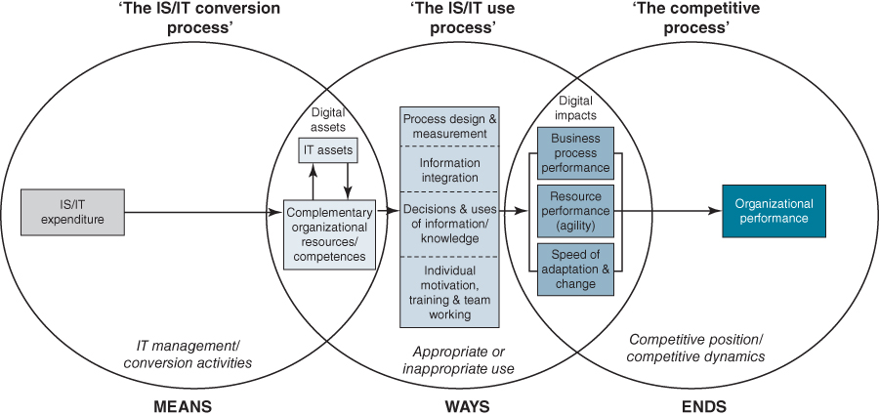
FIGURE 12.3 How IT creates business value.
Source: Derived from C. Soh and M.L. Markus, ‘How IT creates business value: A process theory synthesis’, in Proceedings of the 16th Annual International Conference on Information Systems, Amsterdam, The Netherlands, December 1995, 29–41; and N. Melville, K. Kraemer and V. Gurbaxani, ‘Information technology and organizational performance: an integrative model of business value’, MIS Quarterly, 28, 4, 2004, 283–322.
As we have seen earlier, most previous IS/IT strategy research has focused on deciding what types of IS/IT assets, both applications and infrastructure, to acquire and why – the organizational performance, or business impact – i.e. the first and last parts of the model, essentially the means and ends.⁶³ The middle process of Figure 12.3, connecting IS/IT assets to their impacts – the ways - is the least well understood, particularly in areas such as defining what constitutes ‘appropriate use’, how use differs depending on the type of IT investment and the organizational competences in using IT.
These are a combination of strategy development and implementation issues. As we have described, formulating the strategy should include an assessment of the ways in which the organization can, or is willing to, change its value proposition, operating model or business relationships by using IS/IT to improve its competitive position. New benefits management approaches, discussed in Chapter 9, are being introduced to focus attention on managing the changes to ways of working, organizing and using information needed to deliver the benefits available from IS/IT investments.

Achieving Alignment: a Multi-themed Perspective
Surveys over the last 40 years have consistently presented achieving alignment as the number one challenge face by CIOs.⁶⁴ A critical success factor for any IS/IT strategy is that it is ‘aligned’ with the current business strategy. However alignment takes more than one form, which we labelled intellectual, social and cognitive and they are summarized in Table 12.2. Each alignment theme has a different objective, uses different mechanisms and has a different focus.
TABLE 12.2Core themes in alignment research
 | Alignment themes
 | Intellectual | Social | Cognitive
Objective | Translation of business strategy into IS/IT requirements | Bring together accountable people with relevant knowledge | Synthesis and integration of knowledge
Processes | - ♦ Analytical  - ♦ Tools and techniques  - ♦ ‘Translation’ and ‘thinking’ | - ♦ Relationships  - ♦ Governance structure (e.g. IS steering committee) | - ♦ Learning  - ♦ Shared understanding
Primary focus | Information, systems and technology | People | Knowledge and ‘know-how’
The intellectual approach to alignment is concerned with translating business strategy into IS/IT requirements. Tools and techniques have been proposed to help with this translation, as presented in Chapter 4. While the initial focus of these tools was on translation – the IS/IT strategy being subservient to the business strategy – with the push for competitive advantage from IS/IT the scope was extended to include the search for opportunities for IS/IT to shape strategy. To find these opportunities, a number of ‘tools for thinking’ have been described in Chapter 5 and 6.
Yet using these tools does not guarantee that alignment will be achieved; the experience is that unless the right people come together with the relevant knowledge, achieving alignment will be a challenge.⁶⁵ Bringing together the right people through appropriate governance structures, such as a steering committee charged with developing the IS/IT strategy can overcome the limitations of an intellectual approach to alignment. This social theme also recognizes that fostering trust and establishing relationships is of crucial importance for CIOs and IT leaders as it provides access to people in the organization with relevant knowledge.⁶⁶ In Chapter 10 we emphasized this, suggesting that in many organizations there can be a ‘cultural gap’ between the IT organization and the rest of the business that inhibits this.
However, even having effective governance mechanisms and strong relationships in place does not necessarily lead to good alignment, unless it creates a shared knowledge and understanding of how IS/IT and the business are interrelated. Strong empirical support for this is found in a study reporting: ‘the one construct that seemed to predict long-term alignment was shared domain knowledge.’⁶⁷ This is a cognitive challenge, and we believe that this will become even more important as we move out into the future. To date, there is limited research exploring this challenge.⁶⁸
To achieve shared domain knowledge, executives from across an organization must improve their digital literacy as we believe that its absence is severely hampering many organizations in taking advantage of digital opportunities. One contributor could be that IS/IT management courses are being dropped from the ‘core’ of many MBA programmes. Not being a core course will see it labelled as ‘not important’ so perhaps managers cannot be blamed for not engaging: they don't know what they don't know. This means that future business executives will not know the why and the how of managing IS/IT strategically nor have the language and frameworks to engage in conversations about IS/IT. Another contributing factor could be that many managers mistakenly equate ‘enterprise IT’ with ‘consumer IT’ (see Box 12.1 for an elaboration of this point). Furthermore, in recent research we have observed that in many organizations the role of the CIO is ambiguous,⁶⁹ with little shared understanding across the organization as to what to expect of a CIO or how and where he or she can contribute. The dominant view is that the CIO is a technical role,⁷⁰ leading to CIOs often reporting that their organizations are not embracing digital opportunities to the extent that they believe they could or should.

BOX 12.1

An increasing problem: mistakenly confusing ‘enterprise IT’ with ‘consumer IT’
As users of digital technologies and services in their personal lives, many executives pine for their internal IT systems to give them a similar experience to using IT in their daily lives. They point to the simplicity, ease of use and hassle-free nature of the digital services they use and question why corporate IT makes it seem so complicated. Apps on their smartphone make services available at the push of a button; software can be easily installed and configured at the click of an icon; plug a printer into a USB port on a laptop and it is ready to print. If they want to use a tablet, they just buy one from the local electronics shop, connect to the Internet via WiFi and don't have anyone cautioning them about the potential security risks or possible compatibility problems. In the consumer IT world, everything just seems to work.
Unfortunately, many executives are mistakenly confusing ‘consumer IT’ with ‘enterprise IT’. Expecting everything to be just like consumer IT shows a lack of understanding of the challenges and issues that IT poses within a corporate environment. More worrying, their experience with consumer IT is also giving executives an argument for opting out of involvement in decisions regarding IT. After all, Apple doesn't ask them for their input to iTunes, but it is so easy to use and it syncs seamlessly with multiple devices; and most people are not really too concerned with the jurisdiction where the server that stores their family photos is located when they use Dropbox. Because enterprise IT is not like executives' experience with consumer IT, the chief information officer (CIO) and IT organization can become the ‘whipping boy’ for all the perceived ills with corporate IT. But in the corporate IT world, executives and managers cannot be just users; they must be active participants in many of the decisions that, in the consumer IT world, they leave to the likes of Apple, Google and Yahoo.
In the consumer world, all digital services are vanilla versions: the exact same service is generally available to all other users. Sometimes, you can opt for either cheaper or more expensive versions with less or more functionality, but as a customer, you have no input as to what is offered; you either take it or leave it. If the service doesn't quite fit with what you want, you just have to live with what's available or don't use it. In the corporate world, expecting users to ‘just live’ with a new way of working or new process is the downfall of many IT projects. In consumer IT, the functionality, user experience and workflow decisions about how the application will work, and thus how users should behave, are made by the software vendor. In the corporate world this is akin to the IT organization deciding the application logic, functionality, level of service, quality, availability etc. on behalf of the users, without their input. While many corporations use vanilla versions of a software application such as ERP, the choice of package should be a business decision made by business managers for operational and strategic reasons. These are not technical decisions.
With consumer IT, the services on offer are, for the most part, ‘point’ solutions. Consider arranging to travel to another city to see your favourite band play a gig. When you book a flight with a particular airline, you select your preferred flight and time and enter your name, address, phone numbers and credit-card details to make the purchase, unless of course you are a regular flyer with the airline and this information has been previously entered and stored. Choose another airline and all this data will have to be rekeyed, following a different booking process. When you book a hotel room, you will probably have to key in all this information again and follow the hotel's unique booking process. Aggregators like Expedia and some airlines do allow you to book both flight and hotel from the same portal, but what if you wish to stay at a different hotel that is not a partner? You then still need to log on to Ticketmaster or a similar organization to reserve your concert tickets and will again have to rekey much of the same information. And, of course, the rental car still has to be booked.
While an irritation, we have to accept these inefficiencies and opportunities for errors in our personal lives. But imagine your internal IT organization building systems like this: if data had to be entered multiple times, with no sharing of data across applications, and processes carrying out similar tasks working differently. In business you minimize the rekeying of data and try to eliminate the need for manual reconciliation. Companies generally insist that processes to achieve similar outcomes be standardized, or at least similarly designed, and in the corporate world integration is how efficiencies are achieved and the smooth flow of information facilitated.
With their ERP and CRM systems from vendors like SAP and Oracle, organizations do seek enterprise integration. This is currently not easily achieved with cloud computing unless you purchase a system from a vendor that provides the complete stack. Interoperability across clouds is extremely difficult to realize and there are few standards. This means that choosing so-called ‘best-of-breed’ solutions is not really feasible if you are looking for integration, heightening the risk of being locked into one particular vendor.
It is for this reason that ‘shadow IT’ can be dangerous. While the cloud is promoted by vendors as transformative, executives need to be careful in interpreting what this really means. Applications can be provisioned rapidly, without any hardware or software purchase, available for use from any browser, and payed for on an as-you-go basis. But most solutions available from the cloud are point solutions. For example, Salesforce.com provides automation to help field salesforces manage clients and Workday provides applications for people management (e.g. compensation, absence management). Even where applications run on a private cloud (and the vast majority of cloud implementations are of this type), there are still interoperability challenges, making integration difficult to achieve.
The security and privacy issues are also different in the corporate IT world. As a user of digital services in our personal life, we take responsibility for the protection of our own personal data: how we use it, where we put it, and for the rights we assign to others to use it. In the corporate world we are dealing with other people's data, particularly those of customers, employees, patients and citizens. Business executives have responsibilities defined by law and need to worry about protecting and safeguarding this data and ensuring that it is not used in any inappropriate way. Moreover, as custodians of a business for shareholders, executives need to make sure that data or systems are not compromised in any way that will affect the performance and reputation of the business. There are also data retention requirements to address. These responsibilities again rest with corporate officers and cannot be abdicated to the IT organization.
With consumer IT, we don't have to deal with the legacy and complexity of the IT landscape that exists in the corporate world. This legacy can be the result of inconsistent, short-term decision making leading to the accumulation of diverse IT assets with particular capabilities. But this situation can also occur during the normal course of business activity; for example, acquiring a company generally entails also acquiring its IT applications and the process logic they facilitate. Global companies operating in different geographies are faced with different maturity levels of national IT infrastructures and meeting local regulatory and sometimes customer requirements. With corporate IT, you cannot simply throw away old IT systems and software and replace with new versions as we typically do with consumer IT.
Most people don't typically have a personal strategy for their use of IT. They are not looking for any competitive advantage or indeed to avoid disadvantages by not investing in IT. Executives cannot take this attitude with enterprise IT. Enterprises need to have a strategy for how IT will be harnessed by the organization – a digital strategy – one which is framed by business imperatives and endorsed by the organization's executives. The absence of such a strategy is the root cause of problems many organizations have with digital initiatives.
We are not suggesting that tools and techniques are not necessary or useful. On the contrary, they are extremely valuable in facilitating and focusing discussions, supporting thinking processes and ultimately figuring out where and when to invest. This is why we have advocated using tools and techniques that business managers are familiar with. Similarly, we are not suggesting that appropriate governance is now not necessary; it very much is required to bring together those with relevant knowledge. But unless meaningful and constructive knowledge sharing takes place, achieving ‘alignment’ will still prove elusive.

The Co-evolution of Business and Digital Strategies
In this book we have distinguished between ‘alignment’ and ‘impact’ in building the digital strategy, although in the academic research literature both concepts are generally treated under the single heading of ‘alignment’. The notion of digital and business strategy alignment suggests that these are two separate entities – the business strategy and the digital strategy. Moreover, as you have to align to or with something, most articles published in the academic literature and practitioner media are often titled ‘aligning IS/IT strategies with…’, but never ‘aligning business strategies with…’. This suggests the digital strategy is separate from and subordinate to the business strategy.
That there is continued interest in achieving alignment owes a great deal to research that continues to advance empirical evidence of its positive effects on business performance.⁷¹ The notion of the need for strategic alignment, builds on three central arguments.⁷² First, organizational performance depends on structures and capabilities that support the successful realization of strategic decisions; IS/IT provides one of those capabilities. Second, alignment is a two-way process, where business and digital strategies can act as mutual drivers; third, strategic alignment ‘is not an event but a process of continuous adaptation and change’.⁷³ However, it is still unclear how to achieve and sustain the process of strategic alignment over time, and, as introduced in Chapter 1, there are suggestions that the concept of alignment is no longer appropriate for describing the relationship of IS/IT and business strategies, which should ‘co-evolve’.⁷⁴

Co-evolutionary Theory
The term ‘co-evolution’ itself was coined in the 1960s by the American population biologist Paul Ralph Ehrlich and the botanist Peter Hamilton Raven to refer to evolutionary changes that occur in genetically unrelated species as they interact with each other in their environment.⁷⁵ In contrast to evolutionary theories, which view organizations, populations or other entities in isolation, a co-evolutionary perspective emphasizes the coupled evolution of multiple populations or forms.⁷⁶ Although co-evolutionary theory receives increasing attention in the social sciences and organization theory,⁷⁷ it has seen limited application to the study of IS/IT.
Co-evolutionary thinking allows a dynamic view of the processes and forces acting upon the organization and its environment. Organizations, or business units, do not lead isolated lives but instead are linked inextricably with others. The success of one organization may therefore be as much a function of what other organizations do as what the organization itself does. According to co-evolutional theory, an organization's capacity to co-evolve successfully with its environment depends on a large number of factors; key among those are: its fitness function, absorptive capacity, and value creation mode.
The notion of the fitness function describes the organization's capability for coping with disorder and uncertainty.⁷⁸ Absorptive capacity concerns its ability to assimilate new knowledge, including the speed at which it can learn.⁷⁹ Value creation can be pursued through exploration and exploitation modes or both simultaneously (ambidexterity).⁸⁰ Exploration concerns, in the words of co-evolutionary theory, ‘prospecting’ for new opportunities for value creation. This involves innovation, R&D, venturing, intrapreneurship, risk taking, developing new capabilities and investing in the firm's ability to learn.⁸¹ Exploitation aims at increasing the productivity of existing capabilities and employed capital and assets. Environmental discontinuities such as new entrants, regulatory changes or disruptive technology can promote new conditions for competition and make existing capabilities obsolete.⁸²

A Co-evolutionary Perspective of Digital Strategies
A co-evolutionary view of the dynamic process of mutual adaptation and change of business and digital strategies allows us to view this alignment as a fuzzy, indeterminate and complex process, which better reflects the experience of managers seeking to achieve and sustain alignment in practice. Strategizing in practice is fuzzy because contemporary environments are increasingly dynamic and uncertain, the distinction between external and internal boundaries makes increasingly less sense (e.g. Internet effects, electronic supply chain integration, virtual organization, networks),⁸³ and moving from strategizing to implementation is far from being linear and predictable.⁸⁴
While the label of co-evolution is occasionally found in some articles, there is not much published research on digital strategy that draws on co-evolutionary theory. That which can be found is limited to conceptual analysis.⁸⁵ We have already noted that we know very little about how the digital strategy is actually produced or evolves in practice. We subscribe to the view of strategy as something managers do, rather than as something that firms have. We have already noted that this focus is central to the practice-based approach to strategy that has gained some traction with scholars over the last decade. Before we can build co-evolutionary models, we need to understand the real practice of IS/IT strategy formulation.⁸⁶
A model we presented in Chapter 1 and reproduce below (Figure 12.4) – showing the relationship between the strategic moves that an organization makes and their influence on competitor strategies and a similar influence of competitor strategies; the enabling and shaping role of digital; as well as the game-changing effect of IS/IT on industries – is a crude co-evolutionary model. The digital strategic decisions an organization makes depend on the experience and knowledge of its management. This latter point is crucial, as we have already highlighted the ‘management difference’ as explaining why some organizations are better at leveraging IS/IT than others. The organizing aspects, which are seen as perhaps the most important dimension of IS/IT strategic management, also need to be factored in.
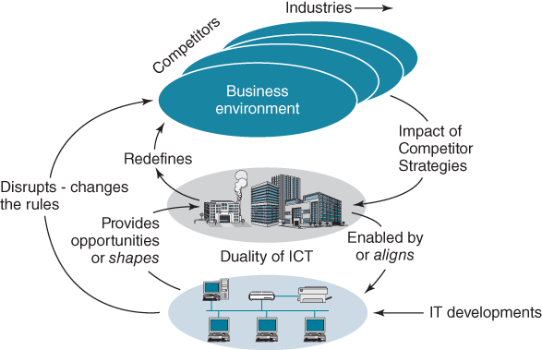
FIGURE 12.4 The competitive dynamics of IS/IT – a co-evolutionary model?
If we take the starting point that investments in IS/IT are essentially investments in change, we can construct a high-level model of the co-evolutionary challenge of matching demand with supply. The requirement to shift emphasis from ‘digital projects’ to ‘change projects’ and programmes, if business benefits are to be forthcoming, is a recurring finding from research.⁸⁷ From this perspective, the digital capability defines the organization's ability to identify and deliver successfully IS/IT-related changes, in response to the demand-side drivers that cause the changes the organization has to make or wants to make (see Figure 12.5). ‘Incompetency’ in any aspect of IS/IT management can severely impact an organization's ability to determine, make and assimilate IS/IT-enabled change. Developing a realistic strategy involves managing supply and demand so that change initiatives work toward a common direction and competences are developed according to business requirements.
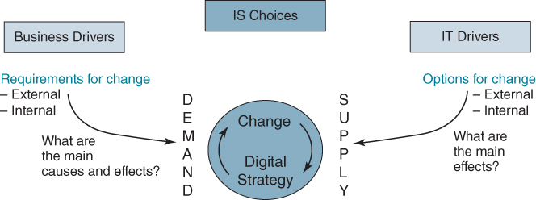
FIGURE 12.5 Co-evolving business and digital strategies.
Recent exploratory research that we have conducted that takes a co-evolutionary perspective of alignment suggests that the conceptual models found in the literature are too narrow.⁸⁸ From our empirical data we have built a causal-loop model of the process of achieving alignment. This model highlights the complex challenge of alignment faced in practice, in particular achieving mutual trust, building relationships, communicating and collaboration. Moreover, it emphasizes the central role of cognition in securing alignment and suggests that absorptive capacity, path dependency and the speed at which learning occurs are key determinants in achieving alignment over time. In contrast to the conceptual models of alignment that focus on the structural dimensions of co-evolution, we advance the view that co-evolution occurs at the structural, social, behavioural, cognitive and intellectual levels. The achievement of alignment is sometimes portrayed as more akin to ‘a dancer dancing a dance and a dance being danced’.
Our research also raises the question as to the relevance of the notion of alignment for today's digital age, suggesting that it might be an obsolete concept. Digital strategy can be created and evolved through ongoing conversations between business and IS/IT professionals and managers. This resonates with the above arguments for a more cognitive perspective of alignment but it also has social and behavioural dimensions. These conversations cannot take place without the ability of all parties to respect each other's knowledge and create a shared understanding. Sense making of new technologies, their opportunities and threats, and devising strategic options all take place via discussion and dialogue.
One study of alignment captured the crucial importance of conversation very well: ‘The most important direct predictor of alignment in this study was a high level of communication between IT and business executives.’⁸⁹ That is, when IT and business executives talk regularly, co-evolution of business and digital strategies usually follows. It is, perhaps, that simple!

The Opportunity for CIOs to Have a Key Strategic Role
Perhaps no executive's role has undergone as many changes in expectations, approaches and philosophies during the past few decades as that of the CIO. If digital and business strategies are to co-evolve, as suggested in the previous section, the role is certain to evolve further as IS/IT becomes critical to meeting demands for both business performance improvements and the creation of new business opportunities.
This changing nature of the CIO role has been reported by scholars, analysts and industry commentators over the last decade:⁹⁰ all describe the increasing emphasis on information and systems and a shift from being a technology director to a company officer charged with managing and leveraging information (the ‘I’ in CIO).⁹¹ The evolution of the role has three main themes:
- From technology manager to business executive. The CIO role is a business role rather than a technology one. While there is a ‘technical’ dimension to the job, CIOs must take a perspective that involves the seamless integration of both business and technology. It also requires CIOs to think, act and communicate differently from their counterparts of yesteryear.
- From order taker to strategic shaper. Despite their protestations, most CIOs have traditionally been ‘order takers’ – they take the business strategy (if one exists) and from this determine the investment portfolio for IT. Most have not had the influence that they would have liked on either strategy or innovation. This has been changing as organizations increasingly recognize the role of digital, with innovations enabled by IT now shaping strategic options.
- From functional head to business leader. Successful CIOs must see themselves not as leaders of an IT function but as business leaders, albeit with a special responsibility for IS/IT. In the same way, a Chief Financial Officer (CFO) is also a business leader who has a special responsibility for finance. Given their pivotal position, where business demand meets technology supply, shown in Figure 12.5, CIOs require an understanding of all aspects of the business, akin to the role of a general manager. However our evidence suggests that many struggle with the leadership dimensions of the role.⁹² This might be a reason why, at the time of writing, there are no CEOs of a current FT350 company who previously served in a CIO position (though there have been a very small number in the past).
Despite these shifts, in many organizations much of the job of the CIO continues to be taken up by technology issues. This is often driven by the expectations of other senior executives and job design and not by choice.⁹³
Additionally, there are paradoxes that they have to navigate. For example, they are mandated to provide cost-efficient and predictable IT services while at the same time it is expected that the company's IT infrastructure will be responsive and agile. The IT unit itself is often seen as a service provider yet increasingly expected to be innovative and a driver of business growth. CIOs are simultaneously expected to contain costs and build new capabilities. Resolving these paradoxes is necessary in order to achieve control and risk objectives as well as providing agility in terms of responsiveness to unexpected changes and business opportunities.⁹⁴
Any CIO should expect to have an operational and innovation role. The operational aspect is perhaps obvious; ensuring the technology continues to ‘work’, whether a fully insourced operation or outsourced, either in part or completely, to third-party suppliers. This is about availability, quality of services and information provision. Moreover, CIOs must be continually searching for opportunities to reduce ongoing IT costs, often by taking account of new technology.
The CIO also has a role in relation to innovation, particularly in bringing new ideas enabled or shaped by IT to the attention of their business colleagues. However, as discussed in Chapter 5, due to relationship and other reasons, CIOs often struggle to get attention for ideas; but influencing colleagues is a key part of being a leader. Importantly, the CIO should be part of the organization's leadership team and hence be a part of the decision-making processes regarding its strategy and future direction. In many organizations this is not the case, and we have already noted that many CIOs find themselves reporting into another chief officer, usually the CFO.
However, if the board and executive leadership team is determined to see digitization solely as a technology issue, then the real benefits of digital technologies are unlikely be realized. A key message from this book is that it is not the deployment of technology that should be in focus but rather how it enables information to be leveraged for operational and strategic purposes. Some businesses have known this for a long time. Fred Smith, founder of FedEx, emphasized back in 1975, that ‘information about the package is as important as the package itself’, and this view has propelled his business to dominate its industry for 40 years. Information is not just the lifeblood of an organization, it is becoming a strategic battleground; early explorers of ‘big data’ can testify that the benefits from information exploitation can be substantial.
CIOs cannot drive the digital agenda alone, but require the active involvement and engagement of the CEO and other executive colleagues. Digital success, or failure, is a shared responsibility. The CIO may be exercised by the complexities of technical change, the implications of legacy IT investments and the quest for greater agility, but for the wider leadership team the challenge is to find ways to leverage information and technology capabilities, both operationally and strategically. This is an increasingly daunting task and it is unsurprising that the annual Society of Information Management survey of CIOs over the last 30 years has always placed the achievement of alignment between business and IT strategies as one of the top three issues.

Conclusion
When we wrote the previous edition of the book, IS/IT had been high on the agenda of most organizations for both positive and negative reasons. The millennium bug, or Y2K issue, had a negative effect – the resources used to avoid a ‘catastrophe’ meant most organizations could make very few other IS/IT investments for 1–2 years before 2000, and then it turned out to be largely a non-event (probably because of all the efforts made to prevent problems!). The latent demand and the capabilities provided by the increasing commercialization of the Internet led to the dot.com, e-business boom which focused organizations on new opportunities and speculative IS/IT investments, at least until boom turned to bust – at about the time the previous edition arrived on the bookshelves. And soon after that the ‘IT doesn't matter’ argument became popular with many business managers. Even though it did still matter, perhaps it had been high on the agenda for too long?
One consequence was that, if IT did not matter, there seemed no need to spend time and effort developing an IS/IT strategy and the alignment gap got wider; businesses were focusing on challenges due to the globalization of both markets and competition, while IT units wrestled with supplying more IT capability at a lower cost. The literature that had been extolling the new innovative opportunities and the ability of IT to create new economic and business models, now pointed at the many expensive failures of IS/IT investments in both private and public sectors, especially the latter. The reasons for the failures were always lessons that could have been learned from failures in previous decades, including the lack of a strategy that clearly linked the IS/IT investments to the business priorities, leading to ill-conceived and poorly managed IS/IT projects and associated change programmes.
While enterprise IT evolved slowly from 2002 onwards, largely by doing ‘more of the same’, consumer IT exploded, fuelled by apparently insatiable demand for new, portable, connected technologies and the emergence of a range of social media apps. Web 2.0 capabilities also enabled the creation of new business models which could be rolled out to huge audiences very quickly. The financial crisis of 2008 and the subsequent worldwide recession actually increased the consumer demand for apps that could save expense and time, making the use of new platform businesses grow exponentially. Investment in IS/IT in more conventional businesses came under careful scrutiny after 2008: cost savings and preventing disadvantage became the main objectives. Interestingly, this caused a resurgence in the development of IS/IT strategies, albeit to focus on achieving a better return on investment and avoiding project failures.
As discussed in Chapter 1, ‘digital disruption’ has returned with an impact probably not seen since the turn of the century, with many organizations finding ways of enhancing products and services, or creating new ones, using digital technologies. The Internet of Things could be the most important new technology innovation since the World Wide Web, provided increasing unease about personal privacy and security can be dealt with adequately. Business digital innovations are perhaps now easier to initiate as many technologies can be acquired and implemented quickly, with less expertise and less expensively from the cloud, reducing the risks involved.
Organizations' need for an IS/IT or digital capability, based on shared knowledge and an understanding of how IS/IT and the business are interrelated, has become ever more acute as the interaction between IS/IT and business activity intensifies. The current ‘hype’ about digital business transformation should not obscure the reality that many organizations are making significant changes to business models, value propositions, structures and competitive capabilities which are either enabled by IS/IT or dependent on IS/IT to work.
As discussed throughout this book, organizations' current performance and future prospects are now, more than ever, dependent on their ability to use IS/IT effectively and advantageously. In the increasingly turbulent business environment, that digital capability has to become more dynamic, adapting quickly and successfully to changes in business and IT environments. In reality it is no longer adequate to develop the IS/IT or digital strategy from a given business strategy nor feasible to formulate a strategy and follow it, without having to adapt it as circumstances change. That does not diminish the need to have a digital strategy, but it must co-evolve with the business strategy if the most beneficial uses of IS/IT are to be identified and implemented successfully.
The last paragraph of the previous edition suggested the ‘Strategic Management of Information Systems’ would be a better title, since the challenge is not solely about devising a strategy but also about making it work. In this edition, with the new title, we have tried to address both.

Endnotes
1. There has been research over the years to support this position. The most recent is based on archival data from 1998–2003 for more than 400 global firms. See S. Mithas, A. Tafti, I. Bardham and J.M. Goh, ‘Information technology and firm profitability: mechanisms and empirical evidence’, MIS Quarterly, 36, 1, 2013, 205–224. In a study of 12 banks over a 12-year period, Shu and Strassmann have shown that IT investment demonstrated the highest marginal product among the input factors they selected. See W. Shu and P.A. Strassmann, ‘Does information technology provide banks with profit?’, Information & Management, 42, 5, 2005, 781–787. See also E. Brynjolfsson and L.M. Hitt, ‘Paradox lost: firm-level evidence on the returns to information systems spending’, Management Science, 42, 4, 1996, 541–558.2. S. Mitra, ‘Information technology as an enabler of growth in firms: an empirical assessment’, Journal of Management Information Systems, 22, 2, 2005, 279–300.3. We dislike the word solution in the context of software and IT, as it suggests that the vendor has ‘the solution’ to a business problem or issue. So, for example, if an organization has a problem with managing the field sales force, Salesforce.com will argue that they have the solution. Such expectations can provide those in ‘the business’ with the comfort that once the software is provisioned, the IS unit will deliver the solution to their problems. Technology can only ever deliver a particular capability based around handling information. Complementary capabilities have to be developed if real business benefits are to be achieved and it is only those managers from the business side that can do this.4. D. Chen, M. Mocker, D. Preston and A. Teubner, ‘Information systems strategy: reconceptualization, measurement, and implications’, MIS Quarterly, 34, 2, 2010, 233–259; and A. Karpovsky, M. Hallanoro and R.D. Galliers, ‘The process of information systems strategizing: review and synthesis’, in R. Cohen, H. Topi and A. Tucker, eds, The CRC Handbook of Computing 3rd ed. Vol. II: Information Systems and Information Technology, London: Chapman & Hall, MA, 2014. See also T. Reponen, ‘Information management strategy – an evolutionary process’, Scandinavian Journal of Management, 9, 3, 1993, 189–209.5. R.D. Galliers, ‘On confronting some common myths of IS strategy discourse’, in R. Mansell, C. Avgerou, D. Quah and R. Silverstone, eds, The Oxford Handbook of Information and Communication Technologies, Oxford: Oxford University Press, 2007, 225–243; and R.D. Galliers, ‘Further developments in information systems strategizing: Unpacking the concept’, in R.D. Galliers and W.L. Currie, eds, The Oxford Handbook of Management Information Systems: Critical Perspectives and New Directions, Oxford: Oxford University Press, 2011, 329–345.6. A. Karpovsky and R.D. Galliers, ‘Aligning in practice: from current cases to a new agenda’, Journal of Information Technology, 30, 2015, 136–160.7. R.L. Martin, ‘The big lie of strategic planning’, Harvard Business Review, January–February, 2014, 3–8.8. B. Ives and G. Learmonth, ‘The information system as a competitive weapon’, Communications of the ACM, 27, 12, 1984, 1193–1201; F.W. McFarlan, ‘Information technology changes the way you compete’, Harvard Business Review, 62, 3, 1984, 98–103; M.E. Porter and V. Millar, ‘How information gives you competitive advantage’, Harvard Business Review, 63, 4, 1985, 149–160; and R.D. Galliers, ‘IT strategies: Beyond competitive advantage’, Journal of Strategic Information Systems, 2, 4, 1993, 283–291.9. S. Somogyi and R.D. Galliers, ‘From data processing to strategic information systems–a historical perspective’, in S. Somogyi and R.D. Galliers, eds, Towards Strategic Information Systems, Abacus Press, Cambridge, MA, 1987, 5-–25.10. A.L. Lederer and V. Gardiner, ‘Strategic information systems planning – The Method/1-approach’, Information Systems Management, 9, 3, 1992, 13–20; and A.L. Lederer and V. Sethi, ‘The implementation of strategic information systems planning methodologies’, MIS Quarterly, 12, 3, 1988, 445–461.11. M. Earl, Information Management: The Strategic Dimension, Oxford, UK: Oxford University Press, 1988.12. J. Henderson and N. Venkatraman, ‘Strategic alignment: Leveraging information technology for transforming organizations’, IBM Systems Journal, 32, 1, 1993, 4–16. For a review of the literature see Chan and Reich. Y. Chan and B. Reich, ‘IT alignment: what have we learned?’, Journal of Information Technology, 22, 4, 2007, 297–315.13. M. Hammer, ‘Reengineering work: don't automate, obliterate’, Harvard Business Review, July/August, 1990, 104–112. Although some were warning about the pitfalls of unthinkingly joining the BPR bandwagon, for example T.H. Davenport, ‘Why business reengineering failed: The fad that forgot people’, Fast Company, Premier Issue, 1996, 70–74.14. R.I. Benjamin and E. Levinson, ‘A framework for managing IT-Enabled change’, Sloan Management Review, Summer, 1993, 23–33; R.D. Galliers, ‘Towards flexible information architecture: Integrating business strategies, information systems strategies and business process redesign’, Information Systems Journal, 3, 3, 1993, 199–213; and W.J. Orlikowski and D. Hofman, ‘An improvisational model for change management: The case of groupware technologies’, Sloan Management Review, Winter, 1997, 11–21.15. J.M. Ward, P. Taylor and P. Bond, ‘Identification, realisation and measurement of IS/IT benefits: An empirical study of current practice’, European Journal of Information Systems, 4, 1996, 214–225; and J. Ward and E. Daniel, Benefits Management: How to increase the business value of your IT projects, John Wiley and Sons, Chichester, UK, 2012.16. J. Peppard, J.M. Ward and E.M. Daniel, ‘Managing the realization of business benefits from IT investments’, MIS Quarterly Executive, 6, 1, 2007, 15–25.17. J. Senn, ‘The myths of strategic systems’, Information Systems Management, 9, 3, 1992, 7–12; C. Ciborra, ‘From thinking to tinkering: the grassroots of IT and strategy’, in C. Ciborra and T. Jelessi, eds, Strategic Information Systems: A European Perspective, Chichester, UK: Wiley, 1994, 70–83.18. E.K. Clemons and M.C. Row, ‘Sustaining IT advantage: The role of structural differences’, MIS Quarterly, 15, 3, 1991, 275–292; W.J. Kettinger, V. Grover, S. Guha and A.H. Segars, ‘Strategic information systems revisited: a study in sustainability and performance’, MIS Quarterly, 18, 1, 1994, 31–58; and R.D. Galliers, ‘IT strategies: Beyond competitive advantage’, Journal of Strategic Information Systems, 2, 4, 1993, 283–291.19. J. Ross, C. Beath and D. Goodhue, ‘Develop long-term competitiveness through IT assets’, Sloan Management Review, 38, 1, 1996, 31–42.20. T.C. Powell and A. Dent-Micallef, ‘Information technology as competitive advantage: The role of human, business, and technology resources’, Strategic Management Journal, 18, 5, 1997, 375–405; and G. Piccoli and B. Ives, ‘Review: IT-dependent strategic initiatives and sustained competitive advantage: A review and synthesis of the literature’, MIS Quarterly, 29, 4, 2005, 747–776.21. F.J. Mata, W.L. Fuerst and J.B. Barney, ‘Information technology and sustained competitive advantage: A resource-based analysis’, MIS Quarterly, 19, 4, 1995, 487–505.22. J. Peppard and J. Ward, ‘Beyond strategic information systems: towards an IS capability’, Journal of Strategic Information Systems, 13, 2, 2004, 167–194.23. A. Bharadwaj, ‘A resource-based perspective on information technology capability and firm performance: an empirical investigation’, MIS Quarterly, 24, 1, 2000, 169–196, p. 171.24. J. Peppard and K. Breu, ‘Beyond alignment: A coevolutionary view of the information systems strategy process’, in Proceedings of Twenty-fourth International Conference on Information Systems, 15–17 December, Seattle, Washington, 2003. The use of the verb aligning in more recent treatments of the topic mirrors research on strategizing. See A. Wilson, J. Baptista and R.D. Galliers, ‘Performing strategy: aligning processes in strategic IT’, in Proceedings of Thirty-Fourth International Conference on Information Systems, 15–18 December, Milan, Italy, 2013.25. A.L. Lederer and V. Sethi, ‘The implementation of strategic information systems planning methodologies’, MIS Quarterly, 12, 3, 1988, 445–461; G. Premkumar and W. King, ‘Assessing strategic information systems planning’, Long Range Planning, 24, 5, 1991, 41–58; and D.J. Flynn and E. Goleniewska, ‘A survey of the use of strategic information systems planning approaches in UK organizations’, Journal of Strategic Information Systems, 2, 4, 1993, 292–319.26. N. Doherty, C. Marples and A. Suhaimi, ‘The relative success of alternative approaches to strategic information systems planning: an empirical analysis’, Journal of Strategic Information Systems, 8, 3, 1999, 263–283.27. G. Premkumar and W. King, ‘Organizational characteristics and information systems planning: an empirical study’, Information Systems Research, 5, 2, 1994, 75–109.28. H. Newkirk and A. Lederer, ‘The effectiveness of strategic information systems planning under environmental uncertainty’, Information and Management, 43, 4, 2007, 481–501.29. D. Mirchandani and A.L. Lederer, ‘Shared objectives and IT achievements: CIO and business manager perspectives’, IT Professional, 14, 6, 2012, 44–50.30. F. Bergeron, C. Buteau and L. Raymond, ‘Identification of strategic information systems opportunities: applying and comparing two methodologies’, MIS Quarterly, 15, 1, 1991, 89–103.31. M. Earl, ‘Experiences in strategic information systems planning’, MIS Quarterly, 17, 1, 1993, 1–21; and T. Wilson, ‘The implementation of information system strategies in UK companies: aims and barriers to success’, International Journal of Information Management, 9, 4, 1989, 245–258.32. J. Luftman, R. Papp and T. Brier, ‘Enablers and inhibitors of business-IT alignment’, Communications of the Association for Information Systems, 1, article 11, 1999.33. B. Reich and I. Benbasat, ‘Factors that influence the social dimension of alignment between business and information technology objectives’, MIS Quarterly, 24, 1, 2000, 81–113.34. R.A. Teubner and M. Mocker, A Literature Overview on Strategic Information Systems Planning, European Research Center for Information Systems, Münster, Germany, 2008.35. E.L. Wagner and S. Newell, ‘Exploring the importance of participation in the post-implementation period of an ES project: a neglected area’, Journal of the Association for Information Systems, 8, 10, 2007, 508–524; E.L. Wagner, S. Newell and G. Piccoli, ‘Understanding project survival in an ES environment: A socio-material practice perspective’, Journal of the Association for Information Systems, 11, 5, 2011, 276–297; and H. Salmela and T. Spil, ‘Dynamic and emergent information systems strategy formulation and implementation’, International Journal of Information Management, 22, 2002, 441–460.36. A. Lederer and V. Sethi, ‘The implementation of strategic information systems planning methodologies’, MIS Quarterly, 12, 3, 1988, 445–461; and P. Gottschalk, ‘Implementation of formal plans: the case of information technology strategy’, Long Range Planning, 32, 3, 1999, 362–372.37. E. Brynjolfsson and S. Yang, ‘Information technology and productivity: A review of the literature’, Advances in Computers, 43, 1996, 179–214.38. For more on this perspective see P. Jarzabkowski and A.P. Spee, ‘Strategy-as-practice: a review and future direction for the field’, International Journal of Management Reviews, 11, 1, 2009 69–95; P. Jarzabkowski, J. Balogun and D. Seidl, ‘Strategizing: the challenges of a practice perspective’, Human Relations, 60, 2007, 5–27; G. Johnson, A. Langley, L. Melin and R. Whittington, Strategy as Practice: Research Directions and Resources, Cambridge University Press, Cambridge, 2007; G. Johnson, L. Melin and R. Whittington, ‘Micro strategy and strategizing: towards an activity-based view’, Journal of Management Studies, 40, 1, 2003, 3–22; R. Whittington, ‘Strategy as practice’, Long Range Planning, 29, 5, 1996, 731–735; and R. Whittington, ‘Completing the practice turn in strategy research’, Organization Studies, 27, 5, 2006, 613–634.39. This theme of relevance is an enduring issue in information systems research. See, for example, J. Senn, ‘The challenge of relating IS research to practice’, Information Resources Management Journal, 11, 1, 1998, 23–28; I. Benbasat and R.W. Zmud, ‘Empirical research in information systems: The practice of relevance’, MIS Quarterly, 23, 1, 1999, 3–16; D. Straub, and S. Ang, ‘Editors' comments’, MIS Quarterly, 35, 1, 2010, iii–xi; and H. Klein and F. Rowe, ‘Marshaling the professional experience of doctoral students: a contribution to the practical relevance debate’, MIS Quarterly 32, 4, 2008, 675–686.40. P. Jarzabkowski, J. Balogun and D. Seidl, ‘Strategizing: the challenges of a practice perspective’, Human Relations, 60, 1, 2007, 5–27; and R. Whittington, ‘Practice perspectives on strategy: unifying and developing a field’, Best Paper Proceedings, Academy of Management, Denver, 2002.41. J. Peppard, R.D. Galliers and A. Thorogood, eds, Journal of Strategic Information Systems, 23, 1, 2014.42. J.M. Ward, ‘Information systems strategy: Quo vadis?’, Journal of Strategic Information Systems, 21, 2012, 165–171.43. For a study examining where CIOs report and its impact on organizational performance, see R. Banker, N. Hu, P. Pavlou and J. Luftman, ‘CIO reporting structure, strategic positioning, and firm performance’, MIS Quarterly, 35, 2, 2011, 487–504.44. N. Carr, ‘IT doesn't matter’, Harvard Business Review, May, 2003, 5–12. Carr later went on to predict the end of corporate computing. See N. Carr, ‘The end of corporate computing’, MIT Sloan Management Review, 46, 3, 2005, 67–73.45. Swanson and Ramiller have addressed the issue of social cognition that drives innovations in new information systems. They introduced the concept of an organizing vision and explain how a collective, cognitive view of new technologies enables success in IS innovation. Martin and Kambil have examined how managers' experiences with a specific strategic information technology in their industry influences cognitive managerial tasks associated with new information technologies. See E.B. Swanson and N.C. Ramiller, ‘The organizing vision in information systems innovation’, Organization Science, 8, 5, 1997, 458–474; and L.L. Martins and A. Kambil, ‘Learning from experience: Managerial interpretations of past and future information technologies’, in Proceedings of the 16th Annual International Conference on Information Systems, Amsterdam, The Netherlands, December 1995, 43–54.46. M. Reeves, K. Haanaes and J. Sinha, Your Strategy Needs a Strategy, Harvard Business Review Press, 2015.47. A.L. Lederer and A.L. Mendelow, ‘Information resource planning: Overcoming difficulties in identifying top management's objectives’, MIS Quarterly, 11, 3, 1987, 389–399; Digital illiteracy at board level has also been highlighted and discussed. See S.L. Huff, P.M. Maher and M.C. Munro, ‘Information technology and the boards of directors: is there an IT attention deficit?’, MIS Quarterly Executive, 5, 2, 2006, 1–14. See also J. Peppard, ‘Unlocking the performance of the Chief Information Officer (CIO)’, California Management Review, 52, 2010, 73–99; T.S.H. Teo and J.S.K. Ang, ‘An examination of major IS planning problems’, International Journal of Information Management, 21, 2001, 457–470; J. Luftman and T. Brier, ‘Achieving and sustaining business-IT alignment’, California Management Review, Fall, 1999, 109–122; and J. Peppard and J.M. Ward, ‘Mind the gap: Diagnosing the relationship between the IT organization and the rest of the business’, The Journal of Strategic Information Systems, 8, 1999, 29–60.48. J. Ward and E. Daniel, Benefits Management: How to Increase the Business Value of your IT Projects, John Wiley and Sons, Chichester, UK, 2012.49. J. Peppard and J. Ward, ‘Beyond strategic information systems: towards an IS capability’, Journal of Strategic Information Systems, 13, 2, 2004, 167–194.50. S. Newell, C. Tansley and J. Huang, ‘Social capital and knowledge integration in an ERP project team: the importance of bridging AND bonding’, British Journal of Management, 15, 2004, S43–S57.51. R.M. Grant, ‘Prospering in dynamically competitive environments: organizational capability as knowledge integration’, Organization Science, 7, 5, 1996, 375–387; B. Kogut and U. Zander, ‘What Firms Do? Coordination, Identity, and Learning’, Organization Science, 7, 5, 1996, 502–518.52. J. Peppard, ‘The conundrum of IT management’, European Journal of Information Systems, 16, 2007, 336–345.53. P.S. Adler and S.-W. Kwon, ‘Social capital: prospects for a new concept’, The Academy of Management Review, 27, 1, 2002, 17–40; N. Lin, Social Capital: A Theory of Social Structure and Action, Cambridge University Press, New York, 2001; and J. Nahapiet and S. Ghoshal, ‘Social capital, intellectual capital, and the organizational advantage’, Academy of Management Review, 23, 1998, 242–266.54. P.S. Adler and S.-W. Kwon, ‘Social capital: prospects for a new concept’, The Academy of Management Review, 27, 1, 2002, 17–40.55. N. Lin, Social Capital: A Theory of Social Structure and Action, Cambridge University Press, New York, 2001.56. P.S. Adler and S.-W. Kwon, ‘Social capital: prospects for a new concept’, The Academy of Management Review, 27, 1, 2002, 17–40.57. W. Tsai and S. Ghoshal, ‘Social capital and value creation: The role of intra-firm networks’, Academy of Management Journal, 41, 4, 1998, 464–476.58. G. Schryen, ‘Revisiting IS business value research: what we already know, what we still need to know, and how we can get there’, European Journal of Information Systems, 22, 2013, 139–169.59. The productivity paradox referred to the fact that, despite the vast sums of money invested in IT each year, the productivity pay-offs were either unclear or did not manifest themselves in studies, particularly in macroeconomic analysis. Economist Robert Salow noted at the time, ‘we see the computer age everywhere except in the productivity statistics’ (New York Times Book Review, 12 July 1987).60. A. McAfee and E. Brynjolfsson, ‘Investing in the IT that makes a competitive difference’, Harvard Business Review, July–August, 2008, 98–107.61. Despite the vast investment in technologies such as CRM and analytics, support marketing, the same is true for studies undertaken by scholars from the marketing discipline. See S. Maklan, J. Peppard and P. Klaus, ‘Show me the money: improving our understanding of how organizations generate return from technology-led marketing change’, European Marketing Journal, 49, 3/4, 2015, 561–595.62. E. Brynjolfsson and S. Yang, ‘The intangible benefits and costs of investments: Evidence from financial markets’, in Proceedings of the 18th Annual International Conference on Information Systems, Atlanta, Georgia, 1997, 147–166; and A. Hughes and M.S. Scott Morton, ‘The transforming power of complementary assets’, MIT Sloan Management Review, Summer, 2006, 50–58.63. For example, research that has looked at alignment continues to build empirical evidence revealing its positive effects. See R. Sabherwal and Y.E. Chan, ‘Alignment between business and IS strategies: A study of prospectors, analyzers and defenders’, Information Systems Research, 12, 1, 2001, 11–33; W. Oh and A. Pinsonneault, ‘On the assessment of the strategic value of information technologies: conceptual and analytical approaches’, MIS Quarterly, 31, 2, 239–265, and J.E. Gerow, J.B. Thatcher and V. Grover, ‘Six types of IT-Business strategic alignment: an investigation of the constructs and their measurement’, European Journal of Information Systems, 24, 3, 2014, 1–27.64. For the most recent in a long series of surveys, see J. Luftman, H.S. Zadeh, B. Derksen, M. Santana and E.H. Rigoni, ‘Key information technology and management issues 2012-2013: an international study’, Journal of Information Technology, 28, 4, 2014, 354–366.65. F. Schlosser, D. Beimborn, T. Weitzel and H.-T. Wagner, ‘Achieving social alignment between business and IT – an empirical evaluation of the efficacy of IT governance mechanisms’, Journal of Information Technology, 30, 2015, 119–135.66. J. Peppard, ‘The conundrum of IT management’, European Journal of Information Systems, 16, 4, 2007, 336–345.67. B. Reich and I. Benbasat, ‘Factors that influence the social dimension of alignment between business and information technology objectives’, MIS Quarterly, 24, 1, 2000, 81–113.68. F.B. Tan and R.B. Gallupe, ‘Aligning business and information systems thinking: a cognitive approach’, IEEE Transactions Engineering Management, 53, 2, 2006, 223–237.69. J. Peppard, C. Edwards and R. Lambert, ‘Clarifying the ambiguous role of the chief information officer’, MIS Quarterly Executive, 10, 2011, 197–201.70. See J. Peppard, ‘Unlocking the performance of the CIO’, California Management Review, 52, 4, 2010, 73–99.71. Y.E. Chan, S.L. Huff, D.G. Copeland and D.W. Barclay, ‘Business strategy, information systems strategy, and strategic alignment’, Information Systems Research, 8, 2, 1997, 125–150; R. Sabherwal and Y.E. Chan, ‘Alignment between business and IS strategies: A study of prospectors, analyzers and defenders’, Information Systems Research, 12, 1, 2001, 11–33; and J.W. Palmer and M.L. Markus, ‘The performance impacts of quick response and strategic alignment in specialty retailing’, Information Systems Research, 11, 3, 2000, 241–259.72. R. Hirschheim and R. Sabherwal, ‘Detours in the path toward strategic information systems alignment’, California Management Review, 44, 1, 2001, 87–108.73. J.C. Henderson and N. Venkatraman, ‘Strategic alignment: leveraging information technology for transforming organizations’, IBM Systems Journal, 32, 1, 1993, 4–16.74. H. Tanriverdi, A. Rai and N. Venkatraman, ‘Research commentary – reframing the dominant quests of information systems strategy research for complex adaptive business systems’, Information Systems Research, 21, 4, 2010, 822–834; and I. Vessey and K. Ward, ‘The dynamics of sustainable IS alignment: The case for IS adaptivity’, Journal of the Association For Information Systems, 14, 6, 2013, 283–311.75. D. Futuyma and M. Slatkin, Coevolution, Sinauer, Sunderland, MA, 1983.76. T.L. Amburgey and J.V. Singh, ‘Organizational evolution’, in J.A.C. Baum, ed., The Blackwell Companion to Organizations, Wiley-Blackwell, 2002, 327–43.77. Seminal work includes the application of co-evolutionary theory to the analysis of the competitive advantage of nations (Porter), strategic management (Barnett and Hansen), strategic alliances (Koza and Lewin), and new organizational forms (Lewin and Volberda). See M. Porter, Competitive Advantage of Nations, Oxford University Press, Oxford, UK, 1990; W.P. Barnett and M.T. Hansen, ‘The red queen in organizational evolution’, Strategic Management Journal, Vol. 17, Special Issue, 1996, 139–57; M.P. Koza and A.Y. Lewin, ‘The co-evolution of strategic alliances’, Organization Science, 9, 3, 1998, 255–64; and A.Y. Lewin and H.W. Volberda, ‘Prolegomena on coevolution: a framework for research on strategy and new organizational forms’, Organization Science, 10, 5, 1999, 519–534.78. C.J. Fombrun, ‘Crafting an institutionally informed ecology of organizations’, in G.R. Carroll, ed., Ecological Models of Organizations, Ballinger, Cambridge, MA, 1988, 223–239.79. W.M. Cohen and D.A. Levinthal, ‘Absorptive capacity: a new perspective on learning and innovation’, Administrative Science Quarterly, 35, 1, 1990, 128–52.80. J.G. March, ‘Exploration and Exploitation in Organizational Learning’, Organization Science, 2, 1, 1991, 71–87.81. This latter point is often referred to as ‘absorptive capacity’. See M.P. Koza and A.Y. Lewin, ‘The co-evolution of strategic alliances’, Organization Science, 9, 3, 1998, 255–64.82. M.L. Tushman and P. Anderson, ‘Technological discontinuities and organizational environments’, Administrative Science Quarterly, 31, 3, 1986, 439–65.83. J. Sampler, ‘Redefining industry structure for the information age’, Strategic Management Journal, Vol. 19, 1998, 343–355.84. C. Ciborra, ‘The grassroots of IT and strategy’, in C. Ciborra and T. Jelessi, eds, Strategic Information Systems: A European Perspective, John Wiley & Sons, Chichester, UK, 1994, 3–24; C. Ciborra, ‘From thinking to tinkering: the grassroots of strategic information systems, in Proceedings of the International Conference on Information Systems (ICIS), New York, 1991, 283–291; C. Ciborra, ‘De profundis? Deconstructing the concept of strategic alignment’, Scandinavian Journal of Information Systems, 9, 1, 1997, 67–82, and M.J. Earl, ‘Experiences in strategic information systems planning’, MIS Quarterly, 17, 1, 1993, 1–25.85. J. Peppard and K. Breu, ‘Beyond alignment: a co-evolutionary view of the information systems strategy process’, in Proceedings of the International Conference on Information Systems, Las Vegas, 2003; H. Benbya and B. McKelvey, ‘Using coevolutionary and complexity theories to improve IS alignment: a multi-level approach’, Journal of Information Technology, 21, 2006, 284–98; and I. Vessey and K. Ward, ‘The dynamics of sustainable IS alignment: The case for IS adaptivity’, Journal of the Association For Information Systems, 14, 6, 2013, 283–311.86. See J. Peppard, R.D. Galliers and A. Thorogood, ‘Information systems strategy as practice: Micro strategy and strategizing for IS’, Journal of Strategic Information Systems, 23, 2014, 1–10.87. M. Markus, ‘Technochange Management: using IT to drive organizational change’, Journal of Information Technology, 19, 1, 2004, 4–20; M. Markus, S. Axline, D. Petrie and C. Tanis, ‘Learning from adopters' experiences with ERP: Problems encountered and success achieved’, Journal of Information Technology, 14, 4, 2000, 245–265; N. Melville, K. Kraemer and V. Gurbaxani, ‘Information technology and organizational performance: an integrative model of business value’, MIS Quarterly, 28, 4, 2004, 283–322; C. Gibson, ‘IT-enabled business change: an approach to understanding and managing risk’, MIS Quarterly Executive, 2, 2, 2003, 104–115; J. Peppard and J. Ward, ‘Unlocking sustained business value from IT investments’, California Management Review, 48, 1, 2005, 52–70; and R. Nelson, ‘Project Retrospectives: Evaluating project success’, MIS Quarterly Executive, 4, 3, 2005, 361–372.88. J. Peppard and B. Campbell, The Co-evolution of Business/Information Systems Strategic Alignment: An Exploratory Study, unpublished manuscript.89. B. Reich and I. Benbasat, ‘Factors that influence the social dimension of alignment between business and information technology objectives’, MIS Quarterly, 24, 1, 2000, 81–113.90. Illustrative studies include B. Ives and M. Olson, ‘Manager or technician? The nature of the information systems job’, MIS Quarterly, 5, 4, 1981, 49–63; R.I. Benjamin, C. Dickson and J. Rockart, ‘Changing role of the corporate information systems officer’, MIS Quarterly, 9, 3, 1985, 177–188; C. Stephens, W. Ledbetter, A. Mitra and F. Ford, ‘Executive or functional manager? The nature of the CIOs job’, MIS Quarterly, 16, 4, 1992, 449–467; and M. Chun and J. Mooney, ‘CIO roles and responsibilities: Twenty-five years of evolution and change’, Information & Management, 46, 2009, 323–334.91. William Synott is generally credited with coining the label ‘chief information officer’. In a speech at the 1980 Information Management Exposition and Conference. Synott predicted that ‘The manager of information systems in the 1980s has to be Superhuman—retaining his technology cape, but doffing the technical suit for a business suit and becoming one of the chief executives of the firm. The job of chief information officer (CIO)—equal in rank to chief executive and chief financial officer—does not exist today, but the CIO will identify, collect and manage information as a resource, set corporate information policy and affect all office and distributed systems.’ In 1986, Business Week ran a story announcing the arrival of the CIO; see G. Bock, K. Carpenter and J.E. Davis, ‘Management's newest star: meet the chief information officer’, Business Week, 2968, October, 1986, 160–172.92. See D. Marchand and J. Peppard. ‘Leadership mindsets for IT success’, The European Business Review, March/April, 2014 and J. Peppard, Why Chief Information Officers (CIOs) can Struggle in a Leadership Role, Working Paper, European School of Management and Technology, Berlin, 2014.93. See J. Peppard, ‘Unlocking the performance of the Chief Information Officer (CIO)’, California Management Review, 52, 2010, 73–99.94. V. Sambamurthy, A. Bharadwaj and V. Grover, ‘Shaping agility through digital options: reconceptualizing the role of information technology in contemporary firms’, MIS Quarterly, 27, 2, 2003, 237–263.

